TECHNICALITIES OF IMDB APP

# APP MODEL & FLOW:

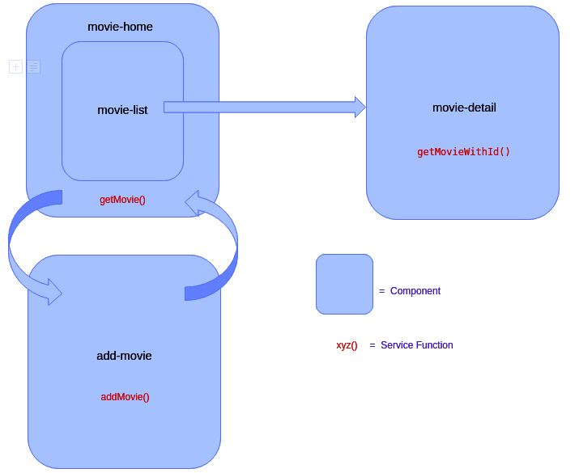

Figure: App model & flow

Note:

1. Arrows depict navigation which is controlled by routing functionality.
2. movie-list is a child component of movie-home.
3. The role of an additional component called PageNotFoundComponent comes into picture when an invalid URL is entered in the address bar. It is a simple notification to the user stating the page they requested wasn’t found.

All the components depend on the MovieModel interface. It has the following properties:

1. id: number
2. movieName: string
3. movieRating: number
4. movieReleaseDate: Date
5. movieDescription: string
6. movieImageURL: string

## Role of Service:

The components communicate and pass data between each other through a service called MovieService. This service provides the following functions:

getMovie(): This function returns the list of all movies added. It basically returns an array of type MovieModel, so it can store several movie details.

getMovieWithId(id: number|string): This function requires the id of a movie as argument. A movie is returned, based on the id passed.

This function is used in the movie-detail component to display a specific movie’s information. When clicking on a movie’s icon in home page, its id/index is passed to the URL. The id is picked and fed to this function which in turn returns the movie at this index.

addMovie(movie: MovieModel): Called from the add-movie component, this function creates a new movie entry in a central array. It is from this array that all other functions pick up details.

## Role of Forms:

Notice the use of reactive driven form and initialization of form values using form builder in add-movie component.

## Role of Custom Directive:

Notice the image icon borders highlighted by different colors depending on the movie’s rating. This feature is controlled by the MyMouseOverDirective custom directive. The border color is determined using switch-case based on the movie rating passed.

## Role of Pipes:

SearchPipe: The functionality of this pipe is what helps in the background when a user searches for a movie’s name in the home page search bar.

|  |
| --- |
|  |
|  |  |
|  |  |
|  |  |
|  |  |
|  |  |
|  |  |
|  |  |