21.INVERTED RIGHT TRIANGLE
CODE:
#include <iostream>
using namespace std;
int main()
{
for (int i=5;i>=1;i--)
{
for (int j=1;j<=i;j++)
cout<<"*";
cout<<endl;
}
}
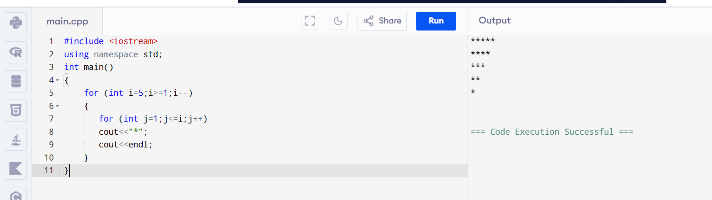

22. STRONG NUMBER
CODE:
#include <iostream>
using namespace std;
int main()
{
int n,t,r,s=0,f;
cin>>n;
t=n;
while(n>0)
{
r=n%10;
f=1;
for(int i=1;i<=r;i++)
f=f*i;
s=s+f;
n=n/10;
}
if(s==t)
cout<<"strong";
else
cout<<"not strong";
}
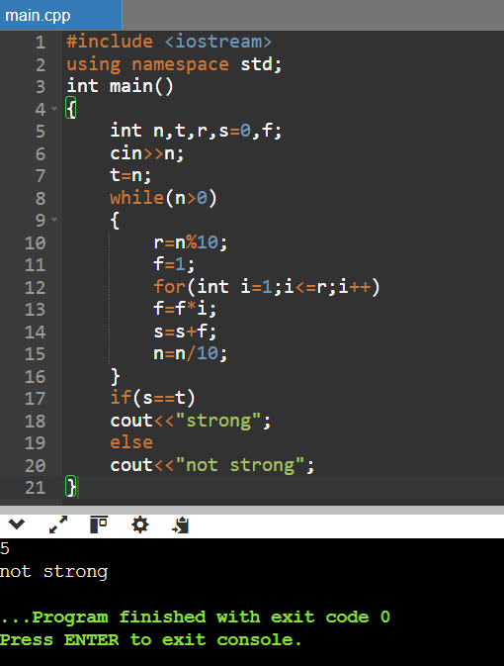
23.frequency
Code:
#include <iostream>
using namespace std;
int main()
{
int n,c=0,d;
cin>>n;
cin>>d;
while(n>0)
{
if(n%10==d)
c++;
n=n/10;
}
cout<<c;
}
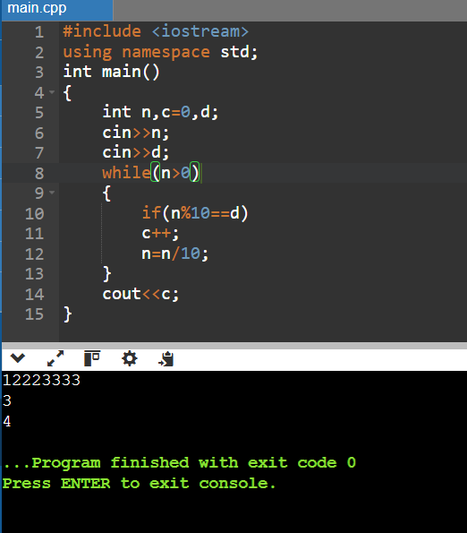
24.count no of divisor
Code:
#include <iostream>
using namespace std;
int main()
{
int n,c=0;
cin>>n;
for(int i=1;i<=n;i++)
if(n%i==0)
c++;
cout<<c;
}
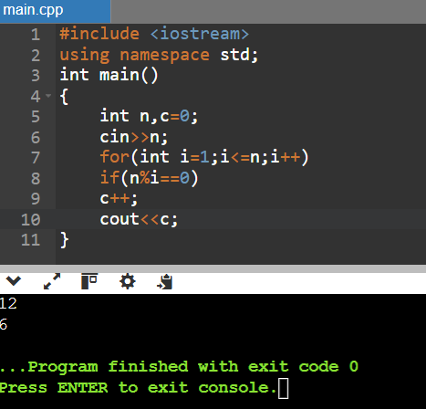
25. compound interest:
Code:
#include <iostream>
#include <cmath>
using namespace std;
int main()
{
float p,r,t;
cin>>p>>r>>t;
cout<<p*pow((1+r/100),t)-p;
}
