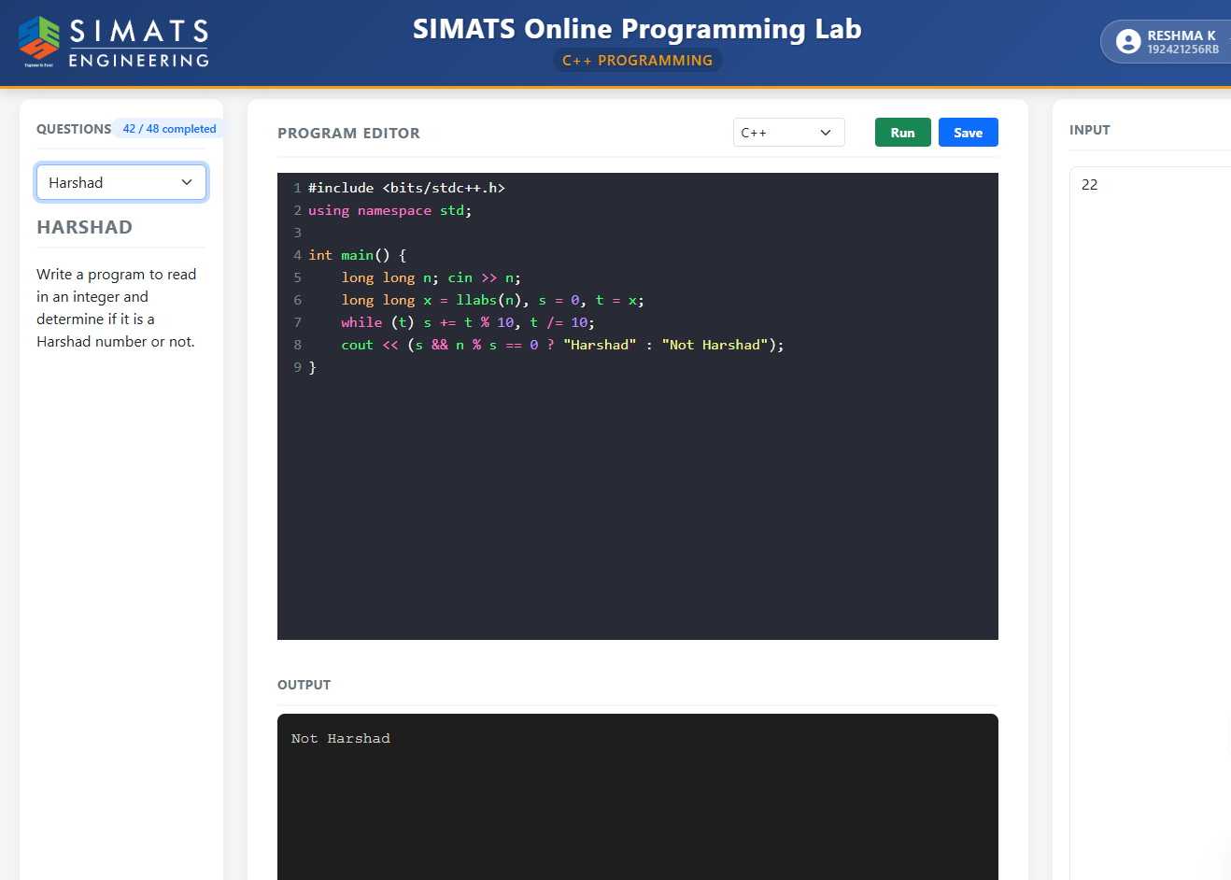
- HARSHAD Code:
#include<iostream>
using namespace std;
int main() {
int n, temp, sum = 0, digit;
cin >> n;
temp = n;
while (temp != 0) {
digit = temp % 10;
sum += digit;
temp /= 10;
}
if (n % sum == 0)
cout << "Harshad" << endl;
else
cout << "Not Harshad" << endl;
return 0;
}

- SWAP Code
#include <iostream>
using namespace std;

int main() {
int a, b;

cout << "Enter two numbers: ";
cin >> a >> b;

// Swapping without using temporary variable
a = a + b;
b = a - b;
a = a - b;

cout << "After swapping:\n";
cout << "a = " << a << " b = " << b;

return 0;
}

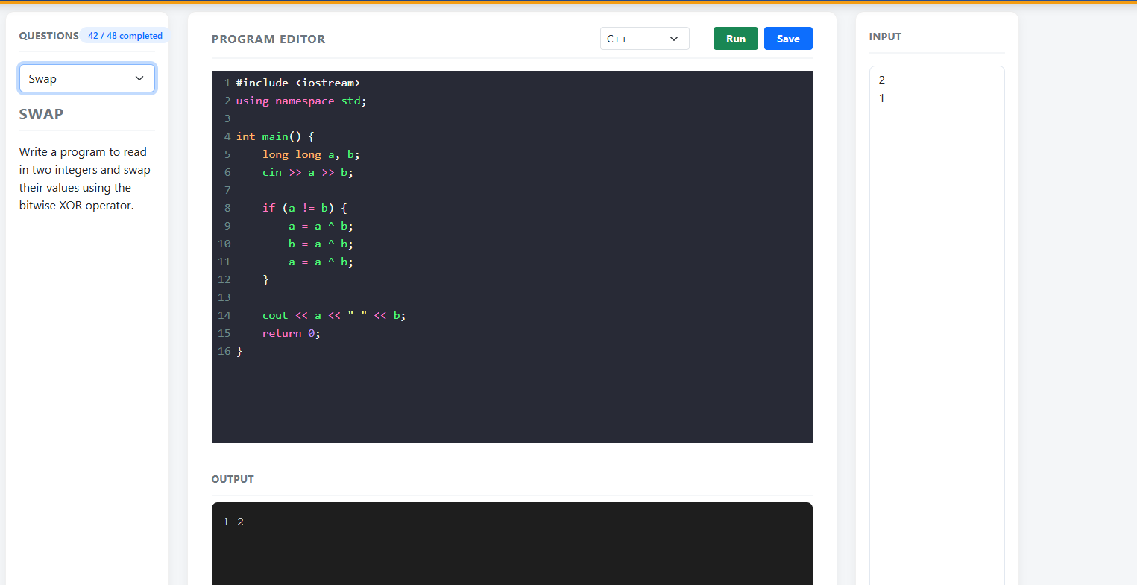

- HOLLOW SQUARE code

#include <iostream>
using namespace std;

int main() {
int n;

cout << "Enter size of square: ";
cin >> n;

for (int i = 1; i <= n; i++) {
for (int j = 1; j <= n; j++) {

// Print * at borders
if (i == 1 || i == n || j == 1 || j == n)
cout << "* ";
else
cout << " ";
}
cout << endl;
}

return 0;
}

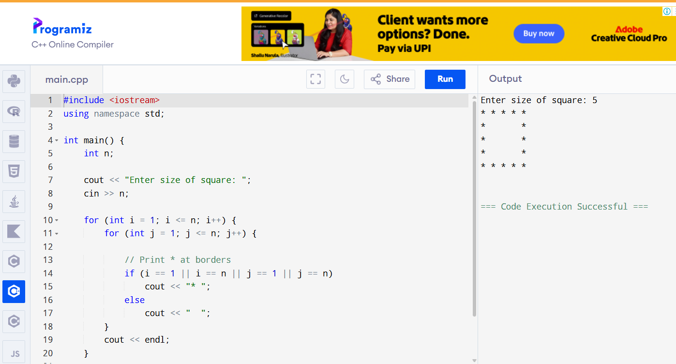

- NUMBER PATTERN code

#include <iostream>
using namespace std;
int main() {
int n;
cin >> n;
for (int i = 1; i <= n; i++) {
for (int j = 1; j <= i; j++) {
cout << j << " ";
}
cout << "\n";
}
return 0;
}

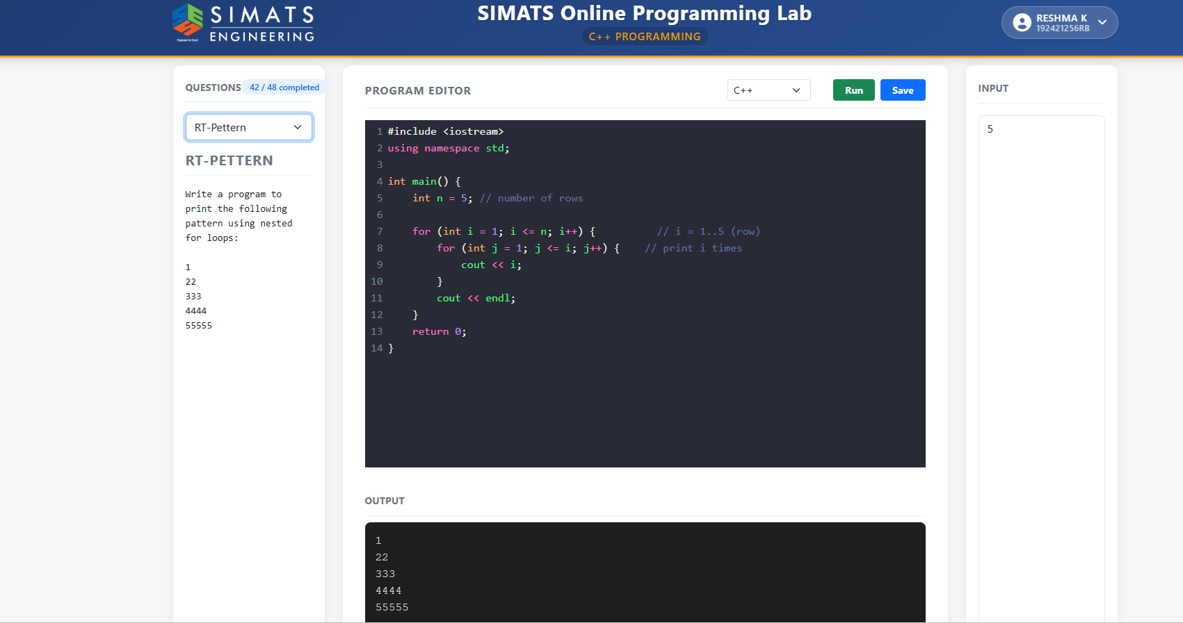

- PALINDROME code

#include <bits/stdc++.h>
using namespace std;
int main() {
long long n, rev = 0, t;
cin >> n;
t = n;
while (t > 0) {
rev = rev * 10 + (t % 10);
t /= 10;
}
cout << (n == rev ? "Palindrome" : "Not Palindrome");
return 0;
}

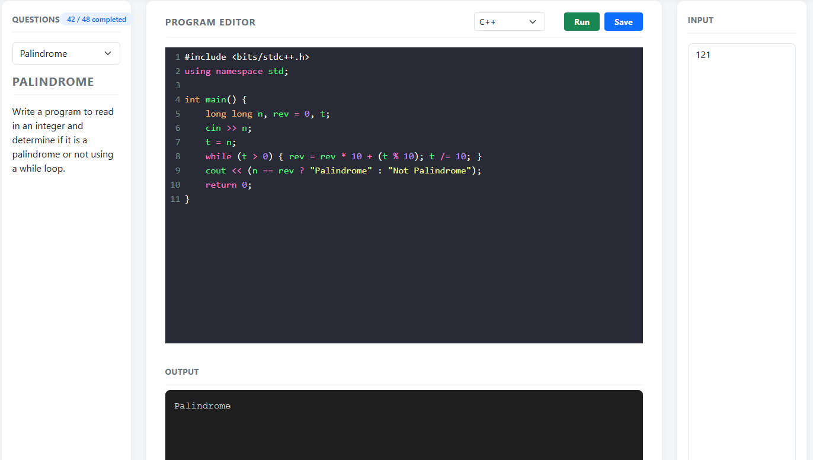

- SUM OF THE CUBES OF THE FIRST N NATURAL NUMBERS code

#include <iostream>
using namespace std;
int main() {
long long N;
cin >> N;
long long sum = 0;
for (long long i = 1; i <= N; i++) {
sum += i * i * i;
}
cout << sum;
return 0;
}

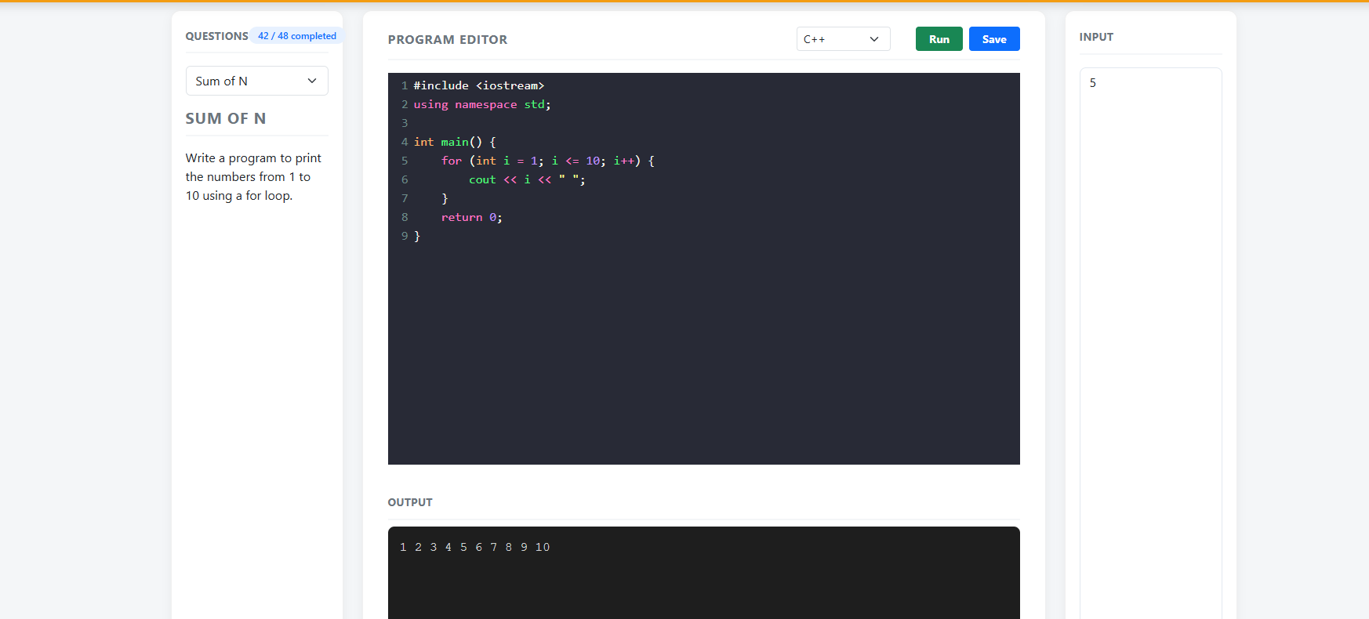

- BINARY TO DECIMAL code
#include <iostream>
#include <string>
using namespace std;

int main() {
string bin;
cin >> bin; // e.g., 10101

long long dec = 0;
for (char c : bin) {
dec = dec * 2 + (c - '0');
}
cout << dec;
return 0;
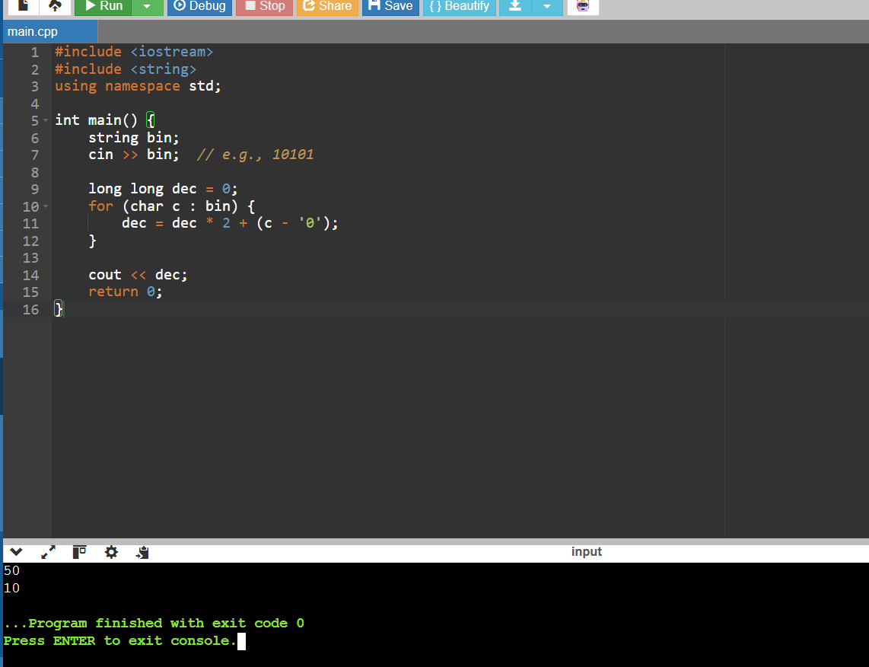

- PALINDROME PATTERN code
#include <iostream>
using namespace std;

int main() {
int n;
cin >> n;

for (int i = 1; i <= n; i++) {
// left part
for (int j = 1; j <= i; j++) cout << j;
// middle
for (int j = i - 1; j >= 1; j--) cout << j;
cout << "\n";
}

// bottom half
for (int i = n - 1; i >= 1; i--) {
for (int j = 1; j <= i; j++) cout << j;
for (int j = i - 1; j >= 1; j--) cout << j;
cout << "\n";
}

return 0;
}
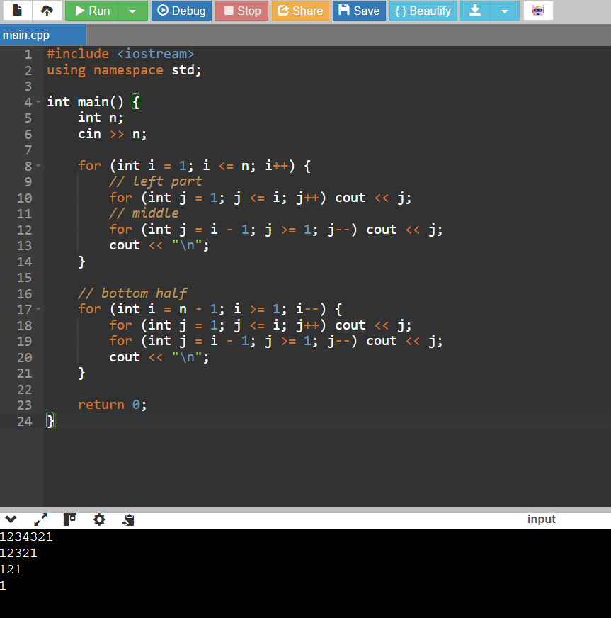

- HOLLOW PYRAMID PATTERN code
#include <iostream>
using namespace std;
int main() {
int n;
cin >> n;
for (int i = 1; i <= n; i++) {
// spaces
for (int s = 1; s <= n - i; s++) cout << " ";
// stars
for (int j = 1; j <= (2 * i - 1); j++) {
if (i == 1 || j == 1 || j == (2 * i - 1))
cout << "*";
else
cout << " ";
}
cout << "\n";
}
return 0;
}

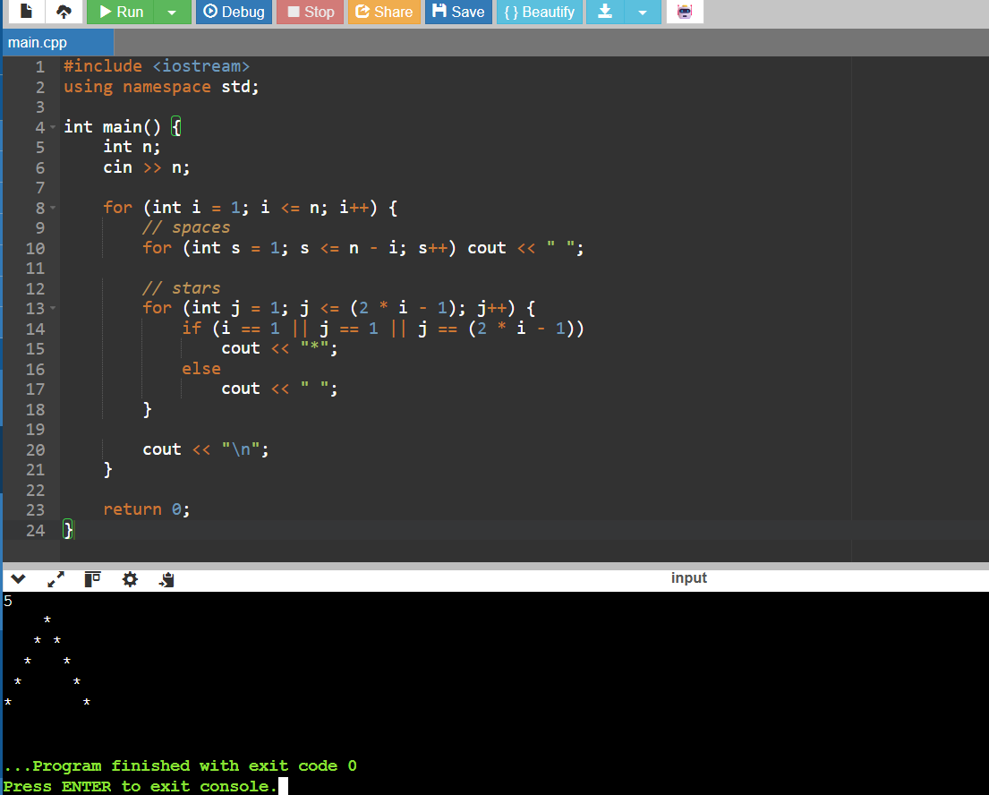

- FIND THE SQUARE OF FIRST N NUMBERS code
#include <iostream>
using namespace std;
int main() {
int n;
cin >> n;
for (int i = 1; i <= n; i++) {
cout << i << " * " << i << " = " << i * i << "\n";
}
return 0;
}

