**Types of Software Architecture:**

**One Tier Architecture:**

One Tier application AKA Standalone application

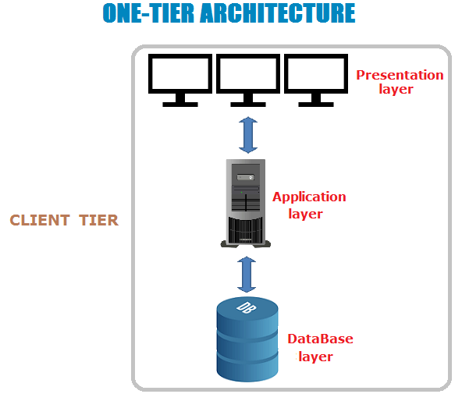

One tier architecture has all the layers such as Presentation, Business, Data Access layers in a single software package. Applications which handles all the three tiers such as MP3 player, MS Office are come under one tier application. The data is stored in the local system or a shared drive.

**Two-Tier Architecture:**

Two Tier application Client-Server application

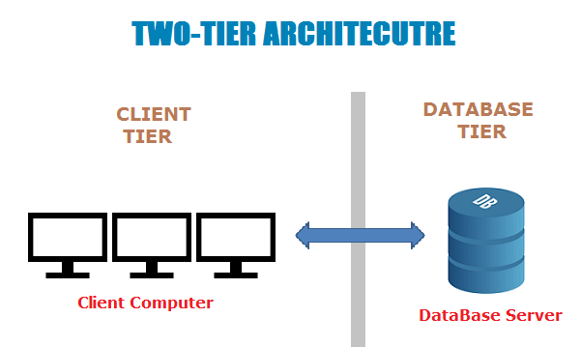

The Two-tier architecture is divided into two parts:

1. Client Application (Client Tier)  
2. Database (Data Tier)

Client system handles both Presentation and Application layers and Server system handles Database layer. It is also known as client server application. The communication takes place between the Client and the Server. Client system sends the request to the Server system and the Server system processes the request and sends back the data to the Client System

Must Read: [SQL for Software Testers Complete Tutorial](https://www.softwaretestingmaterial.com/sql-tutorial-complete/)

**Three-Tier Architecture:**

Three Tier application AKA Web Based application

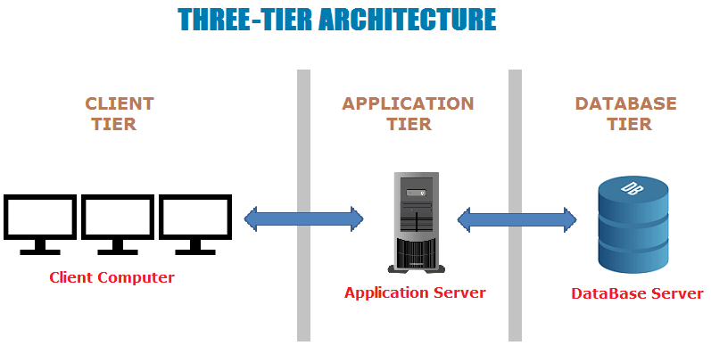

The Three-tier architecture is divided into three parts:

1. Presentation layer (Client Tier)  
2. Application layer (Business Tier)  
2. Database layer (Data Tier)

Client system handles Presentation layer, Application server handles Application layer and Server system handles Database layer.

**Presentation layer** /**Clients Tier** : - It is an end-user.

* We can develop the application for end-user by using

Front-end technologies.

* Front end technologies ex: HTML, JAVASCRIPT, ANGULAR, REACT etc.

**Application layer: -** Here we right business logic of application.

Ex: Java, C#, PHP etc.

**Database layer: -** It is used to store and maintained the data systematically.

Ex: Oracle, MS SQL Server, Sybase, DB2, MySQL, MS Access.