Ocean Acidification Hotspot and MPA Analysis

## Part 1. Create Predicted Aragonite Saturation State Surfaced via Kriging

#### Load packages

if (!require(pacman)) install.packages("pacman")  
library(pacman)  
p_load(  
 tidyverse, here,   
 sp, rgdal, gstat, raster,   
 mapview)

#### Prepare cruise data set

aragonite_data <- read_csv(here("data/WCOAC_2013_test.csv")) #load data  
colnames(aragonite_data) <- c("Date", "Time", "Lat", "Long", "Pressure", "OmegaAr") #rename columns in dataframe  
  
aragonite_data <- aragonite_data %>% #remove N/A values  
 mutate(OmegaAr=replace(OmegaAr, OmegaAr==-999.000, NA)) %>%  
 na.omit(aragonite_data)  
  
aragonite_data<- aragonite_data[aragonite_data[, 5]<5,] #filter for surface observations  
  
coordinates(aragonite_data)<- ~ Long + Lat #transform into spatial points  
  
zd<-zerodist(aragonite_data)  
aragonite_data<-aragonite_data[-zd[,2],] #remove observations taken at same coordinate point

#### Interpolation via simple kriging

aragonite_var<-variogram(OmegaAr ~1, data=aragonite_data, alpha=c(0, 45, 90, 135))  
plot(aragonite_var) #look for anisotropy and create variogram of aragonite values

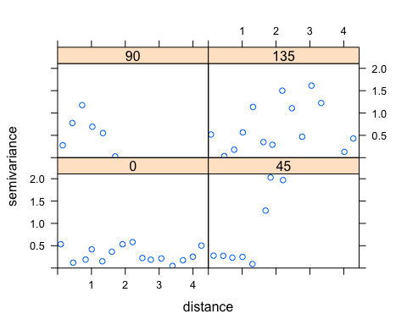

aragonite_fit<-fit.variogram(aragonite_var,model=vgm(nugget=0.2,psill=1,range=2,model="Exp", anis=c(0, 0.3))) #fit a model to the values based on estimated nugget, sill, and range, and anisotropy  
plot(aragonite_var,aragonite_fit)

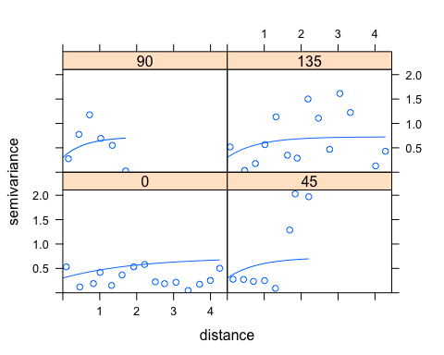

extent <- bbox(aragonite_data) #get extent of cruise observations   
long<-seq(extent[1,1],extent[1,2],length=388) #increase ROI by one degree in each direction  
lat<-seq(extent[2,1],extent[2,2],length=1000)  
  
aragonite_grid<-expand.grid(long,lat) #create grid for interpolation surface  
colnames(aragonite_grid)<- c("long", "lat")  
coordinates(aragonite_grid) <- ~ long + lat  
gridded(aragonite_grid)=TRUE  
  
aragonitekrige<-krige(OmegaAr ~ 1, aragonite_data, newdata=aragonite_grid, model=aragonite_fit) #run kriging on interpolation grid, based on best fit model

#### Create continuous raster

aragonite_raster<-raster(aragonitekrige, layer=1, values=TRUE) #transform krige object to raster  
projection(aragonite_raster) <- CRS("+proj=longlat +datum=WGS84") #set CRS   
aragonite_raster_proj <- projectRaster(aragonite_raster, crs=CRS('+init=EPSG:6414'),method="ngb") #re-project to California Teale Albers Equal Area

## Part 2. Create hotspot thresholds mask

thresholds <- c(0,1,1, 1,1.7,1.7, 1.7,2,2, 2,10,NA)  
thresholdsmatrix <- matrix(thresholds, ncol=3, byrow=TRUE)  
hotspotmask <- reclassify(aragonite_raster_proj, thresholdsmatrix)

## Part 3. Compare predicted aragonite saturation state and hotspots to MPA Location

#### Load shapefiles

poly_MPA <- readOGR(dsn=path.expand("/Users/Madi/Documents/UCSB Bren/ResilienSeas/all_mpas_update"), layer="all_mpas_update") #load MPAs  
  
poly_MPA <- spTransform(poly_MPA, crs(aragonite_raster_proj)) #assign same CRS as aragonite layer  
  
poly_coast<- readOGR(dsn=path.expand("/Users/Madi/Documents/UCSB Bren/ResilienSeas/Export_Output_2"), layer="Export_Output_2") #load coast  
  
poly_coast <- spTransform(poly_coast, crs(aragonite_raster_proj)) #assign same CRS

#### Clip rasters to coast

aragonite_clipped <- mask(aragonite_raster_proj, poly_coast, inverse = TRUE) #clip continuous raster  
  
hotspot_clipped <- mask(hotspotmask, poly_coast, inverse = TRUE) #clip hotspot mask

#### Zonal statistics - mean saturation state

aragonite_mean<- raster::extract(aragonite_clipped, poly_MPA, fun=mean, na.rm=TRUE, df=TRUE) #calculate mean aragonite saturation state from continuous layer and export as dataframe  
colnames(aragonite_mean) <- c("OBJECTID", "ARAGONITE_MEAN")  
  
poly_MPA@data[,1] <- seq(1, length(poly_MPA@data[,1])) #Replace "OBJECTID" with sequenced list to remove duplicates and change from factor to integer form  
poly_MPA@data <- poly_MPA@data %>%   
 left_join(aragonite_mean, by = 'OBJECTID')

#### Zonal statistics - percent cover of hotspot

pctcover <- raster::extract(hotspot_clipped, poly_MPA, fun=function(x, ...) length(na.omit(x))/length(x), df=TRUE) #calculate percentage of total MPA area covered by threshold of concern  
colnames(pctcover) <- c("OBJECTID", "PCT_HOTSPOTCOVER")  
  
poly_MPA@data <- poly_MPA@data %>%   
 left_join(pctcover, by = 'OBJECTID')

## Part 4. Evaluate aragaonite saturation state threat relative to habitat cover