USER MANUAL

1. **General Setup.**

It is important to specify the AppBuilder HOME directory first. Go to Preferences … -> AppBuilder Preferences page -> define where AppBuilder resides.

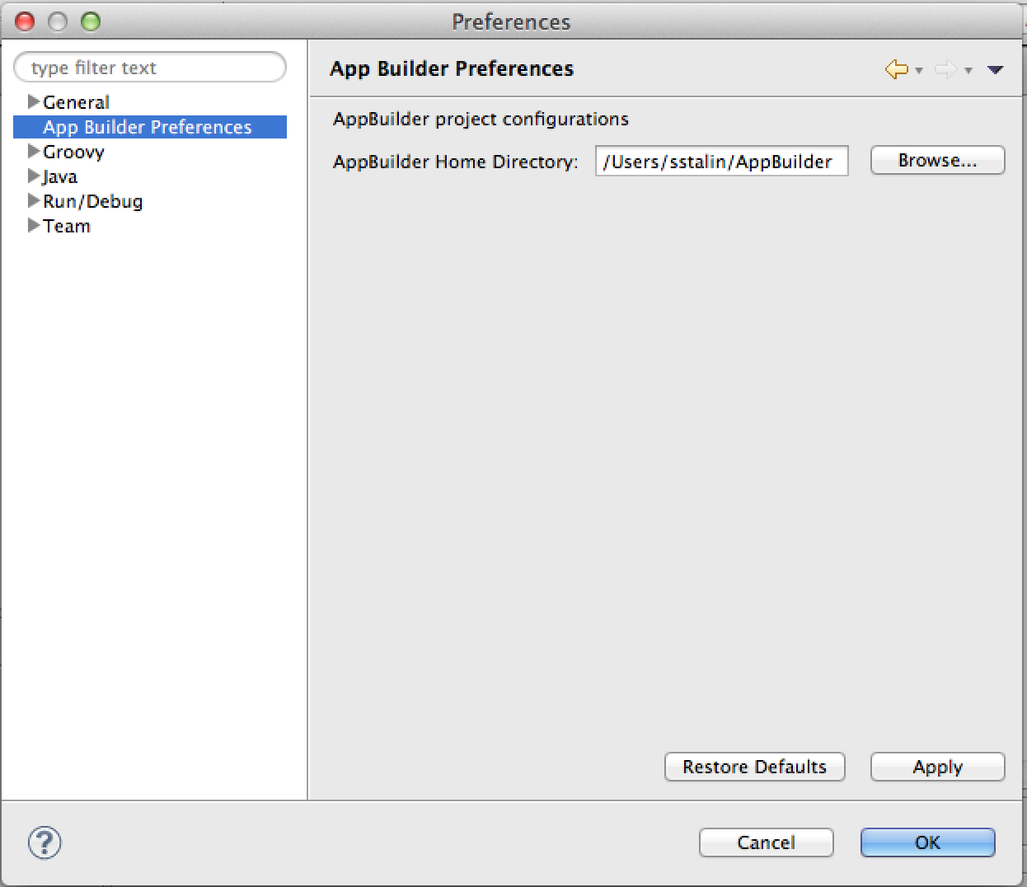

1. **Create new project.**

* Click on New Project … -> AppBuilder Project.

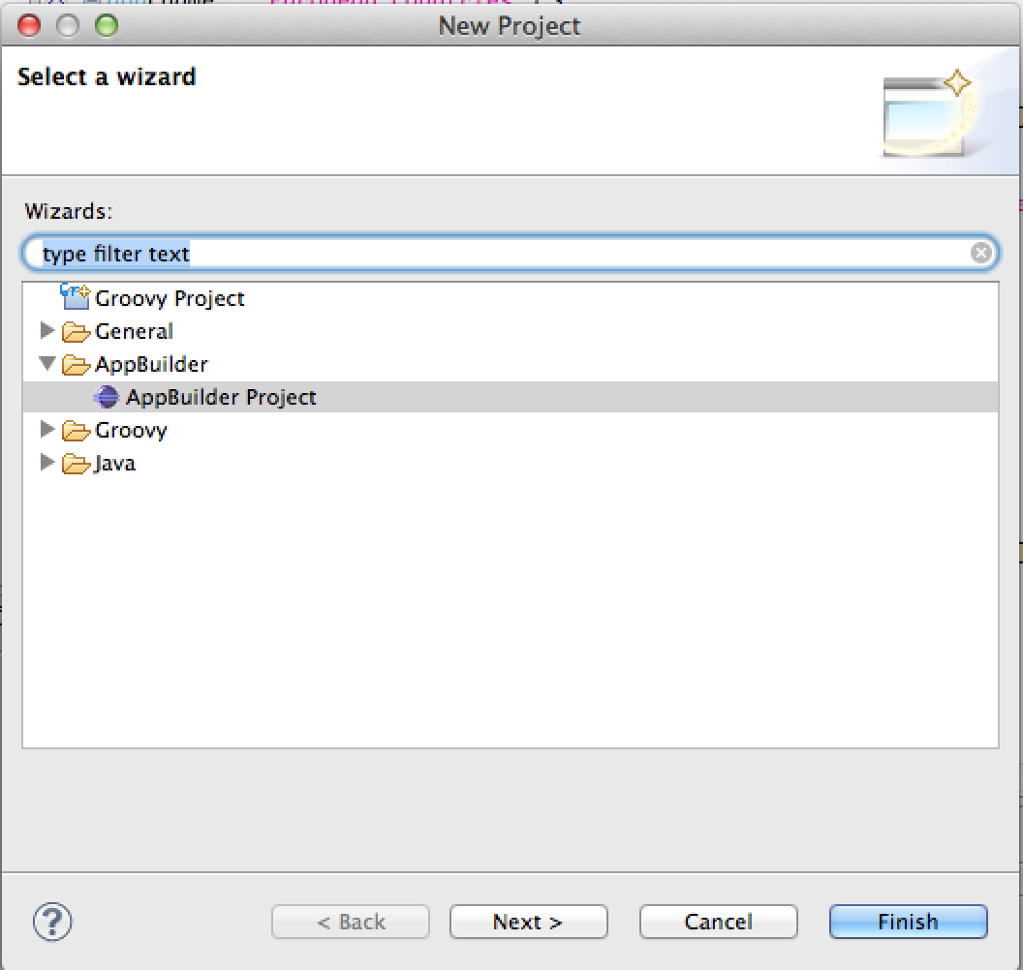

* Fill in project configuration data

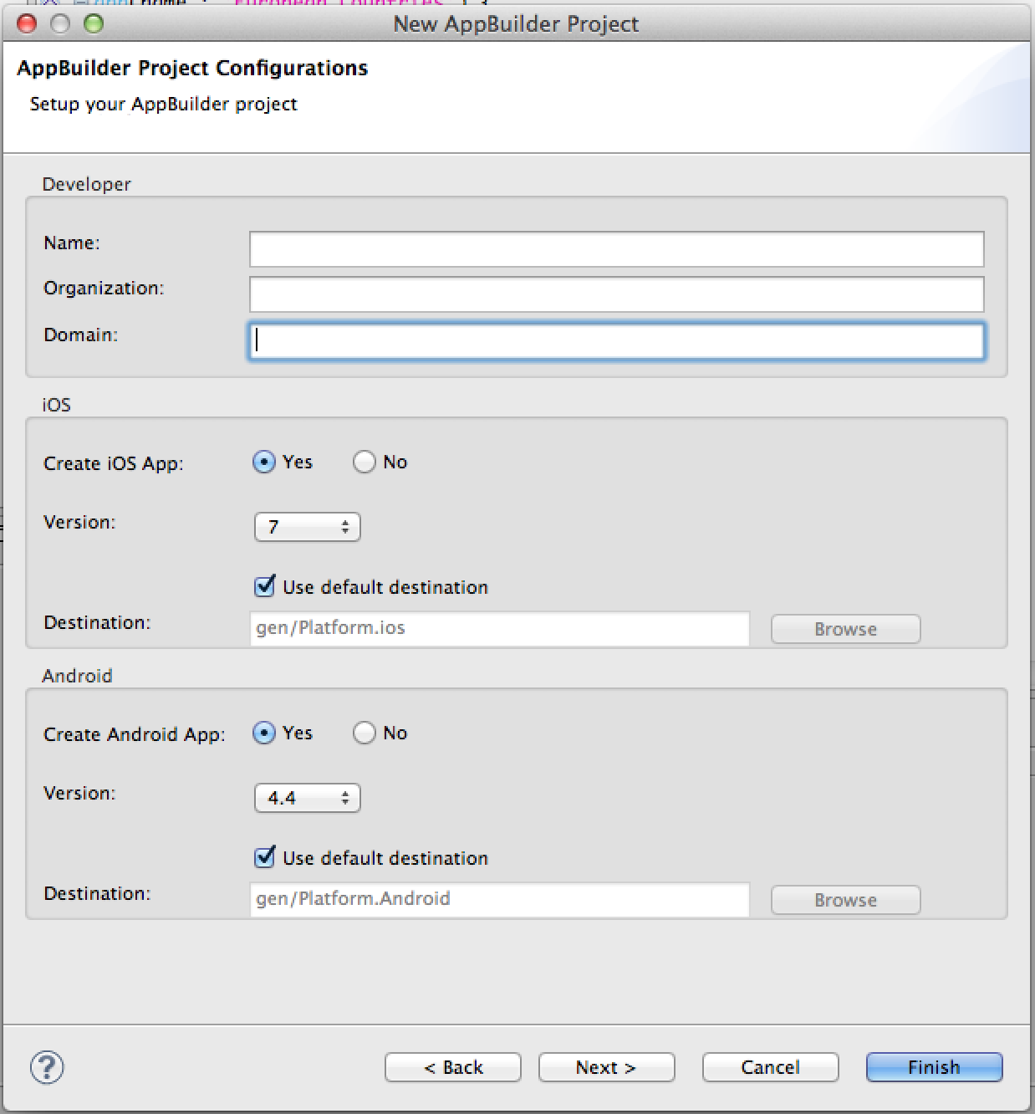

* Select sample template.

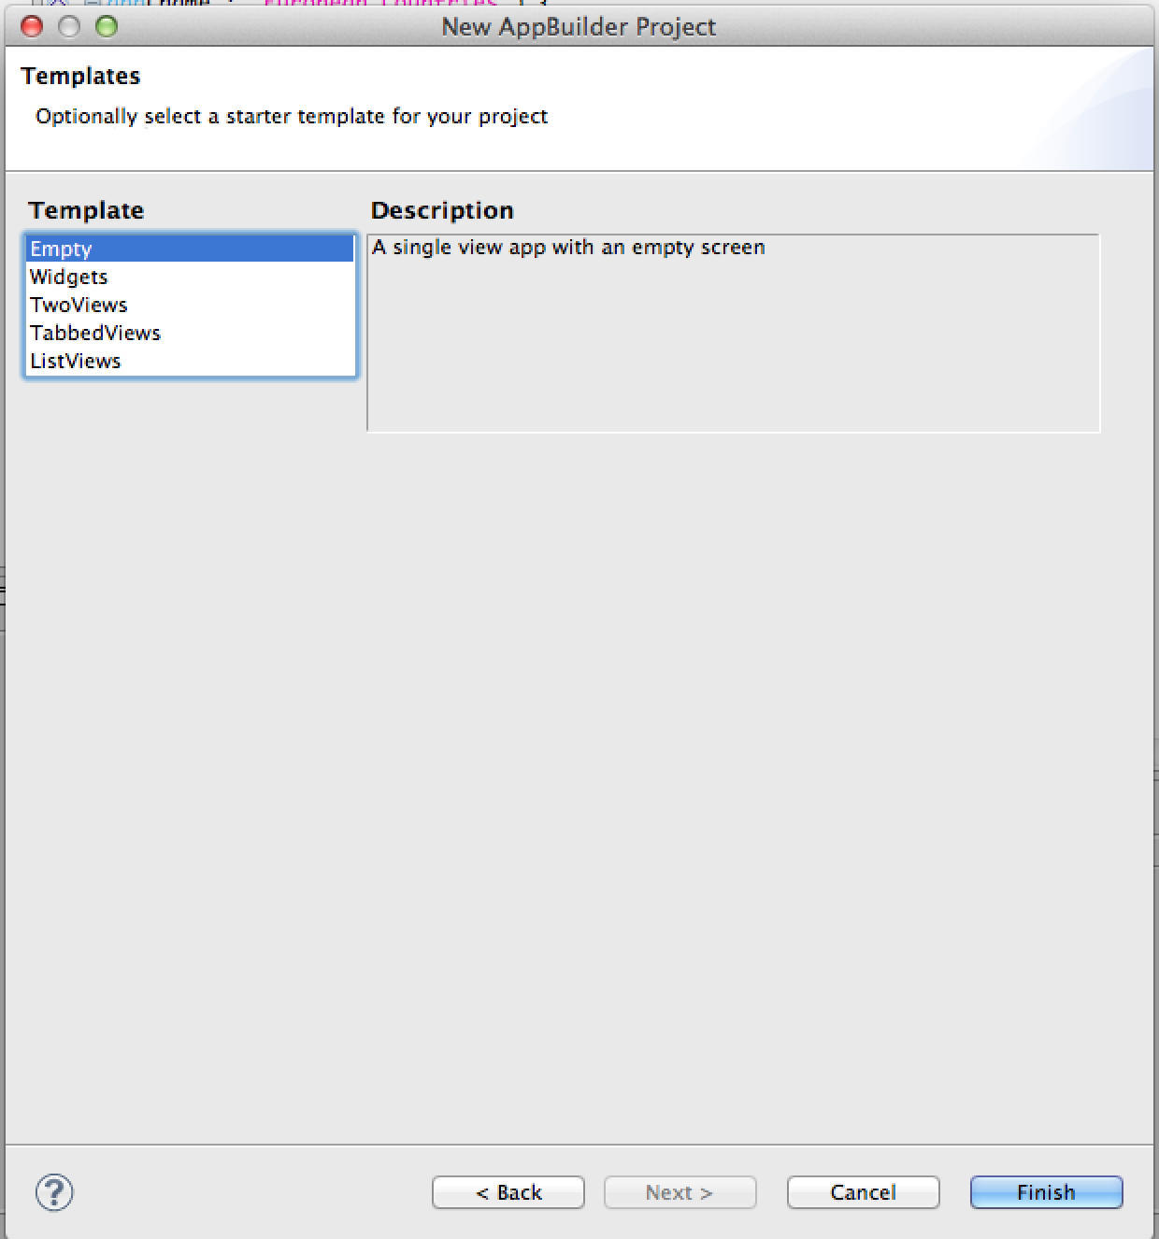

1. **Using MADL launcher.**

Click on RunAs -> MADL Appplication – that will trigger AppBuilder tool, which will compile source code and generate projects for iPhone and Android.

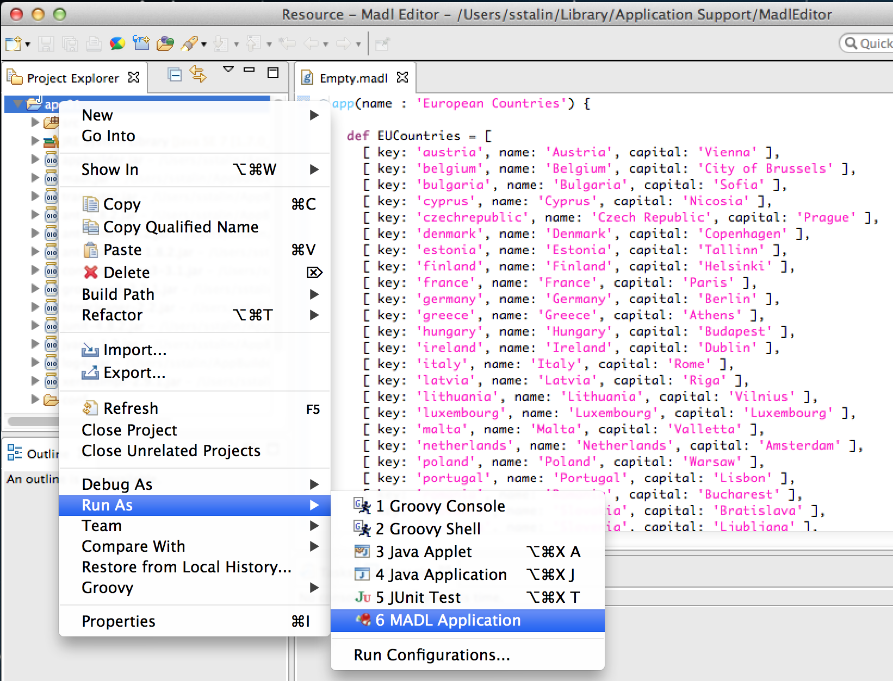

1. **Test on your project in IPhone emulator.**

Click **…**

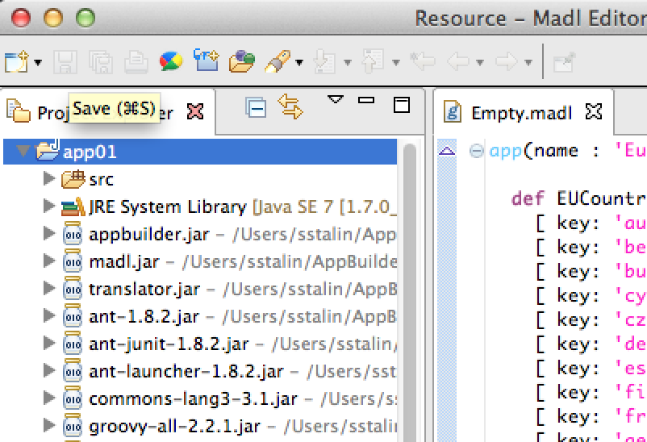

That will trigger XCode and import the project. From there project can be tested on iPhone emulator.

1. **MADL RCP editor instructions.**

Unzip the installation zip file to a folder of choice. After installation the following product folder structure should be present.

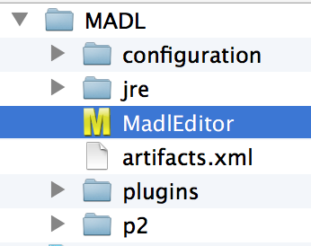

Click on MadlEditor application file to start the application.

Note: Currently the RCP editor is available only for mac OS.