Final Project: Flood Modelling and Risk Assessment Using openLISEM
As part of this course’s final project, you are tasked with conducting realistic flood modelling simulations and scenario testing using the open-source tool openLISEM. This project is designed to help you apply the concepts, data, and workflows introduced during the course to simulate and analyze flooding conditions in the city of Quelimane, Mozambique.
You will use provided input datasets and modeling scripts to simulate T50 rainfall events and coastal boundary conditions. Your role is to assess potential flooding at critical locations, evaluate proposed mitigation measures (such as dike construction), and prepare outputs that can be used to inform local authorities and planners. Data and code link is already provided in lecture 22.
---------------------------------------------------------------------------------------------------------------------------
Task 1: Flood Onset Detection at a Critical Location
- Run the openLISEM model using the T50 rainfall and coastal boundary conditions (as demonstrated in Video Lecture 22).
- Focus on the Campo CFM football stadium, located at column 1018, row 1041 (see Figure 1).
Answer the following:
- At what time (in hours and time steps) does water level first exceed 10 cm at the stadium?
- Is the flooding at that moment caused by rainfall or sea-level rise?
- What was the cause of flooding (e.g., poor drainage, topography, accumulation).
---------------------------------------------------------------------------------------------------------------------------
Task 2: Testing a Flood Mitigation Scenario (Dike Construction)
- Test a flood protection strategy involving the construction of a 4.0-meter-high dike at the estuary outlet. Location of dike is give in shape file [Dike.shp]
- Simulate flooding for 5 days under the following conditions:
- No rainfall
- Sea level rise of 4.7 meters
- Focus on grid cell column 1014, row 1042 (Figure 2).
Answer the following:
- Does this location [grid cell column 1014, row 1042 (Figure 2)] still flood with the dike in place under sea level rise?
- Using QGIS, generate print layout maps to visualize and compare the flood extent under two conditions:
- Original condition: without dike
- Mitigation scenario: with 4.0-meter dike under 4.7 m sea level rise.
Your maps should include:
- A legend
- A north arrow
- A scale bar
- Clear location markers for key areas (e.g., the tested grid cells)
- Descriptive titles (e.g., “Maximum Water Level – T10 Without Dike”)
Export these maps as images or PDFs and insert them into your final report
---------------------------------------------------------------------------------------------------------------------------
Submission Guidelines
- Submit all answers in a single PDF document.
- Make sure all two tasks (simulation answers, and mitigation analysis) are clearly addressed and clearly label each question and section in your submission.
- Your complete submission must not exceed 2 pages, including any figures, maps, or appendices. Make sure all figures and maps are properly labelled and formatted.
- If your computer runs out of memory while running the simulations, you are allowed to reduce the resolution of the input maps (i.e., increase the grid cell size. If you do this, please clearly mention the resolution change in your answer).
- Include your full name and email address at the top of the first page of the document.
- Submit your final report as a PDF file via the Open Learning platform.

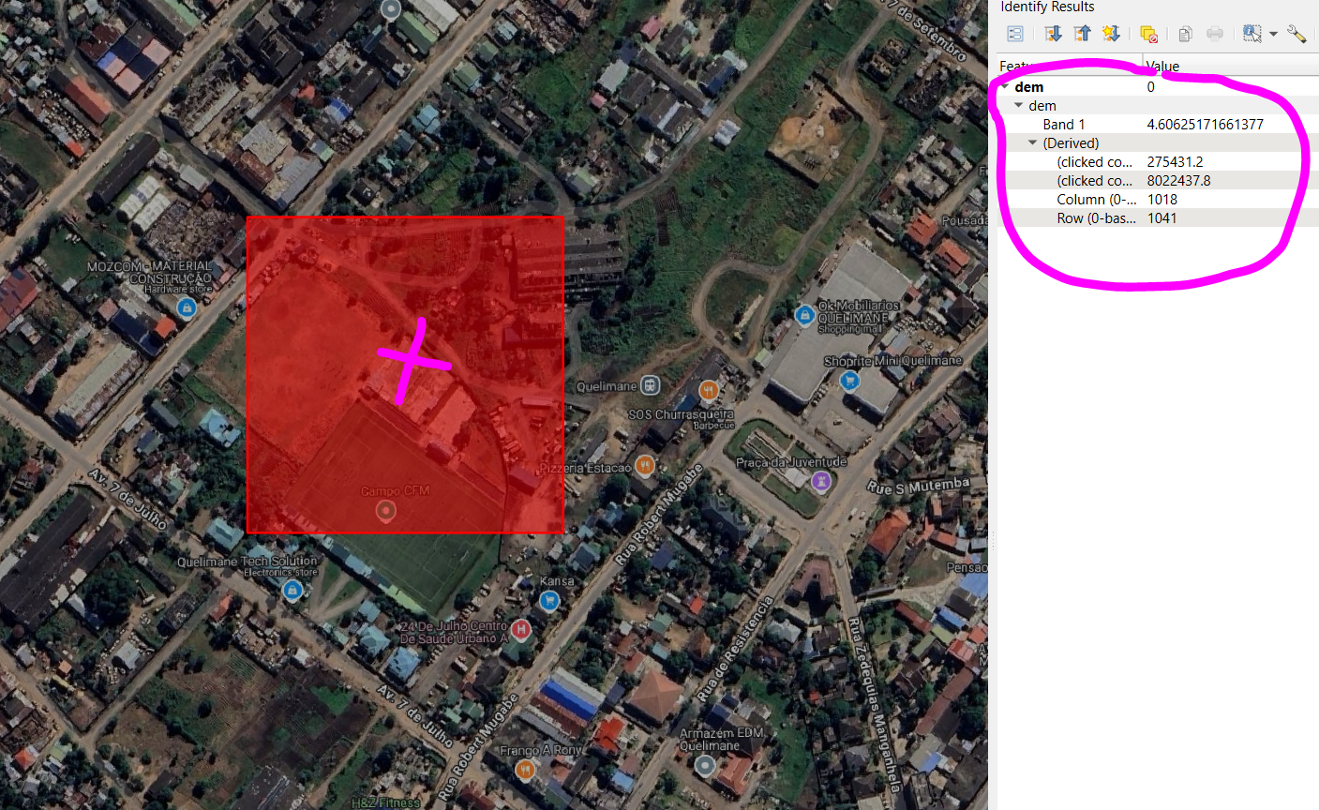
Figure 1: Location of the Football Stadium Campo CFM in Quelimane City
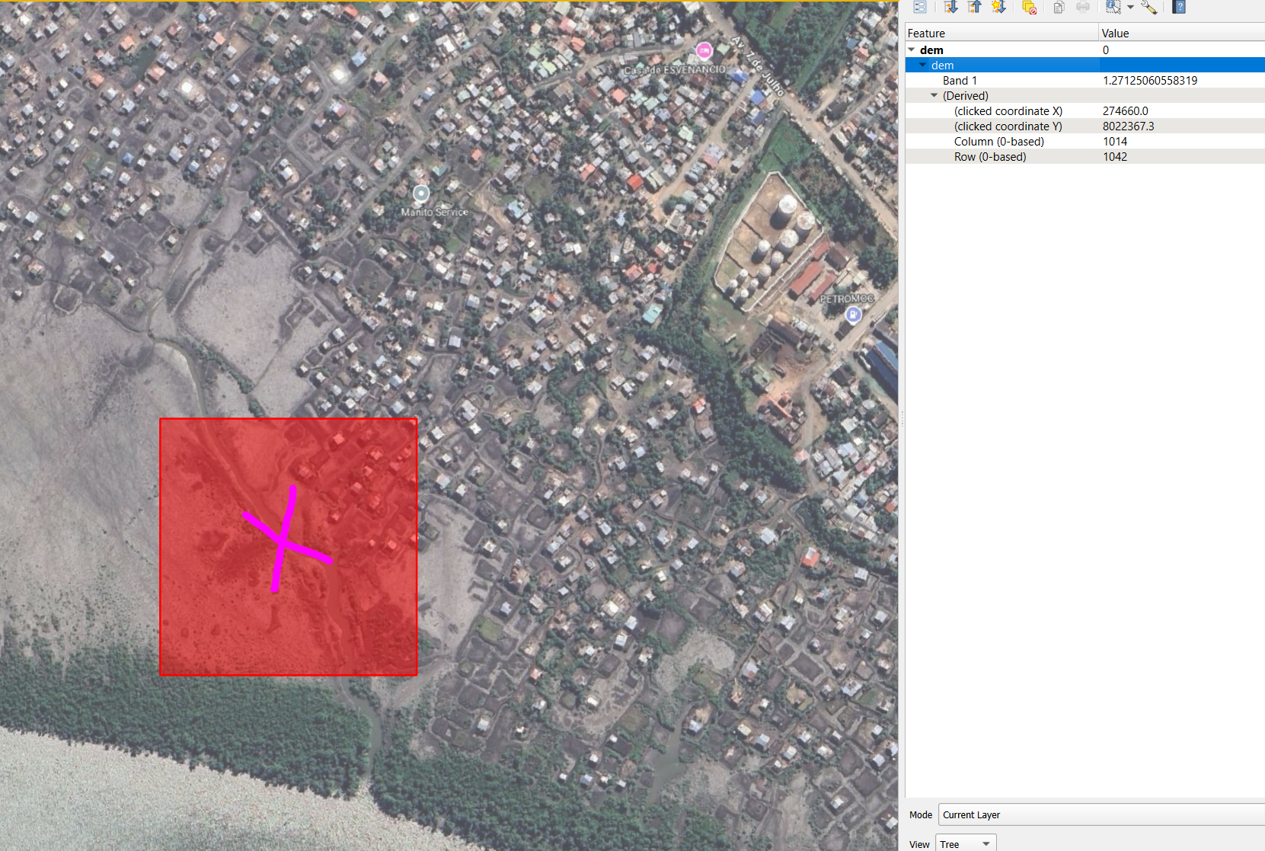
Figure 2: Locations to be tested for potential flooding impact after dike construction.
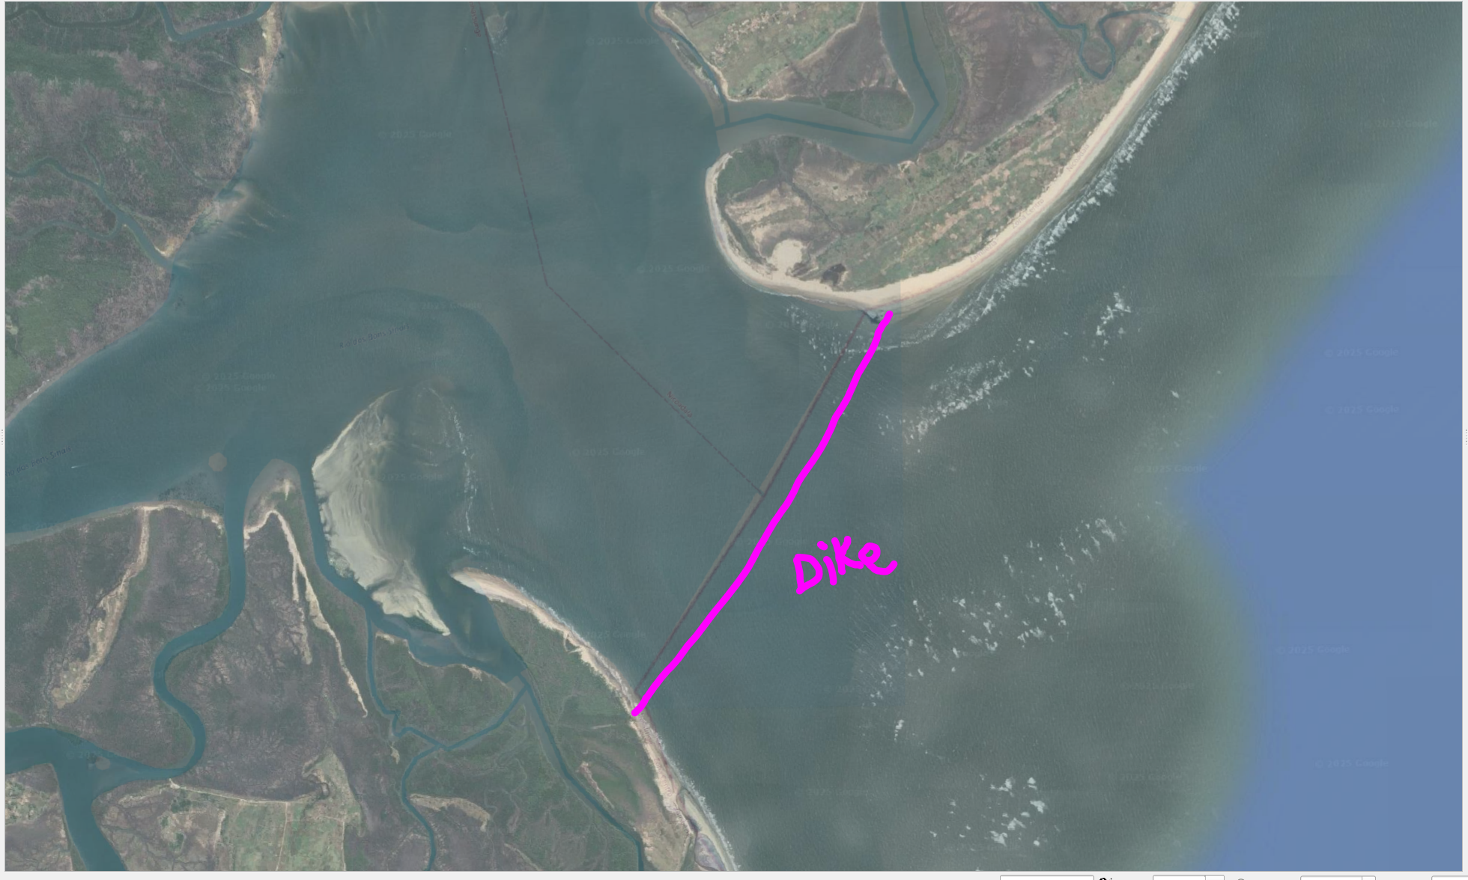
Figure 3: Tentative location of the proposed dike construction. For the exact location, please refer to Dike.shp in the Locations folder in QGIS.

