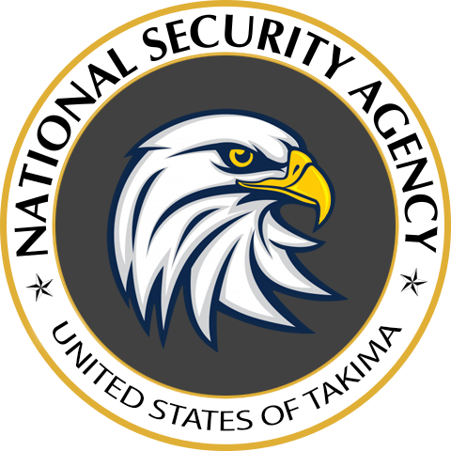
TAKIMA NATIONAL SECURITY AGENCY
Feb, 2 2020

SECRET DOCUMENT LEVEL 5

FROM : M. John McClane TNSA Director

SUBJECT : MEMORANDUM FOR 5+ ACCESS LEVEL AGENTS

To the attention of all agents of authorization level 5 or higher, the TNSA is, as you know, more and more exposed to threats from the group of cyber-terrorists called “Heistkers”.

Their objective - announced on a letter posted last week - is to steal the latest discoveries from our R&D team stored in the safe number 051478.

It is of course impossible to let them put their hands on the content of the safe.
This is why the R&D team has provided you with a high security briefcase to store your sensitive data in the event that an agent is compromised.

These cases have secure access by code which will be provided to you orally by agent Michael Scofield.
Finally, access to the safe is now only accessible to level 6 agents. You will find with this memo a reminder of the access levels.

Thank you for staying on guard.

Director John McClane

REMINDER : ACCESS LEVEL TABLE

1 – PUBLIC
2 – TNSA EMPLOYEES
3 – TNSA AGENTS
4 – CONFIDENTIAL
5 – SECRET
6 – TOP SECRET

