Contents

HSPEXP+ Version 1.11 User’s Manual 1
Disclaimer 2
Acknowledgements 2
User Assistance and Feedback 3
Introduction 3
Background 3
Capabilities of HSPEXP+ 4
Hydrologic Calibration 4
Water Quality Calibration 5
Automated Graph Generation 5
Caveats 6
Using HSPEXP+ 6
User Interface 6
Setting up the Project 7
Setting up UCI and Other Files 7
Setting up EXS File(s) 9
Setting up Graph Specification File (s) for Generating Additional Graphs 13
Setting up BASINS Observed Water Quality Data File 16
Running HSPEXP+ 17
Resolving Errors 17
Load Allocation Tool 18
References 25
November 2015
HSPEXP+ Version 1.11 User’s Manual

Anurag Mishra Paul B. Duda Mark Gray Brian R. Bicknell Anthony S. Donigian, Jr. Rebecca Zeckoski*
AQUA TERRA Consultants (A Division of RESPEC) Mountain View, California 94043 
*Biological Systems Engineering Virginia Tech, Virginia 24061
Disclaimer

HSPEXP+ has been developed by AQUA TERRA Consultants (A Division of RESPEC) to support calibration of watershed models that are developed using HSPF. It is an open source project, and is released free of cost to support modelers who are using HSPF. It is under active development, and no active support is available for HSPEXP+ by AQUA TERRA Consultants or any other agency. AQUA TERRA Consultants and the authors do not assume any responsibility for system operation, output, interpretation, or use.
Acknowledgements

HSPEXP+ is being developed by AQUA TERRA Consultants (A Division of RESPEC) for supporting watershed modeling projects. Dr. Anurag Mishra is the Project Manager, responsible for the design, implementation, testing, and continued development of the program. Technical and administrative guidance is provided by Mr. Paul Duda, Mr. Mark Gray, Mr. Brian Bicknell, and Mr. Tony Donigian. HSPEXP+ is under continuous development, and new capabilities are added to meet the priority needs of the user community, as and when additional resources are available.
Dr. Rebecca Zeckoski from Virginia Tech provided assistance in developing the initial user interface, and coding the expert guidance. Support for Dr. Zeckoski’s contributions was made possible by the Center of Watershed Studies within Virginia Tech’s Biological System Engineering Department.
The “Clean Water Fund” of Minnesota partially supported the development of HSPEXP+. 
AQUA TERRA Consultants thanks the modelers who tested the initial versions of HSPEXP+ and provided valuable feedback.
User Assistance and Feedback

As indicated earlier, active support for HSPEXP+ is not available, however feedback may be provided at hspexpplus@aquaterra.com.
Introduction

HSPEXP stands for Expert System for Calibration of HSPF. The legacy version of HSPEXP was developed by the USGS (Lumb et al., 1994). HSPEXP+ is the next generation of HSPEXP.
HSPEXP+ has been completely re-designed and shares only the legacy input file format, mathematical formulae, and algorithms from HSPEXP. HSPEXP+ can perform several additional functions, and it is evolving into a comprehensive hydrologic and water quality calibration tool for HSPF.
Background

HSPEXP interactively allows the user to edit the input User Control Input (UCI) file for the Hydrologic Simulation Program--Fortran (HSPF), run HSPF simulations, produce plots of HSPF hydrology outputs compared to observed values, compute error statistics for a simulation, and provide the user with expert advice on which parameters should be changed to improve the calibration. In general, use of HSPEXP is an interactive process that requires repeating the cycle of simulation, computing statistics, reviewing plots, getting advice, and modifying parameters.
Artificial intelligence (AI) was first used with HSPF on a project at the Stanford Research Institute (SRI), in Menlo Park, California, to estimate initial values for model parameters. HSPEXP is the result of a USGS project to create an expert system to assist with the calibration of a watershed model. The prototype was developed with AI software tools, and when properly refined was converted to ANSI standard Fortran using the Graphical Kernel System (GKS) for portability.
HSPEXP uses over 35 rules involving over 80 conditions to recommend parameter adjustments. The rules are divided into four groups -- annual volumes, low flows, storm flows, and seasonal flows. Rules in subsequent groups are not tested until all rules in the previous group ‘pass.’ The rules are based on the experience of experts in the use of HSPF in a range of climates and physiographic regions.
Meteorological records of precipitation and estimates of potential evapotranspiration in a Watershed Data Management (WDM) file are required for watershed simulation using HSPF. Air temperature, dew point temperature, wind, and solar radiation also are required for simulation of snow accumulation and melt. Air temperature, wind, solar radiation, humidity, cloud cover, tillage practices, point sources, and (or) pesticide applications may be required for water quality simulation. Physical measurements and related parameters are required to describe the land area, channels, and reservoirs.
Output options include tables of statistics comparing observed data and simulated results, ten different types of graphical presentations, and tables of the expert advice. Time-series output from the simulation is written to the WDM file. Output may be viewed interactively or written to text files for printing or analysis in a spreadsheet program.
HSPEXP has been used to support HSPF application to numerous watersheds including, the Patuxent River, Maryland, the Lesueur River Basin, Minnesota, and the Truckee River Basin, California/Nevada.
HSPEXP was developed for older operating systems, and it has been reported by multiple users that it is not suitable for current computers. The USGS has stopped active development of HSPEXP.
Building on the capabilities of HSPEXP, HSPEXP+ was developed by AQUA TERRA Consultants to facilitate hydrologic and water quality calibration projects. The software is available free of cost at the AQUA TERRA Consultants website, and its source code is available along with the BASINS source code.
Capabilities of HSPEXP+

HSPEXP+ can help in hydrologic and water quality calibration of a watershed model that is developed using HSPF. HSPEXP+ produces several graphs for hydrologic calibration. HSPEXP+, can also be used to generate additional graphs (timeseries, frequency duration, and scatter plots) using its automated graph generation capability.
Unlike its predecessor HSPEXP, HSPEXP+ cannot be used to edit HSPF UCI file interactively. HSPEXP+ cannot generate the BASINS Specifications (EXS) file as well. HSPEXP+ users must prepare the EXS file in a text editor, and edit the UCI file using WinHSPF or a text editor (based on the calibration results and advice generated by HSPEXP+).
Hydrologic Calibration

HSPEXP+ uses the Basin specification file (EXS file, extension “*.exs”) to obtain information about the calibration site, observed flow time series dataset, simulated time series datasets, drainage area, storm periods, error criteria, etc. The format of the EXS file is consistent with that was used in HSPEXP. To read more about this file, please refer to the HSPEXP manual (Lumb et al., 1994).. The content and format of the EXS file has been described in the EXS File section of this manual. HSPEXP+ does not have the capability to produce the EXS file (currently under development). Please refer to the manual and/or start with an existing EXS file to make a file for your watershed.
Listed below are HSPEXP+ capabilities for hydrologic calibration:
- Produce land use and watershed area reports to provide a quick check of watershed segment connectivity.
- Produce Expert Statistics for hydrology calibration (using the computations from the original HSPEXP), at multiple sites in the watershed, in simple text files. The EXS file can list more than one site, or the folder containing the model calibration files can have multiple EXS files, for multiple locations.
- Produce advice for model calibration for each calibration site.
- Produce additional statistics including annual, monthly, and daily flow comparisons.
- Produce overall, annual, and monthly timeseries graphs, flow frequency duration graphs, cumulative flow graphs, and time series graphs of other components such as potential evapotranspiration, lower zone storage, upper zone storage, etc.
- By default, HSPEXP+ (and its predecessor, HSPEXP) considers May, June, July to be the summer months, and December, January, February to be the winter months for calculating seasonal statistics. In HSPEXP+, summer and winter months can be specified in the EXS file, if changes to the default seasons are needed. Please refer to the EXS file section for more details.
- All graphs produced by HSPEXP+ are high quality PNG format that can be directly inserted into reports and presentations.
- All reports produced by HSPEXP+ can be directly opened in any spreadsheet program for quick viewing, formatting, and presentation.
- All graphs and reports are produced in a time-stamped folder with a copy of the UCI file for reference.
- HSPEXP+ can generate water balance reports in several layouts including overall water balance, annual water balance, and water balance grouped by land use, etc.

Water Quality Calibration

For water quality calibration tasks, HSPEXP+ does not require the EXS file.
- HSPEXP+ generates nutrient balance reports in a variety of layouts for sediment, total nitrogen, and total phosphorus.
- HSPEXP+ does not calculate statistics to compare observed and simulated water quality data; however, it provides reports and graphs to better understand the water quality simulation, and guide changes in the parameters accordingly. It does not provide advice for water quality parameter adjustments.

Automated Graph Generation

- HSPEXP+ can generate additional graphs for water quality, snow depth, frequency duration, scatter plots, etc. The specifications for these graphs must be provided in one or more comma-separated file (*.csv format).
- The time series for these graphs can be obtained from a WDM file, HBN file, or a DBF (BASINS Observed WQ file format) file.
- HSPEXP+ also outputs the dataset used for generating the graphs in tab delimited text files. Users can utilize this data for additional analysis outside of BASINS or HSPEXP+.

Caveats

- HSPEXP+ is under development and although we have tested it on several computers and watersheds, it may not work for your specific computer configuration or for your specific HSPF watershed model.
- HSPEXP+ needs extensive testing with different projects.
- HSPEXP+ assumes that the observed hydrology data is continuous for the analysis period.
- HSPEXP+ expects that the model is run with English units.
- If Automated Graphs are requested, HSPEXP+ expects that the graph specification files in the CSV format are present in the same folder as the other model files. All CSV files in the model folder should be graph specification files only.
- HSPEXP+ expects that the binary (*.hbn) output file(s) contain output from all of the model operations at one month or lower interval.
- HSPEXP+ assumes that the Ammonia (NH3+NH4), Nitrate (NO3), Orthophosphate (ORTHO P), and Biochemical Oxygen Demand (BOD) constituents that are simulated in PERLND PQUAL and IMPLND IQUAL have the exact same names as specified in parentheses here, and that they are simulated with the units of lbs.

Using HSPEXP+

Using HSPEXP+ for an HSPF project requires some preparation by the user after setting up the model.

User Interface

HSPEXP+ has a simple user interface. Basic explanations are provided in the User Interface itself. The user needs to browse to the UCI file for the project. The remaining options can be selected or deselected using check boxes. Any grayed-out options are unavailable, as they are under development. 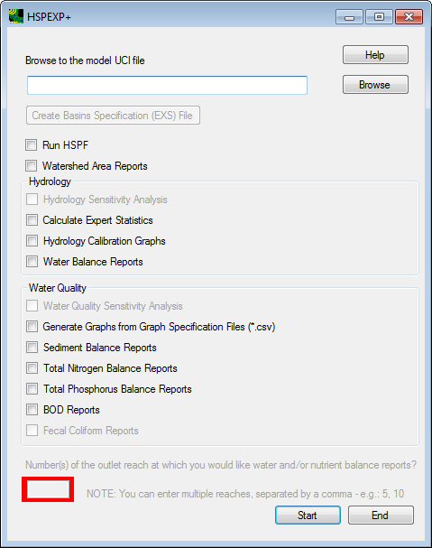
Setting up an HSPF project for analysis using HSPEXP+ is explained in the following sections.
Setting up the Project

Using HSPEXP+ requires the user to modify the UCI files, EXS file(s), and optionally provide a graph specification file.
Setting up UCI and Other Files

HSPEXP+ requires that the name of the output WDM file be less than eight characters. The output file containing the hydrology output (WDM File) from HSPF should be in the same folder as the UCI file. Although HSPF does not require separate WDM files for output and input (there can be as many as four WDM files for each HSPF model), it is recommended to save the output datasets in a different WDM file than the input datasets. When doing hydrologic calibration, the WDM file referred to in the EXS file is used to read the simulated output. The echo (ECH) file from the HSPF run is used to obtain the time stamp of last HSPF run.
The user must set up HSPF such that the hydrologic calibration output is generated at each location of interest. To generate the hydrologic calibration output at the location of interest, open the UCI file in WinHSPF3.0. Open “Output Manager.” 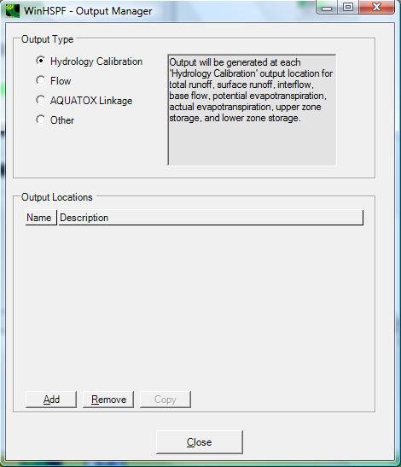
Click the radio button beside “Hydrology Calibration,” and then click “Add.” In the �WinHSPF- Add Output� window, select the output reach of interest. Change the BASE WDM DSN, if needed. 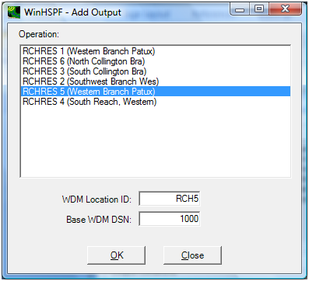
Click “Close” to close the Add Output Window. Save the UCI file, and run it to populate the data in the newly created datasets. The newly created datasets should be included in the EXS file as described in the Setting up EXS File(s) section. If nutrient balance reports are requested, then HSPEXP+ requires that the GEN-INFO table should have names for each PERLND, IMPLND, and RCHRES. HSPEXP+ uses this information from the GEN-INFO table to group the output. If the GEN-INFO table does not have a proper land use description or the name of a RCHRES, the output in some of the reports will not be grouped in a user-friendly fashion.
If nutrient balance reports are required, then the user must name their constituents as follows, and the units must be in lbs.
- Ammonia should be named as “NH3+NH4”
- Nitrate should be named as “NO3”
- Orthophosphorus should be named as “ORTHO P”
- Biochemical Oxygen Demand should be named as “BOD”

Setting up EXS File(s)

HSPEXP+ uses the Basin Specification File (EXS file, extension *.exs) to obtain information about the calibration site, observed flow dataset, simulated datasets, drainage area, storm periods, error criteria, etc. The format of the EXS file is consistent with that used in HSPEXP. To read more about this file, please refer to the HSPEXP manual or refer to the EXS File information at the end of this section. HSPEXP+ currently does not have a capability to produce the EXS file. The EXS file can be used for calibration at one to ten separate locations. If a user wants to calibrate at more than ten locations, or if the storm dates are different for different locations, the user can provide separate EXS file for each location. A user may have as many EXS files as needed.
When used with HSPEXP+, the EXS file can have comments, following the same format of a UCI file. Any line with “***” is treated as a comment by HSPEXP+ (unlike its predecessor, HSPEXP).
As noted in the Hydrologic Calibration section, HSPEXP+ considers May, June, and July to be the summer months, and December, January, February to be the winter months for calculating seasonal statistics. In HSPEXP+, summer and winter months can be specified in the EXS file if needed, using the keyword “Seasons:”, at the end of the EXS file. Add a line with words, “Seasons:”; add a line with numbers for the summer months, separated by commas; and add a second line for the winter months separated by commas.

Description of all the parts of an EXS file are provided in the following table. Most of the information in this table is reproduced from the original HSPEXP manual (Page 34), with some changes that are relevant for HSPEXP+.
Basins-Specification File Content and Format
Line Type/Content | Number of Lines | Line Format | Description
General Information | 1 | A8, 2I5, 4F8, 2X, I4, 2I2, 2X, I4, 2I2 | Name (prefix) of WDM file
 |  |  | Number of Sites
 |  |  | Current Site Number
 |  |  | Latitude and longitude limits of the basins
 |  |  | Start and end date for calibration statistics, if different from simulation period.
WDM Data Set ID#’s | # of sites | 10I4, 1X, I2, 2X, A20 | DSN for simulated runoff (inches)
 |  |  | DSN for observed flow (cfs)
 |  |  | DSN for simulated surface runoff (inches)
 |  |  | DSN for simulated interflow (inches)
 |  |  | DSN for simulated baseflow (inches)
 |  |  | DSN for precipitation (inches)
 |  |  | DSN for potential evapotranspiration (inches)
 |  |  | DSN for actual evapotranspiration (inches)
 |  |  | DSN for upper zone storage (inches)
 |  |  | DSN for lower zone storage (inches)
 |  |  | Flag indicating where statistics have been calculated for the site (not used)
 |  |  | Site Name
Number of Storms | # of storms | I4 | Number of storm periods
Storm periods | # of storms | I5, 5I3, I5, 5I3 | Storm start and end date/time (yr, mo, dy, hr, min, sec)
Drainage Areas | 1 | 10F8 | Drainage area (acres) for each site
Error Criteria | # of sites | 10F8 | Values for error terms and criteria
 |  |  | Acceptable error in total volume (%)
 |  |  | Acceptable error in low flow recession (-)
 |  |  | Acceptable error in 50% lowest flows (%)
 |  |  | Acceptable error in 10% highest flows (%)
 |  |  | Ratio of interflow to surface runoff
 |  |  | Acceptable error in seasonal volumes (%)
 |  |  | Acceptable error in summer storm volumes (%)
 |  |  | Multiplier on third and fourth error terms
 |  |  | Percent of flows to use on low-flow recession error
Seasons keyword | 1 | A7 | Enter the word “Seasons:”
Summer months | 1 | csv | Enter the months for summer in csv format
Winter months | 1 | csv | Enter the months for winter in csv format
EXS file notes:
Line formats

An - character input with column width = n columns
In - integer input with column width = n columns
Fn - real number input with column width = n columns
nX - n blank spaces
csv - comma-separated values

Unneeded lines - the last 5 line types in an EXS file used with the original HSPEXP program are not used on HSPEXP+; these are 3 lines of computed statistics and 2 lines of flags for ancillary data

An example EXS file is shown below. Please refer to HSPEXP manual (page 34) for details about the rest of the format. 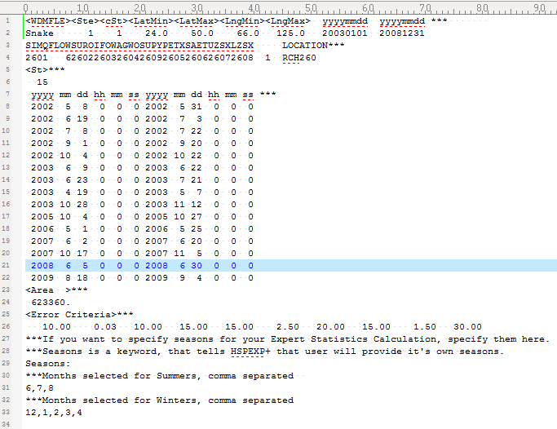
Setting up Graph Specification File (s) for Generating Additional Graphs

Graph specification files can be used for producing additional graphs, if needed. The graph specification files should be in the same folder as the UCI file. The graph specification file(s) is a comma separated values, file where the user can provide specifications for as many graphs as necessary. In this file, blank lines, lines starting with a comma (“,”) or lines containing “***” are not read by HSPEXP+, i.e., they are comments.

In the graph specification file(s), there are two types of input required. The first is the general specification of the graph. For this type of input, the user specifies the type of the graph (timeseries, scatter, or frequency duration), name of the output file (in *.png or *.emf format), number of data series (curves) to be plotted for each graph, axes labels, etc. In the second type of input, the user provides information about each curve that will be plotted. HSPEXP+ expects one line of input for each curve that will be plotted. Each input line then provides information about the source data file, WDM DSN of the dataset, or location and constituent of the dataset, type (point or line) of the curve, color of the curve, legend of the curve, etc. Once the information about each curve is provided, the specification for the next graph may be provided.
The first two lines of the graph specification file are header lines. The first header line has headings for general specifications of a graph, and the second line has headings for specifications of individual curves. General Specification of the Graph
The list below explains all the headings for the general specifications of the graph. Each graph will have one line for general specifications.
- Type of Graph: The type of graph can be “Timeseries”, “Frequency” or “Scatter” only.
- Destination File Name: A unique output file name must be provided with an extension of *.png or *.emf.
- Number of Data Series: An integer value indicating the number of curves in the graph.
- Y-Axis Label: Label for Y Axis(if one writes deg-, or mu-, it is converted to appropriate symbols for “degrees” or “micro”.)
- X-Axis Label: Label for X-Axis (may be blank).
- Aux-Axis Label: Label for Auxiliary Axis, if needed.
- Right Axis Label: Label for Right Axis, if needed.
- Start Date: Start Date in mm/dd/yyyy Format. This date will be used to subset the input dataset. If start and end dates are blank, the dates are read from the simulation time span in the UCI file.
- End Date: End Date in mm/dd/yyyy Format. This date will be used to subset the input dataset.
- Y-Axis Limit (Min): Minimum value for Y-Axis (may be blank).
- Y-Axis Limit (Max): Maximum value for Y-Axis (may be blank).
- Aux-Axis Limit (Min): Minimum value for Aux-Axis (may be blank).
- Aux-Axis Limit (Max): Maximum value for Aux-Axis (may be blank).
- Right-Axis Limit (Min): Minimum value for Right-Axis (may be blank).
- Right-Axis Limit (Max): Maximum value for Right-Axis (may be blank).
- Y-Axis Log?: Should the Y-Axis be a log scale? Please write “yes” or leave it blank.
- Aux-Axis Log?: Should the Aux-Axis be a log scale? Please write “yes” or leave it blank.
- Right-Axis Log?: Should the Right-Axis be a log scale? Please write “yes” or leave it blank.
- Season Start Month/Day: If you want to plot only seasonal data (for example, only winter months for snow depth frequency duration), provide the start day of the season (for example, 10/1).
- Season End Month/Day: If you want to plot only seasonal data (for example, only winter months for snow depth frequency duration), provide the end day of the season (for example, 4/30).
Specification for Curve
This list explains all the headings for the specifications of each individual curve in the graph.
- Axis for the Curve: The curve can be plotted on “Left”, “Right”, or “Aux” axis. For a frequency graph, only a left axis option is available. For scatter graphs, provide the names of axes as “X-Axis,” or “Y-Axis” to differentiate between dependent and independent variables. For scatter graphs, a regression line and/or a 45-deg line may be generated. Instead of Axis for the curves, write, “Regression” and/or, “45-deg line”. These two lines do not need any source.
- Data Source: The data source can be a WDM file (absolute path or relative path must be provided), a BASINS Observed WQ file, or a HBN file.
- If the dataset is read from a WDM file, provide the DSN number. If the dataset is read from the DBF file or the HBN file provide the location name.
- Blank, if WDM File. Constituent, if DBF or HBN File: Leave it blank if the dataset is read from a WDM file, or else provide the constituent name.
- Plot Type (Line or Point): “line” or “point” indicating the type of the plot.
- Color of Plot: Write the color of the plot (line or points).
- StepType: Write “nonstep” for continuous line, and either “forwardstep” or “rearwardstep” for the step type plots.
- Symbol Type, if Point Graph: The available options are circle, square, plus, diamond, star, hdash, vdash, triangle, triangledown, and xcross. Leave this specification blank for line graphs.
- Size of Line or Point: Size of line or points can be provided as an integer value.
- Label for the Curve: User can provide a label for the curve, or leave it blank for HSPEXP+ to generate a default label. User can also write “don’t show” to not show the label and symbol for the curve in the legend
- Aggregation: Prior to plotting, user can aggregate the data from the existing time step to daily, monthly, or yearly.
- Aggregation type: User can select the type of aggregation as average, min, max, or sum. User can also aggregate by percentiles. For example “%50” will extract 50th percentile while aggregating.
- Transformation: User can transform the aggregated dataset by using four key words. “c to f” will transform Celsius data to fahrenheit and “f to c” will do vice versa. “sum c”, will add a constant “c” to every time step, and “product c”, will multiply c to every time step.

An example graph specification file, when opened in a spreadsheet program is shown below. 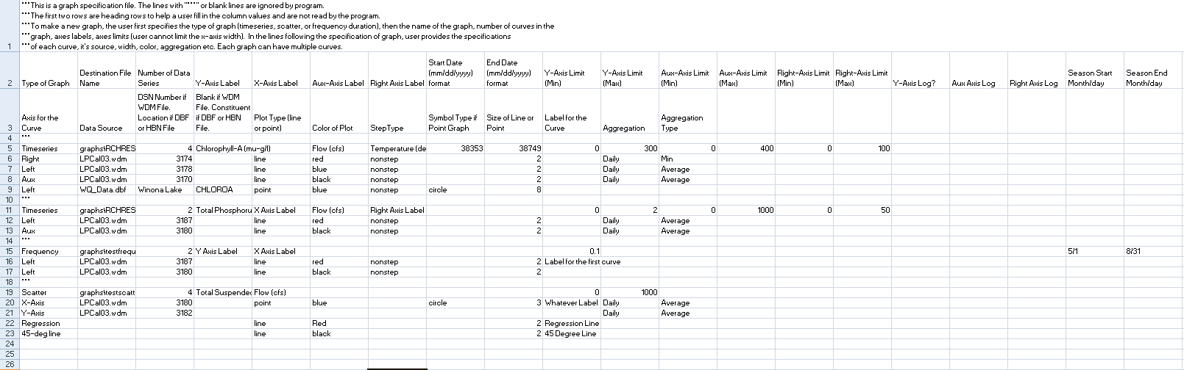
Setting up BASINS Observed Water Quality Data File

The observed Water Quality Data can be provided in a DBF file for BASINS or HSPEXP+ to read. This format is useful when the data is at a non-continuous interval. The DBF file can be edited or created in LibreOffice or OpenOffice (Excel 2007 and newer versions do not allow saving to this format). This file format has only five columns, and they should be named exactly as follows. Any additional columns are not read by BASINS or HSPEXP+.

ID, DATE, TIME, PARM, VALUE
- ID: This column should identify the location of the collected data
- DATE: This column should identify the date in text format (mm/dd/yyyy).
- TIME: This column should identify the time in text format(HHMM).
- PARM: This column should identify the name of the constituent.
- VALUE: This column should identify the value recorded at the respective date and time for the respective location and constituent.

There can be as many locations, parameters, and values as the user may wish, limited by the capacity of the software used to create it. Large DBF files may result in longer times to open/close and read the file. Following is part of an example DBF file. 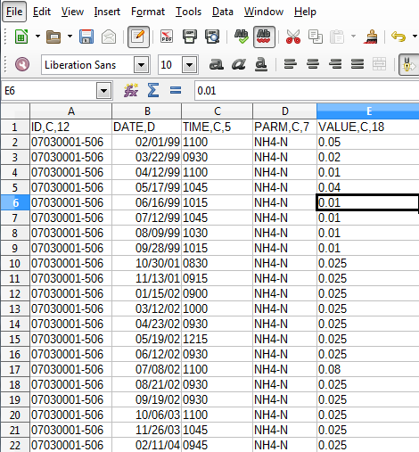
Running HSPEXP+

Running HSPEXP+ is straightforward, provided you have followed all the set up procedures. Browse to “HSPEXP+” from the program menu on your computer and click on it to open. Browse to the UCI file and then select options as needed. Click on “Start” to run it.
Resolving Errors

HSPEXP+ assumes that the user has provided correct data in all the model set-up files; currently, error checking in HSPEXP+ is minimal and rudimentary. In some cases, HSPEXP+ may generate some common errors as a pop-up (if the format of some input in the EXS file is wrong, or if some required files are missing). HSPEXP+ also produces a log file every time it is run. Referring to the log file may give some indication of the cause of the error.
In most cases, you may have to refer to the help manual, and make sure that all input files are set up correctly.
Load Allocation Tool

Under MPCA Work Order #9 (Shell No. 79375), AQUA TERRA Consultants was contracted to develop a Source Allocation Tool to allow users of BASINS/HSPF to identify which contaminant sources are the major contributors to water quality impairments (and the focus of TMDLs) so that remediation strategies and plans can be efficiently prepared.
AQUA TERRA Consultants developed this tool as part of the HSPEXP+ (Enhanced Expert System for Calibration of HSPF) which is currently used for hydrology calibration, and supporting water quality calibration. HSPEXP+ uses the output WDM file for hydrology calibration, and the binary output file for generating water and nutrient balance reports. HSPEXP+ also generates graphs for hydrology and water quality calibration.
HSPEXP+ outputs the source load allocation report as a simple text file that is formatted for viewing and editing in any spreadsheet program. The Source Load Allocation files are generated in a time-stamped (time of last successful HSPF run) folder in the folder containing the HSPF User�s Control Input (UCI) with a name of XX_YYY_LoadAllocation.txt, where XX is replaced by the nutrient of interest (TP or TN), and YYY is replaced by the UCI base file name. If the user requests load allocation reports at specific locations (reach end points) in the watershed, an additional file XX_YYY_LoadAllocation_Locations.txt is generated that contains the load allocation reports at only the requested locations.
In addition to the source load allocation report, HSPEXP+ generates several other nutrient balance reports that include nutrient loadings from each PERLND and IMPLND, and fate and transport of nutrients in each RCHRES on an annual basis and annual average basis. HSPEXP+ also generate reports with detailed nutrient budget for each RCHRES on an annual average basis.
To calculate the source load allocation, the average annual contribution of each individual source (nonpoint, point, direct atmospheric deposition) is calculated at each reach, starting from upstream. If any losses of nutrient occur in the stream on an average annual basis due to settling/deposition to the channel bottom or other biochemical processes, then the losses are applied back to each individual source proportional to its relative contribution. As we move downstream, the contribution of each source is re-calculated, including the upstream sources. If losses occur at a downstream reach, they are applied proportionally (as reductions) to the cumulative sources. This calculation is done for all the reaches in the watershed. If any pollutant gains occur in the reach, the gains are not applied back to the sources, since they are derived from the channel and not the upstream sources. The losses and gains are accumulated separately for each reach and the gains are reported as a separate source. The typical output in the Load Allocation file is shown in the example Tables 1 and 2 for the Illinois River watershed (IRW) model (AQUA TERRA Consultants, 2015). The output locations for the IRW model are shown in Figure 1. Table 1 shows the loads allocated to each source, and Table 2 shows the load percentages derived from each source. The column headings for the two tables are described in Table 3 (Note: Pasture1 and Pasture1-Litter from the IRW watershed modeling report were combined to Pasture1, and the three urban categories were combined to one Urban category �Developed� to save space). 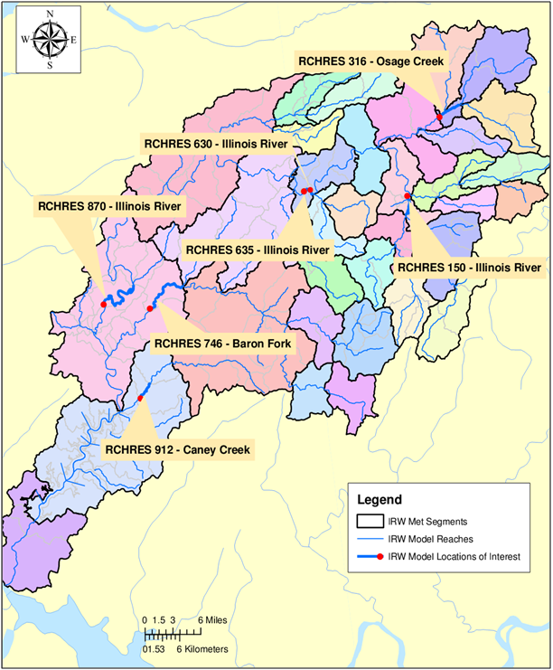 Figure 1. Locations in Illinois River watershed model at which load allocation reports are generated. Table 1. Allocation of loading of total nitrogen (lbs) to individual sources after applying the losses in the stream
Reach | P: Forest | P: Pasture1 | P: Pasture2 | P: Pasture3 | P: Grass/ Shrub/ Barren | P: Developed | P: Wetlands | P: Cropland | I: Developed | Point Sources | Direct Atmospheric Deposition on the Reach | Mass Balance Errors/ Additional Sources* | Diversion | Cumulative Instream Losses | Cumulative Instream Gains | Total**
RCHRES 150 - Illinois River | 210,426 | 291,959 | 125,820 | 232,360 | 13,862 | 83,898 | 1,895 | 4,321 | 3,003 | 30,505 | 32 | 88 | 0 | -4,840 | - | 998,168
RCHRES 316 - Osage Creek | 45,241 | 261,821 | 72,806 | 257,788 | 9,071 | 315,855 | 444 | 4,680 | 29,494 | 476,590 | 29 | 139 | 0 | -12,281 | - | 1,473,958
RCHRES 630 - Illinois River | 443,651 | 734,760 | 282,550 | 822,441 | 43,399 | 619,124 | 5,012 | 11,649 | 52,237 | 599,796 | 145 | 331 | 0 | -49,109 | - | 3,615,095
RCHRES 635 - Illinois River | 444,594 | 736,430 | 282,957 | 823,118 | 43,515 | 619,556 | 5,057 | 11,646 | 52,230 | 599,635 | 148 | 331 | 0 | -50,080 | - | 3,619,216
RCHRES 746 - Baron Fork | 519,203 | 357,183 | 187,292 | 405,728 | 110,723 | 97,807 | 2,095 | 3,040 | 1,487 | 14,667 | 73 | 150 | 0 | -12,542 | - | 1,699,449
RCHRES 870 - Illinois River | 1,023,887 | 1,196,426 | 414,927 | 1,090,350 | 178,289 | 760,938 | 12,107 | 18,652 | 59,083 | 709,303 | 369 | 500 | -48,221*** | -137,356 | - | 5,416,609
RCHRES 912 - Caney Creek | 128,561 | 119,365 | 62,122 | 143,470 | 14,167 | 36,423 | 194 | 1,531 | 1,663 | 19,202 | 12 | 46 | 0 | -2,779 | - | 526,755
*This column shows mass balance errors due to unit conversion and any additional sources that are not represented traditionally. **Total does not include Instream losses as they have already been applied to the individual sources. Table 2. Percent contribution of individual sources at each reach
Reach | P: Forest | P: Pasture1 | P: Pasture2 | P: Pasture3 | P: Grass/ Shrub/ Barren | P: Developed | P: Wetlands | P: Cropland | I: Developed | Point Sources | Direct Atmospheric Deposition on the Reach | Mass Balance Errors/ Additional Sources* | Diversion | Cumulative Instream Losses | Cumulative Instream Gains | Total**
RCHRES 150 - Illinois River | 21.1 | 29.3 | 12.6 | 23.3 | 1.4 | 8.4 | 0.2 | 0.4 | 0.3 | 3.1 | 0.0 | 0.0 | 0.0 | -0.5 | 0.0 | 100.0
RCHRES 316 - Osage Creek | 3.1 | 17.8 | 4.9 | 17.5 | 0.6 | 21.4 | 0.0 | 0.3 | 2.0 | 32.3 | 0.0 | 0.0 | 0.0 | -0.8 | 0.0 | 100.0
RCHRES 630 - Illinois River | 12.3 | 20.3 | 7.8 | 22.8 | 1.2 | 17.1 | 0.1 | 0.3 | 1.5 | 16.6 | 0.0 | 0.0 | 0.0 | -1.4 | 0.0 | 100.0
RCHRES 635 - Illinois River | 12.3 | 20.4 | 7.8 | 22.7 | 1.2 | 17.1 | 0.1 | 0.3 | 1.4 | 16.6 | 0.0 | 0.0 | 0.0 | -1.4 | 0.0 | 100.0
RCHRES 746 - Baron Fork | 30.6 | 21.0 | 11.0 | 23.9 | 6.5 | 5.8 | 0.1 | 0.2 | 0.1 | 0.9 | 0.0 | 0.0 | 0.0 | -0.7 | 0.0 | 100.0
RCHRES 870 - Illinois River | 18.9 | 22.1 | 7.7 | 20.1 | 3.3 | 14.0 | 0.2 | 0.3 | 1.1 | 13.1 | 0.0 | 0.0 | -0.9*** | -2.5 | 0.0 | 100.0
RCHRES 912 - Caney Creek | 24.4 | 22.7 | 11.8 | 27.2 | 2.7 | 6.9 | 0.0 | 0.3 | 0.3 | 3.7 | 0.0 | 0.0 | 0.0 | -0.5 | 0.0 | 100.0
*This column shows mass balance errors due to unit conversion and any additional sources that are not represented traditionally. **Total does not include Instream losses as they have already been applied to the individual sources. Table 3. Explanation of column headings for the Tables 2 and 3.
Column Heading | Explanation
Reach | Name and number of reach. This value is read from the GEN-INFO table for the RCHRES section. It is advisable to have this section as descriptive as possible in the UCI file.
P: PERLND Name, or I: IMPLND Name | These column names are generated from the GEN-INFO table in the UCI file for the PERLND and IMPLND sections. Each land use is listed in these columns. The values in these columns represent the loading from the respective land use to the respective reach once the losses in the reach have been accounted for.
Point Sources | Contribution of point sources to the specific reach, once losses have been accounted for.
Direct Atmospheric Deposition in the Reach | Direct atmospheric deposition that falls on the reach surface. The contribution of direct deposition is reduced, proportionally if losses occur in the reach.
Mass Balance Errors/ Additional Sources* | Pollutant loads that cannot be accounted for by nonpoint source, point source, or atmospheric deposition. This column also includes any mass balance errors that may result because of precision errors in the HSPF code.
Cumulative Instream Losses | The losses are added for each reach and the cumulative losses are reported in this column.
Cumulative Instream Gains | The gains are added for each reach and the cumulative gains are reported in this column. For the purposes of load allocation, gains are considered a source.
Diversions | If there are diversions in any of the reaches, they are listed here. The diversions are considered as lost from the system; they are not applied back to the sources.
Total | Total of all sources

Limitations
Currently, HSPEXP+ can take into account nonpoint sources, point sources, and direct atmospheric deposition to water surfaces only. It cannot account for additional sources such as pollutant loads from tile drainage if represented in a non-conventional manner (e.g., through GENER or SPEC-ACTIONS). Due to the flexibility of HSPF, there are several different ways to model these additional sources, and therefore it is difficult to include them in a standard reporting program. If the user can tabulate these non-conventional source separately, she/he can add these sources into the spreadsheet directly and recalculate the resulting totals and contribution percent.
Another possible limitation of using HSPEXP+ arises in the case of models with multiple UCI files. For example, models of the Redeye, Long Prairie, and Crow Wing rivers were developed as separate watershed models, where the Redeye, and the Long Prairie rivers contributed flow and nutrients to the Crow Wing river (Figure 2). When the load allocation report is prepared for the Crow Wing river model, the Redeye, and Long Prairie rivers are considered as point sources. When losses occur in the Crow Wing river reaches, they are applied back to the Redeye and Long Prairie watershed as point sources, instead of distributing them to the sources upstream of the confluence points of the Redeye and the Long Prairie rivers with the Crow Wing River. The user may have to manually redistribute these losses back to the individual sources of contributing models (in this case Redeye and Long Prairie River watersheds). 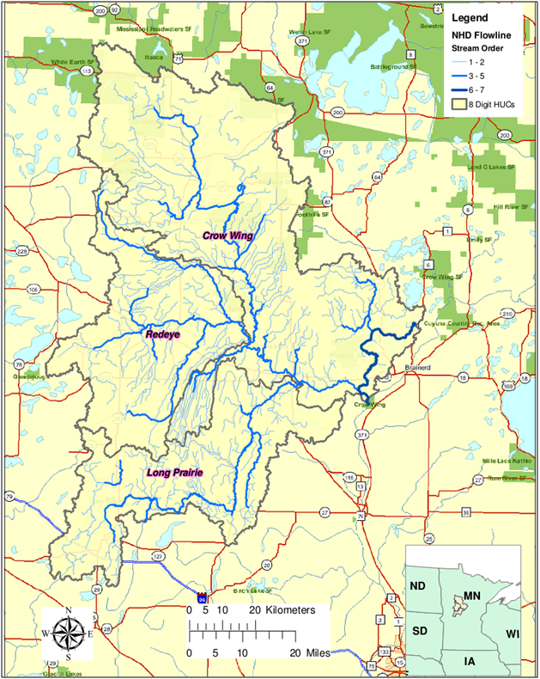 Figure 2. Hydrography of Redeye, Long Prairie, and Crow Wing River Watersheds.
References

AQUA TERRA Consultants. 2015. Illinois River Watershed Nutrient Modeling: Model Calibration and Validation (Draft Final Report). Submitted to USEPA Region 6, Dallas, TX.
Bicknell, Brian R., J.C. Imhoff, J.L. Kittle, T.H. Jobes, A.S. Donigian. 2005. HSPF Version 12.2 User’s Manual. Submitted to Office of Surface Water, EPA, Reston, VA.
Lumb, Alan M., R. B. McCammon, and J.L. Kittle, Jr. 1994. User’s Manual for an Expert System (HSPEXP) for Calibration of the Hydrological Simulation Program-FORTRAN. Reston, VA: U.S. Geological Survey.

