Simulation Data Manager (SDM) ProjectBuilder
somewhere in here the data needs of WASP need to be mentioned, as in the stream segmentation and stream channel characteristic data are also processed in the context of the watershed models (which themselves contain stream water flow/quality capabilities that we are not accessing within iemWatersheds).
1.0 Introduction
The SDMProjectBuilder provides a fully automated means to construct the initial setup of an integrated watershed – surface water modeling project. SDMProjectBuilder is a lightweight interface constructed to access libraries of tools and functionality contained within three open source software systems; Data for Environmental Modeling (D4EM), Better Assessment Science Integrating point & Non-point Sources (BASINS), and MapWindow GIS. SDMProjectBuilder leverages these tools for the purpose of collecting, processing, and organizing data for watershed and surface water models of the iemWatersheds modeling system. This document summarizes the requirements, design, and functionality of the SDMProjectBuilder.
The SDMProjectBuilder satisfies the following high level functional requirements :
- Provide an automated means by which to access and retrieve environmental data needed for conducting integrated watershed and surface water modeling. These data may reside in national databases maintained by various Federal Agencies and accessed via the internet and in local databases constructed and maintained by the user.
- Provide interactive access to a national map of HUC8 and HUC12 headwater watersheds and facilitate a users selection of a particular watershed for modeling.
- Provide the ability to process and integrate the data retrieved into a form suitable for use by watershed and surface water models. Data processing must include all necessary geo-spatial data processing functionality.
- Provide the resulting data in a project database or databases for eventual use by the Simulation Data Manager (SDM) module within FRAMES.
Figure 1 illustrates the conceptual system design to address the requirements. While the immediate objective of the SDMProjectBuilder is to construct datasets for the iemWatersheds models currently included in FRAMES (i.e., SWAT, HSPF, WASP) the software design provides for essentially model independent data processing. That is, SDMProjectBuilder conducts its data processing tasks without direct knowledge of the specific watershed and surface water models that will eventually consume the data. Instead the data are processed in such a manner as to represent a single source of data to multiple watershed and surface water models. The data do not take on a model-specific organization and format until after all processing is complete. In this way SDMProjectBuilder is designed to service watershed and surface water models in general, thus eliminating the need, for example, of encoding a watershed delineation routine for each and every watershed model.
Of special note is the fact that, for this implementation, the model input sequences developed by SDMProjectBuilder should be considered an initial comprehensive dataset constructed from readily available national and local sources via automatic means. They are derived from readily available data that is processed with minimal user involvement. The intent is to relieve the modeler from the resource intensive task of initial gathering, organizing, and formatting of data for a modeling project. It is not intended to replace the expertise of the modeler in terms of assuring the quality of the data and its applicability to the modeling task at hand. Thus, while it is possible to use the data “as is” to run model simulations, the use of the data in this manner is subject to relatively large and uncharacterized uncertainties. Using the data “as is” should be limited to initial explorations of the data, models, and results rather than as definitive indicators or predictions of system behavior. In the final analysis these data must be reviewed and appropriately modified by the modeler (e.g., via calibration) before “official” use of them for modeling purposes such as decision support is pursued.
SDMProjectBuilder represents the current stage of a collaborative software integration effort focused on developing a single set of software libraries, each containing a collection of functions related to one of three basic data processing needs for environmental modeling. These needs include 1) accessing and retrieving data from data sources (most notably accessed via the internet), 2) processing the data (including geo-spatially, statistically, etc.) for the purpose of developing model input data, and 3) organizing and delivering the data to models and modeling systems. The collaboration currently includes the individual groups developing the D4EM, BASINS, and MapWindow software systems and is intended, if interest surfaces, to become a fully open source community.
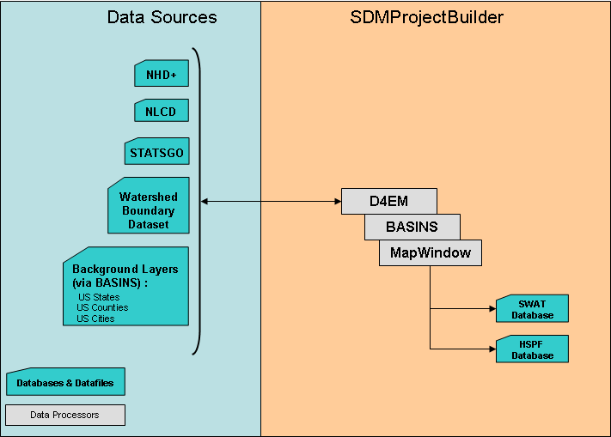
Figure 1 : Conceptual Design of SDMProjectBuilder

The following sections describe the data sources accessed and the data processing performed within the SDMProjectBuilder. A tutorial describing the step by step application of the SDMProjectBuilder in the context of an iemWatersheds implementation in FRAMES is provided in a complementary document.
2.0 Data Sources for SDMProjectBuilder
Table 1 lists the various sources of data currently accessed by the SDMProjectBuilder. Packaged directly with the SDMProjectBuilder is a core set of GIS boundary coverages (states, counties, map tiles, etc.) that assist the user with visually locating a watershed of interest. SDMProjectBuilder downloads additional data from the Internet on an as needed basis, that is, data downloads occur only for geographic areas relevant to a user selected watershed.
Table 1: SDMProjectBuilder Data Types
Data Type | Source | Notes
Boundary Coverages | EPA BASINS | Includes core GIS data for BASINS
Map Tiles | Open Street Map, Yahoo Maps | Configurable
HUC12 boundary | NRCS Watershed Boundary Dataset | Hosted at Aqua Terra
NHDPlus | EPA | Hosted at Horizon Systems
Land Cover | USGS Seamless | NLCD 2001
Meteorlogy | BASINS | Based on NOAA-NCDC
Soil Properties | SWAT 2005 national soils database | STATSGO

Because the necessary data can be extensive, depending upon the size of the watershed of interest and internet connection speed, the downloads may take a while, from several minutes (for a HUC12) to more than an hour (for a HUC8). For efficiency purposes once downloaded for an area, the data is cached on the local harddrive so that Internet retrieval is not necessary in subsequent simulations when the same watershed is involved.
The following sections describe the contents and sources of environmental data utilized for iemWatersheds.
Core Boundary Coverages
Figure 2 illustrates the type of data layers available to all SDMProjecBuilder applications. Among the list of core data items are :
- State/county names and boundaries
- Major roads
- [Kurt, can you complete this list?]
Core data is downloaded from the BASINS web site by SDMProjectBuilder when the user requests a project to be built. These data include boundary and reference layers. These data come from archives stored at http://www.epa.gov/waterscience/ftp/basins/gis_data/huc/.
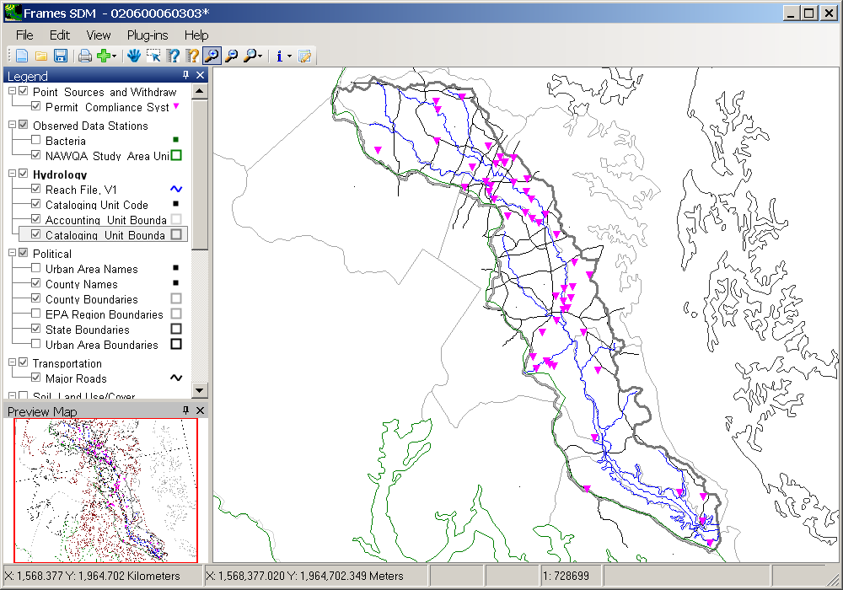
Figure 2 – BASINS Core Data
Figure 3 illustrates MapTiles that are accessed from a variety of open data sites. Map Tiles assist the user with spatially locating the area of interest. Tiles are available from a variety of sites including OpenStreetMap, Yahoo Maps and Yahoo Satellite.
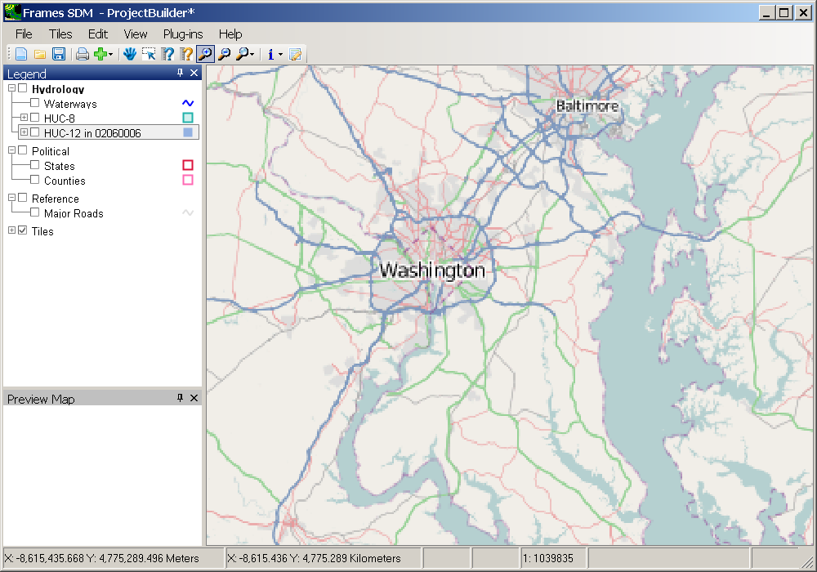
Figure 3 – Map Tiles from OpenStreetMap
National Watershed Boundary Dataset
The National Watershed Boundary Dataset is utilized to facilitate the users selection of a HUC12 watershed. According to “Federal Guidelines, Requirements, and Procedures for the National Watershed Boundary Dataset – USGS Techniques and Methods 11-A3”, watershed boundaries define the aerial extent of surface water drainage to a point. The intent of defining hydrologic units (HU) for the Watershed Boundary Dataset is to establish a base-line drainage boundary framework, accounting for all land and surface areas. The selection and delineation of hydrologic boundaries are determined solely upon science-based hydrologic principles, not favoring any administrative or special projects nor particular program or agency. At a minimum, they are being delineated and georeferenced to the USGS 1:24,000 scale topographic base map meeting National Map Accuracy Standards (NMAS). A hydrologic unit has a single flow outlet except in coastal or lakefront areas. <Source: http://www.ncgc.nrcs.usda.gov/products/datasets/watershed/datainfo.html , also see “Federal Guidelines, Requirements, and Procedures for the National Watershed Boundary Dataset – USGS Techniques and Methods 11-A3>
As stated by the Federal Standard for Delineation of Hydrologic Unit Boundaries,
"A hydrologic unit is a drainage area delineated to nest in a multi-level, hierarchical drainage system. Its boundaries are defined by hydrographic and topographic criteria that delineate an area of land upstream from a specific point on a river, stream or similar surface waters. A hydrologic unit can accept surface water directly from upstream drainage areas, and indirectly from associated surface areas such as remnant, non-contributing, and diversions to form a drainage area with single or multiple outlet points. Hydrologic units are only synonymous with classic watersheds when their boundaries include all the source area contributing surface water to a single defined outlet point."

HUC12 boundary data for a HUC8 are downloaded automatically when a HUC8 is selected in SDMProjectBuilder. The data was originally obtained from Natural Resources Conservation Service (NRCS) at http://www.ncgc.nrcs.usda.gov/products/datasets/watershed/. Local geoprocessing of the base data added a field indicating headwater HUCs. The area represented by a HUC12 is appropriate for many initial watershed modeling efforts. Figure 4 shows a sample project with HUC12 boundaries. In the figure, each individual polygon represents a HUC12, while together the shaded polygons form a single HUC8. The HUC12 layer on the map is rendered to show headwater HUC12s (in green) versus non-headwater HUC12s (in red).
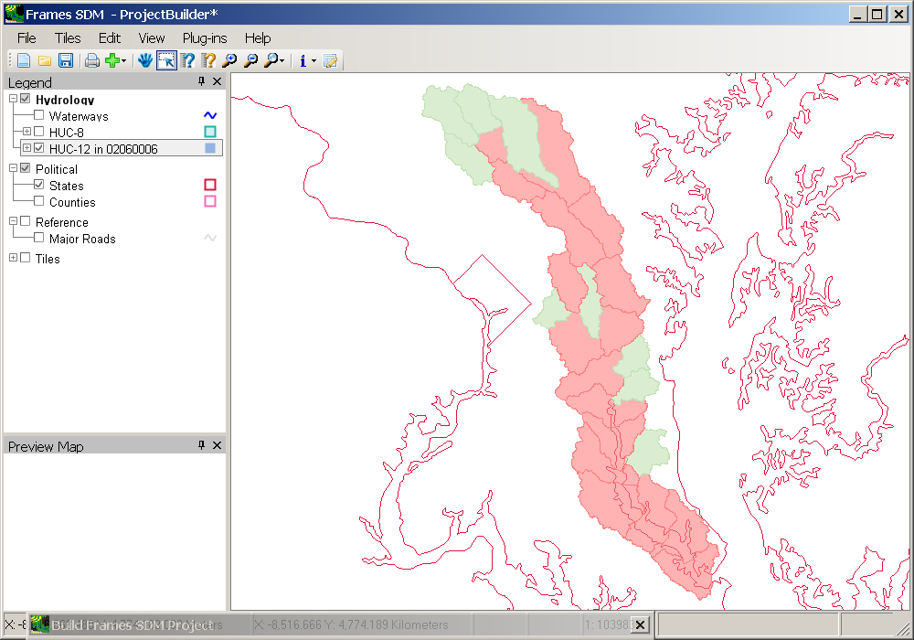
Figure 4 – HUC12 Boundary Layer

National Hydrography Dataset (Plus)
NHDPlus is an integrated suite of geospatial datasets that consists of nine components :
- Improved 1:100K National Hydrography Dataset (NHD)
- A set of value added attributes to enhance stream network navigation, analysis and display
- An elevation-based catchment for each flowline in the stream network
- Catchment characteristics
- Headwater node areas
- Cumulative drainage area characteristics
- Flow direction, flow accumulation and elevation grids
- Flowline min/max elevations and slopes
- Flow volume & velocity estimates for each flowline in the stream network
SDMProjectBuilder utilizes hydrography and elevation data from NHDPlus. Details about the data are available at http://www.horizon-systems.com/nhdplus/. Fgures 5 and 6 illustrate examples of hydrography (watershed and stream network delineations) and elevation data layers, respectively.
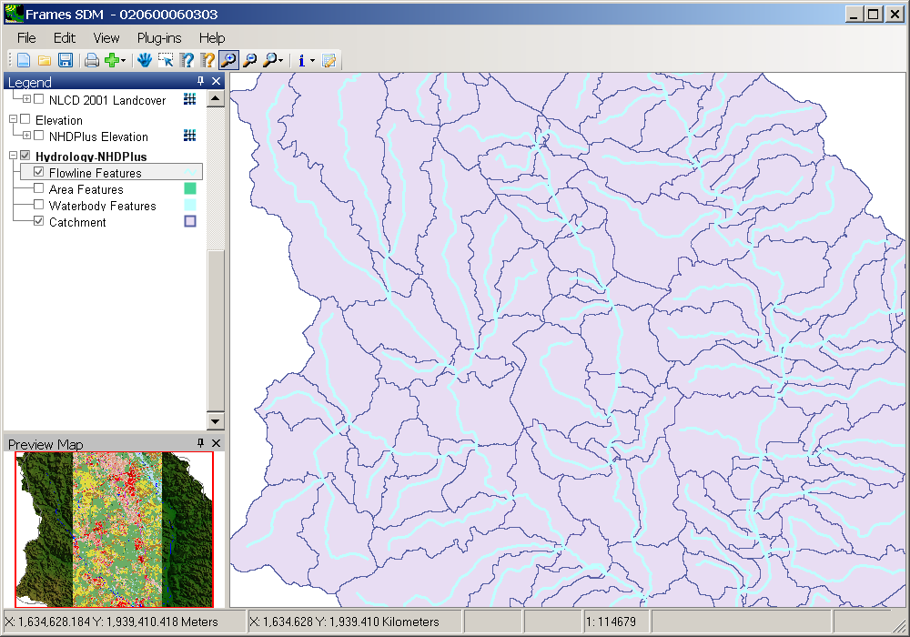
Figure 5 – NHDPlus Hydrography
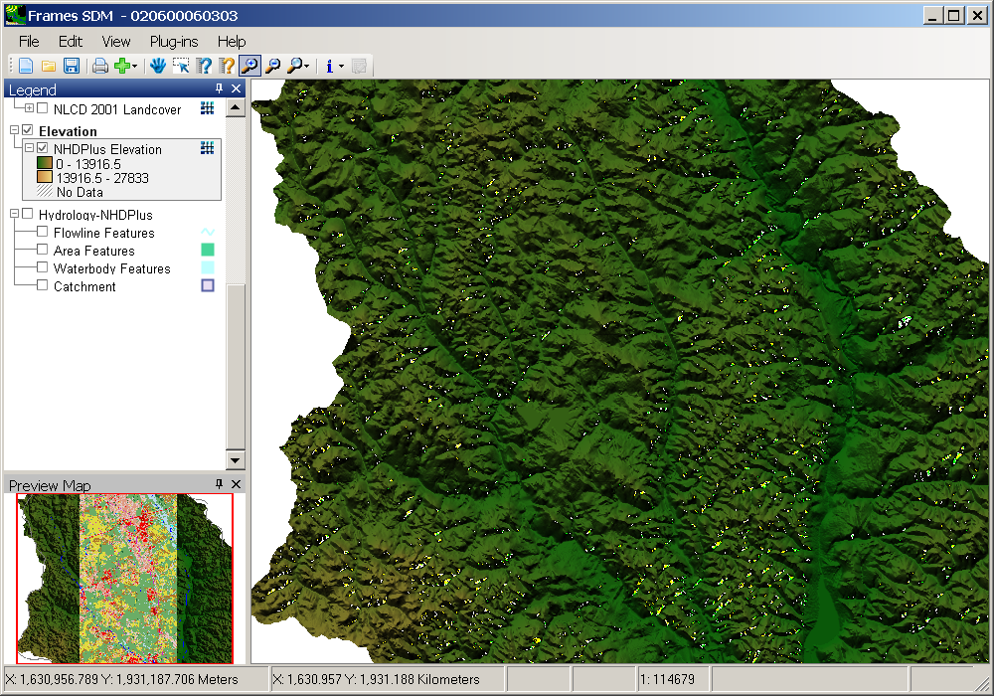
Figure 6 – NHDPlus Elevation Data
Land Use/Cover Data
NLCD2001 provides grids containing land cover data. The land cover data distinguishes 16 different classes. The land-cover image shows the heterogeneous mixture of land-cover types, including the intermixing of evergreen, deciduous, forested wetland, and agriculture on which an urban fabric has been superimposed. Details may be found at http://www.epa.gov/mrlc/nlcd-2001.html. SDMProject Builder automatically downloads spatially appropriate data from http://seamless.usgs.gov/. These data, as illustrated in Figure 7, are combined with soils and slope data, to define hydrologic response units for the watershed models.
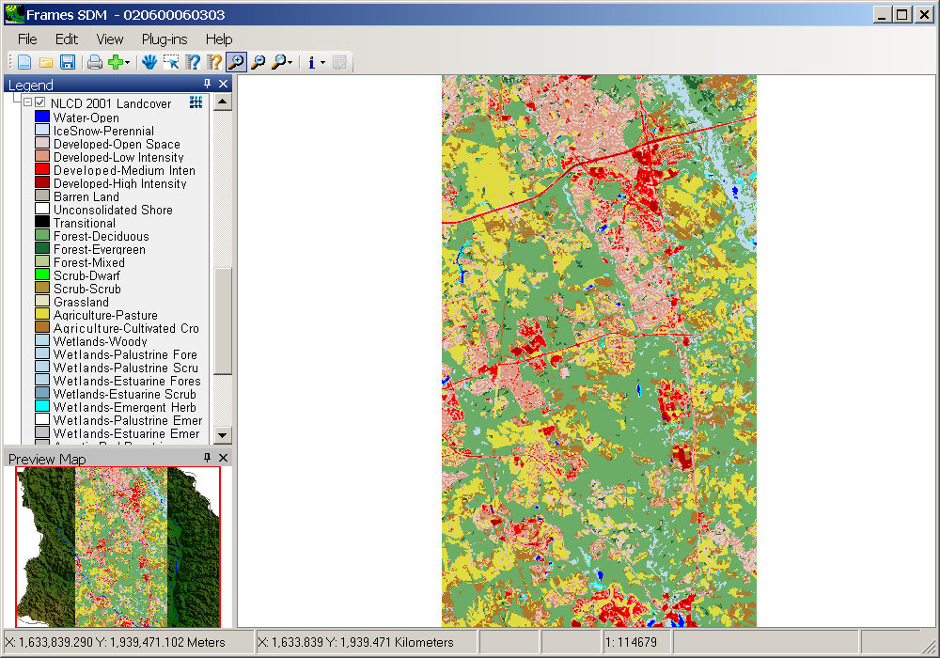
Figure 7 – NLCD 2001 Land Cover Data
Soils Data
The State Soil Geographic Database (STATSGO) is the source of soils data. [Kurt : Need additional info here]
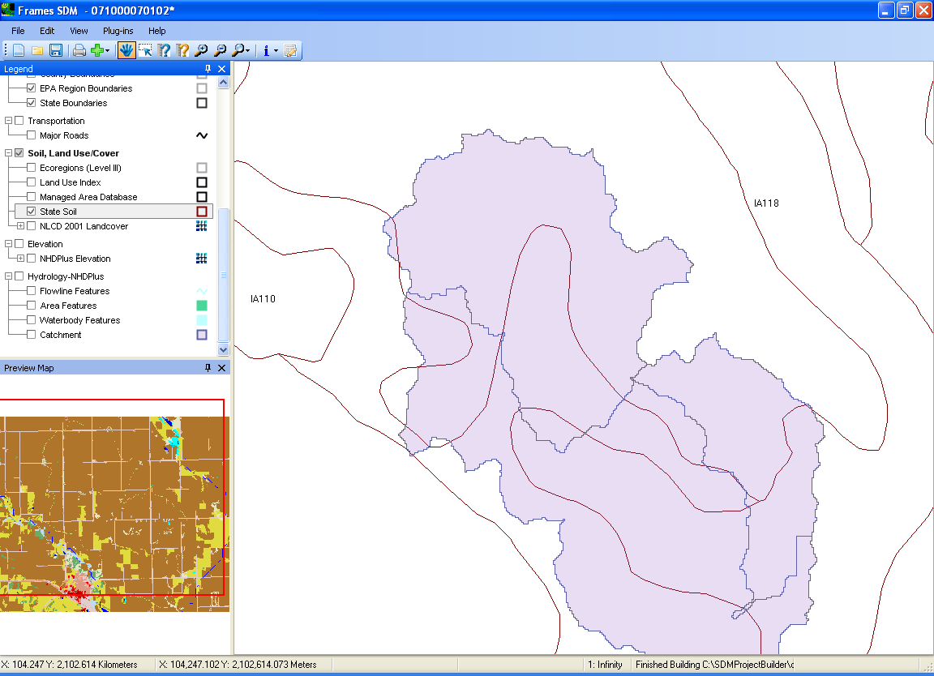
Figure 8 : STATSGO Soil Data

Meteorologic Data
Meteorlogic data needed by the models includes :
- Precipitation
- Temperature (daily min/max)
- Windspeed
- Solar Radiation
- Humidity
- Potential evapotranspiration
- Cloud cover
These data are provided on a daily basis for the simulation time period of interest. Further, the data reflect a single nearest meteorologic station and are applied uniformly across all sub-basins within the watershed. The meteorologic data are available via the BASINS users website and is downloaded by SDMProjectBulder from the related archive at http://www.epa.gov/waterscience/ftp/basins/met_data/. Data obtained by the BASINS development team from the National Climatic Data Center was processed to remove short records, update missing data and generate additional timeseries such as potential evapotranspiration. These data are ready to be used by the watershed models supported by SDMProjectBuilder.
3.0 Geoprocessing for SDMProjectBuilder
Section 2 described the primary sources of data accessed by SDMProjectBuilder. Those data are downloaded for geographic areas associated with specific watersheds selected by the user. To achieve the objective of automatically building model input files these data must undergo significant integrative geoprocessing. Geospatial data processing within SDMProjectBuilder is automated using the open source GIS MapWindow (http://www.mapwindow.org/).
In designing the SDMProjectBuilder careful consideration is given to the fact that multiple models may require the same or similar geoprocessing steps to be executed. The difference among the models is the format of that data in their respective input files and not the information itself. For example, watershed models require that the watershed be delineated into sub-basins. The sub-basin layout is the information that the models require and it is the same for all the models. In order to both maximize efficiency and ensure that multiple models are indeed receiving the same information when appropriate the SDMProjectBuilder is designed to organize its data processing such that common tasks are executed once with results stored in a model independent format. These results can then be mapped to the specific formats required by individual models. This also ensures that when comparing predictions from among multiple watershed models that the differences are related to the science of the model and not differences in how common data was prepared.
The following sections describe the geoprocessing conducted by the SDMProjectBuilder for common data processing tasks and those that are specific to the models of iemWatersheds (i.e., SWAT, HSPF, WASP).
Common geoprocessing tasks :
The following steps occur after the user has selected the HUC-8 or HUC-12 of interest
- All data, as described in the previous section, are downloaded from the Internet or retrieved from the local cache.
- Spatial data is projected to Albers Equal Area.
- NHDPlus contains several tables of value-added attributes. These tables are merged into the catchment and flowline shapefiles so all attributes will stay together during future processing.
- NHDPlus contains a layer of catchments which are the local drainage area of each NHD flowline. Only catchments at least 50% inside the selected area of interest polygon (and associated flowlines) are kept for further processing.
- Braided flowlines sometimes exist in NHDPlus where water flows along more than one path but is still considered part of the same stream. The same catchment then contains more than one flowline. These braids are removed, keeping only the main channel.
- Re-delineation of watershed sub-basin/stream segment layout. Starting with the catchment delineations in NHDPlus and given the user-supplied criteria defining a minimum catchment and/or stream segment length, the SDMProjectBuilder aggregates catchments and related stream segments (beginning at the pour point) to satisfy the criteria. All properties associated with the sub-basins and stream segments are updated based on the new delineation.
Geoprocessing steps for HSPF :
- In each subbasin, values are computed for slope, local area, total (including upstream) contributing area, stream width and depth, and minimum and maximum elevation
- NLCD 2001 land use areas are computed per subbasin and aggregated into categories as specified in NLCD2001.dbf.
- A collection of BASINS/HSPF setup files (WSD, RCH, PTF, PSR, SEG, MAP) are written
- The HSPF model input (UCI and WDM) is created from the BASINS/HSPF setup files.
Geoprocessing tasks for SWAT :
- SWAT 2005 main and soils databases are opened
- A raw slope grid is computed from NHDPlus elevation, then reclassified into three categories for HRU assignment. The slope categories currently in use are < 0.5, 0.5 to 2, and > 2. In the future, the user will have the option to specify slope categories.
- Centroid latitude, longitude, and elevation are computed for each catchment.
- Width, depth, slope, and length are computed for each flowline.
- NLCD 2001 land use is overlaid with layers containing soil, reclassified slope, and subbasin boundary layers to find all existing combinations. Each combination becomes a SWAT Hydrologic Response Unit (HRU).
- If minimum land use fraction was specified, HRUs with land uses that are too small are removed and their area is added proportionally to all other HRUs in the same subbasin.
When all processing is complete the resulting data/information is contained in databases that are accessed from within FRAMES by the Simulation Data Manager (SDM) module, whose function is to distribute the data into FRAMES based input files for each of the models included in the simulation.

