

Tuguegarao City Command Center System

Document | Accomplishment Report (Features and Status)
Reporting Period | December 1, 2025 - January 31, 2026
Status Snapshot Date | January 28, 2026
Version | v0.1.2

This document lists the delivered features and current status of the RESQ-LINK system for the reporting period.

1. Delivered Features and Current Status (By Role)
Status labels used in this report: Implemented / In Progress / Planned.

1.1 Citizen / Caller (Citizen Mobile App)
Account access (Login and Registration) - Implemented
Citizens can log in or register to access reporting features.
Emergency report submission - Implemented
Citizens can submit an emergency report with incident type, description, and location.
Location capture (GPS + address) - Implemented
The app can request location permission and attach current location to reports.
Photo attachment (optional) - Implemented
Citizens can attach a photo from camera or gallery to support the report.
SOS one-tap alert – In Progress
SOS sends an urgent report with the citizen’s current location using minimal steps.
Report confirmation - Implemented
A confirmation screen reassures users that the report was submitted.
Dashboard and history - Implemented
Users can view recent submissions, nearby reports (where available), and history.
Responder locations map (view-only) – In Progress
A map view can display responder/unit locations (supports development/demo behavior).

Citizen app
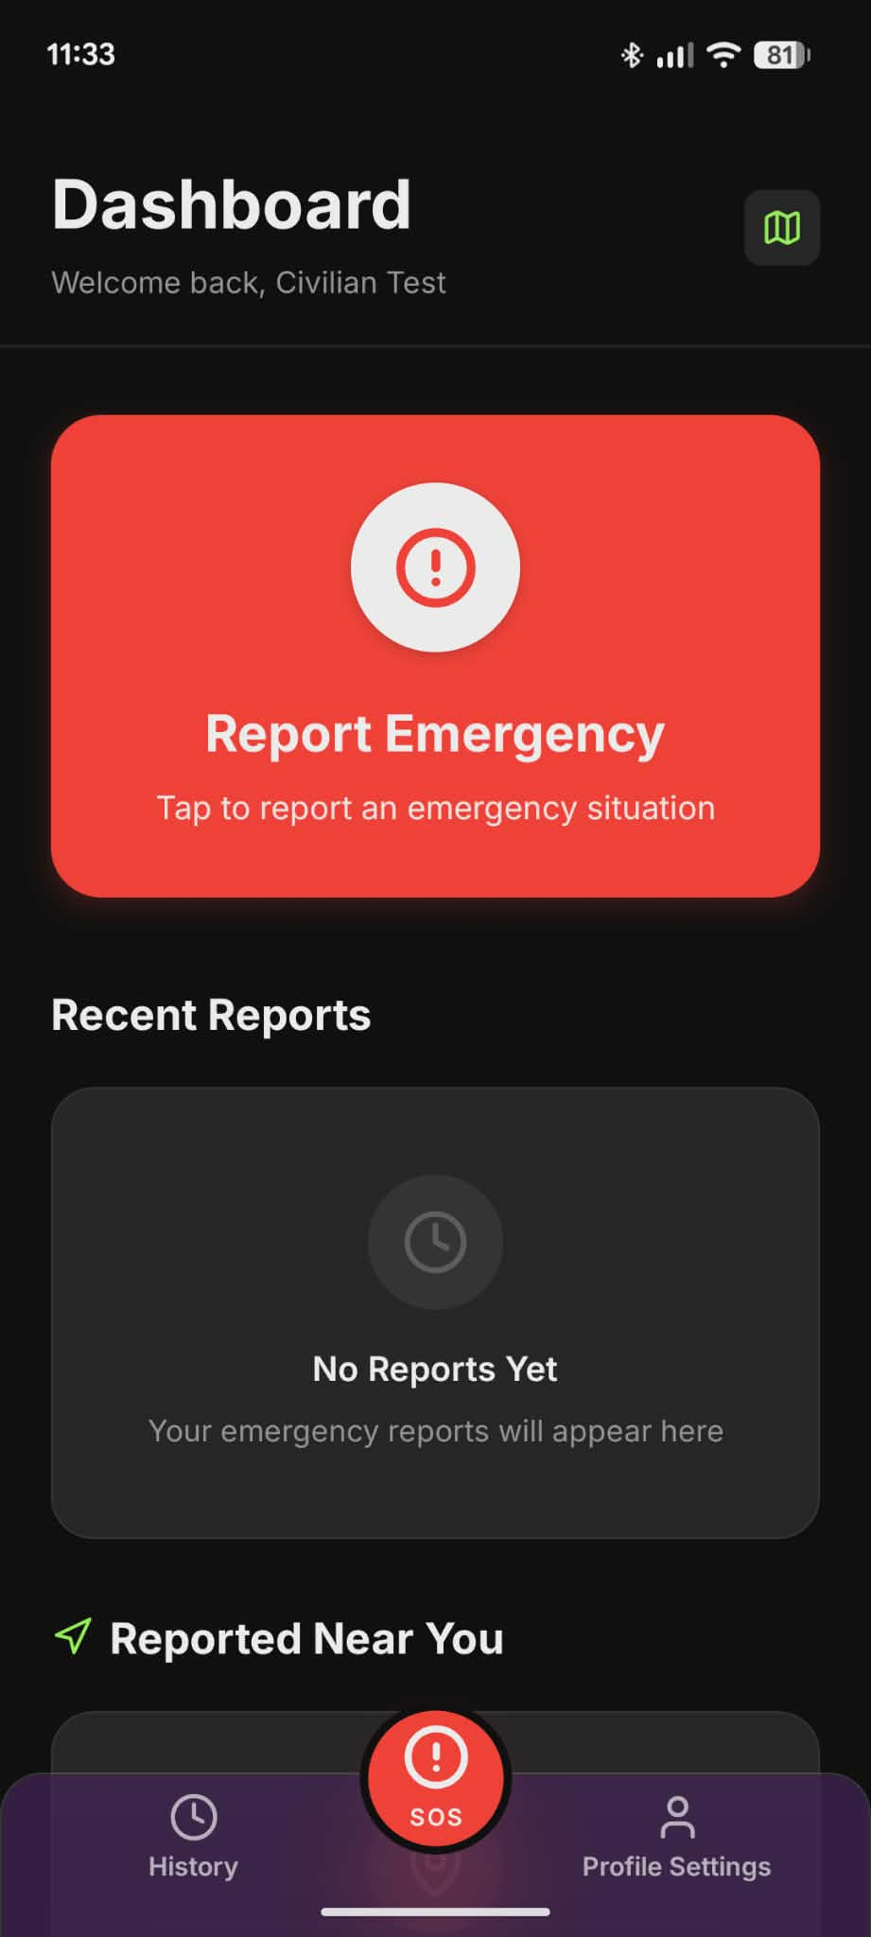

1.2 Command Center Staff (Web Dashboard)
Secure login - Implemented
Command center staff can sign in to access monitoring tools.
Live incident dashboard - Implemented
Incidents appear in a live dashboard for continuous monitoring.
Incident details view - Implemented
Staff can open an incident to review key details (location, description, image if provided, and current status).
Dispatcher assignment workflow – In Progress
Staff can assign, reassign, or unassign a dispatcher/field unit to an incident.
Map view (incidents) - Implemented
Incidents can be visualized on a map to improve situational awareness.
Map view (dispatcher locations) - Implemented
Dispatcher/field unit locations can be viewed when units are online and sharing location.
History page - Implemented
Past incidents can be reviewed for reference and reporting.
New-incident attention/alert - Implemented
The dashboard includes an attention mechanism when new incidents appear.
Command Center live dashboard
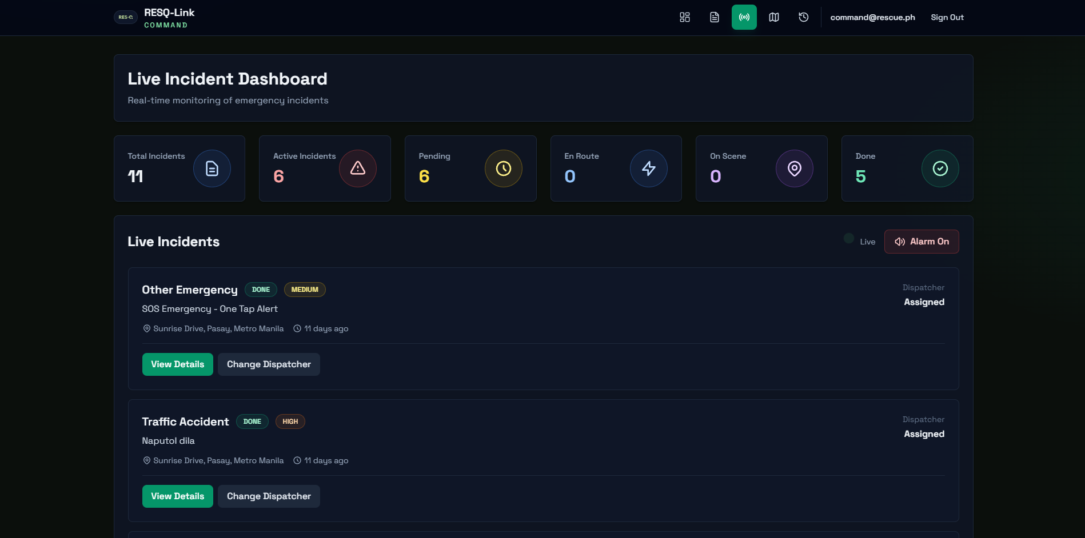
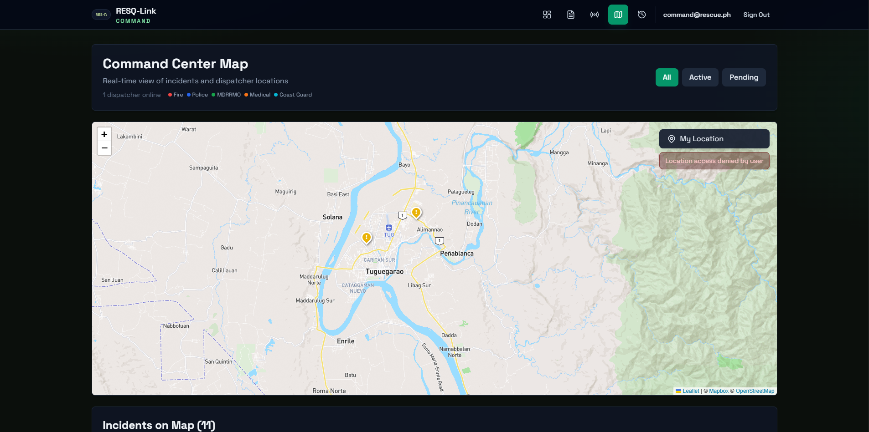

1.3 Dispatchers / Field Units (Dispatcher Mobile App)
Dispatcher-only access - Implemented
Only dispatcher accounts can access the dispatcher app; civilians are blocked.
Assigned cases feed (auto-updating) – In Progress
Assigned cases appear automatically and update as changes happen.
Case details – In Progress
Dispatchers can view full case details, including location and notes.
Accept case - Implemented
Dispatchers can confirm they are taking responsibility for an assigned case.
Progress status updates - Implemented
Dispatchers can update case progress (e.g., En Route, On Scene, Done).
Live location sharing - Implemented
When online, the app shares location periodically to support coordination.
Map view for assigned cases - Implemented
Assigned cases can be viewed on a map for response planning.

Dispatcher dashboard
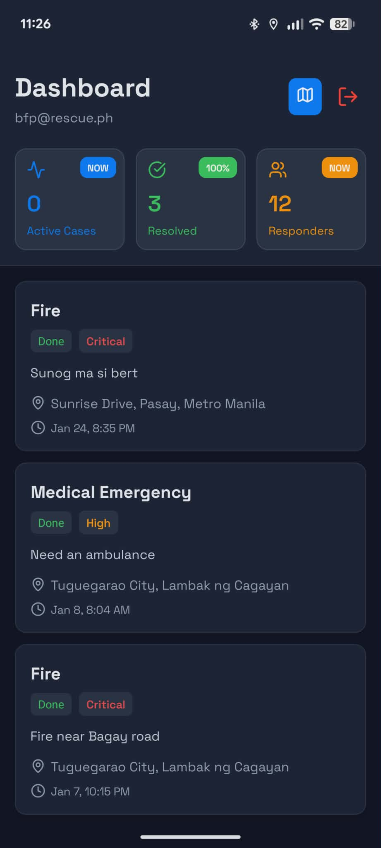

2. Accomplishments During the Reporting Period (Dec 2025 - Jan 2026)
During this period, the team focused on delivering a functional baseline that supports demonstrations and early operational testing. The main accomplishments are listed below.
- Established the core multi-app structure so each user group has the correct tools.
- Enabled emergency report creation from the citizen side, including location and optional photo evidence.
- Enabled command center monitoring so staff can review incidents as they arrive.
- Enabled assignment of incidents to dispatchers/field units.
- Enabled dispatcher-side case handling, including acceptance and progress updates.
- Implemented map-based visibility and location sharing to strengthen operational usefulness.
- Produced setup and security documentation to support onboarding and controlled testing.

3. Recommended Next Steps

3.1 Priority 1 (Immediate - make pilot-ready)
Conduct requirements and data gathering with Tuguegarao Command Center
Schedule a focused data-gathering session with the Tuguegarao Command Center to capture their specific protocols, escalation rules, required forms/fields, and real-world use cases. Use the findings to refine and tailor the system’s workflows and screens to match their exact operational needs, since the current version primarily follows common practices and may not fully reflect local procedures.
Standardize the incident lifecycle and operating procedure
Define and enforce consistent statuses (e.g., Pending / En Route / On Scene / Done) across all apps, with clear staff guidance.
Strengthen reliability and readiness checks
Improve handling of missing permissions (location/camera), incomplete reports, and user-friendly error messages.
Finalize role-based access control
Ensure citizens, dispatchers, and command center users only see and update the data they are authorized to access.

3.2 Priority 2 (Next - operational enhancements)
Add multi-channel reporting intake (SMS and voice calls)
Enable reporting beyond the app, supporting SMS parsing and voice call transcription.
Add assisted categorization and prioritization
Provide suggested incident type/priority to reduce manual workload and speed up dispatch decisions.
Improve dispatcher notifications for assignments
Ensure dispatchers receive clear alerts for new assignments and urgent changes.

3.3 Priority 3 (Later - analytics and governance)
Supervisor/admin analytics
Add reporting views for response times, frequent incident types, and hotspot areas to support management decision-making.
Deployment and rollout preparation
Prepare hosting, monitoring, backup, and operational support plans for production deployment.

Appendix A. Work Distribution
This section summarizes how work was distributed across the team during the reporting period (December 2025 to January 2026). It is included to make ownership clear, highlight each member’s contributions, and support planning for the next phase.

A.1 Summary by Team Member
Shawn — Full-stack implementation and boot strapping lead
- Owned the bulk of end-to-end development work across both the backend and frontend, ensuring features were integrated into a working system.
- Implemented core workflows that enable incident reporting, monitoring, assignment, and updates across the system components.
- Coordinated technical direction and ensured the delivered functionality aligns with the intended system architecture.
Kenji — Front-end development and quality-of-life improvements
- Focused on front-end implementation across the user interfaces to improve usability, clarity, and overall presentation.
- Handled quality-of-life (QoL) improvements such as UI refinements, small workflow enhancements, and user experience polishing.
- Supported stability by addressing minor issues encountered during development and testing.
Engelbert — Front-end development and documentation
- Implemented front-end screens and components to support the required user flows for the reporting and response process.
- Produced and maintained documentation to help the team set up, run, and understand the system during development and demonstrations.
- Helped ensure features are understandable and repeatable by documenting configuration steps and usage guidance.
Andrei — Front-end improvements, program flow, backend support, and documentation
- Led front-end improvements to make the screens clearer and the overall user experience smoother.
- Programmed and refined the end-to-end flow of the program so the main user steps connect properly from screen to screen.
- Contributed to documentation to support onboarding, setup, and consistent usage during demos and testing.

A.2 Work Distribution Table
Team Member | Primary Focus | Key Deliverables (Examples) | Notes / Dependencies
Shawn | Backend + Frontend integration | Core system workflows; integration across apps | May require access to keys/services for full testing
Kenji | Frontend + QoL | UI improvements; UX overhaul | Works closely with feature owners for validation
Engelbert | Frontend + Documentation | UI implementation: setup/run documentation | Documentation supports onboarding and demos
Andrei | Frontend improvements + program flow + backend support | UI/UX refinements; improved screen-to-screen flow; documentation support | Coordinates with feature owners for validation and handoff

