
SYSTEM & TECHNICAL DOCUMENTATION

Integrated Emergency Response Platform
  - Executive overview, operating model, solution architecture, data design, security, deployment, and engineering reference

VERSION | BASELINE | DATE
1.1 | eef022d | 20 August 2026
Connecting civilians, command centers, and field responders across the complete emergency lifecycle.
Prepared from the current RESQ-Link monorepo and public branding resources.

PART I
Executive and High-Level Overview
What RESQ-Link is, who it serves, and how the platform improves coordinated emergency response.

1. Executive Summary
RESQ-Link is an integrated emergency-response platform designed to connect the public, command-center personnel, field responders, and system administrators through one coordinated digital workflow. It combines two Expo mobile applications, two Next.js web applications, and a shared Firebase service package in a single npm-workspace monorepo.
The platform supports the full operational chain: authenticated civilian reporting, command-center intake and triage, incident creation and prioritization, team and resource dispatch, responder acceptance and status updates, live communication, post-incident reporting, historical analysis, and administrative governance. Real-time Firebase subscriptions keep role-specific interfaces synchronized while shared domain modules reduce duplication and enforce common lifecycle rules.
Core value proposition
A report entered once becomes a shared operational record that can be validated, elevated into an incident, assigned to a team and resources, acted on by responders, and closed with traceable outcomes.

1.1 Strategic Outcomes
- Shorter information handoffs between civilians, dispatchers, and responders.
- A shared operational picture for incidents, resources, teams, priorities, and locations.
- Consistent incident and emergency-report lifecycle handling across applications.
- Role-based accountability through timestamps, assignments, status transitions, acknowledgments, and post-incident records.
- Centralized administration of civilian, dispatcher, command-center, and responder accounts.
- Reusable platform services for authentication, storage, messaging, calls, presence, reporting, and real-time synchronization.

1.2 Primary Stakeholders
Stakeholder | Primary need | RESQ-Link capability
Civilian / reporter | Fast, trustworthy emergency reporting and visibility | Guided reports, location, attachments, status history, map tracking, voice calls, and account support
Command-center dispatcher | Accurate triage and coordinated deployment | Real-time intake, incident management, team/resource assignment, map, messaging, alerting, and reporting
Field responder | Clear assignments and safe operational coordination | Incident details, navigation, accept/decline, en-route/on-scene updates, communication, and post-reporting
Super administrator | Governance and secure account lifecycle | Account provisioning, KYC review, email verification support, recovery APIs, and role control
Engineering / operations | Maintainable and deployable platform | Monorepo, shared typed services, security rules, environment conventions, Vercel/EAS configuration, and scripts

2. Platform at a Glance
Product | Audience | Technology | Primary responsibilities
Civilian Mobile App | Residents and reporters | Expo 54, React Native 0.81, Expo Router | Registration, email verification/KYC states, reporting, report history, emergency tracking map, calls, profile and settings
Dispatcher Web App | Command centers and dispatchers | Next.js 15, React 19, TypeScript, Leaflet | Intake, triage, incidents, teams, resources, operational messaging, voice coordination, maps, history, analytics, exports
Responder Mobile App | BFP, PNP, MDRRMO, ambulance, PCG and field teams | Expo 54, React Native 0.81, Expo Router | Assignments, case detail, map/navigation, availability/presence, status transitions, alerts, communication, scene/post reports
Super-Admin Web App | Platform administrators | Next.js 15, React 19, Firebase Admin SDK | User provisioning, command-center management, KYC approval/rejection, OTP support, password recovery
Shared Firebase Package | All applications | TypeScript, Firebase Web/Admin SDKs | Typed domain operations, synchronization, authentication, storage, status logic, presence, messaging, calls and security assets

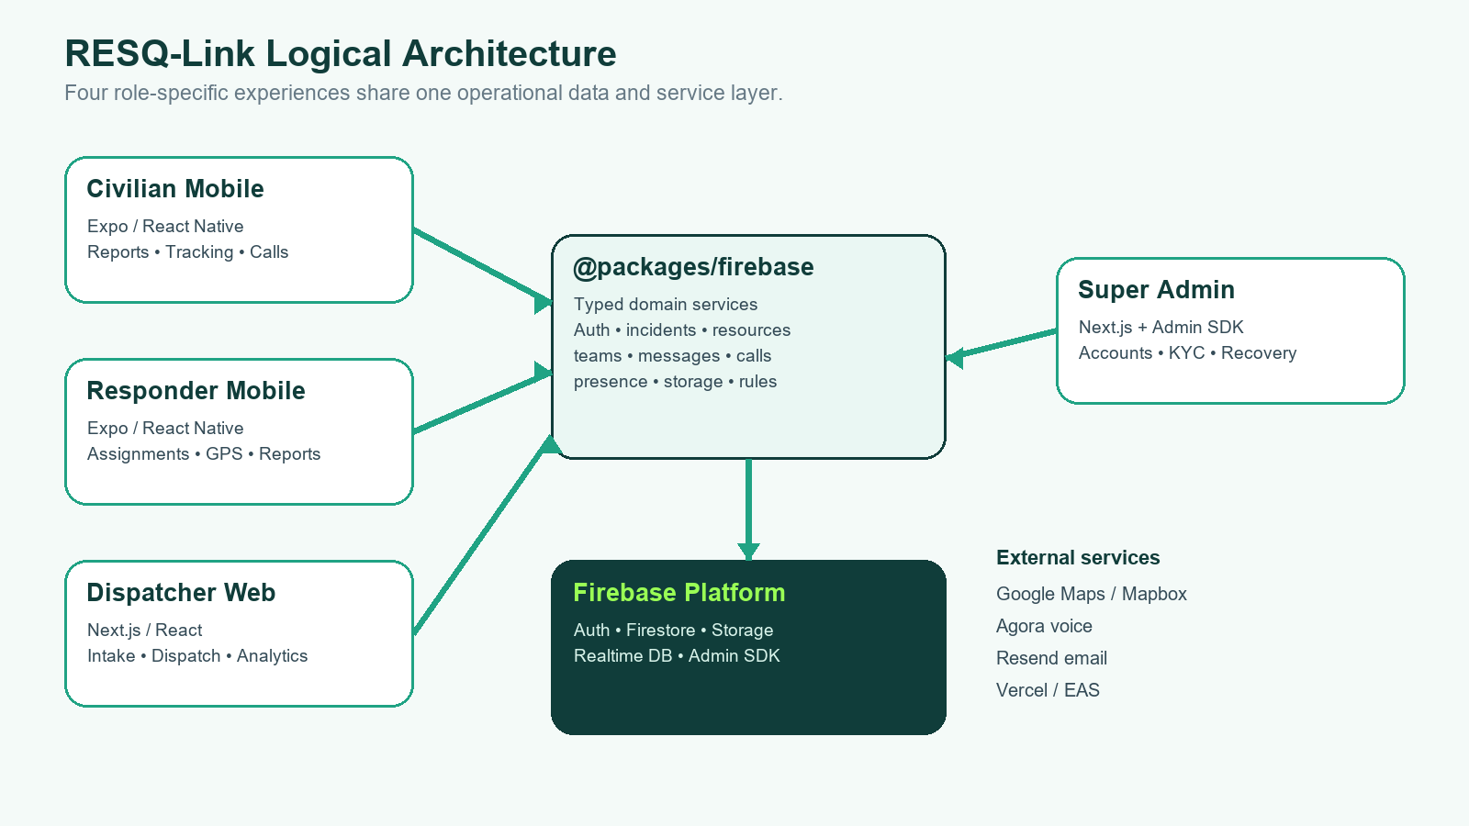
Figure 1. Logical architecture and shared service boundary.

3. End-to-End Operating Model
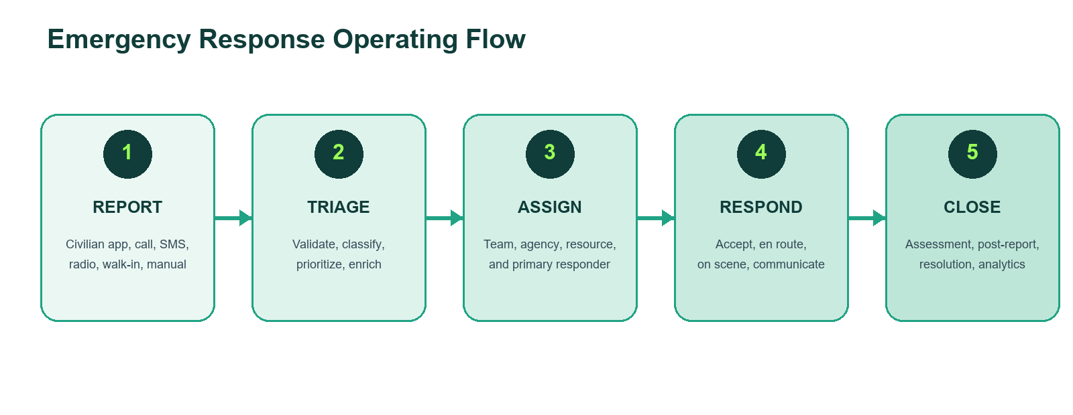
Figure 2. Emergency response operating flow.
- Report or intake — a civilian submits through the mobile app, or the command center records a call, SMS, walk-in, radio, or manual source.
- Triage — dispatch personnel validate the information, determine category/subtype, priority, required agencies, location, and follow-up details.
- Incident formation — eligible emergency reports may be linked or elevated into a canonical incident, preserving report references and field evidence.
- Assignment and dispatch — the command center assigns the active operational team, agencies, resources, and responders; dispatch records preserve the relationship.
- Field response — responders accept or decline, navigate to the scene, update en-route and on-scene states, communicate, and submit assessments.
- Resolution — post-incident information, response timing, outcome, resource release, history movement, and analytics complete the lifecycle.

3.1 Operational Principles
- Single operational thread — reports, incidents, resources, dispatch records, teams, and call/chat sessions retain cross-references.
- Permanent incident ownership — assigned team identifiers and snapshots remain on the incident for filtering, history, and accountability.
- Real-time by default — Firestore listeners update active lists and detail views; Realtime Database improves responder presence accuracy.
- Role-aware actions — security rules and UI gates constrain account, incident, messaging, storage, and administrative operations.
- Graceful degradation — query fallbacks, map-key checks, in-memory sorting, and Firestore presence fallback reduce hard failures.

4. High-Level Capability Catalog
Capability domain | Implemented scope
Identity and onboarding | Email/password authentication, civilian registration, email OTP, KYC workflow, role/designation checks, password recovery
Emergency reporting | Structured incident types, GPS/manual location, field assessment, people involved, photos, review and submission
Command-center intake | Multiple source channels, categorization, priority, additional details, report linking, incident elevation
Dispatch operations | Operational team on duty, agency routing, resource matching, assignments, reassignment, and dispatch records
Field response | Assignment subscription, accept/decline, en route, touchdown/on scene, responder assessment, post-incident report
Situational awareness | Incident maps, reporter/responder coordinates, quadrant data, map filters, markers, banners, and status visualization
Communication | Direct/group chat, incident voice-call sessions, Agora token issuance, alerts, acknowledgments, and notifications
Resource management | Vehicles/equipment, availability, station/current coordinates, responder binding, maintenance/offline states
Evidence and records | Emergency photos, post-report photos, footage requests, history, report exports, PDF/Excel support
Governance | Account management, KYC decisioning, command-center and responder provisioning, server-only OTP records
Operational analytics | Priority/status summaries, response time, team reporting, date filters, print/export workflows
Platform resilience | Lazy Firebase initialization, auth readiness, missing-index fallback, presence fallback, map configuration fallback

PART II
Application Portfolio
Role-specific experiences, major routes, responsibilities, and boundaries.

5. Civilian Mobile Application
The civilian application provides the public-facing entry point into RESQ-Link. Its feature-oriented architecture separates authentication, dashboard, emergency reporting, incident tracking, history, profile, settings, and voice-call concerns behind thin Expo Router route files.

5.1 Functional Scope
- Registration with personal details, government-ID type and KYC evidence; email verification and pending/rejected/active account states.
- Forgot-password request, OTP validation and password reset flows.
- Guided emergency report creation with incident type/profile, narrative fields, people involved, location, photos, review, and submission overlay.
- GPS acquisition with manual address/pin support and a safe fallback when a Google Maps key is unavailable in a native Android build.
- Dashboard, report history, live incident tracking, status timeline, responder/map context, emergency confirmation and voice-call entry points.
- Profile, appearance, notification preferences, privacy/security, FAQs, help/support, and issue reporting.

5.2 Architecture
Layer | Key locations | Responsibility
Routes | src/app/(auth), (main), (settings) | Navigation groups and route-to-screen adapters
Features | src/features/* | Feature screens, components, hooks, constants and utilities
Shared UI | src/components/* | Reusable controls, navigation, feedback and badges
State | src/stores/* | Zustand authentication and user state
Hooks/theme | src/hooks/*; src/theme/* | Cross-feature behavior, theme provider, palettes and factories
Services | src/services/*; @packages/firebase | API, Agora voice and Firebase domain access
Configuration | app.json; app.config.js; metro.config.js | Expo identity, plugins, native permissions, environment injection and monorepo resolution

6. Dispatcher Command-Center Web Application
The dispatcher application is the operational coordination center. It uses the Next.js App Router and a component-rich dashboard to turn incoming reports into managed incidents, assign operational ownership, monitor live status, and produce auditable reports.

6.1 Functional Scope
- Authenticated command-center login and protected navigation.
- Overview and active-incident monitoring with priority alerts and operational widgets.
- Multi-source intake, report detail, additional-information handling, triage, incident creation, association, and deduplication support.
- Incident management with priority, status, agency routing, assignment, team-on-duty context, touch-down timing, history and outcome records.
- Resource and team administration, including assigned responders, current location, availability, and operational team filtering.
- Interactive incident/resource maps using Leaflet and configurable Mapbox tiles/styles.
- Direct/group operational messaging, incident voice calls through Agora, notification/alarm behavior, and assistant endpoint integration.
- Reports, historical filtering, response analytics, print views, PDF export and Excel export.

6.2 Major Pages
Route | Purpose
/overview | Command-center summary and live operational widgets
/intake | Incoming civilian/manual intake and triage workspace
/incidents | Active incident list and management
/incident-management | Incident rules, categories and management workflows
/map | Geographic operational view
/resources | Vehicles, equipment and responder/resource bindings
/teams | Team records, membership and on-duty coordination
/history | Resolved/unresolved operational history
/report and /report/incidents | Analytics, filters, print and export outputs
/footage-requests | Evidence/CCTV request administration

7. Responder Mobile Application
The responder application is optimized for field use. It subscribes responders to assigned reports/incidents, exposes concise case details and map context, and writes operational status and assessment updates back to the shared data layer.

7.1 Functional Scope
- Email/password login with active account, role, and responder-designation validation.
- Dashboard cards for assignments, priority, status and immediate actions.
- Case detail view with reporter data, location, media, narrative/field assessment, timeline, team/resource context and communication controls.
- Accept/decline assignment, mark en route, record touchdown/on-scene state, complete response, and submit post-incident or scene-assessment information.
- Map explorer for case and responder context, with a configuration-aware native Google Maps fallback.
- Notifications, haptics, alarm behavior, operational chat/calls, settings, location controls, about and support screens.
- Realtime Database presence with Firestore online-status fallback when RTDB is not configured.

7.2 Route Model
Route group | Routes | Responsibility
Authentication | /(auth)/login; /index | Session gate and role-aware login
Primary tabs | /(tabs)/dashboard, map, notifications, settings | Daily responder workspace
Incident detail | /incident/[id] | Assignment detail, status transitions and reporting
Support | /support/about, help-support, location | Reference, support and device/location settings

8. Super-Admin Web Application
The super-admin application governs identities and account status. Browser-side Firebase authentication is combined with server-side Firebase Admin SDK routes for privileged account and OTP operations.
- Manage responders/dispatchers by agency role and designation.
- Manage civilian and command-center accounts.
- Review civilian KYC records and approve or reject with a recorded reason.
- Send and verify email OTP records using server-only Firestore collections.
- Issue and validate password-reset OTPs and update credentials through privileged APIs.
- Use Firebase service-account credentials only on the server side; use Resend for transactional email delivery.
Administrative API | Responsibility
POST /api/create-dispatcher | Create dispatcher/agency account and profile
POST /api/create-responder | Create field-responder account
POST /api/create-civilian | Create civilian identity/profile
POST /api/create-command-center | Create command-center identity/profile
POST /api/email-otp/send and /verify | Email verification workflow
POST /api/auth/forgot-password/send and /reset | Password-recovery OTP workflow
POST /api/kyc/approve and /reject | Civilian KYC decision workflow

VISUAL EVIDENCE
Live Application Gallery
Verified browser and Android-emulator captures from the local RESQ-Link runtime.
Capture provenance
Captured on 20 August 2026 from locally running application builds. Web views were rendered in Microsoft Edge headless mode; mobile views were captured from the Android emulator framebuffer. No synthetic UI, substituted screens, or mock credentials were used. Authentication-protected portals are shown at their genuine entry states.

Dispatcher Command-Center Web
Live browser capture of the dispatcher portal's branded authentication entry point.
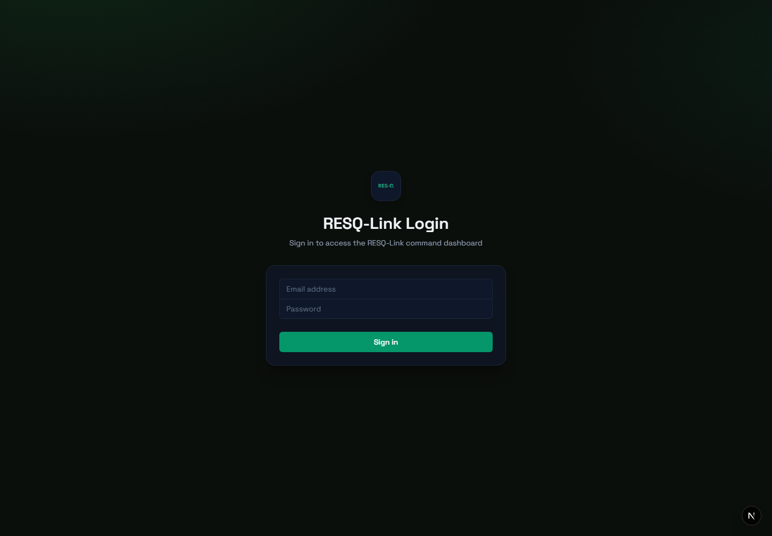
Figure 3. Dispatcher command-center web login — Microsoft Edge, local Next.js runtime.

Super-Admin Web
Live browser capture of the privileged administration portal's authentication entry point.
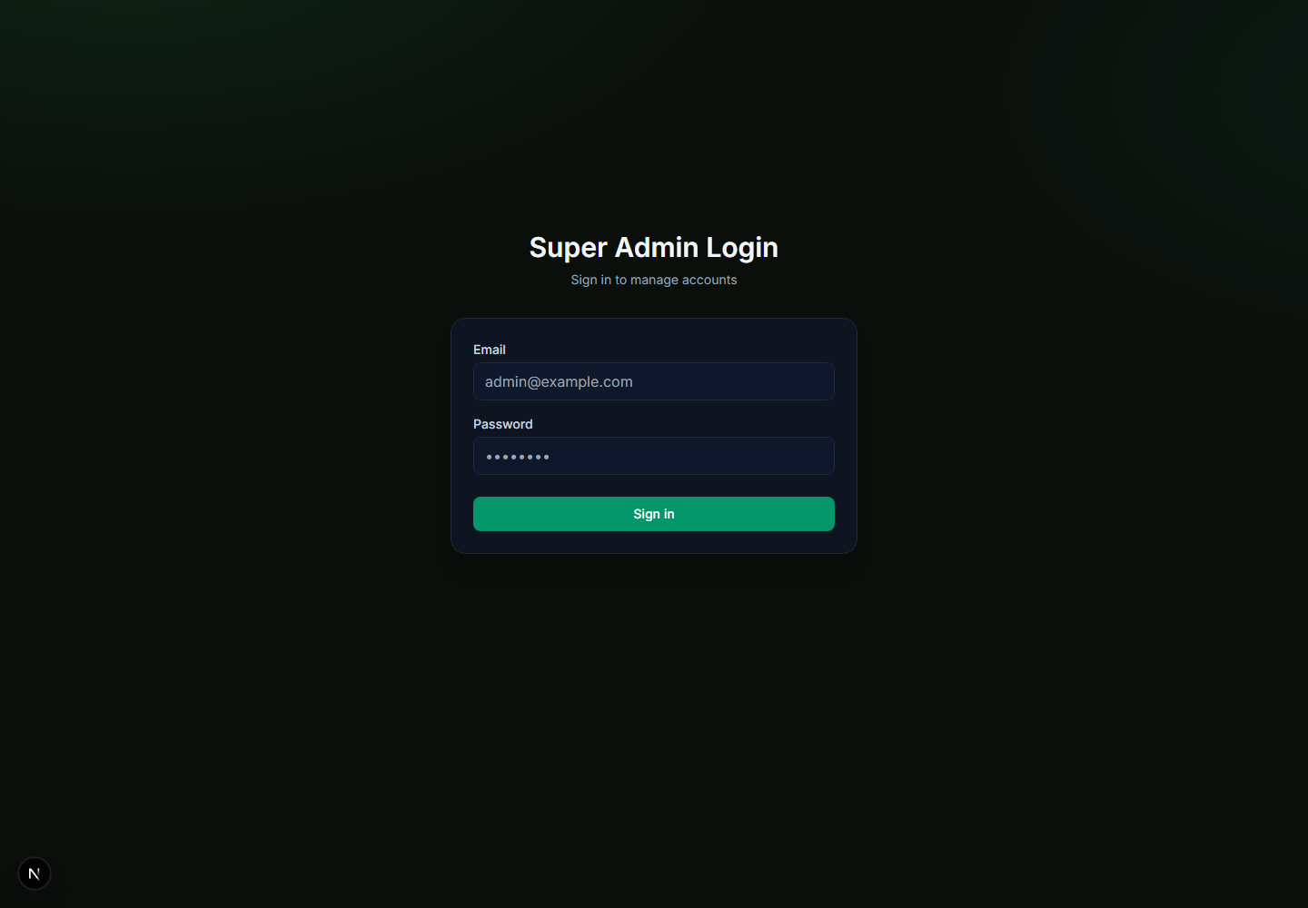
Figure 4. Super-admin web login — Microsoft Edge, local Next.js runtime.

Mobile Applications
Live Android captures showing the role-specific civilian and responder experiences rendered by their native application builds.
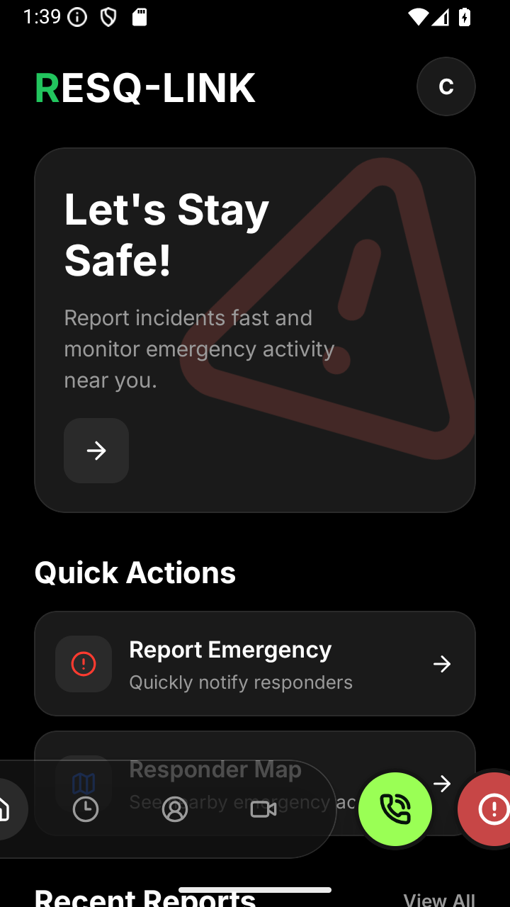 | 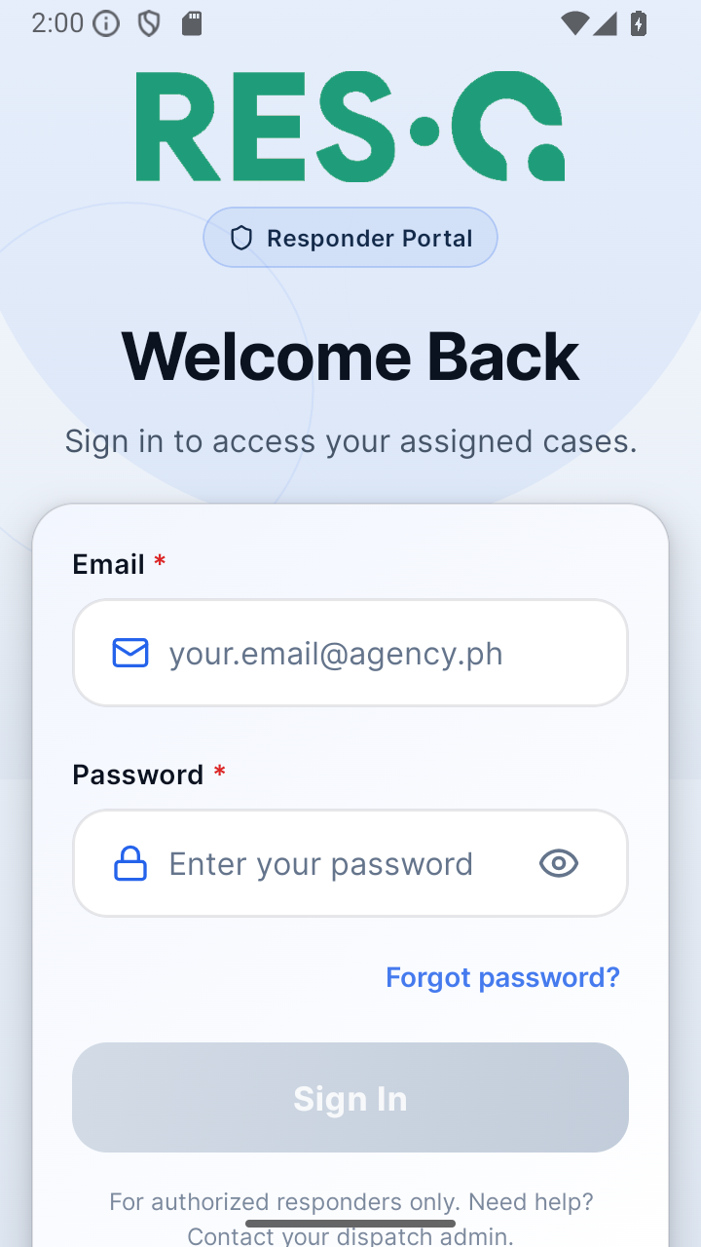
Figure 5. Civilian mobile dashboard — live Android application state. | Figure 6. Responder portal login — live Android development build.

PART III
Solution Architecture
Technology stack, monorepo structure, service boundaries, and runtime interaction patterns.

9. Technology Stack
Layer | Technology | Use in RESQ-Link
Mobile | Expo 54, React Native 0.81, React 19, Expo Router 6 | Civilian and responder applications; Android and iOS configuration
Web | Next.js 15, React 19, TypeScript | Dispatcher and super-admin applications with App Router and API routes
Domain/data | Firebase 12 Web SDK; Firebase Admin SDK | Authentication, Firestore, Storage, Realtime Database, privileged account operations
State | React hooks, contexts, Zustand, TanStack Query | Local/global state, cached asynchronous state and screen-level orchestration
Maps | react-native-maps / Google Maps; Leaflet / Mapbox | Native location and web operational mapping
Communication | Agora RTC; Firestore messaging; Expo notifications | Voice calls, operational chat and device/user alerts
UI | Tailwind CSS, Lucide icons, bottom sheets, Reanimated/Moti | Responsive web/mobile presentation and interaction
Reporting | jsPDF, jsPDF AutoTable, xlsx | Command-center PDF, print and spreadsheet exports
Deployment | Vercel; Expo/EAS | Web deployments and mobile build profiles
Tooling | npm workspaces, TypeScript, patch-package | Monorepo dependency management, compilation and targeted patches

10. Monorepo Structure
resq-link/
├── apps/
│ ├── civilian-mobile-app/ # Public Expo mobile experience
│ ├── dispatcher-web-app/ # Command-center Next.js application
│ ├── responder-mobile-app/ # Field responder Expo application
│ └── super-admin-web-app/ # Administrative Next.js application
├── packages/
│ └── firebase/ # Shared typed Firebase/domain package
├── patches/ # Root dependency patches
├── scripts/ # Documentation and utility scripts
├── package.json # npm workspace and shared overrides
└── package-lock.json # Workspace dependency lock

10.1 Workspace Design
- The root package defines npm workspaces for apps/* and packages/* and pins cross-workspace React, Expo, React Native and tool versions through overrides.
- Each application consumes @packages/firebase through a local file workspace reference.
- The Firebase package compiles TypeScript from src/ to dist/ and exposes its main, admin and civilian-auth entry points.
- Vercel builds install the relevant web workspace plus @packages/firebase, build the shared package first, then build the selected web app.
- Metro configurations provide mobile resolution of the shared package in the monorepo.

11. Runtime Component Model
Component | Boundary | Key collaborators
Civilian presentation/domain | Feature screens, hooks and route adapters | Shared Firebase functions, Expo device APIs, Maps, Agora
Responder presentation/domain | Modules for auth, dashboard, incidents, maps, notifications and settings | Shared Firebase functions, RTDB presence, Maps, Agora
Dispatcher presentation/domain | App Router pages, contexts, operational/reporting components | Firestore listeners, shared domain functions, Leaflet/Mapbox, Agora API
Admin web/API | Protected pages plus server-side API routes | Firebase Admin, Firestore server access, Resend
Shared Firebase domain | Framework-neutral TypeScript modules | Firebase Auth, Firestore, Storage, RTDB
Security policy | firestore.rules, storage.rules, database.rules.json | Authenticated identities, role profiles, participant lists and ownership checks

12. Shared Firebase Package
@packages/firebase acts as the system's primary domain and persistence boundary. Applications import typed operations instead of recreating Firestore queries and lifecycle rules independently.
Module | Primary responsibility
config.ts | Lazy app/auth/Firestore/Storage/RTDB initialization, Expo/Next environment resolution, auth readiness
auth.ts / civilian-auth.ts | Account creation, sign-in, role verification, registration and civilian account states
emergencies.ts | Civilian reports, subscriptions, assignment, linkage, follow-up details, status and post-report operations
incidents.ts | Canonical incidents, rule resolution, report elevation, dispatch, responder lifecycle and resource release
priority.ts / alertAcknowledgment.ts | Priority normalization, visual/audio behavior, escalation phases and acknowledgments
incidentLifecycle.ts / incidentStatusVisual.ts | Shared live/resolved predicates and normalized visual status tokens
civilianFieldAssessment.ts | Structured civilian narrative and follow-up field definitions/mapping
responderAssessment.ts | Scene-assessment definitions, parsing and submission
resources.ts / teams.ts / operationalTeams.ts | Resource CRUD, team records, assignment snapshots and matching
commandCenterShift.ts | Current team-on-duty persistence and subscription
messaging.ts | Direct/group threads, participants, messages and subscriptions
callSessions.ts | Incident voice-call session state machine and subscriptions
dispatchers.ts / responderPresence.ts | Location/online fields and RTDB presence lifecycle
footageRequests.ts / storage.ts | Evidence requests and image uploads
quadrants.ts | Operational quadrant definitions and barangay mapping
admin.ts | Server-only account provisioning and token verification

PART IV
Data and Lifecycle Architecture
Canonical records, relationships, statuses, synchronization, and operational ownership.

13. Data Stores
Store | Purpose | Characteristics
Cloud Firestore | Primary operational system of record | Document collections, role-aware security rules, real-time subscriptions, indexed queries and history
Firebase Authentication | Identity and credential authority | Email/password and phone-related SDK support; token verification for server APIs
Firebase Storage | KYC, emergency and post-report media | Path-scoped rules for ownership, authenticated access and administrative review
Firebase Realtime Database | Responder online presence | presence/responders/{uid}, .info/connected and onDisconnect cleanup; Firestore fallback
Local device storage | Session-supporting mobile state | AsyncStorage/SecureStore used by mobile dependencies and app state

14. Firestore Collection Catalog
Collection | Data responsibility | Primary consumers
admins | Super-admin profiles | Super-admin UI and server authorization
users | Civilian profiles, account status and KYC metadata | Civilian app and super-admin KYC/account management
dispatchers | Dispatcher/responder profiles, roles, designation and location/online fields | Dispatcher, responder and admin apps
commandCenters | Command-center profiles and current team-on-duty state | Dispatcher authentication and operational context
emergencies | Original civilian/manual emergency reports and report-level lifecycle | Civilian, dispatcher and responder experiences
incidents | Canonical command-center incident records | Dispatch, response lifecycle, outcomes and analytics
incidents/{id}/teamAssignmentHistory | Team reassignment audit trail | Operational history and reporting
incidentTypeRules | Subtype, priority, agency and resource-routing rules | Incident creation and administration
resources | Vehicles/equipment, status, location, team and responder bindings | Resource management and dispatch
incidentDispatches | Incident-to-agency/resource assignment records | Traceable dispatch relationships
teams | Operational team catalog and membership context | Team filtering, assignment and reporting
chatThreads / messages | Direct/group operational conversations | Dispatcher-responder messaging
callSessions | Incident voice-call state and participants | Civilian/responder calls with Agora channels
footageRequests | CCTV/evidence request lifecycle | Civilian submission and command-center processing
emailOtps | Server-only email verification OTP records | Super-admin API routes only
passwordResetOtps | Server-only password-reset OTP records | Super-admin API routes only

15. Core Record Relationships
- Emergency report → incident — emergencies.incidentId links a reporter-originated record to a canonical incident; incidents.associatedReportIds supports the reverse relationship.
- Report grouping — primaryReportId enables related reports to be grouped before or alongside incident elevation.
- Incident → dispatch — incidentDispatches reference the incident, agency, resource and responder assignments.
- Incident → resource — incidents.assignedResourceIds and resources.assignedIncidentId represent current allocation; lifecycle functions synchronize release.
- Incident → team — assignedTeamId/name/code provide a permanent snapshot, while team history records capture reassignment.
- Incident → call/chat — call sessions carry incident identifiers; chat threads carry participant lists and operational conversation state.
- User profiles → authentication — Firebase Auth UID is the profile document key for users, dispatchers, command centers and admins.

16. Status and Lifecycle Models
Domain | States | Notes
Civilian account | pending_email_verification → pending_kyc_review → active; rejected | Controls onboarding gate and administrative review
Emergency report | pending, linked, active, enroute, on_scene, done, resolved | Supports legacy and current states while remaining synchronized with incident activity
Incident | new, awaiting_resources, liaison_pending, dispatched, enroute, on_scene, resolved, unresolved | Canonical command-center lifecycle
Resolution | open, resolved, unresolved | Separates outcome from operational status
Resource | available, assigned, en_route, on_scene, maintenance, offline | Availability and deployment lifecycle
Call session | ringing, accepted, connected, ended, missed, failed | Voice signaling state; media handled by Agora
Footage request | Defined in footageRequests domain | Submitted and processed through civilian/command-center views

Lifecycle invariant
Incident updates propagate to linked emergency reports where appropriate, while resource assignments and release operations maintain operational consistency. UI code should call shared lifecycle functions rather than writing status fields directly.

17. Priority, Escalation, and Alerting
- Priority values and rankings are centralized in priority.ts, including incident-type defaults and visual/map tokens.
- Acknowledgment fields include actor, timestamp, dispatcher identity, escalation level and alert timestamps.
- Shared helpers decide whether an alert requires forced visibility, acknowledgment UI, repeating audio, or escalation.
- Dispatcher contexts/components coordinate critical alerts and alarm unlocking; mobile clients use notification and haptic capabilities.
- Status-visual helpers normalize operational states to common labels, colors, Tailwind classes and pulse behavior.

18. Real-Time Synchronization
Subscription | Consumers | Behavior
Emergency reports | Civilian history/map; dispatcher intake; responder assignments | Firestore onSnapshot, status filtering, sorted snapshots and metadata
Incidents | Dispatcher and responder | Filtered real-time incident lists and detail updates
Resources and teams | Dispatcher | Live resource/team availability and management
Messages and threads | Dispatcher and responder | Participant-scoped thread/message listeners
Call sessions | Civilian and responder | Incoming/active incident call signaling
Responder presence | Responder and dispatcher overview | RTDB online nodes with onDisconnect; Firestore fallback
Team on duty | Dispatcher pages | Command-center document subscription

Query resilience
Emergency subscriptions detect missing Firestore indexes, log a single operational warning, fall back to less constrained queries, and sort/filter in memory. Authentication restoration is awaited before attaching protected listeners.

PART V
Integrations and APIs
External services, internal route handlers, environment boundaries, and communication flows.

19. External Integration Matrix
Integration | Purpose | Applications | Configuration
Firebase | Identity, documents, media, presence and admin operations | All | NEXT_PUBLIC_/EXPO_PUBLIC_/FIREBASE variables; service account for admin routes
Google Maps | Native maps and markers | Civilian and responder mobile | GOOGLE_MAPS_API_KEY or EXPO_PUBLIC_GOOGLE_MAPS_API_KEY injected by app.config.js
Mapbox + Leaflet | Web tile styling and map rendering | Dispatcher web | NEXT_PUBLIC_MAPBOX_ACCESS_TOKEN and optional style
Agora | Real-time incident voice communication | Civilian, responder, dispatcher | AGORA_APP_ID, AGORA_APP_CERTIFICATE, token TTL; public app ID for clients
Resend | Verification and recovery email delivery | Super-admin API | RESEND_API_KEY, RESEND_FROM_EMAIL, cooldown
Vercel | Web build and hosting | Dispatcher and super-admin | Per-app vercel.json with workspace-aware install/build commands
Expo/EAS | Native builds and distribution | Mobile apps | Expo project IDs; responder development/preview/production profiles

20. Internal API Route Catalog
Application | Route | Responsibility
Dispatcher | /api/agora/token | Create scoped Agora RTC tokens for incident channels
Dispatcher | /api/create-team-member | Provision or associate operational team members
Dispatcher | /api/agent/chat | Command-center assistant/chat request adapter
Super Admin | /api/create-{dispatcher,responder,civilian,command-center} | Privileged account provisioning
Super Admin | /api/email-otp/{send,verify} | Email ownership verification
Super Admin | /api/auth/forgot-password/{send,reset} | Credential recovery
Super Admin | /api/kyc/{approve,reject} | Civilian identity-review decisions

20.1 API Boundary Rules
- Firebase Admin credentials and Resend secrets are server-side only and must never use NEXT_PUBLIC_ or EXPO_PUBLIC_ prefixes.
- Client applications authenticate users with Firebase Auth and rely on security rules for direct Firestore/Storage access.
- Privileged user creation, KYC and OTP document access execute in protected Next.js API routes.
- Agora clients receive short-lived tokens from the dispatcher token route; the App Certificate remains server-only.
- Public Firebase and map identifiers are build-time/runtime configuration values, not authorization controls; authorization remains rules- and identity-based.

21. Voice Calling and Messaging

21.1 Incident Voice Calls
- A caller creates a callSessions record containing incident, channel, role and target responder metadata.
- Subscribed responder clients receive ringing sessions and accept or decline.
- The application requests an Agora token for the normalized incident channel.
- Clients join Agora media while Firestore tracks accepted, connected, ended, missed or failed state.
- Cleanup functions close signaling state and release client media resources.

21.2 Operational Messaging
- Direct and group chat threads store participant identity, role and thread type.
- Messages are stored in chatThreads/{threadId}/messages and subscribed to in real time.
- Security rules permit participant reads and participant-authored creates; message mutation/deletion is denied.

PART VI
Security, Identity, and Privacy
Authentication, authorization, media protection, privileged operations, and secure configuration.

22. Identity Model
Identity | Profile collection | Authorization signal
Civilian | users/{uid} | Authenticated owner plus account status; KYC metadata on profile
Dispatcher / responder | dispatchers/{uid} | Agency role, designation, active flag, and ownership
Command center | commandCenters/{uid} | Command-center profile and authenticated ownership
Super admin | admins/{uid} | Admin profile verified by web context/server functions

22.1 Agency and Operational Roles
DispatcherRole supports BFP, PNP, MDRRMO, AMBULANCE and PCG. Incident agency routing expands the catalog to include RESCUE_1111, TCPGH, CHO, TFLC, PSSO_TCTMG, barangay officials, utility providers, command center and other agencies.

23. Firestore Authorization
Data area | Read posture | Write posture
Profiles | Owner plus authorized operational/admin roles | Owner and/or administrative role depending on collection
Emergency reports | Authenticated users | Owner/operational roles; deletion restricted to command center
Incidents | Authenticated users | Operational/admin roles with explicit rule conditions
Resources / dispatches | Authenticated users | Command-center/dispatcher roles; super admin included for dispatch records
Teams | Authenticated users | Command-center or super admin
Calls | Authenticated participants/readers | Authenticated updates; restricted create ownership and administrative delete
Chat | Thread/message participants | Participant creates; message update/delete denied
OTP collections | No client access | Server/Admin SDK only
Fallback | Denied | Denied

Security posture
The rule sets use explicit collection matches and end with deny-by-default fallbacks. Administrative API routes bypass client rules through the Firebase Admin SDK and therefore require strict server credential and endpoint protection.

24. Storage Authorization
Path | Write | Read
kyc-documents/{uid}/{fileName} | Authenticated owner with size/type constraints | Owner or super admin
emergencies/photos/{photoId} | Authenticated authorized upload with validation | Authenticated users
post-reports/{incidentId}/{photoId} | Authenticated response workflow | Public in current rule set
All other paths | Denied | Denied

Privacy review item
The current post-report photo rule permits public reads. Confirm that this matches operational and privacy requirements before production deployment; otherwise restrict reads to authenticated participants or authorized operational roles.

25. Secret and Configuration Handling
- Never commit .env, .env.local, service-account JSON, API certificates or email-provider secrets.
- Use EXPO_PUBLIC_ only for values required in mobile client bundles; use NEXT_PUBLIC_ only for values required in browser bundles.
- Keep FIREBASE_SERVICE_ACCOUNT_JSON, GOOGLE_APPLICATION_CREDENTIALS, AGORA_APP_CERTIFICATE and RESEND_API_KEY server-only.
- Treat Firebase web configuration and map keys as identifiers protected through provider restrictions and security rules, not as secrets.
- Restrict Google Maps and Mapbox keys by package/bundle/domain and permitted APIs.
- Rotate credentials after exposure and redeploy affected clients/services.

PART VII
Configuration and Deployment
Environment matrix, build dependencies, web deployment, mobile build profiles, and release sequence.

26. Environment Variable Matrix
Area | Variables | Runtime | Requirement
Firebase client | NEXT_PUBLIC_FIREBASE_API_KEY / EXPO_PUBLIC_FIREBASE_API_KEY | Web browser / mobile bundle | Required
Firebase client | *_FIREBASE_AUTH_DOMAIN, PROJECT_ID, STORAGE_BUCKET, MESSAGING_SENDER_ID, APP_ID | Web/mobile | Required
Firebase presence | NEXT_PUBLIC_FIREBASE_DATABASE_URL / EXPO_PUBLIC_FIREBASE_DATABASE_URL | Web/mobile | Recommended; enables RTDB presence
Firebase scripts | FIREBASE_API_KEY, AUTH_DOMAIN, PROJECT_ID, STORAGE_BUCKET, MESSAGING_SENDER_ID, APP_ID, DATABASE_URL | packages/firebase scripts | As needed
Admin SDK | FIREBASE_SERVICE_ACCOUNT_JSON or GOOGLE_APPLICATION_CREDENTIALS | Super-admin server | Required for privileged APIs
Native maps | GOOGLE_MAPS_API_KEY or EXPO_PUBLIC_GOOGLE_MAPS_API_KEY | Mobile build | Required for Google provider in native Android
Web maps | NEXT_PUBLIC_MAPBOX_ACCESS_TOKEN; NEXT_PUBLIC_MAPBOX_STYLE | Dispatcher browser | Required/optional style
Agora server | AGORA_APP_ID; AGORA_APP_CERTIFICATE; AGORA_TOKEN_TTL_SECONDS | Dispatcher server | Required for production voice
Agora client | EXPO_PUBLIC_AGORA_APP_ID | Mobile bundle | Required for voice
Email | RESEND_API_KEY; RESEND_FROM_EMAIL; RESEND_COOLDOWN_MS | Super-admin server | Required for OTP email
API addressing | EXPO_PUBLIC_API_URL / APP_URL / BASE_URL | Mobile bundle | Environment-specific

27. Build and Dependency Order
- Install Node.js 18 or later, npm, Git, and the platform-specific mobile toolchain when native builds are required.
- From the repository root, run npm install so workspace dependencies and the root lockfile remain consistent.
- Build @packages/firebase before production web builds or after changing shared TypeScript modules.
- Configure application-specific environment files or deployment secrets without committing them.
- Run web builds and mobile configuration/build checks for the target environment.
- Deploy Firebase rules/indexes before releasing client features that depend on new collections or queries.
# Shared package
npm run build --workspace @packages/firebase
# Dispatcher web
npm run build --workspace dispatcher-web-app
# Super-admin web
npm run build --workspace super-admin-web-app
# Mobile development
npm run start --workspace civilian-mobile-app
npm exec --workspace responder-mobile-app -- expo start

28. Web Deployment
- Dispatcher and super-admin apps each provide an app-local vercel.json.
- Install commands include the application workspace, @packages/firebase and the workspace root while ignoring install scripts in the remote build.
- Build commands compile the shared Firebase package first, then run the application build.
- Ignore commands redeploy only when the selected app, shared Firebase package, root package.json or package-lock.json changes.
- Environment variables are configured independently per Vercel project; server-only variables must not be exposed as public variables.

29. Mobile Build and Release
Application | Identity | Release configuration
Civilian | com.tuguegarao.resqlink; scheme resqlink | Expo project metadata, new architecture enabled, microphone/location permissions; environment-driven maps/Firebase/Agora
Responder | com.tuguegarao.resqlink.responder; scheme resqlink-responder | EAS development, preview and production profiles; production auto-increments app version

- Validate Android and iOS permissions and user-facing descriptions before store submission.
- Use build-time secrets/environment profiles for Firebase, maps and Agora configuration.
- Verify native Google Maps behavior on a development/preview build; Expo Go behavior does not fully represent standalone native configuration.
- Exercise voice, location, notifications, background/foreground presence and deep-link routes on physical devices.

30. Firebase Deployment Assets
Asset | Purpose
packages/firebase/firestore.rules | Firestore authorization policy
packages/firebase/firestore.indexes.json | Composite/index query support
packages/firebase/storage.rules | KYC, emergency and post-report media access
packages/firebase/database.rules.json | Realtime Database presence access
packages/firebase/scripts/* | Admin bootstrap, user creation, seeding, migration and lifecycle validation

PART VIII
Engineering, Quality, and Operations
Development standards, verification strategy, observability, recovery, and maintenance priorities.

31. Development Workflow
- Create a short-lived feature or integration branch from the current main baseline.
- Keep shared lifecycle and persistence logic in @packages/firebase; keep role-specific orchestration and presentation in the consuming app.
- Update security rules and indexes in the same change when introducing a new collection, access path or compound query.
- Run shared TypeScript compilation, affected web builds, mobile syntax/config checks and targeted behavior tests.
- Test role boundaries with representative civilian, dispatcher, responder, command-center and admin accounts.
- Document environment or deployment changes and verify rollback points before release.

31.1 Architectural Guardrails
- Do not write incident/report status fields directly when a shared domain transition function exists.
- Do not initialize parallel Firebase app instances; use lazy accessors from config.ts.
- Do not expose Admin SDK or provider secrets to browser/mobile bundles.
- Keep route files thin and place feature logic in screens/hooks/modules.
- Preserve permanent team assignment snapshots and history during reassignment.
- Unsubscribe Firestore/RTDB listeners and Agora sessions during unmount, sign-out and app-background transitions.

32. Verification Strategy
Layer | Minimum checks | Release evidence
Shared package | tsc build; lifecycle and migration scripts; rule/index review | Successful build and script output
Web apps | Next production build, authenticated route smoke tests, API route tests | Build logs and environment checklist
Mobile apps | Expo Doctor/config, native preview build, physical-device smoke tests | EAS build and device test record
Cross-role | Report → triage → dispatch → response → closure | Scenario checklist with record IDs/timestamps
Security | Positive and negative rule tests by role and ownership | Emulator/rules test results
Resilience | Offline/reconnect, missing index, missing map key, denied location, call failure | Observed fallback behavior
Performance | Large active lists, map marker volume, listener cleanup, export size | Timing and memory observations

33. Operational Observability
- Client and shared modules currently use structured console logging helpers, including once-only warnings for repeated Firebase initialization/index conditions.
- Critical operational data is observable through record timestamps, status fields, acknowledgment metadata, response times, team assignment history and call-session state.
- Vercel provides server/API build and runtime logs; EAS provides mobile build logs; Firebase consoles provide Auth, Firestore, Storage and RTDB inspection.
- Production hardening should add centralized error reporting, release/version tags, API correlation IDs, audit-event retention and alert thresholds.

34. Troubleshooting Runbook
Symptom | Likely cause | First actions
Cannot resolve @packages/firebase | Shared package not installed/built or workspace resolution issue | Run root npm install; build @packages/firebase; verify Metro/Next workspace settings
Firebase config incomplete | Missing/mis-prefixed environment values | Check app-specific env file/deployment settings and prefixes; restart/rebuild
Permission denied | Rule mismatch, wrong profile role/status or unauthenticated request | Inspect UID/profile collection, auth token and relevant Firestore/Storage rule
Missing-index warning | Compound query index not deployed | Deploy firestore.indexes.json; temporary in-memory fallback may remain operational
Map unavailable on Android | Google Maps key not injected/restricted incorrectly | Set build variable, verify app.config output and package restriction, rebuild native app
Responder count remains zero | RTDB URL/rules missing or designation mismatch | Check database URL, presence rules, profile designation and Firestore fallback
Voice call fails | Agora credentials/token/channel mismatch or microphone permission | Inspect token route, app ID, certificate, TTL, channel normalization and device permission
OTP email not delivered | Resend configuration, cooldown or sender verification | Check server logs, API key, from address, recipient and OTP document
Web build fails | Shared package, environment or workspace dependency mismatch | Build Firebase first, clean .next, reinstall from lockfile and run app build

35. Backup, Recovery, and Continuity
- Enable scheduled Firestore exports and define retention/recovery ownership for production projects.
- Protect service-account credentials and maintain break-glass access through audited secret management.
- Tag production releases and retain the web/mobile configuration used for each release.
- Document how to disable compromised accounts, rotate provider credentials and revoke active sessions.
- Exercise recovery of Firestore data, Storage objects, Vercel deployments and mobile release configurations.
- Use incident and team assignment history to reconstruct operational actions after service restoration.

36. Current-State Considerations and Recommendations
Area | Observation | Recommendation | Priority
Documentation drift | Some legacy READMEs describe earlier versions or mock-only states | Treat current code and this baseline as authoritative; revise per-app READMEs during future releases | High
Automated testing | Jest dependencies exist, but end-to-end and rule-test coverage is not demonstrated across all apps | Add emulator-backed domain/rules tests and cross-role E2E scenarios | High
Observability | Console-based logging dominates | Integrate centralized error/performance monitoring and correlation IDs | High
Storage privacy | Post-report photos are publicly readable in current storage rules | Confirm requirement and restrict if not explicitly public | High
Dependency health | Workspace uses extensive overrides and patching; lint tooling can be sensitive to install state | Use clean reproducible CI installs, dependency audits and scheduled upgrades | Medium
Mobile parity | Responder has explicit EAS profiles; civilian relies on project metadata/config | Define equivalent checked-in release profiles and environment policy | Medium
Auditability | Operational timestamps exist but a unified audit-event stream is not present | Add immutable administrative/operational audit events | Medium
Performance | Real-time maps and active lists may grow | Adopt pagination/windowing, listener scoping and production volume testing | Medium

PART IX
Reference Appendices
Routes, configuration quick reference, terminology, ownership, and repository evidence.

Appendix A. Route Inventory
Application | Route families
Civilian mobile | (auth): login, register, email verification, account pending, forgot/reset password; (main): dashboard, history, profile, emergency form/confirmation, responder map, calling; (settings): appearance, notifications, privacy/security, FAQ, support, report issue
Responder mobile | auth/login; tabs/dashboard, map, notifications, settings; incident/[id]; support/about, help-support, location
Dispatcher web | overview, intake, incidents, incident-management, map, resources, teams, history, report, report/incidents, footage-requests, login
Super-admin web | dashboard, responders, dispatchers, civilians, command-centers, KYC, login

Appendix B. Operational Status Quick Reference
Phase | Emergency report | Incident | Resource | Responder action
Intake | pending | new | available | No assignment
Needs capacity | pending/linked | awaiting_resources or liaison_pending | available | Await assignment
Dispatched | active/linked | dispatched | assigned | Accept or decline
Travel | enroute | enroute | en_route | Navigate to scene
Scene | on_scene | on_scene | on_scene | Touchdown and assessment
Closure | done/resolved | resolved/unresolved | available | Submit post-report and close

Appendix C. Glossary
Term | Definition
BFP | Bureau of Fire Protection
PNP | Philippine National Police
MDRRMO | Municipal Disaster Risk Reduction and Management Office
PCG | Philippine Coast Guard
KYC | Know Your Customer / identity verification review
Emergency report | Original reporter-facing record, usually in emergencies
Incident | Canonical command-center operational record in incidents
Dispatch record | Incident-to-agency/resource relationship in incidentDispatches
Operational team | Team assigned permanent ownership for an incident
Touchdown | Recorded responder arrival/on-scene event, optionally with distance/source
RTDB | Firebase Realtime Database, used primarily for responder presence
EAS | Expo Application Services for mobile builds and submission
OTP | One-time passcode used for verification or password recovery

Appendix D. Repository Evidence
Evidence area | Repository source
Workspace configuration | package.json; package-lock.json
Civilian architecture | apps/civilian-mobile-app/src; app.json; app.config.js; docs/*
Responder architecture | apps/responder-mobile-app/src; app.json; app.config.js; eas.json; docs/*
Dispatcher architecture | apps/dispatcher-web-app/app; components; contexts; lib; vercel.json; docs/*
Super-admin architecture | apps/super-admin-web-app/app; contexts; lib; vercel.json; README.md
Domain/data layer | packages/firebase/src/*; package.json
Security | packages/firebase/firestore.rules; storage.rules; database.rules.json
Deployment | apps/*/vercel.json; apps/responder-mobile-app/eas.json; Expo app configuration
Branding | apps/dispatcher-web-app/public/branding/resq-link-logo.png and resq-link-icon.png
Live screenshots | docs/screenshots/dispatcher-web-login-live.png; super-admin-live.png; civilian-mobile-live.png; responder-mobile-live.png


RESQ-Link
Connected response. Shared awareness. Accountable outcomes.

