**Code Formatting Rules:**

1. **Two new lines after each function definition.**

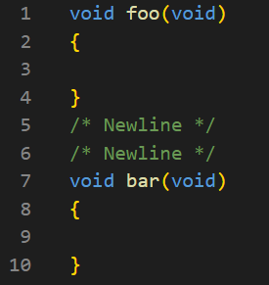

1. **One new line after each #define**

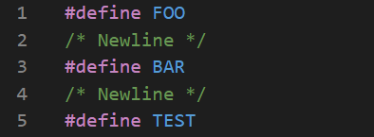

1. **Doxygen style commenting (Picture 1 = Function, Picture 2 = Header/Source File Description)**

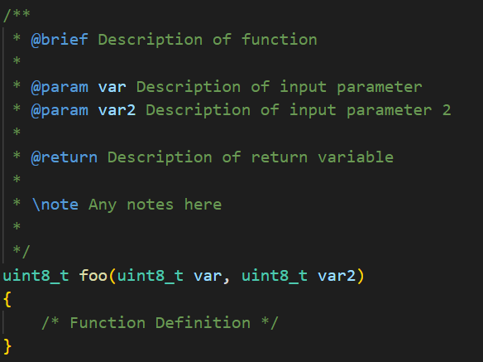

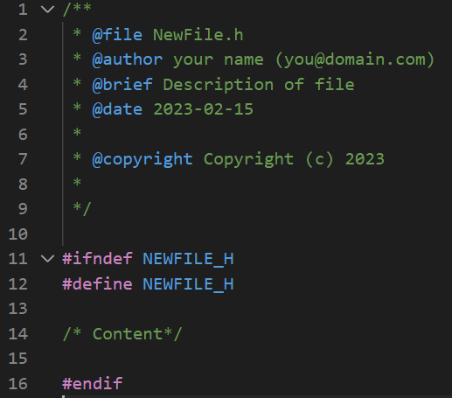

1. **No spaces between function declaration name and parameter inputs.**

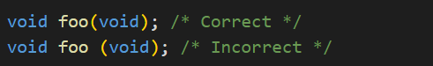

1. **All words in Header and Source Files must be capitalized with no underscores (‘_’)**

* **NewFile.h = Correct**
* **Newfile.h = Incorrect**
* **New_file.h = Incorrect**
* **New_File.h = Incorrect**

1. **If it can be done, include System File Paths first then local file paths. No new lines between include directives. If it can be done, include in alphabetical order.**

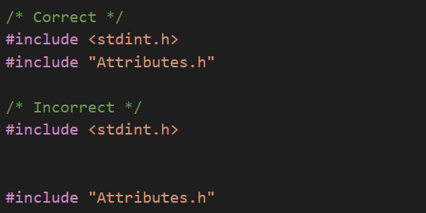

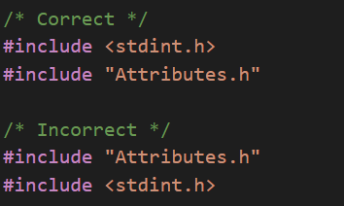

1. **Braces around function definitions, structs, unions, for loops, if statements, etc. must be in this format:**

