**Code Formatting Rules:**

1. **Lower case with underscores for all files.**

* USBHIDDevice.h = Incorrect
* UsbHidDevice.h = Incorrect
* usb_HID_device.h = Incorrect
* usb-hid-device.h = Incorrect
* usbhiddevice.h = Correct
* usbhid_device.h = Correct
* usb_hid_device.h = Correct

1. **Lower case and no spaces for all folders.**

* usb_stack = Incorrect
* USBStack = Incorrect
* usb-stack = Incorrect
* usbstack = Correct

1. **Two new lines after each function definition.**

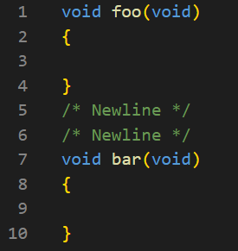

1. **One new line after each #define**

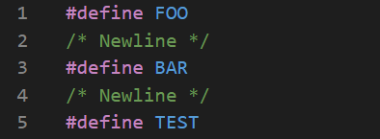

1. **Doxygen style commenting (Picture 1 = Function, Picture 2 = Header/Source File Description)**

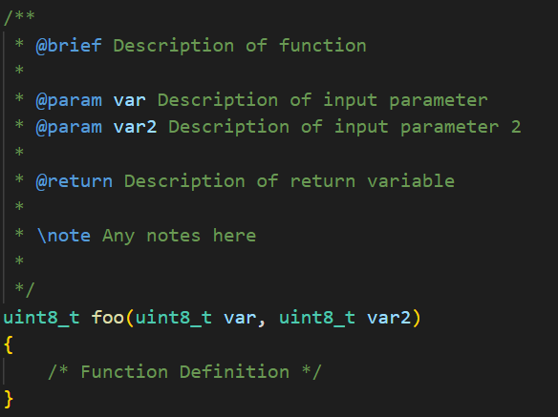

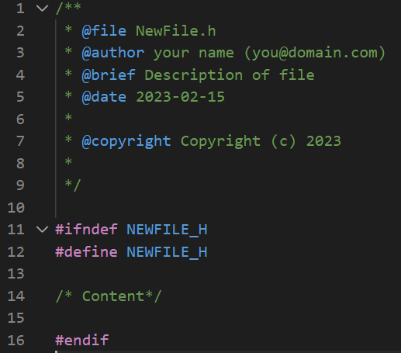

1. **No spaces between function declaration name and parameter inputs.**

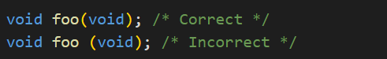

1. **If it can be done, include System File Paths first then local file paths. No new lines between include directives. If it can be done, include in alphabetical order.**

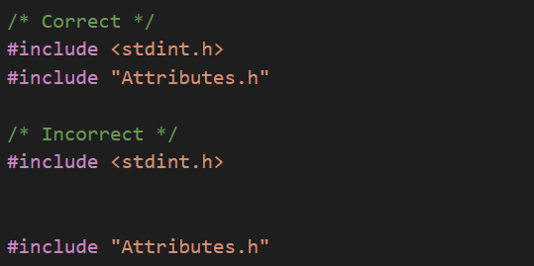

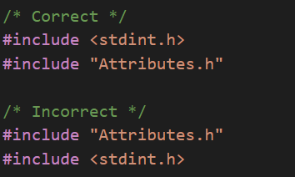

1. **Braces around function definitions, structs, unions, for loops, if statements, etc. must be in this format:**

