AI & BUSINESS AUTOMATION
Comprehensive Notes · Module 2

Week 2: Workflow Automation Design

Topics Covered | Designing workflows · Triggers, Actions & Modules · Multi-step automation · Error handling · Data validation · Testing & Debugging
Tools | Make.com · Google Forms · Google Sheets · Gmail · Notion
Prerequisite | Module 1 completed - Make.com account active & create the first demo practice
Outcome | Build robust, error-proof automation workflows ready for real business deployment

Build · Automate · Grow

1. Designing Automation Workflows in Make.com

1.1 The Anatomy of a Make.com Scenario
Every automation you build in Make.com is called a scenario. A scenario is a visual chain of modules ; each module either listens for something to happen or performs an action in response. Think of it as an assembly line: raw material (data) enters at one end, is processed through stations (modules), and exits as a finished output (email sent, row logged, notification fired).

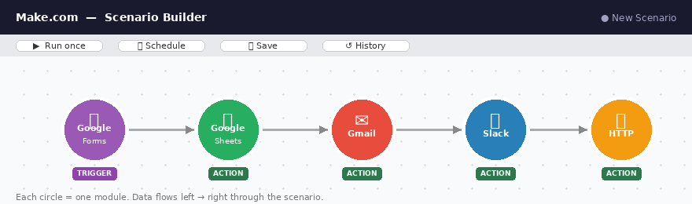
Fig 1.1 — The Make.com Scenario Builder: modules connected left-to-right, data flowing between them
Component | What It Is | Example
Scenario | The complete automation - the full chain of modules | Lead capture → CRM log → Welcome email
Module | A single step that connects to one app and performs one task | Gmail: Send an Email
Trigger | The first module - the event that starts the whole chain | Google Forms: Watch Responses
Action | Any module after the trigger - it does something | Google Sheets: Add a Row
Connection | The authenticated link between Make.com and an app | Your Google account linked securely
Bundle | One unit of data flowing through the scenario | A single customer's form submission

1.2 Workflow Design Principles
Before opening Make.com, you need to design on paper first. Building without a plan leads to fragile, messy automations that break unpredictably. Apply these five principles:

- Start with the trigger - identify exactly what event kicks off the process
- Work left to right - each module feeds data into the next; map the sequence before you build it
- One module, one job -resist the temptation to make a single module do too much
- Always plan for failure - what happens when a form is submitted with missing data? Build for that case first
- Keep it auditable - log important events (errors, key completions) to Google Sheets or Notion so you can review what happened

📌 Design-First Rule
A well-drawn workflow map on paper takes 15 minutes and saves 3 hours of debugging in Make.com. Always map before you build.

1.3 The Workflow Design Template
Use this template for every automation you design:

Design Element | Question to Answer | Your Notes
Trigger | What event starts this workflow? Which app sends the signal?
Input Data | What data arrives with the trigger? Is it clean and reliable?
Steps | What must happen, in what order?
Decisions | Are there IF/THEN branches? What conditions govern them?
Outputs | What does the completed workflow produce?
Error Scenarios | What can go wrong? What is the fallback?
Test Cases | How will you verify it works correctly?

2. Triggers, Actions, and Modules in Make.com

2.1 Triggers - Where Every Scenario Begins
A trigger is the first module in any scenario. It watches an external system and fires the scenario whenever a specified event occurs. Without a trigger, nothing runs.

Types of Triggers
Trigger Type | How It Works | Real Example
Instant (Webhook) | The external app pushes data to Make.com the moment something happens - zero delay | A customer submits a Typeform → instant trigger fires
Scheduled Polling | Make.com checks the external app on a schedule (e.g., every 15 minutes) | Check Google Sheets every 15 min for new rows
Watch Responses | Specific to form tools - monitors for new form submissions | Google Forms: Watch Responses module
Email Trigger | Fires when a new email matching conditions arrives in an inbox | Gmail: Watch Emails - filter by subject or sender
Time-Based Trigger | Fires at a specific scheduled time - daily, weekly, or custom cron | Every Monday at 8:00am - run weekly report

Webhook vs Polling : Why It Matters
Webhooks are instant and efficient. Polling runs every 15 minutes on the free plan — this means a customer could wait up to 15 minutes for their confirmation email. For customer-facing processes, use instant webhook triggers wherever possible.

2.2 Actions - What Your Automation Does
Every module after the trigger is an action. Actions use the data from the trigger (and previous modules) to perform tasks in other applications. The output of one action becomes available as input for the next.

Action Category | Examples | Common Use Cases
Create/Add | Add a row (Sheets), Create a page (Notion), Create a task (Asana) | Logging new submissions, creating project records
Send/Notify | Send an email (Gmail), Post a message (Slack), Send WhatsApp | Customer confirmations, internal team alerts
Update | Update a row (Sheets), Update a record (HubSpot), Edit a page (Notion) | Changing status from Pending to Complete
Search/Get | Search rows (Sheets), Get a record (CRM), List items (Airtable) | Looking up if a customer already exists
Transform | Set Variable, Parse text, Format date, Aggregate data | Cleaning, combining, or reshaping data mid-flow
HTTP / API Call | Make an HTTP request to any API endpoint | Connecting to services without native Make.com modules

2.3 Advanced Module Types

Routers
A Router splits one workflow into multiple parallel paths. Each path has its own filter condition. Use routers when different inputs require different outcomes.

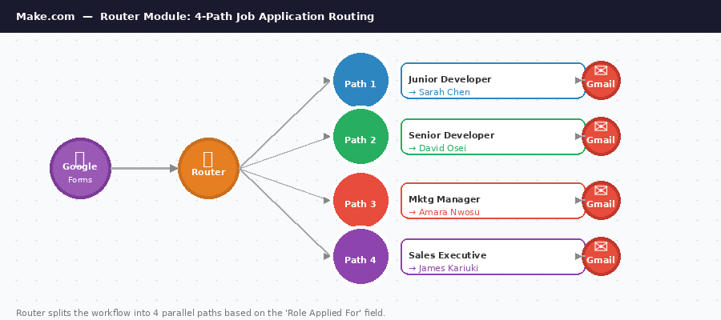
Fig 2.1 — Make.com Router: splits the scenario into 4 paths based on the role applied for
📌 Router Example
An incoming lead form has a field: 'Company Size'. Router path A fires if Company Size > 50 (enterprise lead → assign to senior sales). Router path B fires if Company Size ≤ 50 (SMB lead → add to nurture sequence).

Iterators
An Iterator loops through a list of items and processes each one individually. For example, if a Google Sheet row contains five product names in one cell, an iterator can break them apart and process each separately.

Aggregators
An Aggregator does the opposite of an iterator; it collects multiple bundles of data and combines them into a single output. Useful for building summary reports from multiple rows.

Error Handlers
Make.com allows you to attach error handler routes to any module. If that module fails, instead of stopping the scenario, execution passes to your error handler, which might log the failure, send an alert, or retry the operation.

3. Multi-Step Automation Processes

3.1 What Makes an Automation 'Multi-Step'?
A multi-step automation involves three or more modules working in sequence, with data flowing and transforming between them. Most real-world business automations are multi-step because a single business event typically requires multiple systems to be updated and multiple people to be notified.

3.2 Building Multi-Step Scenarios: The Data Pipeline Model
Stage | Function | What Happens to Data
1. Capture | The trigger receives the initial data bundle | Raw, unprocessed input data arrives
2. Validate | Check that required fields are present and correctly formatted | Bad data is caught before it breaks downstream steps
3. Enrich | Add information — timestamps, formatted names, lookup results | Data grows richer with each module
4. Distribute | Send the enriched data to its destinations | CRM updated, emails sent, dashboards refreshed

3.3 Mapping Data Between Modules
When you add an action module, Make.com presents empty fields for you to fill. Instead of typing static text, you map dynamic variables - references to data from earlier modules. This is the core skill of building in Make.com.

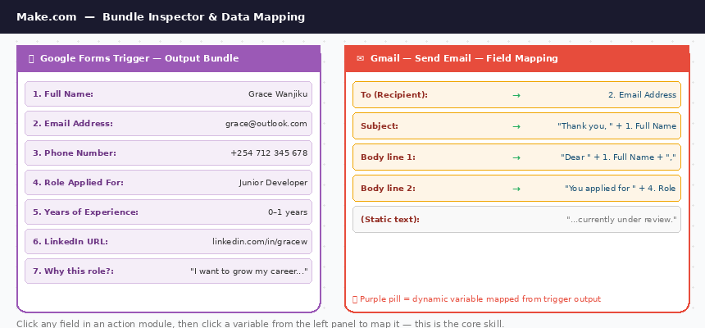
Fig 3.1 — Data Mapping: the left panel shows the trigger's output bundle; the right panel shows how fields are mapped into Gmail
📌 Mapping in Practice
In the Gmail 'Send an Email' module:• To: map the 'Email' field from the Google Forms trigger• Subject: type 'Welcome,' then map the 'Name' field - result: 'Welcome, Sarah!'• Body: write your template, inserting mapped fields where personalisation is neededEvery recipient gets a personalised email with zero manual effort.

3.4 Practical Multi-Step Scenario Architecture
Module # | App | Module Type | What It Does | Data It Produces
1 | Google Forms | Trigger: Watch Responses | Fires when a lead submits the intake form | Name, Email, Company, Need
2 | Make.com Tools | Action: Set Variable | Formats the lead's full name and timestamps the submission | formatted_name, submission_time
3 | Google Sheets | Action: Add a Row | Logs the lead and their details into the CRM sheet | Row ID (can be used downstream)
4 | Gmail | Action: Send an Email | Sends a personalised welcome email to the lead | Email delivery confirmation
5 | Slack / Gmail | Action: Send a Message | Alerts the sales team with lead details | Notification sent

4. Error Handling in Automation

4.1 Why Errors Happen - and Why They Matter
Automated workflows fail. This is not a question of if - it is a question of when. Understanding error types and building resilient systems is what separates amateur automations from professional, production-grade workflows.

⚠️ The Cost of Unhandled Errors
An unhandled error in automation can mean: a customer receives no confirmation email, a lead disappears from the CRM, or a billing system charges the wrong amount. The cost of a bad automation failure can exceed the cost of doing it manually.

4.2 The Five Most Common Automation Error Types
Error Type | What Causes It | Real Example | Severity
Missing Data | A required field is empty in the incoming data bundle | A form submission with no email address - the Gmail module cannot send | 🔴 High
Authentication Failure | The connection to an app expires or the password changes | Google account re-authentication required - scenario stops silently | 🔴 High
API Rate Limit | Too many requests sent to an API in a short period | Sending 500 emails in 60 seconds exceeds Gmail's rate limit | 🟡 Medium
Data Format Mismatch | Data arrives in a format the module does not expect | A date arrives as '13/04/2026' but the module expects 'YYYY-MM-DD' | 🟡 Medium
External Service Downtime | A third-party app is temporarily unavailable | Notion's API is down for maintenance - the 'Create Page' module fails | 🟠 Variable

4.3 Make.com's Error Handling Tools
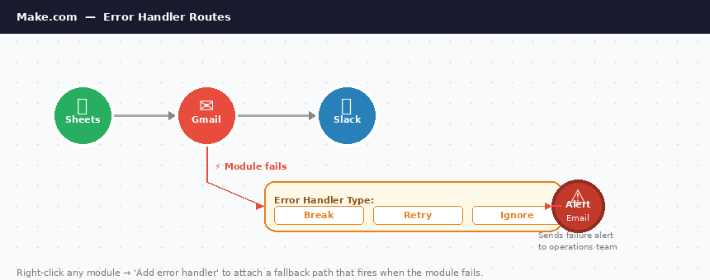
Fig 4.1 — Error Handler attached to the Gmail module: if delivery fails, an alert fires to the operations team

Error Handler Routes
Right-click any module in Make.com and select 'Add error handler'. This attaches a separate branch to that module. If the module fails, execution passes to your error handler instead of stopping.

Error Handler Type | Behaviour | Best Used When
Ignore | Skips the failed module and continues the scenario | The step is non-critical - failure is acceptable
Commit | Saves everything processed so far and stops gracefully | You want to preserve partial progress without retrying
Retry | Attempts the failed module again up to 5 times | Temporary external failures like API timeouts
Rollback | Reverses all actions in the current execution | Financial or compliance workflows where partial execution is dangerous
Resume | Continues from a specified module, bypassing the failure | You have a fallback path for the specific failure
Break | Marks the execution as incomplete for manual review | Critical failures that require human intervention

4.4 Building a Professional Error Notification System
Best Practice - The Error Alert Module
Attach a Gmail or Slack module to every critical module's error handler. When the module fails, the error handler fires and sends you an alert containing:• Which module failed• What data it was processing• The exact error message• A timestampThis creates an automatic operations alert system with no extra cost.

4.5 Real-World Use Case: HR Onboarding Error Handling

The Problem
An HR team uses an onboarding form to collect new employee data. When the form is submitted with a missing field (e.g., the employee forgets to enter their department), the automation breaks — no contract is generated, no system account is created, and the HR team has no idea anything went wrong.

The Error-Proof Solution
- Filter module after the trigger checks: Is the 'Department' field empty? If yes, route to the error path.
- Error path fires a Gmail notification to HR: 'Incomplete onboarding form received from [Name]. Department field missing. Please follow up.'
- A Google Sheets row is still created, but with an 'INCOMPLETE' status flag in column A.
- The main workflow only continues if all required fields are present.
- HR reviews the incomplete submissions log weekly and follows up.

The Key Insight
The automation did not 'fail' - it handled the failure gracefully, created a record, and triggered a human to intervene. This is the difference between a fragile automation and a resilient one.

5. Data Validation Techniques

5.1 Why Data Validation is Non-Negotiable
Garbage in, garbage out. If bad data enters your automation, every downstream step processes that bad data - and bad outputs are the result. In business automations, bad data does not just produce wrong reports - it can trigger emails to wrong addresses, create duplicate CRM records, or charge a customer the wrong amount.

📌 Real Cost of Missing Validation
A subscription business triggers billing automation when a customer completes a signup form. If there is no validation and a test submission with a fake email and missing postcode enters the system, the billing module attempts to charge a non-existent card. The failed charge creates a negative mark in the payment processor's system and wastes developer time investigating.

5.2 The Three Layers of Data Validation

Layer 1 - Form-Level Validation (Before Data Reaches Make.com)
The best time to catch bad data is before it ever enters your automation. Configure validation rules directly in your form tool:
- Mark all critical fields as Required - users cannot submit without them
- Use field type enforcement: email fields only accept valid email format, number fields reject letters
- Set character limits to prevent absurdly long or suspiciously short inputs
- Use dropdown menus instead of free-text fields wherever choices are known in advance

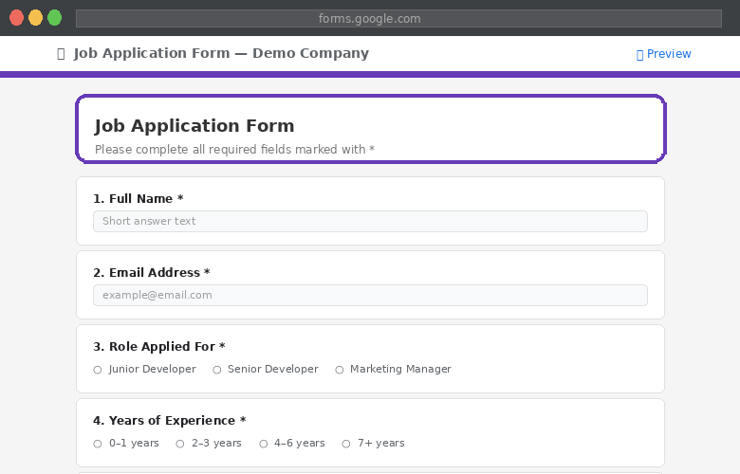
Fig 5.1 — Google Forms Builder: required fields marked with *, multiple-choice options prevent free-text errors

Layer 2 - Filter Modules in Make.com (Gateway Validation)
A Filter module sits between two modules and only allows the workflow to continue if specified conditions are met. If the condition fails, that bundle is simply skipped - no error, no crash.

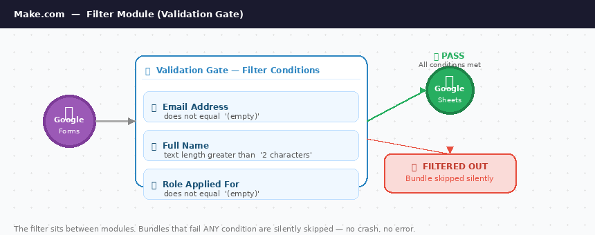
Fig 5.2 — Make.com Filter: three conditions must ALL be met for the workflow to continue. Failed bundles are silently skipped.
Validation Rule | Filter Condition | What It Catches
Email must be present | Email address does not equal empty | Submissions with no email field
Email must be valid format | Email address matches pattern *@*.* | Typos like 'janeATgmail.com'
Name must be realistic | Name length greater than 1 | Test submissions like 'a' or 'test'
Phone must be numeric | Phone number matches \d{10,15} | Phone fields filled with text or symbols
No test submissions | Email does not contain 'test' or 'example.com' | Developer test data polluting live CRM

Layer 3 - Data Transformation Modules (Clean Before Use)
Even valid data may need to be cleaned and standardised before use. Make.com provides built-in functions for data transformation:
- trim() - removes leading and trailing spaces from text fields
- lower() / upper() - normalises email addresses and names to consistent case
- formatDate() - converts date formats to match what the target system expects
- replaceAll() - strips unwanted characters like extra spaces or special symbols
- parseNumber() - converts text that looks like a number into an actual number

5.3 Real-World Use Case: Subscription Business Billing Validation
Gate | Checks Applied | If Check Fails
Gate 1: Identity | Email present + valid format. Full name present, length > 2. No test/dummy email domains. | Log to 'Rejected Signups' sheet. Send re-registration email to user.
Gate 2: Plan | Plan selected matches allowed values. Billing cycle is 'monthly' or 'annual'. Promo code valid. | Route to 'Invalid Plan' error path. Alert billing team for manual review.
Gate 3: Payment | Country code is valid ISO format. Postcode/ZIP present if required. Phone matches E.164. | Send user a 'Please complete your details' email with specific field guidance.
Transform | Trim whitespace. Lowercase email. Format phone. Capitalise name. | Runs silently - transforms data before passing to Stripe
Billing (Stripe) | Charge customer and create subscription | Full Make.com error handler - Slack alert to billing team if Stripe returns error

6. Testing and Debugging Automation Systems in Make.com

6.1 The Testing Mindset
Never assume an automation works because you built it correctly. Test every scenario with real-world data — including edge cases and intentionally bad data — before going live. A scenario that works with perfect data but breaks on messy real-world input is not ready for production.

6.2 Make.com's Built-In Testing Tools
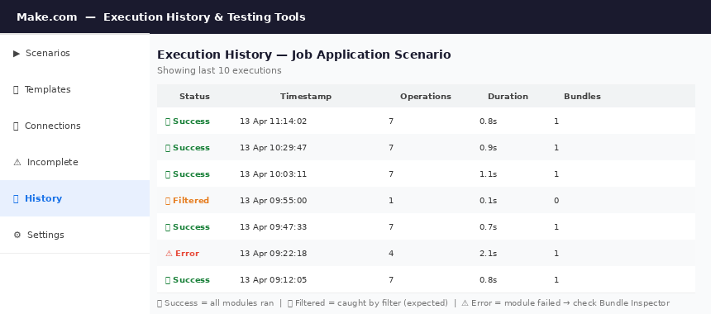
Fig 6.1 — Execution History panel: every run is logged with status, timestamp, operations used, and bundles processed
Tool | How to Access | What It Does
Run Once | Purple 'Run once' button (bottom left) | Executes the scenario one time using new data - ideal for step-by-step testing
Run This Module Only | Right-click any module → 'Run this module only' | Tests a single module in isolation without running the full scenario
Execution History | Scenario page → 'History' tab | Full log of all past executions - successes, errors, and data processed
Bundle Inspector | Click any module bubble after a run | Shows exactly what data entered and exited that module - essential for debugging
Incomplete Executions | Left menu → 'Incomplete Executions' | List of all failed runs with their data - can be re-run once the issue is fixed

6.3 The 5-Stage Testing Protocol
Stage | Test | What to Verify
Stage 1: Module Test | Right-click trigger → 'Run this module only' | Does it connect and retrieve test data correctly?
Stage 2: Step Test | Run once after adding each new module | Does data map correctly into this module's fields?
Stage 3: Happy-Path Test | Submit a complete, correct test form and run once | Do all modules execute? Does output match expectation?
Stage 4: Edge Case Tests | Submit forms with missing fields, invalid emails, unusual characters | Do filters catch bad data? Do error handlers fire?
Stage 5: Load Test | Submit 5–10 test submissions in quick succession | Does the scenario handle multiple bundles without conflict?

6.4 Debugging Workflow - When Something Goes Wrong
- Check the Bundle Inspector on the failed module - what data arrived? Was a field empty or in the wrong format?
- Check Execution History - is this a one-time failure or consistent? What error message is shown?
- Check the connection - has the app's authentication expired? Re-authenticate and re-test.
- Isolate the module - use 'Run this module only' with fresh test data to determine if the module is the problem.
- Check for API rate limits - if running many executions, the external service may have throttled requests.
- Simplify to find the breakpoint - temporarily remove modules until the scenario works, then add them back one at a time.

Pro Debugging Tip
Add a Google Sheets 'Add a Row' module as your very first action after the trigger - log the raw incoming data to a 'Debug Sheet'. This creates a permanent record of everything the trigger received, making it easy to identify whether a problem is in the trigger (bad input data) or in a downstream module (processing failure).

7. Real-World Use Cases

7.1 Marketing Agency: Automated Lead Assignment & Onboarding

Business Context
A digital marketing agency receives 40–60 new client lead enquiries per week. Previously, the owner manually read each submission, decided which account manager to assign, emailed the client a welcome message, and created a project folder — a process taking 20–30 minutes per lead.

Step | Module | Logic
1 | Typeform Trigger: Watch Responses | Fires instantly when the enquiry form is submitted
2 | Make.com Router | Branches based on 'Service Required': SEO → Account Manager A; Paid Ads → B; Social Media → C
3 | Google Sheets: Add a Row | Logs lead details to the CRM sheet with assigned manager and 'New' status
4 | Gmail: Send an Email (to lead) | Sends personalised welcome email naming their assigned account manager
5 | Gmail: Send an Email (to manager) | Alerts account manager with full lead details and direct reply link
6 | Google Drive: Create Folder | Creates a named client folder in the correct team's directory
7 | Slack: Post a Message | Posts lead summary to #new-leads channel for team visibility

Before Automation | After Automation
20–30 minutes per lead manual process | Under 90 seconds - fully automated
Leads occasionally missed during busy periods | Zero leads missed - 100% logged and assigned
Welcome email quality varied by person | Consistent, professional welcome every time
No central visibility of lead pipeline | Real-time Sheets dashboard and Slack feed

7.2 HR Team: Handling Errors in Onboarding Workflows

Business Context
A 200-person company's HR team processes 15–20 new employee onboarding forms per month. Incomplete forms were causing delayed system access, wrong contracts being generated, and IT equipment misorders.

- Google Forms trigger fires when a new onboarding form is submitted.
- Filter: All five required fields present? IF NO - route to error path below.
- Error path: Gmail alert to HR with incomplete submission details. Google Sheets row created with 'INCOMPLETE - NEEDS REVIEW' status.
- IF YES - pass to main path. Data transformation module formats name, normalises department to standard values.
- Google Sheets: Add a row to the Onboarding Tracker with 'IN PROGRESS' status.
- Gmail: Send welcome email to new employee with their start date, manager name, and IT setup instructions.
- Gmail: Send IT notification with equipment requirements.
- Notion: Create onboarding checklist page for the new employee.

📌 Key Design Decision
The automation never crashes - it always produces an output. Either the happy path completes successfully, or the error path logs the issue and alerts a human. There is no silent failure.

7.3 Subscription Business: Pre-Billing Data Validation

Business Context
A subscription software company processes 300–400 new signups per month. Without validation, approximately 5% of signups contained data errors that caused billing failures - enough to generate significant lost revenue and customer support costs each month.

Gate | Checks Applied | If Check Fails
Gate 1: Identity Validation | Email present + valid format. Full name present, length > 2. No test/dummy email domains. | Log to 'Rejected Signups' sheet. Send re-registration email to user.
Gate 2: Plan Validation | Plan selected matches allowed values. Billing cycle is 'monthly' or 'annual'. Promo code valid. | Route to 'Invalid Plan' error path. Alert billing team for manual review.
Gate 3: Payment Readiness | Country code is valid ISO format. Postcode/ZIP present if required. Phone number matches E.164. | Send user a 'Please complete your details' email with specific field guidance.
Transformation Layer | Trim whitespace. Lowercase email. Format phone. Capitalise name. | Runs silently - transforms data before passing to Stripe
Billing Module (Stripe) | Charge customer and create subscription | Full Make.com error handler - Slack alert to billing team if Stripe returns error

8. In-Class Demo: Job Application Processing System
A Complete, Production-Grade Automation - Built Live in Class

8.1 Scenario Overview
We will build a complete job application processing system that a real HR team or recruitment agency could deploy today. This demo covers every concept from Module 2 - triggers, multi-step actions, a router, a filter for data validation, an error handling path, and a manager notification system.

What Students Will See Built Live
A single automation that:1. Captures a job application from a Google Form2. Validates the submitted data before processing3. Routes the applicant to the correct hiring manager based on role applied for4. Logs the application to a Google Sheets tracker5. Sends the applicant a personalised acknowledgement email6. Alerts the hiring manager with applicant details7. Handles errors gracefully - flagging incomplete submissions to HR without crashing

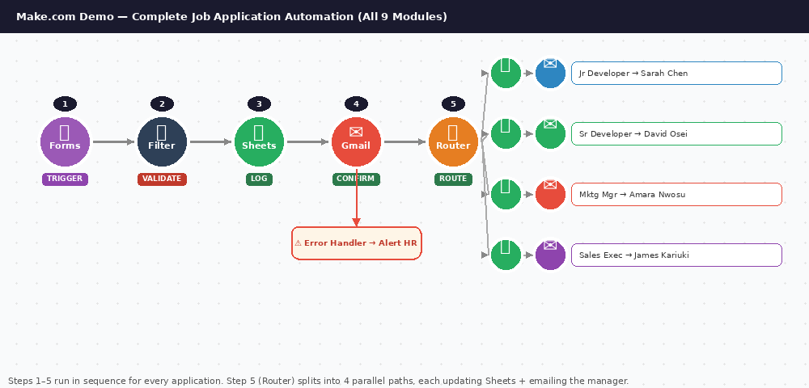
Fig 8.1 — The complete demo scenario: 9 modules, 1 filter, 1 router with 4 paths, and 1 error handler — all built live

8.2 Phase 1: Build the Form and Sheet (10 minutes)

Step 1 - Create the Google Form
Go to forms.google.com and create a new form titled: Job Application Form - [Your Company Name]


Fig 8.2 — The Google Form students will build: 7 questions including multiple-choice role selection
Question # | Field Name | Type | Required? | Notes
1 | Full Name | Short answer | Yes
2 | Email Address | Short answer | Yes
3 | Phone Number | Short answer | Yes
4 | Role Applied For | Multiple choice | Yes | Options: Junior Developer, Senior Developer, Marketing Manager, Sales Executive
5 | Years of Experience | Multiple choice | Yes | Options: 0–1 years, 2–3 years, 4–6 years, 7+ years
6 | LinkedIn Profile URL | Short answer | No | Optional - used to enrich the application record
7 | Why do you want this role? | Paragraph | Yes | Gives Make.com rich text to pass to the hiring manager

Step 2 - Link the Form to Google Sheets
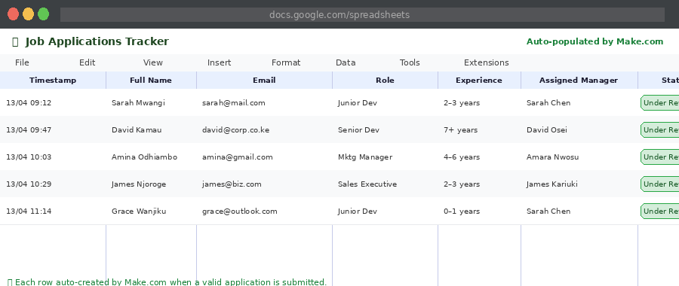
Fig 8.3 — The Google Sheets tracker after linking: each row auto-populated by Make.com per submission
- Click the Responses tab in your form.
- Click the green Google Sheets button.
- Choose 'Create a new spreadsheet' - name it: Job Applications Tracker.
- Open the sheet. Add two additional columns manually: G = Assigned Manager, H = Status.
- Your sheet now has: Timestamp, Full Name, Email, Phone, Role, Experience, LinkedIn, Why This Role, Assigned Manager, Status.

8.3 Phase 2: Build the Make.com Scenario (35 minutes)

Step 3 - Trigger: Google Forms Watch Responses
- In Make.com, create a new scenario.
- Add module: Google Forms → Watch Responses.
- Connect your Google account and select your Job Application Form.
- Run this module only, then submit a test application through the form preview.
- Confirm the bundle inspector shows all 7 fields of your test submission.

Step 4 - Validation Filter
We will add a Filter to ensure no incomplete applications reach the processing pipeline.


Fig 8.4 — The Validation Gate filter: 3 AND conditions must all pass before the workflow continues
- Add a Filter between the trigger and the next module (click the dotted connector).
- Label the filter: 'Validation Gate'.
- Add Condition 1: Email Address - Does not equal - (empty). Click AND.
- Add Condition 2: Full Name - Text length greater than - 2. Click AND.
- Add Condition 3: Role Applied For - Does not equal - (empty).
- Now, only applications with a name, email, and role selected will pass through.

DEMO MOMENT - Intentional Failure Test
After building the filter, submit a test form with the Email field left blank. Run the scenario. Show students that the bundle is stopped at the filter - the scenario receives the data but does not process it. This is safe, silent rejection, not a crash.

Step 5 - Google Sheets: Log the Application
- Add module: Google Sheets → Add a Row.
- Select your Job Applications Tracker sheet, tab 'Form Responses 1'.
- Map the fields: Timestamp → formatDate(now, 'DD/MM/YYYY HH:mm'), Full Name → Name field, Email → Email field, Phone → Phone field, Role → Role field, Experience → Experience field, LinkedIn → LinkedIn field, Why This Role → Paragraph field.
- For column G (Assigned Manager) - leave blank for now; the router in the next step will handle this.
- For column H (Status) - type the static text: Under Review.

Step 6 - Router: Assign to the Correct Hiring Manager
Now we add the Router to split the workflow based on which role was applied for.


Fig 8.5 — The Router module with 4 paths: each path checks the 'Role Applied For' field and routes to the correct manager
- Add module: Router (found under Flow Control).
- The router creates two paths by default. We need four. Click the + on the router to add more paths.

Router Path | Filter Condition | Assigned Manager | Manager Email
Path 1 | Role Applied For = Junior Developer | Sarah Chen - Tech Lead | sarah.chen@company.com (use your own test email)
Path 2 | Role Applied For = Senior Developer | David Osei - CTO | david@company.com
Path 3 | Role Applied For = Marketing Manager | Amara Nwosu - Marketing Director | amara@company.com
Path 4 | Role Applied For = Sales Executive | James Kariuki - Sales Director | james@company.com

On each router path, add the following two modules:
- Google Sheets: Update a Row - update the Assigned Manager column for this application's row
- Gmail: Send an Email - send the manager their alert (covered in Step 8)

Step 7 - Gmail: Applicant Acknowledgement Email
Before the router, add a Gmail module to send the applicant their confirmation. This fires for every valid application regardless of which role they applied for.


Fig 8.6 — Data Mapping for the Gmail module: the applicant's name and role are mapped dynamically into the email subject and body
- Add module: Gmail → Send an Email (after Google Sheets, before Router).
- To: map the Email field from the trigger.
- Subject: Thank you for your application, [Full Name]
- Content Type: HTML
Email body to use:

Dear [Full Name],
Thank you for applying for the [Role Applied For] position at [Company Name].
We have received your application and it is currently under review. Our hiring team will be in touch within 5 business days.
Best regards,The Talent Acquisition Team

Step 8 - Gmail: Hiring Manager Alert (On Each Router Path)
- To: the assigned manager's email (hardcoded per path - this is intentional; each path has a different manager).
- Subject: New Application - [Role Applied For] - [Full Name]
- Body: Include Full Name, Email, Phone, Years of Experience, LinkedIn URL (if provided), and their Why This Role response.

📌 DEMO MOMENT - Show the Power of Mapping
In the manager email body, map the 'Why do you want this role?' paragraph field. Show students that a 200-word personalised response from the applicant automatically appears in the manager's email - zero copy-paste, zero manual effort.

Step 9 - Add Error Handling to the Gmail Module

Fig 8.7 — Error handler on the Gmail module: if email delivery fails, a 'Break' handler stores the bundle and fires an HR alert
- Right-click the applicant confirmation Gmail module.
- Select 'Add error handler'.
- Choose the 'Break' handler type - this stores the failed bundle in Incomplete Executions.
- Add a second Gmail module inside the error handler: send an alert to the HR team email.
- Subject: Automation Error - Application Email Failed Delivery
- Body: Include the applicant's name, email address, role applied for, and the error timestamp.

8.4 Phase 3: Test and Activate (10 minutes)

Step 10 - The Complete Testing Protocol
Test # | What to Submit | What to Verify
Test 1-Happy Path | Complete, valid application for 'Junior Developer' | All modules fire. Sheet row created. Applicant email received. Sarah Chen notified.
Test 2 - Different Route | Complete, valid application for 'Marketing Manager' | Router correctly routes to Path 3. Amara Nwosu notified. Not Sarah.
Test 3 - Missing Email | Form submitted with Email field blank | Filter catches it. No modules fire. No email sent. Scenario does not crash.
Test 4 - Missing Name | Form submitted with Name field blank | Filter catches it. Same outcome as Test 3.
Test 5 - Rapid Submissions | Submit 3 applications in quick succession | All 3 appear in Sheets. All 3 receive emails. No conflicts or missed bundles.

Step 11 - Activate the Scenario
- Click the toggle at the bottom left of the Make.com scenario editor.
- Change the scheduling from manual to 'Immediately' (if using Google Forms webhook) or 'Every 15 minutes'.
- Save the scenario.
- Submit one final live test and watch it execute automatically - without pressing Run Once.

🎉 The Machine is Live
From this moment, every job application submitted through the Google Form will be automatically validated, logged, routed to the correct hiring manager, and acknowledged to the applicant - completely hands-free, 24 hours a day, 7 days a week.

8.5 Extension Challenges (For Advanced Students)
Challenge | What to Build | Concepts Practised
Auto-Rejection Filter | If Years of Experience = '0–1 years' AND Role = 'Senior Developer', send a polite rejection email and do not notify the manager. | Conditional logic · Router paths · Automated communication
Duplicate Detection | Before adding to Sheets, search for existing rows with the same email address. If found, send a 'We already have your application' email. | Search module · Conditional routing · Data lookup
Application Counter Dashboard | Create a separate Sheets tab tracking: total applications this week, applications per role, applications assigned to each manager. | Aggregation · Multi-tab Sheets · Dashboard design
Scheduled Weekly Digest | Build a second scenario running every Monday at 9:00am, reads all 'Under Review' rows, and emails the HR Director a summary. | Scheduled triggers · Iterators · Aggregators

Appendix: Key Terms - Module 2
Term | Definition | Context
Scenario | A complete automation in Make.com - the full chain of connected modules | The entire workflow from trigger to final action
Bundle | One unit of data flowing through a scenario (e.g., one form submission) | Each form response creates one bundle
Router | A module that splits one workflow into multiple conditional paths | Route VIP clients to one path, standard to another
Filter | A condition that must be met for the workflow to continue | Only continue if email is not empty
Iterator | Loops through a list and processes each item individually | Process each product in an order separately
Aggregator | Combines multiple bundles into a single output | Build a summary from multiple data records
Webhook | A URL that receives instant data from an external app | Instant trigger without polling delay
Error Handler | A module branch that fires when a module fails | Log errors, alert team, retry or gracefully stop
Incomplete Execution | A failed run stored for manual review and retry | Re-run failed scenarios after fixing the cause
Data Validation | Checking incoming data is complete and correctly formatted before processing | Catch missing emails before billing automation
Data Transformation | Cleaning, formatting, or reshaping data mid-flow | Trim whitespace, format dates, normalise text
Mapping | Linking a variable from one module as input to another module | Map the email field from trigger to Gmail 'To' field
Rate Limit | A cap on how many API requests can be made in a given time period | Gmail limits bulk sending to prevent spam
Happy Path | The test case where all inputs are correct and all modules succeed | Always test this first - then test failure cases
Production | A live, active automation running on real business data | Contrast with testing/staging environments

