Restful Objects

Draft v0.58

Restful Objects defines a set of RESTful resources, and corresponding representations, for accessing and manipulating a domain object model.
The most up-to-date version of this specification may be downloaded from www.restfulobjects.org where you will also find details of known implementations, and other useful information.

Dan Haywood

licensed under:
Creative Commons Attribution-ShareAlike 3.0
http://creativecommons.org/licenses/by-sa/3.0/
Table of Contents
A Concepts and Building Blocks A-1
1 Introduction A-3
2 Concepts A-9
3 Optional Capabilities A-32
4 Specified Elements A-43
B Supporting Resources and Representations B-47
5 Home Page Resource & Representation B-49
6 User Resource & Representation B-53
7 Domain Services Resource B-57
8 Version Resource & Representation B-59
9 Objects Resource B-63
10 Error Representation B-67
11 List Representation B-69
12 Scalar Value Representation B-71
C Domain Object Resources & Representations C-73
13 Response Scenarios C-75
14 Domain Object Resource & Representation C-83
15 Domain Service Resource C-99
16 Object Property Resource & Representation C-101
17 Object Collection Resource & Representation C-109
18 Object Action Resource & Representation C-117
19 Object Action Invoke Resource C-125
D Domain Type Resources D-135
20 Domain Types Resource D-137
21 Domain Type Resource D-141
22 Domain Property Description Resource D-147
23 Domain Collection Description Resource D-151
24 Domain Action Description Resource D-155
25 Domain Action Parameter Description Resource D-159
26 Domain Type Action Invoke Resource D-163
E Patterns and Practices E-171
27 HATEOAS vs Web APIs E-173
28 Personal vs Shared State E-175
29 Client vs Server Evolution E-179
30 FAQs E-183

Table of Figures
Figure 1: Resources and Representations A-9
Figure 2: Domain Objects vs Domain Types A-35
Figure 3: Home Page Representation B-50
Figure 4: User Representation B-54
Figure 4: Services Representation B-58
Figure 5: Version Representation B-60
Figure 6: Domain Object Representation C-86
Figure 7: Transient Domain Object Representation C-94
Figure 8: Object Property Representation C-104
Figure 9: Object Collection Representation C-112
Figure 10: Object Action Representation C-118
Figure 11: Action Result for Object C-129
Figure 12: Action Result for List C-130
Figure 13: Action Result for Scalar C-132
Figure 14: Action Result for Void C-133
Figure 15: Domain Type List Representation D-138
Figure 16: Domain Type Representation D-143
Figure 17: Domain Property Collection Representation D-148
Figure 18: Domain Collection Description Representation D-152
Figure 19: Domain Action Description Representation D-156
Figure 20: Domain Action Parameter Description Representation D-160
Figure 21: Domain Type Action Representation D-164

Concepts
and
Building Blocks

Introduction
Restful Objects defines a set of RESTful resources by which a client application can interact with a domain model on a server using HTTP. These resources generate JSON representations along with corresponding media types.
This chapter discusses further the goals and approach taken by the spec.

Goals
The goal of Restful Objects is to allow domain models to be accessed through HTTP resources, returning a set of JSON representations. These representations can then be consumed by any client (eg Javascript, Java, .NET, Ruby, Python).
Both the resources and representations are generalized so that they can be applied to any domain model, and by default all representations have media types designed to allow clients to be written fully generically. Such clients would be similar to a web browser that can consume any HTML.
Alternatively, the developer may write custom clients that have some shared knowledge of the domain being exposed, and render the information in a more specific fashion. The analogy here is a screen-scraping application that looks for certain fragments of HTML in order to create a mash-up.
Restful Objects also allows representations to be served up with application-defined media types, rather than its default media types. This allows clients to use content negotiation to ensure that representations do not change in a breaking fashion, enabling server and client to evolve independently. Application-defined media types can be specified only where they are required.
The Restful Objects specification is at a higher-level of abstraction than, say, the JAX-RS specifications for Java platform, or the WCF specifications on .NET. Specifically, the domain classes that it exposes as resources are thought of in similar terms to UML, in that they consist of:
- properties (fields), each holding either a scalar value or reference to another object;
- collections, each holding a vector reference to another entity type;
- actions (operations/methods), whereby the object can execute business logic.
Beyond this, though, Restful Objects makes very few assumptions. In particular, Restful Objects does not prescribe the nature of the resources.

A Uniform Interface
Restful Objects defines a uniform interface to the domain objects. This uniformity is expressed in terms of:
- the standard HTTP methods used (GET, POST, PUT, DELETE) to call these URLs;
- the standard HTTP headers supported for both request and response;
- the use of standard HTTP status return codes;
- the format of URLs used to access the domain object resources (though URLs can also be treated as opaque);
- support for Accept headers and either generic media types (application/json;profile=http://restfulobjects/profiles/xxx) or application-defined media types (e.g. application/json;profile=urn:com.mycompany.myapp.v2.PlaceOrderCommand);
- standard properties within JSON representations;
- a standard representation of links between resources;
- a small number of reserved query parameter names to influence behaviour (eg validation, paging, sorting).
Where possible, existing HTTP standards and supporting W3C standards have been used.

Benefits
Because the spec defines a generalized binding for any domain model, it allows the project team to focus on developing the domain model rather than worrying about the intricacies of following a RESTful style. For example, the debate becomes about whether an action is idempotent, not whether to use HTTP PUT or HTTP POST. And debates about URI structure (should it be customers/{custId}/invoices or should it be invoices/for/{custId}?) disappear because the URL is determined by the responsibilities of the underlying domain objects.
There are also benefits when testing. Since all business logic is expressed only in domain classes, that business logic may be tested using fast and cheap in-memory unit tests. In contrast, if the RESTful API is tailored and tuned to specific use cases, then it can only really be tested through slower integration tests running across a webserver.
More pragmatically, Restful Objects eliminates the need for the project team to explicitly document the rest API, because consumers can infer the structure either directly from the underlying domain classes, or by querying the domain metamodel resources §D.
Furthermore, because Restful Objects defines a generalized binding, it also allows for frameworks to be developed that implement the spec (analogous to how ORMs are able to persist any domain object model with relevant metadata). A project team adopting such a framework can then focus solely on implementing business logic through domain classes.
And following on from this, because Restful Objects is a specification, a generic Restful client written to work with one framework implementation will also inter-operate across any other implementations.
There is further discussion on how the specification enables the RESTful style (along with an FAQ) in §E, "Patterns and Practices".

Audience
This document is written for several audiences:
- for developers intending to write a bespoke domain-driven system and want a guidance on how to implement the infrastructure in order to expose the domain in a RESTful style
- for developers intending to write a bespoke domain-driven system intended to be hosted on a general-purpose framework implementation of this spec;
- for developers intending to write a generic or custom client against an domain object model exposed using Restful Objects;
- for developers intending to write their own general-purpose framework implementation of the specification.
The specification is only semi-formal; examples of representations are provided rather than formal grammars. The hope is that this makes the specification accessible to all its target audiences.

Authorship and License
The original idea for this specification and primary author is Dan Haywood. Substantial contributions have been made by Richard Pawson and Stef Cascarini.
The specification is licensed under Creative Commons Attribution Share-Alike 3.0 (the same license as Wikipedia). As such the document may be shared and adapted. However, any derivative work must be attributed back to the author of this document, and must be licensed under the same license to this one.

Style Conventions
Restful Objects defines that URLs, when generated in resources, are absolute. Because the hostname is likely to be a long string and in any case will vary, in the spec it is shown by a ‘~’ placeholder:
http://~/
Similarly, some URLs also use fully qualified class names. In a Java implementation, this would be a string such as com.mycompany.myapp.Customer, while on .NET this might instead be MyCompany.MyApp.Customer. Again, this has been shown by an "x" placeholder: x.Customer.
There are two important concepts in the spec that both have the name "property": the domain object property, and a property within a JSON representation (the key value of a JSON map). Where there is any possibility of confusion we refer to the latter as a “json-property”.

Change History
Version | Description
v0.10 ~ v0.31 | Internal revisions
v0.40 | DH: made ready for wider review
v0.41 | Removed change history prior to v0.40; updated table formatting
v0.42 | - replaced 403 (forbidden) with 401 (not authorized)  Following feedback from REST community:  - Additional discussion on the goals of the spec, plus FAQ  - Removed custom X-Representation-Type response header, instead use application/vnd.ro-xxx+json media type (based on Accept header);  - removed other custom request headers (X-Follow-Links, X-Validate-Only, X-Sort-By, X-Page, X-Page-Size) and instead defined standard query params (x-ro-follow-links, x-ro-validate-only etc)  - added "next" and "previous" links for list representation so that paging is performed in a standard fashion  - changed validation failure to return 400 rather than 412  - specify use of ETags for concurrency control rather than Last-Modified (lack of precision of Last-Modified); returns 412 rather than 409  - changed successful validation to return 204 rather than 304
V0.43 | RP: Review of v42 and minor textual corrections only
v0.44 | DH: using "application/json;profile='xxx' instead of different media types for each representation; add type property for links; reorganized sections 2 and 3; combined parts C and D; added Error representation; clarified that link to action/invoke indicates the media type returned (using profile parameter).
v0.45 | DH: Reworked introductory sections in chapter 1.
V0.46 | RP: Review and minor edits for clarification and style only
v0.47 | DH: Rels and profile parameter now both formally defined as URNs
v0.48 | DH: "self", "details" and others are now links rather than json-properties; extended coverage of x-ro-follow-links; moved content from introductory chapter into new "Patterns and Practices" section at end, and expanded its discussion; added diagrams to show links
v0.49 | DH: Introduced actionresult representation, with object, list and scalar representations inlined. Various minor corrections.
v0.50 | DH: void actions also now return an actionresult representation.
v0.51 | DH: domain type member resources renamed (to "property/collection/action description"); added domain type action resource and representation; object put, property put, property delete, collection put, collection post, collection delete all now return representations (being respectively the update object or member).
v0.52 | DH: replaced GET Objects/ resource with GET domainTypes/xxx/typeactions/newTransientInstance/invoke; added isSupertypeOf() type action; added GET domainTypes resource (linked from home page); capabilities now includes an RO spec version; PUT Objects/{oid} and POST Objects/ now accept a cut-down domain object representation, rather than a map of property/values. VersionSpec added to Capabilities representation.
V0.53 | RP: Review of recent changes. Suggesting removal of NewTransientInstance from domain type i.e. require it to be done through actions. I18n section added as placeholder.
v0.54 | DH: Removed NewTransientInstance; introduced transient domain object representation; added format json-property to simple & formal schemes to handle date/date-time value types; error handling clarifications; regex property changed to ‘pattern’
v0.55 | RP: Minor edits & corrections, plus comments.
v0.56 | DH: renamed "capabilities" resource → "version" resource; added parent link to user, services, version, domainTypes resources; removed domainType#newTransientInstance() type action; links in arguments only need specify href; URL encoded argument map passed as entire query string (not as value of an "args" queryparam); more detail on how the Accept header is handled; suppress links[rel=modify] if no properties can be modified; i18n handling described; transient object collections are followed automatically, and may optionally have actions;
V0.57 | RP: Removed comments now addressed, Added small number of new comments and minor edits for style/clarity.
v0.58 | DH: renamed chapter 3 "Extensions" -> "Optional capabilities"; "x-ro-domainType" as a further parameter for media type, similar to "profile"; added "attachments" (a new optional capability); "format" now also defines "blob" and "clob"; added "links" and "extensions" for action params; "parent" -> "up"; minor edits on resource arg representation; fixed discrepancies between 3.1.1 and detail in representations in part C; reconciled simple schemes vs formal schemes, and move "extensions" json-properties in formal scheme to top-level json-props; "x-ro-invalidReason" json-property introduced.

Concepts
This section describes the principal concepts that underpin the Restful Objects spec.

Resources vs. Representations
The following diagram shows the RESTful resources defined by the specification, along with the representations that they generate:
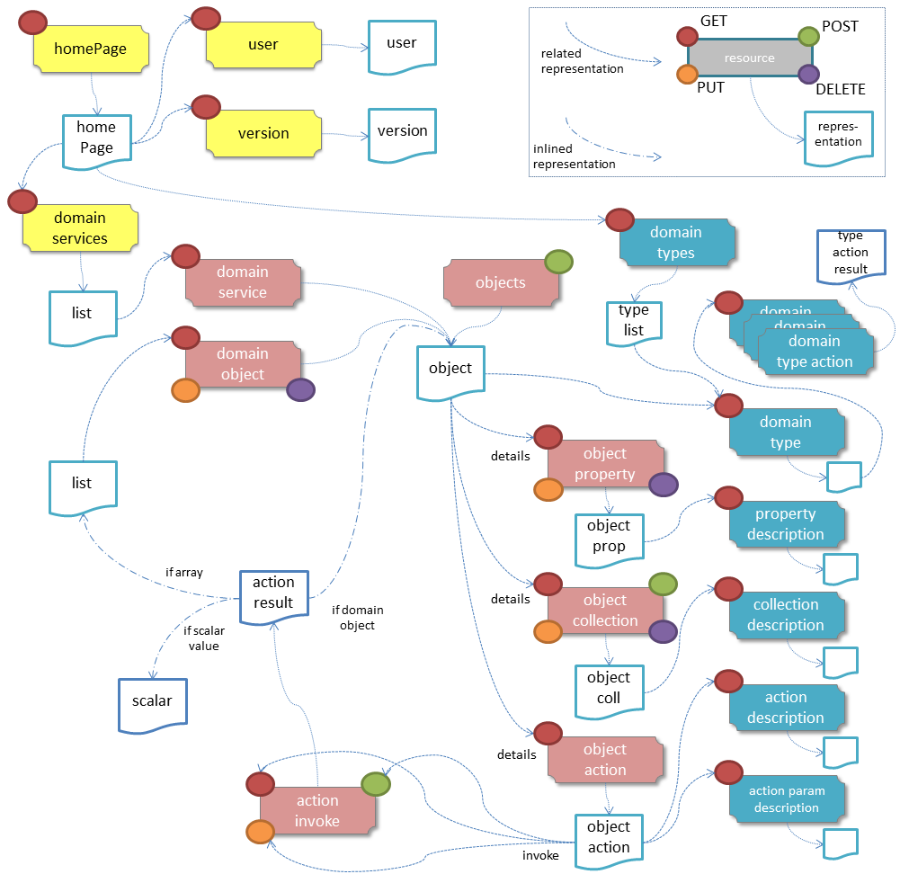
Figure 1: Resources and Representations
In this diagram:
- Each shaded box indicates a resource that can be invoked.
The colour indicates the part of the spec where the resource is defined; yellow is supporting resources §B, pink is domain object resources §C, blue is domain model resources §D;
- The circles on each shaded box indicate the HTTP methods (GET, PUT, POST, DELETE) supported by that resource;
- Most of the resources show a dotted-arrow pointing to a (white) document icon, to indicate the representation generated by the resource.
Many resources generate their own, unique, representation (eg the home page resource, the user resource). However, some representations (most notably the object representation) may be generated by several different resources.
- Text on the arrow from a resource to a representation indicates the HTTP method that generates that representation (the default being GET);
- Dotted arrows from a representation to a resource indicate that the representation contains a link to another resource
Most of the significant GET links are shown; to reduce visual clutter most PUT, DELETE and PUT links are not shown;
- Inlined representations (of object, lists, or scalars within an action result) are shown by a dash-dot-dash line.
Resource Relationships
The home page resource §1 is intended to act as a start page: a well-known location from which a client can start to interact with the server. The representation of this resource provides links to three further resources:
- The user resource §2 represents the currently logged-in user; the returned User Representation provides details such as their user name and roles.
- The version resource §4 provides a mechanism for the client to discover the version of the spec and of the implementation, as well as querying any optional capabilities of the implementation (eg whether it supports automatic pagination of results).
- The domain services resource §3 returns a list representation §7, which contains a link to each domain service resource §3. Since each domain service is actually just a domain object, following the link generates in turn a domain object representation.
The domain object representation §1.53 is arguably the key representation within Restful Objects; from it various sub-resources can be accessed. The most immediate such sub- resources are for:
- each property of the object (§1.53)
- each collection of the object (§1.59), and
- each action of the object (§1.64).
From the (representations of these) sub-resources it is then possible to walk the graph to other domain object resources associated via properties or collections, and/or to modify the contents of properties and collections.
An action on an object may be invoked through its ‘action invoke’ sub-resource (§1.66); the HTTP method to use is dependent on the action's semantics. The representation returned by invoking the action will either be a scalar value §8, a representation of the returned domain object §1.53, or a list §7 (linking to multiple domain object resources §2)
As well as providing access to sub-resources, the domain object resource also allows multiple properties to be updated, and objects to be deleted in a single transaction.
Restful Objects defines two schemes by which implementations can provide domain type information – such as whether a property is mandatory or not – to clients. The "simple" scheme in-lines certain key domain type information directly within the domain object representation. The "formal" scheme, by contrast, defines separate ‘domain type’ resources and corresponding representations, with the domain object representations linking to these domain type resources. There are five such resources (§2, §1.74, §1.76, §1.78, §1.80).
Restful Objects also defines a general mechanism to enable new domain object instances to be created and persisted, through the Objects resource §5.

Domain Object Resources
The following table summarises the resources that relate directly to domain objects.
 | §5  Objects/ | §2  Objects/  {Object} | §1.53  Objects/  {Object}/  Properties/  {Property} | §1.59  Objects/  {Object}/  Collections/  {Collection} | §1.64  Objects/  {Object}  Actions/  {Action} | §1.66  Objects/  {Object}/  Actions/  {Action}/ invoke
GET | create transient instance | object  summary,  member  summary,  property  values | property  details  and value | collection  details  and content | action prompt | invoke (if query only)
PUT | n/a – 405 | update or clear multiple property values | update or  clear value | add object  (if set semantics) | n/a – 405 | invoke (if idempotent)
DELETE | n/a – 405 | delete  object | clear value | remove object | n/a – 405 | n/a – 405
POST | persist transient instance | n/a – 405 | n/a - 405 | add object  (if list semantics) | n/a – 405 | invoke (any)
The columns indicate the domain objects resources shown in the Figure 1, plus the Objects resource §5 used for creating and persisting new object instances. Meanwhile the rows define the HTTP methods used to access these resources.
The HTTP GET method is the most widely supported across the various resources, and is used to obtain a summary representation of an object §1.53 (eg a Customer instance), or detailed information about a specific property of an object §1.59 (eg Customer.firstName) or about a specific collection §1.64 (eg Customer.orders).
In addition, HTTP GET is used to obtain a representation of an object action §1.66, such as the Customer's placeOrder() action. Getting the representation of an action does not invoke the action; rather the returned representation describes the action, providing such information as the arguments required to invoke the action.
Modifying the state of a domain object is performed through resources supporting HTTP PUT, DELETE or POST. The HTTP method to use to request the modification depends upon the resource's semantics:
- if the resource being called is idempotent, meaning that it will change persisted objects but calling that same resource again (with the same inputs) will have no further effect, then either HTTP PUT or HTTP DELETE is used
- if the resource being called is not idempotent, then HTTP POST is used
Whether HTTP PUT or DELETE is used depends on context: if a new data value is being provided then PUT is used, if a value is being cleared or data removed in some way then DELETE is used.
So, properties can be set to a new value using HTTP PUT §1.57, or can be set to null using HTTP DELETE §1.58. Modifying multiple properties is accomplished using an HTTP PUT to the object resource §1.
For collections things are a little more involved because the HTTP method to use depends upon the collection's semantics. The most common situation is where the collection follows ‘set’ semantics (in other words, it does not allow duplicates to be added). In this case the HTTP PUT §1.61 is used; if the object exists then it the request to add it is ignored, so this is idempotent. If the collection does allow duplicates (in other words, it follows ‘list’ semantics) then HTTP POST §1.62 IS USED. In either case references are removed from the collection using HTTP DELETE §1.63.
Finally, for actions the actual invocation of an action is accomplished through the '/invoke’ sub-resource. The method used depends on the action's semantics: if the action is idempotent, then PUT §1.68 is used, otherwise POST §1.69 is used. However, there is a further special case for actions: if the action is query only and so makes no changes to persisted objects at all, then Restful Objects allows HTTP GET §1.67 to be used to invoke the action.
Whether an action is query-only or is idempotent is down to the implementation to determine and to enforce.
Not every HTTP method applies to every resource, and where it does not the specification requires that a 405 ('method not allowed') status code is returned. This will be accompanied by an Allow header to indicate which methods are allowed by the resource.

Example Resource URLs
The following table lists some example URLs for accessing resources:
Resource  Type | Resource
object | http://~/objects/ORD-123
property | http://~/objects/ORD-123/properties/createdOn
collection | http://~/objects/ORD-123/collections/items
action | http://~/objects/ORD-123/actions/placeOrder
action  invocation | http://~/objects/ORD-123/actions/placeOrder/invoke
In the example URLs the "ORD-123" is an object identifier to a persisted instance of a domain object (an Order, in this case). The format of this object identifier is implementation-specific, though that it must be URL-encoded.

Example usage scenario
The following table shows an example of the interactions between a client application and a Restful Objects server, for a simple web-shopping scenario. It is rendered as a sequence of HTTP calls.
Description | Method | URL | Body | Returned repres'n
Go to the home resource | GET | http://~/ | - | Home Page
Follow link to list of Services available | GET | http://~/services | - | List (of links to Services)
Follow link to the ProductRepository service | GET | http://~/services/x.ProductRepository | - | Object
Follow link to ‘Find By Name’ action (to display to user as a dialog) | GET | http://~/services/x.ProductRepository/actions/FindByName | - | Action
Invoke this (query only) action with “cycle” as the parameter | GET | http://~/services/x.ProductRepository/actions/FindByName/invoke/?Name=cycle | - | Action result inlining list of links to Product objects
Follow the link to one of the Product objects in the collection | GET | http://~/objects/object/{x.Product-8071} | - | Object of a Product
Invoke the (zero parameter) action ‘AddToBasket’ on this object | POST | http://~/objects/object/{x.Product-1234}/actions/AddToBasket/invoke | - | -
Invoke the action ‘ViewBasket’ on the BasketService | GET | http://~/services/x.BasketService/actions/FindByName/invoke | - | Action result inlining list of links to Item objects
Modify the Quantity property on the item just added | PUT | http://~/objects/object/{x.Item-1234}/properties/Quantity | Property representation with value=3 | -
Delete a (previously added) item from the Basket | DELETE | http://~/objects/object/{x.Item-55023} | - | -

Media Types (Accept and Content-Type)
Web browsers typically use the media type in order to determine how to render some returned content. For example, text/html indicates an HTML page, while image/png and image/svg are different types of images.
The standard media type for JSON representations is application/json. However, this says nothing about the semantics of that data; it's analogous to returning some XML without indicating the XML schema/DTD that the XML complies with.
Restful Objects therefore uses two media type parameter to provide additional higher-level semantics.

RepresentationType ("profile" parameter)
The representationType is used to indicate the nature of the representation, and is specified as the value of the "profile" parameter . By inspecting the value, the client can dynamically determine how to deal with a representation.
The format of the media type with representation type is therefore:
application/json;profile="urn:org.restfulobjects/xxx"
Every representation defined by the Restful Objects spec has a corresponding representation type:
Representation type | Indicates a representation of
homepage | the start page §1
user | the user requesting the resource §2
version | the version of the spec and implementation §4
list | a list of references to domain objects/services §7
value | a scalar value (as opposed to an entity), for example as inlined within an action invocation's result §1.70
object | a domain object instance (which may represent an entity or a service) §1.53
objectproperty | a domain object property §1.59
objectcollection | a domain object collection §1.64
objectaction | a domain object action §1.66
actionresult | result of invoking a domain object action §1.70
domaintype | a domain type §2
propertydescription | a domain property's description §1.74
collectiondescription | a domain collection's description §1.76
actiondescription | a domain action's description. §1.78
actionparamdescription | an action parameter's description §1.80
typeactionresult | result of invoking a domain type action §7.
error | An error was generated.

Domain Type ("x-ro-domaintype" parameter)
While the "profile" parameter informs the client of the representation type, in the case of an object representation it does not distinguish between, for example, a Customer and an Order.
For clients that would want to handle such representations differently, the spec defines an additional "x-ro-domaintype" parameter. The value of this profile is a URI to the domain type reference (see 1.22, and 2).
For example, the media type for the representation of a Customer would be:
application/json;profile="urn:org.restfulobjects/object";x-ro-domaintype="http://~/types/com.mycompany.myapp.Customer"

Handling of Accept headers
The HTTP protocol defines the Accept request header for the client to specify which media types it can consume; the server then indicates the actual media type using the Content-Type response header. If the server was unable to return the requested type, then it must return a 406 "not acceptable" status return code.
Restful Objects defines the following behaviour:
- if the client omits the "profile" parameter in its Accept header, then the server may serve up any representation. This is the recommended behaviour.
- if the client specifies one or more "profile" parameters, then the server must ensure that the returned representation is one of those that is acceptable. If it is not, then a 406 must be returned.
- the "x-ro-domaintype" parameter, if specified, is always ignored.
If the client does elect to specify profile parameters, then it should take care to always include the error profile. In other words, a request that is expected to return a domain object representation should provide an Accept header of:
Accept:
application/json;profile="urn:org.restfulobjects/object";
application/json;profile="urn:org.restfulobjects/error"
If the error profile is omitted and a (server-side) error occurs, the server may still return the error representation, but must return a 406 (rather than the usual 500 error).
If the client provides an Accept header of either application/* or just */* then these should also all be deemed as acceptable.
Irrespective of what the client provides in its Accept header, the Content-Type will however still indicate the profile.

Browsing the RESTful API
On occasion it can be helpful to informally browse a RESTful API, eg using a browser plugin such as RESTConsole or JSONView. Such plugins provide code such features as folding of the JSON representation, and automatic detection of links in the representation) so that they can be followed (with a GET).
Although designed to consume JSON, some of these tools do not set the Accept header to application/json. In order to accommodate the use of such tools, Restful Objects does not require that application/json be present in the Accept header. Again, the Content-Type returned will be set to application/json along with the profile parameter.

Link representation
Every JSON representation may have relationships to other representations, and this relationship is described through a standard link representation with the format:
{
"id": "abc",
"rel": "xxx",
"href": "http://~/objects/ORD-123",
"type": "application/json;profile=\".../domainobject\"",
"method": "GET",
"title": "xxx",
"arguments": { ... },
"value": { ... }
}
where:
JSON-Property | Description
id | (optional) unique identifier for a link when it appears within a collection of links (§1.15)
rel | A URN indicating the nature of the relationship of the related resource to the resource that generated this representation.
href | the (absolute) address of the related resource. Any characters that are invalid in URLs must be URL encoded.
type | The media type that the representation obtained by following the link will return.
method | the HTTP method to use to traverse the link (GET, POST, PUT or DELETE)
title | (optional) string that the consuming application may use to render the link without necessarily traversing the link in advance
arguments | (optional) map that may be used as the basis for any data (arguments or properties) required to follow the link. Discussed further below.
value | (optional) value that results from traversing the link. This is to support eager loading of links by resources. For example, an Order representation may have a collection of OrderItems, and may want to provide that representation to avoid an additional round-trip request by the client.

"rel"
The "rel" json-property indicates the nature of the relationship of the related resource to the resource that generated this representation. The value of this property is a URN, meaning that it is unique value within a defined namespace (specific to Restful Objects).
The value of the "rel" json-property either takes one of the IANA-specified rel values or a value specific to Restful Objects:
rel | Specified by | Description
self | IANA | "Conveys an identifier for the link's context", in other words, following this link returns the same representation. Discussed further in §1.12.
describedby | IANA | "Refers to a resource providing information about the link's context"; in other words the domain metamodel information about a domain object or object member
help | IANA | "Refers to context-sensitive help"
icon | IANA | "Refers to an icon representing the link's context." A scalable icon for any purpose
icon16 | Restful Objects | A 16x16 pixel icon
icon32 | Restful Objects | A 32x32 pixel icon
up | IANA | Link from member to parent object/type, or from action param to its action
object | Restful Objects | A domain object
service | Restful Objects | A domain service
choice | Restful Objects | A domain object acting as a choice for a property or an action parameter
default | Restful Objects | A domain object acting as a default for a property or an action parameter
details | Restful Objects | Details of a member of a domain object/service
modify | Restful Objects | Modify a domain object property or properties.
clear | Restful Objects | Clear a domain object property
addto | Restful Objects | Add to a domain object collection
removefrom | Restful Objects | Remove from a domain object collection
invoke | Restful Objects | Invoke a domain object action
persist | Restful Objects | Persist a transient object
property | Restful Objects | Linked from domain type to a property
collection | Restful Objects | Linked from domain type to a collection
action | Restful Objects | Linked from domain type to an action
actionparam | Restful Objects | A domain type param, linked from an action
returntype | Restful Objects | The domain type which represents the (return) type of a property, collection, action or param
elementtype | Restful Objects | The domain type which represents the element of a collection
version | Restful Objects | Version of the spec and implementation
user | Restful Objects | The current user
services | Restful Objects | The set of available domain services
domaintypes | Restful Objects | The domain types available in the system.
domaintype | Restful Objects | A domain type.
attachment | Restful Objects | An attachment for a property value; see 1.27.

"type"
The "type" json-property indicates the media type §1.10 of the representation obtained if the link is followed. This will always be "application/json" and may (depending on the implementation §4) have an additional "profile" parameter to further describe the representation; for example:
application/json;profile="urn:org.restfulobjects/domainobject"
To make example more readable, throughout the rest of the spec the "urn:org.restfulobjects" literal within the profile parameter is abbreviated to "…"; the above example is written as:
application/json;profile=".../domainobject"

"arguments"
Sometimes a link represents a resource that requires additional data to be specified. When a representation includes a link to these resources, it may optionally include an "arguments" json-property, for example to provide a default value for an action argument.
Note that the client is not obliged to use this information. The representation of arguments is itself well-defined, see §1.13.

"value"
JSON may be used to represent either a value type (eg String, date, int) or a reference type (eg a link to a Customer, OrderStatus). This is true both for property values and for argument values; collections only ever contain reference types.
For value types, the value that appears in the JSON is the actual string-parseable representation. For example, if the 'createdOn' property is a date, then its value would be represented thus:
{
...
"id": "createdOn",
"memberType": "property",
"value": "2011-06-14",
...
}
For reference properties, the value held is a link. For example, if 'orderStatus' is a property of type OrderStatus, then its representation would be something like:
{
...
"id": "orderStatus",
"memberType": "property",
"value": {
"rel": "object",
"href": "http://~/objects/ORS|IN_PROGRESS",
"type": "application/json;profile=\".../domainobject\"",
"title": "In Progress",
"method": "GET"
},
...
}

"self"
The vast majority of representations include a "self" link, addressing the resource by which the representation may be obtained again.
For example, the following might be the initial part of a representation of an Order:
{
...
"links": [
{
"rel": "self",
"href": "http://~/objects/ORD-123",
"type": "application/json;profile=\".../domainobject\"",
"method": "GET"
},
...
]
}
while the following is the initial part of a Customer's firstName property:
{
...
"links": [
{
"rel": "self",
"href": "http://~/objects/CUS-001/properties/firstName",
"type": "application/json;profile=\".../objectproperty\"",
"method": "GET"
},
...
]
}
In addition, the invocation of a query only action (using GET, §1.67) will also have a "self" link, this time linking back to the action. This allows clients to copy (bookmark) the action link if they so wish.
There are however two sets of representations that do not have a "self" link.
The first set is representations of non-persisted (transient) objects (either created from the objects resource §5 or from an action §7), where there is no server-side resource to address.
The second is representations from non-query action §1.68, §1.69 , to avoid the risk of an end-user bookmarking the link and inadvertently causing side effects in the system.

Resource argument representation
In many cases the resources defined by the Restful Objects spec require additional data, for example representing either action arguments or object properties.
Restful Objects defines two mechanisms for passing in such arguments. The ‘Formal’ mechanism may be used in all circumstances. However, for certain specific situations there is the option to use the “Simple” form, which has the advantage of being simpler to construct and easier for a human to read.

Simple Arguments
If a query only action is being invoked through GET §1.67, and all arguments are scalar values, then the action may be invoked using simple ‘param=value’ arguments.
For example:
GET objects/x.TaskRepository/actions/findTasks?tagged=urgent
However, if the action invoked is not query only (is called using PUT or POST), or if the action takes references to other objects, then this simple form cannot be used.
This form of arguments also cannot be used if providing a set of arguments that represent object properties (if update multiple properties §1.51). For these cases the ‘Formal’ mechanism must be used §1.22.2.

Formal Arguments
Although simple arguments §1.13.1 are convenient to use, their applicability is limited. For all other cases arguments must be provided using a more formal syntax, either as a single argument node, or as a map or argument nodes:
- resources that require a single value (§1.53, §1.59) take a single argument node;
- the action resource methods (§1.64, §1.66) takes a map of argument nodes;
- the update of multiple properties §1.51 also takes a map of argument nodes (the arguments representing the property values)
Treating property values and action arguments in the same way simplifies matters, but it does require that action resources can provide a unique name for each of their arguments (rather than merely by a position, as in a list). For implementations that do not support named parameters, the recommendation is to manufacture one either using existing metadata where available (eg a UI hint), or otherwise to use the type name of the parameter (string, int etc). If the action takes more than one argument of a given type, then the implementation can disambiguate using integer suffixes (string1, string2 and so on).
Note that the representations defined here, although they may look like the body of HTTP requests, apply to all resources, that is, to GET and DELETE as well as to PUT and POST. Section §1.13 explains the mechanics of how the argument structures defined here are passed to the resource.
Incidentally, note that the resources to persist a new object (§5) also takes a map-like structure, though in that case it is based on a cut-down version of the object representation, §1.53).

Argument node structure
The structure of an argument node fulfils a number of inter-related requirements:
- it allows the value for the argument to be specified;
- if any of the argument values supplied are found to be invalid, it allows the same representation to be returned in the response, with an "invalidReason" json-property for those argument(s) that are invalid
- the argument can be omitted from the map to request either:
- that validation should be performed only on those arguments that have been provided, or
- that a representation is generated based on the values of those arguments that have been provided
Note that the client can request validation of a null value by providing an argument node, whose value just happens to be null.
Argument nodes take the following structure:
{
"value": ... ,
"invalidReason": "xxx"
}
where:
JSON-Property | Description
value | is the value of the argument (possibly a link)
invalidReason | (optional) is the reason why the value is invalid.
The "invalidReason" json-property is intended to be populated by the server, not provided by the client. If the client does provide an invalidReason then this will be ignored by the server.
If the "value" is a link to another domain object resource, then only the "href" json-property need be specified; for example:
{
"value": {
"href": "http://~/objects/ABC-123"
}
}

Single value arguments (Property, Collection)
If providing a new value for a property or a collection then a single argument node should be provided.
For example, the following could represent a new value for the "lastName" property of Customer:
{
"value": "Bloggs Smythe"
}
If this value was invalid for some reason, then the server would generate a response:
{
"value": "Bloggs Smythe",
"invalidReason": "Use hyphenated form rather than spaces"
}

Argument maps (Actions, Properties)
Some resources, notably the action resources (§1.64, §1.66) but also the PUT Object resource §1.51 accept arguments only in map form. In the former case the argument nodes are the values of the arguments, in the latter they represent the property values.
For example, suppose an object has an action findProduct(Category category, Subcategory subcategory). Arguments for actions are provided in map form:
{
"category": {
"value": {
"href": "http://~/objects/CGY-BOOK"
}
},
"subcategory": {
"value": {
"href": "http://~/objects/SCG-Fiction"
}
}
}
Similarly, updating multiple properties could be done using the following map:
{
"firstName": {
"value": "Joe"
},
"lastName": {
"value": "Bloggs"
},
"status": {
"value": {
"href": "http://~/objects/STS-NEW"
}
}
}
Only domain object properties that match the json-properties of this map will be updated; json properties that do not match an object property will be ignored.
In both cases, if any of the values provided are invalid, then (again) the returned response will indicate this with an "invalidReason" json-property.
For example:
{
"firstName": {
"value": "Joe"
},
"lastName": {
"value": "Bloggs"
},
"status": {
"value": {
"href": "http://~/objects/STS-NEW"
},
"invalidReason":
"Cannot set customers that have placed orders to 'New' status"
}
}

Validating arguments
The client can also request the validation of arguments; this is done by providing the reserved x-ro-validate-only param (§1.24).
Looking at the example introduced above, where an object has an action findProduct(Category category, Subcategory subcategory).
To validate the category by itself (for example, when the user tabs from the category field in the UI), it would provide only the category argument:
{
"category": {
"value": {
"href": "http://~/objects/CGY-BOOK"
}
},
"x-ro-validate-only": true
}
If the server found that the argument provided was invalid, then it would indicate it in its response using the "invalidReason" json-property:
{
"category": {
"value": {
"href": "http://~/objects/CGY-BOOK"
},
"invalidReason": "renamed to CGY-BOOKS"
}
}

Obtaining argument choices
Continuing with the same example, it's likely that the set of subcategories will depend on the category that's been selected.
Provided that the server implementation supports this optional capability (§1.39), the client can obtain these choices by submitting the following to the GET Action resource (§1.64).
For example:
{
"category": {
"value": {
"href": "http://~/objects/CGY-BOOKS"
}
}
}
Note that this is the same argument structure as the validation example above, but is sent to the action resource §1.64 rather than the action invoke resource §1.66 (and without the x-ro-validate-only request parameter either).
The server will return a representation of the action with the choices list for the subcategory constrained appropriately.

Passing arguments to resources
As noted previously, calling a resource using GET with simple arguments §1.13.1 is straight-forward: the arguments are simply passed as key/value pairs. For example:
GET objects/x.TaskRepository/actions/findTasks?tagged=urgent
Passing formal arguments §1.13.2 through to resources that accept a PUT or a POST is also easy: the arguments' string representation should simply be provided as the body of the request.
However, if formal arguments need to be passed through to a resource using GET and DELETE then matters are slightly more complex, because the HTTP spec does not guarantee that resources called using GET and DELETE will receive a body. Therefore, any query arguments to such resources must be encoded within the URL. In the case of a query argument representing a link, this should be converted to its string form first, and then URL encoded. The result is used as the entire query string.
For example, an argument representation such as:
{
"placedBy": {
"value": {
"ref": "http://~/objects/ABC-123",
}
}
}
can be encoded to:
%7B%0A%20%20%22placedBy%22%3A%20%7B%20%0A%20%20%20%20%22value%22%3A%20%7B%0A%20%20%20%20%20%20%22ref%22%3A%20%22http%3A%2F%2F~%2Fobjects%2FABC-123%22%2C%0A%20%20%20%20%7D%0A%20%20%7D%0A%7D%0A
The same is true if the list or single value representations are used.

Extensible Representations
All of the representations defined by the Restful Objects spec include two json-properties that allow implementations to provide additional (implementation-specific) information in a standardized fashion.
The "links" json-property is intended to allow a list of additional links from the representation to other resources. As always for links, the "rel" json-property of the link indicates the nature of the resource being linked to. The "extensions" json-property, meanwhile, is a map to allow additional data json-properties to be provided.

URL encoding and Case sensitivity
The URLs defined by the Restful Objects spec follow the rules defined by the HTTP spec. In particular, this means that URL matching is case sensitive, and that certain characters (such as "/", "|", "&", ":") may not be used directly and so be URL encoded with respect to a particular character set.
Restful Objects requires that all URLs are encoded using UTF-8. All modern implementation languages (Java, .NET, Ruby, Python etc) provide built-in support for URL encoding to this character set.
The character set of JSON representations is not mandated by the spec; instead the response will indicate the character set through the Content-Type header; for example:
application/json;profile="...";charset=utf-8
Unless there is a good reason to do otherwise, it is recommended that server implementations use UTF-8.

Caching (Cache-Control)
REST-based systems often have a multitude of resource URLs to expose the different elements of server-side state, and then rely on the caching of the representations of those resources in order to reduce round-trips. This is analogous to how a web browser might cache images, CSS or Javascript without necessarily caching the HTML page itself.
Similarly, Restful Objects specifies that all responses must indicate whether they may be cached or not, using the standard Cache-Control header. This takes the values:
- no-cache
to indicate no caching, suitable for transactional resources such as domain objects and domain object members;
- max-age: nnn
to indicate the number of seconds to cache the representation.
For example, 3600 (1 hour) is suitable for user resources, while 86400 (1 day) is suitable for domain model resources. A server may also return a max-age for domain object representations that are immutable (such as reference data).

Security

Authentication
Restful Objects currently does not specify any particular approach to user authentication. Instead, it is expected that an out-of-band mechanism (such as oauth) is used.
Note, though, that the URLs defined by Restful Objects do not encode the identity of the user requesting the resource. This is deliberate: so that representations may be cached by server-side caching infrastructure.

Authorisation ("disabledReason")
Restful Objects defines two mechanisms by which the requesting user's credentials may be reflected in the representations that are returned.
First, if the credentials are such that the object member is hidden/invisible, then that member will be excluded from the representation.
Secondly, if the credentials are such that the object member is visible but disabled, then the representation of the member will exclude any links to resources for mutating that member.
Furthermore, if a member is visible but disabled, then the representation for the disabled member may include an optional "disabledReason" json-property to explain why the member is disabled. The client can, if it wishes, use this information in its user interface (for example as a ‘tooltip’).
Because the URLs defined by Restful Objects are well-defined, there is nothing to prevent a rogue client from guessing URLs and attempting to call them. If the client attempts to access a hidden object member directly (using any HTTP method), then a 404 "not found" will be returned. Or, if the user attempts to mutate a disabled object member using PUT, DELETE or POST, then a 403 "forbidden" will be returned.

Concurrency Control (If-Match, ETag)
Restful Objects defines an optional capability §4 for concurrency control, provided through a combination of the ETag HTTP response header and the If-Match request header.
The ETag header provides a unique digest (typically based on a timestamp for the last time that an object was modified). When a client wishes to perform a (PUT, DELETE or POST) request that will modify the state of a resource, it must also provide the If-Match header to indicate the timestamp of the representation that it previously obtained from the server.
If the object has been modified since that time, then a 412 "Precondition failed" status code will be returned.
If the client fails to provide the If-Match header, then the response will be 400 "Bad Request", with an appropriate Warning header.
If the domain object does not have timestamp information (for example, if it is immutable), then no ETag header need be (nor sensibly can be) generated. For these resources, the If-Match header should not be provided by the client (but if it is, then the server will simply ignore it rather the return an error return code).
Restful Objects does not require that If-Modified response header is provided in representations (though implementations are free to return it if they wish). Note that If-Modified is not appropriate for concurrency control because its precision is only to the nearest second.

Business Logic Warning and Error
When an action is invoked the business logic may raise an informational, warning or error message. The client may in turn display a warning dialog in the UI.
To support this, Restful Objects allows that the standard “Warning” HTTP header can be set. The HTTP status code indicates whether this message should be considered as information (200), or a warning (400).

Internationalisation
The Restful Objects spec supports internationalization as follows:
- json-property keys in representations are never internationalized
- json-property values in representations that would typically be rendered in a UI are internationalised; all others are not. In particular, json-property date-time values are never internationalized (instead are returned in iso date-time string format)
- Internationalized values are with respect to the Accept-Language HTTP header.
The spec explicitly indicates which json-property values should be internationalized in their definition. Broadly speaking, those that are internationized either represent "friendly" names, or descriptions, or are invalidity/disabled reasons.

Optional Capabilities
While Restful Objects aims to define a consistent standard for RESTful interactions with domain models, realistically not every implementation of Restful Objects will implement each and every feature. For example, pagination or sorting might be easy for one framework to accomplish, but much more difficult for another.
Implementations advertise the capabilities that they support through the "version" resource, 4. Clients request these capabilities by providing optional query parameters. For example, if pagination is not supported by a particular implementation then the client can determine this and then manage pagination itself.
In order to minimize clashes with other (application) parameters, these all have an the "x-ro-" prefix. In case it's not obvious: the "x-" is inspired by non-standard HTTP headers; the "ro-" is an abbreviation of Restful Objects.
If a framework has not implemented some aspect of the Restful Objects specification and can reasonably continue, then it should ignore the request (eg the reserved x-ro-page-size query parameter). If there is no reasonable way to continue, then the framework should return a 501 "Not implemented" status code along with a Warning header explaining the feature that has not been implemented.
The sections that follow each indicate the query parameter that is used to request the capability.

Domain Metadata (x-ro-domain-model)
Some clients may wish to perform client-side validation before submitting changes to the server: examples include the enforcement of mandatory properties (or action parameters) and the enforcement of maximum string length. Such rules are applicable to any domain object instance of that given type, and so may be defined on the domain type
Restful Objects defines two ways in which such domain type information may be represented: a "simple" scheme and a "formal" scheme, defined below. Common to both is that the information is accessible by way of links and extensions §1.15.
A client may query the version of the spec supported by an implementation, along with any optional capabilities §4. With regard to those optional capabilities:
- a value of "none" indicates that the implementation does not provide domain type information;
- a value of "simple" or "formal" means that the server supports only that scheme
- a value of "selectable" is for implementations that support both schemes. In this case the client can provide a reserved x-ro-domain-model query parameter, with a value of either "simple" or "formal" and expect to receive back representations that follow the specified scheme.
Implementations that initially support simple scheme and later add in support for the formal scheme (ie return "selectable" as their capability) should nevertheless take care to ensure backwards compatibility with clients that do not provide the x-ro-domain-model query parameter. Specifically, in the absence of the parameter the implementation will continue to return the simple scheme information, and may optionally return the formal scheme information also.

Simple Scheme
In the simple scheme, Restful Objects allows that implementations may inline certain domain type information within the “extensions” json-property of the domain object representation.
For example, the fact that a property is required (may not be left empty) is captured using:
{
...
"extensions": {
"optional": false,
...
}
}
Restful Objects defines the following standard json-properties for the "simple" scheme:
JSON-Property | Values | Applies to | Description
domainType | string | domain object | Fully qualified class name
friendlyName | string | domain object,  property,  collection,  action,  action param | Version of the name suitable for use in a UI (eg as a label). The value should be internationalized, §1.21.
pluralName | string | domain object | Pluralized form of the friendly name, for use in a UI (eg as a label of a collection). The value should be internationalized, §1.21.
description | string | domain object,  property,  collection,  action,  action param | Description, suitable for use in a UI (eg as a tooltip). The value should be internationalized, §1.21.
isService | Boolean | domain object | whether this domain object is a domain service
optional | boolean | property,  action param. | if false, then a value for the property / param must be provided. Default is implementation-specific.
format | string | string property,  string action param | indicates the format §1.22.3 of the string.
maxLength | int | string property,  string action param | the maximum number of characters that the string may contain
pattern | string | string property,  string action param | whether value matches the regular expression that any submitted value must match.
collectionType | string | collection | Either 'set' or 'list'.
elementType | string | collection | Fully qualified type name of the elements held within the collection.
hasParams | boolean | action | whether an action has parameters or not. This may, for example, be used by clients to render ellipsis (…) in their UI.
Implementations are free to extend this list as they require.

Formal Scheme
The formal scheme of providing domain type information defines separate resources that generate representations of the domain metamodel. If this scheme is followed then these resources are obtained by rel="domainModel" links in the "links" json-property.
For example, suppose that the Customer class has an (int) "id" property, a date "since" property, and a "blacklist" action.
In .NET, this could be written as:
public class Customer {
...
public property int id {get; set; }
public property date since {get; set; }
public boolean blacklist(string reason) { ... }
...
}
while in Java it might look like:
public class Customer {
...
private int id;
private Date since;

public int getId() { return this.id; }
public void setId(int id) { this.id = id; {}

public Date getSince() { return this.since; }
public void setSince(Date since) { this.since = since; }

public boolean blacklist(String reason) { ... }
...
}
The resources to expose an instance of this class are shown in §D.
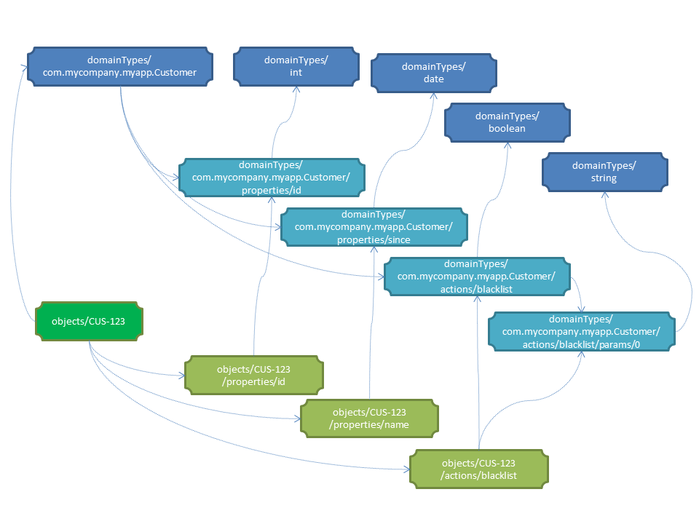
Figure 2: Domain Objects vs Domain Types
If the type being represented has a corresponding JSON built-in type (eg string, long, int, boolean) then that is used as the domain type name. Otherwise the fully qualified type name is used.
The link to the domain type resource is shown in the domain object representation as:
{
...
"links": [ {
"rel": "describedby",
"href": "http://~/domainTypes/x.Customer",
"type": "application/json;profile=\".../domaintype\"",
"method": "GET"
},
...
]
…
}
where the referenced domain type resource will return a representation that describes the domain object instance.

Datatype format
The "format" json-property is used in both the simple and formal schemes, and is used to indicate the format of the string, and thus how to parse it.
The values of this property are taken from JSON schema specification:
- date-time
  - A date in ISO 8601 format of YYYY-MM-DDThh:mm:ssZ in UTC time.
- date
  - A date in the format of YYYY-MM-DD. It is
- time
  - A time in the format of hh:mm:ss.
- utc-millisec
  - The difference, measured in milliseconds, between the specified time and midnight, 00:00 of January 1, 1970 UTC.
In addition, Restful Objects defines two further values for "format":
- blob
  - "binary large object": the string is a base-64 encoded sequence of bytes.
- clob
  - "character large object": the string is a large array of characters, for example an HTML resource
In these cases the "value" of the property is suppressed from both the object representation 2 though is available in the property representation 4 either directly or as an attachment. (Attachments are an optional capability discussed further in 1.27).

Minimizing Round-trips (x-ro-follow-links)
While HTTP caching §1.17 works well enough for non-transactional resources, most of the resources served up by Restful Objects will be transactional. Therefore, Restful Objects also defines an optional capability § 4 to support ‘eager following’ of links. This is specified by setting the reserved x-ro-follow-links query parameter. This acts as a hint to the server to generate in its response a representation that includes additional information as a result of following links.
For example, the client can use this query parameter to:
- obtain additional property details for the object resource, eg, to support an "object edit" use case
- obtain details of objects referenced in a collection, eg, to support rendering the collection in table view format
The query argument is typically a semi-colon separated list of strings, each element being the json-property of a link within the representation to be followed.
For example, the domain object representation §1.53 has links to the each member of the object:
"members": [
{
"id": "createdOn",
"memberType": "property",
"value": ...,
"links": [ {
"rel": "details",
"href": "...",
...
}, ...]
},
{
"id": "customer",
"memberType": "property",
"value": ...,
"links": [ {
"rel": "details",
"href": "...",
...
}, ...]
},
{
"id": "items",
"memberType": "collection",
"links": [ {
"rel": "details",
"href": "...",
...
}, ...]
},
{
"id": "confirm",
"memberType": "action",
"links": [ {
"rel": "details",
"href": "...",
...
}, ...]
...
}
]
In this case, setting x-ro-follow-links to:
- members[memberType=property].links[rel=details]

follows the "details" link of every object property

- members[memberType=action id=confirm].links[rel=details]

follows the details link of the confirm() action
In both these cases the identified elements are links; the returned representation will include a "value" json-property for the identified links
More generally x-ro-follow-links can be used to request the population of a "value" json-property for any node in the map. For example:
- members[id=items]

will populates the "value" json-property of the items collection.

As an alternative to using paths, the x-ro-follow-links may specify a well-defined ("precanned") value that is defined by that resource. For example, the GET Object resource §1.50 defines "ObjectEdit" as a hint to additionally include property details.
Note however that the support of x-ro-follow-links query parameter is an optional capability §4. If a particular server does not support this capability, then the client must be able to follow the links itself.
If the parameter is present and contains a value that does not represent a link or is otherwise not understood by the server, then the server will silently ignore the query parameter.

Validation (x-ro-validate-only)
If validation logic has been defined for a property value, a collection reference, or an action’s parameter(s), then the server implementation is expected to perform that validation prior to initiating any change. For example, a Customer’s firstName property might disallow certain characters , or its showPayments action might require that the toDate parameter is greater than the fromDate.
A validation failure will generate a 400 "bad request" status code. In addition, a warning message will be returned. This will either be a simple Warning header, or, dependent on the request, may be part of the response, in the form of an"invalidReason" json-property.
x-ro-validate-only reserved query parameter
On occasion a client may want to validate one or more property fields, before attempting to mutate the objects, or to validate arguments on an action prompt, before attempting to invoke the action.
Restful Objects defines an optional capability § 4 whereby the client can set the reserved x–ro-validate-only query param for the request to indicate that only validation should be performed:
If the validation completes, then a 204 "No content " status code will be returned. If a validation failure occurs, then the response will be 400 "precondition failed" with corresponding Warning header / "invalidReason" json-properties.

Sorting (x-ro-sort-by / "sortedBy")
Restful Objects defines an optional capability § 4 to allow sorting of returned lists §7 or object collections §1.64.
If supported, the order in which links are returned within the list may be influenced using the reserved x-ro-sort-by query param. If present, this parameter specifies a comma separated list of sort properties, indicating ascending or descending for each (similar to an ORDER BY statement in SQL).
For example:
- mostRecentOrder.placedOn desc, lastName, firstName
for a resource returning a list of links to Customers would order those links by the Customer's mostRecentOrder's placedOn date in descending order, then by the Customers lastName ascending, then by firstName ascending. Note that multipart property keys are supported (that is: ordering is not on a direct property of Customer, it is on the property of an Order which is in turn one of the properties of Customer).
To indicate that sorting has occurred, the representation includes the "sortedBy" json-property. For example:
{
"sortedBy": [{
"clause": "mostRecentOrder.placedOn",
"direction": "desc"
}, {
"clause": "lastName",
"direction": "asc"
},
...
],
"value": [
...
}
Note that the "sortedBy" json-property is a list (rather than a map) because the order of keys in a JSON map is not guaranteed.

Pagination (x-ro-page, x-ro-page-size, "pagination")
Restful Objects defines an optional capability §4 to allow object lists §7 (as returned from action invocations) to be paginated.
If supported, the client may optionally request that a returned list be paginated, by setting the reserved x-ro-page query parameter to specify which page of objects is being requested, and the x-ro-page-size query parameter to specify the size of each page.
For example:
- x-ro-page=3&x-ro-page-size=25
would specify returning a representation for objects 51~75 in the list.
To indicate which page set has been returned, the representation includes a "pagination" json-property, which in turn defines "page", "pageSize" and "numPages" json-propertys, as well as the "totalCount". In addition, it provides a "control" json-property that lists the links to the previous and next pages.
For example:
{
...
"pagination": {
"page": 3,
"numPages": 4,
"pageSize": 25,
"totalCount": 82,
"control": [ {
"rel": "previous",
"href": ...,
"type": ...,
}, {
"rel": "next",
"href": ...,
"type": ...,
}
]
}
"value": [
...
]
}
Using this information the client can manage the paging, for example enabling/disabling next and previous buttons in its UI.

Attachments (x-ro-attachments)
Attachments refer to the optional capability of implementations to provide "rel"="attachment" links for property representations (1.59) where the property value is a blob or clob (indicated by the "format" json-property, 1.22.3), eg representing a media item such as a picture or document.
If followed, such links return a representation of the property value with the appropriate content-type, eg image/jpeg, application/pdf, etc
For example, if a property holds an image, then its representation would include link(s) to a corresponding attachment:
{
"links": [
{
"rel": "attachment",
"href": "http://~/objects/CUS-123/properties/photo/attachments/passport.jpg",
"type": "image/jpeg",
"method": "GET"
}
...
]
}
If the implementation does not support attachments, then the value of the blob or clob is inlined within the property representation 4.
The client can determine the behaviour of the server with regard to attachments by checking the "version" resource 4, and can override the default behaviour using the x-ro-attachments request parameter:
server behaviour | x-ro-attachments query parameter | Description
supports attachments | -- | Attachment links provided, value of blob/clob suppressed from property representation.
supports attachments | "none" | Attachment link not provided, value of blob/clob inlined within property representation
does not support attachments | (does not matter) | Attachment link not provided, value of blob/clob inlined within property representation

Specified Elements
This section summarises the standard json-properties, headers and status codes that are understood by Restful Objects implementations.

Specified json-properties
There are a number of json-properties specified by Restful Objects that have well-defined and with fixed meanings, irrespective of which representation they appear within. They are:
JSON-Property | Description
disabledReason | provides the reason (or the literal "disabled") as to why an object property or collection is un-modifiable, or (in the case of an action) unusable (and hence no links to mutate that member's state, or invoke the action, are provided).
invalidReason | provides the reason (or the literal "invalid’) as to why a proposed value for a property, collection or action argument is invalid.  Appears within an argument representation §1.13 returned as a response.
x-ro-invalidReason | provides the reason as to why a SET OF proposed values for a properties or arguments is invalid.  The "x-ro-" prefix is to avoid name clashes with the property/argument names.
pagination | indicates that a paginated subset of links in the list representations §7 has been returned.
sorting | indicates that the order in which values of links in a list representation §7 or collection property representation §1.64 are returned.
links | a list of additional links from the representation to other resources. Implementation-specific links may also be present in this list; see §1.15.
extensions | map of additional information about the resource. Implementation-specific json-properties may also be present in this map; see §1.15.
Implementation-specific information will only ever be present in the "links" list or in the "extensions" map.

Specified (reserved) query parameters
The query parameters reserved by Restful Objects are:
Header | Description
x-ro-follow-links | Semi-colon-separated list of either paths of links to follow and include in response, or of well-defined keywords that imply the same (eg "ObjectEdit").
x- ro-page | Requesting page number for a resource that returns a list representation. Typically called with X-Page-Size, if latter is omitted, then a default page size (defined by the implementation) is used.
x- ro-page-size | Specifying pages of a certain size for a resource that returns a list representation. Typically called with X-Page; has no effect if X-Page is not also passed.
x-ro-sort-by | Sort order of links for a resource that returns a list representation, or collection property representation §1.64 , as a comma-separated list of clauses.
x-ro-domain-model | Which domain model scheme §1.11 the server should return. Understood only by servers that support both domain model schemes (provide "selectable" for the "domainModel" capability §4)
x-ro-validate-only | Indicate that parameters should be validated but no modification in state should be performed.

Specified headers
Restful Objects defines both request and response headers.

Request headers
The request headers specified by Restful Objects are:
Header | Description
Accept | The list of media types accepted by the client.
If-Match | The value of the ETag response header for the most recently obtained representation of a resource.

Response headers
The response headers specified by Restful Objects are:
Header | Description
Allow | The HTTP methods that are supported by the resource. Returned only in conjunction with a 406 ("Not allowed")
Cache-Control | Whether the representation may be cached or not. Representations of resources representing domain objects will typically disable caching, but some representations (for example, of representation types or types) may be cached.
Last-Modified | The last modified timestamp of a persistent resource. The value of this should be passed as the If-Unmodified-Since header.
Warning | Header to describe either any errors returned by the server implementation, or, as raised by the domain object business logic (eg if the request was syntactically valid but could not be completed).
Content-Type | Depends upon representation; in the form "application/json;profile=http:// restfulobjects.org/xxx ".

Specified status return codes
The status return codes specified by Restful Objects are:
Code | Description | When
200 | Success | Successfully generated representation
204 | No content | Request was successful but generated no representation, or validation (x-ro-validate-only) succeeded. Note however that invoking a void action DOES return a representation §1.70.4.
400 | Bad request | Represents any of a syntactically invalid request, missing mandatory information (eg If-Unmodified-Since header), or a warning message generated by the application.
401 | Not authorized | Not authorized to invoke resource (modify property or collection, or invoke action)
404 | Not found | Property, collection or action not found (could be that the member is hidden for the requesting user)
405 | Method not allowed | An attempt was made to invoke a resource with an HTTP method that is not supported by that resource.
406 | Not acceptable | Concurrency error; the object' has been modified since the If-Unmodified-Since value provided.
412 | Precondition failed | Concurrency error; the object' has been modified and its current etag does not match that provided in the If-Match header.
500 | Internal server error | Indicates that the domain object threw an exception in its business logic
501 | Not implemented | This implementation of Restful Objects does not support the feature requested.
All client- and server-side errors (4xx and 5xx) will also result in a Warning header being returned to describe the nature of the problem. In some cases the implementation will be able to provide a detailed error message; otherwise it should return a standard generic message. The sections describing resource responses detail these messages.

Supporting
Resources
and
Representations

Home Page Resource & Representation
The 'home page' is a well-known resource which acts as the starting point for any client. From it all other resources may be discovered.

HTTP GET
Obtain the representation of the home page resource.
The endpoint URL for this resource is:
/
(in other words the base directory).

Request

Query String
- x-ro-follow-links (optional )
  - user
    - eagerly load currently logged-in user
  - services.value
    - eagerly load domain services representations

Headers
- Accept
  - application/json
  - application/json;profile=…/homepage

Body
        - N/A

Successful Response

Status Code
- 200 "OK"

Headers
- Content-Type
  - application/json;profile=".../homepage"
- Cache-Control:
  - max-age: 86400 (1 day)
    - since home page changes only on redeployment

Body
As per §1.33.

Representation
The links from the home page representation to other resources are as shown in the diagram below:
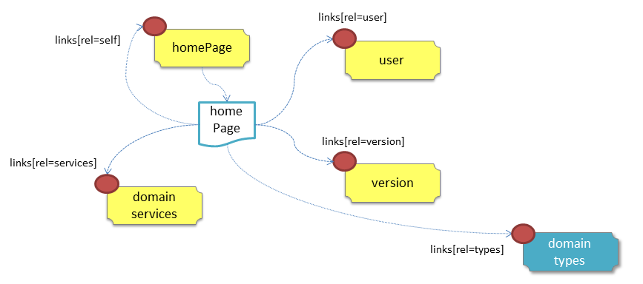
Figure 3: Home Page Representation
The link to the domain types resource is only present if the formal scheme (§1.22.2) capability (§Error: Reference source not found) is supported.
The JSON representation is as follows:
{
"links": [ {
"rel": "self",
"href": "http://~/",
"type": "application/json;profile=\".../homepage\"",
"method": "GET"
}, {
"rel": "user",
"href": "http://~/user",
"type": "application/json;profile=\".../user\"",
"method": "GET"
}, {
"rel": "services",
"href": "http://~/services",
"type": "application/json;profile=\".../list\"",
"method": "GET"
}, {
"rel": "version",
"href": "http://~/version",
"type": "application/json;profile=\".../capabilities\"",
"method": "GET"
}, {
"rel": "types",
"href": "http://~/domainTypes",
"type": "application/json;profile=\".../typelist\"",
"method": "GET"
},
...
],
"extensions": { ... }
}
where:
JSON-Property | Description
links | list of links to resources.
link[rel=self] | link back to the resource that generated this representation.
link[rel=user] | link to the user resource §2
link[rel=services] | link to the services resource §3
link[rel=version] | link to the version resource §4
link[rel=types] | link to the domain types resource §1
extensions | additional information about the resource.
Restful Objects defines no standard json-properties for "extensions". Implementations are free to add to their own links/json-properties to "links" and "extensions" as they require.

User Resource & Representation
The 'user' resource represents the currently logged-in user. For further information on security concepts, see §1.18.
The endpoint URL for this resource is:
/user

HTTP GET
Obtain representation of the currently logged-in user.

GET Request

Query String
- x-ro-follow-links (optional)
  - None

Headers
- Accept
  - application/json
  - application/json;profile=".../user "

Body
        - N/A

GET Successful Response

Status Code
- 200 "OK"

Headers
- Content-Type
  - application/json;profile=".../user"
- Cache-Control
  - max-age: 3600 (1 hour)

Body
As per §1.35.

Representation
The links from the user representation to other resources are as shown in the diagram below:
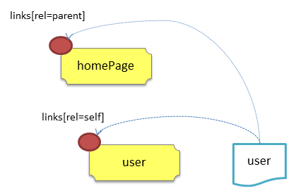
Figure 4: User Representation
The JSON representation is:
{
"links": [ {
"rel": "self",
"href": "http://~/user",
"type": "application/json;profile=\".../user\"",
"method": "GET"
}, {
"rel": "up",
"href": "http://~/",
"type": "application/json;profile=\".../homepage\"",
"method": "GET"
},
...
],
"userName": "joebloggs",
"friendlyName": "Joe Bloggs",
"email": "joe@bloggs.com",
"roles": [
"role1", "role2", ...
],
"extensions": { ... }
}
where:
JSON-Property | Description
links | list of links to resources.
link[rel=self] | link to a resource that can generate this representation
link[rel=up] | link to the homepage resource, §1.
userName | a unique user name
friendlyName | (optional) the user's name in a long form, eg so that it can be rendered in a UI.
email | (optional) the user's email address, if known
roles | list of unique role names that apply to this user (may be empty).
extensions | additional metadata about the resource.
Restful Objects defines no standard json-properties for "extensions". Implementations are free to add to their own links/json-properties to "links" and "extensions" as they require.

Domain Services Resource
Returns a list §7 of (links to) domain service resources §3.
The endpoint URL for this resource is:
/services

HTTP GET

GET Request

Query String
- x-ro-follow-links (optional)
  - value
    - eagerly load representations for all domain services

Headers
- Accept
  - application/json
  - application/json;profile=".../list "

Body
        - N/A

GET Successful Response

Status Code
- 200 "OK"

Headers
- Content-Type
  - application/json;profile=".../list "
- Cache-Control:
  - max-age: 86400 (1 day)

Body
As per §1.37.

Representation
The returned representation is a simple list §7, but with an additional link with a rel="up" referring back to the homepage resource §1.
For example:
{
"links" : [ {
"rel" : "self",
"href" : "http://~/services",
"method" : "GET",
"type" : "application/json;profile=\".../list\""
}, {
"rel": "up",
"href": "http://~/",
"type": "application/json;profile=\".../homepage\"",
"method": "GET"
},
...
} ],
"value" : [ {
"id" : "toDoItems",
"rel" : "service",
"href" : "http://~/services/toDoItems",
"method" : "GET",
"type" : "application/json;profile=\".../domainobject\""
}, {
"id" : "categories",
"rel" : "service",
"href" : "http://~/services/categories",
"method" : "GET",
"type" : "application/json;profile=\".../domainobject\""
},
...
],
"extensions": { ... }
}
The links from the services representation to other resources are as shown in the diagram below:
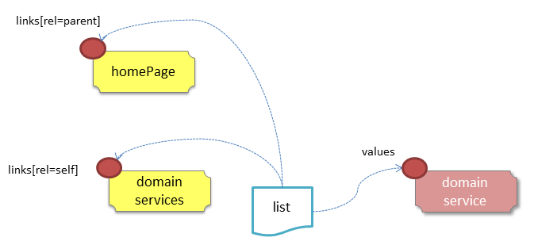
Figure 5: Services Representation
Note that the links in this list will point to domain service resources §3, rather than to domain object resources §2.

Version Resource & Representation
This resource allows a client to dynamically determine which version of the Restful Objects spec a particular implementation supports, and which of the optional capabilities it provides.
The endpoint URL for this resource is:
/version

HTTP GET
Obtain a representation of the implementation's version and optional capabilities.

GET Request

Query String
        - none

Headers
- Accept
  - application/json
  - application/json;profile=".../version"

Body
        - N/A

GET Response

Status Code
        - 200 "OK"

Headers
- Content-Type
  - application/json;profile=".../version"

Body
As per §1.39.

Representation
The links from the version representation to other resources are as shown in the diagram below:
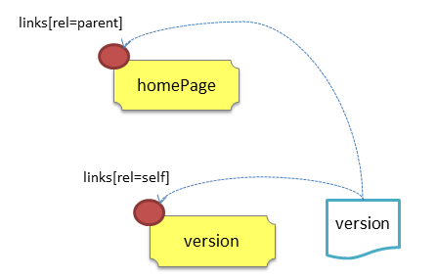
Figure 6: Version Representation
The JSON representation is:
{
"links": [ {
"rel": "self",
"href": "http://~/version",
"type": "application/json;profile=\".../version\"",
"method": "GET"
}, {
"rel": "up",
"href": "http://~/",
"type": "application/json;profile=\".../homepage\"",
"method": "GET"
},
...
],
"specVersion": "0.58",
"implVersion": …,
"optionalCapabilities": {
"concurrencyChecking": "yes",
"transientObjects", "yes",
"deleteObjects", "no",
"partialArguments", "no",
"followLinks", "yes",
"validateOnly", "no",
"sorting", "no",
"pagination", "no",
"domainModel": "formal"
},
"extensions": {
...
}
}
where:
JSON-Property | Description
links | list of links to resources.
links[rel=self] | link to a resource that can generate this representation.
links[rel=up] | link to the home page resource, §1.
specVersion | Version of the Restful Objects spec supported by this implementation
implVersion | Version of the implementation itself.
optionalCapabilities | list of strings representing the capabilities supported by this implementation (see below)
extensions | additional metadata about the resource.
"optionalCapabilities"
The "optionalCapabilities" json-property holds a map of child properties describing the functionality supported by the implementation.
Capability | Value | Meaning
concurrencyChecking | yes  no | Whether concurrency checking using the If-Modified-Since and Last-Modified headers §1.19 is supported.
deleteObjects | yes  no | Whether the DELETE Object resource §1.52 (to delete persisted objects) is supported
partialArguments | yes  no | Whether action representations §1.66 reflecting dependencies between parameters can be generated from a partial argument map to action resource §1.64.
followLinks | yes  no | Whether the x-ro-follow-Links reserved query parameter §1.23 is supported.
validateOnly | yes  no | Whether the reserved x-ro-validate-only §1.24 query parameter is supported
sorting | yes  no | Whether sorting using the reserved x-ro-sort-by query parameter §1.25 is supported
pagination | yes  no | Whether pagination using the reserved x-ro-page and x-ro-page-size query parameters §1.26 is supported.
domainModel | none  simple  formal  selectable | The scheme by which the domain model is represented §1.11. A value of "selectable" means that the reserved x-domain-model query parameter is supported.
"links" and "extensions"
Restful Objects defines no standard links/json-properties for "links" and "extensions", but implementations are free to add to their own links/json-properties as they require.

Objects Resource
Transient objects are representations of objects that have been generated by an action invocation, but do not exist as persisted state within the server. As such, these objects have no oid and therefore no resources that correspond to them.
The transient domain object representation itself §1.54 is a subset of a regular domain object representation §1.53. However – if the domain type is persistable – then they do include a rel=persist link that allows the object to be saved.
The Objects (optional) resource is the target of this persist link. It accepts representations of such transient domain objects and then persists them.
The overall process is:
- client invokes an action that creates the transient object representation
- client uses the "arguments" json-property of the rel=persist link to determine the information required
- client obtains (eg prompts) for this information
- client posts the arguments map back to the Objects resource
- assuming that the values are valid, a representation of the newly persisted domain object is returned. This will now include the "self" link and "oid" json-property to identify it.
Assuming that the property values are valid, the a representation of the newly persisted domain object will be returned, which will now include "self" json-property, and an "oid", to identify it.
The endpoint for this resource is:
/objects

HTTP POST
Persist a domain object by posting a cut-down version of its representation.

POST Request

Headers
- Accept
  - application/json
  - application/json;profile=".../domainobject"

Body
Because this resource is in a sense "uploading" a new object, the body is the cut-down version of the domain object representation §1.53. It consists of:
- members[memberType=property]
- domainType
  - if the simple scheme for domain model information is used
  - links[rel=describedby]
  - if the formal scheme for domain model information is used
In other words, it includes all properties and their values (including those that would normally be hidden), along with a reference to the domaintype of the object being persisted.
In addition, it may include the reserved query parameter:
- x-ro-validate-Only
  - "true"
    - only validate the request, do not persist a new object
For example:
{
"links": [ {
"rel": "describedby",
"href": "http://~/domainTypes/x.Customer"
}],
"members": [ {
"id": "firstName",
"value": ...
}, {
"id": "lastName":
"value": ...
},
...
]
}

POST Successful Response
As per §1.41 (200), returning a domain object representation §1.53.

POST Validation Only and Succeeded

Status Code
        - 204 "No content"

Headers
- none

Body
        - none

POST Validation Failed Response

Status Code
        - 400 "Validation failed"

Headers
        - Warning
  - summary message

Body
Body is the same as that posted, but indicating the properties that were invalid, with a reason in each case.
For example:
{
"links": [ {
"rel": "describedby",
"href": "http://~/domainTypes/x.Customer"
}],
"members": [ {
"id": "firstName",
"value": "Joe",
}, {
"id": "lastName":
"value": null
"invalidReason": "Mandatory"
},
...
]
}

Error Representation
The Error representation defines a standard means for returning detailed diagnostics, typically when a server-side error (status code 500) occurs.
For example, the following might be the result of invoking an action where an exception occurred:
{
"message": "IllegalStateException",
"stackTrace": [
"at Somefile.java#foo():1234",
"at SomeOtherFile.java#bar():4321"
],
"causedBy": {
"message": "IllegalStateException",
"stackTrace": [
"at LibraryFile.java#foz():567",
"at LibraryOtherFile.java#baz():765"
]
},
"links": [ ... ],
"extensions": { ... }
}
where:
JSON-Property | Description
message | the exception message, typically as generated by the underlying implementation programming language. This may or may not be internationalized §1.21, dependent on the the implementation.
stacktrace | (optional) list of strings representing call stack
causedBy | (optional) underlying cause of the exception (to handle nested exception scenarios).
links | list of links to other resources
extensions | additional information about the resource
"stacktrace"
The stack trace is optional. Implementations are free to suppress this information if they wish, or to make available only if a debug flag (or similar) has been enabled.
"links" and "extensions"
Restful Objects defines no standard links/json-properties for "links" and "extensions", but implementations are free to add to their own links/json-properties as they require.

List Representation
The List representation consists of a list of links either to domain object resources. Typically it is obtained as the result of invoking a query action, when it is inlined within the action result representation §1.70. However, it is also be obtained directly from the Services resource §3, when it provides a list of links to domain service resources.
The representation consists of the following json-properties:
{
"value": [
...
],
"links": [ {
"rel": "self",
...
}, {
"rel": "elementtype",
...
},
],
"extensions": { ... }
}
where:
JSON-Property | Description
links | list of links to resources.
links[rel=self] | (optional) link to the resource that generated this list. Present only for domain services.
links[rel=elementtype] | link to the domain type for the elements within the list – if the “domainModel” optional capability §4 is implemented.
value | the actual list of links to the domain object resources (or domain service resources)
extensions | additional information about the resource.
A "self" link will be present only if the representation was generated from the domain services resource §3.
Restful Objects defines no standard child properties of the “extensions” json-property. Implementations are free to add to their own links/json-properties to "links" and "extensions" as they require.
Lists of (links to) domain services
The same representation is also used to return a list of domain services (because domain services are just well-known domain objects). The only difference is that the "href" will be a link to a domain service resource §3 rather than a domain object resource §2.

Scalar Value Representation
The scalar value representation represents a single value that is not itself a domain object.
This representation is never returned directly from a resource, but may appear inlined within the representation of an action invocation §1.70 if the action returned a scalar type such as a string or an integer.
The representation consists of the following json-properties:
{
"value": ...,
"links": [ {
"rel": "returntype",
...
},
...
],
"extensions": { ... }
}
where:
JSON-Property | Description
links | list of links to other resources.
links[rel=returntype] | (optional) link to the domain type of the value – if the “formal” domain capability §4 is supported.
value | the scalar value itself. If text is returned then this should be internationalized, §1.21.
extensions | additional metadata about the representation.
Note that NO "self" link is present, because the scalar value is not a persisted resource (is transient).
Restful Objects defines no standard child properties for the "extensions" json-property. Implementations are free to add to their own links/json-properties to "links" and "extensions" as they require.

Domain Object
Resources & Representations

Response Scenarios
When a domain object resource is invoked, one of several responses can occur. These can be distinguished by the HTTP status return code
- 200 – Request succeeded, and generated a representation
- 204 – Request succeeded, but generated no representation; or validation succeeded
- 400 – Either syntactically invalid request, or validation failed
- 401 – Not authorised (user not authorised to access resource)
- 404 – Object or object member not found or not visible
- 405 – Method not valid for the resource
- 406 – Client accepts only media types not generated by resource.
- 412 – Precondition failed ( object changed by another user)
- 500 – Domain logic failed
The following table indicates which of these status return codes may be generated for each resource:
 | Method | Res. | Repr. | 200 | 204 | 400 | 401 | 404 | 405 | 406 | 412 | 500
Service | GET | §3 | §7 | y |  | y |  | y |  | y |  | y
Object | GET | §1.50 | §1.53 | y |  | y |  | y |  | y |  | y
 | PUT | §1.51 | --- | y |  | y | y | y |  | y | y | y
 | DELETE | §1.52 | --- |  | y | y | y | y | y | y | y | y
Property | GET | §1.56 | §1.59 | y |  | y |  | y |  | y |  | y
 | PUT | §1.57 | --- | y |  | y | y | y |  | y | y | y
 | DELETE | §1.58 | --- | y |  | y | y | y |  | y | y | y
Collection | GET | §1.60 | §1.64 | y |  | y |  | y |  | y |  | y
 | PUT | §1.61 | --- | y |  | y | y | y | y | y | y | y
 | POST | §1.62 | --- | y |  | y | y | y | y | y | y | y
 | DELETE | §1.63 | --- | y |  | y | y | y |  | y | y | y
Action | GET | §1.65 | §1.66 | y |  | y |  | y | y | y |  | y
Action  invoke | GET | §1.67 | §7  §8  §1.53 | y |  | y |  | y | y | y |  | y
 | PUT | §1.68 | --- | y |  | y | y | y | y | y | y | y
 | POST | §1.69 | --- | y |  | y | y | y | y | y | y | y
Objects | POST | §1.40 | §1.53 | y |  | y |  |  | y | y |  | y
For a given status code, the specific headers and body returned by these resources vary little between the different resources; this is especially so for the failure scenarios (4xx and 5xx).
This section (§1) describes all the responses irrespective of resource called. Sections §2 to § 1.66 identify the various request/response scenarios for each of the domain object resources. In each case they define the request URL, headers and body, and also identify the standard (success) response headers and body, if any.

Request succeeded, and generated a representation
For resources that return a body containing some representation.
If the response has been generated by a resource that has also modified the state (eg modifying a property or collection or invoking an action), then there will be no self link. This prevents clients from easily bookmarking the link.

Status code
- 200 "OK"

Headers
- Content-Type:
  - application/json;profile=".../xxx"
    - where xxx indicates the representation type
- Cache-Control
  - no-cache
    - if the object is transactional
  - max-age: nn
    - if the implementation can determine that the returned representation is safe to cache (eg the returned objects are immutable reference data)
- ETag
  - digest of timestamp

Body (representation)
The representation will depend on the resource being requested.

Request succeeded, but generated no content
This response is most often generated as the result of a validation succeeding (if x-ro-validate-only is supported, §1.24). Note however that invoking a void action DOES return a representation §1.70.4.

Status code
- 204 "No content"

Headers
- Warning (optional)
  - indicates an informational message generated by the domain object's business logic

Body
- empty

Bad request
May be generated either as the result of a syntactically invalid request, or as the result of validation failure.

Status code
- 400 ("bad request")
  - missing arguments
  - arguments are malformed
  - property member values are invalid (if updating multiple properties §1.51, or if persisting a transient object §1.40)
  - mandatory header missing (eg If-Match)
  - "Arguments invalid"
    - details are provided in the body

Headers
- Warning
  - Message text is implementation-specific, but should describe the error condition sufficiently to enable developer-level debugging

Body
If arguments §1.13.2/properties (§1.51, §1.40) are invalid, then the response body is the same as the request body, but additionally indicating the arguments/properties that are invalid using an "invalidReason" json-property to indicate why they are invalid
For example:
{
"fromDate": {
"value": "2009-12-01"
"invalidReason": "The from date cannot be in the past"
}
...,
}
If no individual argument/property was invalid, but the set of such is invalid (eg fromDate > toDate), then an "x-ro-invalidReason" json-property is provided at the root of the map.
For example:
{
"fromDate": ...,
"toDate": ...,
"x-ro-invalidReason": "To date cannot be before from date"
}
The json-property has the prefix "x-ro-" in this case in order to avoid clashes with the argument/property names

Forbidden (user not authorised to access resource)
If the user attempts to invoke a resource that is disabled.

Status Code
- 401 "Not authorised"

Headers
- Warning
  - same text as "disabledReason" in object representation

Body
- empty

Object or object member not found or not visible
This is the response if a requested object or object member does not exist, or if the object/member exists but is not visible based on the current user's credentials.

Status Code
- 404 "Not found"

Headers
- Warning
  - No such service {serviceId}
  - No such domain object {oid}
  - No such property {propertyId}
  - No such collection {collectionId}
  - No such action {actionId}

Body
- empty

Resource has invalid semantics for method called

Status code
- 405 ("method not allowed")

Headers
- Allow
  - comma-separated list of methods that are supported, as per RFC 2616
- Warning
  - object is immutable (if attempt any PUT, DELETE or POST)
  - action is not side-effect free (if attempt GET Act/Invoke)
  - action is not idempotent (if attempt PUT Act/Invoke)
  - collection is not a list (if attempt POST Collection)
  - collection is not a set (if attempt PUT Collection)
  - object cannot be safely deleted (if attempt DELETE Object)

Body
- empty

Not acceptable
The client has specified an Accept header that does not include a media type provided by the resource.

Status code
- 406 ("not acceptable")

Headers
- none

Body
- empty

Precondition failed (object changed by other user)

Status code
- 412 "precondition failed"

Headers
- Warning
  - "Object changed by another user".
The ETag header is deliberately not returned in order to force client to re-retrieve an up-to-date representation

Body
- empty

Domain logic failed, or Implementation defect

Status code
- 500 ("internal server error")

Headers
- Warning
  - error message raised by business logic in the domain model, or
  - exception message raised by the Restful Objects implementation itself

Body
- the error representation §6.

Domain Object Resource & Representation
The domain object resource can be used to obtain the summary domain object representation §1.53 for a particular domain object instance, and can also be used to update or delete individual persisted domain object instances.
The endpoint URL for this resource is:
/objects/{oid}
where:
- {oid} is the object identifier

HTTP GET
Obtain a summary representation of a domain object §1.53.
The intention is that enough information is provided to render the object in the client's UI. If required, the reserved x-ro-follow-links query parameter can be used to request additional information in the generated representation.

Request

Query String
- x-ro-follow-links (optional)
  - members.domainModel
    - eagerly load domain model metadata about all members
  - members.propertyDetails
    - eagerly load details about all properties
  - members.collectionDetails
    - eagerly load details (including their contents) of all collections
  - members.collectionContents
    - eagerly load the items for all collections
  - embers.collectionCount
    - eagerly load the count for all collections
  - members.actionDetails
    - eagerly load details about all actions
  - ObjectEdit
    - equivalent to specifying members.domainModel;members.propertyDetails
The x-ro-follow-links request param can also be targeted to specific members by using an xpath qualifier on members; for example:
members[rel='items'].collectionContents;members[rel='overdue'].collectionCount

Headers
- Accept
  - application/json
  - application/json;profile=".../domainobject"

Body
        - N/A

Success Response
As per §1.41 (200), returning a domain object representation §1.53.

HTTP PUT
Update multiple properties of the object at the same time, or alternatively validate the proposed values but do not modify the object.

Request
The request can either be to update the property, or to request validation of the proposed value using the x-ro-validate-only query param §1.24.

Query String
        - none

Headers
- If-Match
  - timestamp digest
    - obtained from ETag header of representation

Body
The body is the map of new properties, as per §1.13.2.3.
In addition, it may include the reserved query parameter:
- x-ro-validate-only (optional)
  - "true"
    - only validate the request, do not modify the property
For example:
{
"firstName": {
"value": ...
},
"lastName": {
"value": ...
},
...
}

Success Response
As per 1.42 (200), returning a domain object representation §1.53. Because the resource has mutated the state, there will be no self link (so that it cannot be bookmarked by clients).

HTTP DELETE
Deletes an object. This is an optional capability §4 because implementing a generic ‘delete object’ capability - which includes managing any references to the deleted object throughout the system - is potentially complex, and not necessarily practicable for many implementations.
If the implementation does support the capability then it must also determine that it is safe to delete the object. A 405 ("method not allowed") error will be returned otherwise.

DELETE Request

Query String
        - none

Headers
- If-Match
  - timestamp digest
    - obtained from ETag header of representation

Body
        - N/A

DELETE Success Response
As per §1.42 (204), returning no representation.

Representation (Persistent)
The domain object representation provides summary information about a single domain object instance, along with links to other sub-resources by which the domain object may be interacted with, or mutated. As such, it the single most important representation defined by Restful Objects.
The Content-Type for the representation is:
application/json;profile=".../domainobject"
The representation is typically generated from the Domain Object resource §1.50, though it can also be generated by the Domain Service resource §3 (since Restful Objects regards a domain service as being just a well-known domain object). It may also be obtained as the result of an action invocation returning a single domain object (§1.66), or as the result updating multiple properties §1.51, or of persisting a transient object §5.
The links from the domain object representation to other resources are as shown in the diagram below:
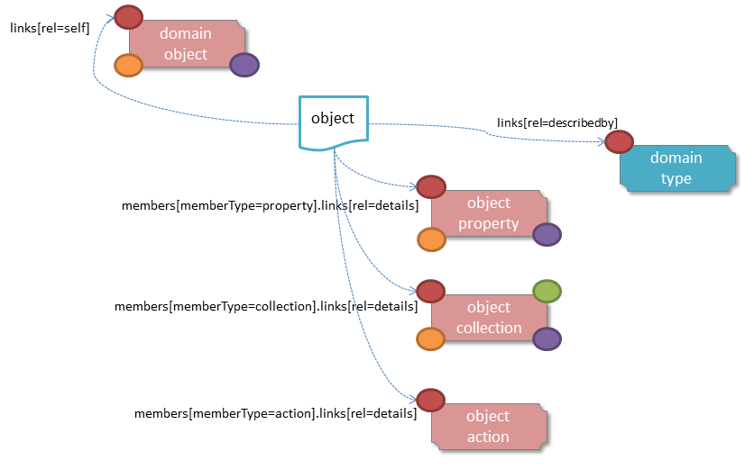
Figure 7: Domain Object Representation
For example, the representation of an Order might be:
{
"oid": "ORD-123",
"title": "Joe Blogg's Order #1",
"members": [
...
],
"links": [ {
"rel": "self",
"href": "http://~/objects/ORD-123",
"type": "application/json;profile=\".../domainobject\"",
"method": "GET",
},
...
],
"extensions": { ... }
}
where:
JSON-Property | Description
links | list of links to other resources.
links[rel=self] | link to a resource that can obtain this representation. Note that the href for a service will be http://~/services/{serviceName}.
links[rel=modify] | (optional) link to modify multiple properties of the domain object (using §1.51). The link should only be present if the object has at least one modifiable property.
oid | the object identifier, to use when building template URIs.
serviceId | (optional) the service Id, present only if the object is a domain service §3.
title | a string identifier of the object, suitable for rendering in a UI.
members | list of object members (properties, collections, actions)
links[rel=icon] | (optional) link to an image representing a scalable icon for this object
links[rel=icon32] | (optional) link to an image to represent this icon at 32x32 pixels
links[rel=icon16] | (optional) link to an image to represent this icon at 16x16 pixels
extensions | additional information about the resource.
"members"
The "members" list contains a value for every (visible) member.
As described in the sections below §1.53.1, §1.53.2, §1.53.3, in each case the information returned is a subset of the detailed representation for each member (§1.59, §1.64, §1.66).
The order of members implies the default display order in which members should be rendered in a client's UI.
"links" and "extensions"
Domain model information about the type is available through either the "links" or the "extensions" json-properties. This is discussed separately in §1.53.4.
Implementations are free to add to their own links/properties to "links" and "extensions" as they require.

Properties
This contains a subset of the information shown in the detailed property representation §1.59. The intention is to provide enough information to render the property value in a user interface without having to make additional requests.
For example, the "createdOn" property would look something like:
"members": [
...
{
"id": "createdOn",
"memberType": "property",
"value": ...,
"disabledReason": ...,
"links": [ {
"rel": "details",
"href": "http://~/objects/ORD-123/properties/createdOn",
"type": "application/json;profile=\".../objectproperty\"",
"method": "GET"
}
...
],
"extensions": { ... }
},
...
]
where:
JSON-Property | Description
id | the property ID, to use when building template URIs
memberType | the constant value "property"
value | the current value of the property, either a scalar, a (link representing a) reference or null.
disabledReason | optional; if populated then indicates the reason why the property cannot be modified.
links | list of links to resources.
links[rel=details] | link to the detailed representation of the property, §1.59 (eg to access defaults and choices).
extensions | map of additional information about the resource.
"links" and "extensions"
Other domain model information about the property is available through either the "links" or the "extensions" json-properties. The information that may be available is the same as provided in the domain object property representation, see §1.59.3.
Implementations are free to add to their own links/json-properties to "links" and "extensions" as they require

Collections
The "members" list also contains an entry for every (visible) collection.
Typically, this entry provides summary information about the collection (for example, its size) so that the client can render the collection without having to make additional requests to the server.
However, if the domain object being represented is non-persistent, then the collection's representation also inlines the contents of the domain object collection representation §1.64 (obtainable from the Collection resource §1.59). This provides support for view model objects that exist solely as a projection of a number of (persistent) domain object entities.
As for (object) properties, the json-property representing a collection has a type, a details link, and links to the state.
For example, the Order's items collection would look something like:
"members": [
...
{
"id": "items",
"memberType": "collection",
"disabledReason": ...,
"value": [ ... ],
"size": ...,
"links": [ {
"rel": "details",
"href": "http://~/objects/ORD-123/collections/items",
"type": "application/json;profile=\".../objectcollection\"",
"method": "GET"
}, ... ],
"extensions": { ... }
},
...
]
where:
JSON-Property | Description
id | the collection ID, for use when building templated URIs
memberType | the constant value "collection"
disabledReason | optional; if populated then indicates the reason why the collection cannot be modified.
value | optional; contains the list of the links to elements within the collection (if requested using x-ro-follow-links).
size | optional; contains a count of the elements in the collection (if requested using x-ro-follow-links).
links | links to other resources.
links[rel=details] | link to the detailed representation of the collection, §1.64, which includes such information as defaults and choices.
extensions | additional information about the resource.
"links[rel=details]", "value" and "size"
The representation of the collection as it appears in summary form does not include a value. This allows implementations to load only the object and not all of its related references (in other words, lazy loading). Note that this is different from the behaviour of properties.
However, the x-ro-follow-links query parameter influences this behaviour:
- setting the query parameter to "links[rel=details]" will cause the "rel"="details" link to be populated, from which full information about the contents of the collection can be obtained;
- setting the query parameter to "value" will cause the optional "value" to be returned, holding a list of links to the actual elements. These links will have their "title" json-property §1.28 populated;
- setting the query parameter to "size" will cause the optional "size" to be returned. This is useful if the client needs to know only the number of elements in a collection.
These three values for x-ro-follow-links should be considered as mutually exclusive (since: details => value => size).
"links" and "extensions"
Other domain model information about the collection is available through either the "links" or the "extensions" json-properties. The information that may be available is the same as provided in the domain object collection representation, see §1.64.3.
Restful Objects defines no other standard links for the "links" json-property, but does define two more standard json-properties for the "extensions" json-property:
JSON-Property | Description
friendlyName | the friendly name for the type of element within the collection. This should be internationalized, §1.21.
pluralForm | the plural form of the type of element within the collection. This should be internationalized, §1.21.
These json-properties make it easy for a client to render useful summary information (eg "3 Customers") if the x-ro-follow-links query param has been set to "size" or to "value".
Implementations are free to add to their own links/json-properties to "links" and "extensions" as they require

Actions
The "members" list also contains a value for every (visible) action.
This contains a subset of the information shown in the detailed representation §1.66 (obtainable from the GET Action resource §1.66). The intention is to provide enough information to render the action without having to make additional requests.
Like properties and collection, actions have a link to 'details' which allows additional information (specifically, choices and defaults on parameters) to be obtained that might otherwise be expensive to compute. They also indicate the link to follow in order to invoke the action.
For example, the Order's submit() action might be represented as:
"members": [
...
{
"id": "submit",
"memberType": "action",
"disabledReason": ...,
"links": [ {
"rel": "details",
"href": "http://~/objects/ORD-101/actions/submit",
"type": "application/json;profile=\".../objectaction\"",
"method": "GET"
} ... ],
"extensions": { ... }
},
...
]
where:
JSON-Property | Description
id | the action ID, to use when building templated URIs
memberType | the constant value "action"
disabledReason | optional; if populated then indicates the reason why the action may not be invoked.
links | list of links to other resources.
links[rel=details] | link to the detailed representation of the action, §1.66.
extensions | additional metadata about the resource
"links" and "extensions"
Other domain model information about the action is available through either the "links" or the "extensions" json-properties. The information that may be available is the same as provided in the domain object action representation, see §1.66.3.
Restful Objects defines no further standard links/json-properties for "links" or "extensions". However, implementations are free to add to their own links/json-properties as they require.

Domain model information
Domain model information is available through either the "links" or the "extensions" json-properties.

Simple scheme
Implementations that support the simple scheme provide extra data in the "extensions" json-properties. For example:
"extensions": {
"domainType": "x.Order",
"friendlyName": "Order",
"pluralName": "Orders",
"description": "Orders that have been placed by customers",
"isService": false
}
See §1.22.1 for the full definitions of these json-properties.

Formal scheme
Implementations that support the formal scheme §1.22.2 provide an additional link in the "links" json-property:
"links": [
{
"rel": "describedby",
"href": "http://~/domainTypes/x.Order",
"type": "application/json;profile=\".../domaintype\"",
"method": "GET"
},
...
]
which links to the domain type resource §2 corresponding to this domain object.

Representation (Transient)
A ‘transient object’ is a representation of a domain object that does not have any persistent state on the server. A transient object is generated by an action on a service or on an existing persistent object.
There are two common use cases for returning a transient object:
- the first is to allow the client to populate the properties on the object and then persist it explicilty (in common user interface parlence: to complete and then save the object)
Here the transient object returned provides a persist link, the arguments of which is a map of property values. Typically the client prompts for the missing information through its UI; when all details have been provided it will save the object by invoking the persist link.
For example, an action on a Customer object could create and return a new transient Order for that Customer. The client would prompt for the required details of the Order , then persist the Order.
- the second is to provide a view model (or more formally, a projection) of the data in some set of entity objects.
In this case the returned object is not intended to be persisted; instead it exists to aggregate a set of data, usually so that it can be rendered in a particular view in the UI.
For example, an action on a Customer object could return an analysis of which Products ordered by that Customer were the most profitable.
Note for the first case, if the system already has sufficient information then it may create a new object and persist it before returning it to the user, in which case the regular (persistent) domain object representation is used.
The representation of a transient object is similar to that of a persisted domain object §1.53(as used to represent persistent objects). The differences are:
- the transient object representation it has no OID and has no a ‘self’ link.
This is because the server has no knowledge of these objects.
- (as alluded to above), the transient object may have a "persist" link if the client is able to persist the transient object.
This specification does not define the mechanism by which implementations distinguish whether to provide a persist link or not (though it is expected that they will use some sort of metadata)
- if the transient object has collection members, then the values of those collections are automatically followed.
Again, this is because there is no collection resource §1.60 that can be queried.
Most transient object are not expected to have actions; again, the reason being that there are no action resources pertaining to the transient object itself §6, §7 that can be accessed.
That said, implementations are at liberty to provide mechanisms that simulate the appearance of actions on transient objects (similar to extension methods in C#, for example). Restful Objects clients should therefore be able to handle representations of transient domain objects that have actions.
In order that a client can easily distinguish between persistent and transient domain objects, a different Content-Type is used:
application/json;profile=".../transientdomainobject"
The links from the transient domain object representation to other resources are as shown in the diagram below:
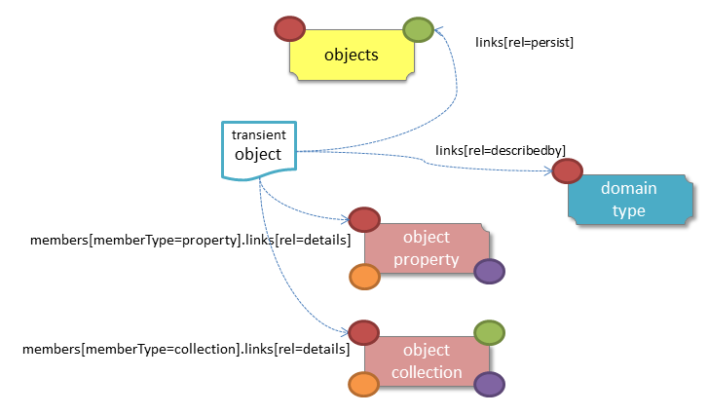
Figure 8: Transient Domain Object Representation
For example, the representation of a transient Order might be:
{
"title": "Joe Blogg's Order #1",
"members": [ {
"rel": "property",
"id": "placedBy",
...
}, {
"rel": "property",
"id": "placedOn",
...
},
...
],
"links": [ {
"rel": "persist",
...
},
...
],
"extensions": { ... }
}
where:
JSON-Property | Description
links | list of links to other resources.
links[rel=persist] | (optional); link to persist domain object (using §1.40); not present if the implementation determines that the domain type cannot be persisted
title | a string identifier of the object, suitable for rendering in a UI. This should be internationalized, §1.21.
members | list of object properties, collections and (optionally) actions. The values of any collections should be automatically followed.
links[rel=icon] | (optional) link to an image representing a scalable icon for this object
links[rel=icon32] | (optional) link to an image to represent this icon at 32x32 pixels
links[rel=icon16] | (optional) link to an image to represent this icon at 16x16 pixels
extensions | additional information about the resource.
"members"
The "members" list contains a value for every (visible) property and collection. Links to the detailed representation for each property (§1.59) or collection §1.64 are excluded.
The representation may optionally also include actions. However, if present these will not be actions of the transient object itself, but of some related persisted object or service. As such, these will have a link to a detailed representation §1.65. The mechanism by which this relationship is made is implementation-specific, and is not defined in this specification.

Domain Model Information
Domain model information is provided about the transient domain object instance in the same way as it is for persistent domain objects, 1.53.4.

Persist Link
For transient domain objects that can be persisted, a rel="persist" link is provided.
The arguments map of this link is a subset of the object representation itself, containing the (property) members of the domain object itself, along with the domain type (specified either with the simple scheme or formal scheme). In particular, the "members" list need only specify the "id" and the "value" of each property member. There is no need to specify other information (such as the "memberType").
For example, the persist link for an Order using the simple scheme might look something like:
"links": [
{
"rel": "persist",
"href": "http://~/objects",
"type": "application/json;profile=\".../domainobject\"",
"method": "POST",
"arguments": {
"domainType": "x.Order",
"members": [ {
"id": "placedBy",
"value": ...
}, {
"id": "placedOn",
"value": ...
},
...
]
}
},
...
]
In addition, note that the "members" list must provide values for every property of the domain object, not just those that are visible.
If the formal scheme is used, then the link will look like:
"links": [
{
"rel": "persist",
"href": "http://~/objects",
"type": "application/json;profile=\".../domainobject\"",
"method": "POST",
"arguments": {
"links": [ {
"rel": "describedby",
"href": "http://~/domaintypes/x.Order",
...
}
],
"members": [ {
"id": "placedBy",
"value": ...
}, {
"id": "placedOn",
"value": ...
},
...
]
}
}
]

Domain Service Resource
A domain service is a well-known (singleton) domain object that typically acts as a repository and/or factory, providing actions for obtaining other domain object instances.
Domain services can be accessed from the object list representation §7 returned by the GET Domain Services resource §3.

HTTP GET
Obtain summary representation of a domain service. .
The endpoint URL for this resource is:
/services/{serviceName}
where:
- {serviceName} is the fully-qualified class name of the service

Request

Query String
- x-ro-follow-Links (optional)
  - members.domainModel
    - eagerly load domain metadata about all members
  - members.actionDetails

Headers
- Accept
  - application/json
  - application/json;profile=".../domainobject"

Body
        - N/A

Success Response
As per §1.41 (200), returning a domain object representation §1.53.

Object Property Resource & Representation
The domain object property resource can be used to obtain the detailed domain object property representation §1.59 for a particular domain object instance. It also allows the value of that property to be modified (or to validate a proposed new value for a property).
The endpoint URL for this resource is:
/objects/{oid}/properties/{propertyId}
where:
- {oid} is the object identifier
- {propertyId} is the property identifier

HTTP GET
Obtain a detailed representation of a property §1.59.
This resource is typically requested as a result of following a link from the domain object representation §1.53.

Request

Query String
- x-ro-follow-links (optional)
  - domainModel
    - eagerly load domain model metadata

Headers
- Accept
  - application/json
  - application/json;profile=".../objectproperty"

Body
        - N/A

Success Response
As per §1.41 (200), returning an object property representation §1.59.

HTTP PUT
Update property value of an object, or validate that the proposed new value for the property is valid. The PUT method may be used to clear the property by passing in a null value, but the recommended practice is to use DELETE §1.58 for that purpose.

Request
The request can either be to update the property, or to request validation of the proposed value using the reserved x-ro-validate-only query parameter §1.24.

Query String
        - none

Headers
- If-Match
  - timestamp digest
    - obtained from ETag header of representation
    - only validate the request, do not modify the property

Body
- should be formatted as a single argument node §1.13.2.2.
- x-ro-validate-only (optional)
  - "true"
    - only validate the request, do not modify the property

Success Response
As per §1.41 (200), returning an object property representation §1.59. Because the resource has mutated the state, there will be no self link (so that it cannot be bookmarked by clients).

HTTP DELETE
This is the recommended resource for clearing property value, or alternatively for validating that a property can be cleared but making no change to the object.
Strictly speaking the DELETE Object Property resource is redundant because it is also possible to clear a property using the PUT method, passing in a null value. However, the DELETE Object Property resource has been included in the spec because it offers a simpler syntax (no body to pass in) and because it is more ‘intentional’ (the intent of calling the resource is clearer to anyone reading the code).

Request

Query Params
        - none

Headers
- If-Match
  - timestamp digest
    - obtained from ETag header of representation
    - only validate the request, do not modify the property

Body
- x-ro-validate-only (optional)
  - "true"
    - only validate the request, do not modify the property

Success Response
As per §1.41 (200), returning an object property representation §1.59. Because the resource has mutated the state, there will be no self link (so that it cannot be bookmarked by clients).

Representation
The domain object property representation provides full details about a property of a domain object instance, and provides links to resources to allow the property to be modified (if it is not disabled).
The Content-Type for the representation is:
application/json;profile=".../objectproperty"
Typically the representation is obtained from the GET Object Property resource §1.56, but it can also be obtained using the x-ro-follow-links qury param when requesting the Get Object resource §1.50.
The links from the object property representation to other resources are as shown in the diagram below:
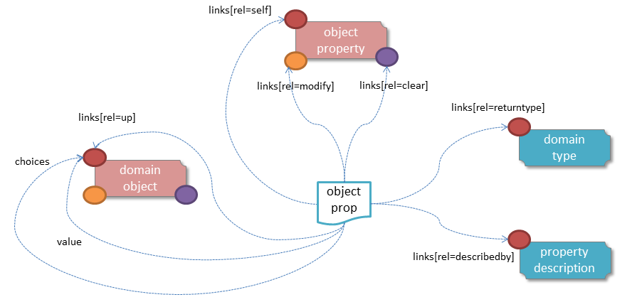
Figure 9: Object Property Representation
For example, the representation of an Order's deliveryOptions property might be:
{
"id": deliveryOptions",
"disabledReason": ...,
"value": ...,
"choices": [ ... ]
"links": [ {
"rel": "self",
"href": "http://~/objects/ORD-123/properties/deliveryOptions",
"type": "application/json;profile=\".../objectproperty\"",
"method": "GET",
}, {
"rel": "modify",
...
}, {
"rel": "clear",
...
}, {
"rel": "up",
...
...
],
"extensions": { ... }
}
where:
JSON-Property | Description
links | list of links to resources.
links[rel=self] | link to a resource that can obtain this representation
id | property ID, to use when building templated URIs
value | the current value of the property.
choices | optional list of suggested/recommended choices for the property
disabledReason | optional; if populated then indicates the reason why the property cannot be modified. The value should be internationalized, §1.21.
links[rel=modify] | optional link back to self to modify property value; discussed below, §1.59.2.
links[rel=clear] | optional link back to self to clear property value; discussed below, §1.59.2.
links[rel=up] | link to the object that is the owner of this property.
extensions | additional information about the resource.
"choices"
The "choices" json-property lists a set of values which are valid for the property. Whether other values might also be valid with respect to the domain model is implementation-specific.
"links" and "extensions"
Both the "links" and the "extensions" json-properties may contain domain model information; this is discussed in §1.59.3.
Restful Objects defines no further standard child properties for the "extensions" json-property. Implementations are free to add further links/json-properties to "links" and "extensions" as they required.

Property values and choices
For reference properties, the "value" and "choices" json-properties hold links to other object resources:
{
...
"id": "paymentMethod",
...,
"value": {
"rel": "value",
"href": "http://~/objects/PMT|VISA",
"type": "application/json;profile=\".../domainobject\"",
"method": "GET",
"title": "Visa"
},
"choices": [
{
"rel": "object",
"href": "http://~/objects/PMT|VISA",
"type": "application/json;profile=\".../domainobject\"",
"method": "GET",
"title": "Visa"
},
{
"rel": "object",
"href": "http://~/objects/PMT|AMEX",
"type": "application/json;profile=\".../domainobject\"",
"method": "GET",
"title": "American Express"
},
{
"rel": "object",
"href": "http://~/objects/PMT|MCRD",
"type": "application/json;profile=\".../domainobject\"",
"method": "GET",
"title": "Mastercard"
},
]
}
For value properties, the "value" and "choices" json-properties are directly parseable strings:
{
...
"id": "deliveryOptions",
...
"value": "PRIORITY",
"choices": ["PRIORITY", "STANDARD", "PARCEL"],
...
}

Property modification
If the property is modifiable, then the "modify" and "clear" json-properties provide links to the resources used to change the property's state.
For example:
{
"id": "deliveryTime",
...
"links": [ {
"rel": "modify",
"href": "http://~/objects/ORD-123/properties/deliveryTime",
"type": "application/json;profile=\".../objectproperty\"",
"method": "PUT",
"arguments": {
"value": null
}
}, {
"rel": "clear",
"href": "http://~/objects/ORD-123/properties/deliveryTime",
"type": "application/json;profile=\".../objectproperty\"",
"method": "DELETE"
},
...
]
}
where:
JSON-Property | Description
links[rel=modify] | link back to self to modify property value; not included if the property is disabled
links[rel=clear] | link back to self to clear property value; not included if the property is disabled
The new value (for the "modify") is sent in the body request via HTTP PUT. Validation of properties occurs when the modify is made. If only validation is of a property is required, then specify the x-ro-validate-only request parameter §1.24.
If the domain object property is NOT modifiable, then the representation will include a "disabledReason" json-property that indicates either the reason (or just the literal "disabled") as to why the value of the property cannot be modified:
{
...
"disabledReason":
"Cannot add items to order that has already shipped",
...
}
where:
JSON-Property | Description
disabledReason | indicates the reason why the property cannot be modified/cleared; only included if the property is disabled. The value should be internationalized, §1.21.

Domain model information
Domain model information is available through either the "links" or the "extensions" json-properties.

Simple scheme
Implementations that support the simple scheme provide extra data in the "extensions" json-property. For example:
"extensions": {
"friendlyName": "Delivery Time",
"description": "Time that the order will be delivered",
"optional": false,
"format": ... // for string properties only
"maxLength": ... // for string properties only
"pattern": ... // for string properties only
}
See §1.22.1 for the full definitions of these json-properties.

Formal scheme
Implementations that support the formal scheme §1.22.2 provide an additional link only in the "links" json-property:
"links": [
{
"rel": "describedby",
"href": "http://~/domainTypes/x.Order/properties/deliveryTime",
"type": "application/json;profile=\".../typeproperty\"",
"method": "GET"
}
]
which links to the domain property description resource §1.74 corresponding to this domain object property.

Object Collection Resource & Representation
The domain object collection resource can be used to obtain the detailed domain object collection representation §1.64 for a particular domain object instance. It also allows elements to be added to, or removed from, the collection (or optionally to validate the adding and removal of elements without modifying the collection.
The endpoint URL for this resource is:
/objects/{oid}/collections/{collectionId}
where:
- {oid} is the object identifier
- {collectionId} is the collection identifier

HTTP GET
Obtain a detailed representation of a collection §1.64.
This resource is typically requested as a result of following a link from the domain object representation §1.53.

Request

Query String
- x-ro-follow-links (optional)
  - timestamp
  - domainModel
    - eagerly load domain model metadata

Headers
- Accept
  - application/json
  - application/json;profile=".../objectcollection"

Body
        - N/A

Success Response
As per §1.41 (200), returning an object collection representation §1.64.

HTTP PUT
Add an object to a collection, or alternatively validate that the proposed object to add to the collection is valid but do not modify the collection.
This method is valid only if the collection has set semantics (the most common case, where duplicate entries are not permitted).

Request

Query String
        - none

Headers
- If-Match
  - timestamp digest
    - obtained from ETag header of representation

Body
- should be formatted as a single argument node §1.13.2.2.
- x-ro-validate-only (optional)
  - "true"
    - only validate the request, do not modify the collection

Success Response
As per §1.41 (200), returning an object collection representation §1.64. Because the resource has mutated the state, there will be no self link (so that it cannot be bookmarked by clients).

HTTP POST
Add an object to a collection, or alternatively validate that the proposed object to add to the collection is valid but do not modify the collection.
This method is valid only if the collection has list semantics (where duplicate entries are permitted).

Request

Query String
        - none

Headers
- If-Match
  - timestamp digest
    - obtained from ETag header of representation

Body
- should be formatted as a single argument node §1.13.2.2.
- x-ro-validate-only (optional)
  - "true"
    - only validate the request, do not modify the collection

Success Response
As per §1.41 (200), returning an object collection representation §1.64. Because the resource has mutated the state, there will be no self link (so that it cannot be bookmarked by clients).

HTTP DELETE
Remove an object from a collection, or alternatively validate that an object can be removed from a collection but make no changes.

Request

Query String
A single query argument should be formatted as a single argument node §1.13.2.2 referencing the object to remove:
{
"value": {
"rel": "object",
"href": "http://~/objects/XXX-yyyy",
"method": "GET"
}
}
In addition:
- x-ro-validate-only (optional)
  - "true"
    - only validate the request, do not modify the collection

Headers
- If-Match
  - timestamp digest
    - obtained from ETag header of representation

Body
        - None

Success Response
As per §1.41 (200), returning an object collection representation §1.64. Because the resource has mutated the state, there will be no self link (so that it cannot be bookmarked by clients).

Representation
The domain object collection representation provides full details of a collection of a domain object type, and provides links to resources that can modify the contents of the collection, if allowable.
The Content-Type for the representation is:
application/json;profile=".../objectcollection"
Typically the representation is obtained from the Object Collection resource §1.60, but it can also be obtained using the x-ro-follow-links request parameter when requesting the Object resource §1.50.
The links from the object collection representation to other resources are as shown in the diagram below:
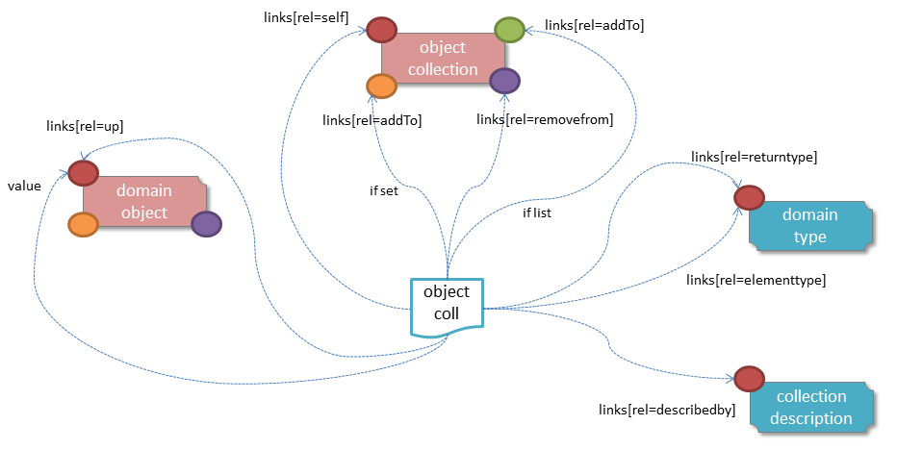
Figure 10: Object Collection Representation
For example, the representation of an Order#items collection might be:
{
"id": items",
"value": [ ... ],
"disabledReason": ...,
"links": [ {
"rel": "self",
"href": "http://~/objects/ORD-123/collections/items",
"type": "application/json;profile=\".../objectcollection\"",
"method": "GET",
}, {
"rel": "addTo",
...
}. {
"rel": "removeFrom",
...
}, {
"rel": "up",
...
}
...
],
"extensions": { ... }
}
where:
JSON-Property | Description
links | list of links to other resources.
links[rel=self] | link to a resource that can obtain this representation
id | collection ID, to use when building templated URIs
value | list of links to the domain objects referenced by the collection.
disabledReason | optional; if populated then indicates the reason why the collection cannot be modified. The value should be internationalized, §1.21.
links[rel=addTo] | optional link back to self to add item to collection; discussed below, §1.64.2.
links[rel=removeFrom] | optional link back to self to remove item from collection; discussed below, §1.64.2.
links[rel=up] | link to the object that is the owner of this collection.
extensions | additional information about the resource.
Both the "links" and the "extensions" json-properties may contain domain model information; this is discussed in §1.64.3.
Restful Objects defines no further standard child properties for the "extensions" json-property. Implementations are free to add further links/json-properties to "links" and "extensions" as they required.

Collection values
The value of a collection is a list of links to other objects:
"value": [
{
"rel": "object",
"href": "http://~/objects/ORD-123-1",
"type": "application/json;profile=\".../domainobject\"",
"method": "GET",
"title": "Harry Potter and the Goblet of Fire"
},
{
"rel": "object",
"href": "http://~/objects/ORD-123-2",
"type": "application/json;profile=\".../domainobject\"",
"method": "GET",
"title": "Rubiks Cube"
},
{
"rel": "object",
"href": "http://~/objects/ORD-123-3",
"type": "application/json;profile=\".../domainobject\"",
"method": "GET",
"title": "Xbox"
}
]

Collection modification
If the collection is a modifiable (by the current user), then the "addTo" and "removeFrom" json-properties will be provided.
If the collection is a set (the common case, where entries cannot be duplicated), then the "addTo" link will be a PUT:
{
...
"links": [ {
"rel": "addTo",
"href": "http://~/objects/ORD-123/collections/items",
"type": "application/json;profile=\".../objectproperty\"",
"method": "PUT",
"arguments": {
"value": null
},
...
],
...
}
If the collection is a list (the rarer case, where entries can be duplicated), then the "addTo" link will be a POST:
{
...
"links": [ {
"rel": "addTo",
"href":"http://~/objects/ORD-123/collections/items",
"type": "application/json;profile=\".../objectproperty\"",
"method": "POST"
"arguments": {
"value": null
}
},
...
],
...
}
In both cases, the "removeFrom" link will be a DELETE:
{
...
"links": [ {
"rel": "removeFrom",
"href": "http://~/objects/ORD-123/collections/items",
"type": "application/json;profile=\".../objectproperty\"",
"method": "DELETE"
"arguments": {
"value": null
}
...
],
...
}
To summarize:
JSON-Property | Description
links[rel=addTo] | link back to self to add to collection; not included if the collection is disabled
links[rel=removeFrom] | link back to self to remove from collection; not included if the collection is disabled
If the collection is NOT modifiable (by the current user), then the representation will include a "disabledReason" json-property to indicate the reason (or just the literal "disabled") as to why the contents of the collection cannot be modified:
{
...
"disabledReason":
"Cannot add items to order that has already shipped",
...
}
where:
JSON-Property | Description
disabledReason | indicates the reason why the collection cannot be added to/removed from; only included if the collection is disabled

Domain model information
Domain model information is available through either the "links" or the "extensions" json-properties.

Simple scheme
Implementations that support the simple scheme provide extra data in the "extensions" json-properties. For example:
"extensions": {
"friendlyName": "items",
"description": "Line items (details) of the order",
"collectionType": "list ",
"elementType": "x.OrderItem"
}
See §1.22.1 for the full definitions of these json-properties.

Formal scheme
Implementations that support the formal scheme §1.22.2 provide an additional link only in the "links" json-property:
"links": [
{
"rel": "describedby",
"href": "http://~/domainTypes/x.Order/collections/items",
"type": "application/json;profile=\".../typecollection\"",
"method": "GET"
},
...
]
which links to the domain collection description resource §1.76 corresponding to this domain object collection.

Object Action Resource & Representation
The domain object property resource can be used to obtain the detailed domain object action representation §1.66 for a particular domain object instance. This provides a description of the action only; to invoke it, the object action invoke sub-resource §1.66is used.
This resource is typically requested as a result of following a link from the domain object representation §1.53.
The endpoint URL for this resource is:
/objects/{oid}/actions/{actionId}
where:
- {oid} is the object identifier
- {actionId} is the action identifier

HTTP GET
Obtain a detailed representation of an action §1.66.
Restful Objects defines an optional capability §4 that allows this resource to accept a partial argument map §1.13.2. The main use case is for actions that take multiple parameters where the valid choices for one parameter depend on the value of another parameter; for example category/subcategory or country/region.

GET Request

Query String
If the "partialArguments" optional capability § 4 is supported, then partial argument maps may be provided, for example:
{
"category": {
"value": {
"rel": "argument",
"href": "http://~/objects/CGY-BOOKS",
"method": "GET"
}
}
}
In addition:
- x-ro-follow-links (optional)

Headers
- Accept
  - application/json
  - application/json;profile=".../objectaction"

Body
- N/A

GET Success Response
As per §1.41 (200), returning an object action representation §1.66.
The exact contents (specifically, of the "choices" json-property) may vary depending on whether a partial argument map was provided

Representation
The domain object action representation provides full details of an action on a domain object instance, and provides links to resources that can invoke the action (if allowed).
The Content-Type for the representation is:
application/json;profile=".../objectaction"
Typically the representation is obtained from the GET Object Action resource §1.66, but it can also be obtained using the x-ro-follow-links request parameter when requesting the Object resource §1.50.
The links from the object action representation to other resources are as shown in the diagram below:
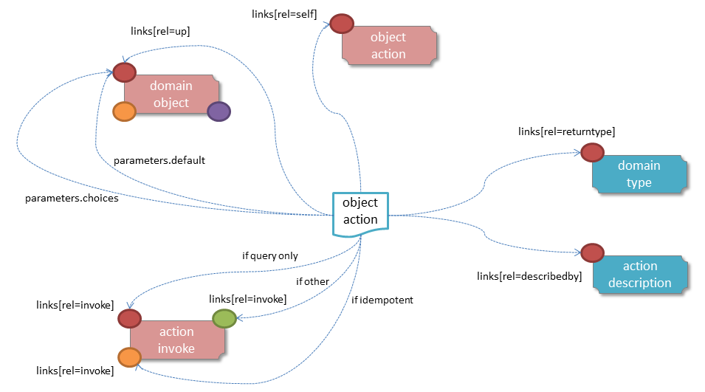
Figure 11: Object Action Representation
For example, the representation of Order's submit action might be:
{
"id": submit",
...
]
"parameters": [
...
],
"disabledReason": ...,
"links": [ {
"rel": "self",
"href": "http://~/objects/ORD-123/actions/submit",
"type": "application/json;profile=\".../objectaction\"",
"method": "GET",
}, {
"rel": "invoke",
...
}, {
"rel": "up",
...
}
...
],
"extensions": { ... }
}
where:
JSON-Property | Description
links | list of links to other resources.
links[rel=self] | link to a resource that can generate this representation.
id | the action ID, to use when building templated URIs
parameters | list of parameters; discussed below §1.66.1
disabledReason | optional; if populated then indicates the reason why the collection cannot be modified. The value should be internationalized, §1.21.
links[rel=invoke] | optional; is a link to invoke the action (if it is not disabled)
links[rel=up] | link to the object that is the owner of this action.
extensions | additional metadata about the resource
Both the "links" and the "extensions" json-properties may contain domain model information; this is discussed in §1.66.3.
Restful Objects defines no standard child properties for the "extensions" json-property (other than any domain model information). Implementations are free to add further links/json-properties to both "links" and "extensions" as they required.

Action parameters
The action resource lists the parameter details in the "parameters" list:
"parameters": [
{
"name": ...
"choices": [ {
"rel": "choice",
...
}, {
"rel": "choice",
...
}, {
"rel": "choice",
...
}
...
],
"default": {
"rel": "default",
...
},
"links": [ ... ]
"extensions": { ... }
},
{
"name": ...
"choices": [ ... ],
"default": { ... },
"links": [ ... ]
"extensions": { ... }
},
{
"name": ...
"choices": [ ... ],
"default": { ... },
"links": [ ... ]
"extensions": { ... }
}
]
where:
JSON-Property | Description
name | the name of the parameter argument (used as the key in argument maps 1.13.2).
choices | an optional list of choices for the parameter argument
default | an optional value/link to act as the default for the parameter argument
links | list of links to other resources related to the action parameter
extensions | additional metadata about the action parameter
In particular, note that the "links" and/or "extensions" json-property may hold domain model metadata; see 1.66.3.

Action invocation
If the action can be invoked then the "rel" = "invoke" link will contain a link by which the action can be invoked. This will be either a GET, a PUT or a POST dependent upon the action's semantics.
If the implementation can determine that the action is ‘query only’, then a GET link should be provided:
{
...
"links": [ {
"rel": "invoke",
"href": "http://~/objects/ORD-123/actions/submit/invoke",
"type": "application/json;profile=\".../actionresult\"",
"arguments": {
"shipMethod": {
"value": ”overnight express”
},
...
},
"method": "GET"
}
...
],
...
}

"type" property
The "type" json-property always indicates that the urn:org.restfulobjects/actionresult representation will be returned §1.70.

"arguments" property
The "arguments" json-property has placeholders for the values of each of the arguments. Commonly, these values will be null - it is up to the client to determine the value to use when invoking the action. However the server may provide a default value, as shown for the "shipMethod” parameter in the example above).
If the implementation can determine that the action is idempotent then a PUT link will be provided:
{
...
"links": [ {
"rel": "invoke",
"href":
"http://~/objects/ORD-123/actions/placeOrder/invoke",
"type": "application/json;profile=\".../actionresult\"",
"arguments": [ ... ],
"method": "PUT"
} ],
...
}
Finally, if the action to be invoked is neither query-only nor idempotent,(or if the implementation is unable to determine this), then a POST link will be provided:
{
...
"links": [ {
"rel": "invoke",
"href":
"http://~/objects/ORD-123/actions/placeOrder/invoke",
"type": "application/json;profile=\".../actionresult\"",
"arguments": [ ... ],
"method": "POST"
} ],
...
}
To summarize:
JSON-Property | Description
link[rel=invoke] | link to invoke the action, either as query only, idempotent or neither; not included if the action is disabled
If the action may NOT be invoked (for example because of the status of the object to which the action applied), then the representation should include a "disabledReason" json-property (or just the literal "disabled") as to why the action cannot be invoked:
{
...
"disabledReason":
"Cannot place order because customer has been blacklisted",
...
}
where:
JSON-Property | Description
disabledReason | indicates the reason why the action cannot be invoked; only included if the action is disabled. The value should be internationalized, §1.21.

Domain model information (for action)
Domain model information is available for action for both the action itself and also for each of the action parameters. In both cases the information is either under the "links" or under the "extensions" json-properties.

Simple scheme
Implementations that support the simple scheme provide extra data about the action in the "extensions" json-properties. For example:
"extensions": {
"friendlyName": "Place order",
"description": "Place a new order",
"hasParams": true,
...
}
In addition, such implementations may also provide extra data about each action parameter in that parameter's own "extensions" json-property. For example:
"parameters": [
{
"name": "product",
...
"extensions": {
"friendlyName": "Product",
"description": "The product being ordered",
"optional": false,
"format": ... // for string params only
"maxLength": ... // for string params only
"pattern": ... // for string params only
}
}
...
]
See §1.22.1 for the full definitions of these json-properties.
Implementations may also provide their own extensions.

Formal scheme
Implementations that support the formal scheme §1.22.2 provide several additional links about the action in the "links" json-property. For example:
"links": [
{
"rel": "returntype",
"href": "http://~/domainTypes/x.OrderReceipt",
"type": "application/json;profile=\".../domaintype\"",
"method": "GET"
},
{
"rel": "describedby",
"href": "http://~/domainTypes/x.Order/actions/submit",
"type": "application/json;profile=\".../typeaction\"",
"method": "GET"
},
{
"id": "shipMethod",
"rel": "actionparam",
"href":
"http://~/domainTypes/x.Order/actions/submit/params/shipMethod",
"method": "GET"
"type": "application/json;profile=\".../typeactionparameter\"",
},
{
"id": "rush",
"rel": "actionparam",
"href":
"http://~/domainTypes/x.Order/actions/submit/params/rush",
"type": "application/json;profile=\".../typeactionparameter\"",
"method": "GET"
},
...
]
In addition, such implementations may also provide extra data about each action parameter in that parameter's own "links" json-property. For example:
"parameters": [
{
"name": "product",
...
"links": [
{
"rel": "describedby",
"href":
"http://~/domainTypes/x.Order/actions/submit/params/product",
"type": "application/json;profile=\".../typeactionparam\"",
"method": "GET"
}
]
}
...
]

Object Action Invoke Resource
The domain object action invoke resource is used to either invoke an action on a particular domain object instance, or optionally just validate arguments to an action without invoking it. It is usually obtained from the detailed representation §1.66 returned by domain object action resource §1.64.
The endpoint URL for this resource is:
/objects/{oid}/actions/{actionId}/invoke
where:
- {oid} is the object identifier
- {actionId} is the action identifier

HTTP GET
Invoke an action and return a representation. Alternatively, validate the query arguments without invoking the action.
The action invoked must be query only (does not modify any persisted objects); a typical example is to search for objects from a domain service repository.
The action cannot be void (it must return some representation).

Request
The request can either be to invoke the action, or to request validation of arguments using the reserved x-ro-validate-only query parameter §1.24.

Query String
Query arguments should be formatted as a map (§1.13.2), and encoded in the URL (§1.13.2.5).
In addition, the following may optionally be included in the map:
- x-ro-validate-only
  - the argument map can be incomplete; only those arguments provided will be validated.
- x-ro-follow-links
- x-ro-page
  - nn; only applies if a list representation (of objects) §7 is returned
- x-ro-page-size
  - nn; only applies if a list representation (of objects) §7 is returned, and x-ro-page query param also provided
- x-ro-sort-by (optional)
  - xxx,yyy; only applies if a list representation (of objects) §7 is returned

Headers
- Accept
  - application/json
  - application/json;profile=".../actionresult"
There is no need to pass If-Match for query-only actions.

Body
        - N/A

Success Response
As per 1.41 (200), returning an action result §1.70

HTTP PUT
Invoke an action and return a representation if the action returns a result. Alternatively, validate the query arguments but do not invoke the action.
The action invoked must be idempotent (though may have side-effects). An example might be Order#submit(), which has the same post-conditions irrespective of whether the order is submitted or not.

Request

Query String
        - none

Headers
- Accept
  - application/json
  - application/json;profile=".../actionresult"
- If-Match
  - timestamp digest
    - obtained from ETag header of representation

Body
Arguments should be formatted as a map (§1.13.2), and sent as the body (§1.13.2.5).
In addition:
- x-ro-validate-only (optional)
  - "true"
    - only validate the request, do not invoke the action

Success Response
As per 1.41 (200), returning an action result §1.70.

HTTP POST
Invoke an action, and return a representation if the action returns a result. Alternatively, validate the query arguments but do not invoke the action.
The action invoked can have side effects and need not be idempotent.

Request

Query String
        - none

Headers
- Accept
  - application/json
  - application/json;profile=".../actionresult"
- If-Match
  - timestamp digest
    - obtained from ETag header of representation

Body
Arguments should be formatted as a map (§1.13.2), and sent as the body (§1.13.2.5).
In addition:
- x-ro-validate-only (optional)
  - "true"
    - only validate the request, do not invoke the action

Success Response
As per 1.41 (200), returning an action result §1.70.

Representation
All action invocations (even of void actions) return an actionresult representation. This provides details of the action invocation, and (for non-void actions) also inlines the representation of the result of the invocation.
For example:
{
"links": [ {
"rel": "self",
"href": "http://~/services/TaskRepository/actions/countUrgentTasksFor/invoke",
"type": "application/json;profile=\".../actionresult\"",
"arguments": [
{
"rel": "argument",
"href": "http://~/objects/EMP-090123",
"type": "application/json;profile=\".../domainobject\"",
"method": "GET"
}
}
],
"resulttype": ...
"value": ...,
"extensions": { ... }
}
where:
JSON-Property | Description
links | list of links to other resources.
links[rel=self] | (optional) link to the action invocation resource that generated the representation
resulttype | either "object", "list", "scalar" or "void"
result | (optional) the action result itself. Not present if void action.
extensions | additional metadata about the representation.
The "self" link can be used as a bookmark so that the action can easily be resubmitted. However, the link is only included in the representation if the action is query only. This is to prevent accidental bookmarking of links that if followed would result in side-effects.
The "resulttype" indicates whether there is an inlined representation (for an action returning a domain object, a list, a scalar) or none (if void).
Finally, the "result" holds the representation of the returned domain object, a list or a scalar. This is discussed in sections below.

Action returning a Domain Object
If the action invocation returns a domain object, then the actionresult representation will inline the domain object's representation (§1.50):
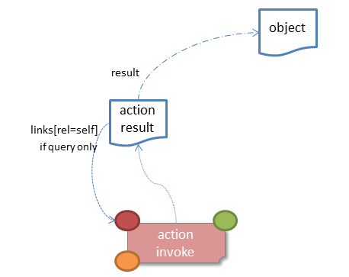
Figure 12: Action Result for Object
For example, the following might be the result of invoking an action representing Customer's favoriteProduct() action:
{
"links": [ {
"rel": "self",
"href": "http://~/objects/CUS-123/actions/favoriteProduct/invoke",
"type": "application/json;profile=\".../actionresult\"",
"arguments": {},
"method": "GET"
}
],
"resulttype": "object",
"result": {
"links": [ {
"rel": "self",
"href": "http://~/objects/PRD-2468"
"type": "application/json;profile=\".../object\"",
"method": "GET"
},
...
],
"members": [
...
],
"extensions": { ... }
...
}
"extensions": { ... }
}
Note that this representation has two "self" links:
- links[rel=self]
  - is the link to the action invocation.
  - result.links[rel=self]
  - is the link to the returned domain object.
If the action returned null, then the "result" json-property will still be present, but set to the JSON value null:
{
...
"resulttype": "object",
"result": null
...
}

Action Returning a List
If the action invocation returns a list, then the actionresult representation will inline a list representation (§7):
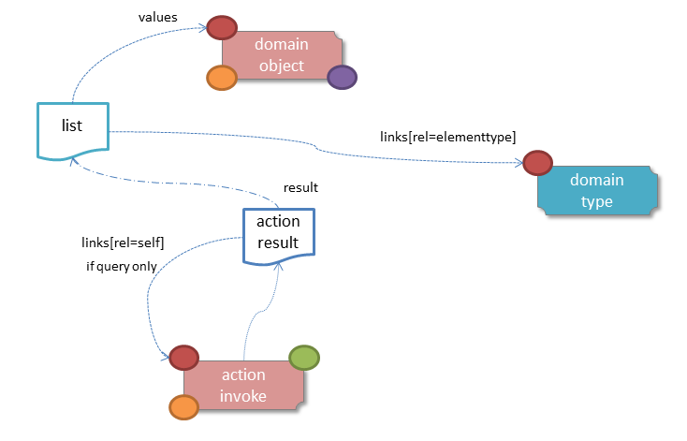
Figure 13: Action Result for List
For example, the following might be the result of invoking an action resource §1.64 representing CustomerRepository's findBlacklistedCustomers() action:
{
"links": [ {
"rel": "self",
"href": "http://~/services/CustomerRepository/actions/findBlackListedCustomers/invoke",
"type": "application/json;profile=\".../actionresult\"",
"arguments": {},
"method": "GET"
}
],
"resulttype": "list",
"result": {
"links": [{
"rel": "elementtype",
"href": "http://~/domainTypes/x.Customer,
"type": "application/json;profile=\".../domaintype\"",
"method": "GET"
},
],
"value": [ {
"ref": "object",
"href": "http://~/objects/CUS-123",
"type": "application/json;profile=\".../domainobject\"",
"method": "GET"
}, {
"ref": "object",
"href": "http://~/objects/CUS-456",
"type": "application/json;profile=\".../domainobject\"",
"method": "GET"
},
...
],
"extensions": { ... }
},
"extensions": { ... }
}
Actions that return no links typically are expected to return an empty list:
{
...
"resulttype": "list",
"result": {
...
"value": [ ]
...
}
...
}
However, it is legal for actions to return a null list. In this case the "result" json-property will still be present, but set to the JSON value null:
{
...
"resulttype": "list",
"result": null
...
}

Action returning a Scalar Value
If the action invocation returns a scalar, then the actionresult representation will inline a scalar representation (§8):
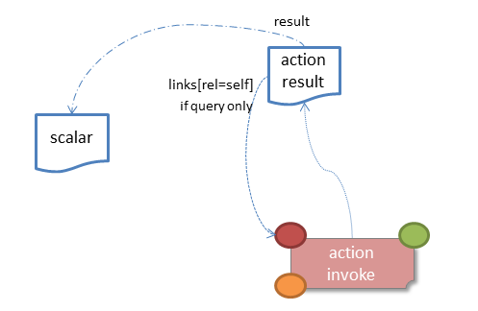
Figure 14: Action Result for Scalar
For example, the TaskRepository's countUrgentTasksFor(Employee) action might generate the following representation:
{
"links": [ {
"rel": "self",
"href": "http://~/services/TaskRepository/actions/countUrgentTasksFor/invoke",
"type": "application/json;profile=\".../actionresult\"",
"arguments": {
"employee": {
"rel": "argument",
"href": "http://~/objects/EMP-090123",
"type": "application/json;profile=\".../domainobject\"",
"method": "GET"
}
},
"method": "GET"
}
],
"resulttype": "scalar",
"result": {
"links": [ {
"rel": "returntype",
"href": "http://~/domainTypes/int,
"type": "application/json;profile=\".../domaintype\"",
"method": "GET"
}
],
"value": 25,
"extensions": { ... }
},
"extensions": { ... }
}
As for actions returning lists and domain objects, if the scalar return type is non-primitive and a null is returned, then the "result" json-property will be set to the JSON null value:
{
...
"resulttype": "scalar",
"result": null
...
}

Action returning a Void
If the action invocation returns a void, then the simple actionresult representation (with no inlined representation) will be returned.
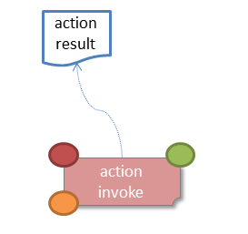
Figure 15: Action Result for Void
For example, the Customer's toggleBlacklistStatus() action might generate the following representation:
{
"links": [ {
"rel": "self",
"href": "http://~/objects/CUS-123/actions/toggleBlacklistStatus/invoke",
"type": "application/json;profile=\".../actionresult\"",
"arguments": {}
],
"method": "GET"
},
...
],
"resulttype": "void",
"extensions": { ... }
}
Note that there is no "result" json-property.

Domain Type
Resources

Domain Types Resource
The domain types resource provides a list of all the domain types that are known to the system.
The endpoint URL for this resource is simply:
/domainTypes/

HTTP GET

Request

Query String
- x-ro-follow-links (optional)
  - value
    - eagerly load representations for all domain types

Headers
- Accept
  - application/json
  - application/json;profile=".../typelist"

Body
        - N/A

Successful Response

Status Code
- 200 "OK"

Headers
- Content-Type
  - application/json;profile=".../typelist"
- Cache-Control:
  - max-age: 86400 (1 day)

Body
As per §1.74.

Representation
The links from the typelist representation to other resources are as shown in the diagram below:
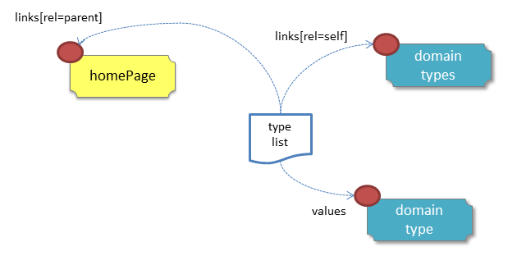
Figure 16: Domain Type List Representation
For example, the JSON representation of the collection of domain types for a system looks something like:
{
"links" : [ {
"rel" : "self",
"href" : "http://localhost:8080/domainTypes",
"method" : "GET",
"type" : "application/json;profile=\"urn:org.restfulobjects/typelist\""
}, {
"rel": "up",
"href": "http://~/",
"type": "application/json;profile=\".../homepage\"",
"method": "GET"
}
],
"value" : [ {
"rel" : "domaintype",
"href" : "http://~/domainTypes/x.Customer",
"method" : "GET",
"type" :
"application/json;profile=\"urn:org.restfulobjects/domaintype\""
}, {
"rel" : "domaintype",
"href" : "http://~/domainTypes/x.Order",
"method" : "GET",
"type" :
"application/json;profile=\"urn:org.restfulobjects/domaintype\""
},
...
"extensions" : { ... }
}
where:
JSON-Property | Description
links | list of links to resources
links[rel=self] | link to a resource that can obtain this representation
links[rel=up] | link to the homepage resource, 1.
values | List of links to domain types, §2
extensions | map of additional information about the resource.

Domain Type Resource
The domain type resource represents the type of a domain object instance, within the metamodel. Its representation links through to other elements of the metamodel which represent the domain type's properties, collections and actions. These link back in turn to other domain type resources, for example representing the property type or an action's parameter types.
Clients can use the domain type to, for example, render a data element using a particular UI widget (datetime picker, textfield, spinner).
Server implementations are free to extend the representation as required, for example providing links to additional media (icons, videos and so forth).
The endpoint URL for this resource is:
/domainTypes/{domainType}
where:
- {domainType} is either
  - the fully qualified type name, or
  - is a built-in JSON type

HTTP GET
Obtain a representation of a domain type within the metamodel.

Request

Query String
- x-ro-follow-links (optional)
  - propertyDetails
    - additionally include property details
  - collectionDetails
    - additionally include collection details
  - actionDetails
    - additionally include action details

Headers
- Accept
  - application/json
  - application/json;profile=".../domaintype"

Body
        - N/A

Successful Response

Status Code
- 200 "OK"

Headers
- Content-Type
  - application/json;profile=".../domaintype"
- Cache-Control:
  - max-age: 86400 (1 day)

Body
As per §1.74.

Not found Response

Status Code
- 404 "Not found"

Headers
- Warning:
  - No such domain type {domainType}.

Body
- empty

Representation
The links from the domain type representation to other resources are as shown in the diagram below:
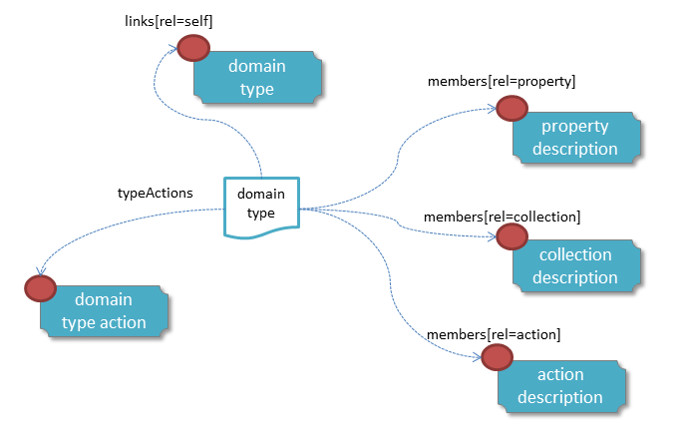
Figure 17: Domain Type Representation
For example, the JSON representation (for a Customer type) looks something like:
{
"name": "x.Customer",
"friendlyName": "Customer",
"pluralName": "Customers",
"description": "Customers with a registered account and confirmed billing details. ",
"isService": false
"members": [
{
"rel": "property",
"href":
"http://~/domainType/x.Customer/properties/firstName",
"type": "application/json;profile=\".../typeproperty\"",
"method": "GET"
},
{
"rel": "collection",
"href":
"http://~/domainType/x.Customer/collections/recentOrders",
"type": "application/json;profile=\".../typecollection\"",
"method": "GET"
},
{
"rel": "action",
"href":
"http://~/domainType/x.Customer/actions/blackList",
"type": "application/json;profile=\".../typeaction\"",
"method": "GET"
},
...
],
"typeActions" : [ {
"id" : "isSubtypeOf",
"rel" : "typeaction",
"href": "http://~/domainTypes/x.Customer/typeactions/isSubtypeOf/invoke",
"method" : "GET",
"type" : "application/json;profile=\".../typeactionresult\"",
"arguments" : {
"supertype" : {
"href" : null
}
}, {
"id" : "isSupertypeOf",
"rel" : "typeaction",
"href": "http://~/domainTypes/x.Customer/typeactions/isSupertypeOf/invoke",
"method" : "GET",
"type" : "application/json;profile=\".../typeactionresult\"",
"arguments" : {
"subtype" : {
"href" : null
}
},
...
],
"links": [ {
"rel": "self",
...
}, {
"rel": "icon",
...
},
...
],
"extensions": {
...
}
}
where:
JSON-Property | Description
links | list of links to resources
links[rel=self] | link to a resource that can obtain this representation
links[rel=icon] | optional; link to an image representing a scalable icon for this type
links[rel=icon32] | optional; link to an image to represent this type as an icon of 32x32 pixels
links[rel=icon16] | optional; link to an image to represent this type as an icon of 16x16 pixels
links[rel=help] | optional; link to a media resource providing help about the type
canonicalName | the fully qualified class name (or JSON type, if there is an equivalent)
friendlyName | the singular form of the type, as would be suitable for rendering in a UI. The value should be internationalized, §1.21.
pluralName | the plural form of the type, as would be suitable for rendering in a UI. The value should be internationalized, §1.21.
description | a description of the type, eg to render as a tooltip. The value should be internationalized, §1.21.
isService | indicates whether the type is a domain service or not
typeActions | list of type action invocation resources, §7.
members | list of links to resources representing a description of domain a object property §1.75, a domain object collection §1.76 or a domain object actions §1.78.
extensions | map of additional information about the resource.
"links"
The "links" list may contain links to a number of optional resources. For example:
"links": [ {
"rel": "icon",
"href": "http://~/images/Customer-32x32.jpg",
"type": "image/jpg",
"method": "GET"
},
{
"rel": "icon32",
"href": "http://~/images/Customer-32x32.jpg",
"type": "image/jpg",
"method": "GET"
},
{
"rel": "icon16",
"href": "http://~/images/Customer-16x16.jpg",
"type": "image/jpg",
"method": "GET"
},
{
"rel": "help",
"href": "http://~/videos/training/Customer-walkthru.mpg",
"type": "audio/mpeg",
"method": "GET"
},
...
]
Implementations are free to add their own resources to this list as they require.
"extensions"
Restful Objects defines no standard json-properties for the "extensions" json-property, but implementations are free to add further links or extension json-properties to "links" and "extensions" as they require.

Domain Property Description Resource
The domain property description resource describes a property of a domain type within the metamodel.
Clients can use the domain property description's representation as hints when building a UI. For example, there will be links back to a domain type representing the property type; this can be used to select the relevant widget for that property. Or, the client can use information in the representation to apply client-side validation of declarative semantics (for example, mandatory properties, or regex patterns).
The endpoint URL for this resource is:
/domainTypes/{domainType}/properties/{propertyId}
where:
- {domainType} is either
  - the fully qualified type name, or
  - is a built-in JSON type
- {propertyId} identifies the property.

HTTP GET
Obtain a representation that describes a domain property within the metamodel.

GET Request

Query String
        - none

Headers
- Accept
  - application/json
  - application/json;profile=".../typeproperty"

Body
        - N/A

GET Successful Response

Status Code
        - 200 "OK"

Headers
- Content-Type
  - application/json;profile=".../typeproperty"
- Cache-Control:
  - max-age: 86400 (1 day)

Body
As per §1.76.

GET Not found Response

Status Code
- 404 "Not found"

Headers
- Warning:
  - No such domain type {domainType}.
  - No such domain property {propertyId} in domain type {domainType}

Body
- empty

Representation
The links from the domain property description representation to other resources are as shown in the diagram below:
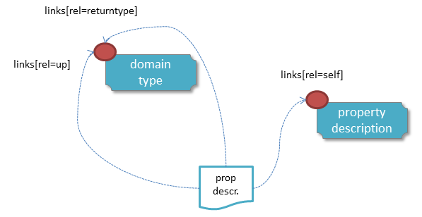
Figure 18: Domain Property Collection Representation
The JSON representation (for the Order's deliveryOptions property) looks something like:
{
"id": "deliveryOptions",
"friendlyName": "Delivery Options",
"description": "Time that the order will be delivered",
"optional": false,
"format": ... // for string properties only
"maxLength": ... // for string properties only
"pattern": ... // for string properties only
"links": [ {
"rel": "self",
...
}, {
"rel": "up",
"href":
"http://~/domainTypes/x.Order",
"type": "application/json;profile=\".../domaintype\"",
"method": "GET"
}, {
"rel": "returntype",
"href":
"http://~/domainTypes/string",
"type": "application/json;profile=\".../domaintype\"",
"method": "GET"
},
...
],
"extensions": { ... }
}
where:
JSON-Property | Description
links | list of links to resources
links[rel=self] | link to a resource that can obtain this representation
id | the Id of this property
friendlyName | the property name, formatted for rendering in a UI. The value should be internationalized, §1.21.
description | a description of the property, eg to render as a tooltip. The value should be internationalized, §1.21.
optional | indicates whether the property is optional
maxLength | for string properties, indicates the maximum allowable length
pattern | for string properties, indicates a regular expression for the property to match.
format | for string properties, indicates the format of the data type §1.22.3.
links[rel=up] | link to the domain type which owns this property
links[rel=returntype] | link to the domain type of which this property holds a value (ie, its return type)
links[rel=help] | optional; link to a media resource providing help about the property
extensions | additional information about the resource.
"extensions"
Restful Objects defines no standard json-properties within "extensions", but implementations are free to add further links/ json-properties to "links" and "extensions" as they require.
One possible example is to specify which properties should appear as table columns when the domain type in question is the element type of a collection or list being rendered as such.

Domain Collection Description Resource
The domain collection description resource represents a description of a domain collection, within the metamodel.
Clients can use the domain collection description's representation as hints when building a UI. For example, there will be links back to the domain type representing the collection's element type; this can be used by a client to determine columns for a table view. Or, the client can use information in the representation in order to apply client-side validation of declarative semantics (for example, minimum or maximum cardinality of a collection).
The endpoint URL for this resource is:
/domainTypes/{domainType}/collections/{collectionId}
where:
- {domainType} is either
  - the fully qualified type name, or
  - is a built-in JSON type
- {collectionId} identifies the collection.

HTTP GET
Obtain a representation of a description of a domain collection, within the metamodel.

GET Request

Query String
        - none

Headers
- Accept
  - application/json
  - application/json;profile=… /typecollection

Body
        - N/A

GET Response

Status Code
        - 200 "OK"

Headers
- Content-Type
  - application/json;profile=".../typecollection"
- Cache-Control:
  - max-age: 86400 (1 day)

Body
As per §1.78.

GET Not found Response

Status Code
- 404 "Not found"

Headers
- Warning:
  - No such domain type {domainType}.
  - No such domain collection {id} in domain type {domainType}

Body
- empty

Representation
The links from the domain collection description representation to other resources are as shown in the diagram below:
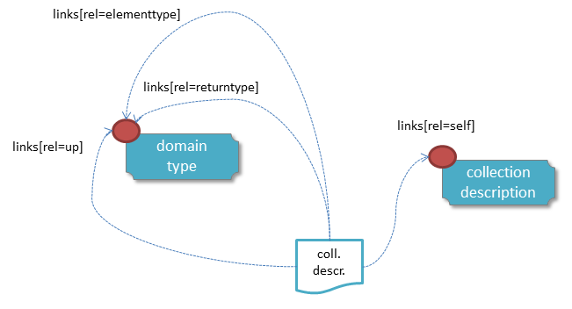
Figure 19: Domain Collection Description Representation
The JSON returned representation (for the Order's items collection) would look something like:
{
"id": "items",
"friendlyName": "items",
"description": "Line items (details) of the order",
"collectionType": "list ",
"links": [ {
"rel": "self",
...
}, {
"rel": "up",
"href": "http://~/domainTypes/x.Order",
"type": "application/json;profile=\".../domaintype\"",
"method": "GET"
},
{
"rel": "returntype",
"href": "http://~/domainTypes/java.util.List",
"type": "application/json;profile=\".../domaintype\"",
"method": "GET"
},
{
"rel": "elementtype",
"href": "http://~/domainTypes/x.OrderItem",
"type": "application/json;profile=\".../domaintype\"",
"method": "GET"
},
{
"rel": "help",
"href":
"http://~/videos/training/Order-items-explained.mpg",
"type": "audio/mpeg",
"method": "GET"
},
...
],
"extensions": { ... }
}
where:
JSON-Property | Description
links | list of links to other resources.
links[rel=self] | link to a resource that can obtain this representation
id | the Id of this collection
friendlyName | the collection name, formatted for rendering in a UI. The value should be internationalized, §1.21.
description | a description of the collection, eg to render as a tooltip. The value should be internationalized, §1.21.
collectionType | either 'list' or 'set'
links[rel=up] | link to the domain type which owns this property
links[rel=returntype] | link to the domain type of which this property holds a value (ie, its return type)
links[rel=elementtype] | link to the domain type of which this property holds a value (ie, its return type)
links[rel=help] | optional; link to a media resource providing help about the property
extensions | additional information about the resource.
"extensions"
Restful Objects defines no standard json-properties within "extensions", but implementations are free to add further links/properties to "links" and "extensions" as they require.

Domain Action Description Resource
The domain action description resource represents an action of a domain type, within the metamodel.
Clients can use the domain action description's representation as hints when building a UI. For example, the representation of an object action may include a link to that action's return type. A client can inspect all query-only domain service actions and make them available in the UI whenever an instance of their return type is required (as a property value, to add to collection or as an action argument)
The endpoint URL for this resource is:
/domainTypes/{domainType}/actions/{actionId}
where:
- {domainType} is either
  - the fully qualified type name, or
  - is a built-in JSON type
- {actionId} identifies the action.

HTTP GET
Obtain a representation of a description of a domain action, within the metamodel.

GET Request

Query String
        - none

Headers
- Accept
  - application/json
  - application/json;profile=".../typecollection"

Body
        - N/A

GET Response

Status Code
        - 200 "OK"

Headers
- Content-Type
  - application/json;profile=".../typecollection"
- Cache-Control:
  - max-age: 86400 (1 day)

Body
As per §1.80.

GET Not found Response

Status Code
- 404 "Not found"

Headers
- Warning:
  - No such domain type {domainType}.
  - No such domain action {actiond} in domain type {domainType}

Body
- empty

Representation
The links from the domain action description representation to other resources are as shown in the diagram below:
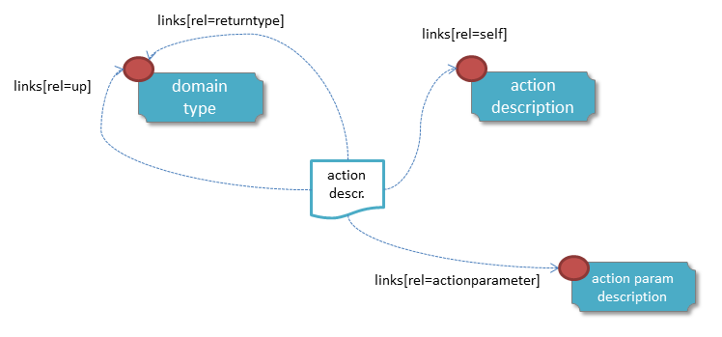
Figure 20: Domain Action Description Representation
The JSON representation of the domain action description (for the Order's submit action), it would look something like:
{
"id": "submit",
"friendlyName": "Submit",
"description": ...,
"hasParams": true
"links": [ {
"rel": "self",
...
}, {
"rel": "up",
"href": "http://~/domainTypes/x.Order",
"type": "application/json;profile=\".../domaintype\"",
"method": "GET"
},
{
"rel": "returntype",
"href": "http://~/domainTypes/java.util.List",
"type": "application/json;profile=\".../domaintype\"",
"method": "GET"
},
{
"rel": "elementType",
"href": "http://~/domainTypes/x.OrderReceipt",
"type": "application/json;profile=\".../domaintype\"",
"method": "GET"
},
{
"rel": "help",
"href": "http://~/videos/training/Order-submit.mpg",
"type": "audio/mpeg",
"method": "GET"
},
...
],
"parameters": [
{
"rel": "actionparam ",
"href": "http://~/domainTypes/x.Order/submit/params/ship",
"type":
"application/json;profile=\".../typeactionparameter\"",
"method": "GET"
},
{
"rel": "actionparam ",
"href": "http://~/domainTypes/x.Order/submit/params/rush",
"type":
"application/json;profile=\".../typeactionparameter\"",
"method": "GET"
},
...
],
"extensions": { ... }
}
where:
JSON-Property | Description
links | list of links to resources.
links[rel=self] | link to a resource that can obtain this representation
id | the Id of this action
friendlyName | the action name, formatted for rendering in a UI. The value should be internationalized, §1.21.
description | a description of the action, eg to render as a tooltip. The value should be internationalized, §1.21.
hasParams | whether the action has parameters
links[rel=up] | link to the domain type which owns this action
links[rel=returntype] | link to the action's return type
links[rel=elementtype] | optional; link to the element type if the action returns a collection.
links[rel=help] | optional; link to a media resource providing help about the action
parameters | list of links to parameter details §6
extensions | map of additional information about the resource.
"extensions"
Restful Objects defines the no standard json-properties within "extensions", but implementations are free to add further links/json-properties to "links" and "extensions" as they require.

Domain Action Parameter Description Resource
The domain action parameter description resource represents a description parameter of an action on a domain type, within the metamodel.
Clients can use the domain action parameter description representations as hints when building a UI. For example, there will be links back to the domain type representing each of the action parameter return types; this might be used in order to select the appropriate widgets when building a UI. Or, the client can use information in the representation to apply client-side validation of declarative semantics (for example, mandatory parameters, or regex patterns).
The endpoint URL for this resource is:
/domainTypes/{domainType}/actions/{actionId}/params/{paramName}
where:
- {domainType} is either
  - the fully qualified type name, or
  - is a built-in JSON type
- {actionId} identifies the action
- {paramName} is the named action parameter

HTTP GET
Obtain a representation of a description of a domain action parameter, within the metamodel.

GET Request

Query String
        - none

Headers
- Accept
  - application/json
  - application/json;profile=".../typeactionparameter"

Body
        - N/A

GET Response

Status Code
        - 200 "OK"

Headers
- Content-Type
  - application/json;profile=".../typeactionparameter"
- Cache-Control:
  - max-age: 86400 (1 day)

Body
As per §1.82.

GET Not found Response

Status Code
- 404 "Not found"

Headers
- Warning:
  - No such domain type {domainType}.
  - No such domain action { actionId} in domain type {domainType}
  - No such parameter name

Body
empty

Representation
The links from the domain action parameter description representation to other resources are as shown in the diagram below:
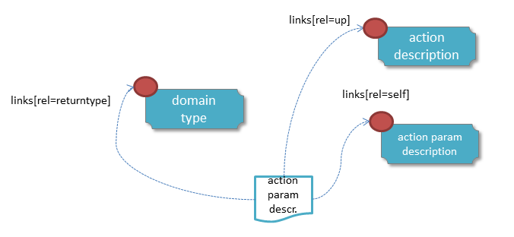
Figure 21: Domain Action Parameter Description Representation
The JSON representation returned (for example, if the Order's submit action's first parameter is a "shipMethod" string parameter) might look something like:
{
"id": "submit-shipMethod",
"number": 0,
"name": "shipMethod",
"friendlyName": "Ship Method",
"description": ...,
"optional": false,
"format": ... // for string params only
"maxLength": ... // for string params only
"pattern": ... // for string params only
"links": [ {
"rel": "self",
...
}, {
"rel": "up",
"href": "http://~/domainTypes/x.Order/actions/submit",
"type": "application/json;profile=\".../typeaction\"",
"method": "GET"
}, {
"rel": "returntype",
"href": "http://~/domainTypes/string",
"type": "application/json;profile=\".../domaintype\"",
"method": "GET"
}, {
"rel": "help",
"href":
"http://~/videos/training/Order-submit-shipMethod.mpg ",
"type": "audio/mpeg",
"method": "GET"
},
...
],
"extensions": { ... }
}
where:
JSON-Property | Description
links | list of links to other resources.
links[rel=self] | link to a resource that can obtain this representation
id | the Id of this action parameter (a concatenation of the parent action Id with the parameter name)
name | the name of the parameter
number | the number of the parameter (starting from 0)
friendlyName | the action parameter name, formatted for rendering in a UI. The value should be internationalized, §1.21.
description | a description of the action parameter, eg to render as a tooltip. The value should be internationalized, §1.21.
optional | indicates whether the action parameter is optional
maxLength | for string action parameters, indicates the maximum allowable length
pattern | for string action parameters, indicates a regular expression for the property to match.
format | for string action parameter, indicates the format of the data type §1.22.3.
links[rel=up] | link to the action which owns this parameter
links[rel=returntype] | link to the action parameter's return type
links[rel=help] | optional; link to a media resource providing help about the action parameter
extensions | map of additional information about the resource.
"extensions"
Restful Objects defines the no standard json-properties within "extensions", but implementations are free to add further links or json-properties as they require.

Domain Type Action Invoke Resource
The domain type action invoke resource represents an action that can be invoked on the domain type itself.
Conceptually it is similar to the domain object action invoke resource, §7, but the action is on the type rather than an instance of the type. However, (whereas the object action invoke resource can be used to invoke any domain object action), the type actions available to be invoked are explicitly specified.
Restful Objects defines the following type actions.
Type action | See | Description
isSubtypeOf() | §1.83 | to determine if a domain type is a subtype of (or the same as) a supertype.
isSupertypeOf() | §1.84 | to determine if a domain type is a supertype of (or the same as) a subtype.
The endpoint URL for this resource is:
/domainTypes/{domainType}/typeactions/{typeactionId}/invoke
where:
- {domainType} is either
  - the fully qualified type name, or
  - is a built-in JSON type
- {typeactionId} identifies the action
Both of the defined type actions take a single argument representing a link to the supertype.
As for the invocation of object actions (§7), type actions return a representation that links back to the type action and also to the result of the action (eg a list §7, a scalar §8, or a domain object, §2).
The links from the domain type action result representation to other resources are as shown in the diagram below:
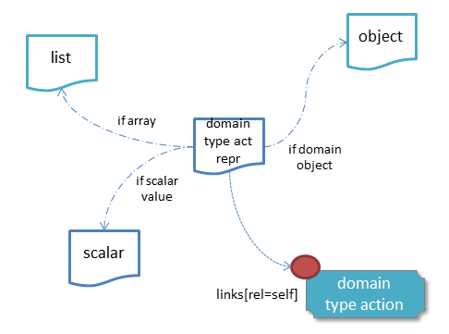
Figure 22: Domain Type Action Representation
The representations returned by type actions follow the format:
{
"links" : [ {
"rel" : "self",
"href" : "http://~/domainTypes/x.Customer/typeactions/... /invoke",
"method" : "GET",
"type" : "application/json;profile=\"urn:org.restfulobjects/typeactionsresult\"",
"arguments" : ...
} ],
"id": ...
"value" : ...,
"extensions" : { ... }
}
where:
JSON-Property | Description
links | list of links to other resources.
links[rel=self] | link to a resource that can obtain this representation
id | the typeActionId of this action
value | the result of the action
extensions | map of additional information about the resource.

HTTP GET isSubtypeOf()
Obtain a representation resulting from the invocation of the isSubtypeOf() domain type action. This is the reciprocal of the isSupertypeOf() type action §1.84.

GET Request

URL and Query String
The endpoint URL for this resource is:
/domainTypes/{domainType}/typeactions/isSubtypeOf/invoke
This resource requires a parameter "supertype" which can be specified either in the simple style, or in the formal style.

Simple Style
If the simple style of arguments §1.13.1 are supported by the implementation, then the query string is simply:
?supertype=xxx
where xxx is the fully qualified type name of the supertype.

Formal Style
If query arguments are specified using the formal style (§1.13.2) then the supertype should be specified as a map and then the map encoded as a URL (§1.13.2.5).
For example:
{
"supertype": {
"href":
"http://~/domaintypes/x.BasketOwner",
}
}
Note that the value should be a link to the supertype, rather than simply the name of the supertype.

Headers
- Accept
  - application/json
  - application/json;profile=".../typeactionresult"

Body
        - N/A

GET Response

Status Code
        - 200 "OK"

Headers
- Content-Type
  - application/json;profile=".../typeactionresult"
- Cache-Control:
  - max-age: 86400 (1 day)

Body (representation)
The JSON representation returned The JSON representation returned is a typeactionresult representation (as described earlier) with a scalar representation §8 inlined.
For example, if checking that the Customers domain type is a subtype of BasketOwner interface type, then the returned representation might look something like:
{
"links" : [ {
"rel" : "self",
"href" : "http://~/domainTypes/x.Customer/typeactions/isSubtypeOf/invoke",
"method" : "GET",
"type" : "application/json;profile=\"urn:org.restfulobjects/typeactionresult \"",
"arguments" : {
"supertype" : {
"href" :
"http://~/domainTypes/x.BasketOwner"
}
}
} ],
"id": "isSubtypeOf",
"value" : true,
"extensions" : { ... }
}
where:
JSON-Property | Description
id | the literal "isSubtypeOf" for this type action
value | a scalar boolean value.
and other properties are as described earlier.

GET Not found Response

Status Code
- 404 "Not found"

Headers
- Warning:
  - No such domain type {domainType}.
  - No such domain type action { actionId} in domain type {domainType}
  - No such super/subtype

Body
empty

HTTP GET isSupertypeOf()
Obtain a representation resulting from the invocation of the isSupertypeOf() domain type action. This is the reciprocal of the isSubtypeOf() type action §1.83.

GET Request

URL and Query String
The endpoint URL for this resource is:
/domainTypes/{domainType}/typeactions/isSupertypeOf/invoke
This resource requires a parameter "subtype" which can be specified either in the simple style, or in the formal style.

Simple Style
If the simple style of arguments §1.13.1 are supported by the implementation, then the query string is simply:
?subtype=xxx
where xxx is the fully qualified type name of the subtype.

Formal Style
If query arguments are specified using the formal style (§1.13.2) then the subtype should be specified as a map and then the map encoded as a URL (§1.13.2.5).
For example:
{
"subtype": {
"href":
"http://~/domaintypes/x.Customer",
}
}
Note that the value should be a link to the subtype, rather than simply the name of the subtype.

Headers
- Accept
  - application/json
  - application/json;profile=".../typeactionresult"

Body
        - N/A

GET Response

Status Code
        - 200 "OK"

Headers
- Content-Type
  - application/json;profile=".../typeactionresult"
- Cache-Control:
  - max-age: 86400 (1 day)

Body (representation)
The JSON representation returned The JSON representation returned is a typeactionresult representation (as described earlier) with a scalar representation §8 inlined.
For example, if checking that the BasketOwner domain type is a supertype of the Customer domain type, then the returned representation might look something like:
{
"links" : [ {
"rel" : "self",
"href" : "http://~/domainTypes/x.BasketOwner/typeactions/isSupertypeOf/invoke",
"method" : "GET",
"type" : "application/json;profile=\"urn:org.restfulobjects/typeactionresult \"",
"arguments" : {
"supertype" : {
"href" :
"http://~/domainTypes/x.Customer"
}
}
} ],
"id": "isSupertypeOf",
"value" : true,
"extensions" : { ... }
}
where:
JSON-Property | Description
id | the literal "isSupertypeOf" for this type action
value | a scalar boolean value.
and other properties are as described earlier.

GET Not found Response

Status Code
- 404 "Not found"

Headers
- Warning:
  - No such domain type {domainType}.
  - No such domain type action { actionId} in domain type {domainType}
  - No such super/subtype

Body
empty

Patterns
and
Practices

HATEOAS vs Web APIs
Comparing two styles of distributed system.

HATEOAS (Hypermedia Controls)
REST-based systems are typically designed to have a single or small number of starting (home page) resources, from which all other resources can be traversed. This is REST’s HATEOAS concept: hypertext as the engine of application state. Just as when using a web browser you can click through links to get to the next page, so should a REST client be able to follow a link to another resource.
Said more generally, links are an example of a hypermedia control by which the REST client can navigate the resources. The client knows what the link represents; however the value of the URL is opaque.
This style of REST is supported by Restful Objects in that all resources in Restful Objects are discoverable from the Home Page resource §1, acting as a well-known starting point.
All other resources can be obtained from the home page, for example by following the links that represent reference properties and collections between domain objects, or by invoking domain object actions can return references to other objects. Links are only included in representations if it makes sense for the client to follow them.

Web APIs (Templated URIs)
Some REST practitioners take the view that a pure-HATEOAS design places too much responsibility on the part of the client (having to traverse through multiple sets of representations from the start page), and that it is performant (for much the same reasons).
This isn't strictly true; a client is free to cache the value of a link between interactions (rather than find it out "from first principles" each time). Said another way: clients may bookmark links in order to move from one representation to the next (though should be prepared to recover if the link is no longer valid).
Even so, many developers prefer a system designed following a more API-based approach works, defining a set of well-known templated URIs, documented in the form:
path/{pathParam1}/pathPart/{pathParam2}/…
So long as the client has arguments for each of the {pathParam}'s then it can directly contruct the URL and invoke it.
It is debatable whether this style of system should be called REST; a better name is probably a(n HTTP-based) web API. Nevertheless it is popular, and is practicable. It is also supported by Restful Objects; the URLs for each of the resources included in the specification are well-defined, and the information needed to construct the URLs (such as the object identifiers) are provided as properties in the JSON representations.
Implementations of the spec may also choose to provide additional support (for example leveraging the capabilities of lower-level frameworks such as JBoss RESTEasy (http://www.jboss.org/resteasy) that provide explicit support for client-side templated URIs.

Personal vs Shared State
Different types of resource state, what is not resource state, and discussion of the "domain-model rest anti-pattern" paper.

Resources representing Shared State
In Roy Fielding's thesis that originally describes the REST architectural style, the definition of a resource is very general, with the focus being that resources may be identified and thus may be linked to.
The examples of resources given by Fielding in his thesis tend towards shared information, for example a document, an image, "today's weather in Los Angeles", or "revision 1.2.7 of a source code file".
These examples of resources are shared in the sense that any user could ask the system for a representation of the resource, and would obtain broadly the same information. Put another way, these resources correspond to domain entities, with the representations being a projection of the state of those entities. Their representation may need to be versioned to allow clients to evolve independently of server, but that is a separate issue (see §3).
Most of the examples in this specification are of domain entities: customer, order, product and so forth. The representations of these entities have hypermedia controls (links) to enable to client to navigate between entities, either as a result of following a property or collection, or as the result of invoking an action. The links available may vary depending upon both the state of the resource, and upon the authorization of the user requesting the representation.
For example, the client can use the (link representing the) Order's placedBy property to find the Customer that placed the order, or can use the (lnk representing the) Order's items collection to find the items within the Order. However, an Order that has not yet been placed might suppress the Customer link.
Links not only represent static relationships between entities, they can also represent entity behaviour. So, the Order could have been created in the first place by the client following the (link representing the) Customer's placeOrder() action. However, a user with insufficient privileges might not see the placeOrder() link.
In this way, resources representing domain entities fully support the HATEOAS constraint (§1.85) of RESTful systems.

Resources representing Personal State
Whereas domain entities constitute shared state (available to any requesting user), some state is private to a given user and should not be accessible to other users.
The classic example is that of a ShoppingCart. Each user may have access to a resource representing "their" ShoppingCart, but should not be able to access (or even determine the existence of) other users' ShoppingCarts.
Resources that capture such "personal" state often double up as a means to take the user through the process of completing a user goal. For example, the initial representation of a ShoppingCart may provide links to browse for products to add to the cart. Once some products have been added, it may additionally provide a link to checkout the cart. Once the checkout is started, the links will change to the various steps of the checkout process (credit card, delivery options and so on).
Restful Objects does not specify how implementations should distinguish between a resource that holds personal state and one that holds shared state. One possible approach though would be for implementations to look for a reserved/annotated "UserId" property in the domain object; for example:
public class ShoppingCart {
@UserId
public int getPersonalTo() { … }

public List<Item> getItems() { … }
…
}
If the "UserId" property is present then the implementation infers that the object is personal to that user, and never returned as a resource if requested by any other user.

Application State
Personal state, discussed above, is not the same as application state, though the distinction is subtle. In a blog post from 2008, Roy Fielding wrote:
Don’t confuse application state (the state of the user’s application of computing to a given task) with resource state (the state of the world as exposed by a given service). They are not the same thing.
At first glance one might consider that this definition does not afford for resources to represent personal state; after all, a personal state resource exists to manage the state of a user's application. However, we should not confuse the state of a resource on the server with the state that consuming its representation generates on the client. Put another way: if a user accesses their shopping cart with a web browser, then the application state is not the shopping cart resource, it is the in-memory DOM structure within their browser.
What this also means is that the phrase "state of the world" in Fielding's definition is quite narrow: it should be taken to mean "as observed by a given user" rather than "as observed by any user". REST does therefore allow for resources to have either personal state or to have shared state.

Domain Model Resources an Anti-Pattern?
Some REST practitioners argue that exposing domain model objects through REST is an anti-pattern. Or to use the terminology introduced in this chapter, the argument is that resources should only expose personal state, never shared state. To this, we strongly disagree.
For a system to be called RESTful it must obey the HATEOAS constraint and provide hypermedia controls to enable the client to navigate its resources. As described above, both personal state resources (shopping carts) and shared state resources (customer, order, product) can do this. And in both cases the set of links returned in the representation will depend upon the state of the resource and upon the requesting user. There is nothing intrinsically different between personal and shared state resources in this regard; the real objection to exposing domain entities through REST would seem to lie elsewhere.

Inductive vs Deductive Style
A more useful distinction is between systems that use an inductive style and those that use a deductive style. The inductive style is about taking the user through a series of steps in order to accomplish a goal. The inductive style works well when the domain is complex and the users needs explicit assistance in order to navigate it. One of the earliest examples was Microsoft Money 2000, which took users through various common-place financial book-keeping tasks.
The opposite of the inductive style is the deductive style, and a good example is a word-processor that starts with a blank page and more-or-less leaves the user to write the document in any order that they choose.
Other examples of deductive style apps are IDEs and the UNIX shell. The developer is free to write code in any order, or to string UNIX commands together as they see wish. Deductive style applications have much in common with sovereign applications.

Application styles and Resource state
The key distinction between inductive and deductive style is about who is in charge – the user or the computer?. With an inductive application the process is hard-wired into the system, and the user must follow this process. With a deductive application the system offers the functionality to allow the user to accomplish their goal, but does not mandate the order of the user's interactions; the process is in the user's head.
There is no right or wrong to this; as already noted it depends on the experience of the user with respect to the domain. An inductive system can be frustrating to use for an experienced user, while a deductive system can leave an inexperienced user at a loss as to how to proceed.
Tying the above back to REST, applications built in the inductive style are make heavy use of resources with personal state, with those resources modelling a user's goal and holding the state of the user's progression to that goal. The resource represents a use case instance, and its representation has links that represent the state transitions of the use case instance. These resources will most likely interact with underlying domain entities structures but those entities are never exposed.
In contrast, applications built in the deductive style will more likely make use of resources with shared state (domain entities), with the functionality of those entities made directly available for the user to invoke as they see fit. This is not a CRUD system; the behaviour on the entities is every bit as rich as the behaviour exposed by a use case resource.
In practice, most systems mix of inductive and deductive styles, with corresponding resources to match. In an internet shop, the browsing of the shop is deductive in nature; the user can hop from product to product as they see fit. The checkout process though is more well-defined, and users tend to expect to be taken through it.
A related approach is to start with a deductive system, and then to add look for the "commonly-trodden path". These paths can be determined by observing experienced users' behaviour of the system, and then using this to provide inductive guidance for less experienced users.

Client vs Server Evolution
Why content negotiation may be needed, and when it is not needed.

Motivation
One of the goals of REST is to enable both the client and server to evolve independently. In particular, a server should be able to be enhanced to offer new functionality but existing clients should carry on working and simply ignore (be unaware of) this new functionality. As clients require the new functionality, they can be updated and deployed separately from the server.
In many cases it is relatively easy to maintain backward compatibility. For example, a representation of a Customer may initially include the Customer's firstName and lastName. Adding a new middleInitial property will not break existing clients.
Sometimes, however, representations are restructured in a way that would break the client. For example, the developer might want to restructure the representation of a Customer such that the firstName, middleInitial and lastName are all moved onto an associated Name object. In this case any client expecting there to be a firstName or lastName property on Customer will break.

Content Negotiation
The standard solution to this is to version representations, with media types as the identifier for a particular version of a representation. The client indicates the version of the representation it requires using the Accept header. The server either serves up that representation with a matching Content-Type header, or returns a 406 "not acceptable" error. The name for this process is ‘content negotiation’ (sometimes shortened to ‘conneg’).
Restful Objects supports conneg by allowing the certain representations to be served using an application-defined media type, rather than its generic media type. The mechanism by which this is indicated is implementation-specific, though typically would be through an annotation or attribute.
For example, a Customer (in Java) might be written as:
package com.mycompany.myapp.v1;
...
@ApplicationDefinedMediaType
public class Customer {
...
private String firstName;
private String lastName;
private String middleInitial;
...
}
Any representation of Customer would then have a Content-Type of:
application/json;profile=urn:com.mycompany.myapp.v1.Customer
The implementation then ensures that any request received that would render a Customer representation has a compatible Accept header. Meanwhile, for the server-side developer, the annotation is an indicator to the developer that no breaking changes should be introduced.
If the Customer class needs to be modified, then the developer should create a new class:
package com.mycompany.myapp.v2;
...
@ApplicationDefinedMediaType
public class Customer {
...
private Name name;
...
}
where Name would most likely also be served up with an application-defined media type::
package com.mycompany.myapp.v2;
...
@ApplicationDefinedMediaType
public class Name {
...
private String firstName;
private String lastName;
private String middleInitial;
...
}
At this point the server-side developer has two versions of Customer to deal with, though both represent the same server-side state. Put another way, the two versions of Customer are both projections of the same state.
This spec does not mandate how implementations should handle these versions, though two possible strategies are either:
- to rely upon the underlying persistence mechanism to provide projection support.
For example, an implementation that persists to an RDBMS can use views and "instead-of" triggers.
- or, to provide an SPI allowing the server-side developer to mediate between the underlying resource state and the projections.

When Conneg isn't required
While content negotiation and application-defined media types are undoubtedly important, they do bring with them a maintenance overhead for the application developer. It's therefore also worth understanding when they are not needed.
First, if new versons of client(s) and server can be deployed at the same time (typically when the developer "owns both ends of the pipe"), then application-defined media types can be dispensed with. This is a realistic scenario for many (most?) enterprise applications that are only used internally within organizations.
Another scenario where application-default media types are not required is when the client is generic, in other words able to process any representation served up by Restful Objects. Indeed, one of the objectives of Restful Objects is to enable the development of clients such as this.
The analogy here is the humble web browser which has built-in knowledge of the text/html media type and is able to render any representation with this media type. Similarly, a Restful Objects "browser" would have built in knowledge of the various application/json;profile="urn:org.restfulobjects/xxx" representations, and as such would be able to render domain objects, lists, action prompts and so on.
To summarize:
- If the client and server are developed together, then the default media types may be used.
- If the server and client are developed independently, but the client is generic, then again the default media types may be used.
- If the server and client are independent and the client makes hard-coded assumptions about the representations that it consumes, then application-defined media types and content negotiation should be used.

FAQs

"Restful Objects can expose domain entities as resources. But doesn't exposing domain entities mean that the server and client are closely coupled, thereby violating REST?"
The media types for the representations defined by Restful Objects indicate that a representation is of an object, a property, a collection or an action, but they do not indicate a particular type of object (like Customer). It is therefore possible to write a fully generic, purely RESTful client, driven purely from hypertext, if you so wish.
Alternatively, you can use application-defined media types so that clients can use conneg to request specific representations of domain objects. That these domain objects may be entities is an implementation concern; §2 provides some background on how frameworks may choose to address this point.
It is also worth noting that close coupling between client and server may not be an issue; an application team may control the deployment of both and has chosen to use REST to connect them together for other reasons. In this case domain entities can be exposed without any need to create a projection or application-defined media types. An obvious example is a client written using code-on-demand (ie Javascript), where the client pulls representations from multiple resources to support specific use cases.

But isn't exposing domain entities just the wrong thing to do? Surely I should be exposing use cases as resources?
Not necessarily; both are valid approaches.
Some practitioners have claimed that exposing entities makes it difficult to render the relevant links to support hypermedia-driven designs. While this may be a legitimate issue with some frameworks, such issues are not a problem with Restful Objects (due to framework implementations' use of an underlying metamodel).
As noted in §2, Restful Objects is agnostic as to what it exposes: use cases, or entities. Because of that, you can start off exposing behaviour directly on entities. Later on – if you find that you need them – then you can start to add in either commands/use case objects to support the commonly-trod paths.
In other words, Restful Objects lets you add in layering as and when it's justified, but allows you to defer that decision until a later point in the project when you've learnt more.

I prefer having an application service layer that exposes use cases and views. Doesn't Restful Objects simply move the design work that I would normally have done in my resources back a level".
Yes, it does.
But the benefits of doing so are that it reduces the learning curve for new developers, it separates responsibilities of your system, it eliminates the need to explicitly document the REST API, and it makes the domain classes easier/faster to test. There's further discussion on all this in §1.3.

http://en.wikipedia.org/wiki/REST
http://www.ics.uci.edu/~fielding/pubs/dissertation/rest_arch_style.htm
The spec tries not to reinvent existing wheels, but we always welcome suggestions as to other existing standards that Restful Objects might usefully incorporate.
A list of known implementations of the Restful Objects specification is maintained at www.restfulobjects.org
http://creativecommons.org/licenses/by-sa/3.0/
In computer science terms, an idempotent function is one that if repeatedly applied, has the same impact as being applied once ; see http://en.wikipedia.org/wiki/Idempotence.
In computer science terms, a query-only action is "side-effect-free": it does not make any change to persisted data. See http://en.wikipedia.org/wiki/Side_effect_(computer_science). A query only action is always idempotent)
http://www.w3.org/Protocols/rfc2616/rfc2616-sec14.html#sec14.7
Note that the spec does allow for non-JSON media types of attachments, eg application/pdf. See 1.27.
http://buzzword.org.uk/2009/draft-inkster-profile-parameter-00.html
Unlike the "profile" parameter, there is no standard or semi-standard parameter to reuse. The "x-ro-" prefix of the "x-ro-domaintype" parameter is to avoid name clashes with other emerging standards.
http://www.w3.org/Protocols/rfc2616/rfc2616-sec14.html
http://www.iana.org/assignments/link-relations/link-relations.xml
The term "arguments" is used here in a very general sense, applying both to the providing of values of object properties as well as of action arguments.
http://www.w3.org/Protocols/rfc2616/rfc2616.html, sec 4.3 and 9.7.
Emperical testing confirms that bodies are not preserved by servlet containers such as Tomcat and Jetty. Proxies may also strip out the body.
eg, using http://meyerweb.com/eric/tools/dencoder/
http://www.ietf.org/rfc/rfc1738.txt;
excluding the hostname part of a URL, which is case insensitive.
http://oauth.net
assuming, that is, that Cache-Control header is not set to no-cache.
http://tools.ietf.org/html/draft-zyp-json-schema-03, section 5.23.
Note that unlike sorting §1.25 Restful Objects does NOT require that implementations can page object collections. This reflects the authors' view that collections with large cardinality should be broken out into actions.
http://en.wikipedia.org/wiki/Query_string
Note that this is different from the body provided to PUT Object §1.51 used to update multiple properties.
the reserved x-ro-follow-links query parameter may also be used to request that more detailed information is returned in the representation.
Since the representation obtained from this resource is just a domain object representation, it is possible to use the {oid} and also access domain services using the GET Domain Object resource §2. However, this is discouraged.
http://roy.gbiv.com/untangled/2008/rest-apis-must-be-hypertext-driven#comment-744 . The main objections relate to
And they argue quite strongly; see for example http://java.dzone.com/articles/domain-model-rest-anti-pattern.
http://msdn.microsoft.com/en-us/library/ms997506.aspx
http://en.wikipedia.org/wiki/Application_posture
Code-on-demand can also be used to develop quite sophisticated generic clients, using Javascript templating engines.

