**1.**

**All.sh**

#!/bin/bash

Echo “Name of program: $0”

Echo “There are $# parameter(s)”

Echo “The parameters are $*”

**OUTPUT**

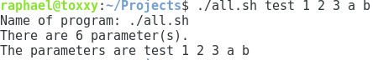

**2.**

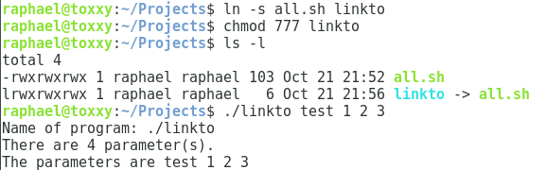

**3.**

**ifRead.sh**

#!/bin/bash

WORD1=$1

WORD2=$2

If [ $WORD1 = $WORD2 ]

Then

Echo “Match”

Fi

Echo “End of program.”

**OUTPUT**



