Extra Dimensions
It was in 2000 when we started our group on extra dimensions in Frankfurt. I still remember how The-Other-Stefan called me from the Les Houches summer school. Knowing that I had been obsessed with the idea of extra dimensions for years, he told me 'Here, everyone is talking about extra dimensions. It's completely nuts!'
The following week, Horst stomped into my office with the article in Scientific American (The Universe's Unseen Dimensions, August 2000), just to find it already lying on my desk. I am not sure who put it there, it wasn't me, but apparently there was no way around reading the papers by Arkani-Hamed & Co.
I can't say I liked what I read. I liked the original Kaluza-Klein idea, but these extra dimensions had little, if anything, to do with it. Anyway, I was completely stuck with my work (work on something I found out years later had been done already in the 80ies) and thought I could give the 'modern' extra dimensions a try.
We kept telling ourselves the topic would vanish soon, and we shouldn't spent to much time on it. Instead, the idea of phenomenologically accessible extra dimensions has flourished since (in an almost scary way), and the parameters of the models are by now included in the Particle Data Group's search for physics beyond the Standard Model.
Here, I would like to briefly introduce the main concepts, together with some references, to give you an impression of what I have been working on.
For a very readable introduction on the subject to non-experts, I can recommend Lisa Randall's book 'Warped passages'.
1. Why Extra Dimensions?
2. Models With Extra Dimensions
3. Observables of Extra Dimensions
4. Further Reading

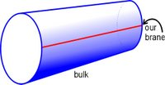
1. Why Extra Dimensions?
My motivation to study models with extra dimensions is simple. As long as I don't know of any good reason why we live in 3+1 dimensions, the question whether our spacetime has additional dimensions is definitely worth the effort of examination. This means one has to figure out how the assumption of additional extra dimensions can be included into our current theory, the Standard Model (SM), in such a way that this is compatible with our present day observation, and then ask what observable consequences this yields.
However, we first have to explain why we don't see any of the extra dimensions in our daily live, since we rarely witness things vanish into the 5th dimension. The most common way to do this is to assume that the extra dimensions are compactified on a small radius (ADD and UXD-models). Another way is to give the extra dimensions a strong curvature, which basically makes it hard to escape into them (RS-models).
In the ADD and RS-model, we - or the particles of the SM respectively - are bound to a 3-dimensional submanifold. This submanifold is often referred to as 'our brane', whereas the whole higher dimensional spacetime is called 'the bulk'.
The setup of these brane-world models is motivated by string theory, and whenever you post a paper and forget to cite Antoniadis '90, I can picture him jumping up and down in his office, tearing out his last some hears - before he writes you a polite email demanding to be cited appropriately. Which I have done hereby.
The attractive feature of models with extra dimension is that they provide us with an useful description to predict observable effects beyond the SM. They do by no means claim to be a theory of first principles or a candidate for a grand unification! Instead, their simplified framework allows the derivation of testable results which can in turn help us to gain insights about the underlying theory.
On the other hand this means that theories with extra dimensions are not consistent on their own. E.g. they don't explain without invoking further mechanisms why which particles are bound to the brane, or how the extra dimensions are stabilized

2. Models with Extra Dimensions
There are different ways to build a model with an extra dimensional space-time. The most common ones are:
2. a) Large Extra Dimensions
The ADD-model proposed by Arkani-Hamed, Dimopoulos and Dvali in '98 adds d extra spacelike dimensions without curvature, in general each of them compactified to the same radius. All SM particles are confined to our brane, while gravitons are allowed to propagate freely in the bulk.

- The Hierarchy Problem and New Dimensions at a Millimeter
- New Dimensions at a Millimeter to a Fermi and Superstrings at a TeV
- Phenomenology, Astrophysics and Cosmology of Theories with Sub-Millimeter Dimensions and TeV Scale Quantum Gravity
In four dimensions, the scale at which effects of quantum gravity are expected to become important is the Planck scale. It's large value of ~ 1016 TeV is far out of reach for future collider experiments. It is puzzeling why this scale is so much larger than all the other mass scales in the SM. This is the so-called hierarchy problem.
The higher dimensional theory comes with a higher dimensional Planck scale Mf which can be close by a TeV. The large observed value of our Planck scale is then caused by the presence of the extra dimensions: In contrast to all the other interactions, gravity dilutes into the extra dimensions. Thereby, the gravitational potential falls off faster at distances smaller than the radius of the extra dimensions. At larger distances however, the usual behaviour is recovered, but with an already weakend strength. This is shematically illustrated in the figure below.
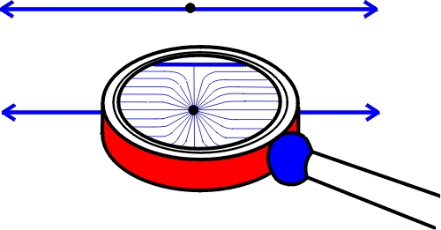
These models thus explain why gravity is so much weaker than the other interactions (or at least reformulate it in a geometrical language).
This in turn means that at smaller distances, gravity is much stronger than what we expect from the extrapolation of the 3-dimensional force law. It will run with a different power law in the radial distance r, which is related to the number of dimensions as 1/rd+1.
These extra dimensions are called 'large' because the radius is much larger than the inverse of the new fundamental scale. It turns out that the model with one extra dimension is incompativle with observation (the extra dimension would have about the size of the solar system). For d=2, the radius of the extra dimension can be as large as 1/10 mm. The larger the number of extra dimensions, the smaller the radius.
b) Universal Extra Dimensions
Within the model of universal extra dimensions all particles (or in some extensions, only gauge fields) can propagate in the whole higher dimensional spacetime. These extra dimensions typically have radii of ~ 10-18 m are compactified on an orbifold to reproduce SM gauge degrees of freedom. These models come closest to the original idea of Kaluza and Klein.
- Bounds on Universal Extra Dimensions
- Collider Implications of Universal Extra Dimensions
- Probes Of Universal Extra Dimensions at Colliders
It is worth noting that, unlike the ADD-model, no location along the extra dimension is exeptional and thus, translational invariance holds. This means, that the momentum in direction of the extra dimensions is conserved.
c) Warped Extra Dimensions
The setting of the model from Randall and Sundrum is a 5-dimensional spacetime with
an non-factorizable, so called 'warped' geometry. Roughly spoken, when you go into the direction of the extra dimensions, all your scales will be stretched by a factor depending on the distance to our brane. The solution for the metric is found by analyzing the solution of Einstein's field equations with a constant energy density on our brane where the SM particles live. In the type I model the extra dimension is compactified, in the type II model it is infinite. The resulting metric is an AdS-Space, which makes the model particularly interesting.
- An Alternative to Compactification
- A Large Mass Hierarchy from a Small Extra Dimension
d) Split Fermions
The split fermion model is not exactly a model on its own, but it serves as a quick fix for some problems that arise within models with a lowered fundamental scale. Namely, contributions in the SM that e.g. cause the proton to decay, are usually suppressed by the large value of the Planck scale. If the Planck scale is lowered they can become quite troublesome, and would allow the proton to decay rather fast. Since - luckily - the proton seems to be very long lived, it remains to explain why these processes do not occur.
In the split fermion model, the wave-functions that correspond to the particles of the standard model, are localized around different positions in the direction of the extra dimensions.
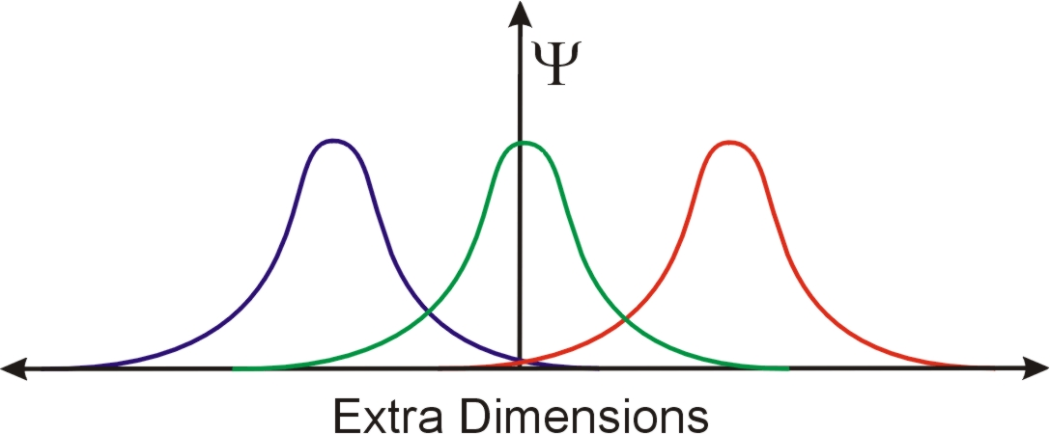
To compute the effective coupling between these particles, and thus, the strength of the above mentioned decay modes, one has to integrate the product of these wave-functions over the extra dimension. This overlap can be tiny, even with small separations. This is not only useful to suppress higher dimensional operators (also flavor changing ones), but can also be used to explain the very different masses of the fermions.
- Hierarchies without Symmetries from Extra Dimensions
- Yukawa Hierarchies from Split Fermions in Extra Dimensions
- Split Fermions in Extra Dimensions and Exponentially Small Cross-Sections at Future Colliders

3. Observables of Extra Dimension
The above mentioned models lead to a vast number of observable predictions, for high energy physics, high precision measurements and astrophysics. The current constraints on the parameters of the models can be found in the Particle Data Book.
a) Newtons Law
The most obvious experimental test for the existence of extra dimensions is a measurement of the Newtonian potential at sub-mm distances, since we have seen above that large extra dimensions predict a different power law. Cavendish-like experiments which search for deviations from the 1/r potential have been performed during the last years with increasing precision and do currently require the extra dimensions to have radii not larger than ~ 0.045 mm (which disfavors the case of two extra dimensions).
- Sub-millimeter Tests of the Gravitational Inverse-square Law
- New Experimental Limits on Macroscopic Forces Below 100 Microns
- Measuring Gravity on Small Length Scales
- Upper limits to submillimetre-range forces from extra space-time dimensions
- Short-Range Searches for Non-Newtonian Gravity
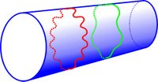
b) KK-Excitations
Periodic boundary conditions, as caused by compactification, lead to geometrically quantized momenta in the direction of the extra dimensions. This means the momentum in the extra dimension can only come in discrete steps. The step-size is the inverse of the radius. A particle with non-zero momentum in the extra dimension will appear to have less momentum left for the usual dimensions. It will thus behave on our brane as if it had an additional mass.
A particle that is allowed to enter the extra dimensions will therefore come with a whole 'tower' of momenta that on our brane appear like copies of the same particle with different masses. These so-called KK-excitations of the particles can in principle be produced in scattering experiments, if the energy is high enough to provide enough momentum.
- TeV Strings and Collider Probes of Large Extra Dimensions
- Particle Physics Probes Of Extra Spacetime Dimensions
- Probes Of Universal Extra Dimensions at Colliders
- On Kaluza-Klein States from Large Extra Dimensions
c) Real and Virtual Graviton Production
In the ADD-model the graviton will have a tower of KK-excitations, and since the radii of the dimensions are large, the mass spacing will be very small. It takes a whole lot of these flimsy gravitons to add up to an observable contribution. Typically, these contributions become comparable to SM-processes if the total energy of a collision reaches the new fundamental scale.
Real graviton production would lead to an apparent loss of energy, since the graviton does not lead to a signal in the detector. Also, virtual exchange of gravitons can take place, which modifies predictions for processes made within the SM.
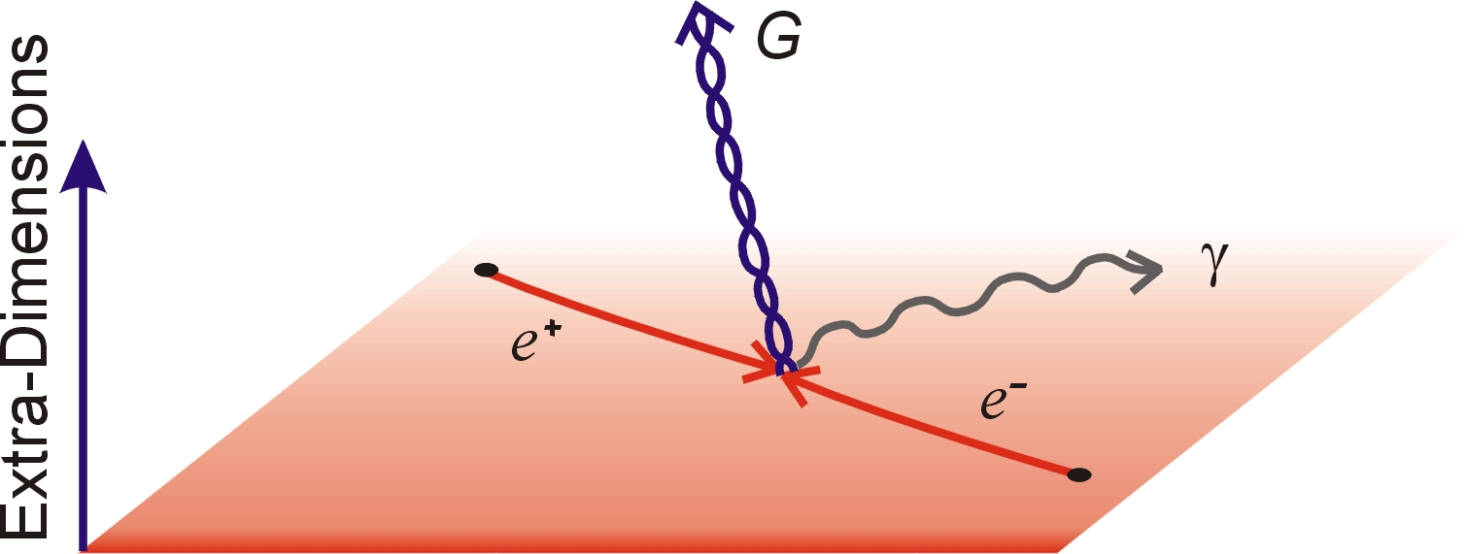
d) Black Hole Production
As we have seen, in the ADD-model gravity on distances significantly smaller than the radius of the extra dimension, is much stronger than in the usual three-dimensional scenario. The horizon of a black hole is the surface at which photons can no longer escape the gravitational pull. In the presence of extra dimensions, this happens at a much larger distance. Black holes can therefore be produced easier. The density that is needed to cause a gravitational collapse is such that it can be reached at future colliders.
Whenever two colliding particles with sufficiently high energy come closer together than the horizon radius of their total energy, the system will collapse and cause a black hole. One can estimate the number of black holes that would be produced at the LHC. For Mf ~ 1TeV one finds about 1 black hole per second.
These black holes would not be stable. Due to quantum effects, they undergo Hawking evaporation with a very high temperature (~ 300 GeV ~ 1015 K) and decay before they reach the detector. They will however give a very distinct signature.

