Nama : Restu Lestari Mulianingrum

NIM : A11.2022.14668

Kelompok : A11.4415

**Tugas 1**

Program sederhana untuk menampilkan data pribadi

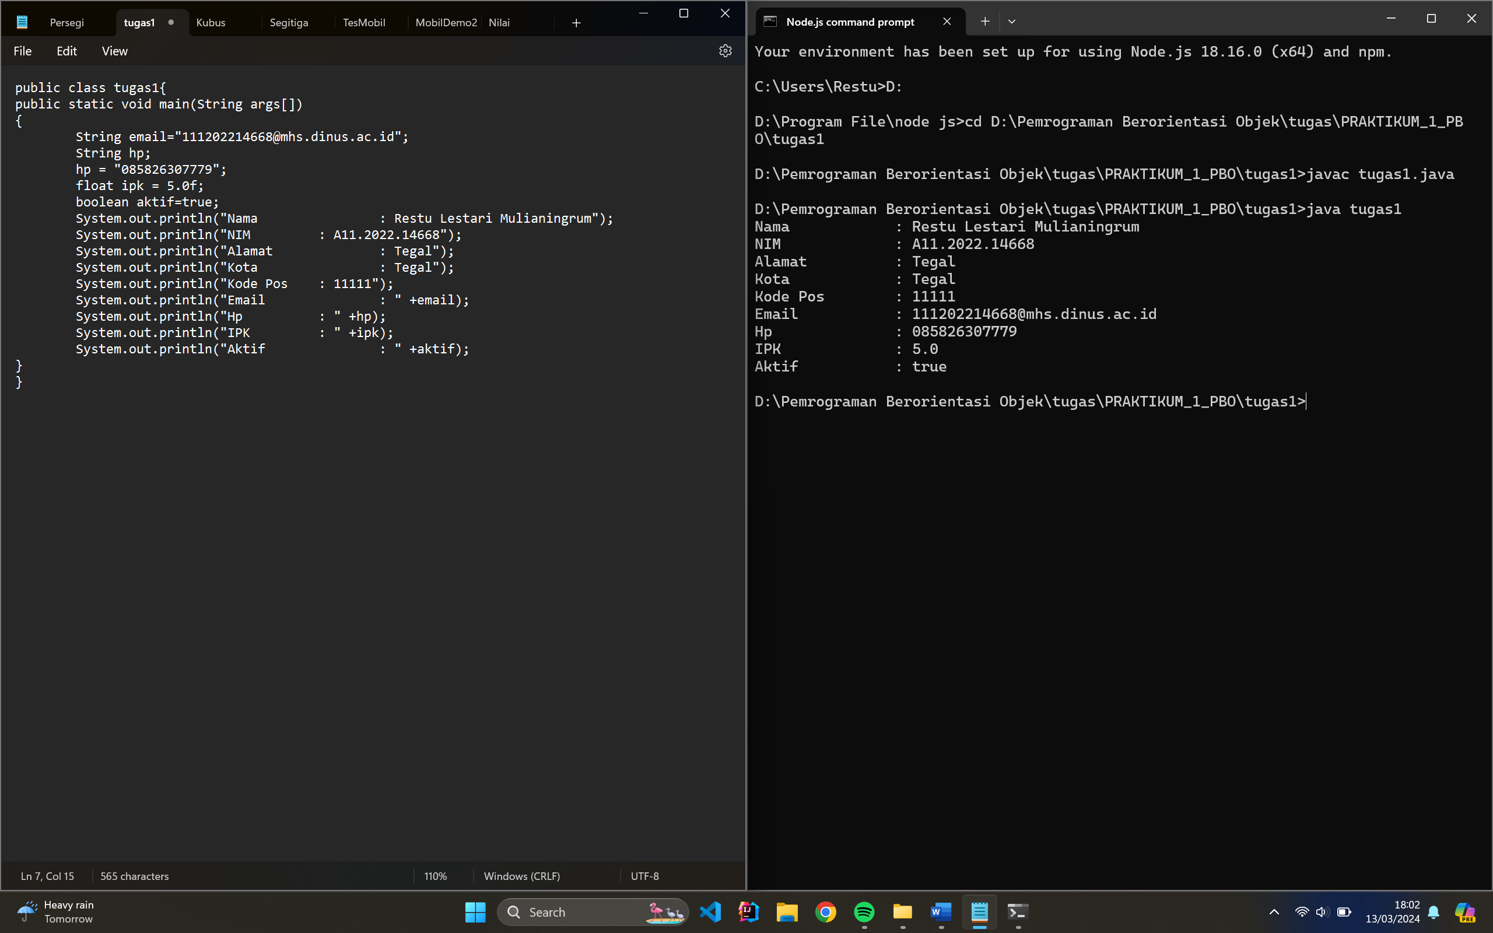

**Code Program:**

public class tugas1{

public static void main(String args[])

{

String email="111202214668@mhs.dinus.ac.id";

String hp;

hp = "085826307779";

float ipk = 5.0f;

boolean aktif=true;

System.out.println("Nama : Restu Lestari Mulianingrum");

System.out.println("NIM : A11.2022.14668");

System.out.println("Alamat : Tegal");

System.out.println("Kota : Tegal");

System.out.println("Kode Pos : 11111");

System.out.println("Email : " +email);

System.out.println("Hp : " +hp);

System.out.println("IPK : " +ipk);

System.out.println("Aktif : " +aktif);

}

}

**Output:**

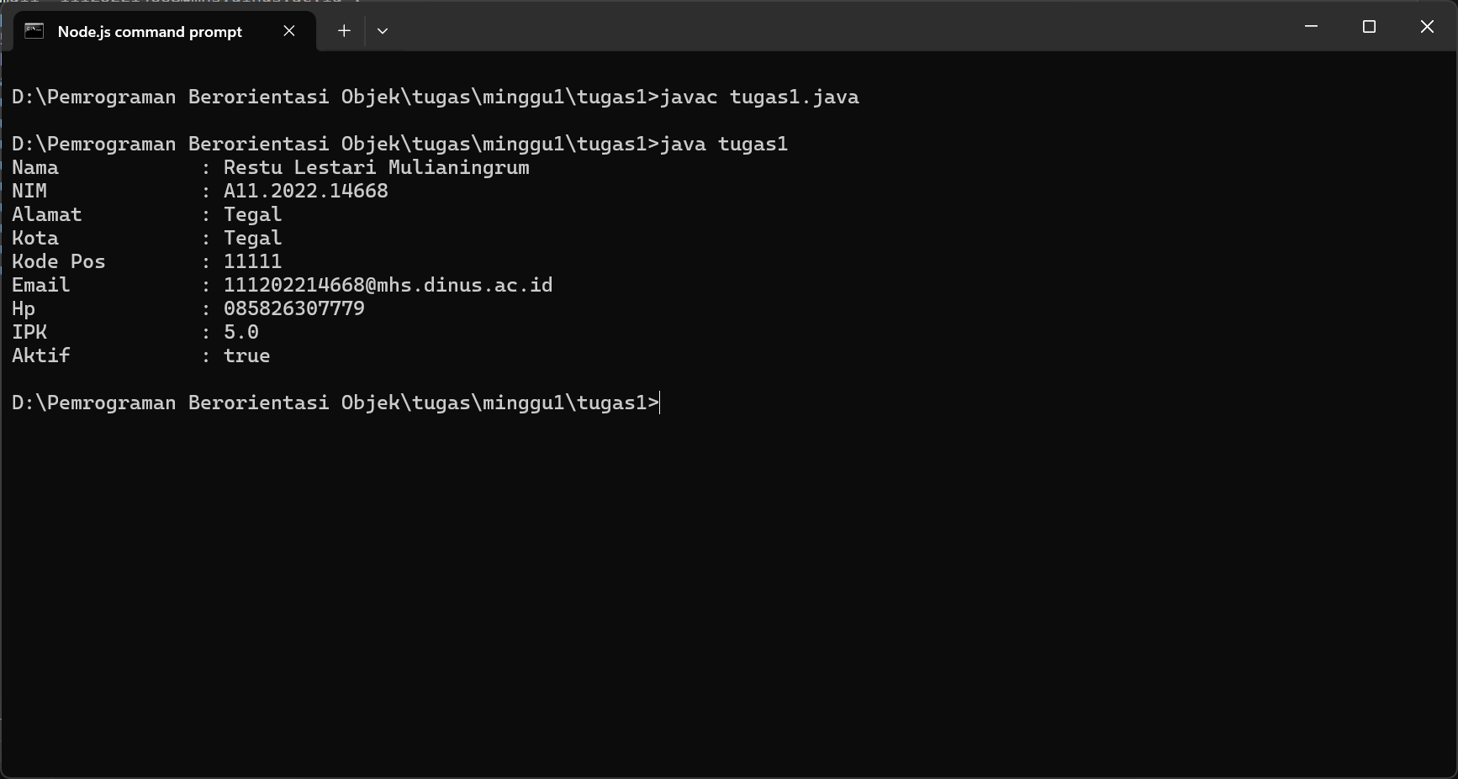

**Tugas 2**

Program menghitung luas dan keliling

1. **Persegi**

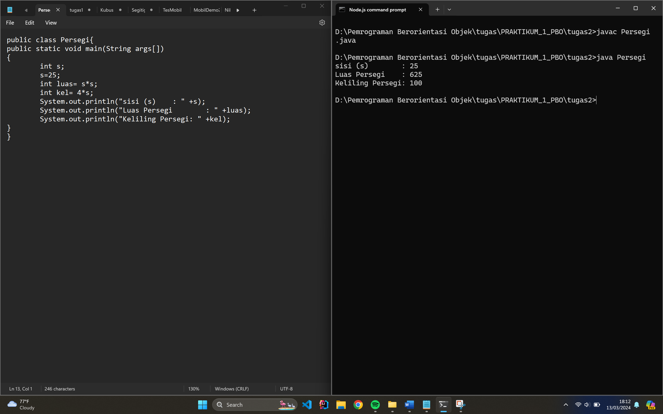

**Code Program:**

public class Persegi{

public static void main(String args[])

{

int s;

s = 25;

int luas= s*s;

int kel= 4*s;

System.out.println("sisi (s) : " +s);

System.out.println("Luas Persegi : " +luas);

System.out.println("Keliling Persegi: " +kel);

}

}

**Output:**

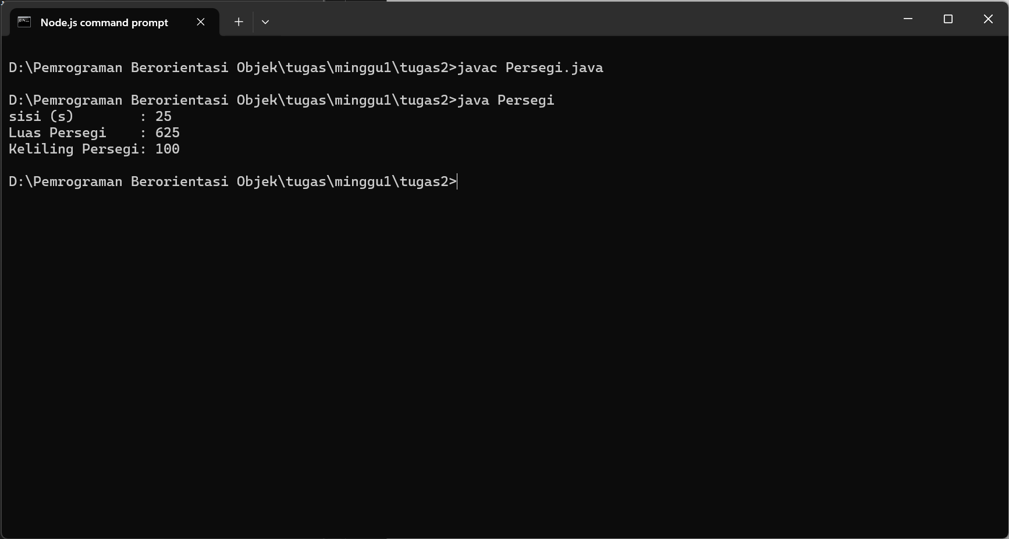

1. **Segitiga**

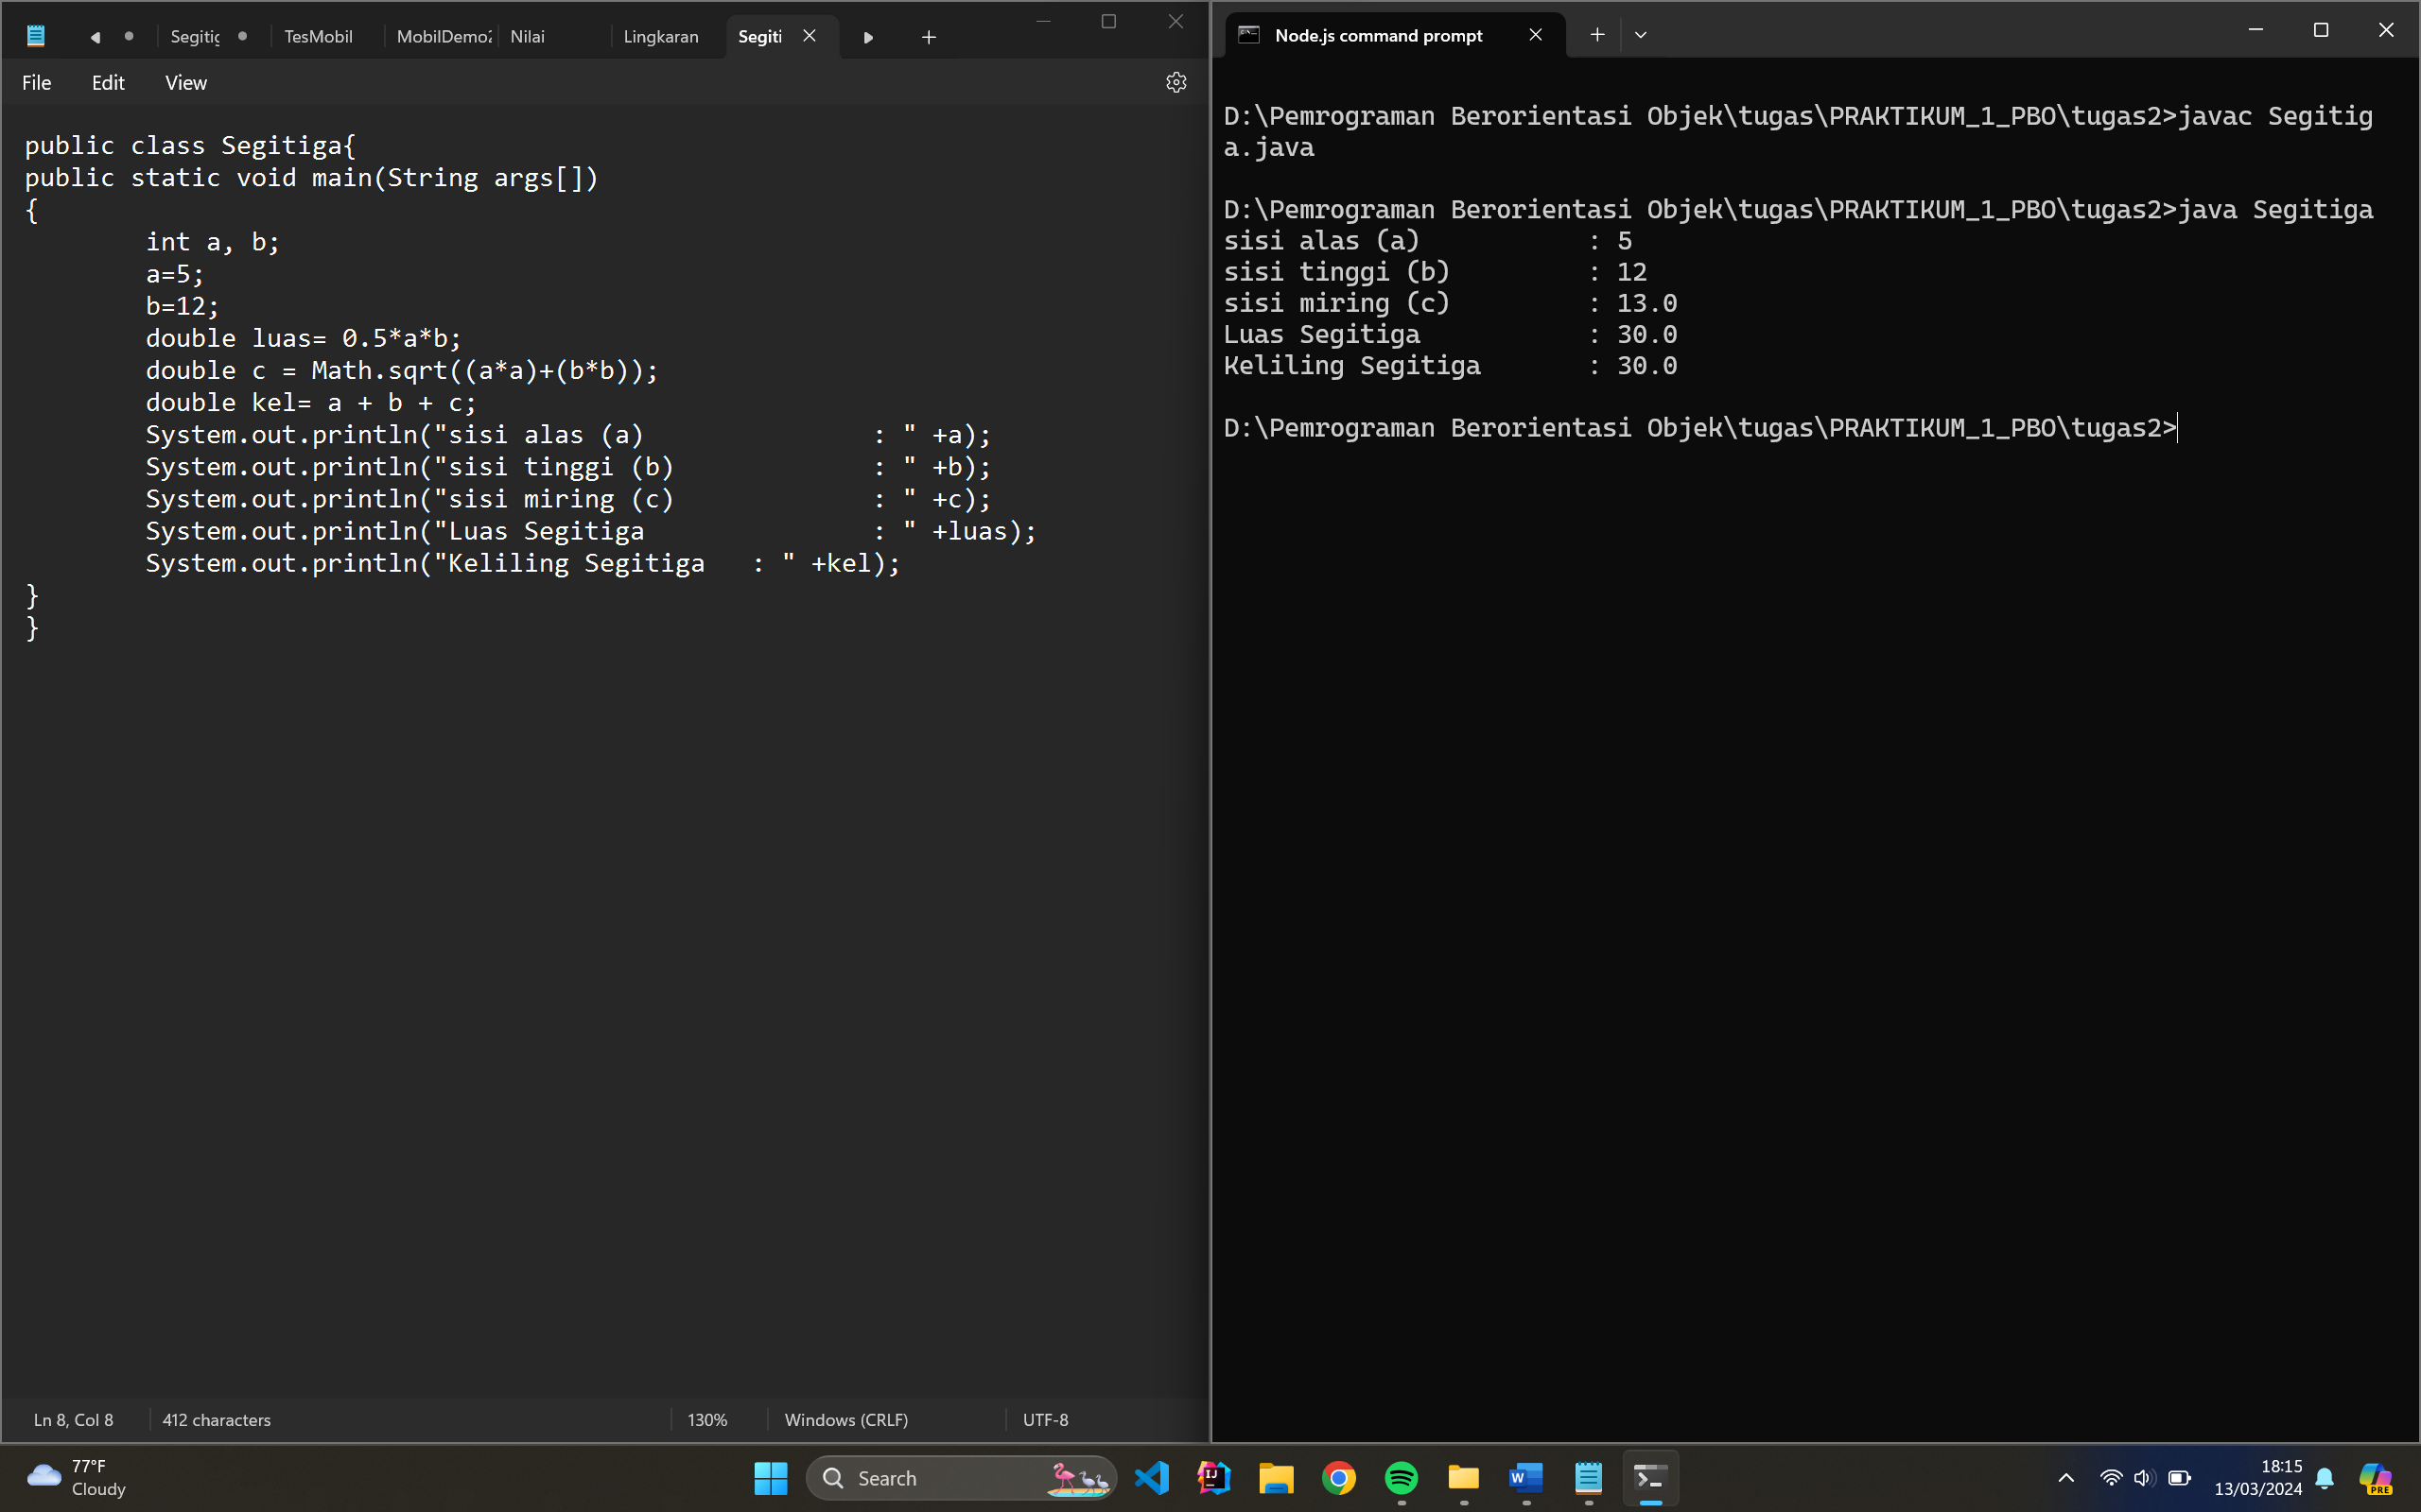

**Code Program:**

public class Segitiga{

public static void main(String args[])

{

int a, b;

a=5;

b=12;

double luas= 0.5*a*b;

double c = Math.sqrt((a*a)+(b*b));

double kel= a + b + c;

System.out.println("sisi alas (a) : " +a);

System.out.println("sisi tinggi (b) : " +b);

System.out.println("sisi miring (c) : " +c);

System.out.println("Luas Segitiga : " +luas);

System.out.println("Keliling Segitiga : " +kel);

}

}

**Output:**

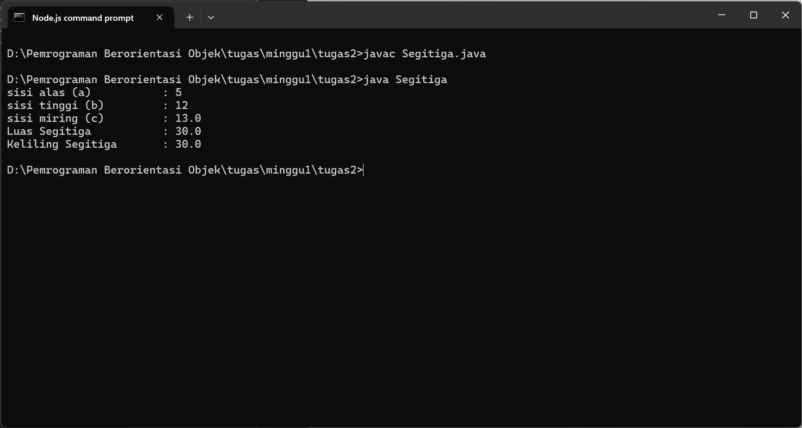

1. **Lingkaran**

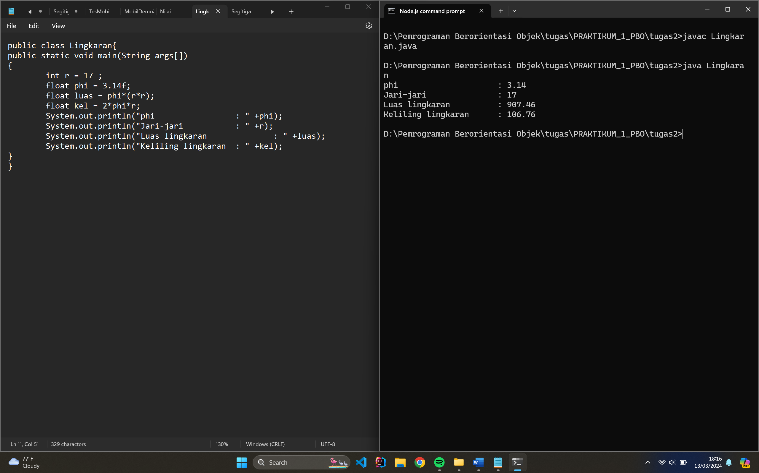

**Code Program:**

public class Lingkaran{

public static void main(String args[])

{

int r = 17 ;

float phi = 3.14f;

float luas = phi*(r*r);

float kel = 2*phi*r;

System.out.println("phi : " +phi);

System.out.println("Jari-jari : " +r);

System.out.println("Luas lingkaran : " +luas);

System.out.println("Keliling lingkaran : " +kel);

}

}

**Output:**

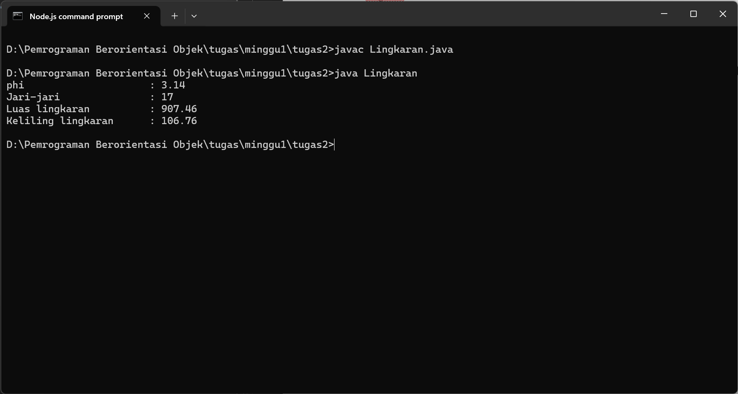

1. **Kubus**

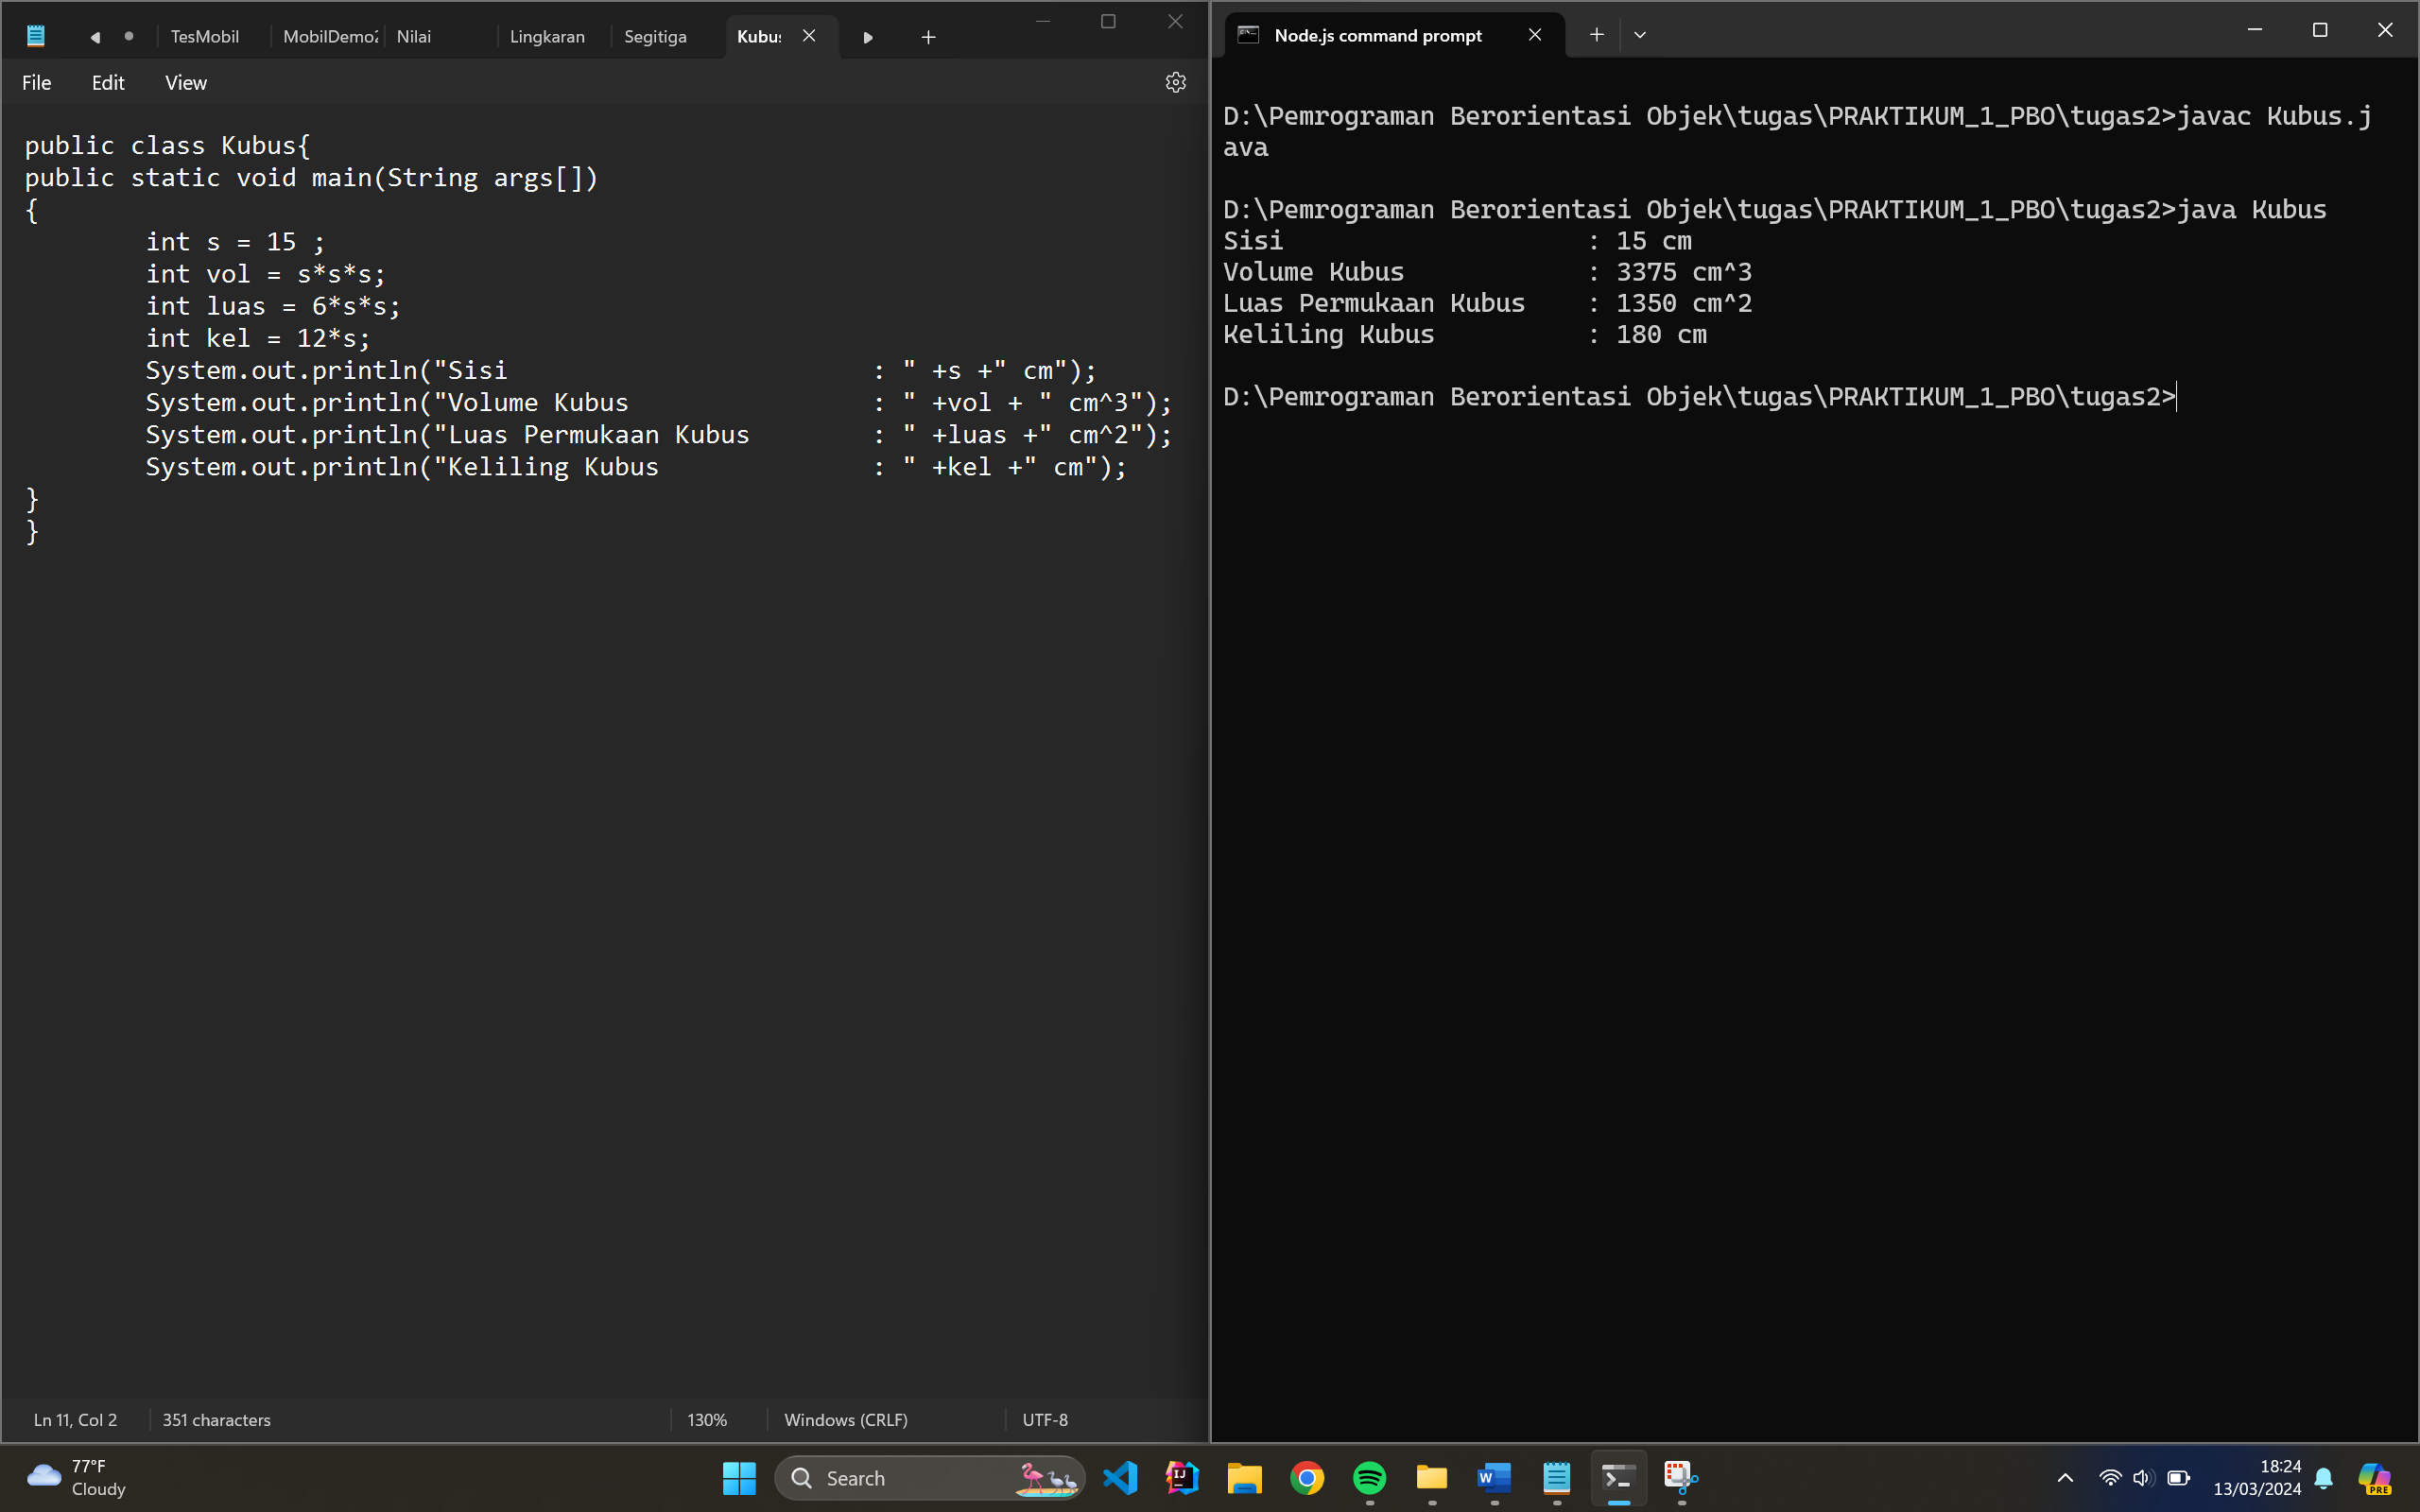

**Code Program:**

public class Kubus{

public static void main(String args[])

{

int s = 15 ;

int vol = s*s*s;

int luas = 6*s*s;

int kel = 12*s;

System.out.println("Sisi : " +s +" cm");

System.out.println("Volume Kubus : " +vol + " cm^3");

System.out.println("Luas Permukaan Kubus : " +luas +" cm^2");

System.out.println("Keliling Kubus : " +kel +" cm");

}

}

**Output:**

