Nama : Restu Lestari Mulianingrum

NIM : A11.2022.14668

Kelompok : A11.4415

**PRAKTIKUM 2**

**Latihan 1**

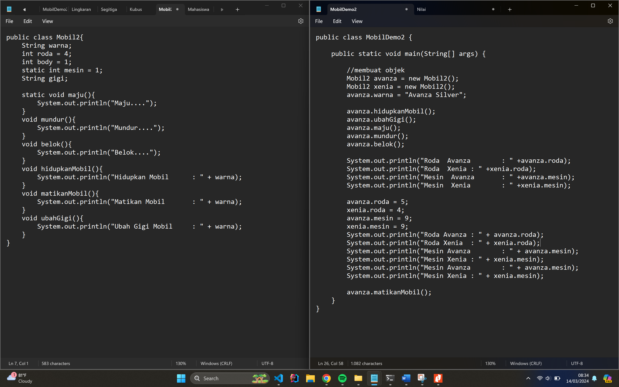

**Code Mobil2.java : Kembangkan Class Mobil, ubah nama menjadi Mobil2**

public class Mobil2{

String warna;

int roda = 4;

int body = 1;

static int mesin = 1;

String gigi;

static void maju(){

System.out.println("Maju....");

}

void mundur(){

System.out.println("Mundur....");

}

void belok(){

System.out.println("Belok....");

}

void hidupkanMobil(){

System.out.println("Hidupkan Mobil : " + warna);

}

void matikanMobil(){

System.out.println("Matikan Mobil : " + warna);

}

void ubahGigi(){

System.out.println("Ubah Gigi Mobil : " + warna);

}

}

**Code MobilDemo2.java : Panggil method-method diatas dari MobilDemo2**

public class MobilDemo2 {

public static void main(String[] args) {

Mobil2 avanza = new Mobil2();

Mobil2 xenia = new Mobil2();

avanza.warna = "Avanza Silver";

avanza.hidupkanMobil();

avanza.ubahGigi();

avanza.maju();

avanza.mundur();

avanza.belok();

System.out.println("Roda Avanza : " +avanza.roda);

System.out.println("Roda Xenia : " +xenia.roda);

System.out.println("Mesin Avanza : " +avanza.mesin);

System.out.println("Mesin Xenia : " +xenia.mesin);

avanza.roda = 5;

xenia.roda = 4;

avanza.mesin = 9;

xenia.mesin = 9;

System.out.println("Roda Avanza : " + avanza.roda);

System.out.println("Roda Xenia : " + xenia.roda);

System.out.println("Mesin Avanza : " + avanza.mesin);

System.out.println("Mesin Xenia : " + xenia.mesin);

System.out.println("Mesin Avanza : " + avanza.mesin);

System.out.println("Mesin Xenia : " + xenia.mesin)

avanza.matikanMobil();

}

}

**Output:**

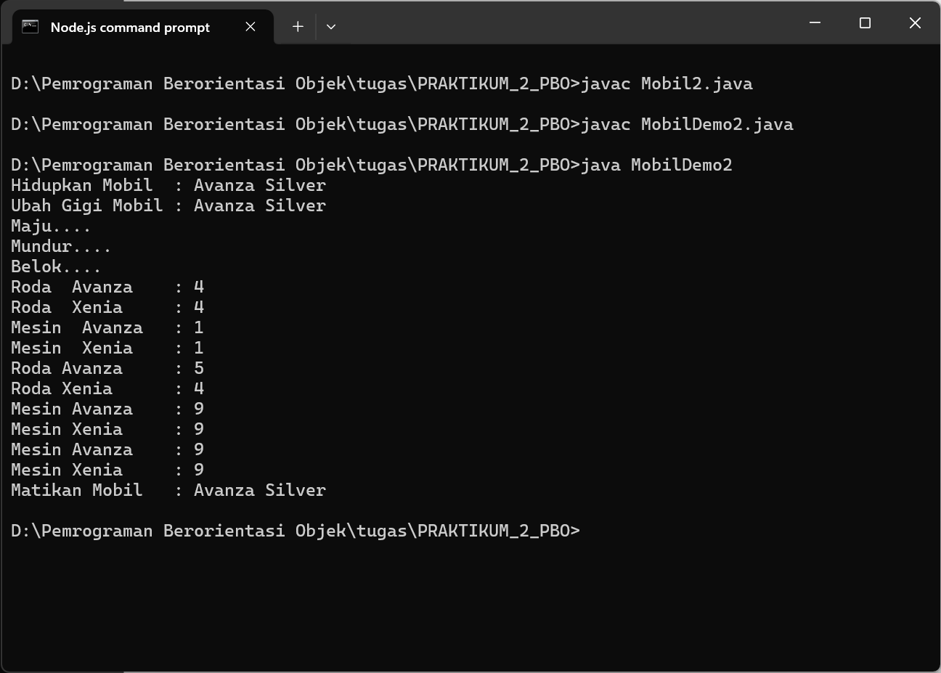

**Latihan 2**

Program untuk menghitung nilai

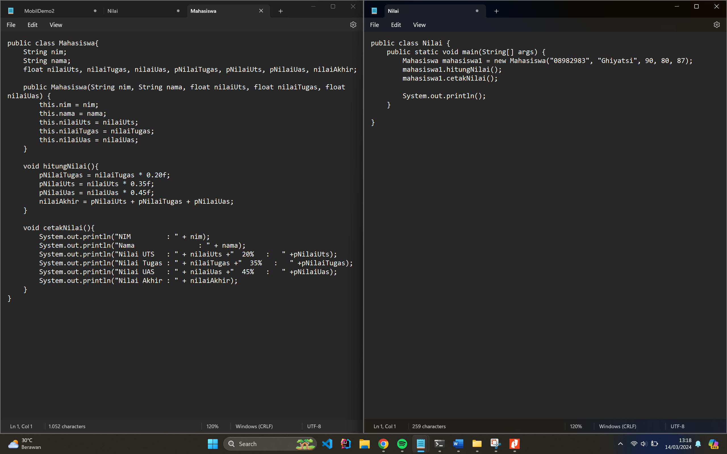

**Code 1 : Class Mahasiswa (Mahasiswa.java)**

public class Mahasiswa{

String nim;

String nama;

float nilaiUts, nilaiTugas, nilaiUas, pNilaiTugas, pNilaiUts, pNilaiUas, nilaiAkhir;

public Mahasiswa(String nim, String nama, float nilaiUts, float nilaiTugas, float nilaiUas) {

this.nim = nim;

this.nama = nama;

this.nilaiUts = nilaiUts;

this.nilaiTugas = nilaiTugas;

this.nilaiUas = nilaiUas;

}

void hitungNilai(){

pNilaiTugas = nilaiTugas * 0.20f;

pNilaiUts = nilaiUts * 0.35f;

pNilaiUas = nilaiUas * 0.45f;

nilaiAkhir = pNilaiUts + pNilaiTugas + pNilaiUas;

}

void cetakNilai(){

System.out.println("NIM : " + nim);

System.out.println("Nama : " + nama);

System.out.println("Nilai UTS : " + nilaiUts +" 20% : " +pNilaiUts);

System.out.println("Nilai Tugas : " + nilaiTugas +" 35% : " +pNilaiTugas);

System.out.println("Nilai UAS : " + nilaiUas +" 45% : " +pNilaiUas);

System.out.println("Nilai Akhir : " + nilaiAkhir);

}

}

**Code 2 : Class Nilai (Nilai.java)**

public class Nilai {

public static void main(String[] args) {

Mahasiswa mahasiswa1 = new Mahasiswa("08982983", "Ghiyatsi", 90, 80, 87);

mahasiswa1.hitungNilai();

mahasiswa1.cetakNilai();

System.out.println();

}

}

**Output:**

