Nama : Restu Lestari Mulianingrum

NIM : A11.2022.14668

Kelompok : A11.4415

**PRAKTIKUM 3**

**Membuat class Bicycle dan BicycleDemo**

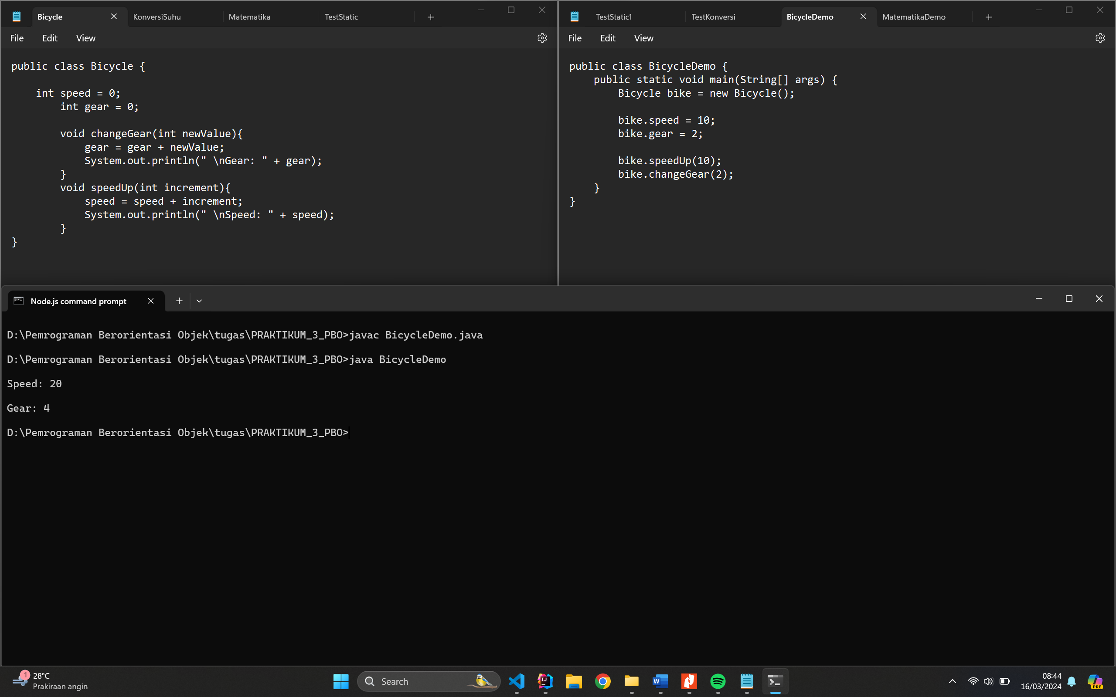

**Code Bicycle.java:**

public class Bicycle {

    int speed = 0;

        int gear = 0;

        void changeGear(int newValue){

            gear = gear + newValue;

            System.out.println(" \nGear: " + gear);

        }

        void speedUp(int increment){

            speed = speed + increment;

            System.out.println(" \nSpeed: " + speed);

        }

}

**Code BicycleDemo.java:**

public class BicycleDemo {

    public static void main(String[] args) {

        Bicycle bike = new Bicycle();

        bike.speed = 10;

        bike.gear = 2;

        bike.speedUp(10);

        bike.changeGear(2);

    }

}

**Latihan 1**

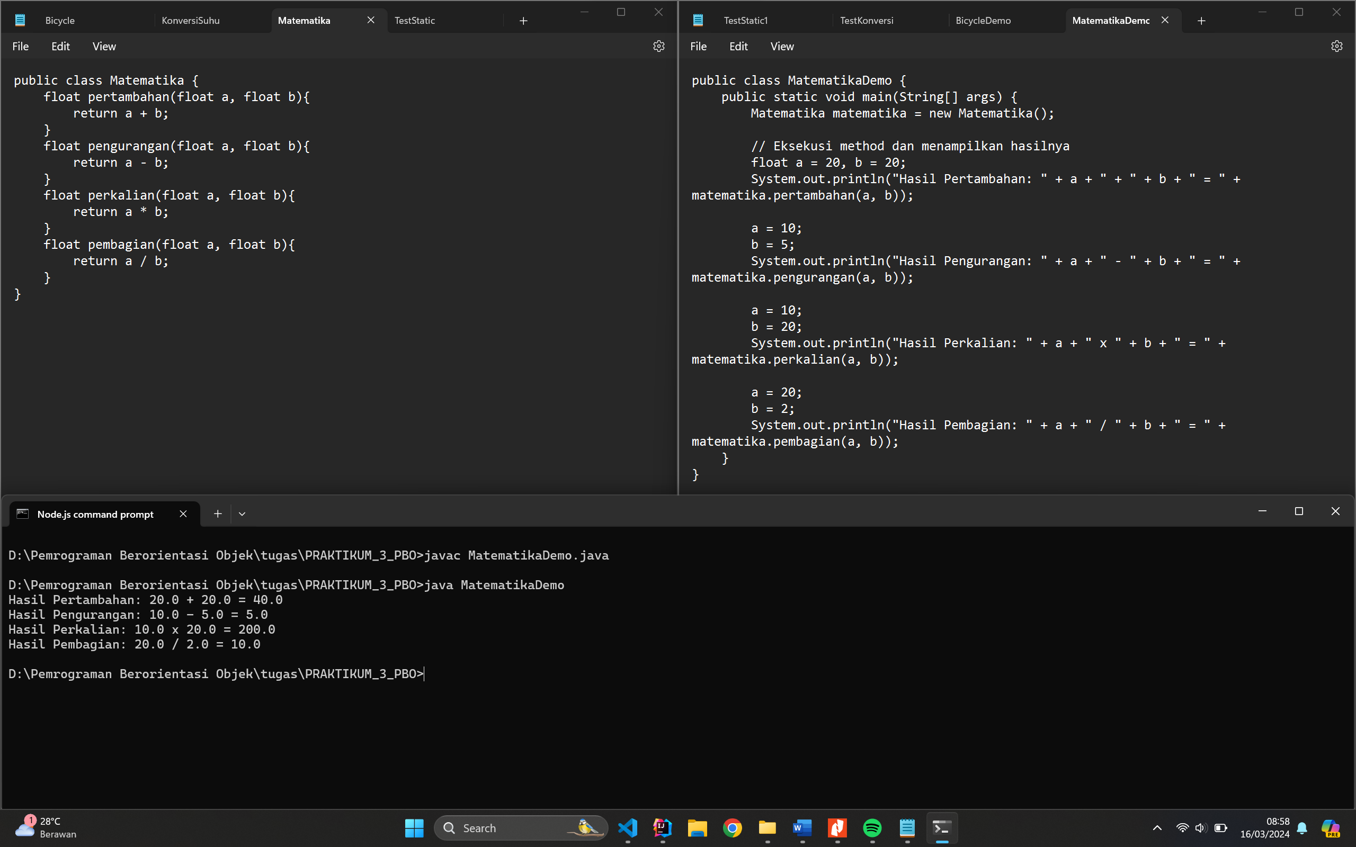

**Code Matematika.java :**

public class Matematika {

    float pertambahan(float a, float b){

        return a + b;

    }

    float pengurangan(float a, float b){

        return a - b;

    }

    float perkalian(float a, float b){

        return a * b;

    }

    float pembagian(float a, float b){

        return a / b;

    }

}

**Code MatematikaDemo.java:**

public class MatematikaDemo {

    public static void main(String[] args) {

        Matematika matematika = new Matematika();

        // Eksekusi method dan menampilkan hasilnya

        float a = 20, b = 20;

        System.out.println("Hasil Pertambahan: " + a + " + " + b + " = " + matematika.pertambahan(a, b));

        a = 10;

        b = 5;

        System.out.println("Hasil Pengurangan: " + a + " - " + b + " = " + matematika.pengurangan(a, b));

        a = 10;

        b = 20;

        System.out.println("Hasil Perkalian: " + a + " x " + b + " = " + matematika.perkalian(a, b));

        a = 20;

        b = 2;

        System.out.println("Hasil Pembagian: " + a + " / " + b + " = " + matematika.pembagian(a, b));

    }

}

**Latihan 2**

Program konversi suhu, dari Celcius

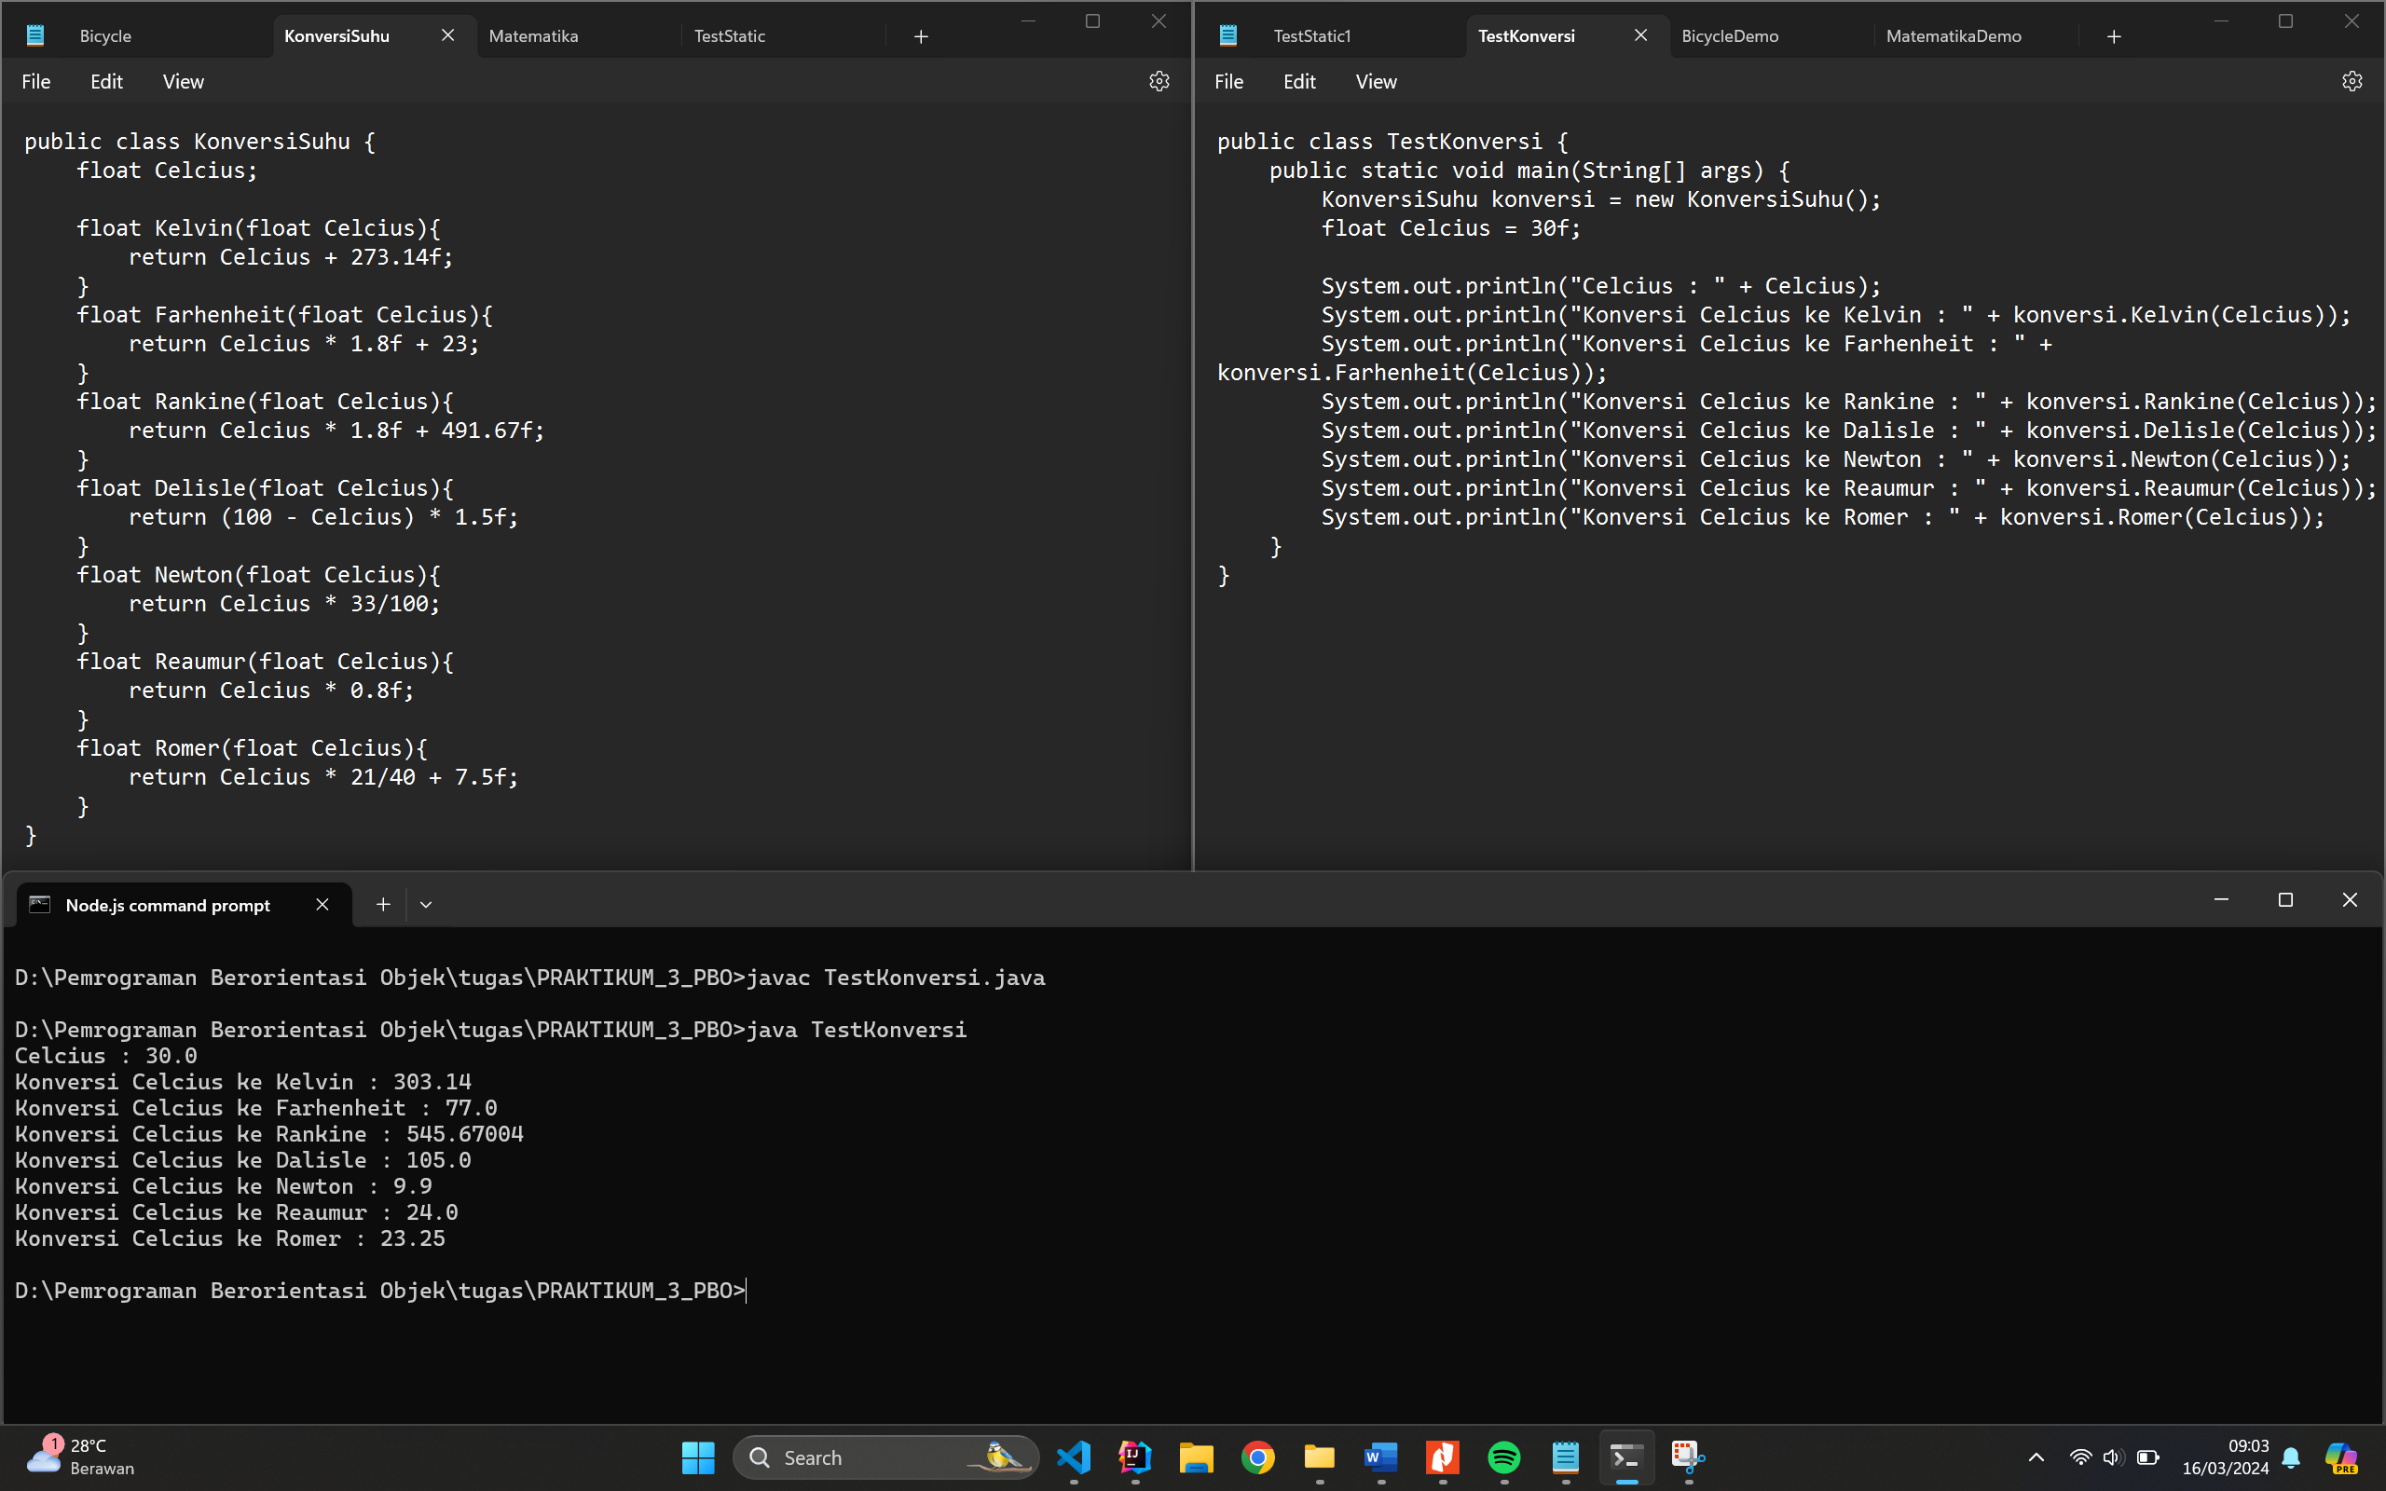

**Code KonversiSuhu.java**

public class KonversiSuhu {

    float Celcius;

    float Kelvin(float Celcius){

        return Celcius + 273.14f;

    }

    float Farhenheit(float Celcius){

        return Celcius * 1.8f + 23;

    }

    float Rankine(float Celcius){

        return Celcius * 1.8f + 491.67f;

    }

    float Delisle(float Celcius){

        return (100 - Celcius) * 1.5f;

    }

    float Newton(float Celcius){

        return Celcius * 33/100;

    }

    float Reaumur(float Celcius){

        return Celcius * 0.8f;

    }

    float Romer(float Celcius){

        return Celcius * 21/40 + 7.5f;

    }

}

**Code TestKonversi.java**

public class TestKonversi {

    public static void main(String[] args) {

        KonversiSuhu konversi = new KonversiSuhu();

        float Celcius = 30f;

        System.out.println("Celcius : " + Celcius);

        System.out.println("Konversi Celcius ke Kelvin : " + konversi.Kelvin(Celcius));

        System.out.println("Konversi Celcius ke Farhenheit : " + konversi.Farhenheit(Celcius));

        System.out.println("Konversi Celcius ke Rankine : " + konversi.Rankine(Celcius));

        System.out.println("Konversi Celcius ke Dalisle : " + konversi.Delisle(Celcius));

        System.out.println("Konversi Celcius ke Newton : " + konversi.Newton(Celcius));

        System.out.println("Konversi Celcius ke Reaumur : " + konversi.Reaumur(Celcius));

        System.out.println("Konversi Celcius ke Romer : " + konversi.Romer(Celcius));

    }

}

**Latihan 3**

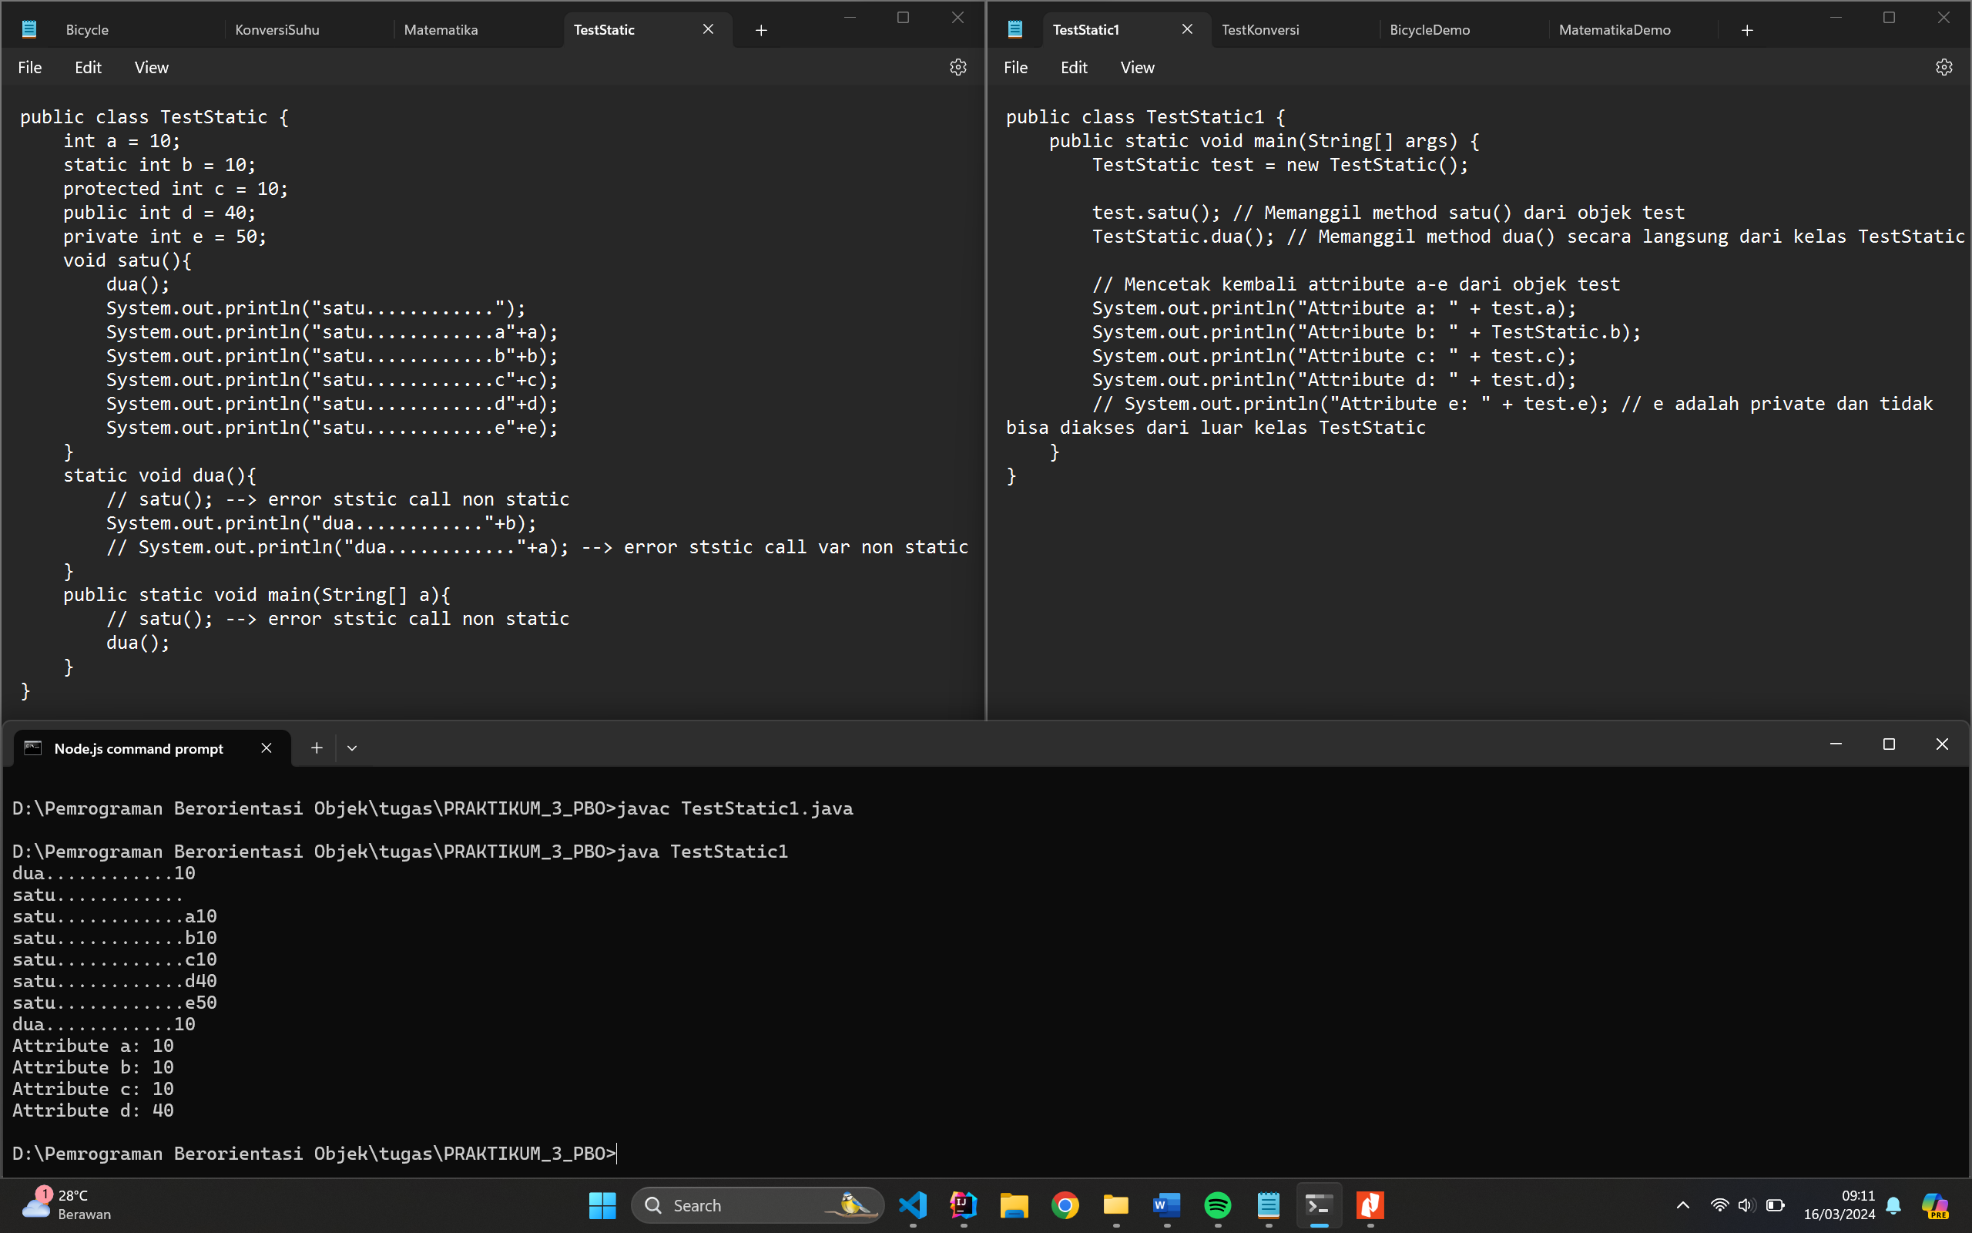

**Code TestStatic.java**

public class TestStatic {

    int a = 10;

    static int b = 10;

    protected int c = 10;

    public int d = 40;

    private int e = 50;

    void satu(){

        dua();

        System.out.println("satu............");

        System.out.println("satu............a"+a);

        System.out.println("satu............b"+b);

        System.out.println("satu............c"+c);

        System.out.println("satu............d"+d);

        System.out.println("satu............e"+e);

    }

    static void dua(){

        // satu(); --> error ststic call non static

        System.out.println("dua............"+b);

        // System.out.println("dua............"+a); --> error ststic call var non static

    }

    public static void main(String[] a){

        // satu(); --> error ststic call non static

        dua();

    }

}

**Code TestStatic1.java**

public class TestStatic1 {

    public static void main(String[] args) {

        TestStatic test = new TestStatic();

        test.satu(); // Memanggil method satu() dari objek test

        TestStatic.dua(); // Memanggil method dua() secara langsung dari kelas TestStatic

        // Mencetak kembali attribute a-e dari objek test

        System.out.println("Attribute a: " + test.a);

        System.out.println("Attribute b: " + TestStatic.b);

        System.out.println("Attribute c: " + test.c);

        System.out.println("Attribute d: " + test.d);

        // System.out.println("Attribute e: " + test.e); // e adalah private dan tidak bisa diakses dari luar kelas TestStatic

    }

}