Nama : Restu Lestari Mulianingrum

NIM : A11.2022.14668

Kelompok : A11.4415

**PRAKTIKUM 6**

**Package**

**Latihan 1**

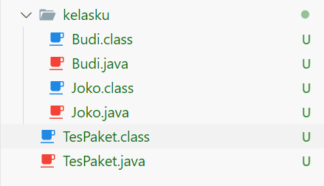

|  |  |
| --- | --- |
| **Budi.java** | **Joko.java** |
| package kelasku;  public class Budi {      public void info(){          System.out.println("Kelas Budi");      }  } | package kelasku;  public class Joko{      public void info(){          System.out.println("Kelas Joko");      }  } |
| **TestPaket.java** | |
| import kelasku.Budi;  import kelasku.Joko;  public class TesPaket {      public static void main(String[] args) {          Budi ObjectBudi = new Budi();          ObjectBudi.info();          Joko objectJoko = new Joko();          objectJoko.info();      }  } | |
| **Output** | |
|  | |

**Latihan 2**

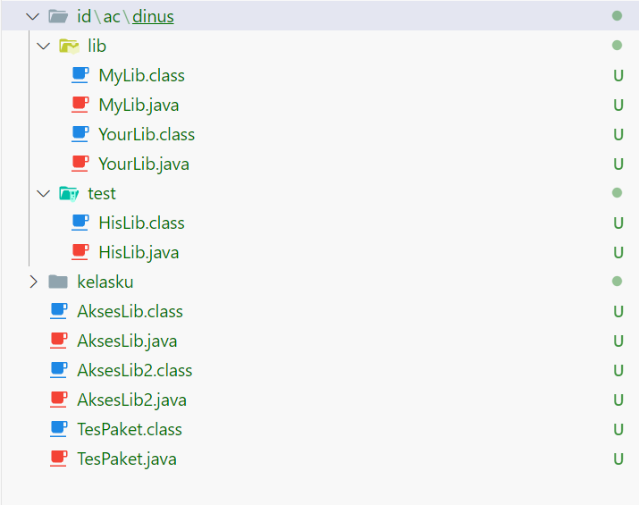

1. Lib

|  |  |
| --- | --- |
| **MyLib.java** | **YourLib.java** |
| package id.ac.dinus.lib;  public class MyLib{      public void cetak(){          System.out.println("MyLib.Cetak...........");      }  } | package id.ac.dinus.lib;  public class YourLib{      public void cetak2(){          System.out.println("cetak your lib...........");      }  } |

1. Test

|  |
| --- |
| **HisLib.java** |
| package id.ac.dinus.test;  import id.ac.dinus.lib.*;  public class HisLib{      public void cetak3(){          MyLib m = new MyLib();          m.cetak();          System.out.println("his lib cetak()........");      }  } |

1. Main folder/direktori

|  |  |
| --- | --- |
| **AksesLib.java** | **AksesLib2.java** |
| import id.ac.dinus.lib.*;  import id.ac.dinus.test.*;  public class AksesLib{      public static void main(String[] a){          MyLib m = new MyLib();          m.cetak();          YourLib y = new YourLib();          y.cetak2();          HisLib h = new HisLib();          h.cetak3();      }  } | import id.ac.dinus.lib.MyLib; //langsung ke class  import id.ac.dinus.lib.YourLib;  import id.ac.dinus.test.*;  public class AksesLib2{      public static void main(String[] a){          MyLib m = new MyLib();          m.cetak();          YourLib y = new YourLib();          y.cetak2();          HisLib h = new HisLib();          h.cetak3();      }  } |

1. Output

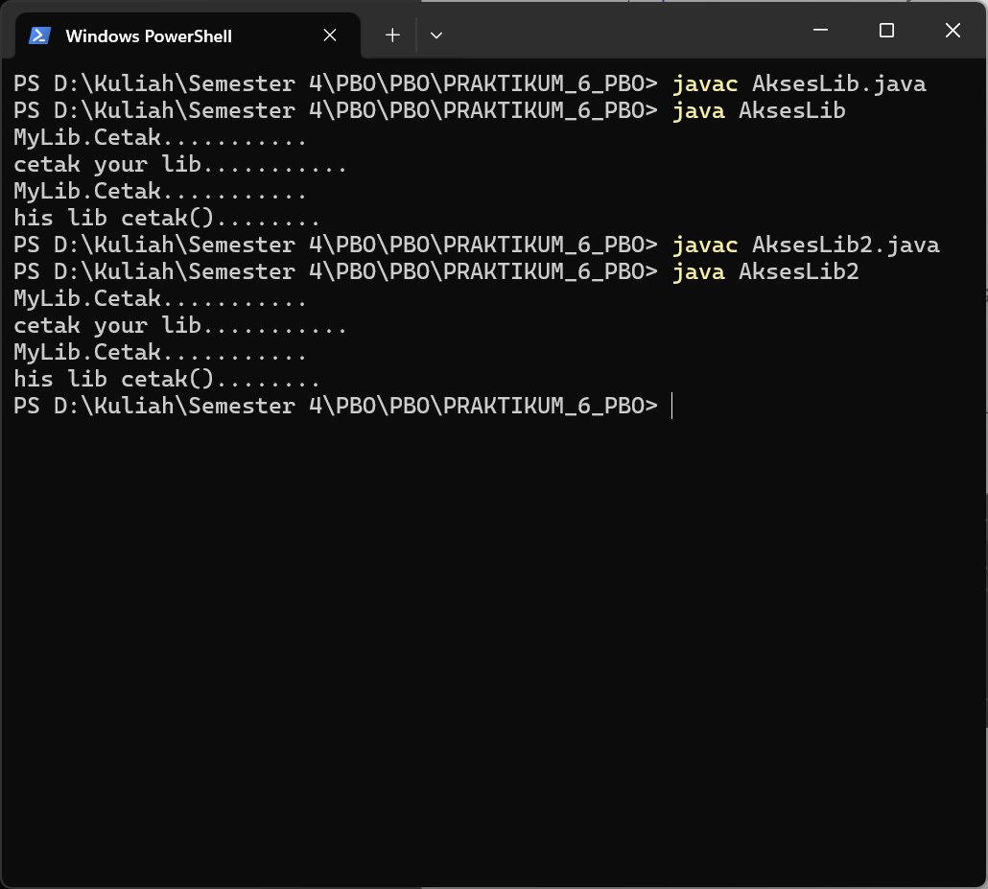

**Latihan 3**

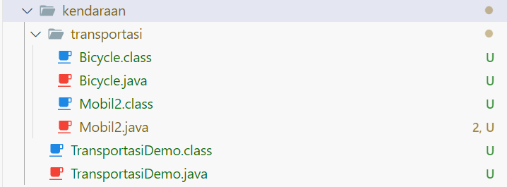

|  |
| --- |
| **Bicycle.java** |
| package transportasi;  public class Bicycle {      int speed = 0;      int gear = 0;      //method      public void changeGear(int newValue) {          gear = gear + newValue;          System.out.println(" \nGear     : "+gear);      }      public void speedUp(int increment) {          speed = speed + increment;          System.out.println(" \nSpeed    : "+speed);      }  } |
| **Mobil2.java** |
| package transportasi;  public class Mobil2{      private int roda = 4;      private int body = 1;      static int mesin = 1;      public void maju(){          System.out.println("Maju .....");      }      public void mundur(){          System.out.println("Mundur .....");      }      public void belok(){          System.out.println("Belok.....");      }      public void hidup(String nama){          System.out.println("Hidupkan Mobil : "+nama);      }      public void mati(String nama){          System.out.println("Matikan Mobil : "+nama);      }      public void ubahGigi(String nama){          System.out.println("Ubah Gigi Mobil : "+nama);      }      public void setRoda(int roda){          this.roda = roda;      }      public int getRoda(){          return roda;      }      public void setMesin(int mesin){          this.mesin = mesin;      }      public int getMesin(){          return mesin;      }  } |
| **TransportasiDemo.java** |
| import transportasi.Bicycle;  import transportasi.Mobil2;  public class TransportasiDemo {      public static void main(String[] args) {          Mobil2 avanza = new Mobil2();          Bicycle sepeda = new Bicycle();          avanza.setRoda(4);          avanza.setMesin(1);          avanza.hidup("Avanza Silver");          avanza.ubahGigi("Xenia");          avanza.maju();          avanza.mundur();          avanza.belok();          sepeda.changeGear(5);          sepeda.speedUp(4);      }  } |
| **Output** |
|  |

**Latihan 4**

