Journals: Introducing a Mock Dataset

Resul Umit

15 March 2021

## Summary

This document introduces a mock dataset, which is generated with the *fabricatr* package (Blair et al., 2019). It includes nine variables on 1,091 fictitious journals. The dataset can be used for an imaginary exploration of these journals’ Google Scholar rankings.

## Variables

The dataset includes nine variables, as presented in Table 1.

Table 1: Variables in the dataset

|  |  |
| --- | --- |
| Variables | Explanations |
| name | journals (1090 random titles) |
| origin | geographic origins (five continents) |
| branch | major discipline of journals (four branches) |
| since | time of first publication (years) |
| h5_index | H5 Index (integers) |
| h5_median | H5 Median (integers) |
| english | English (1) vs. other-language (0) journals |
| subfield | subfield (1) vs. generalist (0) journals |
| issues | number of issues published per year (integers) |

## Observations

There are 1,091 journal-level observations in the dataset. Figure 1 plots these journals’ h5-index and h5-median — two popular metrics by Google Scholar. the figure divides the journals along the four branches of science (with facets; *formal*, *life*, *physical*, *social*) and two categories of scope (with colour; *generalist* and *subfield*).

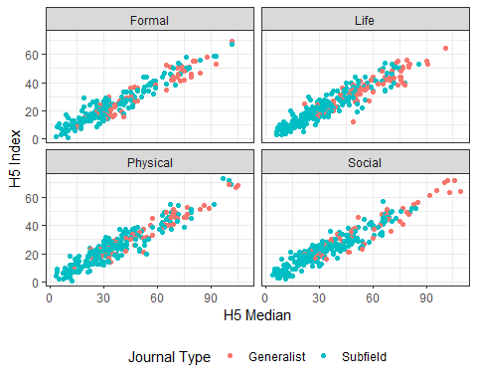

Figure 1: Google Scholar metrics.

Based on this figure, we can make infer that:

* life is the branch with the most journals, and
* generalist journals have higher rankings than specialist journals in all four branches.

## References

Blair, G., Cooper, J., Coppock, A., Humphreys, M., Rudkin, A. and Fultz, N. (2019). *fabricatr: Imagine your data before you collect it*. R package, version 0.10.0.