Q1: Code:

<!DOCTYPE html>

<html lang="en">

<head>

<meta charset="UTF-8">

<meta name="viewport" content="width=device-width, initial-scale=1.0">

<title>Change Background Color and Text</title>

<style>

    body {

        font-family: Arial, sans-serif;

        text-align: center;

    }

    h1 {

        font-size: 36px;

        margin-top: 50px;

    }

    #changeButton {

        padding: 10px 20px;

        font-size: 18px;

        background-color: #007bff;

        color: white;

        border: none;

        cursor: pointer;

        margin-top: 20px;

    }

</style>

</head>

<body>

<h1 id="heading">Original Heading</h1>

<button id="changeButton" onclick="changeStyles()">Change Styles</button>

<script>

function changeStyles() {

    var heading = document.getElementById('heading');

    var button = document.getElementById('changeButton');

    var randomColor = '#'+(Math.random()*0xFFFFFF<<0).toString(16);

    document.body.style.backgroundColor = randomColor;

    heading.innerText = "New Heading";

    button.innerText = "Styles Changed!";

}

</script>

</body>

</html>

Web Page:

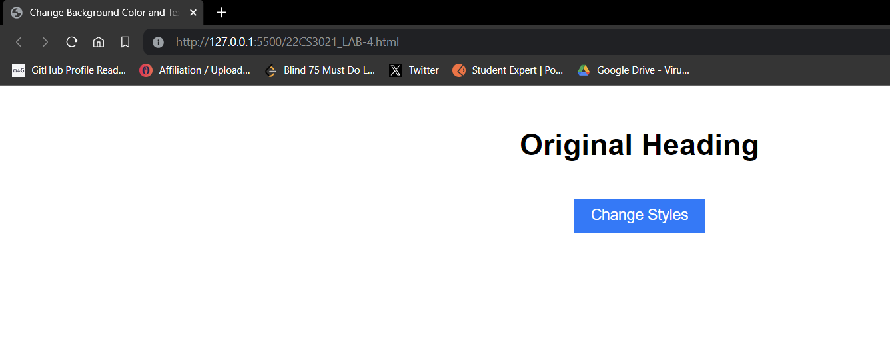

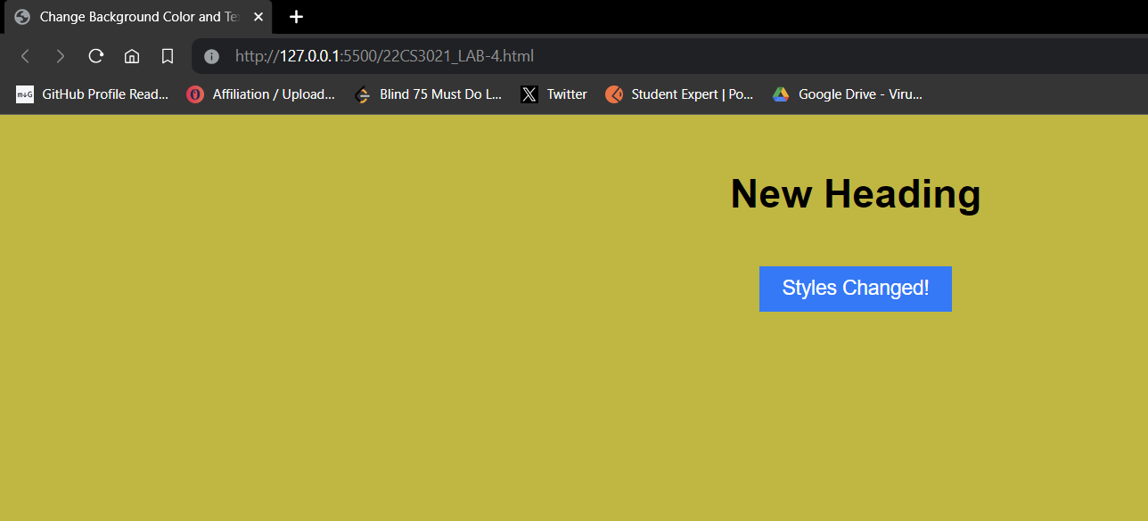

Q2: Code:

<!DOCTYPE html>

<html lang="en">

<head>

<meta charset="UTF-8">

<meta name="viewport" content="width=device-width, initial-scale=1.0">

<title>Change Background Color and Text</title>

<style>

    body {

        font-family: Arial, sans-serif;

        text-align: center;

    }

    h1 {

        font-size: 36px;

        margin-top: 50px;

    }

    #changeButton {

        padding: 10px 20px;

        font-size: 18px;

        background-color: #007bff;

        color: white;

        border: none;

        cursor: pointer;

        margin-top: 20px;

    }

</style>

</head>

<body>

<h1 id="heading">Original Heading</h1>

<button id="changeButton" onclick="changeStyles()">Change Styles</button>

<script>

function changeStyles() {

    var heading = document.getElementById('heading');

    var button = document.getElementById('changeButton');

    document.body.style.backgroundColor = 'lightgreen';

    heading.style.color = 'red';

    heading.style.fontSize = '48pt';

    heading.innerText = "Modified Heading";

    heading.insertAdjacentHTML('afterend', '<button>Click Me</button>');

}

</script>

</body>

</html>

Web Page:





Q3: Code:

<!DOCTYPE html>

<html lang="en">

<head>

<meta charset="UTF-8">

<meta name="viewport" content="width=device-width, initial-scale=1.0">

<title>Change Background Color and Text</title>

<style>

    body {

        font-family: Arial, sans-serif;

        text-align: center;

    }

    .light-blue-bg {

        background-color: lightblue;

    }

    h1 {

        font-size: 36px;

        margin-top: 50px;

    }

    #changeButton {

        padding: 10px 20px;

        font-size: 18px;

        background-color: #007bff;

        color: white;

        border: none;

        cursor: pointer;

        margin-top: 20px;

    }

</style>

</head>

<body>

<h1 id="heading">Original Heading</h1>

<button id="changeButton" onclick="changeStyles()">Change Styles</button>

<script>

function changeStyles() {

    alert("Before changing styles");

    document.body.className = "light-blue-bg";

    document.getElementById('heading').innerText = "New Heading";

    alert("After changing styles");

}

</script>

</body>

</html>

Web Page:

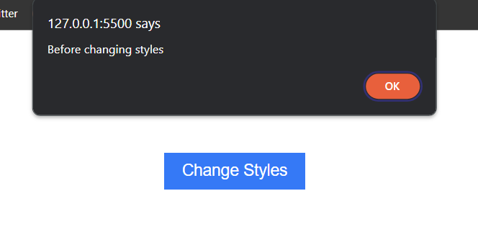

Q4: Code:

<!DOCTYPE html>

<html lang="en">

<head>

<meta charset="UTF-8">

<meta name="viewport" content="width=device-width, initial-scale=1.0">

<title>Content Replacement</title>

<style>

    body {

        font-family: Arial, sans-serif;

        text-align: center;

    }

    main {

        padding: 20px;

        margin-top: 20px;

        border: 2px solid #333;

    }

    .content1 {

        font-size: 24px;

        color: #007bff;

    }

    .content2 {

        font-size: 36px;

        color: #ff5733;

    }

    #replaceButton {

        padding: 10px 20px;

        font-size: 18px;

        background-color: #007bff;

        color: white;

        border: none;

        cursor: pointer;

        margin-top: 20px;

    }

</style>

</head>

<body>

<h1>Page Contents</h1>

<main class="content1">

    <p>This is the initial content within the main section.</p>

</main>

<button id="replaceButton" onclick="replaceContent()">Replace Content</button>

<footer>

    <p>This is content outside the main section.</p>

</footer>

<script>

function replaceContent() {

    var mainSection = document.querySelector('main');

    mainSection.innerHTML = "<p>This is the replaced content with a different style.</p>";

    mainSection.classList.remove('content1');

    mainSection.classList.add('content2');

}

</script>

</body>

</html>

Web Page:

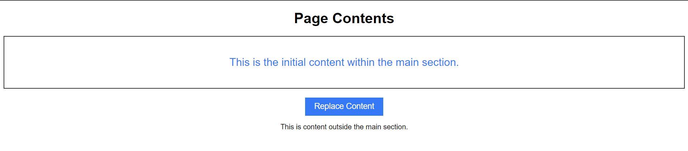

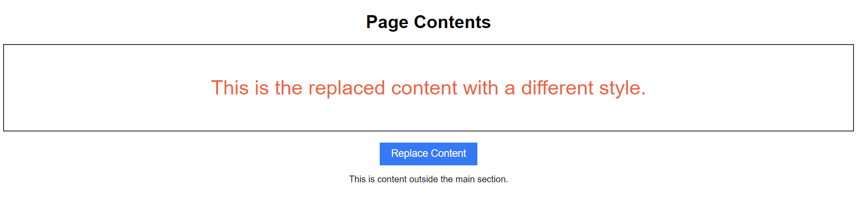

Q5: Code:

<!DOCTYPE html>

<html lang="en">

<head>

<meta charset="UTF-8">

<meta name="viewport" content="width=device-width, initial-scale=1.0">

<title>Change Heading Color</title>

<style>

    body {

        font-family: Arial, sans-serif;

        text-align: center;

    }

    h1 {

        margin-top: 20px;

    }

</style>

</head>

<body>

<h1 id="heading1" style="color: blue;">Heading with Inline Style</h1>

<h1 id="heading2">Heading with JavaScript</h1>

<h1 id="heading3" class="heading-class">Heading with CSS</h1>

<button onclick="changeColor()">Change Color (JavaScript)</button>

<script>

function changeColor() {

    var heading2 = document.getElementById('heading2');

    heading2.style.color = 'green';

}

</script>

</body>

</html>

Web Page:





Q6: Code:

<!DOCTYPE html>

<html lang="en">

<head>

<meta charset="UTF-8">

<meta name="viewport" content="width=device-width, initial-scale=1.0">

<title>Browser Versions</title>

<style>

    body {

        font-family: Arial, sans-serif;

        text-align: center;

    }

    .grid-container {

        display: grid;

        grid-template-rows: auto auto; /* Two rows */

        grid-template-columns: repeat(5, 1fr);

        gap: 10px;

        margin-top: 20px;

    }

    .grid-item {

        padding: 10px;

        border: 1px solid #ccc;

    }

    .icon {

        width: 50px;

        height: 50px;

        margin-bottom: 5px;

    }

    .grid-item p {

        background-color: #f2f2f2; /* Light gray background for paragraphs */

        margin: 0; /* Remove default margin */

        padding: 5px; /* Add padding */

    }

</style>

</head>

<body>

<h1>Browser Versions</h1>

<div class="grid-container">

    <div class="grid-item">

        <img class="icon" src="https://encrypted-tbn0.gstatic.com/images?q=tbn:ANd9GcR1F-4Ur0DjA3-95keAyiZ-dU2AUGdJUTDlM5tpN6v33A&s" alt="Chrome">

        <p>Chrome</p>

        <p>Version 98</p>

    </div>

    <div class="grid-item">

        <img class="icon" src="https://upload.wikimedia.org/wikipedia/commons/thumb/2/28/Firefox_logo%2C_2017.svg/2048px-Firefox_logo%2C_2017.svg.png" alt="Firefox">

        <p>Firefox</p>

        <p>Version 96</p>

    </div>

    <div class="grid-item">

        <img class="icon" src="https://upload.wikimedia.org/wikipedia/commons/thumb/5/52/Safari_browser_logo.svg/2057px-Safari_browser_logo.svg.png" alt="Safari">

        <p>Safari</p>

        <p>Version 15</p>

    </div>

    <div class="grid-item">

        <img class="icon" src="https://static-00.iconduck.com/assets.00/microsoft-edge-icon-2048x2048-c1i8mtto.png" alt="Edge">

        <p>Edge</p>

        <p>Version 98</p>

    </div>

    <div class="grid-item">

        <img class="icon" src="https://encrypted-tbn0.gstatic.com/images?q=tbn:ANd9GcQ6UOnAe1NUUwJl6ygDOWYvk9eLDVSA9Yg107BfLTIsuA&s" alt="Opera">

        <p>Opera</p>

        <p>Version 84</p>

    </div>

</div>

</body>

</html>

Web Page:

