Q1

<!DOCTYPE html>

<html lang="en">

<head>

<meta charset="UTF-8">

<meta name="viewport" content="width=device-width, initial-scale=1.0">

<title>Spinner</title>

<style>

body {

font-family: Arial, sans-serif;

display: flex;

justify-content: center;

align-items: center;

height: 100vh;

margin: 0;

}

.container {

text-align: center;

}

h2 {

font-size: 24px;

margin-bottom: 20px;

animation: spin 1s infinite linear;

}

@keyframes spin {

from {

transform: rotate(0deg);

}

to {

transform: rotate(360deg);

}

}

</style>

</head>

<body>

<div class="container">

<h2 id="word">Hello</h2>

<input type="text" id="textInput" placeholder="Enter a word or phrase">

<button onclick="changeWord()">Change Word</button>

</div>

<script>

function changeWord() {

var input = document.getElementById("textInput").value;

if (input !== "") {

document.getElementById("word").innerText = input;

}

}

</script>

</body>

</html>

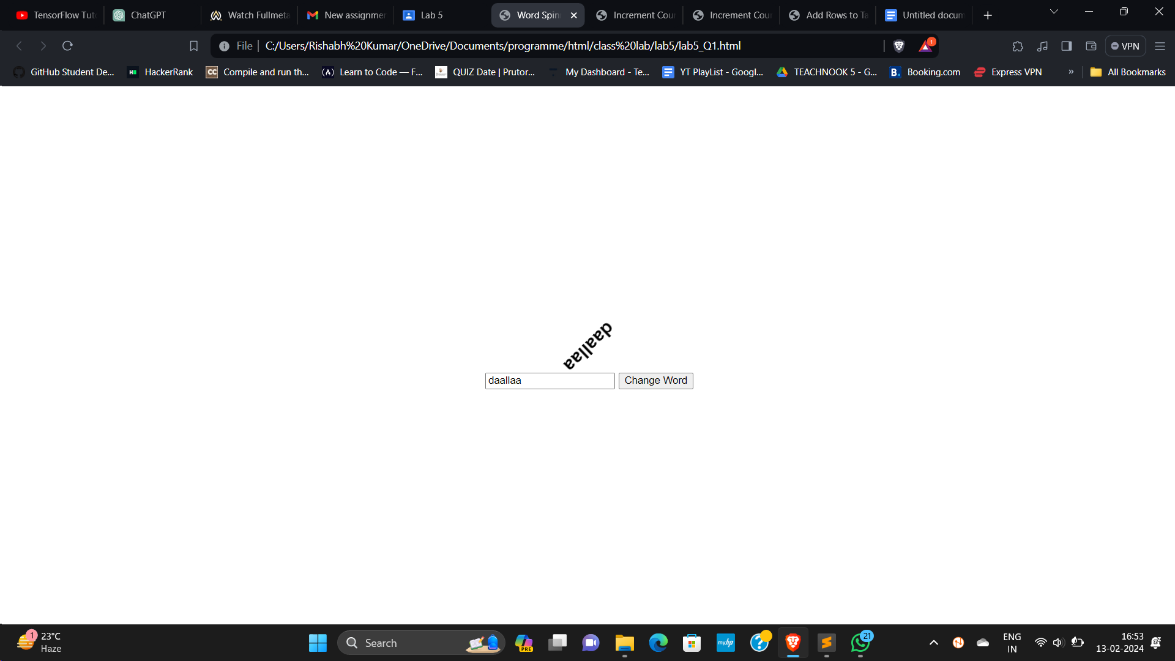

Q2

<!DOCTYPE html>

<html lang="en">

<head>

<meta charset="UTF-8">

<meta name="viewport" content="width=device-width, initial-scale=1.0">

<title>Increment Counter</title>

<style>

body {

font-family: Arial, sans-serif;

display: flex;

justify-content: center;

align-items: center;

height: 100vh;

margin: 0;

}

p {

font-size: 16px;

transition: font-size 0.3s ease-in-out;

}

</style>

</head>

<body>

<button onclick="incrementCounter()">Increment Count</button>

<p id="count">0</p>

<script>

var count = 0;

function incrementCounter() {

count++;

document.getElementById("count").innerText = count;

document.getElementById("count").style.fontSize = count \* 2 + "px";

}

</script>

</body>

</html>

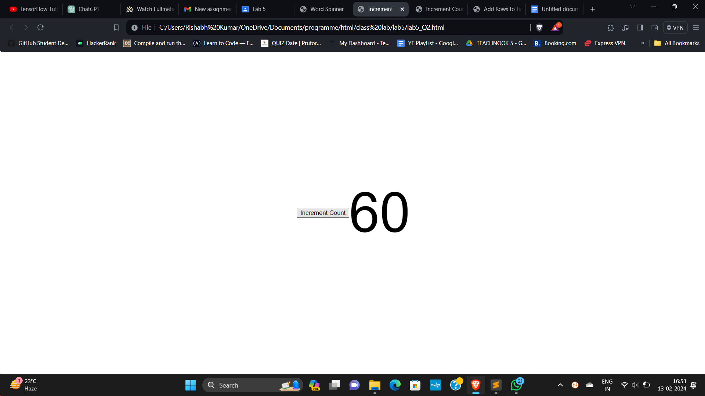

Q3

<!DOCTYPE html>

<html lang="en">

<head>

<meta charset="UTF-8">

<meta name="viewport" content="width=device-width, initial-scale=1.0">

<title>Increment Counter with List</title>

<style>

body {

font-family: Arial, sans-serif;

display: flex;

justify-content: center;

align-items: center;

height: 100vh;

margin: 0;

}

ul {

list-style-type: none;

padding: 0;

}

li {

font-size: 16px;

transition: font-size 0.3s ease-in-out;

}

</style>

</head>

<body>

<button onclick="incrementCounter()">Increment Count</button>

<ul id="countList"></ul>

<script>

var count = 0;

function incrementCounter() {

count++;

var listItem = document.createElement("li");

listItem.innerText = count;

listItem.style.fontSize = count \* 2 + "px";

document.getElementById("countList").appendChild(listItem);

}

</script>

</body>

</html>

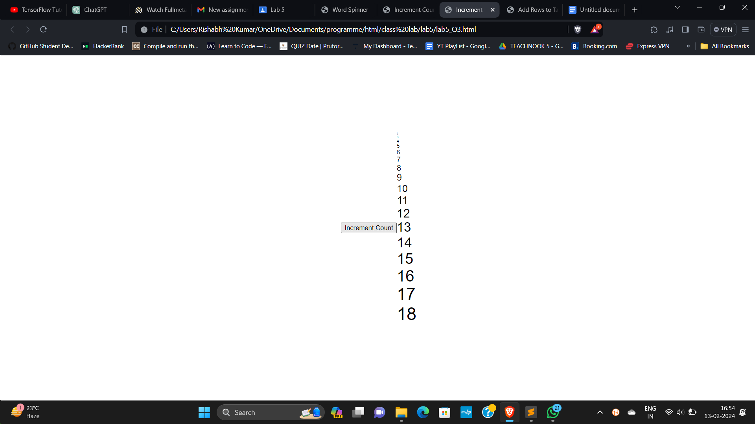

Q4

<!DOCTYPE html>

<html lang="en">

<head>

<meta charset="UTF-8">

<meta name="viewport" content="width=device-width, initial-scale=1.0">

<title>Add Rows to Table</title>

</head>

<body>

<button onclick="addRow()">Add Row</button>

<table id="myTable" border="1">

<tr>

<th>Row Number</th>

<th>Sum of Previous Two Rows</th>

</tr>

<tr>

<td>1</td>

<td>0</td>

</tr>

<tr>

<td>2</td>

<td>1</td>

</tr>

</table>

<script>

function addRow() {

var table = document.getElementById("myTable");

var rowCount = table.rows.length;

var lastRow = table.lastChild.previousSibling; // Get the last row

var lastSum = parseInt(lastRow.cells[1].innerText); // Get the sum of the previous two rows

var newRow = table.insertRow(rowCount); // Insert a new row

var cell1 = newRow.insertCell(0); // Insert a cell for row number

var cell2 = newRow.insertCell(1); // Insert a cell for the sum

cell1.innerText = rowCount;

cell2.innerText = lastSum + parseInt(lastRow.previousSibling.cells[1].innerText); // Calculate and set the sum for the new row

}

</script>

</body>

</html>

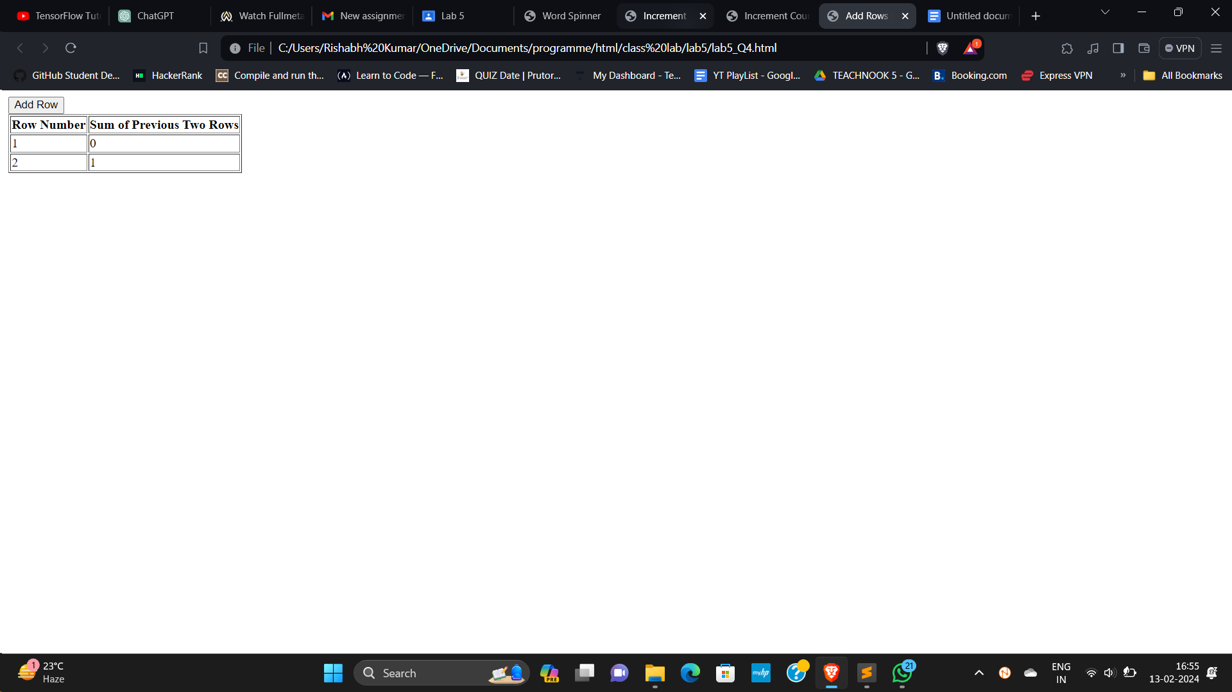

Q5.

<!DOCTYPE html>

<html lang="en">

<head>

<meta charset="UTF-8">

<meta name="viewport" content="width=device-width, initial-scale=1.0">

<title>Calculator</title>

</head>

<body>

<input type="text" id="input1">

<input type="text" id="input2">

<br>

<button onclick="calculate('+')">+</button>

<button onclick="calculate('-')">-</button>

<button onclick="calculate('\*')">\*</button>

<button onclick="calculate('/')">/</button>

<br>

<div id="result"></div>

<script>

function calculate(operation) {

var input1 = Number.parseInt(document.getElementById('input1').value);

var input2 = Number.parseInt(document.getElementById('input2').value);

var result;

switch(operation) {

case '+':

result = input1 + input2;

break;

case '-':

result = input1 - input2;

break;

case '\*':

result = input1 \* input2;

break;

case '/':

result = input1 / input2;

break;

default:

result = "Invalid operation";

}

document.getElementById('result').innerText = "Result: " + result;

}

</script>

</body>

</html>

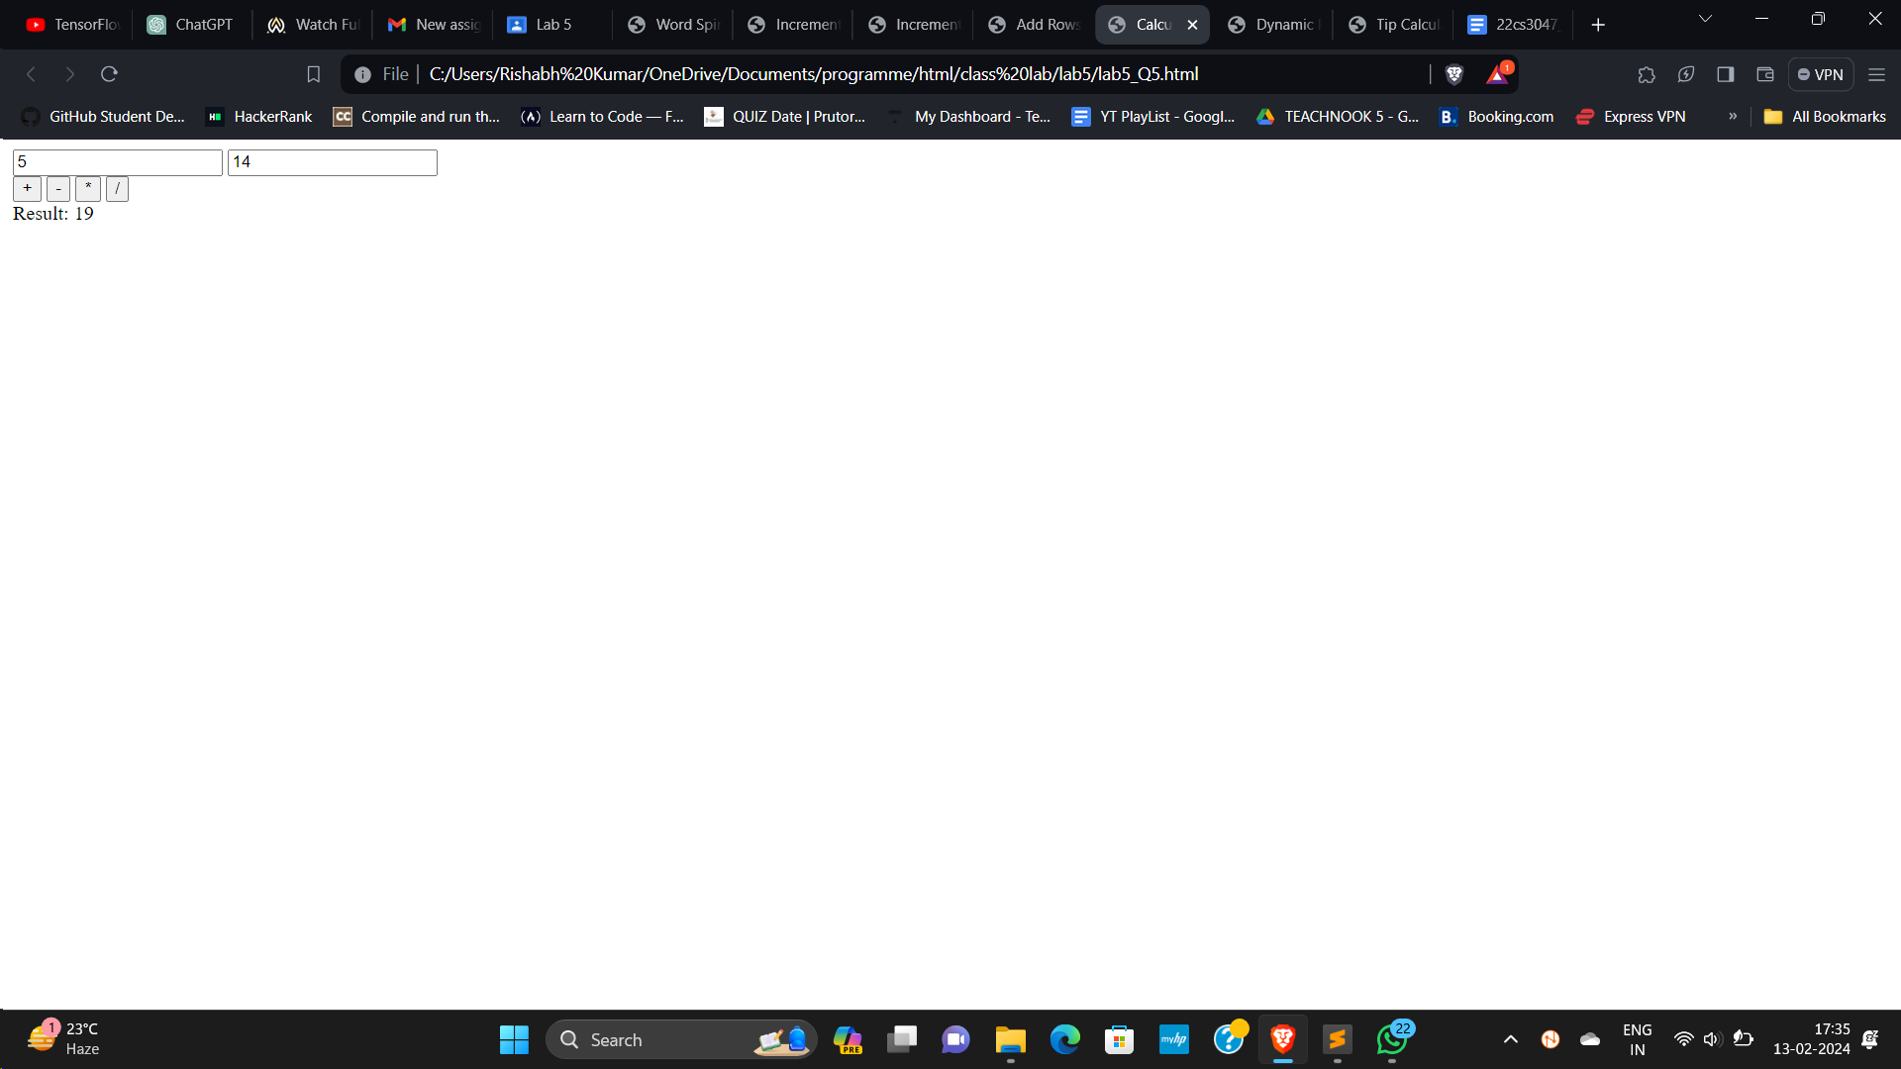

Q6.

<!DOCTYPE html>

<html lang="en">

<head>

<meta charset="UTF-8">

<meta name="viewport" content="width=device-width, initial-scale=1.0">

<title>Dynamic Page Creation</title>

</head>

<body>

<button onclick="makePage();">Click Here</button>

<script>

function makePage() {

var h1 = document.createElement('h1');

h1.textContent = "I am an H1";

var paragraph = document.createElement('p');

paragraph.textContent = "This is a paragraph followed by a list";

var ol = document.createElement('ol');

ol.setAttribute('type', 'I');

var li1 = document.createElement('li');

li1.textContent = "This is first";

ol.appendChild(li1);

var li2 = document.createElement('li');

li2.textContent = "This is second";

ol.appendChild(li2);

document.body.appendChild(h1);

document.body.appendChild(paragraph);

document.body.appendChild(ol);

}

</script>

</body>

</html>

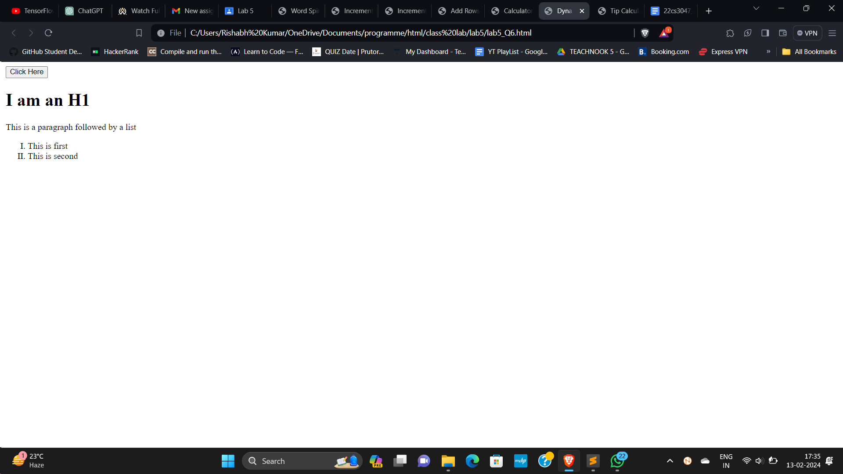

Q7.

<!DOCTYPE html>

<html lang="en">

<head>

<meta charset="UTF-8">

<meta name="viewport" content="width=device-width, initial-scale=1.0">

<title>Tip Calculator</title>

<style>

body {

font-family: Arial, sans-serif;

margin: 0;

padding: 0;

display: flex;

justify-content: center;

align-items: center;

height: 100vh;

background-color: #f4f4f4;

}

.calculator {

background-color: #fff;

border-radius: 5px;

padding: 20px;

box-shadow: 0 0 10px rgba(0, 0, 0, 0.1);

}

.input-group {

margin-bottom: 10px;

}

.input-group label {

display: block;

margin-bottom: 5px;

}

.input-group input {

width: 100%;

padding: 8px;

border-radius: 3px;

border: 1px solid #ccc;

}

.result {

margin-top: 20px;

}

</style>

</head>

<body>

<div class="calculator">

<div class="input-group">

<label for="billAmount">Bill Amount:</label>

<input type="number" id="billAmount" min="0" step="0.01">

</div>

<div class="input-group">

<label for="tipPercentage">Tip Percentage:</label>

<input type="number" id="tipPercentage" min="0" max="100" step="1">

</div>

<div class="input-group">

<label for="numberOfPeople">Number of People:</label>

<input type="number" id="numberOfPeople" min="1">

</div>

<button onclick="calculateTip()">Calculate</button>

<div class="result" id="result"></div>

</div>

<script>

function calculateTip() {

var billAmount = parseFloat(document.getElementById('billAmount').value);

var tipPercentage = parseFloat(document.getElementById('tipPercentage').value);

var numberOfPeople = parseInt(document.getElementById('numberOfPeople').value);

if (isNaN(billAmount) || isNaN(tipPercentage) || isNaN(numberOfPeople) || billAmount <= 0 || tipPercentage < 0 || numberOfPeople <= 0) {

document.getElementById('result').textContent = "Please enter valid values";

return;

}

var tipAmount = billAmount \* (tipPercentage / 100);

var amountPerPerson = tipAmount / numberOfPeople;

document.getElementById('result').textContent = "Tip per person: Rs. " + amountPerPerson.toFixed(2);

}

</script>

</body>

</html>

