Q1.

<!DOCTYPE html>

<html lang="en">

<head>

<meta charset="UTF-8">

<meta name="viewport" content="width=device-width, initial-scale=1.0">

<title>Prototype 3</title>

</head>

<body>

<h1>Shopping List</h1>

<input type="text" id="item" placeholder="Enter item">

<button onclick="addItem()">Add Item</button>

<ul id="list"></ul>

<script>

// Function to add item to the list

function addItem() {

var itemInput = document.getElementById('item');

var item = itemInput.value.trim();

if (item !== '') {

var list = document.getElementById('list');

var listItem = document.createElement('li');

listItem.textContent = item;

list.appendChild(listItem);

saveListToLocalStorage();

itemInput.value = ''; // Clear the input field

}

}

// Function to save list to local storage

function saveListToLocalStorage() {

var listItems = document.querySelectorAll('#list li');

var itemList = [];

listItems.forEach(function (item) {

itemList.push(item.textContent);

});

localStorage.setItem('shoppingList', JSON.stringify(itemList));

}

// Function to load list from local storage

function loadListFromLocalStorage() {

var storedList = localStorage.getItem('shoppingList');

if (storedList) {

var itemList = JSON.parse(storedList);

var list = document.getElementById('list');

itemList.forEach(function (item) {

var listItem = document.createElement('li');

listItem.textContent = item;

list.appendChild(listItem);

});

}

}

// Load list when the page loads

window.onload = loadListFromLocalStorage;

</script>

</body>

</html>

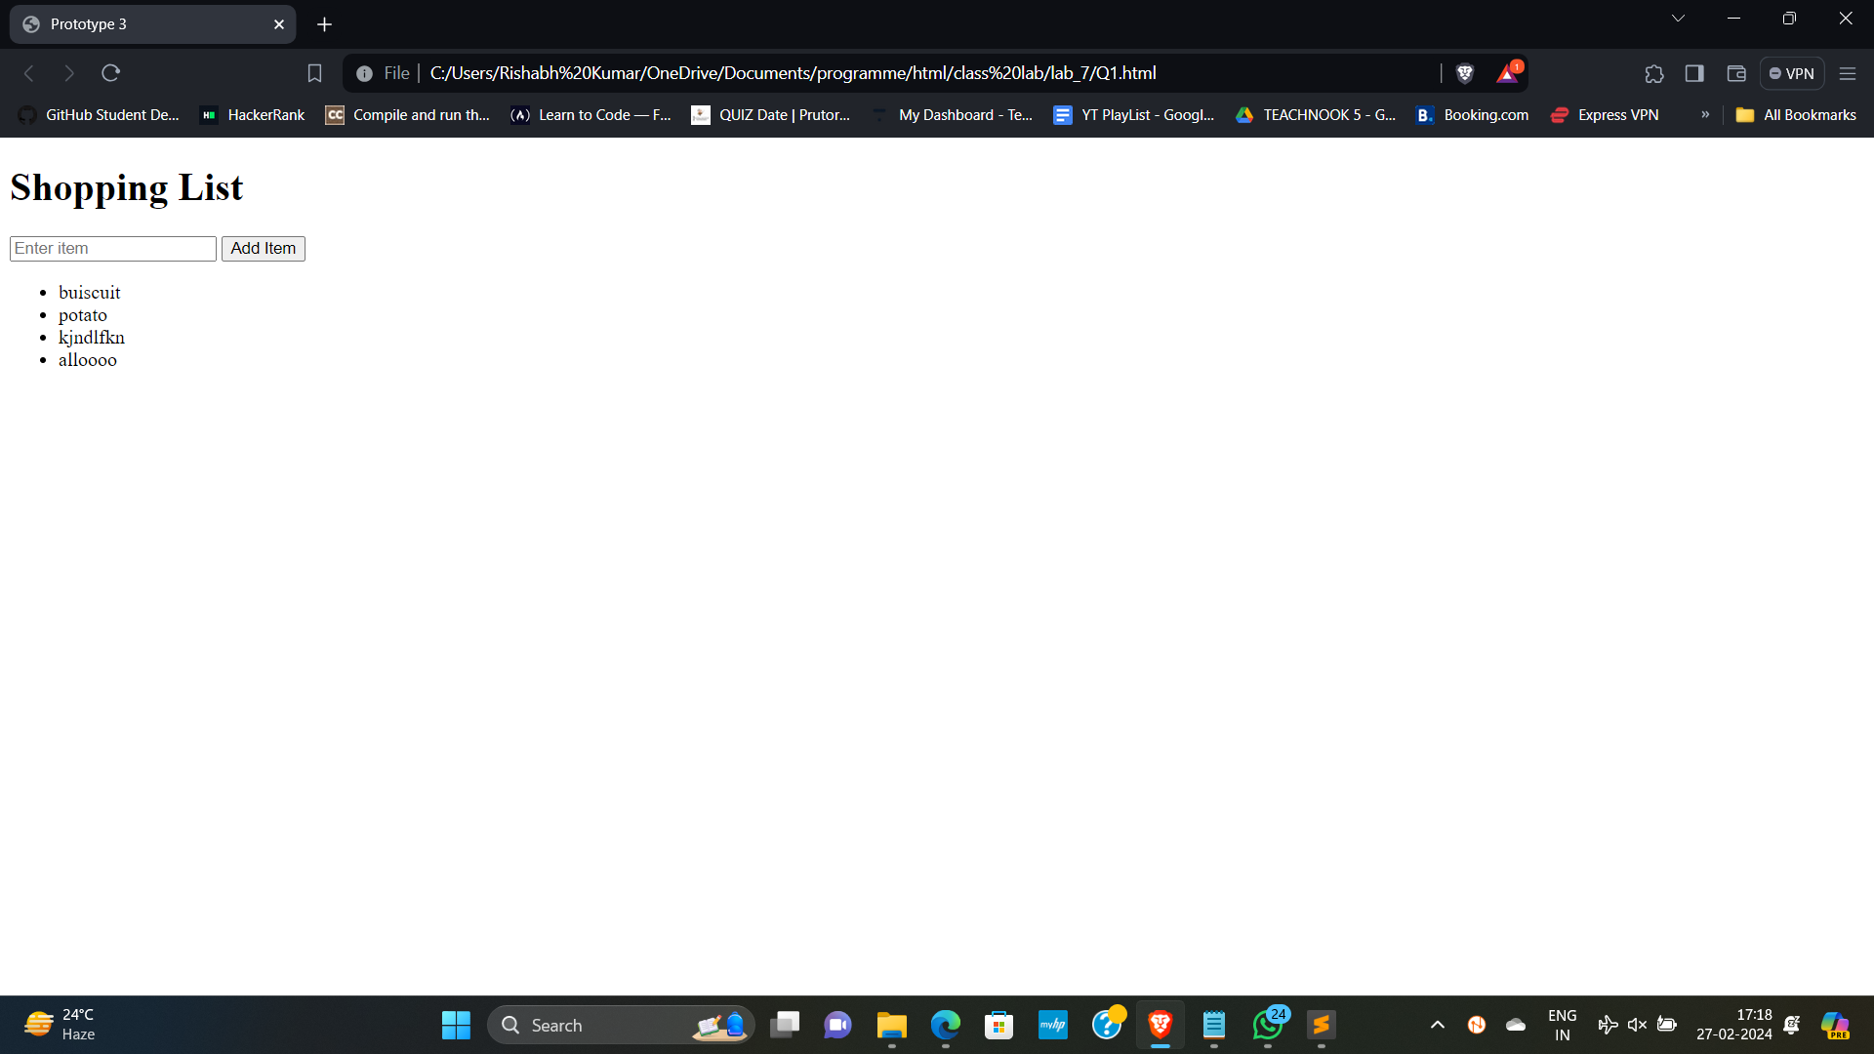

Q2.

<!DOCTYPE html>

<html lang="en">

<head>

<meta charset="UTF-8">

<meta name="viewport" content="width=device-width, initial-scale=1.0">

<title>Prototype 3</title>

</head>

<body>

<h1>Shopping List</h1>

<input type="text" id="item" placeholder="Enter item">

<button onclick="addItem()">Add Item</button>

<ul id="list"></ul>

<h2>Page Access Count</h2>

<p id="accessCount"></p>

<script>

// Function to add item to the list

function addItem() {

var itemInput = document.getElementById('item');

var item = itemInput.value.trim();

if (item !== '') {

var list = document.getElementById('list');

var listItem = document.createElement('li');

listItem.textContent = item;

list.appendChild(listItem);

saveListToLocalStorage();

itemInput.value = ''; // Clear the input field

}

}

// Function to save list to local storage

function saveListToLocalStorage() {

var listItems = document.querySelectorAll('#list li');

var itemList = [];

listItems.forEach(function (item) {

itemList.push(item.textContent);

});

localStorage.setItem('shoppingList', JSON.stringify(itemList));

}

// Function to load list from local storage

function loadListFromLocalStorage() {

var storedList = localStorage.getItem('shoppingList');

if (storedList) {

var itemList = JSON.parse(storedList);

var list = document.getElementById('list');

itemList.forEach(function (item) {

var listItem = document.createElement('li');

listItem.textContent = item;

list.appendChild(listItem);

});

}

}

// Function to update and display page access count

function updatePageAccessCount() {

var count = localStorage.getItem('pageAccessCount');

if (!count) {

count = 1;

} else {

count = parseInt(count) + 1;

}

localStorage.setItem('pageAccessCount', count);

document.getElementById('accessCount').textContent = 'Page accessed ' + count + ' times.';

}

// Load list and update page access count when the page loads

window.onload = function () {

loadListFromLocalStorage();

updatePageAccessCount();

};

</script>

</body>

</html>

