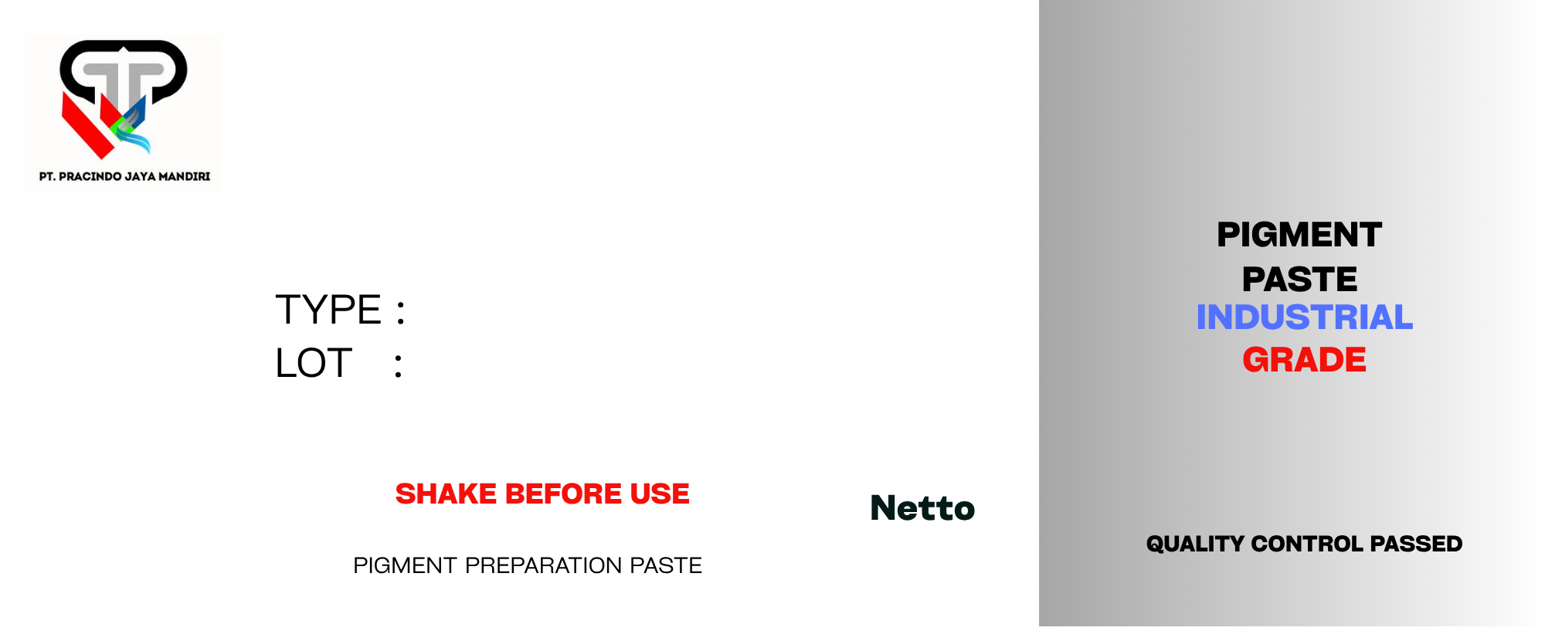
{{slot1_net}} KG
{{slot1_lot}}
{{slot1_tipe}}
{{slot1_nama}}
{{slot1_net}} KG
{{slot1_lot}}
{{slot1_tipe}}
{{slot1_nama}}
{{slot1_net}} KG
{{slot1_lot}}
{{slot1_tipe}}
{{slot1_nama}}
{{slot1_net}} KG
{{slot1_lot}}
{{slot1_tipe}}
{{slot1_nama}}

