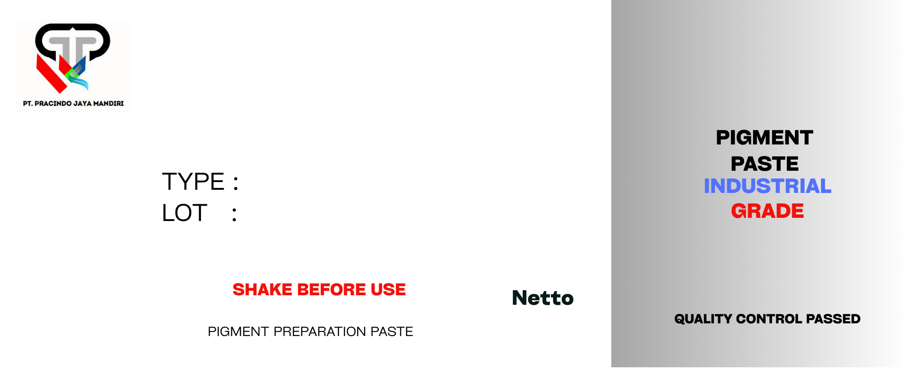
{{slot1_net}} KG
{{slot1_lot}}
{{slot1_tipe}}
{{slot1_nama}}
{{slot1_net}} KG
{{slot1_lot}}
{{slot1_tipe}}
{{slot1_nama}}
{{slot2_net}} KG

{{slot2_lot}}

{{slot2_tipe}}

{{slot2_nama}}

{{slot2_net}} KG

{{slot2_lot}}

{{slot2_tipe}}

{{slot2_nama}}

