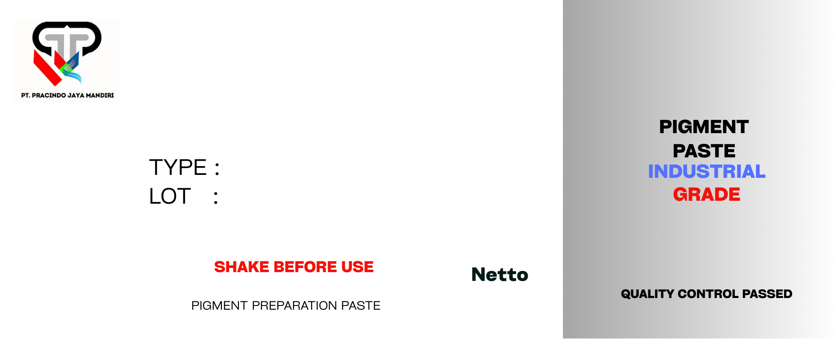
{{slot1_net}} KG
{{slot1_lot}}
{{slot1_tipe}}
{{slot1_nama}}
{{slot1_net}} KG
{{slot1_lot}}
{{slot1_tipe}}
{{slot1_nama}}
{{slot2_net}} KG
{{slot2_lot}}
{{slot2_tipe}}
{{slot2_nama}}
{{slot3_net}} KG
{{slot3_lot}}
{{slot3_tipe}}
{{slot3_nama}}

