RFID - RC522

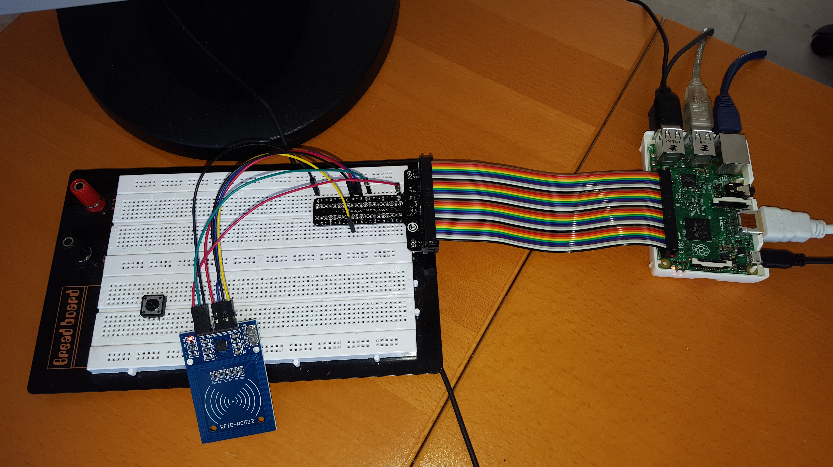

Table of Contents
Foreword : so why ?? 2
Hardware connection 3
Software setup on the Raspberry Pi. 4
RS522 Configuration file (/etc/RS522.conf) 5
Source code... as it was intended..... 7
Source code : as it is now 8
Following files in the directory 10
Addendum 1 : original RC522 software 10

Foreword : so why ??

Background
As I focus to learn more about the area of Internet of Things (IOT), connecting hardware and software is a clear point of study. The Serial Peripheral Interface (SPI) interface is one of those aspects to study. I decided to combine that with understanding more about Radio-frequency identification (RFID) and found the cheap RS522 the ideal combination. There is already a lot of information and examples available and I already had one in a experimental box.

So this would be “walk in the park”.

Well it was a larger park than expected. As I wanted to write this in “c” instead of other projects done in Python, I decided to use RC522.c which was referenced on a number of websites, in combination with the BCM2835 library. The later library is excellent.
However for the RC522 software it was very hard to find a good working solutions. Actually I found a number of prove of concepts and examples but not a real working solution. (see as source code as it was intended). It mend I had to spend more time BUT it also means that I have learned a TON about SPI (wrote a debugger/analyzer that I will extend and share later), but also the MIFARE cards and RC522 have no secrets anymore.

The program is working it can read, write blocks, you can update access bits for specific blocks and KEYA or KEYB for a specific sector. You can start programs based on content of a block or serial-number of a card etc.

Disclaimer
RC522 and MIFARE are trademarks from NXP Semiconductors.

RFID-RC522 contains part of the software from the original RC522.c package, written by alexs in 2013, which is freely available /down-loadable from the Internet. As that package does not contain license documentation it is assumed to be free-ware without distribution or usage constraints.

RFID-RC522 is free software: you can redistribute it and/or modify it under the terms of the GNU General Public License as published by the Free Software Foundation, either version 3 of the License, or (at your option) any later version.

RFID-RC522 is distributed in the hope that it will be useful, but WITHOUT ANY WARRANTY; without even the implied warranty of MERCHANTABILITY or FITNESS FOR A PARTICULAR PURPOSE. See the GNU General Public License for more details.

You should have received a copy of the GNU General Public License along with RFID-RC522. If not, see <http://www.gnu.org/licenses/>.

Paul van Haastrecht
Paulvha@hotmail.com
March 2016

Hardware connection

Pin-layout (component side up)

[ RC522 ]
[_______________________________________]
| | | | | | | |
SDA SCK MOSI MISO IRQ GND RST 3.3V

Connect to Raspberry pin

pin GPIO
sda 24 8 // chip select
sck 23 11 // clock
mosi 19 IO // master out, slave in
miso 21 9 // master in, slave out
IRQ --
gnd 20
rst 15 22 // hard reset
3.3V 1

Note:
Remark: The size and tuning of the antenna and the power supply voltage have an
important impact on the achievable operating distance (SOURCE RC522 datasheet)

Some people have tried to read Near Field Communication (NFC) from the credit cards but even though RC522 is ISO 14443-2 compliant, that hardly works. Seems the wave power is not enough and some have used 5V instead of 3.3V (seems the RC522 can handle that although specification don’t show that) others have been reworking the antenna hardware. Even if you would succeed you still can not do anything with those case as the ISO 14443-4 security layer is not supported.

While MIFARE classic cards and it's encryption are older, people have analyzed and written about it so it is known not to be 100% water proof. It still can be used (and is used) in many solutions. In order to crack it, you need special skills and especially if you change the authentication KEYA from the default you need a real specialist with specific software and tools. For many implementations that is not worth the investment time and money to even try to crack it.

Software setup on the Raspberry Pi.
Make sure you are on latest versions
1. sudo apt-get update & sudo apt-get upgrade & raspi-update
2. Make sure you have SPI in raspi-config (advanced section)
3. Make sure that Device tree is enabled in raspi config (advanced)

cd /home/pi (assuming this is your home directory)

BCM2835 library
Install latest from BCM2835 from : http://www.airspayce.com/mikem/bcm2835/
- wget http://www.airspayce.com/mikem/bcm2835/bcm2835-1.50.tar.gz
- tar -zxf bcm2835-1.50.tar.gz
- cd bcm2835-1.50
- ./configure
- sudo make check
- sudo make install
- cd ..

RC522 utility
- cd rfid-rc522
- tar -zxvf rc522-1-5-0.tar.gz
- cd rc522
- ./mc // compile executable
- sudo cp RC522.conf /etc
- sudo chmod 666 /etc/RC522.conf
- edit /etc/RC522.conf // if necessary

Reboot
cd rc522
Run command as root : ./rc522 -h

Note: The software was tested on Jessie Debian version with a Pi2 and Pi3. The GPIO section has not changed with the BCM2836, only the processor.

RS522 Configuration file (/etc/RS522.conf)

SPI speed

According to the header about Khz etc. It seems to be mixing SPI speed and reading from card. The following information is based on the specification of BMC2835 and measured with a scope.

SPI speed is System_clock / (2 * (divider +1)) in Mhz

Raspberry clock is in rest ~600Mhz and under heavy load/usage the frequency is what you have put in raspi-config. (often 900Mhz or 1000Mhz)

With a 600Mhz system clock, the value in the configuration file

Value SPI clock
10000 → ~10Mhz
1000 → ~1Mhz
100 → ~100khz

The RC522 can handle SPI speed up to 10Mhz and thus 10000 should be the maximum in the configuration file, however got it running on 15000 as well. If your cable is long or reading is bad with errors, consider a lower number like 100 (100Khz).

That said, the cards that have been delivered with the box (MIFARE MF1ICS50) only have 106K transfer speed. So while you work fast with the RS522, if you try to read a card , it could often fail with CRC errors. A value of 1000 was working fine for me and is default in configuration file.

UID/GUI
While you can not run the BCM2835 library without being root, this UID and GID will be used for running the program and for the commands to be run based on the serial or block number (see below). If you don't know keep it to the Pi-user values : 1000 for both.

New_tag_path=/tmp/
Directory path to store the content of the tags, where filename will be named as serial number. The default path is “/tmp/”.

GPIO=22
This should be set to the GPIO on RST (in our case 22). It will reset the RC522.

LOOP=10
The program terminates after it has read LOOP cards. If LOOP = 0 , it will be an endless loop.

[0457ce6acb3182] sudo /usr/sbin/etherwake -i wlan0 78:e3:b5:b2:6c:52 #example
#[0457ce6acb3182] whoami >>/tmp/wh
[04af674a782f82] sleep 10
Enable executing programs based on a card serial-number. The number in between brackets is the serial number of the card. If that serial number matches the number read from a card, the command behind it will be executed in a child process that is time bound to 1 minute to run.

[@bbccdd] whoami >>/tmp/wh

This is a newly added feature to the original software. It allows to execute a command based on the content of a block. (see program description below). The header is '[@' and in this case the content of a block is 3 bytes 'bbccdd', it is then closed with a trailer ']', followed by the command. The content for an address can be written with the program. The command behind it will be executed in a child process that is time bound to 1 minute to run.

[03A{c319eba4}aa bb cc dd ee ff]
This is a newly added feature to the original software : it enables a different KEYA and/or KEYB per sector & per card than the default. The program allows to change the KEYA and or KEYB per sector. However to keep easy usage, this key is added to the configuration file. By default this is enabled for a single card with the corresponding serial number, however if the serial number is replaced with a '*' it applies to the sector on all cards.
Every time a block is accessed it is checked whether the sector of this block has different authentication key than default. If match is found the default key will be replaced. Which key is used can be checked in debug mode ( '-d'). The format is as follows:

# Header [xxy{
# xx = Sector-number (between 00 - 15)
# y = A or B (whether KEYA or KEYB)
# card serial-number (* = applies to all cards, otherwise specific card)
# separator }
# KEY (6 digits separated by spaces)
# Trailer ]
# example : [03A{c319eba4}aa bb cc dd ee ff]
# example : [02A{*}ff ff ff ff ff aa]

Note: to make a key active, remove the hash ('#') at the start of the line.

Source code... as it was intended.....

The first aspect is to discover whether or not to run in debug mode (only option available). Standard SPI only SPI0 is used as port. It then reads the parameters from the config file for GPIO, SPI_speed to perform a Hw_Init(). This HW_init, will setup the pins (GPIO and SPI0).
It is needed in case of a child process to run in user mode. It reads the UID from the config file to do a setuid().

An InitRc522() is performed to reset and set the RC522 . It then reads the new_tag_path from the config file. If that has been found, save_mem will be set for later and the content of the card will be read and stored.

In an never ending loop, it tries to find a tag with find_tag (), if successful and no error it will read the type and serial number of the card with select_tag_sn().

A match on the serial number is tried to be found in the config file. If found, the command behind it will be executed in a child process that is time bound to 1 minute to run. If it terminates before, great, otherwise it will be before being killed. The communication with the RC522 will be stopped, reset will be set and exit procedure with restore GPIO PIN from SPI mode, closing BCM library and closing the configuration file.

If there is no match with the serial number in the configuration file, the information will display in debug mode, or written to syslog. If save_mem, depending on the type of ultralight card different actions. In case of 0x400 (blue small tag), the RC522 will be put on hold with PcdHalt() and the RST will be set. In case of the 0x4400 (different card ??) with information, it will create the filename based on the serial number. It will check whether the file already exist, if so it will stop , otherwise it will try to read the max_page (0x3f) from the card and store that in the file.

BUT... it is not working....

The code is more prove of concept, then really working.....

First and for most, the reset signal needs to be moving from low to high to perform a reset on the RC522 and STAY high during operation. This is ONE time done after a card had been detected. The logic is mixed up, reversed !

Not clear when it stops reading, unclear when it puts RC522 on hold and raises reset. Reset requires a complete new initialization of the RC522, but that never happens but keeps looping even after reset ??

The save_mem does not work in case of 0x400 Ctype. There is a “continue” instruction to skip that activity, but after raising reset?

There is no authentication done before while try to read the content of the card. Hence that fails by default with an unknown error and content is not stored.

I like to be able to write information on the card, not only reading.

Source code : as it is now

While some of the original source code is still there 60% is new. The program is now driven with instructions from the command line. The debug mode '-d' is still there and can be used in combination with the other commands to provide more status updates if necessary.

The program will loop the amount specific in the configuration file and will display the number of cards to still handle. If started without options it will read & display the card information and sleep for 5 seconds for the card to be removed.

The following options can be provided.

'-r'
Reads a specific block. This will call read_from_card() and will ask for the block number. It will then ask for the card and display the block information. This block can also be a trailer. If you enter '99' the program will terminate nicely.

'-w'
Writes information to a specific block. This will call write_to_card() and will ask for the block number. If you enter '99' the program will terminate nicely. A trailer block number will not be accepted. Then it will ask for the number of bytes (max 16) to write to the block. It will ask for each byte to enter and checks this is a valid hex-number. Once the amount of valid bytes have been entered, it will ask for confirmation. It will then ask for the card and after writing it will read the block and display the block content.

'-s'
Saves all blocks to a file. This will call read_card_to_file(). The directory location of that file is specific in the configuration file and the filename will be that of the card serial-number. If that file already exists it will NOT save the content again. A counter will show the read progress. This is a text file (.txt).

'-p'
Perform a specific action based on card serial-number. This will call perform_action(). The configuration file must have an entry with the serial-number and action to perform. See configuration file. When a match has been found a child process will be start to execute the command for maximum 1 minute.

'-a'
Perform action based on content of a block. This will call addr_action(). It will ask for the block to read and reads the card. The configuration file must have an entry with the block content and action to perform. See configuration file. When a match has been found a child process will be start to execute the command for maximum 1 minute.

'-c'
Change the access rights of a specific block. This will call change_con() and will ask for the block number. If you enter '99' the program will terminate nicely. A trailer block will not be accepted. It will then read the card, display the current access rights and will ask whether you want to change. DO NOT REMOVE THE CARD WHILE MAKING SELECTION. You can either select 'n' = NOT to change or provide a number 0 – 7 for the access rights. It will then update the access rights.

'-k'
Change authentication KEYA or KEYB for a specific sector. This will call key_upd() and will ask whether you want to determine the sector based on sector number or the block address. A classic card has 16 sectors (0 – 15), each of which have 4 blocks. As such there are 64 blocks (0 -63). For full description of your card look at the card specification document.
Depending your selection it will ask for a block or sector number. If you enter '99' the program will terminate nicely.
It will then ask which KEY needs to be changed KEYA or KEYB, followed by asking the 6 new authentication bytes for that specific sector on the card. It will then display and ask for confirmation. As changing the KEY has real impact on access to the sector, you have to answer 'yes' or 'no' to make sure you know what you are doing.
Then hold the card to the reader and the trailer will be updated with the new KEYA or KEYB. It will display the new authentication key. To get access in the future you need to add an entry in the configuration file. This will be tried to perform automatically. You have to make that manually active by removing the starting '#' on the last line in the configuration file. PLEASE make sure /etc/RC522.conf has READ & WRITE rights for the UID/GID specific in the configuration file. If adding fails it will display an error message with the content to be added manually.

'-h'
Will display help by calling usage() and terminate

'-n'
Will surpress colors with the messages displayed.

Supporting routines

get_config_file()
Will be called at the beginning and set parameters depending on the content in the configuration file.

HW_init()
Called at the beginning and will set the GPIO pin and SPI interface in the correct state.

get_card_info()
Will ask and wait for a card (display a regular '.') to be presented and try to read the card-type and select the card with reading the serial number.

get_card_permission()
Will call get_card_info() and set parameters based upon the card type.

p_printf()
Display messages in color

authorize()
Will be called after the card has been selected ( e.g. after get_card_info()). It will determine the right authentication key to use ( KEYA/ KEYB) and will call read_conf_key() in config.c. There it will check whether the configuration file has a specific entry for this sector and card-number with a different then default ( 0xFFFFFFFFFFFF) authentication key (as set with '-k' option). However if the same sector was accessed before, it will take the information from cache. It will then perform authentication for the sector

close_out()
Is the proper way to terminate the program and will reset the GPIO pins. Called at the end of the program. On most places where a number is asked, entering '99' will call close_out() or when the loop count has been reached.

Following files in the directory

main.c main program
main.h header file with information about main.c
rfid.c routines to read and select the tag
rfid.h header file with information about rfid.c
config.c routines to read/write from configuration files
config.h header file with information about config.c
rc522.c routines to read/write to rc522
rc522.h header file with information about rc522.c
RC522.conf configuration file example (to be copied to /etc)
mc shell script to compile the code to rc522 executable

Addendum 1 : original RC522 software

Original software came from :
sudo apt-get install subversion
svn checkout http://rpi-rc522.googlecode.com/svn/trunk/ rpi-rc522-read-only
cd rpi-rc522-read-only/rc522
gcc config.c rfid.c rc522.c main.c -o rc522_reader -lbcm2835
// edit the RS522.conf – see below
sudo cp RC522.conf /etc
./rc522_reader -d

note : the original software had serious issues with the usage of reset and reading a card. Actually it is more a prove-of-concept.

