Secure Application Access and Application-Specific Access Policies using Zscaler Private Access (ZPA)

LIST OF MEMBERS:

S.NO | NAME | COLLEGE NAME | CONTACT
01 | AARONGRACE G | SRI KRISHNA ADITHYA  COLLEGE OF  ARTS AND SCIENCE | 23bscs102aarongraceg@skacas.ac.in
02 | AJAY S | SRI KRISHNA ADITHYA  COLLEGE OF  ARTS AND SCIENCE | 23bscs103ajays@skacas.ac.in
03 | YUGABHARATH R | SRI KRISHNA ADITHYA  COLLEGE OF  ARTS AND SCIENCE | 23bscs166yugabharathr@skacas.ac.in
04 | ARJUN P | SRI KRISHNA ADITHYA  COLLEGE OF  ARTS AND SCIENCE | 23bscs106arjunp@skacas.ac.in
05 | BALA GANESH P | SRI KRISHNA ADITHYA  COLLEGE OF  ARTS AND SCIENCE | 23bscs110balaganeshp@skacas.ac.in

INTRODUCTON:

In today's rapidly evolving digital environment, organizations increasingly rely on cloud services, remote work, and distributed applications. As a result, securing access to internal applications has become a critical challenge. Traditional remote access methods such as Virtual Private Networks (VPNs) often provide users with broad network-level access, which can increase the attack surface and expose sensitive systems to potential cyber threats. These limitations highlight the need for a more secure and controlled method of accessing enterprise applications.
To address these challenges, modern organizations are adopting the Zero Trust security model, which follows the principle of “never trust, always verify.” Unlike traditional security approaches that rely on network location to determine trust, Zero Trust requires continuous verification of user identity, device status, and access context before granting access to any resource. This approach ensures that users are granted access only to the specific applications they are authorized to use.
This project focuses on implementing secure application access and application-specific access policies using Zscaler Private Access (ZPA). ZPA is a cloud-based Zero Trust Network Access (ZTNA) solution that allows users to securely connect to internal applications without exposing the corporate network to the internet. Instead of placing users inside the network like traditional VPNs, ZPA creates a secure, direct connection between the authenticated user and the specific application they are allowed to access.
By using application-specific access policies, organizations can define precise access controls based on user identity, device posture, and security policies. This ensures that users can only access authorized applications while all other resources remain hidden and inaccessible. Such an approach significantly reduces the risk of cyberattacks such as unauthorized access, lateral movement, and network reconnaissance.
Ultimately, this project demonstrates how Zscaler Private Access can enhance enterprise security by enforcing a least-privilege access model, where users receive only the minimum level of access required for their tasks. By replacing traditional VPN-based access with a Zero Trust architecture, organizations can strengthen security, reduce the attack surface, and provide a safer and more efficient way for users to access applications.

ABSTRACT:
The rapid growth of hybrid work environments and cloud-based applications has made traditional perimeter-based security models, such as Virtual Private Networks (VPNs), less effective and increasingly vulnerable to cyber threats. These legacy solutions often grant users broad network-level access, which can expose organizations to risks such as unauthorized access, lateral movement within the network, and an expanded attack surface. To overcome these challenges, modern enterprises are adopting a Zero Trust security architecture that focuses on secure, identity-based access to applications.
This project focuses on implementing secure application access and application-specific access policies using Zscaler Private Access (ZPA). ZPA is a cloud-delivered Zero Trust Network Access (ZTNA) solution that enables users to securely connect to internal applications without exposing the corporate network to the internet. Instead of granting full network access like traditional VPNs, ZPA establishes secure, direct connections between authenticated users and the specific applications they are authorized to access.
The system uses application-specific access policies to control user access based on factors such as user identity, device status, and contextual information. These policies ensure that users can only access the applications necessary for their roles while all other network resources remain hidden and protected. By implementing this approach, the organization can significantly reduce the risk of cyberattacks, prevent unauthorized access, and minimize the possibility of lateral movement within the network.
Overall, this project demonstrates how Zscaler Private Access can enhance enterprise security by enforcing a least-privilege access model and separating application access from network access. The solution provides a secure, scalable, and efficient framework for remote application access while improving user experience and strengthening the organization's overall cybersecurity posture.

Use Case Scenarios
Scenario 1: Finance Department Secure Access to ERP Application
- A senior accountant from the finance department needs to access the organization’s ERP application to manage payroll operations. The employee connects remotely using a company laptop and authenticates through the Zscaler Client Connector using identity verification and multi-factor authentication (MFA). ZPA verifies the user's identity, device security status, and group membership before granting access.
- Based on the defined application-specific access policy, ZPA creates a secure connection only to the ERP application. The user can perform payroll tasks but cannot view or access any other internal applications or servers.
- Output:
- User authenticated using identity verification and MFA
- Secure connection created only to the ERP application
- Other internal applications remain hidden and inaccessible

Scenario 2: Contractor Access to Project Repository
- An external contractor working on a development project requires access to a specific Git repository hosted within the organization. The contractor is added to the system with limited access permissions and assigned to a specific project group.
- When the contractor connects using ZPA, the system verifies the user identity and device security conditions. Based on the defined access policies, the contractor is granted access only to the Git repository during approved working hours.
- The contractor can interact with the repository but cannot access any other internal systems such as corporate servers or internal databases.
- Output:
- Role-based access control enforced
- Contractor allowed to access only the project repository
- Unauthorized access to other internal systems prevented

Scenario 3: Executive Access to Confidential Documents
- A company executive needs to access confidential board meeting documents stored on an internal file server while traveling. The executive connects using a mobile device that is verified through the organization's device management system.
- ZPA evaluates the access policy based on the user role, device compliance, and connection location. After successful verification, a secure connection is created directly to the board documents folder.
- The executive can securely access the required documents while all other internal resources remain protected.
- Output:
- Access granted based on identity, device compliance, and location
- Secure access provided only to the board documents folder
- All other resources remain inaccessible

Scenario 4: IT Administrator Secure Server Management
- An IT administrator needs to manage internal servers for maintenance and system updates. Instead of providing full network access through VPN, ZPA allows administrators to access only the specific servers they are responsible for.
- The system verifies the administrator’s identity and role before establishing a secure connection to the required server management interface such as SSH or Remote Desktop.
- The administrator can manage the assigned servers but cannot scan or access other servers within the network.
- Output:
- Role-based access to specific server management interfaces
- Secure connection created only to authorized servers
- Network-level access and server discovery prevented

Scenario 5: Temporary Access for Business Collaboration
- When an organization collaborates with another company during a partnership or merger, temporary access may be required for certain applications. ZPA allows external users to securely access only the specific internal application required for collaboration.
- External users authenticate through the identity provider and are granted access only to the designated application based on predefined policies. The rest of the organization’s internal network remains completely hidden.
- Once the collaboration period ends, the access policies can be removed easily without affecting the internal infrastructure.
- Output:
- Temporary and controlled application access for external users
- Internal network remains hidden and protected
- Easy removal of access after collaboration ends

Stage – 1

Title:
Secure Application Access and Application-Specific Access Policies using Zscaler Private Access (ZPA)

Overview:
With the rapid growth of cloud services, remote work, and digital transformation, organizations are facing increasing challenges in securing access to internal applications. Traditional remote access methods such as Virtual Private Networks (VPNs) provide users with broad network-level access, which can increase the risk of cyber threats, unauthorized access, and lateral movement within the network. These limitations highlight the need for a more secure and controlled method for accessing enterprise applications.
To address these challenges, modern organizations are adopting the Zero Trust security model, which follows the principle of “never trust, always verify.” In this model, trust is not automatically granted based on network location. Instead, user access is continuously verified using identity, device security status, and contextual information before allowing access to any application.
This project focuses on implementing secure application access and application-specific access policies using Zscaler Private Access (ZPA). ZPA is a cloud-based Zero Trust Network Access solution that enables secure connections between authorized users and internal applications without exposing the corporate network to the internet. Unlike traditional VPNs that place users inside the internal network, ZPA provides direct and secure connections only to the specific applications that users are permitted to access.
Through application-specific access policies, organizations can control user access based on identity, role, device posture, and security policies. This ensures that users can access only the applications required for their tasks, while all other internal resources remain hidden and protected from unauthorized access.
By implementing Zscaler Private Access, the system enforces a least-privilege access model, where users receive only the minimum level of access necessary for their work. This approach reduces the attack surface, prevents lateral movement within the network, and improves overall cybersecurity. At the same time, it simplifies remote access management and provides a secure and efficient way for users to connect to enterprise applications.

List of Vulnerability:

S. No. | Vulnerability Name | CWE No.
1. | Improper Access Control | 284
2. | Insecure Temporary File | 377
3. | Cleartext Storage of Sensitive Information in a Cookie | 315
4. | Active Debug Code | 489
5. | Unimplemented or Unsupported Feature in UI | 447
6. | Reusing a Nonce, Key Pair in Encryption | 323
7. | Neutralization of Special Elements used in an OS Command ('OS Command Injection') | 78
8. | Cleartext Storage in a File or on Disk | 313
9. | Improper Certificate Validation | 1021
10. | webserver allows password auto-completion | 310
11. | Cross-site scripting (DOM-based XSS) | 79
12. | Improper Handling of Insufficient Privileges | 274
Report:
- Vulnerability name: Improper Access Control
CWE: 284
OWASP category: A01:2025 Broken Access Control
Description:
It occurs when a system fails to properly restrict access to resources from unauthorized users. Improper access control allows users to perform actions or access data beyond their intended permissions. This vulnerability happens when authentication or authorization mechanisms are not correctly implemented, allowing attackers to bypass security restrictions and gain unauthorized access to sensitive systems or information.

Business Impact:
Improper access control can allow attackers to access confidential data, modify system settings, or perform actions with higher privileges than intended. From an attacker's perspective, this vulnerability can be exploited to bypass security checks and gain unauthorized access to critical resources. If a privileged user account is compromised, the attacker may perform administrative operations, steal sensitive information, or disrupt system functionality, which can lead to data breaches, financial loss, and damage to the organization's reputation.

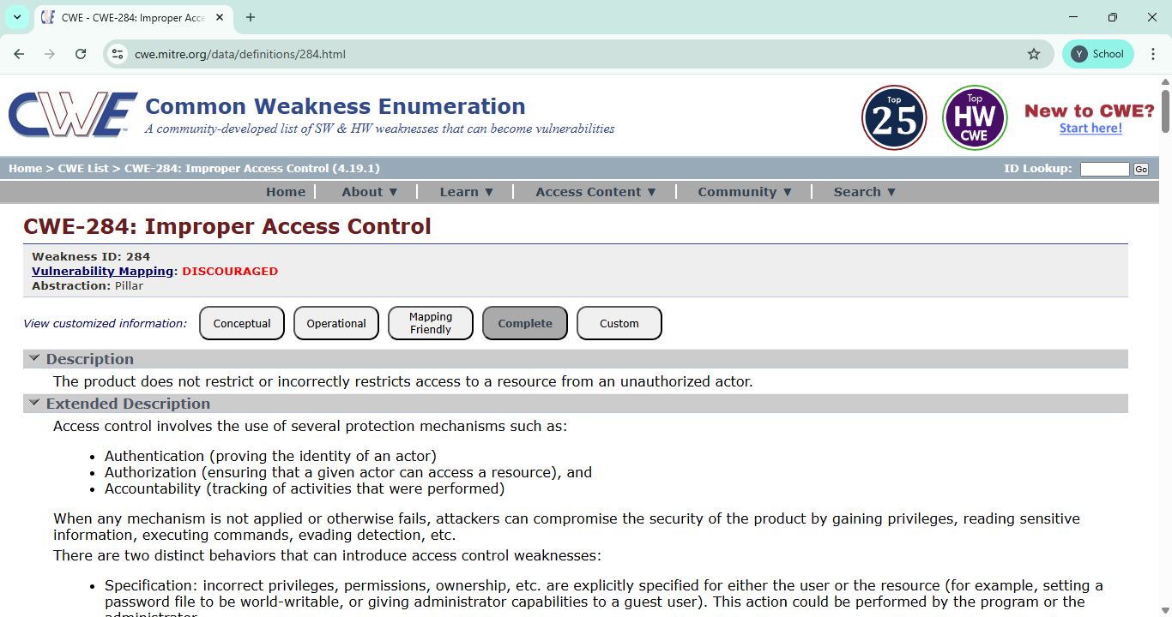

- Vulnerability name: Insecure Temporary File
CWE: 377
OWASP category: A01:2025 Broken Access Control

Description:
This vulnerability occurs when an application creates temporary files in an insecure location or without proper permissions. As a result, unauthorized users may access, modify, or delete these files, which can expose sensitive information or affect system functionality.

Business Impact:
This vulnerability can lead to data exposure, system manipulation, financial loss, and damage to the organization's reputation. It may also cause operational disruption and loss of customer trust.

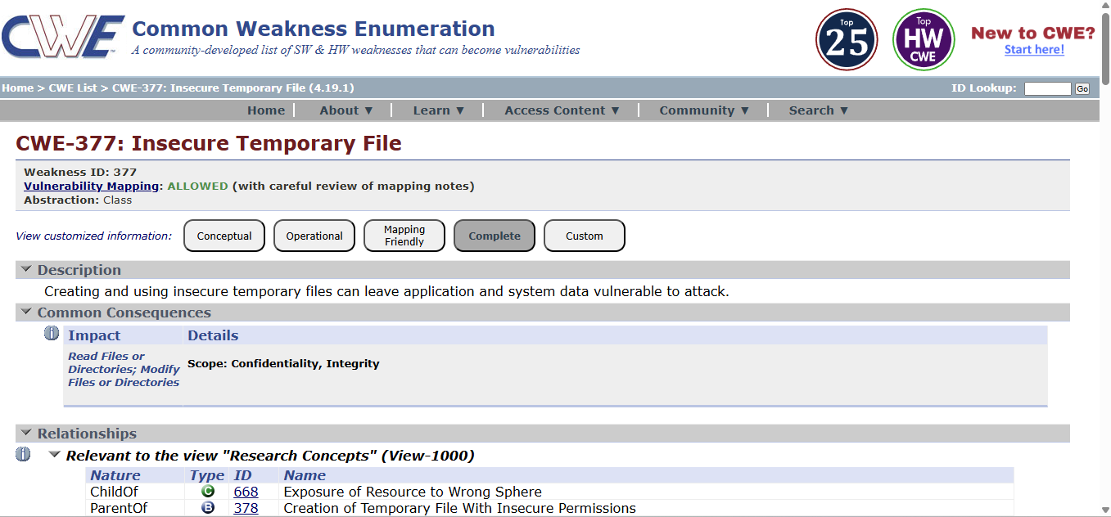

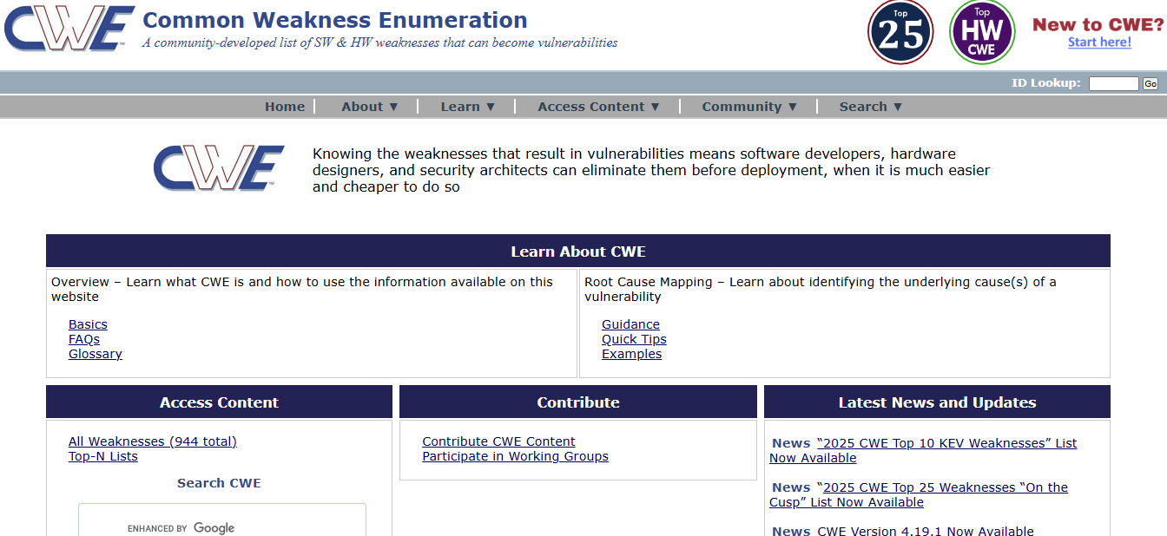

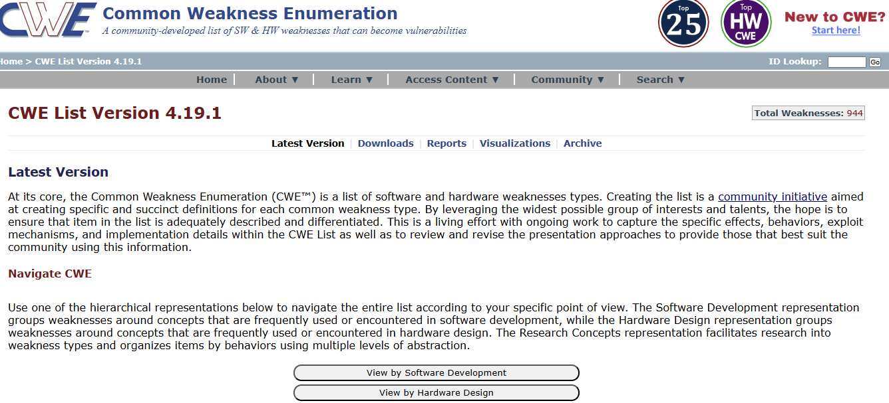

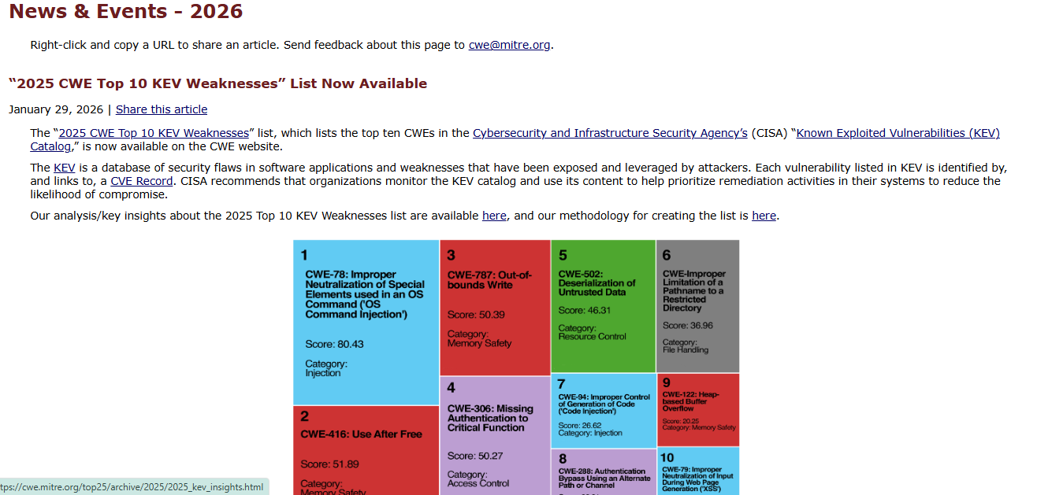
3.Vulnerability name: Cleartext Storage of Sensitive Information in a Cookie
CWE: 315
OWASP category: A02:2025 Security Misconfiguration

Description:
This vulnerability occurs when sensitive information such as user credentials, session IDs, or personal data is stored in cookies without proper encryption. Because cookies are stored on the user's browser, attackers may access or intercept this information if it is stored in cleartext.

Business Impact:
This vulnerability can lead to unauthorized access to user accounts, data leakage, and session hijacking. It may result in financial loss, privacy violations, and damage to the organization's reputation.

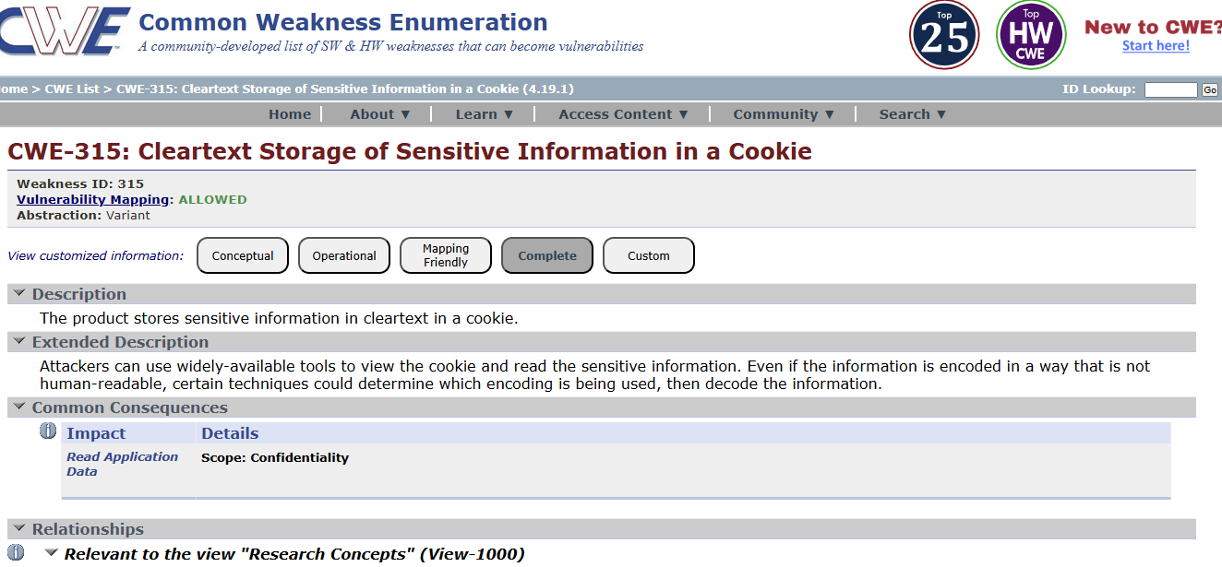

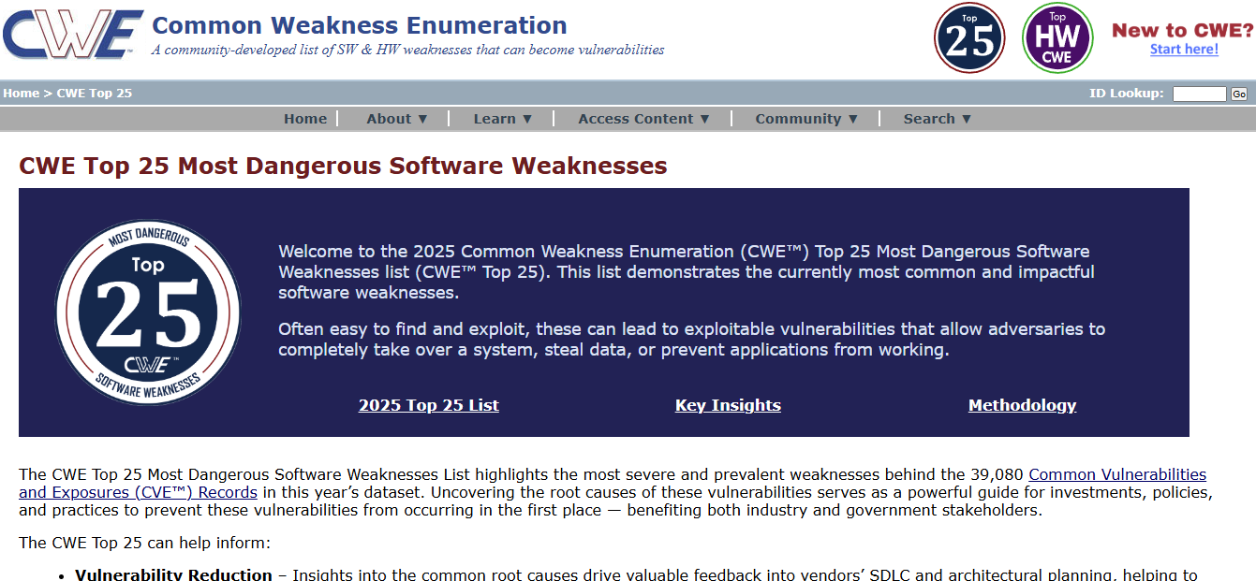

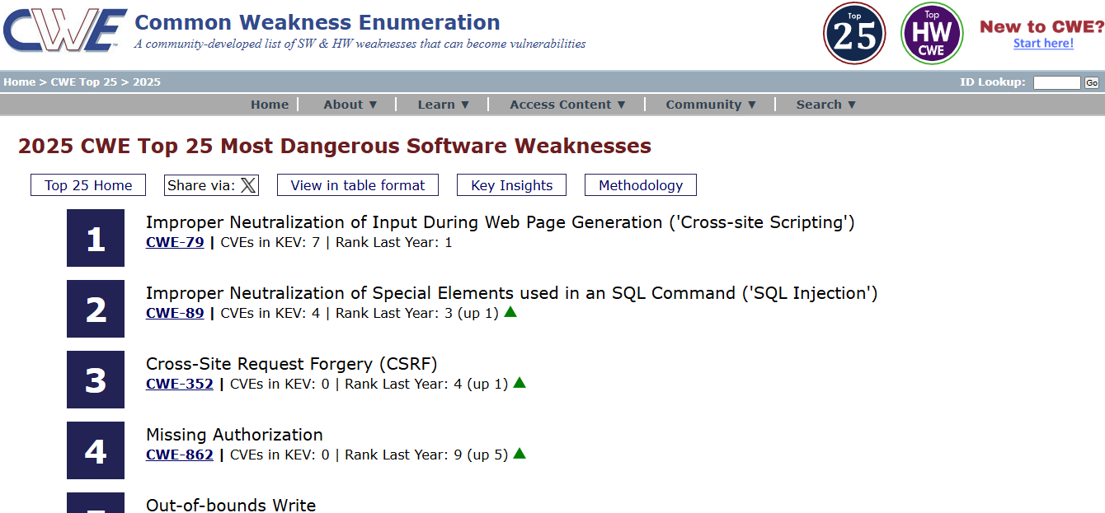

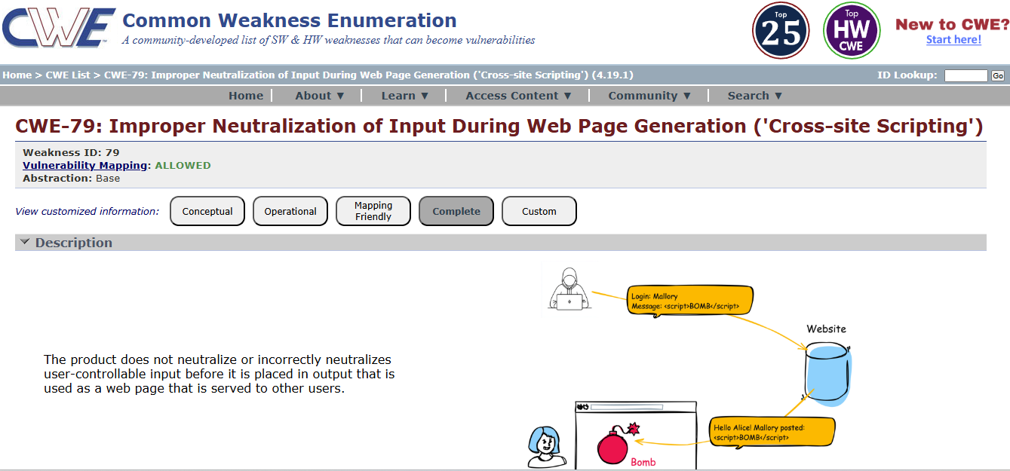

4. Vulnerability name: Active Debug Code
CWE: 489
OWASP category: A02:2025 Security Misconfiguration

Description:
This vulnerability occurs when debug or testing code is left active in the application after development. Debug code may expose internal system information, error messages, or hidden functionalities that attackers can use to understand the system and exploit vulnerabilities.
Business Impact:
Active debug code can expose sensitive system details and make it easier for attackers to identify security weaknesses. This may lead to unauthorized access, system manipulation, data breaches, and damage to the organization's reputation.

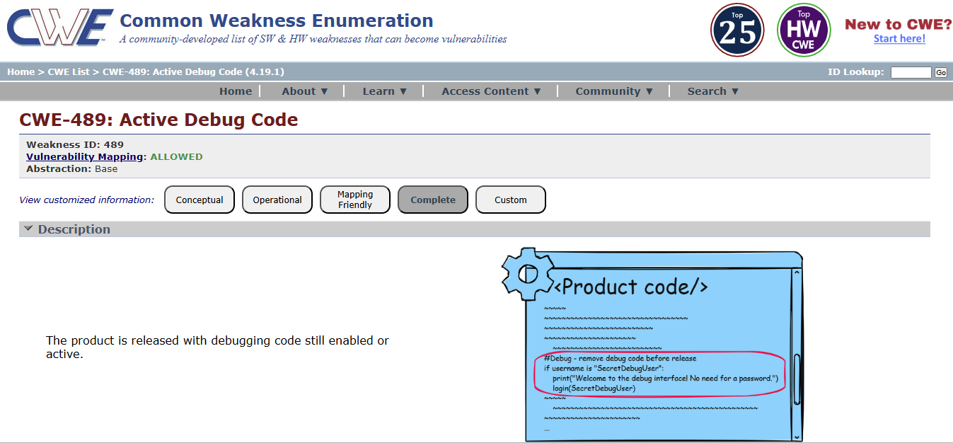
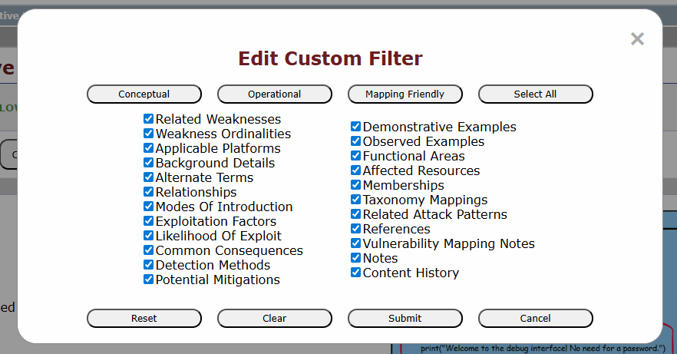
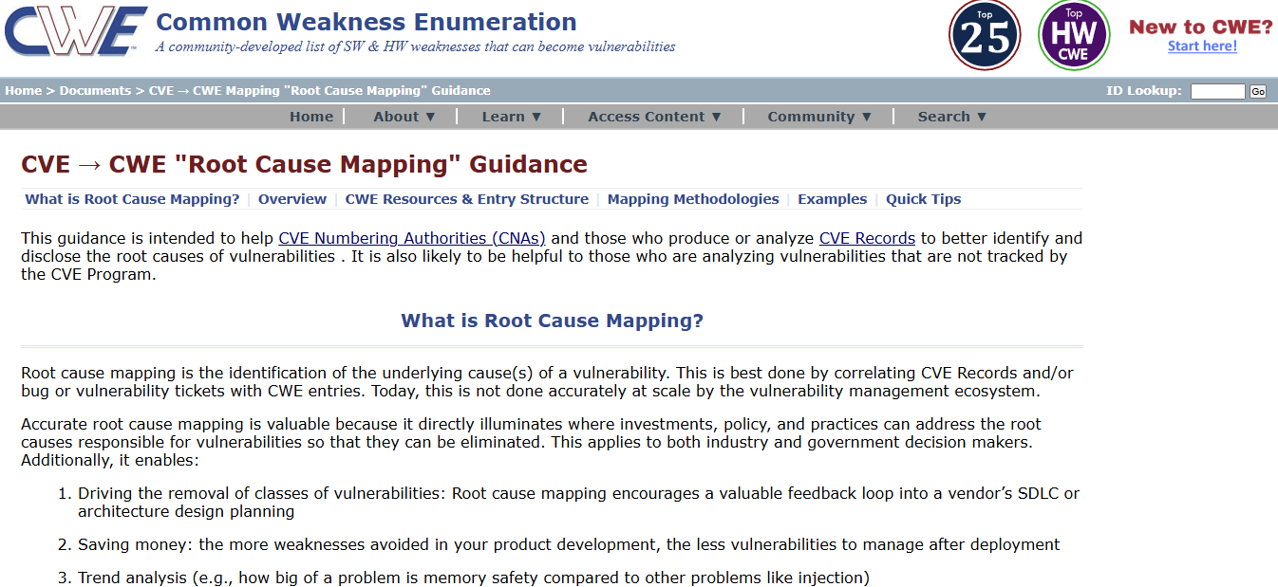

  - Vulnerability Name: Unimplemented or Unsupported Feature in UI
CWE: 447
OWASP Category: A03:2025 Software Supply Chain Failures

Description:
This vulnerability occurs when a user interface displays features or options that are not fully implemented or supported by the system. Such features may confuse users or create security risks if they trigger unexpected system behavior or expose incomplete functionality.

Business Impact:
Unimplemented or unsupported features can lead to user confusion, system errors, and potential security risks. Attackers may attempt to exploit these incomplete features to gain unauthorized access or disrupt system operations, which can affect the reliability and reputation of the organization.

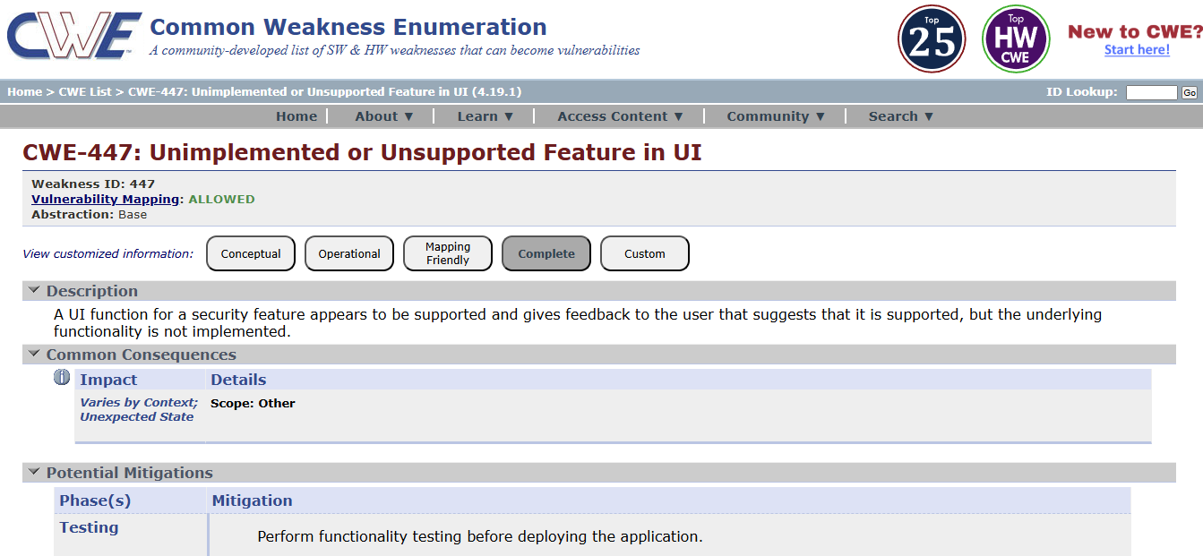

  - Vulnerability name: Reusing a Nonce, Key Pair in Encryption
CWE:323
OWASP Category: A04:2025 Cryptographic Failures
Description:
This vulnerability occurs when the same nonce (number used once) or cryptographic key pair is reused during encryption processes. Nonces and key pairs are meant to be unique for each encryption operation. Reusing them can weaken the security of the encryption algorithm and may allow attackers to analyze patterns and potentially recover sensitive data.
Business Impact:
Reusing nonces or key pairs can compromise the confidentiality of encrypted data. Attackers may decrypt sensitive information, leading to data breaches, financial loss, and damage to the organization's reputation.

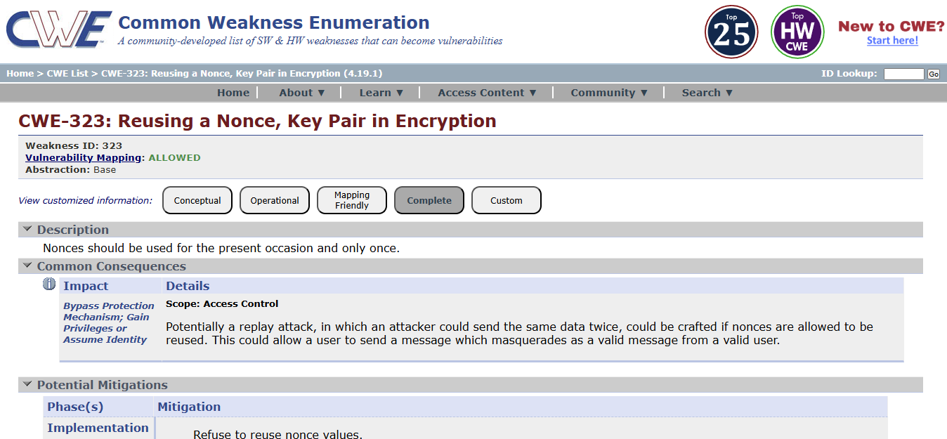

  - Vulnerability Name: Improper Neutralization of Special Elements used in an OS Command ('OS Command Injection')
CWS: 78
OWASP Category: A05:2025 Injection
Description:
This vulnerability occurs when an application executes operating system commands using user input without properly validating or sanitizing that input. Attackers can insert malicious commands into the input fields, which the system may execute on the server. This can allow attackers to run unauthorized system commands and gain control over the affected system.
Business Impact:
OS Command Injection can allow attackers to execute arbitrary commands on the server, leading to unauthorized access, data theft, or system compromise. This may cause operational disruption, financial loss, and damage to the organization's reputation.

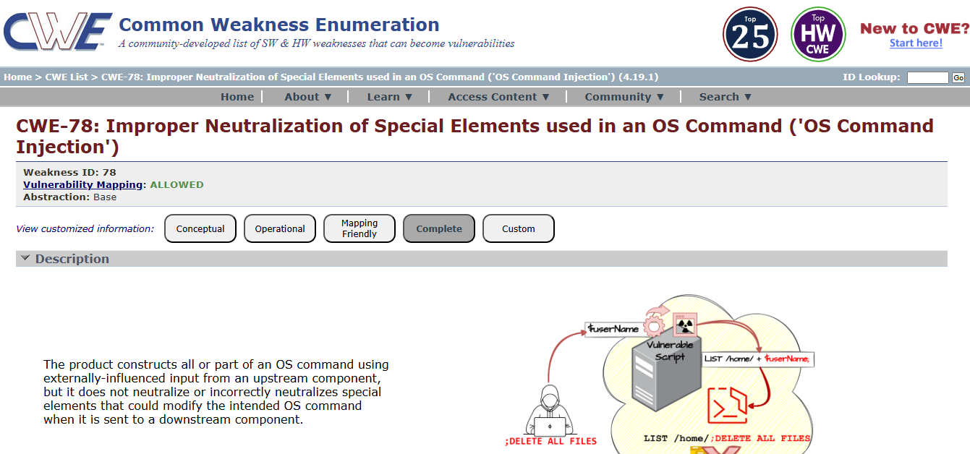

  - Vulnerability name: Cleartext Storage in a File or on Disk
CWE: 313
OWASP Category: A06:2025 Insecure Design
Description:
This vulnerability occurs when sensitive information such as passwords, personal data, or confidential system information is stored in files or on disk without encryption. If an attacker gains access to the system or storage location, they may easily read and misuse the stored data.
Business Impact:
Cleartext storage of sensitive data can lead to data breaches, unauthorized access, and exposure of confidential information. This may result in financial loss, legal issues, and damage to the organization’s reputation.

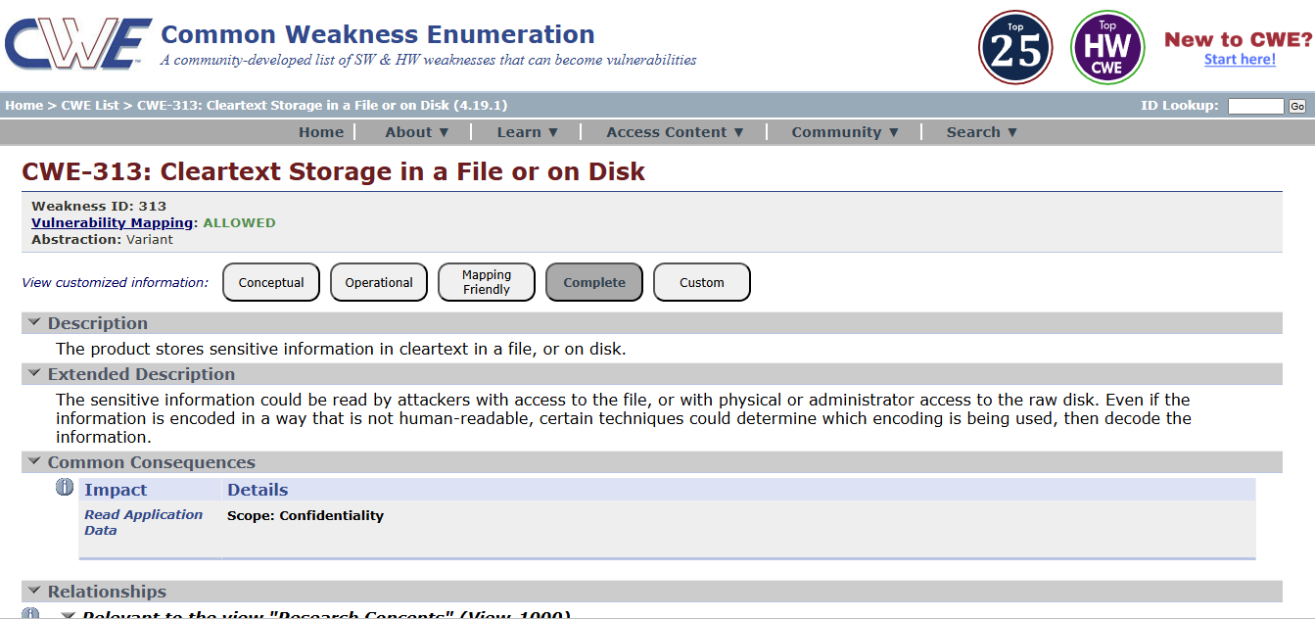

9. Vulnerability name: Improper Certificate Validation
CWE: 295
OWASP Category: A07:2025 Authentication Failures

Description:
This vulnerability occurs when an application fails to properly verify the validity of SSL/TLS certificates during secure communication. If certificate validation is not performed correctly, attackers may use fake or malicious certificates to intercept communication between the user and the server.
Business Impact:
Improper certificate validation can allow attackers to perform man-in-the-middle (MITM) attacks, leading to data interception, unauthorized access, and exposure of sensitive information. This can result in financial loss, security breaches, and damage to the organization’s reputation.

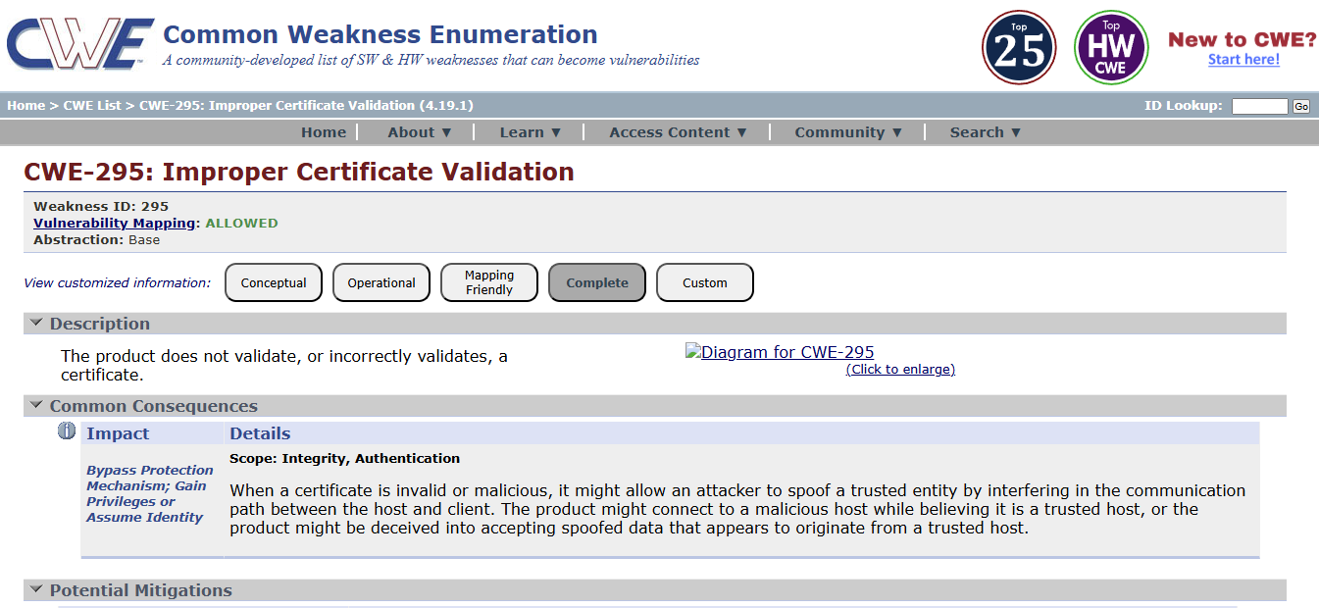

10. Vulnerability name: Deserialization of Untrusted Data
CWE: 502
OWASP Category: A08:2025 Software or Data Integrity Failures
Description:
This vulnerability occurs when an application deserializes data from untrusted or unknown sources without proper validation. Attackers may modify serialized data and send malicious input to the application. When the application processes this data, it may execute harmful code or perform unintended actions.
Business Impact:
Deserialization of untrusted data can allow attackers to execute arbitrary code, access sensitive information, or compromise the entire system. This can lead to data breaches, financial loss, and damage to the organization's reputation.

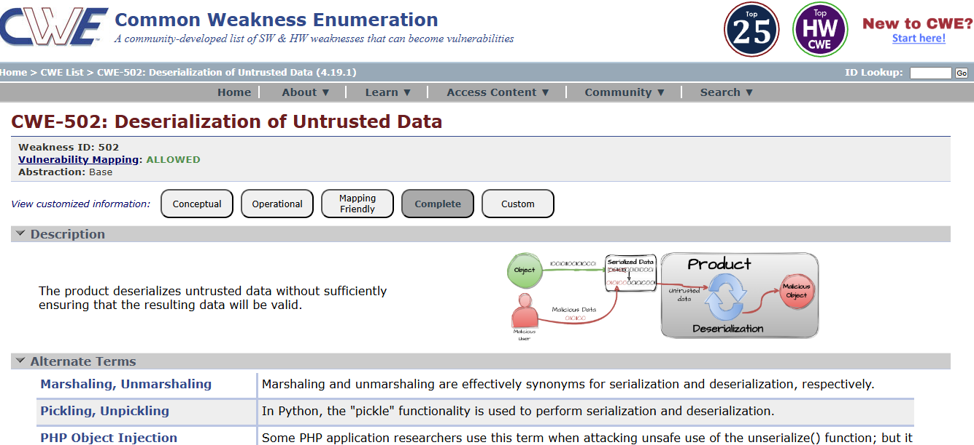

- Vulnerability name: Information Loss or Omission
CWE: 221
OWASP category: A09:2025 Security Logging & Alerting Failures

Description:
This vulnerability occurs when important information is lost, omitted, or not properly recorded during data processing, communication, or system operations. Missing or incomplete information may lead to incorrect system behavior, misunderstanding of data, or failure to properly track user actions and system events.

Business Impact:
Information loss or omission can cause inaccurate decision-making, operational errors, and difficulty in auditing system activities. It may also lead to compliance issues, reduced data reliability, and potential security risks for the organization.

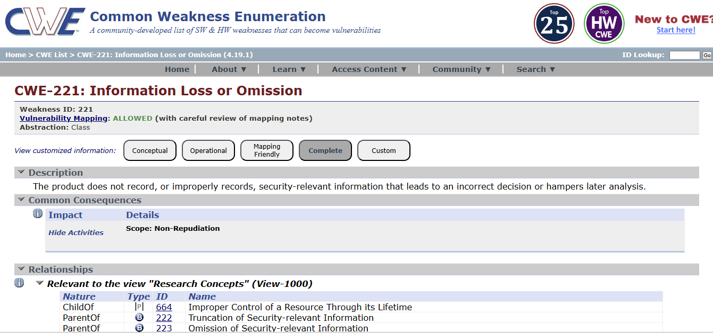

- Vulnerability name: Improper Handling of Insufficient Privileges
CWE: 274
OWASP category: A10:2025 Mishandling of Exceptional Conditions

Description:
This vulnerability occurs when an application does not properly handle situations where a user has insufficient privileges to perform an action. Instead of denying access, the system may allow the operation to proceed or may not correctly enforce permission checks. This can enable unauthorized users to access restricted resources or perform actions beyond their assigned permissions.

Business Impact:
Improper handling of insufficient privileges can lead to unauthorized access to sensitive data or system functions. Attackers may exploit this weakness to bypass security restrictions, which can result in data breaches, system misuse, and damage to the organization's reputation.

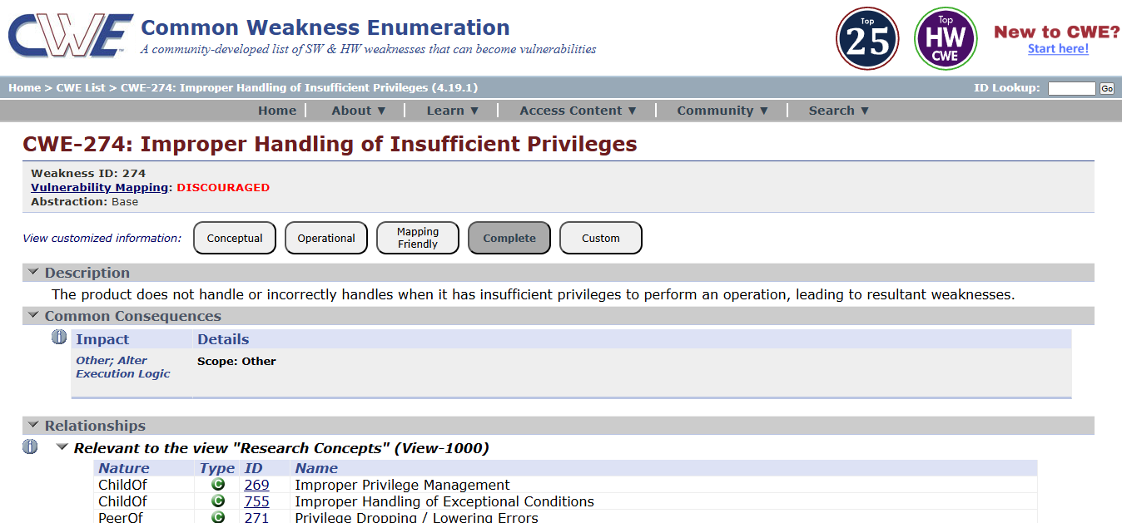

NESSUS SCAN REPORT:

ginandjuice.shop

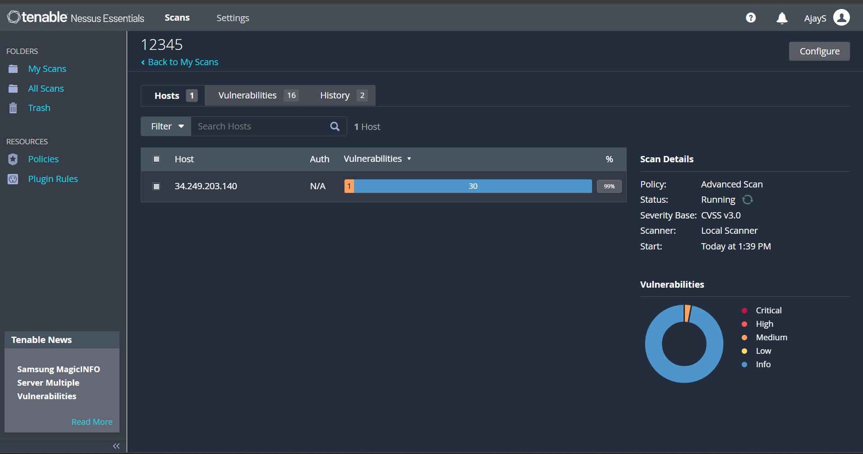

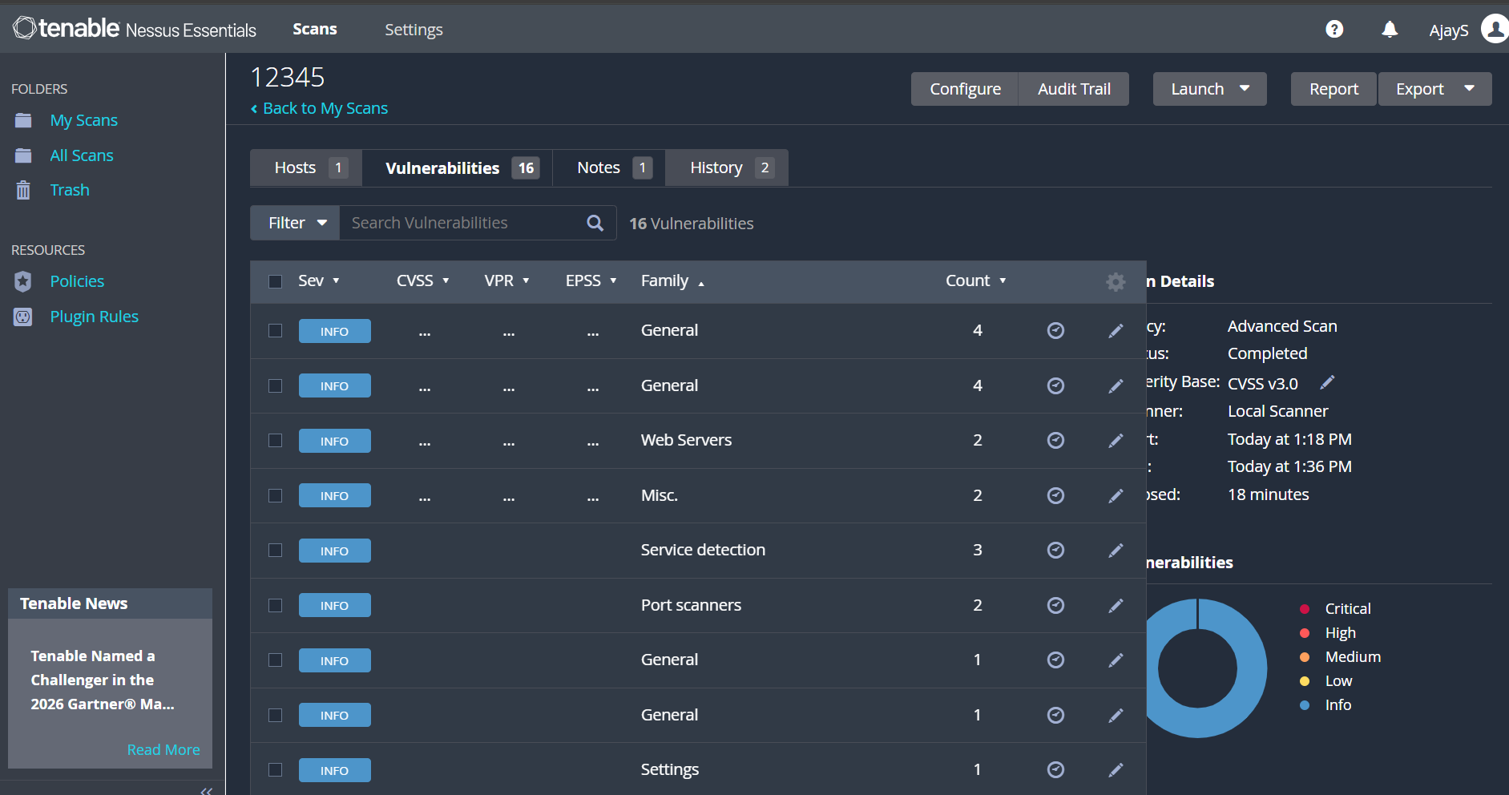

"With the Nessus scan report now at our disposal, we're equipped with critical data on the existing vulnerabilities and potential threats. This invaluable information will serve as a foundation for our project planning phase, as we chart the course to develop our AI-driven incident response platform with a well- informed strategy and timeline."

Stage – 2

Overview: -
An overview of Secure Application Access and Application-Specific Access Policies using Zscaler Private Access (ZPA) typically involves the following key steps and aspects:

1. Preparation:
Define Objectives:
Determine the scope and objectives of the secure access management system. Identify which applications, users, and network resources need secure access and what level of protection is required.
System Access:
Ensure that administrators have the necessary permissions and configurations to deploy ZPA and integrate AI-based security monitoring mechanisms.

2. Configuration
SetUpAccessPolicies:
Create security and access policies using ZPA to control how users connect to internal applications. AI models can assist in identifying unusual access patterns and enforcing adaptive security policies.
DefineProtectedApplications:
Specify the internal applications, servers, and services that need to be protected and accessed securely through the ZPA platform.

3. Secure Access Implementation
DeployZPAConnectors:
Install ZPA connectors within the internal network environment to establish a secure connection between users and applications without exposing the internal network.
AI-BasedMonitoring:
AI technologies analyze user behavior and access patterns to detect anomalies and potential threats in real time.

4. Threat Detection and Access Control
The system continuously monitors user activities and application access requests. AI-based analytics help detect suspicious behavior, unauthorized access attempts, and abnormal traffic patterns. Based on severity and risk level, the system can automatically enforce stricter access controls or block malicious activity.

5. Reporting
The system generates detailed reports on user access activities, detected threats, and security events. These reports include severity levels, recommended mitigation strategies, and evidence of suspicious activity. Reports can be exported in formats such as PDF, CSV, or dashboards for security monitoring.

6. Remediation
ReviewSecurityFindings:
Security teams analyze alerts and reports generated by the AI monitoring system and ZPA platform.
CorrectiveActions:
Take appropriate actions such as modifying access policies, blocking malicious users, updating security configurations, or strengthening authentication mechanisms.

7. Follow-Up and Continuous Monitoring
ContinuousMonitoring:
Regular monitoring ensures that the system detects new threats and unauthorized access attempts.
Integration:
Integrate the system with other security tools such as SIEM platforms or identity management systems to enhance the overall security posture.

8. Compliance Management
If compliance requirements are applicable, review security policies and access logs to ensure adherence to regulatory standards and organizational security policies.

9. Documentation
Maintain detailed records of system configurations, access logs, detected threats, and remediation actions. Proper documentation helps in auditing, compliance verification, and improving the system.

10. User Awareness and Training
Ensure that IT administrators and users understand how the secure access system works, including authentication procedures and security best practices to prevent unauthorized access.

Understanding the System:
AI-Enhanced Secure Application Access Management using Zscaler Private Access is a modern security approach designed to protect internal applications and network resources. It follows the Zero Trust security model, where users are granted access only after verification of identity, device posture, and security policies.

Key Features:
- Secure Application Access:
Users can securely access internal applications without exposing the internal network to the internet.
- Zero Trust Architecture:
Access is granted based on identity verification and security policies rather than traditional network trust.
- AI-Based Threat Detection:
Artificial Intelligence helps analyze access patterns and identify suspicious activities.
- Application Segmentation:
Applications are segmented and protected individually, reducing the attack surface.
- Policy-Based Access Control:
Administrators can define granular access policies based on user roles, devices, and location.
- Detailed Reporting:
The system provides comprehensive logs and reports for monitoring access activities and security events.
- Continuous Monitoring:
AI continuously monitors system behavior to detect and prevent potential threats.
- Integration Capabilities:
The system can integrate with identity providers, security tools, and monitoring platforms.
- Scalability:
ZPA supports large-scale enterprise environments and cloud-based applications.
- User-Friendly Management Interface:
Administrators can easily manage policies, monitor activity, and generate reports through an intuitive interface.

It's important to note that Nessus is a valuable tool for identifying vulnerabilities, but it doesn't fix these vulnerabilities itself. It's up to the organization's IT and security teams to take the necessary steps to remediate the identified issues to enhance their security.

S. No | Vulnerability Name | Severity | Plugins
1. | Service Detection | Info | 22964
2. | Nessus SYN scanner | Info | 11219
3. | Host Fully Qualified Domain Name (FQDN) Resolution | Info | 12053
4. | Additional DNS Hostnames | Info | 46180
5. | HSTS Missing From HTTPS Server (RFC 6797) | Medium | 142960
6. | Device Type | Info | 54615
7. | Host Fully Qualified Domain Name (FQDN) Resolution | Info | 12053
8. | OS Fingerprints Detected | Info | 209654
9. | OS Identification | Info | 11936

10. | Remote Services Not Using Post-Quantum Ciphers | Info | 277650
Target Website: ginandjuice.shop
Target IP Address: 34.246.169.176

Report:
- VULNERABILITY NAME: Service Detection SEVERITY: Info
PLUGIN: 22964
PORT: 80 / tcp / www

Description:
Nessus was able to identify the remote service running on the target system by analyzing the service banner or the response generated when an HTTP request was sent. This means the server is revealing information about the service or software running on the system.

Solution:
• Disable unnecessary services that are not required on the server.
• Configure the web server to hide or limit banner information that reveals server details.
• Use security configurations to prevent detailed error messages from being displayed.
• Regularly update and patch the web server software to reduce the risk of vulnerabilities.
• Implement firewall rules to restrict unauthorized access to open ports and services.

Business Impact:
If attackers are able to identify the Fully Qualified Domain Name of a system, it may reveal useful information about the organization’s network structure and domain environment. This information can assist attackers in mapping the network and identifying potential targets for further attacks.

- VULNERABILITY NAME: Nessus SYN scanner
SEVERITY: Info
PLUGIN: 11219
PORT: 80 / tcp / www

Description:
The Nessus SYN scanner is used to identify open TCP ports on the target system by sending SYN packets and analyzing the responses. This type of scan helps determine which services are running on the system and whether those services are accessible from the network.

Solution:
• Disable or close unnecessary ports and services that are not required for the system’s operation.
• Configure firewall rules to restrict access to critical services and limit connections from unauthorized sources.
• Use intrusion detection or intrusion prevention systems (IDS/IPS) to monitor suspicious scanning activities.
• Regularly review open ports and network services to ensure that only essential services are exposed.
• Implement network segmentation to reduce the exposure of internal systems.

Business Impact:
Open ports and exposed services may provide attackers with information about the system’s network structure and running services. This information can be used by attackers to identify potential vulnerabilities and plan further attacks. If sensitive services are exposed, it could lead to unauthorized access, exploitation of known vulnerabilities, and compromise of system security.

- VULNERABILITY NAME: Host Fully Qualified Domain Name (FQDN) Resolution
SEVERITY: Info
PLUGIN: 12053
PORT: port 80/443

Description:

Nessus was able to determine the Fully Qualified Domain Name (FQDN) of the target host. The FQDN is the complete domain name that uniquely identifies a host within the Domain Name System (DNS). This information can help identify the system’s role in the network and the domain it belongs to.

Solution:

• Restrict unnecessary DNS information exposure to external users or networks.
• Configure DNS servers and network devices to limit domain name information disclosure.
• Implement firewall rules to control external access to internal network services.
• Ensure proper network segmentation to prevent attackers from gathering detailed system information.
• Regularly review system configurations to avoid revealing sensitive network details.
Business Impact:
If attackers are able to identify the Fully Qualified Domain Name of a system, it may reveal useful information about the organization’s network structure and domain environment. This information can assist attackers in mapping the network and identifying potential targets for further attacks. Although this issue is informational, it can still contribute to reconnaissance activities that may lead to more serious security threats.

- VULNERABILITY NAME:
Additional DNS Hostnames
SEVERITY: Info
PLUGIN: 46180
PORT: N/A

Description:
Nessus discovered additional DNS hostnames that resolve to the target system. These hostnames may represent alternative domain names or aliases associated with the same host. This information can reveal additional details about the network structure or services related to the target system.

Solution:
• Limit unnecessary DNS information exposure to external networks.
• Configure DNS servers to restrict public access to internal hostname records.
• Use firewall rules to control access to internal network services.
• Regularly review DNS configurations and remove unused or unnecessary hostnames.
• Implement network monitoring tools to detect suspicious DNS queries.

Business Impact:
If additional DNS hostnames are publicly accessible, attackers may gain insights into the organization’s network infrastructure and discover related systems or services. This information can assist attackers in reconnaissance activities, helping them identify potential targets for further attacks. Although this vulnerability is informational, it may increase the risk of targeted attacks if sensitive network details are exposed.

- VULNERABILITY NAME:
HSTS Missing From HTTPS Server (RFC 6797)
SEVERITY: Medium
PLUGIN: 142960
PORT: 443 / tcp / www

Description:
The remote HTTPS server does not send the HTTP Strict Transport Security (HSTS) header. HSTS is a security feature that forces browsers to communicate with the server only over secure HTTPS connections. Without HSTS, users may still connect to the website using insecure HTTP connections, which could expose them to man-in-the-middle attacks.

Solution:
• Configure the web server to enable the HTTP Strict Transport Security (HSTS) header.
• Ensure that all HTTP requests are automatically redirected to HTTPS.
• Use strong SSL/TLS configurations to secure communication between the client and the server.
• Regularly review web server security configurations to ensure secure transport protocols are enforced.
• Example header configuration:
Strict-Transport-Security: max-age=31536000; includeSubDomains

Business Impact:
If HSTS is not enabled, users may accidentally access the website over insecure HTTP connections. Attackers could intercept or manipulate the communication between the user and the server through man-in-the-middle attacks. This could lead to the exposure of sensitive information such as login credentials, personal data, or session cookies, potentially resulting in data breaches and
loss of user trust
- VULNERABILITY NAME: Device Type
SEVERITY: Info
PLUGIN: 54615
PORT: N/A

Description:
Nessus was able to determine the type of device running on the target system. The scanner identifies whether the host is a server, workstation, network device, printer, or another type of system based on its responses and detected services. This information helps in understanding the role of the system within the network.

Solution:
• Limit unnecessary information disclosure about system configuration and device details.
• Configure network security controls such as firewalls to restrict unauthorized scanning activities.
• Regularly review system and network configurations to ensure sensitive information is not publicly exposed.
• Implement network monitoring tools to detect suspicious reconnaissance or scanning attempts.

Business Impact:
If attackers can identify the type of device running on a system, it may help them understand the role of the system in the network and plan targeted attacks. For example, knowing that a system is a database server or network device may allow attackers to search for specific vulnerabilities related to that device. Although this issue is informational, it may assist attackers during the reconnaissance phase of an attack.

- VULNERABILITY NAME:
Host Fully Qualified Domain Name (FQDN) ResolutionForgery
SEVERITY: Info
PLUGIN: 12053
PORT: N/A

Description:
Nessus was able to determine the Fully Qualified Domain Name (FQDN) of the target host. The FQDN represents the complete domain name of a system in the Domain Name System (DNS), which uniquely identifies the host within a network. This information can reveal details about the system’s domain structure and its role within the organization’s network.

Solution:
• Restrict unnecessary exposure of DNS information to external networks.
• Configure DNS servers to limit access to internal domain information.
• Use firewall rules to control external access to internal systems and services.
• Regularly review DNS records and remove unused or unnecessary domain entries.
• Implement network monitoring tools to detect suspicious reconnaissance or scanning activities.

Business Impact:
If attackers are able to identify the Fully Qualified Domain Name of a system, it may provide useful information about the organization’s domain structure and network environment. This information can assist attackers during the reconnaissance phase of an attack, helping them map the network and identify potential targets. Although this vulnerability is informational, it may increase the risk of further attacks if sensitive network details are exposed.

- VULNERABILITY NAME: OS Fingerprints Detected
SEVERITY: Info
PLUGIN: 209654
PORT: N/A

Description:
Nessus detected operating system fingerprints on the target host. By analyzing network responses and system characteristics, the scanner was able to identify the probable operating system running on the device. This information may include details about the operating system type, version, or platform used by the host.

Solution:
• Limit unnecessary exposure of system information that may reveal operating system details.
• Configure firewalls and security devices to restrict unauthorized network scanning activities.
• Keep the operating system updated with the latest security patches and updates.
• Implement network monitoring tools to detect suspicious reconnaissance or fingerprinting attempts.
• Apply security hardening techniques to minimize system information disclosure.

Business Impact:
If attackers are able to identify the operating system running on a system, they may use this information to search for known vulnerabilities related to that specific OS version. This can help attackers plan targeted attacks against the system. Although this issue is informational, it may assist attackers during the reconnaissance phase and increase the likelihood of further exploitation attempts.

- VULNERABILITY NAME: OS Identification
SEVERITY: Info
PLUGIN: 11936
PORT: N/A

Description:

Nessus was able to identify the operating system running on the remote host. This is achieved by analyzing network responses, service banners, and system characteristics. The identified information may include the operating system type, platform, or version used by the target system.

Solution:

• Limit unnecessary disclosure of system and operating system information.
• Configure firewalls and network security devices to block unauthorized scanning attempts.
• Apply operating system security hardening techniques to reduce information exposure.
• Keep the operating system updated with the latest security patches and updates.
• Monitor network traffic to detect suspicious scanning or reconnaissance activities.

Business Impact:

If attackers can identify the operating system running on a system, they may use this information to search for known vulnerabilities associated with that OS version. This can help attackers plan targeted attacks or exploit specific weaknesses in the system. Although this vulnerability is informational, it may assist attackers in the reconnaissance phase of an attack.

- VULNERABILITY NAME:
Remote Services Not Using Post-Quantum Ciphers
SEVERITY: Info
PLUGIN: 277650
PORT: 443 / tcp / www

Description:
The remote service supports standard TLS encryption but does not use post-quantum cryptographic ciphers. Post-quantum cryptography refers to encryption algorithms designed to remain secure even against attacks from quantum computers. The absence of such ciphers does not currently pose an immediate risk, but it indicates that the system may not be prepared for future cryptographic threats.

Solution:
• Monitor developments in post-quantum cryptography standards and update cryptographic implementations when supported.
• Keep TLS configurations updated with modern and secure cipher suites.
• Regularly update server software and security libraries to support newer cryptographic algorithms.
• Follow security recommendations from standards organizations and vendors regarding quantum-resistant encryption.

Business Impact:
Currently, this issue has minimal immediate impact because most systems today still rely on traditional encryption algorithms. However, as quantum computing technology evolves, traditional cryptographic methods may become vulnerable to advanced attacks. Organizations that do not adopt future-ready encryption standards may face long-term risks related to data confidentiality and security.

Stage – 3

Title:
Secure Application Access and Application-Specific Access Policies using Zscaler Private Access (ZPA)

Context-aware access controls play a crucial role in enabling secure application access within a Zero Trust architecture. Instead of relying on static access rules or traditional network-based security models, Zero Trust introduces a dynamic and adaptive approach to access control. In modern enterprises where employees work remotely, devices vary widely, and cyber threats are constantly evolving, granting access based only on a username and password is no longer sufficient. Secure application access requires evaluating multiple contextual factors before allowing a connection to internal applications. By implementing context-aware policies, organizations can build an intelligent access system that evaluates each request in real time and decides whether to allow, restrict, challenge, or deny access. This dynamic approach ensures that application security continuously adapts based on the risk level associated with each access attempt.
The foundation of this system begins with strong integration between Zscaler Private Access (ZPA) and the organization’s identity and security infrastructure. The most important element in this design is user identity verification. In modern Zero Trust environments, identity is not limited to a simple username or login credential. Instead, it includes multiple attributes retrieved from the organization’s Identity Provider (IdP), such as Azure Active Directory or Okta. Through secure authentication protocols like SAML, users connecting through the ZPA Client Connector are authenticated using multi-factor authentication (MFA). Once authentication is successful, ZPA collects additional identity attributes such as group membership, user roles, department information, and organizational privileges. These attributes allow administrators to define application-specific access policies that directly correspond to the user’s responsibilities within the organization. For example, a policy may specify that only users belonging to the “Finance-Payroll” group are permitted to access the payroll management application.
While verifying user identity is essential, identity alone cannot guarantee security. A legitimate user connecting from a compromised or insecure device can still pose a serious risk to the organization. Therefore, the second layer of secure application access focuses on device posture verification. ZPA integrates with endpoint security platforms such as Endpoint Detection and Response (EDR) systems and Mobile Device Management (MDM) solutions. These integrations allow ZPA to continuously evaluate the health and security condition of the device attempting to access an application. The system can check whether disk encryption is enabled, whether antivirus protection is active and updated, whether the operating system is fully patched, and whether the device has been rooted or jailbroken. If the device fails these security checks, the policy engine can automatically restrict access. In some situations, users may be redirected to a remediation portal where they must update their device security settings before accessing any organizational applications. This prevents compromised devices from becoming entry points for attackers attempting to penetrate the organization’s infrastructure.
The third contextual factor used in secure application access is the user’s location and network environment. The location from which a user connects can significantly influence the risk level of the access request. For example, an employee accessing internal applications from a trusted corporate network or known home location is generally considered low risk. However, access attempts originating from unfamiliar geographic regions, anonymized VPN networks, or public internet hotspots may indicate higher risk. ZPA allows administrators to design access policies that consider geographic location, network reputation, and IP address ranges. For instance, access to sensitive development systems or source code repositories may be limited to users connecting from corporate networks or approved home networks. If a legitimate employee attempts to connect while traveling internationally, the system may require additional authentication factors or temporarily restrict certain application capabilities such as file downloads or administrative functions.

Another critical aspect of secure application access is application risk classification. Not all enterprise applications carry the same level of importance or sensitivity. Some applications contain highly sensitive information such as financial data, intellectual property, or confidential customer records, while others provide general information with lower security risks. During the system design phase, applications are categorized based on their risk level. Low-risk applications may require only basic identity verification and device compliance checks. However, high-risk applications may require multiple layers of security validation, including identity verification, device compliance, location verification, and additional authentication challenges. By categorizing applications based on risk, organizations can ensure that critical business systems receive the highest level of protection while maintaining efficient access to lower-risk resources.
In practical implementation, these security conditions are defined through application-specific access policies within Zscaler Private Access. Administrators use ZPA’s policy management system to create conditional rules that determine whether users are permitted to access particular applications. For example, a policy may specify that access to a certain application is allowed only if the user belongs to a specific group, the device meets security compliance standards, and the connection originates from an approved network location. For highly sensitive applications, additional restrictions such as time-based access controls, session monitoring, or step-up authentication may also be required. By combining multiple contextual signals, ZPA creates a highly adaptive security environment that evaluates every access request individually.
Through this layered approach to security, Secure Application Access and Application-Specific Access Policies using Zscaler Private Access (ZPA) provide organizations with a powerful mechanism for protecting internal applications. By continuously validating identity, device health, location, and application risk, organizations can enforce strict access control while still providing employees with secure and seamless access to the resources they need. This approach strongly supports the fundamental principle of Zero Trust security: “never trust, always verify.”

Conclusion:

Stage 1:
In conclusion, secure application access has become a fundamental requirement for modern organizations that rely heavily on cloud services, remote work environments, and distributed digital infrastructure. Traditional network-based security approaches such as VPNs often grant users broad access to internal networks, which increases the risk of unauthorized access, data breaches, and lateral movement within the system. To overcome these challenges, organizations are increasingly adopting Zero Trust security architectures, which focus on verifying every user, device, and access request before granting access to sensitive applications.
The implementation of Secure Application Access using Zscaler Private Access (ZPA) ensures that users connect directly to the specific applications they are authorized to access rather than being placed inside the internal network. By enforcing application-specific access policies, organizations can control access based on identity, device posture, and contextual information such as location and network environment. This approach significantly improves security, minimizes the attack surface, and protects critical enterprise resources. In the modern digital era, implementing secure access mechanisms such as ZPA is essential for delivering a reliable, secure, and efficient application access experience for employees, partners, and remote users.

Stage 2:
The implementation of Zscaler Private Access (ZPA) provides organizations with a modern and scalable framework for managing secure access to internal applications. By replacing traditional VPN-based connectivity with a Zero Trust Network Access (ZTNA) model, organizations can ensure that users are granted only the minimum level of access required for their job responsibilities. This least-privilege access approach significantly reduces the risk of cyberattacks and prevents unauthorized exploration of internal networks.

ZPA allows administrators to define granular application-specific access policies based on multiple contextual signals such as user identity, device security posture, network location, and application sensitivity. These context-aware policies dynamically evaluate each access request and determine whether access should be granted, restricted, or challenged with additional authentication measures. Additionally, ZPA provides detailed logging and monitoring capabilities that enable security teams to track application usage, detect suspicious behavior, and respond quickly to potential security incidents. Continuous monitoring, policy updates, and integration with enterprise security tools help organizations maintain a strong and resilient security posture against evolving cyber threats.

Stage 3:
The deployment of Zscaler Private Access (ZPA) represents a significant transformation from traditional network-centric security models to a modern identity-centric Zero Trust architecture. By implementing application-specific access policies and enforcing least-privilege principles, ZPA ensures that internal applications remain hidden from the public internet and accessible only to authorized users. This approach effectively prevents common attack techniques such as lateral movement, network reconnaissance, and unauthorized access attempts.
Beyond strengthening security, ZPA also improves operational efficiency by simplifying remote access management and reducing reliance on legacy VPN infrastructure. Users are able to securely access applications from any location without compromising organizational security. The centralized policy management and visibility provided by ZPA allow IT teams to monitor user-application interactions and maintain greater control over enterprise resources. Overall, this implementation establishes a secure, scalable, and future-ready foundation for modern digital transformation, enabling organizations to protect critical applications while supporting flexible and secure access for a distributed workforce.

Future Scope
Stage 1: Future Scope of Secure Application Access
The future scope of secure application access using Zero Trust architecture is rapidly expanding as organizations continue to adopt cloud computing, remote work models, and digital services.
Some important aspects of its future scope include:
▪ Growing Demand for Zero Trust Security: As cyber threats become more sophisticated, organizations will increasingly adopt Zero Trust models to secure application access and protect sensitive enterprise data.
▪ Cloud and Hybrid Infrastructure Security: With more organizations migrating applications to cloud platforms, secure application access solutions like ZPA will play a critical role in protecting cloud-based workloads and hybrid environments.
▪ Enhanced User Experience: Future access systems will focus on balancing strong security with seamless user experience, ensuring employees can securely access applications without complex authentication procedures.
▪ Secure Access for Remote and Mobile Workforce: As remote work continues to grow, organizations will require scalable solutions that provide secure application access from any location or device.

Stage 2: Future Scope of Zero Trust Access Management
The future of Zero Trust access management will continue to evolve with advancements in cybersecurity technologies and increasing digital transformation across industries.
Key developments may include:

▪ AI-Driven Security Analysis: Artificial intelligence and machine learning will be used to analyze user behavior patterns and detect abnormal access activities in real time.
▪ Advanced Device Security Validation: Future access systems will perform deeper device posture checks, including real-time threat intelligence from endpoint security platforms.
▪ Integration with Cloud-Native Security Platforms: Zero Trust access solutions will integrate with cloud security tools to protect applications deployed across multi-cloud environments.
▪ Automation of Security Policies: Automated policy engines will dynamically update access controls based on changing security conditions, reducing manual security management.
▪ Improved Threat Detection: Advanced analytics will enable organizations to detect unusual access attempts or suspicious user behavior before security incidents occur.

Stage 3: Future Scope of Context-Aware Access Control
The successful deployment of context-aware access control using Zscaler Private Access (ZPA) opens opportunities for building a more advanced and integrated enterprise security ecosystem.
Future improvements may include:
▪ Integration with Secure Access Service Edge (SASE): Combining ZPA with other security services to create a unified cloud-based security architecture for both internet and private application access.
▪ Advanced Device Posture Evaluation: Using real-time endpoint risk scoring from EDR tools to automatically block compromised devices from accessing critical applications.
▪ Privileged Access Management: Extending ZPA to securely manage privileged access for administrators, vendors, and third-party contractors.
▪ IoT and Operational Technology Security: Applying Zero Trust access principles to secure IoT devices and industrial control systems.
▪ AI-Based Behavioral Monitoring: Using machine learning algorithms to detect unusual user behavior such as abnormal login times or suspicious access patterns.
▪ Cloud Workload Protection: Securing communication between cloud workloads, microservices, and containers across multiple cloud environments.
▪ Automated Access Provisioning: Integrating identity management systems to automatically grant or revoke application access when employee roles change.
▪ Digital Experience Monitoring: Implementing monitoring tools that track user experience and application performance to ensure both security and productivity are maintained.

Topics Explored:
- Zscaler
- Zero trust
- ZPA
- VPN
- MISP
- College Network Information
- Deployment of SOC in the College
- Threat Intelligence
- Incident Response

Tools Explored:
  - Nessus Scanner

