SEN381 — SOFTWARE ENGINEERING 381
CivicConnect
Project Engineering Document (PED) v2.0
Milestone 2 — Architecture, Technology & Initial Design Baseline
Item | Detail
Team | Runtime Terrors
Members | Nhlavutelo Shiviri (602944) — Frontend Developer  Tsholofelo Lephondo (602745) — Backend Developer  Rethabile Ledidi (601910) — Database Developer
Version / date | 2.0 — 30 September 2026 (evolves PED v1.0, the M1 baseline)
Stack | React 19 web frontend · Java 21 REST API on Apache Tomcat 10.1 · PostgreSQL 16
Repository | github.com/rethabileledidi/CivicConnect_Runtime-Terrors (branch integration/m2-final)
Referencing | Harvard

PED v2.0 continues PED v1.0. Changed sections are marked [CHANGED v2.0] with their change request (CR); new sections are marked [NEW v2.0]. Superseded wording is kept in the change records (SEN381, 2026a).

Contents
0. Document Control 3
1. Response to M1 Lecturer Feedback [NEW v2.0] 4
2. Baseline Review and Controlled Changes [NEW v2.0] 4
3. Scope Baseline v2.0 [CHANGED v2.0] 5
4. Constraints and Assumptions [CHANGED v2.0] 5
5. Requirements Update [CHANGED v2.0 — CR-04] 6
6. Architecturally Significant Requirements [NEW v2.0] 8
7. Architecture Decision [NEW v2.0] 8
8. Technology Stack [NEW v2.0 — CR-05] 10
9. Data and Persistence [NEW v2.0] 10
10. Research-Informed Design Decisions [NEW v2.0] 12
11. Interface Design — REST API [NEW v2.0] 13
12. Information Architecture and UI [NEW v2.0] 13
13. Security Design [NEW v2.0] 15
14. Environments and Deployment [NEW v2.0] 16
15. Project Management and Collaboration [NEW v2.0] 16
16. Architecture Decision Records [NEW v2.0] 16
17. Decision Log [CHANGED v2.0] 16
18. Risk Register [CHANGED v2.0] 18
19. Requirements Traceability Matrix v2.0 [CHANGED v2.0] 19
20. End-to-End Trace: FR-08 [CHANGED v2.0] 20
21. AI Usage Register [CHANGED v2.0] 20
22. Baseline Sign-off 20
References 21

(Right-click the table and choose Update Field to refresh page numbers.)

0. Document Control
Version | Date | Summary | Status
1.0 | 2026-09-09 | M1 baseline: problem, stakeholders, scope, 13 FRs, 7 NFRs, RTM, risks, decision log, governance | Baselined
1.1 | 2026-09-18 | Lecturer feedback F1–F5 recorded; change requests opened | Superseded
2.0 | 2026-09-30 | CR-01 to CR-05; ASRs; architecture; stack; data model; five design decisions; API contract; UI; security; ADRs; updated RTM and risks; integrated application | Submitted for baseline

0.1 Roles and ownership
Roles follow the layers of the architecture (Section 7). Every member can defend every section, as the individual defence requires (SEN381, 2026a).
Member | Role | Owns in M2 | Reviews
Nhlavutelo Shiviri | Frontend | React app (landing, sign-in/register, report form, resident dashboard, staff work queue, notifications); frontend–API boundary; UI and accessibility; GitHub Projects board | Backend PRs
Tsholofelo Lephondo | Backend | REST API, authentication, request lifecycle (State), notifications and simulated SMS/WhatsApp (Observer/outbox), V5–V6 SQL, unit tests, CI, integration, RTM | Database PRs
Rethabile Ledidi | Database | PostgreSQL schema V0–V4, data module (repository, transactions, concurrency), management dashboard and reports, CSV export, backups, POPIA data handling; approves schema changes | Frontend PRs

1. Response to M1 Lecturer Feedback [NEW v2.0]
ID | Feedback | Response | Where
F1 | Evidence from similar projects for constraints and out-of-scope items (resources, cost, difficulty). | Every exclusion now cites published costs, platform limits or comparable projects. | Section 3.3, Section 4
F2 | Back performance requirements with sources. | NFR-01, 08 and 09 are quantified from response-time research, a web benchmark and a comparable helpdesk study. | Section 5.3
F3 | A project management tool is needed. | GitHub Projects, linked to issues and pull requests. | Section 15
F4 | SMS and WhatsApp can be simulated. | Adopted: an outbox and a simulated channel, labelled SIMULATED on screen. | CR-03, Section 10
F5 | The team could not answer most questions. | Each decision is an ADR with alternatives; each member owns at least one design decision. | Section 0.1, Section 10, Section 16

2. Baseline Review and Controlled Changes [NEW v2.0]
Each change followed Change Request → Impact Analysis → Decision → Update Baseline, with the original wording preserved (SEN381, 2026a).
CR | Change (M1 wording preserved) | Reason and evidence | Impact / decision
CR-01 | Hosting: D-02 'free cloud tier, chosen in M2' → run locally for M2–M3; decide production hosting at M4 | Render's free services sleep after 15 minutes idle and its free PostgreSQL (1 GB) expires after 30 days (Render, 2026). Azure's F1 tier stops apps after 60 CPU minutes a day (Microsoft Q&A, 2026) and unloads idle apps after about 20 minutes (CAMPUX, 2026). | NFR-05 re-baselined; D-08 opened. Accepted
CR-02 | Scope cut to the core lifecycle; attachments, escalation timers, password reset, MFA deferred | Capstones usually run one semester with 4–5 students and proof-of-concept output (Tenhunen et al., 2023); typical teams are 3–5 (Li et al., 2023). A comparable helpdesk reached 85% satisfaction with the core lifecycle alone (Wasono et al., 2026). | No Must requirement removed. Accepted
CR-03 | SMS/email 'deferred' → SMS and WhatsApp simulated | Lecturer feedback F4. WhatsApp bills per delivered template message (Meta, 2026a) and requires a payment method from 1 October 2026 (Meta, 2026b); SA SMS costs about USD 0.0070–0.1089 per message (Sent.dm, 2025; Twilio, 2026). | Outbox + simulated channel (ADR-07). Accepted
CR-04 | NFR thresholds 'fixed at M2' | The platform is now known; feedback F2. | Section 5.2. Accepted
CR-05 | Internal draft (29 Sep, not submitted): C# WinForms + SQL Server → React 19 + Java 21/Tomcat + PostgreSQL 16 | The frontend (Shiviri, 2026) and the data and reporting module (Ledidi, 2026a) were already built and tested in these technologies. The change keeps M1's responsive-web decision (D-03). PostgreSQL (55.6%), React (44.7%) and Java (29.4%) are widely used (Stack Overflow, 2025). | One backend language and one database; empty WinForms template removed. Accepted

3. Scope Baseline v2.0 [CHANGED v2.0]

3.1 In scope
- Resident: register, sign in, submit a request (FR-01), see the reference number immediately (FR-02), track status and history (FR-03/04), confirm-and-close or reopen, rate the repair, in-app notifications (FR-13).
- Staff: own work queue, start work, resolve with notes (FR-05, FR-08, FR-10). Coordinator: assign or reject all open requests (FR-07).
- Manager: management dashboard, reports, search/filter/sort and CSV export (FR-05, FR-11).
- Cross-cutting: role-based access (FR-12), append-only audit history (NFR-03), simulated SMS/WhatsApp (CR-03), health check.

3.2 Out of scope and deferred
Item | Status | Trigger to reconsider
Native mobile apps | Out (D-03): the responsive web app serves phones | —
Real SMS/WhatsApp provider | Deferred (CR-03) | Stakeholder budget; CR
Production hosting | Deferred (CR-01, D-08) | M4, with measured load
Attachments, escalation timers, password reset, MFA | Deferred (CR-02) | After M3 quality gates
Free-standing staff comments (rest of FR-09) | Sprint 3 | FR-09 is Must

3.3 Evidence for exclusions (feedback F1)
Item | Evidence of cost or difficulty
Native apps | Apple charges USD 99 a year and Google USD 25 once; new Play accounts must run a 12-tester, 14-day closed test (GTStudios, 2026). A comparable mobile helpdesk was a full research project (Uwimbabazi, Nyambo and Sam, 2026).
Free cloud hosting | Spin-down, quotas and expiring databases (Render, 2026; Microsoft Q&A, 2026).
Real messaging | Per-message billing and provider onboarding (Meta, 2026a; Twilio, 2026).
Oracle JDK | JDK 21 updates move to the OTN licence from the October 2026 patch (Oracle, 2026). The team uses Eclipse Temurin 21, which is free (Adoptium, 2026a) and available at least to December 2029 (Adoptium, 2026b).

4. Constraints and Assumptions [CHANGED v2.0]
Constraint | M2 position
Cost | R0: open-source stack and GitHub free plan; messaging simulated.
Schedule | Three modules built in parallel by their owners and integrated on one branch (Section 15).
Team capability | Each member built their layer in a mainstream technology (Stack Overflow, 2025).
Support lifetime | Java 21 Premier Support to September 2028 (Oracle, 2026); PostgreSQL 16 to 9 November 2028 (PostgreSQL, 2026a); Tomcat 10.1 is a supported branch (Apache Software Foundation, 2026).
Security | Broken access control is OWASP's top risk (OWASP, 2025); access is checked on every server call (Section 13).

Assumption | If false
A-M2-01: lab/demo machines can run JDK 21, Tomcat, PostgreSQL and Node (SEN381, 2026a warns this is not guaranteed). | Demo from a team laptop (R-14).
A-M2-02: residents have a modern browser; Tailwind 4 targets Chrome 120+, Safari 16.4+, Firefox 128+ (Anderson, 2025). | Service desk logs requests for residents.
A-M2-03: about 50 requests a day for one municipality (team estimate). | Re-run the Section 9 capacity estimate.

5. Requirements Update [CHANGED v2.0 — CR-04]

5.1 Functional requirements — status
ID | Summary (v1.0) | Implemented by | Status
FR-01 | Submit request | /report → POST /api/requests → RequestService → repository | In development
FR-02 | Confirm with reference number | Generated column reference_no (CC-000123) | In development
FR-03/04 | View own status / history | /dashboard; GET /api/requests?scope=mine | In development
FR-05 | Search / filter / sort | /staff work queue; /reports search, filter, sort | In development
FR-06 | Detail with history | GET /api/requests/{id} | In development
FR-07 | Assign / accept | Submitted → Assigned (coordinator, active staff only) | In development
FR-08 | Controlled transitions | State pattern (com.civicconnect.lifecycle) | In development
FR-09 | Comments and resolution information | Note on every change + resolution notes; comments in Sprint 3 | Partial
FR-10 | Resolve / close with notes | Resolve requires notes (State + DB CHECK) | In development
FR-11 | Status/category summary | Management dashboard (views) | In development
FR-12 | Restrict access to sensitive requests | AccessPolicy by role and assignment; category flag in Sprint 3 (D-12) | Partial
FR-13 | In-app notification | Observer → notification bell | In development

5.2 NFR re-baseline
ID | v2.0 wording | Change
NFR-01 | Reference number shown within 2.0 s at p95 on staging with 10,000 seeded requests | Quantified
NFR-05 | Runs on one staging machine with free software; hosting quotas documented before M4 | Re-baselined (CR-01)
NFR-07 | Core flows usable from 360 px wide to desktop; keyboard-operable; text contrast ≥ 4.5:1 (W3C, 2023) | Made measurable
NFR-08 | Visible feedback on every action within 0.2 s | New
NFR-09 | Work queue over 10,000 requests within 1.0 s at p95 | New
NFR-10 | Passwords ≥ 15 characters; PBKDF2-HMAC-SHA256, ≥ 600,000 iterations; lock after 5 failures | New

5.3 Evidence for the targets (feedback F2)
- 1 s and 2 s: about 1 s keeps the user's flow of thought, delays over 1 s need a busy indicator, and users stay on task up to about 10 s (Nielsen, 2024).
- 0.2 s: Google rates web interactions of 200 ms or less at the 75th percentile as good (Google, 2025); INP became a Core Web Vital in March 2024 (Google, 2024).
- Value: a comparable helpdesk cut response time from 6–8 hours to under 10 minutes (Wasono et al., 2026).
- NFR-10: NIST requires at least 15 characters for single-factor passwords (NIST, 2025); OWASP recommends 600,000 PBKDF2-HMAC-SHA256 iterations (OWASP, 2026a); the JDK provides PBKDF2WithHmacSHA256 (Oracle, 2023).

6. Architecturally Significant Requirements [NEW v2.0]
ASR | Driver | Quality (ISO/IEC, 2023) | Architectural response
ASR-01 | FR-08, NFR-03, NFR-06 | Integrity | Rules in the Business layer; status + history in one transaction; deferred consistency trigger
ASR-02 | FR-12, NFR-02, NFR-10 | Security | Server session; access check on every call; CSRF header; PBKDF2; least-privilege DB role
ASR-03 | NFR-01, 08, 09 | Performance | Indexed views; one API call per action
ASR-04 | Team, schedule | Maintainability | Layers; repository interfaces; unit tests with in-memory fakes
ASR-05 | CR-03, FR-13 | Extensibility | Observer + outbox + channel interface

7. Architecture Decision [NEW v2.0]

7.1 Alternatives and matrix
Options must first pass a gate — the Must security and audit requirements (NFR-02, NFR-03) — and are then scored 1–5 against weighted criteria (total out of 500).
- A — Frontend talks straight to a hosted database (rules in the browser, security via row policies). CVE-2025-48757 showed apps built this way exposing data to unauthenticated users (SentinelOne, 2025).
- B — Layered monolith with a REST API (chosen): one Java web app on Tomcat holds the API, business rules, data access and reports.
- C — Microservices: more network boundaries than three people need; A2 advised against unjustified boundaries (Lephondo, Shiviri and Ledidi, 2026b).
- D — Browser-only prototype: fails the gate (no shared data or audit).
Criterion (weight) | A | B (chosen) | C
Team capability (25) | 3 | 4 | 2
Integrity & security (20) | 2 | 5 | 4
Schedule & complexity (20) | 4 | 4 | 1
Cost (15) | 3 | 5 | 3
Testability (10) | 2 | 4 | 4
Reuses built modules (10) | 1 | 5 | 3
Weighted total | 270 | 445 | 265

7.2 Logical architecture
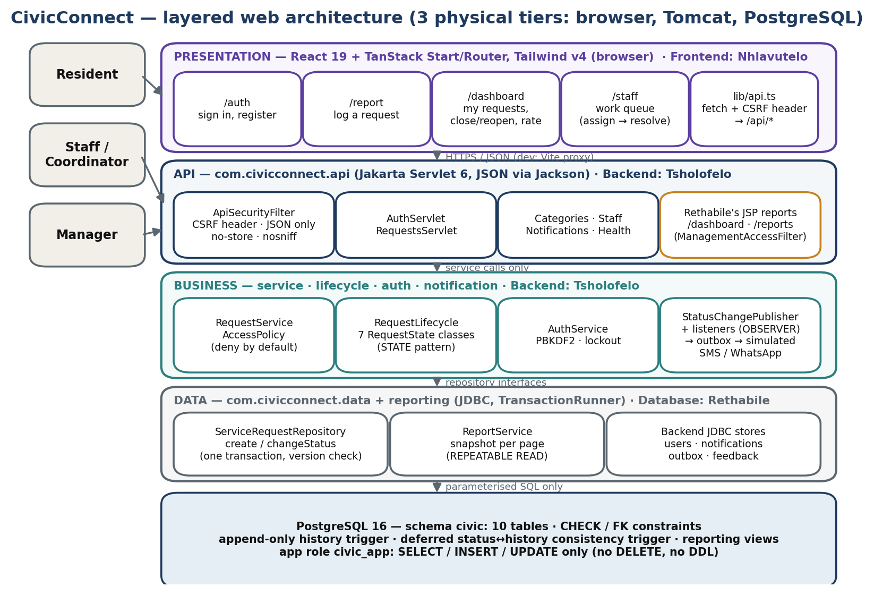
Figure 1 — Layers, owners and call direction.
React pages → API servlets → Business services → Data repositories → PostgreSQL, one direction only. Only the Data layer runs SQL, always with bound parameters. The layers are the architecture; React, Servlets, JDBC and PostgreSQL are the technologies. Five logical layers run in three physical tiers: browser, Tomcat and the database server. In development Vite proxies /api to Tomcat so the browser sees one site (Vite, 2026).

8. Technology Stack [NEW v2.0 — CR-05]
Layer | Choice (version) | Alternatives | Why
Frontend | React 19.2, TanStack Start/Router 1.x, Tailwind CSS 4, Vite 8 | JSP only; Angular | Built by the frontend owner; React 19 stable since December 2024 (React, 2024); TanStack Start v1 announced September 2025 (TanStack, 2025)
Backend | Java 21 (Eclipse Temurin), Jakarta Servlet 6 on Tomcat 10.1, Jackson 2.18 | Spring Boot; Node; ASP.NET Core | Same web app as the reporting module; one transaction layer; no second framework mid-project
Database | PostgreSQL 16 via JDBC (pgjdbc 42.7) | SQL Server Express; MySQL | Constraints, views and deferrable triggers (PostgreSQL, 2026b); chosen and built by the database owner (Ledidi, 2026a)
Build / test / CI | Maven, JUnit 5, npm, GitHub Actions | Gradle | setup-java + Maven is GitHub's documented path (GitHub, 2026c)

9. Data and Persistence [NEW v2.0]
The schema and data module were designed by the Database Developer (ADR-P3-01 to ADR-P3-03 — Ledidi, 2026a). The backend adds four columns and three tables in V5, approved by the database owner.
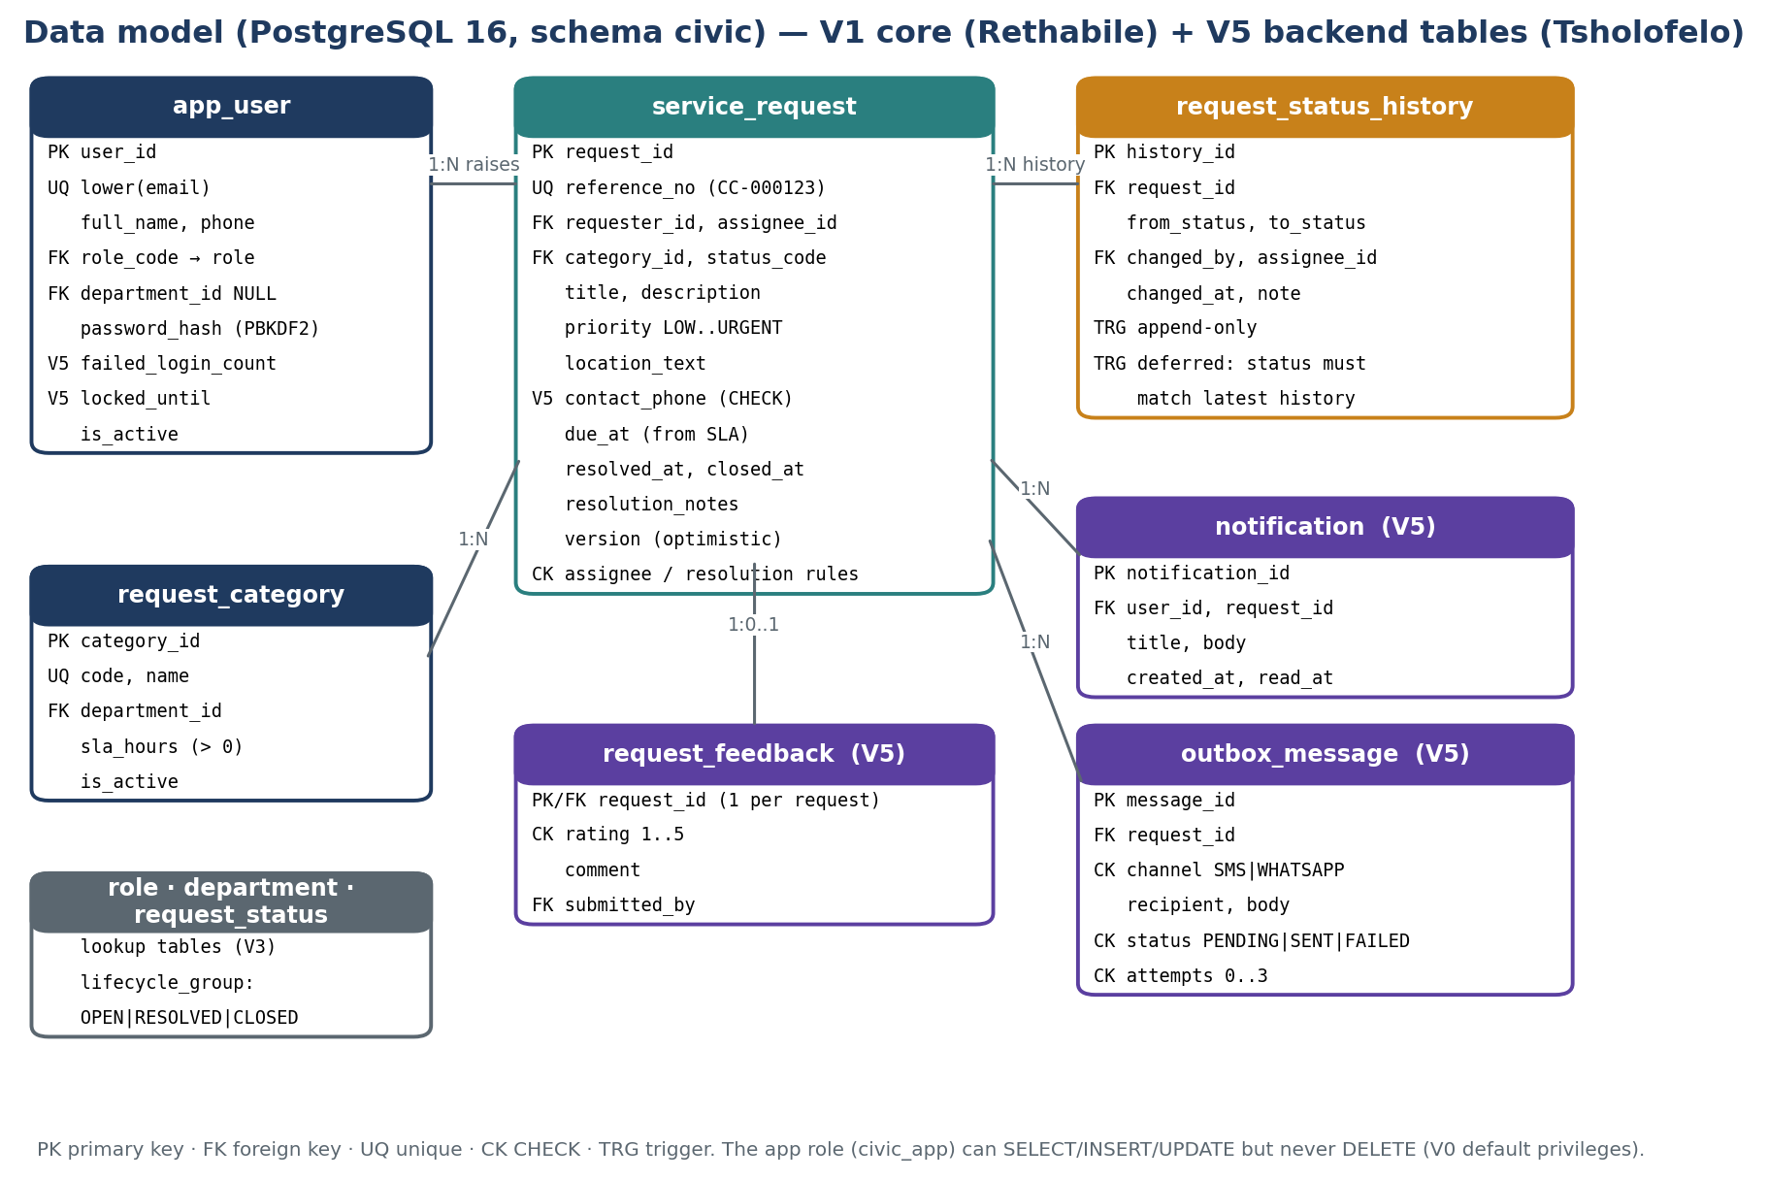
Figure 2 — Schema civic (V1 core, V3 lookups, V5 backend tables).
- Relational model: structured, related and correctness-critical data with reports that need joins and aggregates.
- Atomic write: the repository updates the request and inserts its history row in one transaction; a DEFERRABLE INITIALLY DEFERRED constraint trigger re-checks at commit that status and latest history agree (PostgreSQL, 2026b). Notifications are written after commit (Lephondo, Shiviri and Ledidi, 2026b).
- Concurrency: UPDATE … WHERE version = ? AND status_code = ?; no match → HTTP 409 'reload'.
- Least privilege: the app role can SELECT, INSERT and UPDATE only — no DELETE or DDL; history is append-only.
- Capacity: ≈ 18,250 requests a year × ~4 KB ≈ 73 MB a year. SPOF: one PostgreSQL instance; daily pg_dump, restore test in M3.
- POPIA: every security compromise must be reported (Information Regulator, 2025), through the eServices portal since April 2025 (Werksmans Attorneys, 2026). Phone numbers are optional and masked; test data is synthetic.
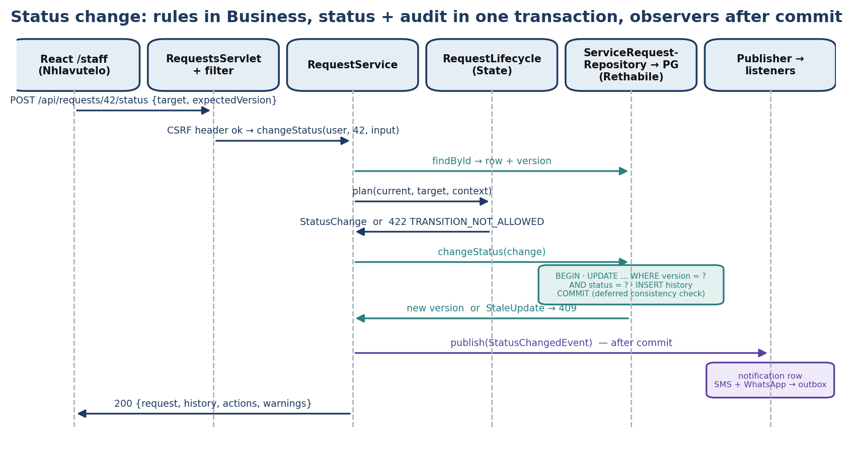
Figure 3 — One status change end to end.

10. Research-Informed Design Decisions [NEW v2.0]
The M2 brief asks for at least two design problems (SEN381, 2026b); the team recorded five, each with an owner. Alternatives come from Assignment 2 (Lephondo, Shiviri and Ledidi, 2026b).
ID (owner) | Problem | Alternatives | Decision and reason
DP-1 (Tsholofelo) | Where do transition rules live? (FR-08) | State; Strategy; transition table | State pattern: seven state classes listing legal moves, who may make them and what they need. A table cannot express actor rules and obligations; Strategy picks algorithms, not stages. 8 of 42 pairs legal; all 42 tested.
DP-2 (Tsholofelo) | Reactions to a status change | Observer; direct calls; mediator | Observer for notifications only. Audit history is written inside the transaction so it cannot fail silently — a deliberate difference from A2.
DP-3 (Tsholofelo) | Simulated SMS/WhatsApp boundary | Synchronous call; broker; outbox | Outbox + dispatcher, 3 attempts then FAILED. A broker is disproportionate for simulation; a real provider is one new channel class.
DP-4 (Rethabile) | Consistent management figures (FR-11) | Live views; observer counters; nightly extracts | Live views in one snapshot transaction with a reconciliation check; counters could drift.
DP-5 (Nhlavutelo) | Move the UI from browser storage to the API | Rewrite pages; CORS; keep functions, swap internals | Typed API client behind unchanged page functions; same-origin proxy in development; buttons come from the API's allowed actions.

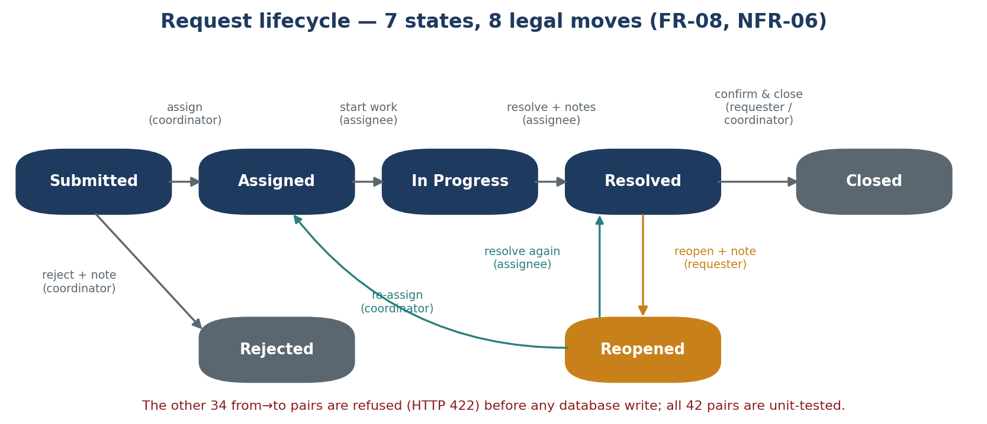
Figure 4 — The eight legal moves; all others return HTTP 422.

11. Interface Design — REST API [NEW v2.0]
JSON over HTTP with a server session cookie. Every POST carries X-Requested-With: CivicConnect. Errors return {error, message, fieldErrors}. Full contract: docs/backend-api.md.
Endpoint | Who | Purpose
POST /api/auth/register · login · logout; GET /api/auth/me | anyone / signed in | Accounts and session
GET /api/categories | anyone | Categories with SLA hours
GET /api/requests?scope=mine | queue | signed in / staff roles | Own requests; open work queue
POST /api/requests | signed in | Submit (validated on the server)
GET /api/requests/{id} | owner, assignee, oversight | Detail, history, allowed actions, simulated messages (404 if not yours)
POST /api/requests/{id}/status | per lifecycle rule | Change status (422 illegal, 409 stale)
POST /api/requests/{id}/feedback | requester, once | Rating 1–5
GET /api/staff; GET/POST /api/notifications; GET /api/health | various | Assign list; notification bell; health check
/dashboard, /reports/requests (JSP) | manager, coordinator, admin | Management reports on the same session

12. Information Architecture and UI [NEW v2.0]
Role | Pages | Main path
Resident | Home · Report an issue · My dashboard · bell | Report → reference → track → confirm/reopen → rate
Staff | Work queue (own) | Start work → resolve with notes
Coordinator | Work queue (all open) | Assign or reject
Manager / Admin | Work queue · Management dashboard | Overdue report → request

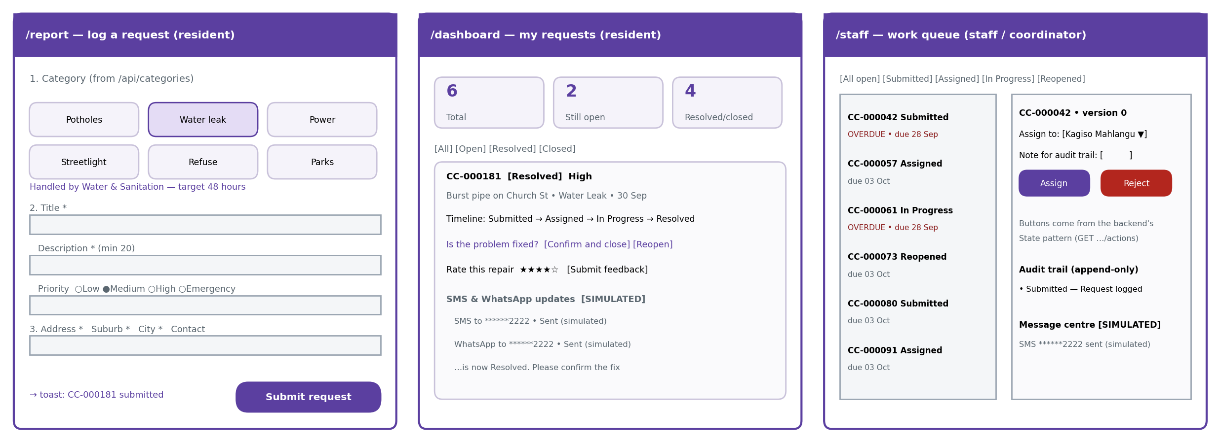
Figure 5 — Report form, resident dashboard and staff work queue.
- Categories and SLAs load from the database, so the form and reports agree (NFR-04).
- WCAG 2.2 contrast of 4.5:1 and visible focus (W3C, 2023); colours defined once as design tokens; overdue shown as a word, not colour alone.
- Buttons disable with 'Please wait…' immediately (NFR-08); server field errors appear under the matching inputs; simulated messages are labelled SIMULATED.

13. Security Design [NEW v2.0]
Action | Resident | Staff | Coordinator | Manager/Admin
Submit; view own | ✔ | ✔ | ✔ | ✔
View a request | own | assigned | all | all
Assign / reject | — | — | ✔ | ✔
Start work / resolve | — | assigned | — | —
Close / reopen resolved | own | — | close | close
Dashboard and reports | — | — | ✔ | ✔

Threat | Control | Evidence
Password guessing | 15-character minimum (NIST, 2025); PBKDF2 × 600,000 (OWASP, 2026a); 5-failure lockout; one generic error | AuthServiceTest
Broken access control | AccessPolicy on every call; 404 for other users' requests | RequestServiceTest
CSRF | Custom header on every POST — browsers pre-flight custom headers and the API grants no cross-origin access (OWASP, 2026c); SameSite=Lax cookie (OWASP, 2026d) | ApiSecurityFilter
Session fixation | New session ID at sign-in; HttpOnly cookie; 30-minute timeout (OWASP, 2026d) | AuthServlet
SQL injection | Bound parameters; whitelisted sort columns (OWASP, 2026b) | RequestQueryBuilderTest
History tampering | Append-only trigger; no DELETE grant | SQL test
Insecure third-party or generated code | PR review by another layer; rules only on the server (Perry et al., 2023) | PR template

14. Environments and Deployment [NEW v2.0]
Environment | Configuration | Purpose
Development | Vite :8080 → Tomcat 10.1 :8081 → PostgreSQL 16; DB credentials in environment variables | Daily work
CI | GitHub Actions: Maven build with a throw-away PostgreSQL 16; frontend build (GitHub, 2026c) | Build and tests on every PR
Staging | Team laptop or lab with 10,000 seeded requests | Measure NFR-01/08/09
Production | Deferred to M4 (D-08) | Decide with measured load

15. Project Management and Collaboration [NEW v2.0]
GitHub Projects gives a table, board and roadmap linked to issues and pull requests (GitHub, 2026a; GitHub, 2026b). Board: Backlog → Ready → In Progress → In Review → Done; a table view grouped by requirement ID is the live RTM check. Rules: an issue per task, a pull request per change reviewed by someone from another layer, CI green before merge, schema changes approved by the database owner. The three modules were integrated on branch integration/m2-final.

16. Architecture Decision Records [NEW v2.0]
Full ADRs are in docs/adr/.
ADR | Decision | Key consequence
ADR-01 | Layered monolith with REST API; three tiers | Can move behind Spring later without changing services
ADR-02 | React 19 · Java 21 (Temurin) + Tomcat 10.1 · PostgreSQL 16 | Two languages; mainstream and free
ADR-03 (P3-01) | PostgreSQL + JDBC; versioned SQL scripts | Hand-written mapping
ADR-04 | State pattern for the lifecycle | Seven small classes; all pairs tested
ADR-05 | Audit in the transaction; notifications as observers | Listener failure never undoes a change
ADR-06 (P3-02) | Optimistic concurrency with a version column | Occasional 'reload' (409)
ADR-07 | Simulated SMS/WhatsApp via outbox | No real messages (R-13)
ADR-08 (P2-02) | Sessions, PBKDF2, lockout, custom-header CSRF | No MFA yet
ADR-09 | GitHub Projects + GitHub Actions | Board and PR history are evidence
ADR-10 (P3-03) | Reports from live views in one snapshot | Materialised views if volume grows
ADR-11 | Typed API client + same-origin dev proxy | Two dev servers

17. Decision Log [CHANGED v2.0]
ID | Decision | Status
D-01 | Technology stack | Closed — ADR-02
D-02 | Hosting | Local for M2–M3 (closed); production → D-08
D-03 | Responsive web app, no native apps | Unchanged
D-04 / D-05 | MoSCoW; AI usage policy | Unchanged
D-06 / D-07 | Simulate messaging; GitHub Projects | Closed
D-08 | Production hosting | Open — M4
D-09 / D-10 | Temurin 21 (closed); Java 25 upgrade (open — M4) | —
D-12 | Category-level 'restricted' flag (FR-12) | Open — Sprint 3

18. Risk Register [CHANGED v2.0]
ID | Risk | P / I | Mitigation | Owner | Status
R-02 | Schedule overrun | H / H | CR-02 scope; weekly iterations | All | Active
R-03 | Scope creep | M / H | CR process | All | Active
R-04 | Security as afterthought | L / C | Section 13; tests; M3 review | TL | Active
R-05 | Free-tier limits | — | No hosting until M4 | — | Closed → D-08
R-08 | Oracle JDK 21 licence change (Oracle, 2026) | M / M | Temurin 21 | TL | New
R-09 | Single PostgreSQL instance fails | L / H | Daily pg_dump; restore test M3 | RL | New
R-10 | Young frontend framework (TanStack, 2025) | M / M | Versions pinned | NS | New
R-11 | Notification listener fails silently | M / L | Audit not an observer; warnings logged | TL | New
R-12 | Dev auto-login left enabled | M / H | Disabled in context.xml; PR checklist | RL | Mitigated
R-13 | Simulated messages taken as real | M / M | SIMULATED labels | NS | New
R-14 | Lab cannot install the stack | M / H | Laptop staging; RUNNING.md | RL | New
R-16 | Insecure code from any source (Perry et al., 2023) | M / H | Cross-layer review; server-side rules | All | New
R-18 | Integration regressions across modules | M / H | Integration branch; smoke test; CI | All | Active
R-19 | FR-12 category flag missing | M / M | D-12 in Sprint 3 | RL | New

TL = Tsholofelo Lephondo, RL = Rethabile Ledidi, NS = Nhlavutelo Shiviri. R-01, R-06 and R-07 are unchanged from v1.0.

19. Requirements Traceability Matrix v2.0 [CHANGED v2.0]
A row becomes Implemented when its PR is merged with green CI and it passes the end-to-end smoke test.
Req | ASR | Component | Data | Design / interface | Implementation (repo path) | Verification | Status | ADR
FR-01 | 03 | /report; RequestService.submit | service_request + history | POST /api/requests | routes/report.tsx; service/RequestService.java | UT submit…; smoke test | In dev. | 11
FR-02 | 03 | repository.create | reference_no | response detail | database/V1__schema.sql | UT; DB test | In dev. | —
FR-03/04 | 02 | /dashboard | v_request_overview | scope=mine | routes/dashboard.tsx | UT access tests | In dev. | 08
FR-05 | 03 | /staff; /reports | indexes | scope=queue; query builder | routes/staff.tsx; reporting/* | RequestQueryBuilderTest | In dev. | 10
FR-06 | 01 | RequestService.detail | history | GET /api/requests/{id} | service/RequestService.java | UT lifecycle | In dev. | —
FR-07 | 01 | Submitted → Assigned | CK assignee | needsAssignee | lifecycle/RequestStates.java | UT assign rules | In dev. | 04
FR-08 | 01 | lifecycle (State) | version; deferred trigger | 422 / 409 | lifecycle/*.java | UT 42 pairs | In dev. | 04/06
FR-09 | 01 | notes on transitions | note; resolution_notes | note, resolutionNotes | RequestService.changeStatus | UT resolution notes | Partial | —
FR-10 | 01 | In Progress → Resolved | CK resolution | needsResolutionNotes | RequestStates.java | UT | In dev. | 04
FR-11 | 03 | Management dashboard | reporting views | /dashboard | web/DashboardServlet.java; V2 | ReportConsistencyDbTest | In dev. | 10
FR-12 | 02 | AccessPolicy | role, assignee | 404 if not yours | service/AccessPolicy.java | UT access | Partial | 08
FR-13 | 05 | Observer listeners | notification; outbox | /api/notifications | notification/*.java | UT; OutboxDispatcherTest | In dev. | 05/07
NFR-02/10 | 02 | AuthService | app_user | session | auth/*.java | AuthServiceTest | In dev. | 08
NFR-03 | 01 | history triggers | append-only | — | V1__schema.sql | SQL/DB test | In dev. | 05
NFR-01/08/09 | 03 | submit path; queue | indexes | busy states | routes/*.tsx; JdbcRequestQueries | Planned: staging p95 | Re-baselined | —

20. End-to-End Trace: FR-08 [CHANGED v2.0]
Stage | Evidence
Stakeholder need | Management's auditable trail vs staff flexibility (PED v1.0 Section 2.1)
Requirement / ASR | FR-08, NFR-03, NFR-06 → ASR-01
Architecture / data | Business layer owns rules; one transaction + deferred trigger; version column
Design / ADR | State pattern (DP-1, ADR-04); audit in transaction (ADR-05)
Code | lifecycle/RequestStates.java, RequestLifecycle.java, RequestService.changeStatus, JdbcServiceRequestRepository.changeStatus
Verification | RequestLifecycleTest (all 42 pairs), RequestServiceTest (illegal moves never reach the database), DB tests, smoke test

21. AI Usage Register [CHANGED v2.0]
AI tools were used alongside the team's own work, under the policy in D-05. Every output was reviewed, tested and integrated by the member who owns that layer, and each member can explain their code without the tool (SEN381, 2026a).
Member | Tool | Used for | Team verification
N. Shiviri | Lovable | Scaffolding of UI components and page layouts | Pages reviewed and adapted; wired to the API; no rules or secrets in the browser
R. Ledidi | AI assistant | Drafting support for SQL, Java and ADR wording from the team's A2 research | All scripts run on PostgreSQL 16; unit and DB tests
T. Lephondo | Claude | Troubleshooting backend code and testing, compiling presentation slides | Compiled and unit-tested; SQL run as the app role; integrated and smoke-tested; every source checked

22. Baseline Sign-off
Item | Value
Baseline | Architecture, Technology & Initial Design Baseline — PED v2.0, 30 Sep 2026
Included | CR-01 to CR-05; scope; NFR re-baseline; ASRs; ADR-01 to ADR-11; data model; DP-1 to DP-5; API contract; UI; security; integrated application
Open | D-08 hosting; D-10 Java 25; D-12 restricted category; FR-09 comments
Outcome | ACCEPTED / CONDITIONALLY ACCEPTED / REVISION REQUIRED (assessor)
Team sign-off | N. Shiviri __N.S____ T. Lephondo ___T.L.___ R. Ledidi ___R.L.___

References
Adoptium (2026a) Eclipse Temurin. Eclipse Foundation.
Adoptium (2026b) Support — Temurin release roadmap. Eclipse Foundation.
Anderson, T. (2025) 'Tailwind CSS 4.0 released with ground-up rewrite for faster Rust-powered build', DevClass, 24 January.
Apache Software Foundation (2026) Apache Tomcat versions.
CAMPUX (2026) Azure App Service plans explained: Free, Basic, Standard, Premium.
GitHub (2026a) About Projects. GitHub Docs.
GitHub (2026b) Changing the layout of a view. GitHub Docs.
GitHub (2026c) Building and testing Java with Maven. GitHub Docs.
Google (2024) 'Interaction to Next Paint is officially a Core Web Vital', web.dev, 12 March.
Google (2025) Interaction to Next Paint (INP). web.dev.
GTStudios (2026) Apple & Google Play fees: official costs to publish an app.
Information Regulator (2025) Fact sheet on handling of security compromises. Pretoria: Information Regulator (South Africa).
ISO/IEC (2023) ISO/IEC 25010:2023 Systems and software engineering — Product quality model. Geneva: ISO.
Ledidi, R. (2026a) CivicConnect database and management reporting module: README and ADR-P3-01 to ADR-P3-03. GitHub repository rethabileledidi/CivicConnect_Runtime-Terrors. Unpublished team artefact.
Lephondo, T., Shiviri, N. and Ledidi, R. (2026b) SEN381 Assignment 2: research for engineering decisions. Unpublished team submission.
Li, Z.S., Arony, N.N., Devathasan, K. and Damian, D. (2023) '"Software is the easy part of software engineering" — lessons and experiences from a large-scale, multi-team capstone course', in Proceedings of ICSE-SEET 2023. IEEE, pp. 223–234.
Meta (2026a) Pricing on the WhatsApp Business Platform. Meta for Developers.
Meta (2026b) Upcoming pricing updates for Meta Business Agent, service and utility messages. Meta for Developers.
Microsoft Q&A (2026) Cannot load or deploy free tier app services. Microsoft Learn Q&A.
National Institute of Standards and Technology (NIST) (2025) Digital identity guidelines: authentication and authenticator management. NIST SP 800-63B-4.
Nielsen, J. (2024) Response time limits. Nielsen Norman Group.
Oracle (2023) Java Security Standard Algorithm Names — Java SE 21.
Oracle (2026) Oracle Java SE support roadmap, updated 15 September 2026.
OWASP (2025) OWASP Top 10:2025.
OWASP (2026a) Password storage cheat sheet.
OWASP (2026b) SQL injection prevention cheat sheet.
OWASP (2026c) Cross-site request forgery prevention cheat sheet.
OWASP (2026d) Session management cheat sheet.
Perry, N., Srivastava, M., Kumar, D. and Boneh, D. (2023) 'Do users write more insecure code with AI assistants?', in Proceedings of CCS '23. New York: ACM.
PostgreSQL Global Development Group (2026a) Versioning policy.
PostgreSQL Global Development Group (2026b) CREATE TRIGGER. PostgreSQL 18 documentation.
React (2024) 'React v19', React Blog, 5 December.
Render (2026) Deploy for free. Render Docs.
SEN381 (2026a) CivicConnect Master Project Brief, v1.1. Software Engineering 381, Belgium Campus ITversity.
SEN381 (2026b) CivicConnect Milestone 2: Architecture, technology & initial design baseline. Software Engineering 381, Belgium Campus ITversity.
Sent.dm (2025) South Africa SMS pricing 2025.
SentinelOne (2025) CVE-2025-48757. Vulnerability database, 30 May.
Shiviri, N. (2026) CivicConnect frontend & requester module. GitHub repository rethabileledidi/CivicConnect_Runtime-Terrors, folder CivicConnect-Frontend. Unpublished team artefact.
Stack Overflow (2025) 2025 Developer Survey: technology.
TanStack (2025) 'Announcing TanStack Start v1', TanStack Blog, 23 September.
Tenhunen, S., Männistö, T., Luukkainen, M. and Ihantola, P. (2023) 'A systematic literature review of capstone courses in software engineering', Information and Software Technology, 159, 107191.
Twilio (2026) SMS pricing in South Africa.
Uwimbabazi, J., Nyambo, D. and Sam, A. (2026) 'Mobile-based ticket tracking helpdesk system for technical support', in Advancement in Embedded and Mobile Systems (ICTA-EMOS 2024). Cham: Springer.
Vite (2026) Server options: server.proxy. Vite 8 documentation.
W3C (2023) Web Content Accessibility Guidelines (WCAG) 2.2. W3C Recommendation, 5 October.
Wasono, S.S., Hidayatullah, A.S., Said, R.M. and Syifaurachman, S. (2026) 'Design and evaluation of a web-based helpdesk ticketing system using Extreme Programming', Jutisi, 15(3)..
Werksmans Attorneys (2026) South Africa's Information Regulator: what the 2025/26 Annual Performance Plan means for business. 5 May.

