Nov 20, 2014, F. Retière

Connection PCBs for nEXO photo-detector tester

PCBs were produced in summer 2014. Designed was done by D. Bishop and it is available on edev at <https://edev.triumf.ca/projects/edevel00308>. We have copied some of the information in this document for completeness. Ummc cables and connectors were used as they provided the very small form factor required to use the nEXO cooler with a lead. And ummc to LEMO adapter was also included (center board below). As of November 2014, we need to make new PCBs to accommodate more devices. The ummc connectors are to be replaced by cables soldered directly on the board. The other hand of the cable should be LEMO.As outlined below, we need 6 new PCBs: FBK-RGB, FBK-NUV, FBK-Stanford, SensL, MEG-4, and MEG-Multi. We need at least 5 boards of each type.

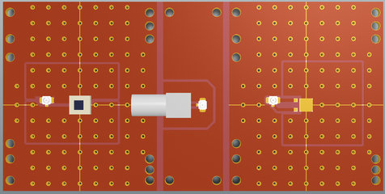

Figure 1. Picture of the connection PCB produced in summer 2014. It includes a connection PCB for 2 pins SiPM (right-hand side), a UMCC to LEMO transition board (center) and a connection PCB for wire bounded FBK SiPMs (right-hand side).

**Existing: Generic 2 pins for Hamamamstu, Excelitas and KETEK**

This board is used for multiple devices with 2 pins connection. It is shown in Figure 1 on the left-hand side. Refer to edev for details. Need more boards. About x20.

**Existing: FBK wired bounded**

This board was used to accommodate bare silicon chip from FBK. They were wired bounded at UBC. The board is shown on the right-hand side in Figure 1. Refer to edev for details.

**Existing but kludgy: FBK-RGB (FBK/Advansid RGB)**

FBK SiPMs are expected to be received at TRIUMF during the week on Nov 17. Figure 2 shows a picture of the device and a detailed drawing. The “front” pin is to be connected to the core conductor and the back pin to the cable ground.

|  |  |
| --- | --- |
|  |  |

Figure . Picture of FBK RGD SiPM. The package thickness is 1.6mm.

**To do: FBK-NUV (FBK/Advansid NUV)**

FBK SiPMs are expected to be received at TRIUMF during the week on Nov 17. Figure 3 shows a detailed drawing of the SiPM. The notched pad is to be connected to the cable core and the straight pad to the cable ground.

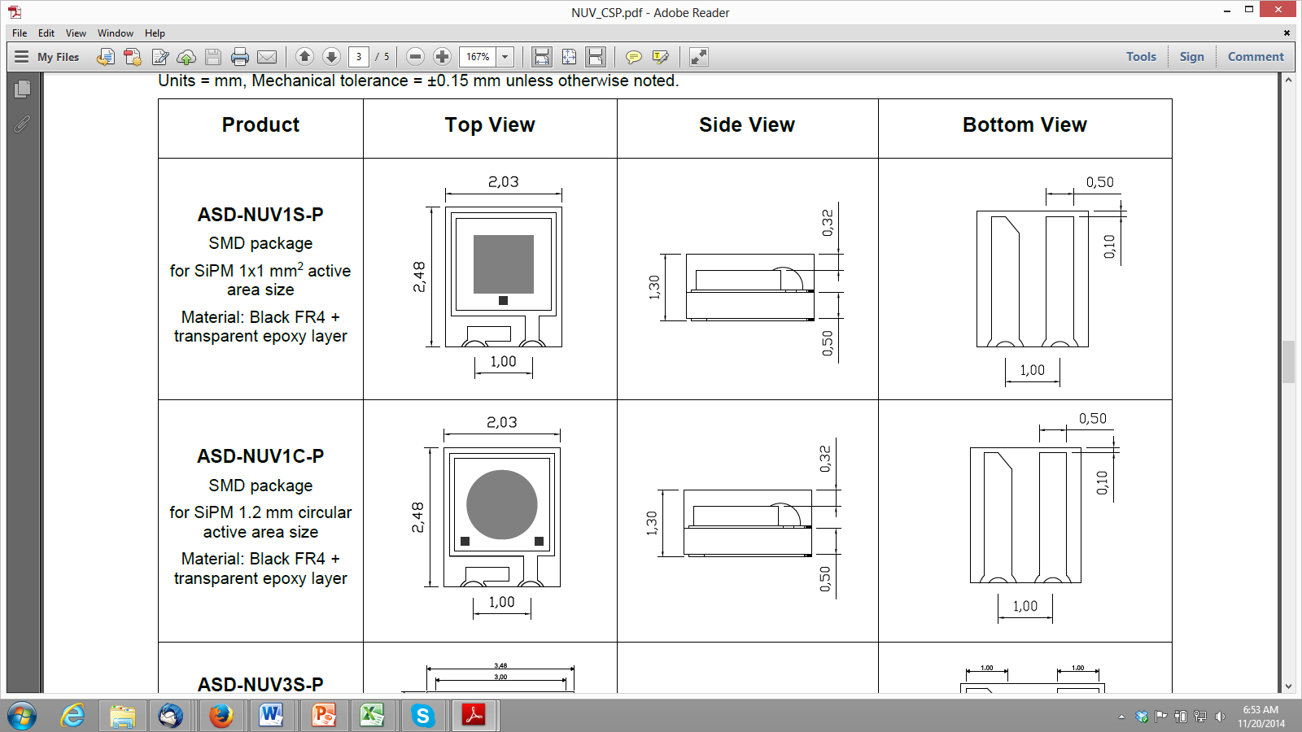

Figure . Picture of the FBK NUV package

**Done but does not work: FBK-Stan (FBK Stanford package)**

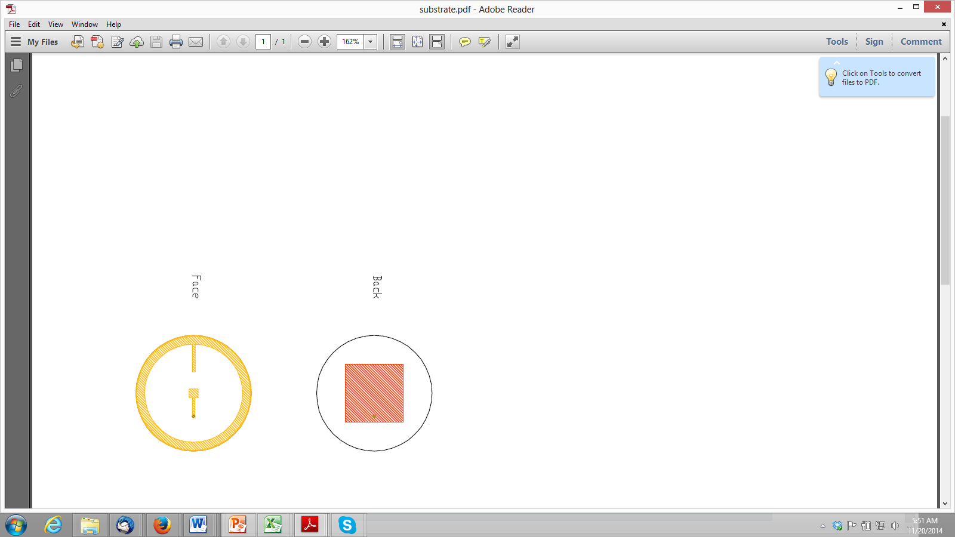

Figure 4. Wire bounded FBK device. Left: top, right: back. The SiPMs is glued to the center of the pad on the top side. The SiPM cathode connection is through the pad on the back side. The SiPM anode connection is through the ring on the front side.

This package was developed by Stanford for accommodating bare silicon chips produced by FBK. The SiPMs are wire bounded in the center. The cable core is to be connected to the center pad and the cable ground to the ring. *Dimensions will be provided or measured*.

**To do: SensL (microFC package)**

Dimension drawings are shown in Figure 5. Ideally we would like to have access to both fast and slow outputs. We will need 2 cables as follow: 1) [cable 1] ground connected to pin 1, core connected to pin 3, 2) [cable 2] ground connected to pin 1, core connected to pin 2. The SensL devices will be readout in two ways: 1) cable 1 through the MARS board (voltage source through MARS board) and cable 2 not connected, 2) cable 2 through MARS board and cable 1 connected to voltage source.

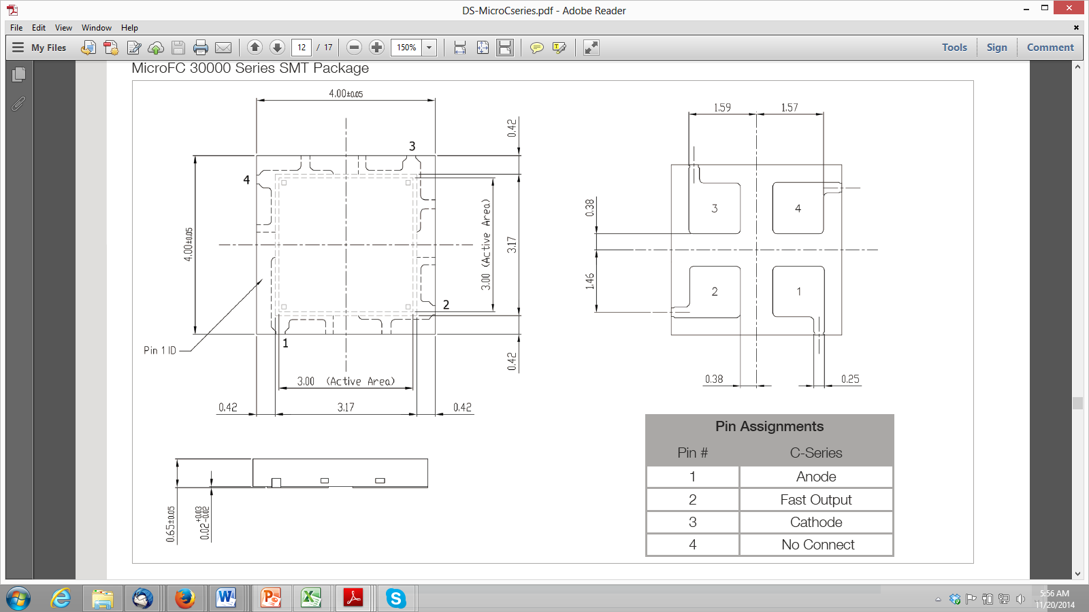

Figure

**To do: MEG-4 and MEG-Multi (Hamamatsu MEG MPPC matrix)**

The MEG MPPC connection drawing is shown in Figure 6. It has 4 independent MPPCs. We would like 2 different boards: 1) 4 independent cables connected to each MPPC with the cable core connected to the cathode and the cable ground connected to the anode and 2) 1 single cable with the hybrid/series used in this project <https://edev.triumf.ca/projects/edevel00290> and described here <https://edev.triumf.ca/projects/edevel00290/repository/changes/datasheets/SpecForMultiplexingMatrix.pdf>

