May 27
Taking too long to read large hdf5 files.
This is probably due to the current method of searching for each waveform.
Learning hdf5 in order to solve this issue.
Processed data. Data doesn't look good. Baseline keeps shifting, causing the peak finder to fail. Also, dark noise is quite high even at -100C (radioactivity?).
Upgrading peak finder to calculate local baseline (one peak width) as it scans the histogram for peaks.
Paul will retake data.
Fabrice suggests that problem may be caused by one of the four MPPCs being bad. Will switch to a different one.
WF on scope looks much better. Taking full dataset.
Constructed box ot of alimunum to protect reference MPPC.
May 28
Data from yesterday still looks bad.

Created algorithm to count zeros using the minimum of the WF to see if the issue is with the data or analysis.
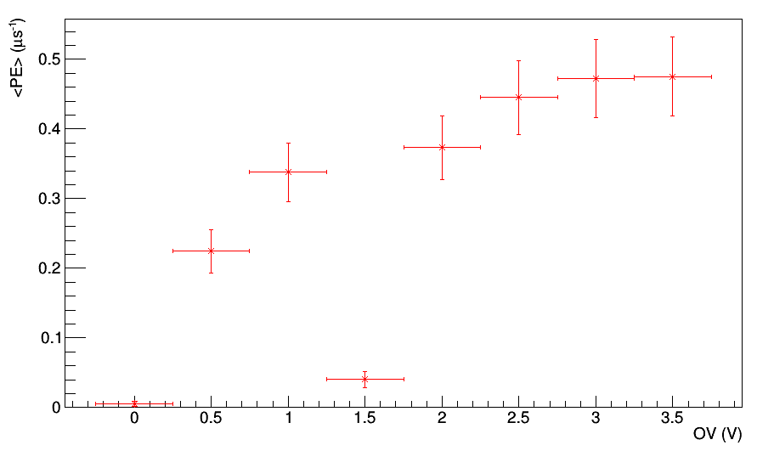
Point at 1.5 is strange. This may be a data issue. Above plot made with only 1000 wf. Doing full set now.
Setup github.
Data is greatly improved with more statistics. See May28*-100* for plots.
Biggest issue is now the processing time. Need to make hdf5 reader more efficient.
Need to prepare talk.

May 29
Worked on talk.
Processed data.

May 31
Processed data to be used in talk. Finished preparing talk.

June 1
Photo-detector meeting with talk.
Now need to address cross-talk.
Met with Fabrice and got new objectives.
Now need to stagger hours to maximize data taking. Will work 16 hours/day in total.
12 SiPMs to be measured. Will measure <PE>, <DN>, and <avalanche>.

June 2
Showed Paul how code works.
Got cross-talk analysis working using ntuple that finds dark noise pulses that were triggered on in the data. This pulse is at the centre of the WF. Finding the histogram of minimum values works the best in this case, since the probability of having multiple pulses in this 200ns range is very low at -100C. The ntuple mst be analyzed manually, however.
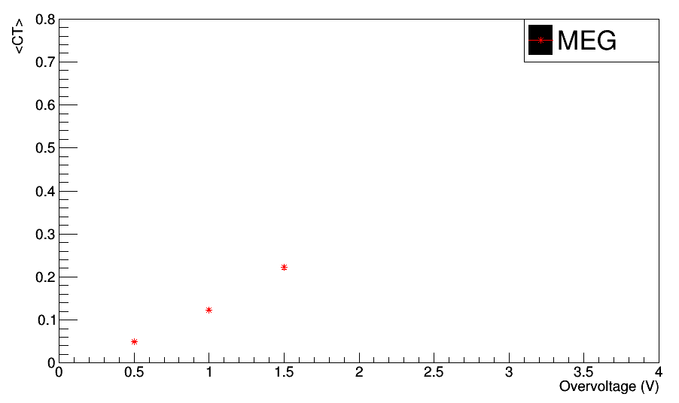
More data is being taken by Paul.
Working on afterpulse. Will simply integrate WF after the dark noise pulse at the tigger point.

