Manuscript prepared October 3, 2026.
Safe Reinforcement-Learning-Based Tuning of PID and Sliding-Mode Controllers for a DC–DC Boost Converter
Reththika Murugadasan¹
¹Control Systems course project [department and institution to be completed by the author]
Corresponding author: Reththika Murugadasan (e-mail: reththika@gmail.com).
This paper reports a course project. The source code, trained models and all result files are in the accompanying project folder (adaptive_dc_dc_rl).
ABSTRACT Regulating the output voltage of a boost converter is difficult because the plant is lightly damped, non-minimum phase and exposed to input-voltage and load disturbances. This paper studies, in simulation, whether reinforcement learning can improve two classical controllers, a PID controller and a sliding-mode controller, without compromising safety. A cycle-averaged converter model with continuous and discontinuous conduction is validated against a switch-level simulation (0.013 V RMS error). Both baselines are tuned systematically, and it is shown that the textbook voltage-based sliding surface fails on this plant whereas a surface on the inductor current regulates the output. Three Twin Delayed DDPG (TD3) controllers are compared with the baselines: a direct duty-cycle policy and two adaptive controllers that only tune PID gains or sliding-mode parameters inside stability-checked bounds, with rate limiting and a baseline-recovery supervisor. All five controllers are evaluated on five identical scenarios, with three training seeds for each learning controller. No controller is best on every metric. Direct TD3 gives the smallest mean peak deviation after all four disturbances, but it moves the duty cycle 25 to 70 times more than the baselines, shows intermittent duty-cycle oscillations and varies strongly across seeds. The supervised adaptive controllers stay within a few percent of their baselines, and no evaluated run triggered a protection limit. The results show both the potential and the limits of learning-based tuning.
INDEX TERMS Boost converter, DC–DC power conversion, PID control, reinforcement learning, sliding-mode control, TD3.

- INTRODUCTION
DC–DC boost converters raise a source voltage to a higher regulated level and are used in battery, photovoltaic and automotive power systems [1]. Regulating the output is challenging. The averaged plant is a lightly damped second-order system with a right-half-plane (RHP) zero, so a duty-cycle increase first lowers the output voltage [1], [6], and both the input voltage and the load change in operation. PID control [2] and sliding-mode control (SMC) [3]–[5] are the usual solutions, but their fixed parameters are tuned for one nominal point.
Deep reinforcement learning (RL) [7]–[9] can learn control policies from interaction. This raises two questions: can RL improve classical controllers, and can it do so without endangering the converter? This paper investigates both in simulation. Its contributions are: (i) a validated converter simulator with explicit continuous (CCM) and discontinuous (DCM) conduction handling (Section II); (ii) two systematically tuned baselines, including a demonstration that the textbook voltage-based sliding surface fails on this non-minimum-phase plant (Section III); (iii) three TD3-based controllers, one acting directly on the duty cycle and two that adapt PID gains or SMC parameters inside stability-checked bounds, with smoothing and a baseline-recovery supervisor (Sections IV and V); and (iv) a multi-seed comparison on identical scenarios that reports every metric without ranking (Sections VI and VII).
The study is limited to an ideal averaged model and a single circuit. Section VIII states what this does and does not establish.
CONVERTER MODEL
- AVERAGED MODEL
The converter is a boost stage with input voltage V_{in}, inductance L = 1 mH, output capacitance C = 470 µF and load resistance R = 20 Ω, switched at f_{sw} = 20 kHz (T_{s} = 50 µs). The duty cycle D, limited to 0.05 ≤ D ≤ 0.95, is the only control input. With inductor current i_{L} and output voltage v_{out} as states, the cycle-averaged CCM model is
di_{L}/dt = [V_{in} − (1 − D) v_{out}] / L (1)
dv_{out}/dt = [(1 − D) i_{L} − v_{out}/R] / C (2)
For D = 0.5 and V_{in} = 12 V, v_{out} = V_{in}/(1 − D) = 24 V and i_{L} = 2.4 A. For a held duty cycle, (1) and (2) are linear, so each step of T_{s} is integrated exactly with the matrix exponential of the augmented system matrix, which removes truncation error and step-size instability. The plant has a lightly damped resonance (damping ratio about 0.07 at D = 0.5) and an RHP zero at R(1 − D)²/L ≈ 5000 rad/s [1], [6].
- DISCONTINUOUS CONDUCTION
A first implementation using only (1) and (2) let the inductor current become negative (down to −4.26 A during start-up), which is impossible with a diode. The model therefore switches to DCM when v_{out} > V_{in}/(1 − D) and the average current is below half the ripple, V_{in}DT_{s}/(2L). In DCM the inductor current is algebraic,
i_{L} = V_{in} D² T_{s} v_{out} / [2L(v_{out} − V_{in})] (3)
and only v_{out} is integrated (fourth-order Runge–Kutta), with
C dv_{out}/dt = V_{in}² D² T_{s} / [2L(v_{out} − V_{in})] − v_{out}/R (4)
Each control step is divided into five sub-steps so that a CCM/DCM transition inside a step is resolved. With R between 10 and 30 Ω, K = 2L/(RT_{s}) ≥ 1.33 exceeds the largest critical value 4/27, so steady state is always CCM; DCM appears only in transients such as the cold start.
- VALIDATION
The model was validated against theory and against an event-accurate switch-level simulation with an ideal switch and diode (Table I). Cycle-averaged transients match the switching reference with 0.013 V RMS voltage error and 0.009 A RMS current error. The large open-loop overshoot (33.6 V peak for D = 0.5) is the lightly damped resonance of the lossless circuit, not a numerical artefact.
TABLE I
Simulator Validation
Test | Model | Reference
Steady state, D = 0.3 (V) | 17.143 | 17.143
Steady state, D = 0.5 (V) | 24.000 | 24.000
Steady state, D = 0.6 (V) | 30.000 | 30.000
Transient RMS error (V) | 0.013 | switch-level
Minimum i_{L}, D = 0.5 (A) | 0.000 | −3.46 (CCM only)
DCM point, R = 500 Ω (V) | 28.045 | 28.045 (closed form)

BASELINE CONTROLLERS
- PID CONTROLLER
With error e = V_{ref} − v_{out}, the PID law is
D = K_{p}e + K_{i} ∫e dt + K_{d} de/dt (5)
The derivative acts on the measurement through a first-order filter (100 µs), the integral state is stored in duty units and unwound by back-calculation when the duty saturates, and the output is clipped to [0.05, 0.95]. A constant bias was deliberately avoided: an early version with a 0.5 duty offset applied half duty while v_{out} = 0 and gave 43.5 % start-up overshoot, against about 0 % for the pure PID form.
The gains were derived in three steps. First, the plant was linearised, which shows the RHP zero that caps the usable bandwidth. Second, a differential-evolution search maximised the nominal crossover frequency (capped at 600 rad/s) subject to at least 45° phase margin and 6 dB gain margin on all 27 operating points (V_{in} = 10, 12, 14 V; R = 10, 20, 30 Ω; V_{ref} = 20, 24, 28 V) with a 1.5-sample delay. Third, a Nelder–Mead search refined the gains on a time-domain cost over the five test scenarios while keeping the margins and a minimum K_{p}. The result (Table II) has worst-case margins of 56.5° and 6.0 dB.
- SLIDING-MODE CONTROLLER
The usual surface s = de/dt + λe, built from the voltage alone, does not work here. Because v_{out} depends directly on D with a sign opposite to its steady-state gain (the RHP zero), forcing such a surface to zero hides unstable inductor-current dynamics. In simulation the output collapses to 12.6 V when 26 V is requested. The inductor current responds to D with the correct sign, so the surface is placed on the current and the voltage error enters through the current reference:
s = i_{L} − i_{ref} (6)
i_{ref} = clip(K_{v}e + K_{i} ∫e dt, 0, I_{max}) (7)
D = (1 − V_{in,nom}/v_{out}) − K sat(s/φ) (8)
The first term of (8) is the equivalent control for the nominal 12 V input, which is assumed rather than measured, so input steps are genuine disturbances. The saturation function replaces the sign function to limit chattering [4]. The current reference is limited to [0, 10 A], which prevents negative current requests (consistent with the DCM model) and limits start-up inrush. Inside the boundary layer the law is a proportional current loop whose discrete gain (K/φ)(T_{s}·v_{out}/L) must stay below 2; the design value is 0.45 at 24 V. The outer-loop gains follow from the first-order plant with the current held at its reference and were refined with the same time-domain cost as the PID.
TABLE II
Baseline Controller Parameters
Controller | Parameter | Value
PID | K_{p}, K_{i}, K_{d} | 0.0049154, 6.6994, 2.7364×10⁻⁵
SMC | K_{v} (A/V), K_{i} (A/(V·s)) | 0.65641, 164.74
SMC | K, φ (A), I_{max} (A) | 0.3, 0.8, 10

REINFORCEMENT-LEARNING FORMULATION
- ENVIRONMENT
The converter is wrapped in a Gymnasium environment [11]. One agent step holds the action for four converter steps (200 µs) and an episode lasts 400 steps (80 ms). The observation has five normalised entries: voltage error (divided by 10 V), its change per step, the clamped integral of the error, v_{out}/24 V and i_{L}/10 A; the agent sees neither V_{in} nor R. The action is a normalised number a ∈ [−1, 1]. The reward at each step is the sum of a tracking term −(0.5x + 0.5√x) with x = |e|/10 V (the square-root part keeps small offsets costly), an extra overshoot penalty, a pseudo-Huber penalty on the duty change, a penalty on the error change, a soft penalty above 12 A, a smooth precision bonus of up to 0.5, and a survival bonus of 1. A protection trip (v_{out} > 60 V, i_{L} > 30 A, or an invalid state) ends the episode with a reward of −50.
Every training episode draws random conditions: V_{in} ∈ [10, 14] V, R ∈ [10, 30] Ω, V_{ref} ∈ [20, 28] V, a random start state (cold, pre-charged or near the operating point), and with probability 0.5 a random input-voltage and/or load step between 25 % and 60 % of the episode. The five evaluation scenarios are never sampled exactly. The reward was tested against reference policies before long training: an earlier linear version ranked a weak 5,000-step policy above the PID (+38.0 against +26.5), whereas the final version ranks the PID first (+499.7 against +431.7).
- TD3 TRAINING
TD3 [9] is an off-policy actor–critic method for continuous actions that curbs value over-estimation with twin critics, delayed actor updates and target-policy smoothing. It was implemented with Stable-Baselines3 [10] and PyTorch. All three RL controllers use the same settings: two hidden layers of 64 units for actor and critics, learning rate 10⁻³, discount 0.99, target rate 0.005, batch size 256, replay buffer 200,000, policy delay 2, target-noise 0.2 (clipped at 0.5) and Gaussian exploration noise of 0.1. Each controller was trained for 200,000 steps with seeds 0, 1 and 2 (nine runs, 19 minutes in total).
- CONTROLLER STRUCTURES
In the direct controller the network output is mapped linearly to D = 0.05 + 0.45(a + 1). In the adaptive controllers (Fig. 1) the network never touches the duty cycle: its output tunes the parameters of the unchanged baseline controller, which runs at the converter rate. For each parameter with baseline K₀ and allowed range [K_{lo}, K_{hi}] the mapping is logarithmic,
K = K₀ (K_{hi}/K₀)ª (9)
for a ≥ 0; for a < 0, K_{hi} is replaced by K_{lo} and a by −a. A zero action therefore reproduces the baseline exactly, which was verified bit for bit. The adaptive PID tunes (K_{p}, K_{i}, K_{d}) and the adaptive SMC tunes (K_{v}, K_{i}, K, φ); their observations add the current parameters, the last duty and a recovery flag.
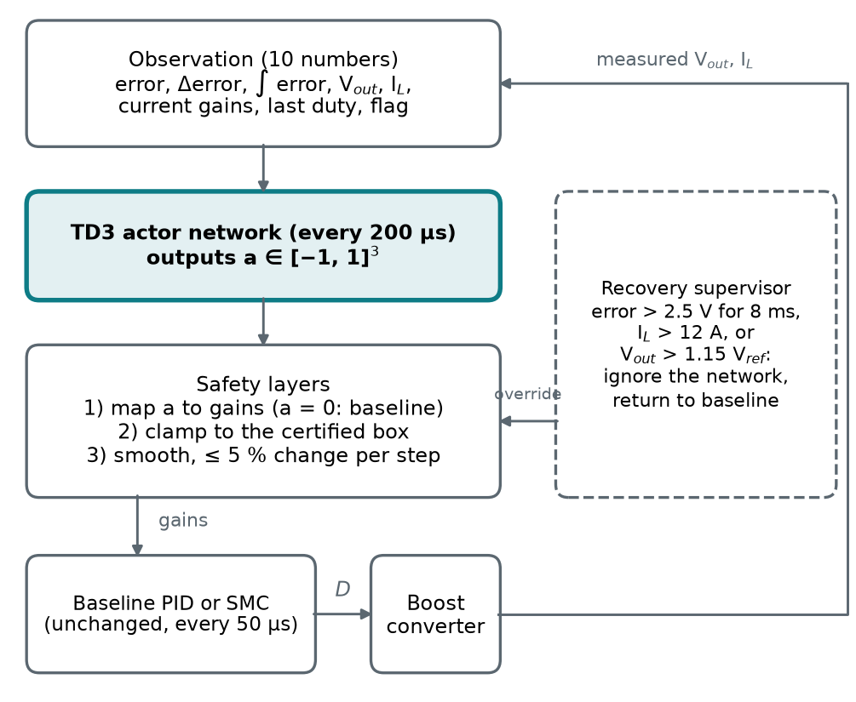
- Adaptive controller: the network only tunes the baseline controller; safety layers and a supervisor can override it.
SAFETY MECHANISMS
- CERTIFIED PARAMETER BOXES
The baseline PID lies in a narrow stable region. Table III shows the worst-case phase margin over the 27 operating points when gains are scaled: K_{i} × 1.5 leaves 18°, K_{i} × 2 and K_{d} × 0.5 are unstable, and moving all three gains together is far worse. A first adaptive version with a wide box (worst case 25° and 2.1 dB) let the trained agent drive K_{i} to its lower limit, which slowed the start-up settling from 11.5 ms to 37 ms. The final box (K_{p} × 0.7–1.5, K_{i} × 0.7–1.05, K_{d} × 0.9–1.2) is the largest found whose full 5 × 5 × 5 grid of gain combinations keeps at least 40° and 4 dB on every operating point (measured 40.3° and 4.2 dB). The code refuses ranges outside this certified box.
TABLE III
Worst-Case Phase Margin over 27 Operating Points
Change to the baseline gains | Margin (deg)
Baseline | 56.5
K_{i} × 1.5 | 18.2
K_{i} × 2 | −24.3 (unstable)
K_{d} × 0.7 | 19.6
K_{d} × 0.5 | −13.7 (unstable)
All gains ×/÷ 1.25 (worst corner) | 3.8
All gains ×/÷ 1.5 | −41.2
All gains ×/÷ 2 | −72.6
Certified box (worst grid point) | 40.3

For the SMC no simple margin test exists, so candidate boxes were checked by closed-loop simulation from a cold start at every corner and mid-point on nine extreme operating points. Each plant was judged relative to the baseline SMC on that plant, because the diode pre-charge alone drives the cold-start output to 1.35–1.5 times the reference when V_{in} = 14 V and V_{ref} = 20 V whatever the controller does. The certified box (K_{v}, K_{i} × 0.8–1.25, K × 0.9–1.1, φ × 0.85–1.25, with K/φ ≤ 1.2 times its baseline) passed all 1,296 simulations; wider boxes failed some plants through slow settling or limit cycles. The active box is slightly tighter (φ × 0.9–1.15). These are model-based guarantees on a grid, not proofs for all conditions.
- SMOOTHING AND SUPERVISION
Every proposed parameter set is clamped to the box, filtered (first-order, 0.1) and rate limited to 5 % per agent step, so parameters never jump. A supervisor running at the converter rate overrides the network when the low-pass filtered error stays above 2.5 V for 8 ms, the inductor current exceeds 12 A, or v_{out} exceeds 1.15 V_{ref} (the SMC version also detects sustained duty chatter). While engaged it ignores the network and returns the parameters to the baseline through the same rate limit; it releases once the error stays below 1 V for 5 ms. The baseline controllers keep their own anti-windup and duty limits.
EXPERIMENTAL SETUP
Every run starts from a cold start (v_{out} = i_{L} = 0) with V_{in} = 12 V, R = 20 Ω and V_{ref} = 24 V, regulates until 150 ms, applies one disturbance and ends at 300 ms. The five scenarios are: nominal (no disturbance); V_{in} 12 → 10 V; V_{in} 12 → 14 V; R 20 → 10 Ω; and R 20 → 30 Ω. All controllers are recorded at every 50 µs converter step; RL policies are evaluated deterministically, and a protection trip is judged from the recorded waveform with the same limits for every controller. The metrics are the 2 % settling time, overshoot, start-up undershoot (the deepest dip after first reaching 90 %), steady-state error, RMS error, maximum deviation after the disturbance, recovery time (time until the output stays within ±2 %), mean absolute duty change per step, and extreme inductor currents. The RL controllers use three seeds, and results are reported as mean ± sample standard deviation. No ranking or composite score is computed.
The software uses Python 3.12, NumPy, SciPy, Gymnasium 1.3.0, Stable-Baselines3 2.9.0 and PyTorch 2.14.1 [10]–[12]. Fixed seeds make training reproducible on one machine (identical weights for identical seeds), and the 228 automated tests include checks of the converter, controllers, environment, reward, safety limits and the evaluation pipeline.
RESULTS AND DISCUSSION
- BASELINES
Table IV and Fig. 2 show the cold start. The PID settles in 11.5 ms with about 0 % overshoot; its output first rises to 24 V on the diode pre-charge surge and then dips to about 18.6 V (5.40 V) before settling. The SMC settles in 2.9 ms with 2.62 % overshoot and a 2.07 V dip. After input-voltage steps the SMC deviates far less (Table VI: 0.65 and 0.56 V against 3.40 and 3.00 V) and recovers faster (Table VII), whereas after load steps the two are similar and the PID is slightly better (1.94 and 0.64 V against 2.09 and 0.80 V). The comparison is not like for like: the SMC senses the inductor current and its law encodes the boost structure, while the PID uses only v_{out}.
TABLE IV
Cold-Start Metrics, Nominal Scenario (RL: Mean ± Std over 3 Seeds)
Controller | t_{s} (ms) | Overshoot (%) | Dip (V) | RMSE (V)
Fixed PID | 11.5 | ≈ 0 | 5.40 | 1.375
Fixed SMC | 2.9 | 2.62 | 2.06 | 1.256
Direct TD3 | 11.2±14.4 | 3.31±0.07 | 2.23±0.21 | 1.264±0.011
Adaptive PID | 12.1±2.1 | ≈ 0 | 5.13±0.06 | 1.365±0.007
Adaptive SMC | 5.1±1.9 | 3.41±0.38 | 2.00±0.02 | 1.259±0.001

- REINFORCEMENT-LEARNING CONTROLLERS
Direct TD3 learned far more than a 5,000-step trial suggested. Its cold-start RMSE (1.264 V) is within 1 % of the fixed SMC’s, and its mean peak deviation is the smallest of all five controllers after all four disturbances (Table VI), although after R 20 → 10 Ω the margin (1.85 V against 1.94 V for the PID) lies within its seed spread (±0.21 V). It has no integral action and leaves offsets of up to 0.18 V, and its recovery after R 20 → 10 Ω is slow (Table VII). The price is control activity: its mean duty change per step is 25–49 times the SMC’s and 35–67 times the PID’s (Table V). Fig. 3 shows why: after disturbances, some seeds fall into intermittent duty-cycle oscillations with a peak-to-peak amplitude of up to 0.4 (for example R 20 → 10 Ω, seed 2, still oscillating at the end of the run), while the duty cycle is perfectly flat in the undisturbed nominal run for all seeds. Seeds differ strongly: the nominal settling time is 3.0, 27.9 and 2.7 ms.
TABLE V
Control Activity, Current and Protection Trips
Controller | Duty change (×10⁻⁴) | Peak i_{L} (A) | Trips
Fixed PID | 1.0–1.3 | 8.88 | 0/5
Fixed SMC | 1.5–1.8 | 9.12 | 0/5
Direct TD3 | 37.7–83.3 | 8.95±0.15 | 0/15
Adaptive PID | 1.1–1.4 | 8.88±0.01 | 0/15
Adaptive SMC | 1.7–3.6 | 9.25±0.04 | 0/15
Duty change: mean absolute change per 50 µs step (range over the five scenarios). Trips: protection trips / evaluation runs.
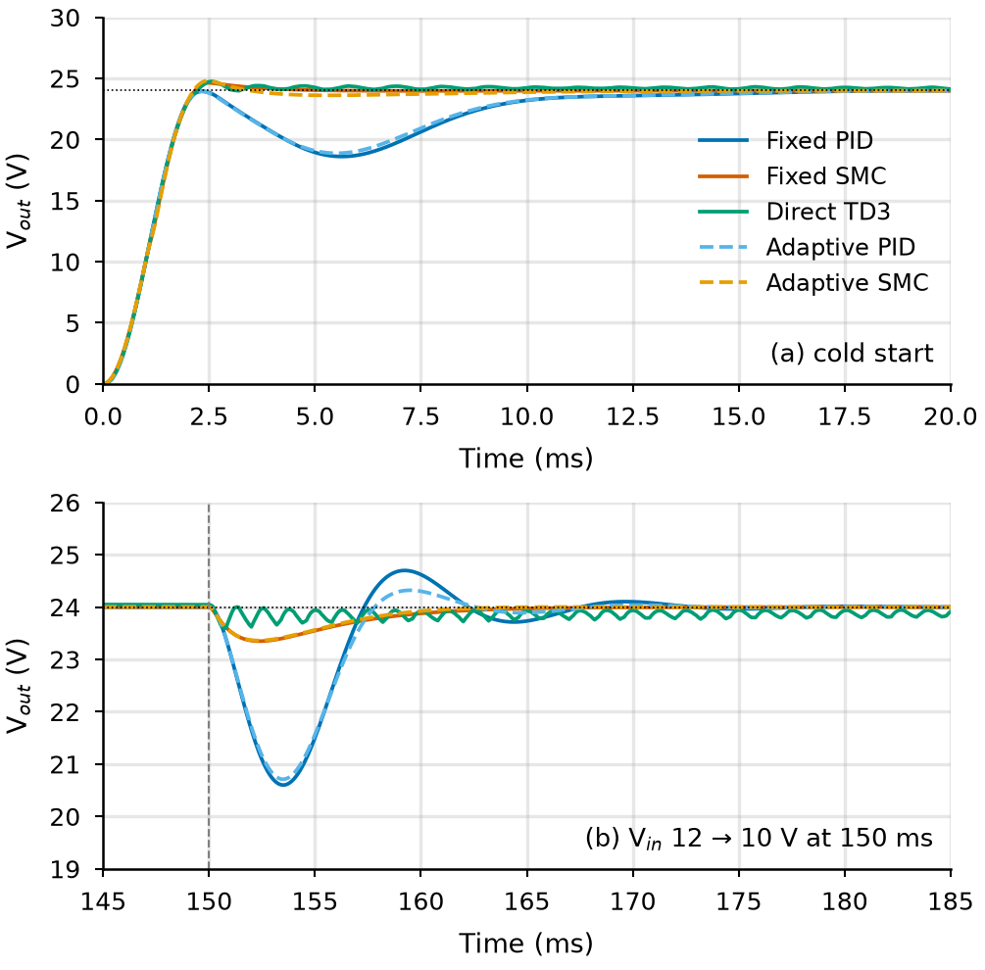
- Output voltage of the five controllers: (a) cold start and (b) after V_{in} 12 → 10 V (RL curves: mean over three seeds).
The adaptive controllers stay close to their baselines by design. The adaptive PID has 3–7 % smaller peak deviations, faster recovery after three of the four disturbances but slower after V_{in} 12 → 14 V (9.4 against 6.5 ms), and a similar cold-start settling time. The adaptive SMC has 0.4–6 % smaller peak deviations and 3–10 % faster recovery after all four disturbances, but a slower and more oscillatory cold start (settling 5.1 ± 1.9 against 2.9 ms), 1.2–2.1 times the duty activity, and a mean peak current 0.13 A higher. Their parameters now react to each disturbance and differ from seed to seed, in some runs with a sustained ripple, but never leave the certified boxes. The PID supervisor engaged once per run (during the cold start) and the SMC supervisor never. Several of these differences are within the seed spread.
TABLE VI
Maximum Deviation after the Disturbance (V)
Controller | V_{in} 12→10 V | V_{in} 12→14 V | R 20→10 Ω | R 20→30 Ω
Fixed PID | 3.40 | 3.00 | 1.94 | 0.64
Fixed SMC | 0.65 | 0.56 | 2.09 | 0.80
Direct TD3 | 0.44±0.08 | 0.39±0.01 | 1.85±0.21 | 0.43±0.00
Adaptive PID | 3.29±0.03 | 2.79±0.09 | 1.88±0.03 | 0.61±0.01
Adaptive SMC | 0.64±0.04 | 0.56±0.01 | 1.97±0.06 | 0.78±0.05

TABLE VII
Recovery Time to Within ±2 % (ms)
Controller | V_{in} 12→10 V | V_{in} 12→14 V | R 20→10 Ω | R 20→30 Ω
Fixed PID | 10.6 | 6.5 | 7.6 | 2.1
Fixed SMC | 4.7 | 3.3 | 9.9 | 5.2
Direct TD3 | 4.4±7.6 | 0 | 49.1±5.5† | 0
Adaptive PID | 8.2±1.7 | 9.4±0.3 | 7.4±0.2 | 1.9±0.1
Adaptive SMC | 4.6±0.2 | 3.1±0.1 | 9.0±0.5 | 4.8±0.4
0: the output never left the band. †: one of three seeds never returned to the band before the run ended.
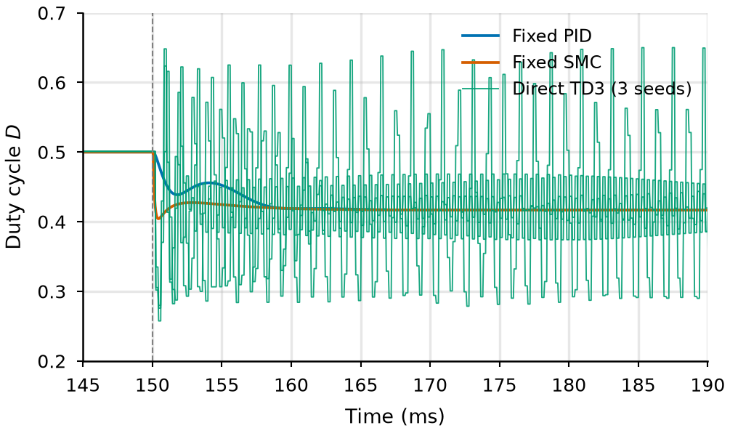
- Duty cycle after V_{in} 12 → 14 V: three direct-TD3 seeds against the fixed PID and SMC.
- SAFETY RECORD
No protection limit was reached in any of the 55 final evaluation runs (Table V). During training, the direct-TD3 runs triggered 3–6 trips each, all within the first 15,000 steps, whereas the adaptive controllers triggered none. This is consistent with the intended role of the bounds and the supervisor, but it is not a guarantee: the guarantees hold on the linearised model and the tested grids.
LIMITATIONS
The model is ideal and averaged: it has no inductor resistance, diode drop, capacitor ESR or switching ripple, so real hardware would show more damping and losses, and all gains and bounds would have to be re-derived. Only one circuit and five scenarios were evaluated. Three seeds give only a rough estimate of the spread, and one training configuration was used (200,000 steps, default hyper-parameters), so differences of a few percent between controllers are inconclusive. The SMC senses current and the PID does not, so the baseline comparison is not like for like. The averaged simulation cannot show how the duty-cycle oscillations of direct TD3 would affect real switches, so its good voltage regulation is not evidence that it would be acceptable in hardware.
CONCLUSION
A validated converter simulator, two systematically tuned baselines and three TD3-based controllers were compared on identical scenarios with three training seeds. A voltage-based sliding surface fails on this non-minimum-phase plant, while a current-based surface works. Learning inside stability-checked bounds and under a supervisor is safe in all evaluated runs but changes performance by only a few percent, and an unconstrained direct policy regulates tightly but moves the duty cycle much more, oscillates intermittently and varies across seeds. No controller was best on every metric. Natural next steps are more seeds and longer training, a stronger duty-change penalty for the direct policy, a more realistic converter model (ESR, diode drop, inductor resistance) with re-derived bounds, and hardware-in-the-loop tests.
REFERENCES
- R. W. Erickson and D. Maksimović, Fundamentals of Power Electronics, 2nd ed. Norwell, MA, USA: Kluwer, 2001.
- K. J. Åström and T. Hägglund, PID Controllers: Theory, Design, and Tuning, 2nd ed. Research Triangle Park, NC, USA: ISA, 1995.
- V. I. Utkin, J. Guldner, and J. Shi, Sliding Mode Control in Electro-Mechanical Systems, 2nd ed. Boca Raton, FL, USA: CRC Press, 2009.
- J.-J. E. Slotine and W. Li, Applied Nonlinear Control. Englewood Cliffs, NJ, USA: Prentice-Hall, 1991.
- H. Sira-Ramírez and R. Silva-Ortigoza, Control Design Techniques in Power Electronics Devices. London, U.K.: Springer, 2006.
- S. Skogestad and I. Postlethwaite, Multivariable Feedback Control: Analysis and Design, 2nd ed. Chichester, U.K.: Wiley, 2005.
- R. S. Sutton and A. G. Barto, Reinforcement Learning: An Introduction, 2nd ed. Cambridge, MA, USA: MIT Press, 2018.
- T. P. Lillicrap et al., “Continuous control with deep reinforcement learning,” in Proc. Int. Conf. Learn. Represent. (ICLR), San Juan, Puerto Rico, 2016.
- S. Fujimoto, H. van Hoof, and D. Meger, “Addressing function approximation error in actor-critic methods,” in Proc. 35th Int. Conf. Mach. Learn. (ICML), Stockholm, Sweden, 2018, pp. 1587–1596.
- A. Raffin, A. Hill, A. Gleave, A. Kanervisto, M. Ernestus, and N. Dormann, “Stable-Baselines3: Reliable reinforcement learning implementations,” J. Mach. Learn. Res., vol. 22, no. 268, pp. 1–8, 2021.
- M. Towers et al., “Gymnasium: A standard interface for reinforcement learning environments,” 2024, arXiv:2407.17032.
- P. Virtanen et al., “SciPy 1.0: Fundamental algorithms for scientific computing in Python,” Nature Methods, vol. 17, pp. 261–272, 2020.

It is recommended that footnotes be avoided (except for the unnumbered footnote with the receipt date on the first page). Instead, try to integrate the footnote information into the text.

