一、

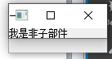

#include "widget.h"

#include <QApplication>

#include <QLabel>

#include <QWidget>

int main(int argc, char *argv[])

{

QApplication a(argc, argv);

QWidget* w = new QWidget();

QLabel *label1 = new QLabel(), *label2 = new QLabel(w);

label1->setText(QObject::tr("我是非子部件"));

label2->setText(QObject::tr("我是widegt的子部件"));

w->show();

label1->show();

return a.exec();

}

二、

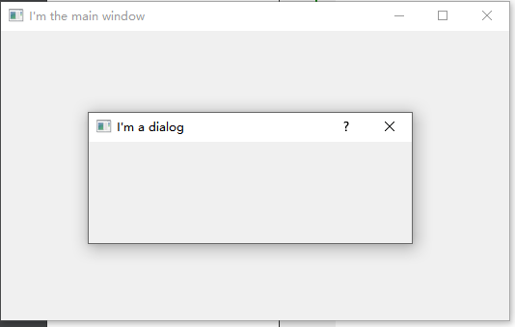

模态对话框在关闭对话框之后，widget才会弹出，

非模态对话框的对话框和widget都会弹出。

非模态对话框：

#include "widget.h"

#include "ui_widget.h"

#include <QDialog>

Widget::Widget(QWidget *parent) :

QWidget(parent),

ui(new Ui::Widget)

{

ui->setupUi(this);

QDialog* dlg = new QDialog(this);

dlg->setWindowTitle(QObject::tr("I'm a dialog"));

dlg->show();

}

Widget::~*Widget*()

{

delete ui;

}

模态对话框：

#include "widget.h"

#include "ui_widget.h"

#include <QDialog>

Widget::Widget(QWidget *parent) :

QWidget(parent),

ui(new Ui::Widget)

{

ui->setupUi(this);

QDialog* dlg = new QDialog(this);

dlg->setWindowTitle(QObject::tr("I'm a dialog"));

dlg->*exec*();

}

Widget::~*Widget*()

{

delete ui;

}

void Widget::showNormalDlg() {

}

三、四、

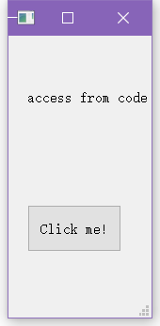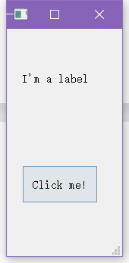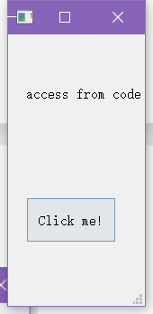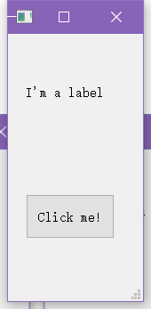

form.h:

#ifndef FORM_H

#define FORM_H

#include <QWidget>

#include <QPushButton>

#include <QLabel>

namespace **Ui** {

class **Form**;

}

class **Form** : public QWidget

{

Q_OBJECT

public:

explicit **Form**(QWidget *parent = nullptr);

void **showDlg**();

~***Form***();

private slots:

void **changeLabelText**();

private:

Ui::Form *ui;

};

#endif // FORM_H

form.cpp:

#include "form.h"

#include "ui_form.h"

Form::**Form**(QWidget *parent) :

QWidget(parent),

ui(new Ui::Form)

{

ui->setupUi(this);

QPushButton* pushbutton = new QPushButton(this);

pushbutton->resize(100, 50);

pushbutton->move(20, 180);

pushbutton->setText(QObject::tr("Click me!"));

ui->label->move(20, 50);

ui->label->setText(QObject::tr("access from code"));

connect(pushbutton, SIGNAL(clicked()), this, SLOT(changeLabelText()));

}

void Form::**changeLabelText**()

{

QString s = ui->label->text();

if(s == "access from code") ui->label->setText(QObject::tr("I'm a label"));

else if(s == "I'm a label") ui->label->setText(QObject::tr("access from code"));

}

void Form::**showDlg**() {

QString s = ui->label->text();

if(s == "access from code") ui->label->setText(QObject::tr("I'm a label"));

else if(s == "I'm a label") ui->label->setText(QObject::tr("access from code"));

}

Form::~***Form***()

{

delete ui;

}

main.cpp:

#include "widget.h"

#include "mainwindow.h"

#include "form.h"

#include <QApplication>

int main(int argc, char *argv[])

{

QApplication a(*argc*, argv);

Form* form = new Form();

form->resize(150, 300);

form->show();

return a.exec();

}

五、

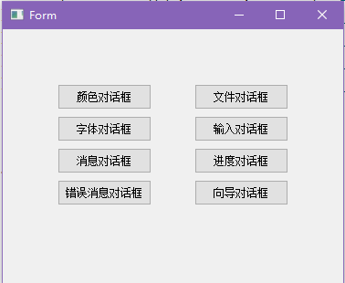

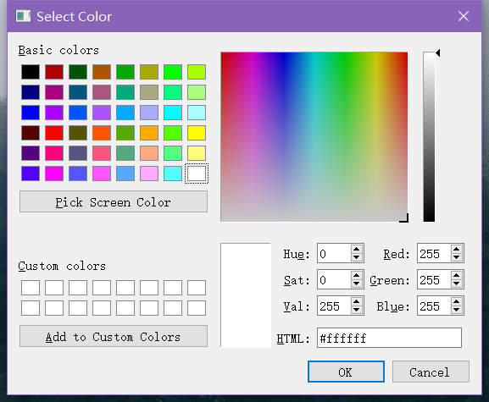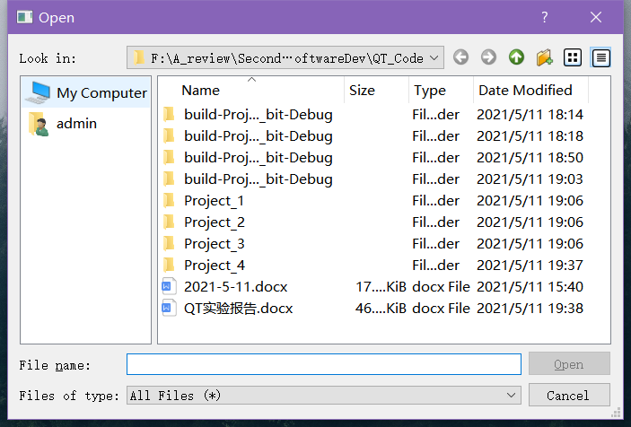

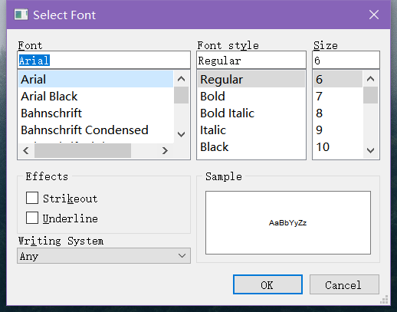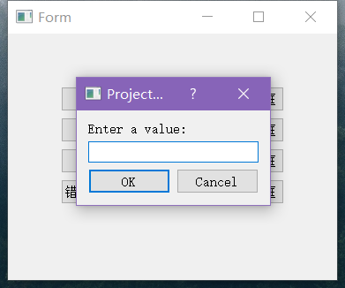

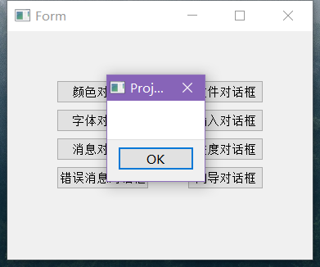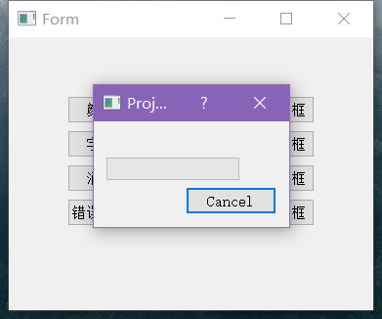

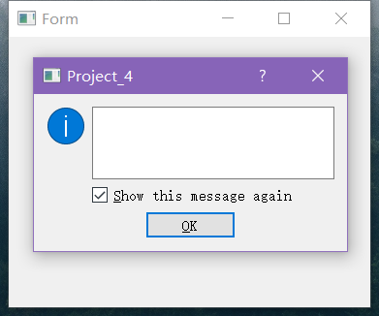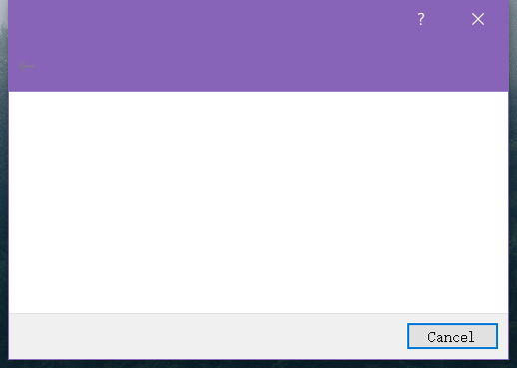

form.h:

#ifndef FORM_H

#define FORM_H

#include <QWidget>

#include <QColorDialog>

#include <QFileDialog>

#include <QFontDialog>

#include <QInputDialog>

#include <QMessageBox>

#include <QProgressDialog>

#include <QErrorMessage>

#include <QWizard>

namespace **Ui** {

class **Form**;

}

class **Form** : public QWidget

{

Q_OBJECT

public:

explicit **Form**(QWidget *parent = nullptr);

~***Form***();

private slots:

void **on_pushbutton_colordialog**();

void **on_pushbutton_filedialog**();

void **on_pushbutton_fontdialog**();

void **on_pushbutton_inputdialog**();

void **on_pushbutton_messagebox**();

void **on_pushbutton_progressdialog**();

void **on_pushbutton_errormessage**();

void **on_pushbutton_wizard**();

private:

Ui::Form *ui;

};

#endif // FORM_H

form.cpp:

#include "form.h"

#include "ui_form.h"

Form::**Form**(QWidget *parent) :

QWidget(parent),

ui(new Ui::Form)

{

ui->setupUi(this);

connect(ui->pushButton, SIGNAL(clicked()), this, SLOT(on_pushbutton_colordialog()));

connect(ui->pushButton_5, SIGNAL(clicked()), this, SLOT(on_pushbutton_filedialog()));

connect(ui->pushButton_2, SIGNAL(clicked()), this, SLOT(on_pushbutton_fontdialog()));

connect(ui->pushButton_6, SIGNAL(clicked()), this, SLOT(on_pushbutton_inputdialog()));

connect(ui->pushButton_3, SIGNAL(clicked()), this, SLOT(on_pushbutton_messagebox()));

connect(ui->pushButton_7, SIGNAL(clicked()), this, SLOT(on_pushbutton_progressdialog()));

connect(ui->pushButton_4, SIGNAL(clicked()), this, SLOT(on_pushbutton_errormessage()));

connect(ui->pushButton_8, SIGNAL(clicked()), this, SLOT(on_pushbutton_wizard()));

}

void Form::**on_pushbutton_colordialog**() {

QColorDialog* colordialog = new QColorDialog();

colordialog->show();

}

void Form::**on_pushbutton_filedialog**() {

QFileDialog* filedialog = new QFileDialog();

filedialog->show();

}

void Form::**on_pushbutton_fontdialog**() {

QFontDialog* fontdialog = new QFontDialog();

fontdialog->show();

}

void Form::**on_pushbutton_inputdialog**() {

QInputDialog* inputdialog = new QInputDialog();

inputdialog->show();

}

void Form::**on_pushbutton_messagebox**() {

QMessageBox* messagebox = new QMessageBox();

messagebox->show();

}

void Form::**on_pushbutton_progressdialog**() {

QProgressDialog* progressdialog = new QProgressDialog();

progressdialog->show();

}

void Form::**on_pushbutton_errormessage**() {

QErrorMessage* errormessage = new QErrorMessage();

errormessage->show();

}

void Form::**on_pushbutton_wizard**() {

QWizard* wizard = new QWizard();

wizard->show();

}

Form::~***Form***()

{

delete ui;

}

main.cpp:

#include "widget.h"

#include "form.h"

#include <QApplication>

int main(int argc, char *argv[])

{

QApplication a(*argc*, argv);

Form* form = new Form();

form->show();

return a.exec();

}