1. project_1

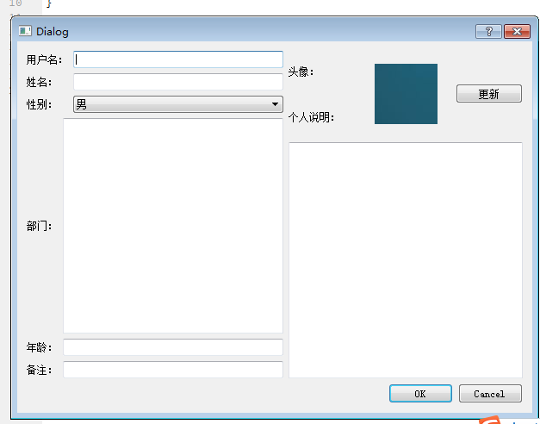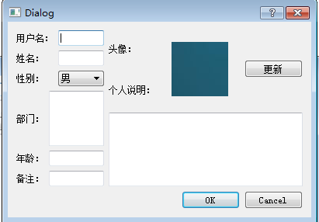

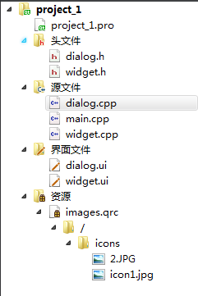

1. project_2

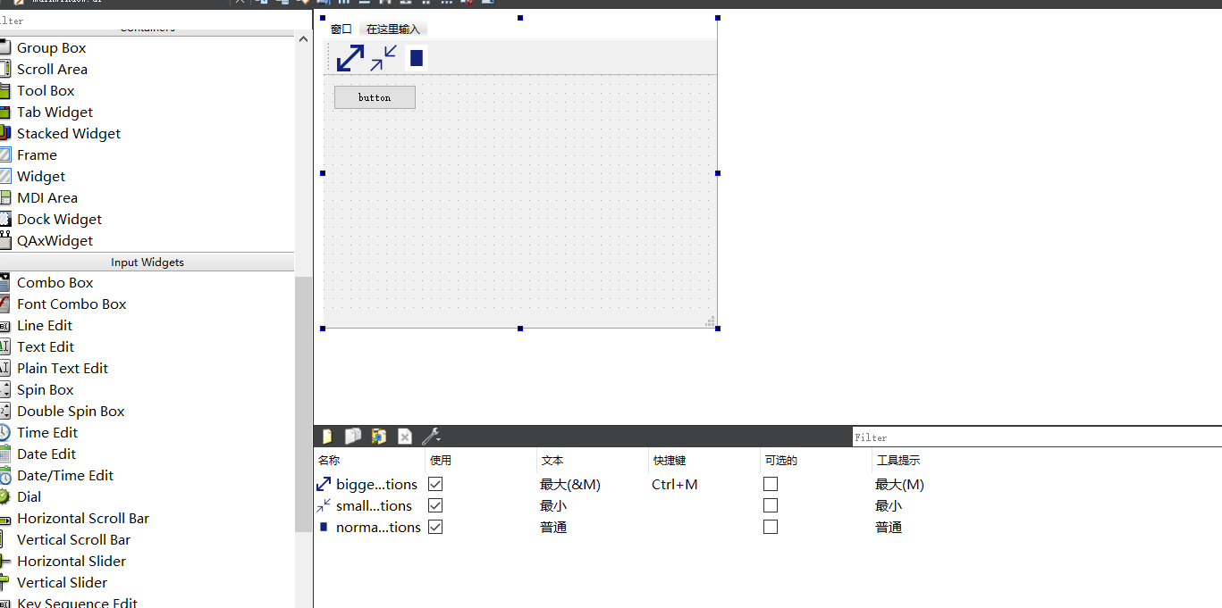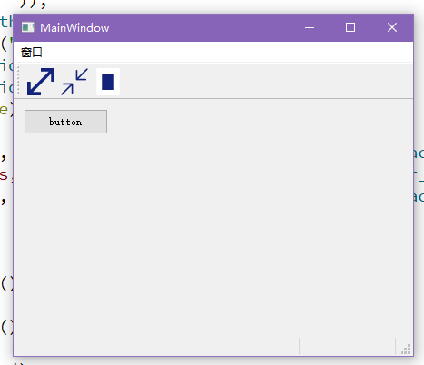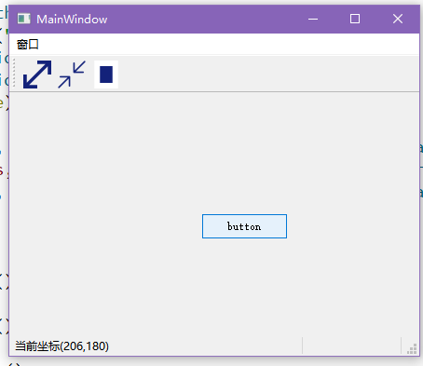

mainwindow.h:

#ifndef MAINWINDOW_H

#define MAINWINDOW_H

#include <QMainWindow>

#include <QMainWindow>

#include <QLabel>

#include <QStatusBar>

#include <QMouseEvent>

#include <QPushButton>

#include <QAction>

#include <QIcon>

namespace **Ui** {

class **MainWindow**;

}

class **MainWindow** : public QMainWindow

{

Q_OBJECT

public:

int nowx = 400, nowy = 400;

int nowwidth = 400, nowheight = 400;

explicit **MainWindow**(QWidget *parent = 0);

~***MainWindow***();

private:

Ui::MainWindow *ui;

QLabel *statusLabel;

QLabel *MousePosLabel;

private slots:

void **bigger_action**();

void **normal_action**();

void **smaller_action**();

protected:

int doit = 0;

void ***mousePressEvent***(QMouseEvent*e);

void ***mouseMoveEvent***(QMouseEvent*e);

void ***mouseReleaseEvent***(QMouseEvent*e);

void ***mouseDoubleClickEvent***(QMouseEvent *e);

};

#endif // MAINWINDOW_H

mainwindow.cpp:

#include "mainwindow.h"

#include "ui_mainwindow.h"

MainWindow::**MainWindow**(QWidget *parent) :

QMainWindow(parent),

ui(new Ui::MainWindow)

{

ui->setupUi(this);

statusLabel = new QLabel;

statusLabel->setText("");

statusLabel->setFixedWidth(100);

MousePosLabel = new QLabel;

MousePosLabel->setText(tr(""));

MousePosLabel->setFixedWidth(100);

ui->pushButton->setText(tr("button"));

statusBar()->addPermanentWidget(statusLabel);

statusBar()->addPermanentWidget(MousePosLabel);

this->setMouseTracking(true);

connect(ui->bigger_actions, SIGNAL(triggered()), this, SLOT(bigger_action()));

connect(ui->smaller_actions, SIGNAL(triggered()), this, SLOT(smaller_action()));

connect(ui->normal_actions, SIGNAL(triggered()), this, SLOT(normal_action()));

}

void MainWindow::**bigger_action**()

{

nowwidth = this->frameGeometry().width();

nowheight = this->frameGeometry().height();

nowx = this->frameGeometry().x();

nowy = this->frameGeometry().y();

setWindowState(Qt::WindowMaximized);

}

void MainWindow::**normal_action**()

{

this->move(nowx, nowy);

this->resize(nowwidth, nowheight);

}

void MainWindow::**smaller_action**()

{

setWindowState(Qt::WindowMinimized);

}

void MainWindow::***mousePressEvent***(QMouseEvent *e)

{

doit = 1;

}

void MainWindow::***mouseMoveEvent***(QMouseEvent *e)

{

if(doit == 1) {

QString str="("+QString::number(e->x())+","+QString::number(e->y())+")";

statusBar()->showMessage("当前坐标" + str);

ui->pushButton->move(e->pos().x(), e->pos().y() - 50);

}

}

void MainWindow::***mouseReleaseEvent***(QMouseEvent *e)

{

doit = 0;

// statusBar()->showMessage("");

}

void MainWindow::***mouseDoubleClickEvent***(QMouseEvent* e)

{

if(e->button()==Qt::LeftButton)

bigger_action();

if(e->button()==Qt::RightButton)

normal_action();

}

MainWindow::~***MainWindow***()

{

delete ui;

}

1. project_3

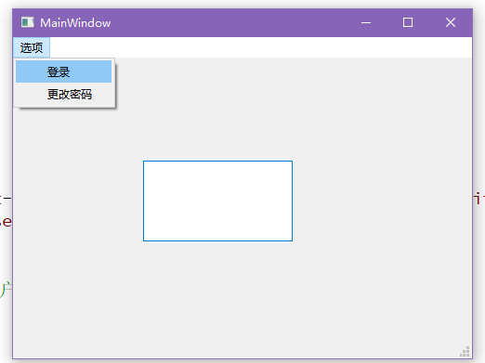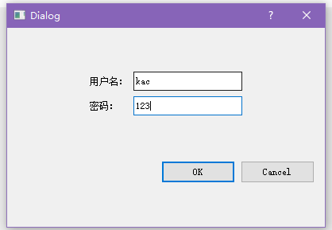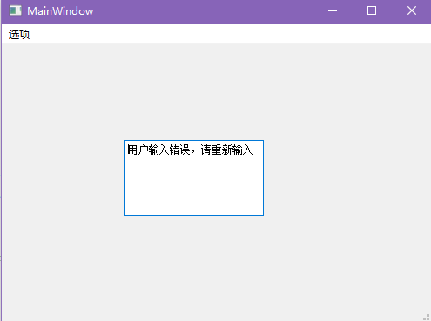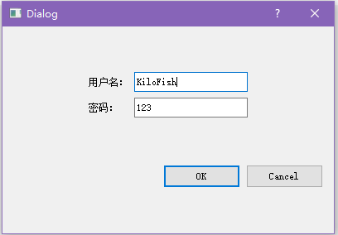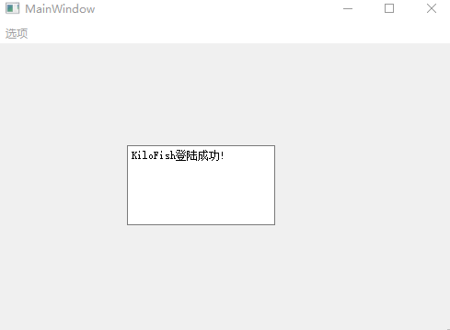

dialog.h:

#ifndef DIALOG_H

#define DIALOG_H

#include <QDialog>

#include <QMessageBox>

namespace **Ui** {

class **Dialog**;

}

class **Dialog** : public QDialog

{

Q_OBJECT

public:

int doit = 0;

explicit **Dialog**(QWidget *parent = nullptr);

~***Dialog***();

signals:

void **get_text**(QString s);

protected:

void ***accept***() override;

private:

Ui::Dialog *ui;

};

#endif // DIALOG_H

dialog.cpp:

#include "dialog.h"

#include "ui_dialog.h"

Dialog::**Dialog**(QWidget *parent) :

QDialog(parent),

ui(new Ui::Dialog)

{

ui->setupUi(this);

}

Dialog::~***Dialog***()

{

delete ui;

}

void Dialog::***accept***()

{

if(ui->username_lineEdit->text() == "KiloFish" && (ui->password_lineEdit->text() == "520" || ui->password_lineEdit->text() == "123")) {

emit get_text(ui->username_lineEdit->text() + tr("登陆成功!"));

} else {

doit = 1;

emit get_text(tr("用户输入错误，请重新输入"));

}

ui->username_lineEdit->setText("");

ui->password_lineEdit->setText("");

close();

}

mainwindow.h:

#ifndef MAINWINDOW_H

#define MAINWINDOW_H

#include <QMainWindow>

#include "dialog.h"

QT_BEGIN_NAMESPACE

namespace **Ui** { class **MainWindow**; }

QT_END_NAMESPACE

class **MainWindow** : public QMainWindow

{

Q_OBJECT

public:

Dialog* dlg = new Dialog();

**MainWindow**(QWidget *parent = nullptr);

~***MainWindow***();

private slots:

void **sign_action_click**();

void **update_action_click**();

void **change_text**(QString s);

protected:

void ***mouseDoubleClickEvent***(QMouseEvent* e);

void ***mouseMoveEvent***(QMouseEvent *e);

private:

Ui::MainWindow *ui;

};

#endif // MAINWINDOW_H

mainwindow.cpp:

#include "mainwindow.h"

#include "ui_mainwindow.h"

MainWindow::**MainWindow**(QWidget *parent)

: QMainWindow(parent)

, ui(new Ui::MainWindow)

{

ui->setupUi(this);

connect(ui->sign_action, SIGNAL(triggered()), this, SLOT(sign_action_click()));

// connect(dlg, SIGNAL(Dialog::get_text()), this, SLOT(change_text()));

connect(dlg, &Dialog::get_text, this, &MainWindow::change_text);

}

void MainWindow::**change_text**(QString s)

{

ui->main_textEdit->setText(s);

}

MainWindow::~***MainWindow***()

{

delete ui;

}

void MainWindow::**sign_action_click**()

{

dlg->show();

}

void MainWindow::**update_action_click**()

{

}

void MainWindow::***mouseDoubleClickEvent***(QMouseEvent* e)

{

if(dlg->doit == 1) {

dlg->show();

}

}

void MainWindow::***mouseMoveEvent***(QMouseEvent *e)

{

}