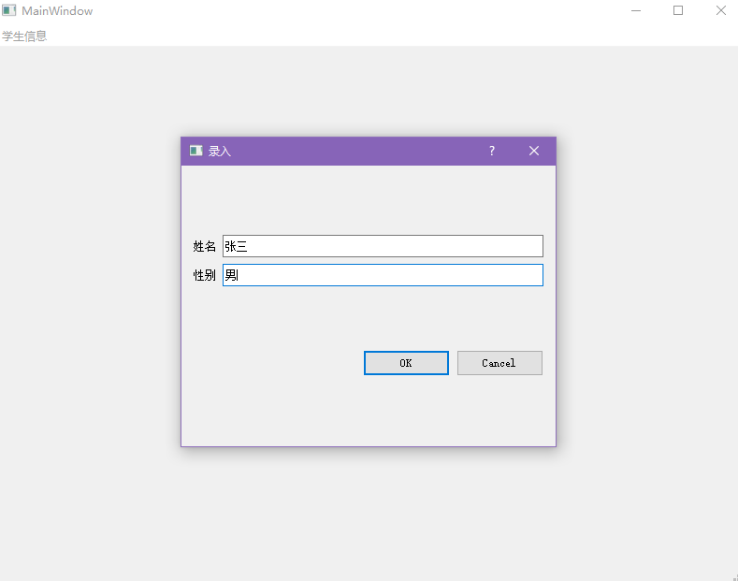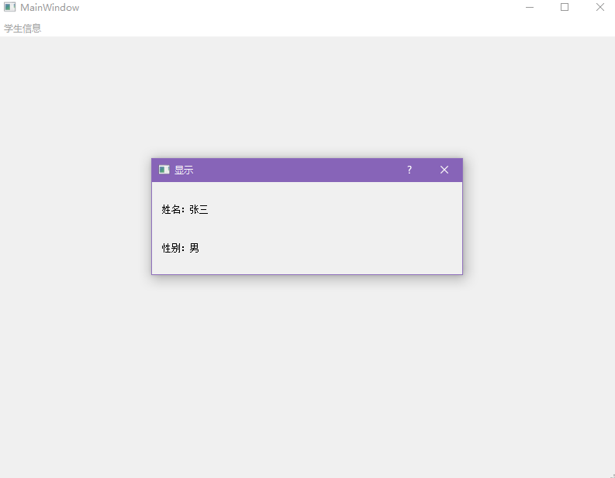
右键“用户区”和点击“显示”按钮效果一样，显示“显示对话框”。
catchinfodialog.h
#ifndef CATCHINFODIALOG_H
#define CATCHINFODIALOG_H

#include <QDialog>
#include <QDebug>
namespace Ui {
class catchinfodialog;
}

class catchinfodialog : public QDialog
{
Q_OBJECT

public:
QString name, sex;
explicit catchinfodialog(QWidget *parent = nullptr);
void accept() override;
~catchinfodialog();

private:
Ui::catchinfodialog *ui;
};

#endif // CATCHINFODIALOG_H
catchinfodialog.cpp:
#include "catchinfodialog.h"
#include "ui_catchinfodialog.h"

catchinfodialog::catchinfodialog(QWidget *parent) :
QDialog(parent),
ui(new Ui::catchinfodialog)
{
ui->setupUi(this);

name = ui->name_lineEdit->text();
sex = ui->sex_lineEdit->text();
}

void catchinfodialog::accept() {
name = ui->name_lineEdit->text();
sex = ui->sex_lineEdit->text();
qDebug()<<name<<endl;
qDebug()<<sex<<endl;
close();
}

catchinfodialog::~catchinfodialog()
{
delete ui;
}
showinfodialog:
#ifndef SHOWINFODIALOG_H
#define SHOWINFODIALOG_H

#include <QDialog>

namespace Ui {
class showinfoDialog;
}

class showinfoDialog : public QDialog
{
Q_OBJECT

public:
QString name, sex;
explicit showinfoDialog(QWidget *parent = nullptr);
void show_info();
~showinfoDialog();

private:
Ui::showinfoDialog *ui;
};

#endif // SHOWINFODIALOG_H

showinfodialog.cpp:
#include "showinfodialog.h"
#include "ui_showinfodialog.h"

showinfoDialog::showinfoDialog(QWidget *parent) :
QDialog(parent),
ui(new Ui::showinfoDialog)
{
ui->setupUi(this);
}

void showinfoDialog::show_info()
{
ui->name_label->setText("姓名：" + name);
ui->sex_label->setText("性别：" + sex);
return ;
}

showinfoDialog::~showinfoDialog()
{
delete ui;
}
mainwindow.h:
#ifndef MAINWINDOW_H
#define MAINWINDOW_H

#include <QMainWindow>
#include <QDialog>
#include <QPushButton>
#include <QLineEdit>
#include <QInputDialog>
#include <QLabel>
#include <QDebug>
#include <QDialogButtonBox>
#include "catchinfodialog.h"
#include "showinfodialog.h"
#include <QMouseEvent>
QT_BEGIN_NAMESPACE
namespace Ui { class MainWindow; }
QT_END_NAMESPACE

class MainWindow : public QMainWindow
{
Q_OBJECT

public:
catchinfodialog* catch_dialog;
showinfoDialog* show_dialog;
void mousePressEvent(QMouseEvent *event);
MainWindow(QWidget *parent = nullptr);
~MainWindow();

private slots:
void Catch_Info_Click();
void Show_Info_Click();

private:
Ui::MainWindow *ui;
};
#endif // MAINWINDOW_H

mainwindow.cpp:
#include "mainwindow.h"
#include "ui_mainwindow.h"
MainWindow::MainWindow(QWidget *parent)
: QMainWindow(parent)
, ui(new Ui::MainWindow)
{
ui->setupUi(this);
catch_dialog = new catchinfodialog(); catch_dialog->setWindowTitle("录入");
show_dialog = new showinfoDialog(); show_dialog->setWindowTitle("显示");

connect(ui->Catch_Info, SIGNAL(triggered()), this, SLOT(Catch_Info_Click()));
connect(ui->Show_Info, SIGNAL(triggered()), this, SLOT(Show_Info_Click()));
connect(ui->centralwidget, SIGNAL(triggered()), this, SLOT(Show_Info_Cl
ick()));

}

void MainWindow::Catch_Info_Click()
{
catch_dialog->show();
ui->Catch_Info->setEnabled(false);
ui->Show_Info->setEnabled(true);
return;
}

void MainWindow::Show_Info_Click()
{
show_dialog->name = catch_dialog->name;
show_dialog->sex = catch_dialog->sex;
show_dialog->show_info();
show_dialog->show();
ui->Catch_Info->setEnabled(true);
ui->Show_Info->setEnabled(false);
return;
}

void MainWindow::mousePressEvent(QMouseEvent *event)
{
if (event->button() == Qt::RightButton)
{
Show_Info_Click();
}
}
MainWindow::~MainWindow()
{
delete ui;
}

2.
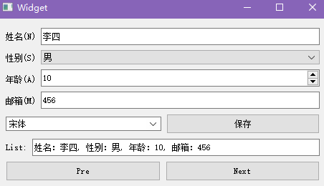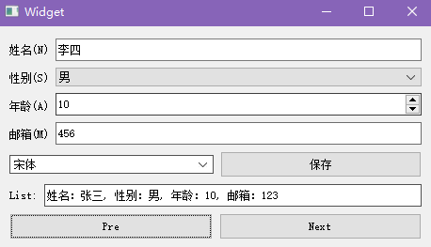
widget.h:
#ifndef WIDGET_H
#define WIDGET_H

#include <QWidget>
#include <QDialog>
#include <QLineEdit>
#include <list>
#include <QDebug>
QT_BEGIN_NAMESPACE
namespace Ui { class Widget; }
QT_END_NAMESPACE
using namespace std;
struct Node {
QString name, sex, age, mail;
Node(QString _name, QString _sex, QString _age, QString _mail) : name(_name), sex(_sex), age(_age), mail(_mail) {}
};

class Widget : public QWidget
{
Q_OBJECT

public:
list<Node> lis;
list<Node>::iterator pos;
Widget(QWidget *parent = nullptr);
~Widget();

private slots:
void save_info();
void pre_list();
void next_list();

private:
Ui::Widget *ui;
};
#endif // WIDGET_H

widget.cpp:
#include "widget.h"
#include "ui_widget.h"

Widget::Widget(QWidget *parent)
: QWidget(parent)
, ui(new Ui::Widget)
{
ui->setupUi(this);
connect(ui->save_button, SIGNAL(clicked()), this, SLOT(save_info()));
connect(ui->pre_button, SIGNAL(clicked()), this, SLOT(pre_list()));
connect(ui->next_button, SIGNAL(clicked()), this, SLOT(next_list()));
}

void Widget::save_info()
{
if(ui->name_lineedit->text() == "" && ui->mail_lineedit->text() == "") {
QDialog* dlg = new QDialog();
QLineEdit* led = new QLineEdit(dlg);
led->setText("未填写姓名和邮箱！");
dlg->show();
} else if(ui->name_lineedit->text() == "") {
QDialog* dlg = new QDialog();
QLineEdit* led = new QLineEdit(dlg);
led->setText("未填写姓名！");
dlg->show();
} else if(ui->mail_lineedit->text() == "") {
QDialog* dlg = new QDialog();
QLineEdit* led = new QLineEdit(dlg);
led->setText("未填写邮箱！");
dlg->show();
} else {
pos = lis.begin();
lis.push_back(Node(ui->name_lineedit->text(), ui->sex_comboBox->currentText(), ui->age_spinBox->text(), ui->mail_lineedit->text()));
qDebug()<<ui->name_lineedit->text()<<ui->sex_comboBox->currentText()<<ui->age_spinBox->text()<<ui->mail_lineedit->text();
}
}

void Widget::pre_list()
{
if(pos != lis.begin()) pos --;
ui->show_lineedit->setText("姓名：" + (*pos).name + ", 性别：" + (*pos).sex + ", 年龄：" + (*pos).age + ", 邮箱：" + (*pos).mail);
}

void Widget::next_list()
{
if(pos != lis.end()) pos ++;
ui->show_lineedit->setText("姓名：" + (*pos).name + ", 性别：" + (*pos).sex + ", 年龄：" + (*pos).age + ", 邮箱：" + (*pos).mail);
}

Widget::~Widget()
{
delete ui;
}

main.cpp:
#include "widget.h"

#include <QApplication>

int main(int argc, char *argv[])
{
QApplication a(argc, argv);
Widget w;
w.show();
return a.exec();
}

