**eCom.CodingChallenge**

**This project is used to manage Contact information**

**Prerequisite**

**API:**

* **Visual studio 2022**
* **.Net framework 6.0**

**UI**

* **Angular 14.2.0**
* **Node.js**

**Installation**

**Node.js “**<https://nodejs.org/en/download/>**”**

**Commands : “npm i @angular/cli”**

**API Endpoints**

* **GET /contacts List all contacts**
* **POST /contacts Create a new contact**
* **PUT /contacts/{id} Update a contact**
* **GET /contacts/{id} Get a specific contact**
* **DELETE /contacts/{id} Delete a contact**
* **GET /contacts/call-list Get a call list.**

**Database Diagram**

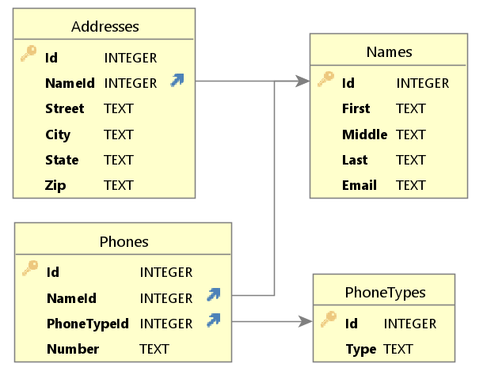

**Usage**

* **Open solution: “eCom.CodingChallenge.sln” using VS 2022**
* **If “eComDB.db” is not exist in “eCom.CodingChallenge\bin\Debug\net6.0”**
  + **Run “update-database” in package manager console**

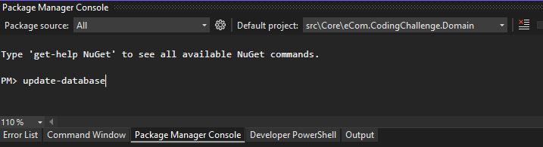

* **Run “eCom.CodingChallenge” Project**



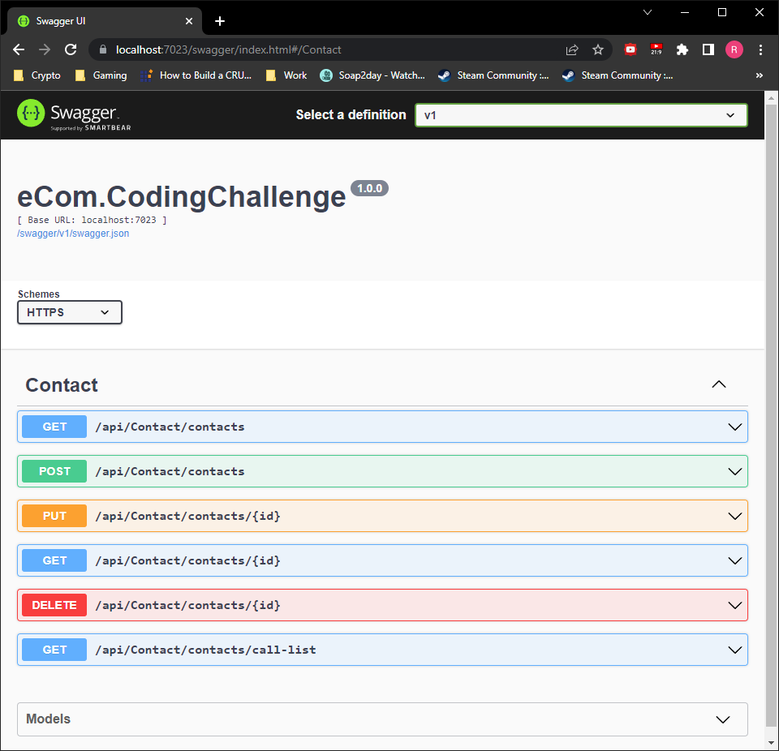

* **Open terminal or Powershell**
  + **Under “View>Terminal”**
* **Run these commands without double quotation marks**
  + **“cd .\eCom.CodingChallenge.UI\”**
  + **“npm-install” – if npm is not installed as global**
  + **“ng serve -o”**

