Multi-Projector Warping and Blending with X-Plane on the NVIDIA GPU

Introduction
This is about setting up multi-projector visuals on a cylindrical screen for a flight simulator home cockpit. There are three image transformations one will need to accomplish for it to work properly.
- Transformation of the rendered content from a flat to a cylindrical projection
- Warping of the projected image to the cylindrical screen geometry
- Blending of the individual projected images at their overlapping regions
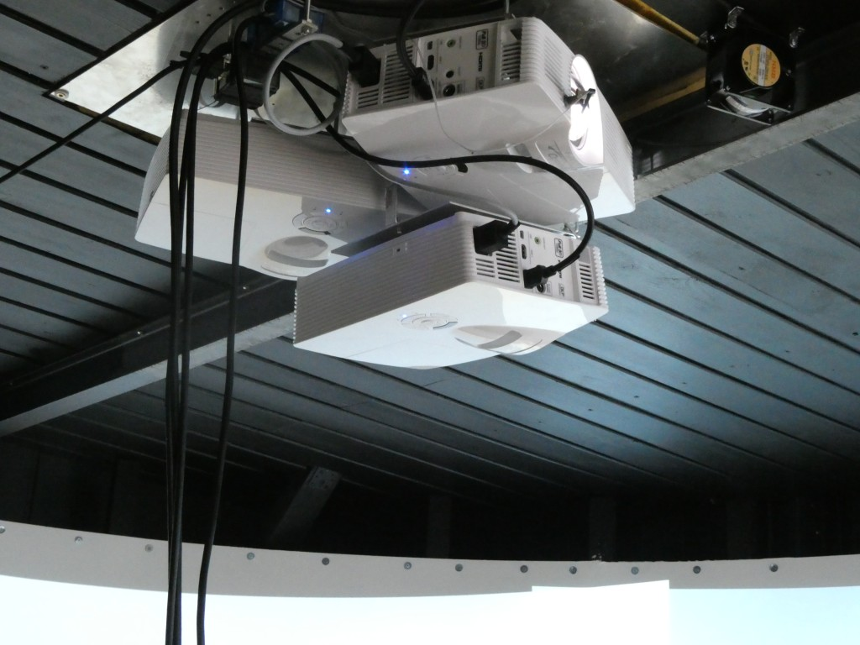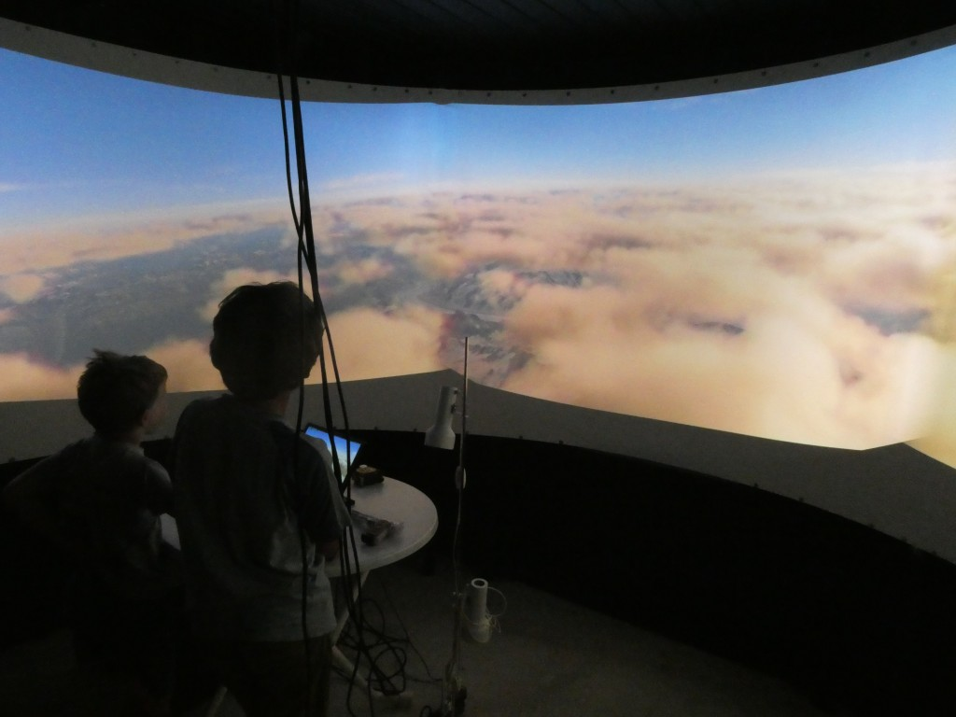
Figure: Sample projector system (left) with cylindrical screen (right) in my setup.
There are several software solutions to achieve these three steps. These are for instance, among others, Fly Elise NG, Warpalizer or Pixelwix. Their price ranges from a few hundred to a few thousand US$, which is justified for the amount of sophisticated projection design, calibration and transformation features offered. Most of the software packages include manual, geometric and camera-based warping technology and are suitable driving a highly complex and professional multi-projector setup for commercial use. However, if you’re a home cockpit builder like I am, these solutions are too sophisticated. They further make you dependent on yet another third party supplier, which can cause sleepless nights in case of missing updates and incompatibilities. And if you work on Linux like I am, these solutions do not apply at all since they all require Windows.
There is a simple solution to that: if you use X-Plane, it has steps 1 — 3 built in. No need to buy an additional software: planar – cylindrical transformation, warping to cylindrical screen and blending IS part of X-Plane. Thanks to Austin and his superb crew!
However, there are three drawbacks in X-Plane’s native support for multi-projector setups:
- Transformation from planar to cylindrical projection cuts of a substantial part of the image at image edges.
- You can only manually define the warping grid, which needs quite some fiddling with many control points and a horizontal / vertical laser calibration.
- X-Plane’s native solutions is mostly CPU based. So if you’re already CPU limited in X-Plane and have your GPU sitting around, then running warping and blending through X-Plane will make your FPS drop, depending on CPU model.
I am now going to show how to implement steps 1 — 3 and concurrently curing X-Plane shortcomings A — C, all native on Linux and free of cost. AND: to stay 100% compatible with X-Plane’s native warping and blending. All related code is available on github.

Transforming Rendered Content from Planar to Cylindrical Projection
The 3D content of computer games is rendered on an imaginary flat plane sitting in front of the user. Ideally this plane reflects the distance of the flat monitor from the user. This means that the horizontal and vertical Field Of Views (FOVx and FOVy) of the rendered plane and of the eye-to-monitor geometry are comparable. To cover a true 180 degree FOVx the monitor would need to be infinitely wide. This trouble can be avoided by having a cylindrical screen around you. However, it requires to reproject the image content of the planar rendering in your application into a cylindrical projection. So, if you ever buy a curved monitor and think that your game will look nicer, you simply got fooled. The content at the edges will simply appear closer than it really is and you might get a headache from playing. Those curved monitors would need a game that can render its content on a curved monitor. Which is not the case for any of the games I know. Except for X-Plane. And the latter is said not to be a game.
The solution to render on curved or cylindrical (or even spherical) screens is very simple and applied in most panorama stitching software: it is a simple geometric transformation from X / Y to horizontal angle and screen height coordinates (Example formula see LINK):
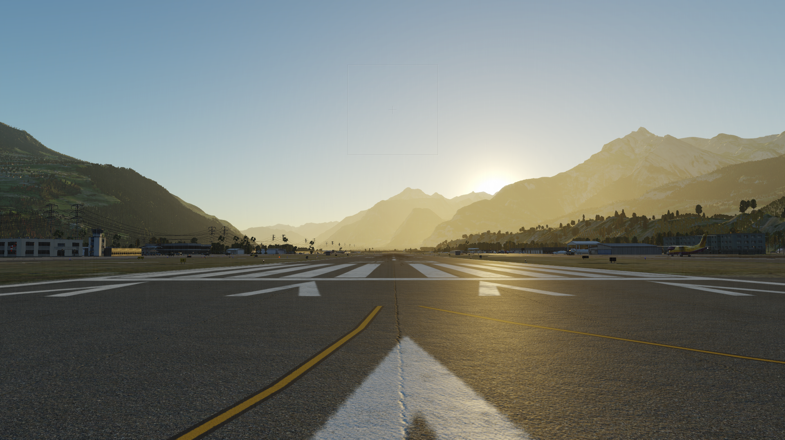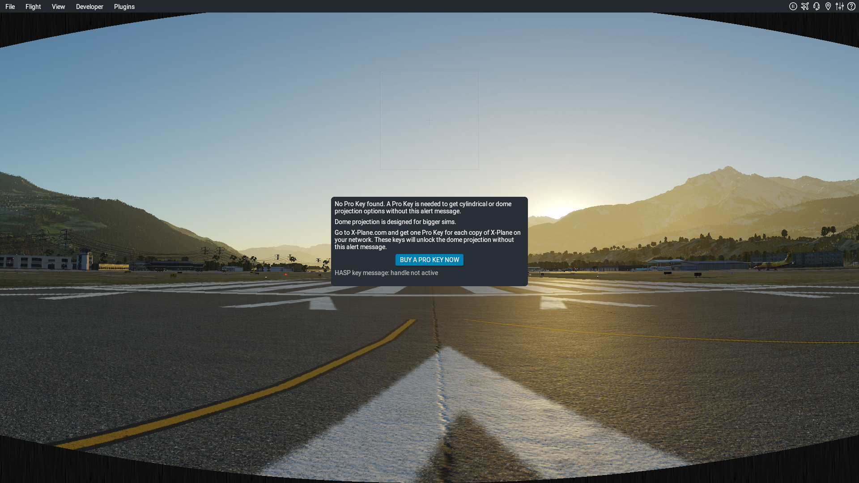
FIGURE: Planar rendering (left) and cylindrical transformation (right) of the planar rendering. Note about the dialog box in the right image: in order to use the advanced projection features without the warning box the professional version of X-Plane has to be bought. I don’t have it. The images here are just displayed for demonstration purpose and thus contain the warning dialog box.
The left planar rendering cannot be stitched together. The cylindrical rendering (right below) allows perfect stitching.
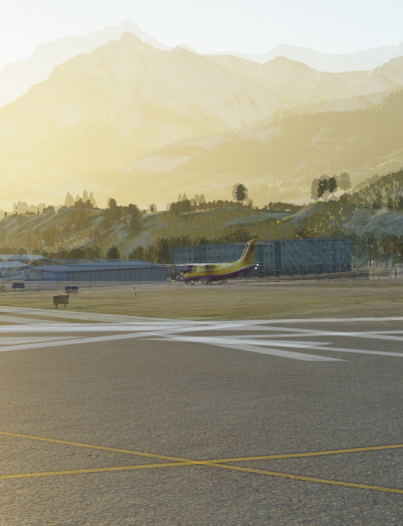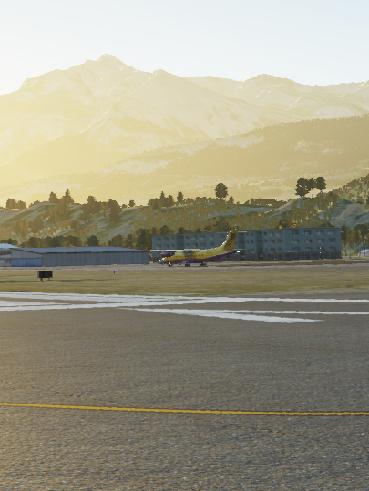
FIGURE: Stitching (overlapping) the planar rendered (left) and the cylinder transformed (right) image.
A common cylindrical projection squeezes the scenery vertically. In the X-Plane internal solution this is overcome by linearly stretching it during the planar to cylindrical projection. This still leaves unused (black) screen areas at the corners due to the planar to cylindrical projection geometry. My solution here is to render a slightly higher FOVy and stretch the vertical coordinates so that the rendered content entirely fills the image. Additional stretching has to be proportional to the tan() of the additional FOVy. This will in turn render unused / unseen content in the upper and lower center of the projected area but fill the corners.
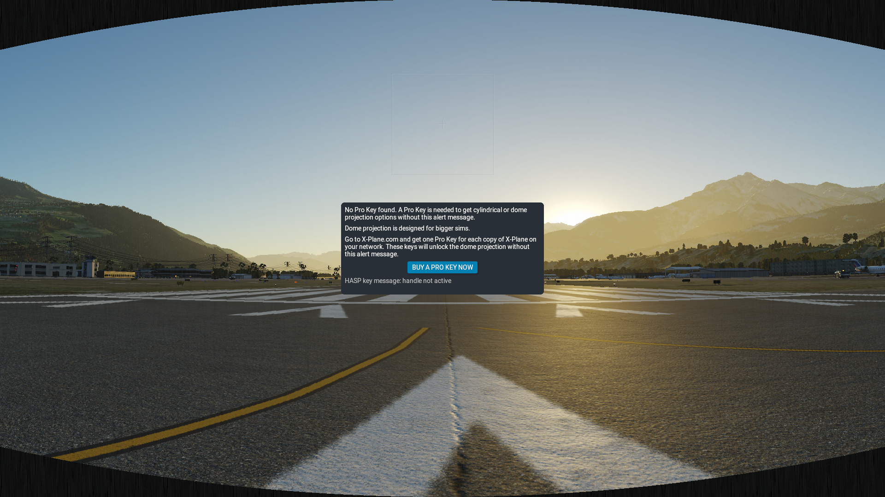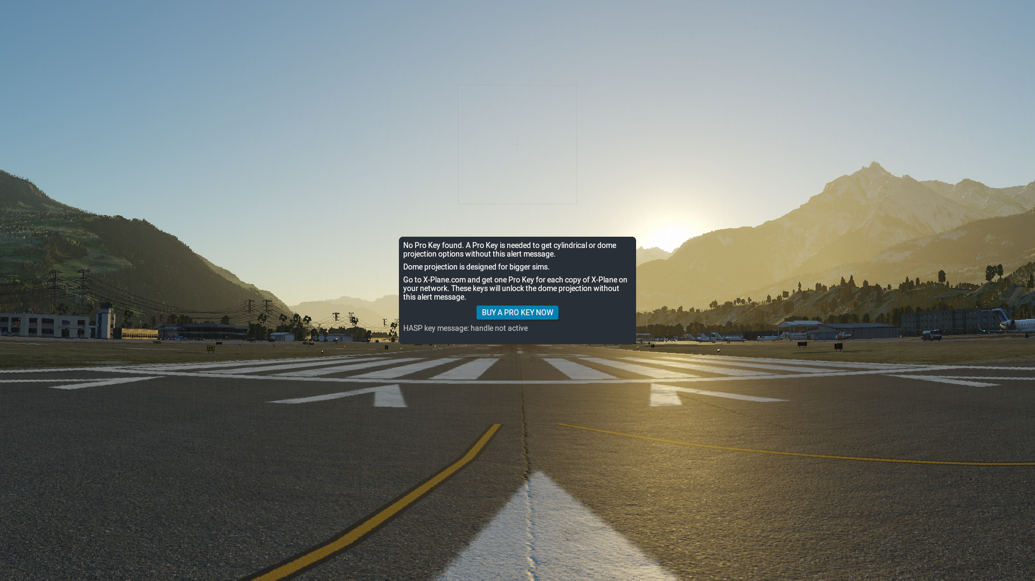
FIGURE: X-Plane’s native cylinder projection (left) and image filling cylinder projection using a higher FOVy and vertical stretch (right).
Rendering a higher FOVy might produce a higher CPU and GPU load since more objects will need to be calculated. In my setup with a per-projector FOVx of 77.6º, the FOVx has to be increased from 48.6º to 52.1º, which is acceptable.

Warping and Blending of the projected image to the cylindrical screen geometry
Projectors are built to display on a flat / planar screen mounted orthogonal in front of the projector axis. If the projector or the screen is tilted, the so-called “keystone” effect has to be corrected (image appears wider on one end than on the other and is squeezed vertically). If you project on a cylindrical screen, it gets distorted even more. See an example below from my setup. The left and right projectors are mounted level, the center projector is tilted vertically by around 6 degrees.
FIGURE: Unwarped X-Plane output on a cylindrical screen.
The classic way to overcome this is to set up a grid of control points and manually make these points level again with the help of a laser leveler. The laser leveler can be found in every hardware shop and will draw precise horizontal and vertical lines on your cylindrical screen. You can use it to mark a “real’ grid on you cylindrical screen, then adjust your warping grid points to this “real” grid. And basta. let us call this the empirical warping method. This method is available in X-Plane and in most projection software solutions.
Most projection software solutions also include a camera-based warping method. A simple web cam connected to the projection software and filming the projection screen allows to adjust the warping grid automatically. This solution is usually free of trouble, but you have to buy it.
The solution that I would like to propagate here is the geometric warping. It is available in some projection software solutions as well. If you know the size and radius of your projection screen and know the distance and angle of your projectors, then with the application of a few trigonometric functions one can calculate the position of each projected pixel on the cylindrical screen and in turn also correct this position. The solution is very simple for projectors mounted radially from the center of the projector screen and pointing in the direction of the screen.
FIGURE: Scheme of the projection – screen geometry. Horizontal and vertical view.
It gets a bit more complicated if the projector is tilted up or down. But this is perfectly solvable. I have not implemented the solution for projectors which are not mounted radially and / or pointing away from the radial direction to the screen.
What you will need to know to apply my solution:
- Radius of screen R [cm]
- Throw ratio of projector tr [-]
- Distance of projector focal point (or lens front, if not known) from center of screen d₀ [cm]
- Lower height h₀ of image above focal point (or lens center if not known) when projected at a screen in distance d₁ [cm]
- Projector tilt angle ε [deg]
The code to calculate the projection geometry and the resulting warping grid is written in python and called warpblend.py (find it here on github). The warping grid is written into a regular ‘X-Plane Window Positions.prf’ preference file. This file goes into the directory ‘Output/preferences’ of X-Plane. The geometric calculation in the warping grid loads into X-Plane if this file is in the preferences directory.
FIGURE: Unwarped and warped projection grid on a cylindrical screen.
That is a perfectly aligned warping grid. However, the resulting X-Plane output does not stitch. Lines do not match in direction in the overlapping areas. We also have to enable planar – to – cylinder correction in my code:
FIGURE: Warped X-Plane output without blending and without planar-cylinder correction.
Planar to cylindrical image projection is also stored in the warping grid. This is different to X-Plane where only the geometric projection warping is stored into the warping grid. If you use the warping grid of my code, simply leave the ‘use cylindrical projection on all displays’ in X-Plane’s projection dialog box unticked. You can enable it in my code and it will be part of the projection warping grid:
FIGURE: Warped X-Plane output without blending and with planar-cylinder correction.
Blending is also stored in the file ‘X-Plane Window Positions.prf’. You calibrate and store it in my code and it will be applied in X-Plane:

FIGURE: Warped X-Plane Output with blending and with planar-cylinder correction.
What did I show: a perfect projection warping to a cylindrical screen can be achieved without even moving a single control point by hand and by use of a (relatively simple) python script to calculate corrected pixel positions for your projector. Given you know the dimensions of the screen and some specifications of your projector. For this calculation projectors have to be arranged radially towards the screen and can be tilted. In case they would be positioned anywhere on your ceiling, the geometric correction presented here would need to be adapted.
For Windows users: you can use everything up to this step. Same file, same warping grid.

Speeding things up by running it on the GPU
When loading the warping grid, applying blending as well on three screens you will notice a significant increase in CPU load, and if you’re CPU limited in X-Plane like many others, you will also see a significant FPS drop:
FIGURE: FPS before (left) and after (right) warping.
Fortunately, NVIDIA (and possibly other GPU companies) has built a native support for image warping and blending. And the good news is that these features come at almost no cost, neither for GPU nor for CPU. So, what I am going to demonstrate here for Linux is how to read the X-Plane’s warping grid and blending directly into your NVIDIA card and run it from there. This will save X-Plane from doing these calculations on the CPU and kick your FPS back to normal.
The theory and API behind this functionality is explained very well in a presentation Doug Traill held at the GTC 2017 conference (LINK: WARPING & BLENDING FOR MULTI-DISPLAY SYSTEM USING NVIDIA DESIGNWORKS). The API is implemented for both Windows and Linux. Since I have no access to a Windows programming environment (an operating system that does not ship with its compiler cannot be called an operating system) the whole work has been done on Linux by using the sample code nv-control-warpblend.c found in nvidia-settings (find it here on github). It should be pretty simple for a programmer to add the windows functionality with the Windows API of NVIDIA.
My code does the following: it reads the regular ‘X-Plane Window Positions.prf’ file and fills the NVIDIA warp matrix polygons with it. It also reads the blend information out of this file and creates the projector edge blending. There is

