**NAME – Krish Srivastava**

**REG.NO – AP21110010302**

**CLASS – CSE-E**

DBMS-WEEK3

**1)** 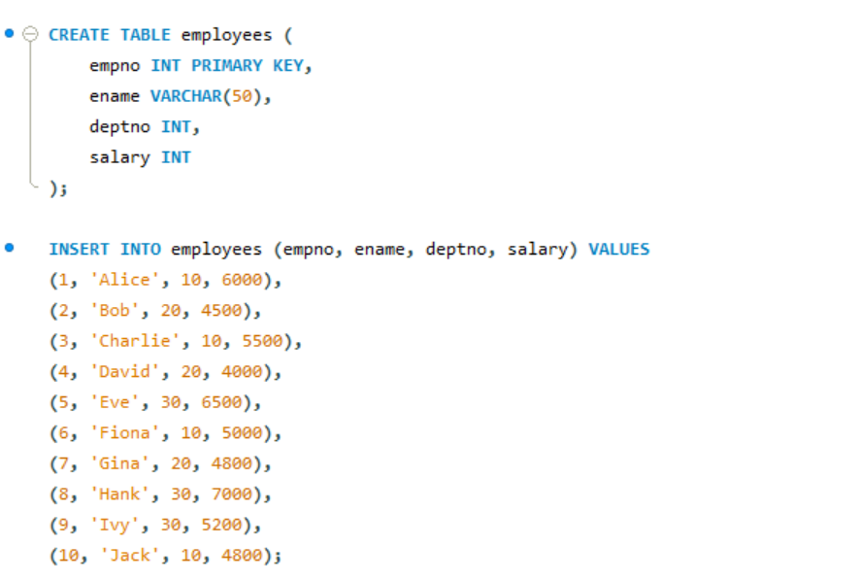

**a)**

SELECT ename, AVG(salary) AS average_salary

FROM employees

WHERE deptno = 10

GROUP BY ename;

**b)**

SELECT deptno, ename, salary

FROM employees

WHERE (deptno, salary) IN (

SELECT deptno, MIN(salary)

FROM employees

GROUP BY deptno

);

**c)**

SELECT deptno, COUNT(*) AS num_employees

FROM employees

GROUP BY deptno;

**d)**

CREATE TABLE dept (

deptno INT PRIMARY KEY,

deptname VARCHAR(50)

);

INSERT INTO dept (deptno, deptname) VALUES

(10, 'HR'),

(20, 'Finance'),

(30, 'IT');

SELECT d.deptno, d.deptname, COUNT(e.empno) AS num_employees

FROM dept d

LEFT JOIN employees e ON d.deptno = e.deptno

GROUP BY d.deptno, d.deptname;

**e)**

SELECT ename

FROM employees

WHERE ename LIKE 'B%' OR ename LIKE 'C%';

**f)**

SELECT ename

FROM employees

WHERE salary >= 5000;

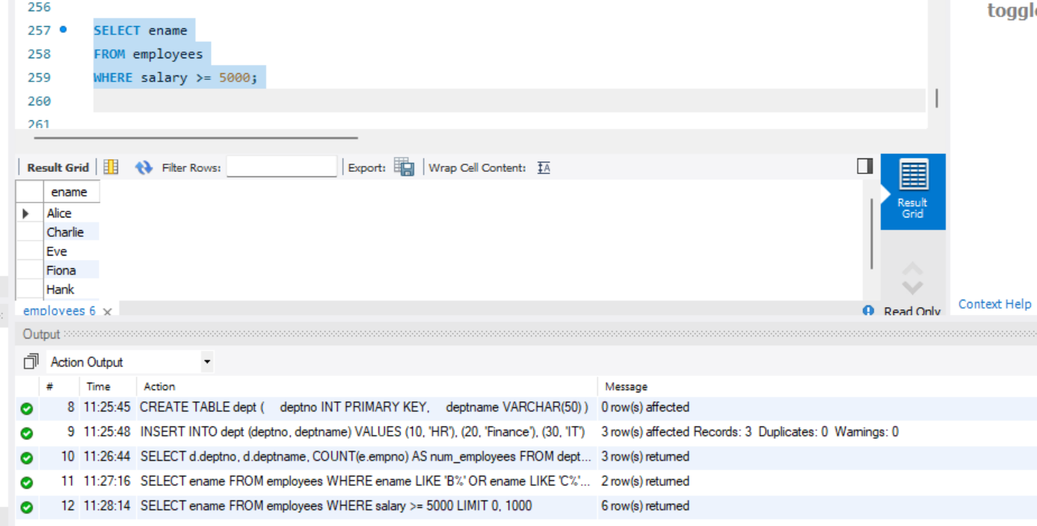

FINAL OUTPUT:



**2)**

ALTER TABLE employees

ADD COLUMN job VARCHAR(50);

SET SQL_SAFE_UPDATES = 0;

UPDATE employees SET job = 'Manager' WHERE ename = 'Alice';

UPDATE employees SET job = 'Developer' WHERE ename = 'Bob';

UPDATE employees SET job = 'Manager' WHERE ename = 'Charlie';

UPDATE employees SET job = 'Developer' WHERE ename = 'David';

UPDATE employees SET job = 'HR Assistant' WHERE ename = 'Eve';

UPDATE employees SET job = 'IT Specialist' WHERE ename = 'Fiona';

UPDATE employees SET job = 'Finance Analyst' WHERE ename = 'Gina';

UPDATE employees SET job = 'IT Specialist' WHERE ename = 'Hank';

UPDATE employees SET job = 'Finance Analyst' WHERE ename = 'Ivy';

UPDATE employees SET job = 'HR Assistant' WHERE ename = 'Jack';

**a)**

SELECT job, AVG(salary) AS average_salary

FROM employees

GROUP BY job;

**b)**

SELECT job, AVG(salary) AS average_salary

FROM employees

WHERE job NOT LIKE 'Manager'

GROUP BY job;

**c)**

SELECT deptno, AVG(salary) AS average_salary

FROM employees

GROUP BY deptno

HAVING COUNT(*) > 3;

**d)**

SELECT *

FROM employees

WHERE salary > (SELECT MIN(salary) FROM employees WHERE deptno = 30);

**e)**

SELECT ename, salary, SIGN(salary) AS sign_value

FROM employees;

**f)**

ALTER TABLE employees

ADD COLUMN birth_date DATE;

UPDATE employees SET birth_date = '1990-01-15' WHERE ename = 'Alice';

UPDATE employees SET birth_date = '1988-07-21' WHERE ename = 'Bob';

UPDATE employees SET birth_date = '1992-04-05' WHERE ename = 'Charlie';

UPDATE employees SET birth_date = '1995-10-10' WHERE ename = 'David';

UPDATE employees SET birth_date = '1993-12-03' WHERE ename = 'Eve';

UPDATE employees SET birth_date = '1989-06-18' WHERE ename = 'Fiona';

UPDATE employees SET birth_date = '1991-09-27' WHERE ename = 'Gina';

UPDATE employees SET birth_date = '1987-03-14' WHERE ename = 'Hank';

UPDATE employees SET birth_date = '1990-08-08' WHERE ename = 'Ivy';

UPDATE employees SET birth_date = '1994-11-02' WHERE ename = 'Jack';

SELECT ename, DATEDIFF(CURRENT_DATE(), birth_date) AS days_since_birth

FROM employees;

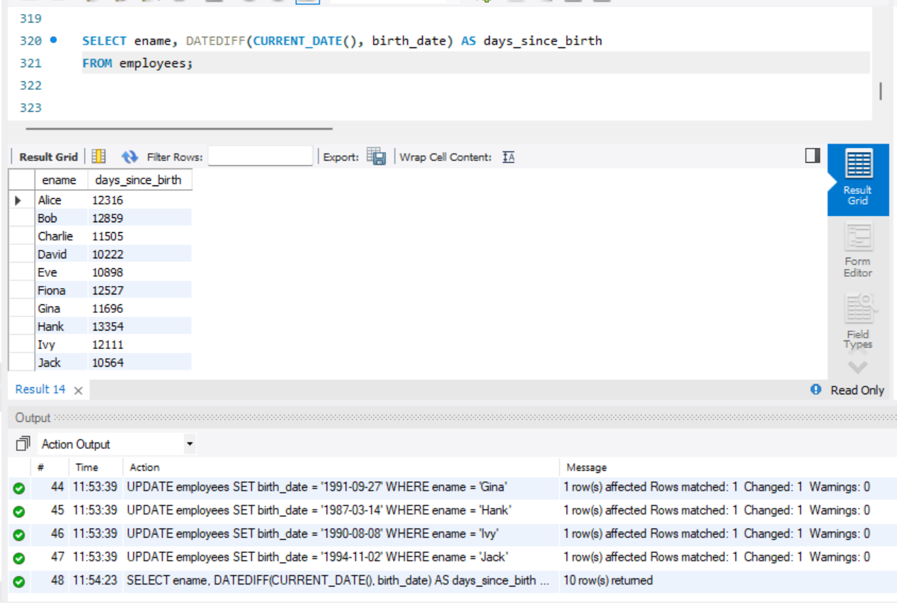

FINAL OUT:

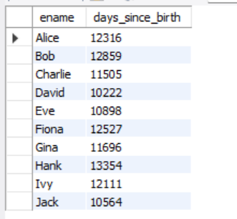

**3)**

ALTER TABLE employees

ADD COLUMN manager_id INT;

UPDATE employees SET manager_id = empno - 1;

**a)**

SELECT CONCAT('Substring1', ' ', 'Substring2') AS combined_string;

**b)**

SELECT ename, salary, salary * 1.15 AS increased_salary

FROM employees;

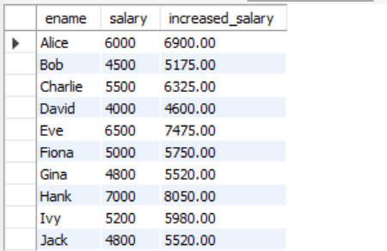

**c)**

SELECT m.ename AS manager_name, e.ename AS employee_name, e.salary

FROM employees e

JOIN **employees** m ON e.manager_id = m.empno

WHERE e.salary = (SELECT MIN(salary) FROM employees WHERE manager_id = m.empno);

**d)**

SELECT deptno, AVG(salary) AS average_monthly_salary_bill

FROM employees

GROUP BY deptno;

**e)**

SELECT deptno, AVG(salary) AS average_salary

FROM employees

GROUP BY deptno

HAVING COUNT(*) > 2;

**f)**

SELECT empno, AVG(salary) AS average_salary

FROM employees

WHERE deptno = 5

GROUP BY empno;

FINAL OUTPUT:

