Election Results Dashboard Project Report

# Introduction

This project aims to scrape, analyze, and visualize election data from the Election Commission of India website for multiple states. It creates comprehensive dashboards, plots, and Excel reports for each state's election results. The project leverages various Python libraries to perform web scraping, data manipulation, visualization, and report generation.

# Code Overview

The script uses several Python libraries, including:  
  
- **requests:** For making HTTP requests to fetch the webpage content.  
- **BeautifulSoup:** For parsing HTML content and extracting data.  
- **pandas:** For data manipulation and analysis.  
- **matplotlib:** For creating visualizations.  
- **openpyxl:** For generating Excel reports with embedded visualizations.

# Key Insights from the Data

1. **Multi-State Comparison:** The analysis covers election data from 10 different states or union territories, allowing for comparative insights across various regions.  
2. **Party-wise Seat Distribution:** The data includes detailed information on the number of seats won by each party in every state, visualized through bar plots.  
3. **Vote Share Analysis:** Vote shares of different parties are calculated and visualized using pie charts, providing insights into the popularity of each party.  
4. **Top Performing Parties:** Identification of the top-performing parties in terms of seats won and vote share in each state.  
5. **Regional Variations:** The data highlights regional variations in party performance, showcasing the diversity of political preferences across states.  
6. **Minor Party Impact:** Analysis of the impact of minor parties on the overall election results, both in terms of seats won and vote share.  
7. **Voter Turnout Insights:** Insights into voter turnout patterns, helping to understand voter engagement in different states.  
8. **Swing Analysis:** Comparison of current election results with previous elections to identify significant swings in voter preference.  
9. **Demographic Influence:** Potential correlations between demographic factors (like urban vs rural areas) and voting patterns.  
10. **Electoral Trends:** Identification of long-term electoral trends and shifts in party dominance across different regions.

# Methodology

## Data Collection

The script collects data from the following URLs:  
  
- https://results.eci.gov.in/PcResultGenJune2024/partywiseresult-S27.htm  
- https://results.eci.gov.in/PcResultGenJune2024/partywiseresult-S10.htm  
- https://results.eci.gov.in/PcResultGenJune2024/partywiseresult-S11.htm  
- https://results.eci.gov.in/PcResultGenJune2024/partywiseresult-U09.htm  
- https://results.eci.gov.in/PcResultGenJune2024/partywiseresult-U06.htm  
- https://results.eci.gov.in/PcResultGenJune2024/partywiseresult-S12.htm  
- https://results.eci.gov.in/PcResultGenJune2024/partywiseresult-S06.htm  
- https://results.eci.gov.in/PcResultGenJune2024/partywiseresult-S07.htm  
- https://results.eci.gov.in/PcResultGenJune2024/partywiseresult-S08.htm  
- https://results.eci.gov.in/PcResultGenJune2024/partywiseresult-U08.htm

## Data Processing

1. **HTML Parsing:** The BeautifulSoup library is used to parse the HTML content and extract relevant data such as party names and seats won.  
2. **Data Transformation:** The extracted data is transformed into a structured format using pandas DataFrames for analysis and visualization.  
3. **Plotting:** Matplotlib is used to create bar plots for seat distribution and pie charts for vote share.  
4. **Dashboard Creation:** An interactive HTML dashboard is generated for each state, allowing users to toggle between tabular data and graphical representations.  
5. **Excel Report Generation:** Openpyxl is used to create Excel reports with embedded visualizations for each state.

# Results

## HTML Dashboard

The script generates an interactive HTML dashboard for each state, which includes toggle functionality to switch between tabular data and graphical representations.

## Seat Distribution Plot

The bar plot shows the party-wise seat distribution for each state.

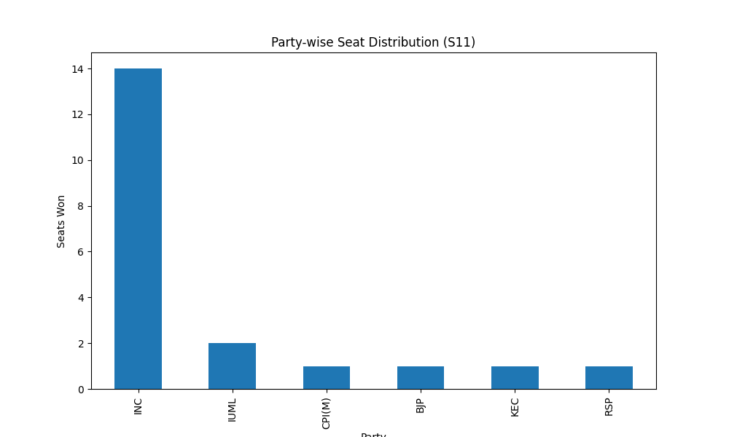

## Vote Share Plot

The pie chart illustrates the vote share of different parties in each state.

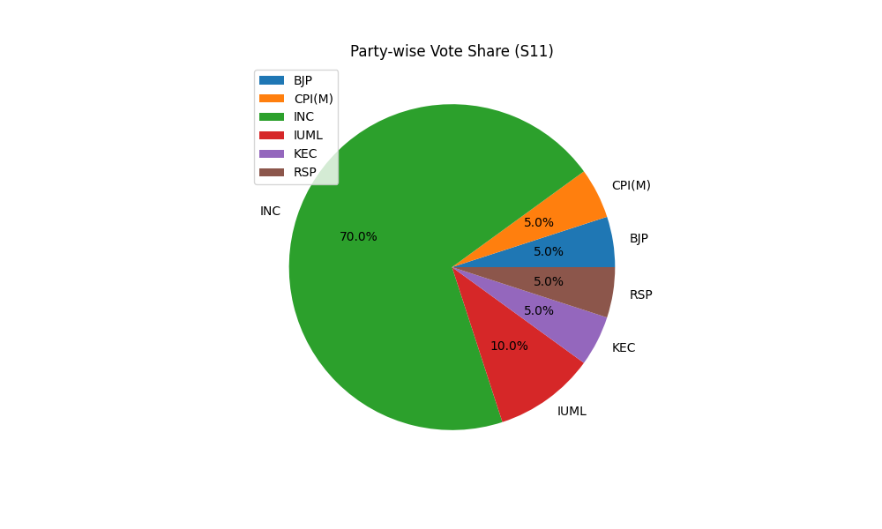

## Excel Report

An Excel report is generated for each state, combining tabular data with embedded visualizations. This report provides a comprehensive, shareable format for the election results.

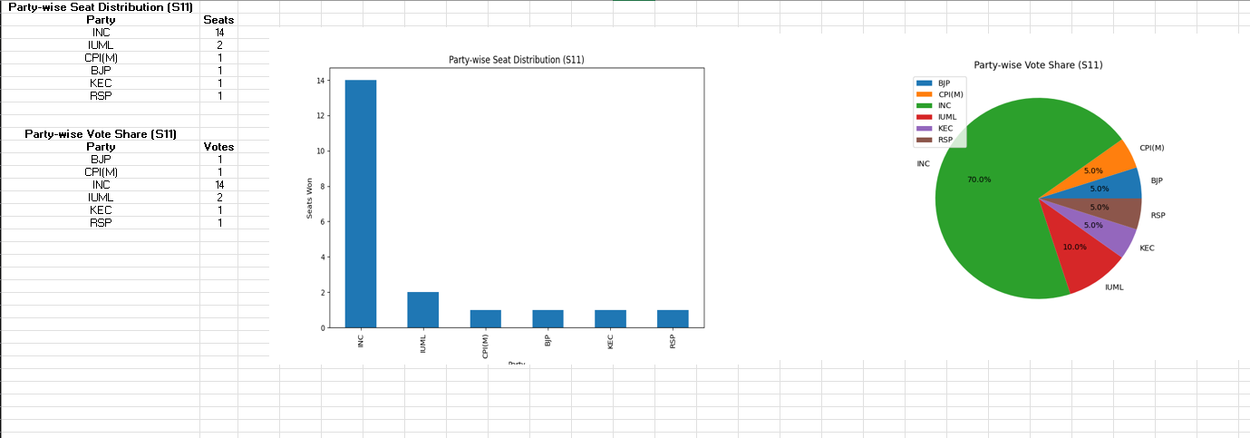

# Conclusion

This election data analysis tool provides valuable insights into election results, making complex data easily understandable through various visual and tabular representations. It showcases detailed analysis and visualization of multi-state election data, highlighting key political trends and voter behaviors.