(After Episode 3)

I never would have imagined this mission would be so dangerous. Though I didn’t get hit, my crewmates suffered heavy damage.
Dutch tried to stand up to that brute, but got his rib broken in the process.
Luckily I was able to find some supplies at the bazaar we stopped at. He should be healed in a few days.
That’s the second time I’ve had to save him.
I feel like I’m starting to bond with some of the crew members. Morra has a similar interest in flora, Zion is a very reasonable type, and Dutch…
Well, Dutch might be the closest thing I have to a friend on this ship. We’ve been able to chat whenever I tend to his wounds.
He’s a bit reckless at times, but I admire his bravery.
I’ll be prepared to come to his aid any time he needs.

The stars are extra beautiful tonight. It’s amazing how much you can see from space…



(After Episode 3, A Little Later)

Bellow looks at the number the shopkeep gave him, with the words “Call Me” written next to it.
After a moment, he decides to call.

(Ring….)

Bellow: “Um…Hello?”

???: “Oh! It’s you, Handsome!”

Bellow: “It’s me…”

???: “I forgot to give you my name. Terry Keep!”

Bellow: “Bellow Brightlight.”

Terry: “So, I was wondering, maybe you would want to come by for dinner sometime? There’s this amazing diner by the shop I’d love to take you to!”

Bellow: “Oh…but, I barely know you.”

Terry: “Well that’s what dinner is for silly! We can get to know each other a bit better.”

Bellow: “You mean…like a date?”

Terry: “I mean, if you’re okay with that.”

Bellow: “....I…Don’t take this the wrong way, it’s just…My species, well…we don’t, uh, mesh well with other species. Not in that way…”

Terry: “O-Oh.”

Bellow: “Plus, me personally…I’d rather focus on my mission than a relationship…but, dinner still sounds nice.”
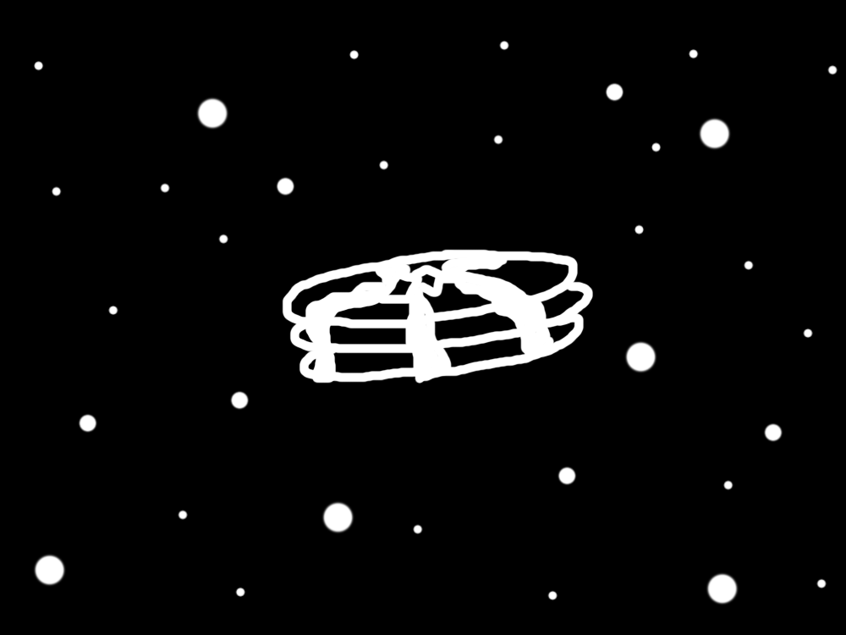
Terry: “Hey, it was worth a shot. See you there!”

Bellow: “Bye.”

(Click.)

“I hope there’ll be pancakes…”
(After Episode 4)

We visited an ocean planet this week.
I’m not…the BIGGEST fan of water, being from the dryer side of Moonshine.
In fact, for the first time in a long time, I lost my ability to fly due to my wings getting too wet. Not a pleasant experience.
We got a new crew member today. Zach, the human. It’s been an awfully long time since I met a human…
Dutch almost got himself killed again, but as always, I was there to revive him. He really should be more careful.
I did get to destroy him in blackjack though.

The reflection of the stars in the ocean waves are the only redeeming quality of this planet…


(After Episode 11)

I…don’t know how to feel about our captain, or about Dutch, or anyone else on the team anymore.
There was a big fight today, and I snapped at multiple people. I’ve never lost myself to anger before, but…I think I really scared Zach. Seeing that kind of reaction really made me scared of myself. I didn’t know I could just lose myself altogether like that.
Eventually Zion and I worked something out, and he’s going to talk to the fungus, or, Vec now, about his behavior.
Dutch will be harder to convince. I don’t know if he’s ever going to forgive Zion OR Vec for what happened today.
And to be honest, I don’t know if I will either.
I just hope Dutch stops being so…ANGRY about it. It’s only going to compel him to make rash decisions that could get himself killed.
He’s still one of my very best friends, but…I can’t stand watching him be like this.
And I don’t know what to do about it.

The stars burn fiercely tonight…

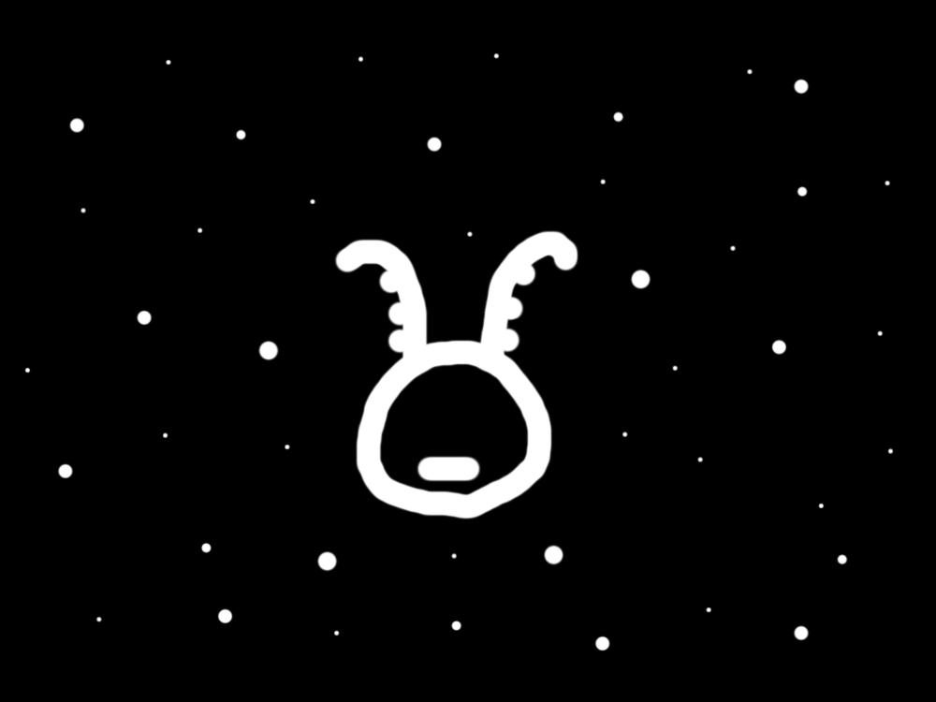
(After Episode 14)

AUDIO LOG

Bellow:
No, no, no, no, this isn’t happening…
But it clearly is, I saw it with my own eyes!
How could that man be Zach’s father???
And then those blasted criminals took them both away!
They’re going to be trapped together for a while…
I can’t let that happen.
I WON’T let that happen.
But then, what’s going to happen to my parents?
Not important, Zach comes first.
But does he? Isn’t family the most important?
Zach IS family.
Maybe not in the traditional sense, but…
I have to get out there.
I don’t even know where they went…
…
…
*While Quietly Crying:* What am I supposed to do?

END OF AUDIO LOG

In the night sky, a warrior declares his triumph despite all odds…



