

Department of Computer Engineering & Technology

CSE

Capstone Project Synopsis - Level 2

Group No: | Students names | PRN | Email, Mobile number | Panel | Sign of student
P91 | Ibrahim Ansari | 1032233145 | 8087155155 | B
P91 | Chayan Raj Bharati | 1032233134 | 8876022414 | B
P91 | Omkar Darekar | 1032232336 | 8605204831 | A

Name of Guide : Dr. Pratvina Vinayak Talele

Project Title: Distributed Server Process Manager with Containerisation

Project Domain: Cloud Computing, Distributed Systems, DevOps
Name of the Company (for Industry Supported Project only): _______________________________________________
Name of the External Guide (for Industry Supported Project only):

Inhouse project : Yes / No : Yes
Name of Company if Sponsored :

Abstract:
Managing many long-running server applications across several machines is manual and error-prone. Simple process managers run applications as bare operating-system processes, with no isolation and no resource limits, and they control only one machine at a time.
The proposed system is a distributed server process manager written in Go, with a Docker-based execution backend: each managed application runs in a container with CPU and memory limits, a persistent data volume, and a restart policy. Two to three peer nodes share user sessions through a common Redis instance, so one login works on all nodes. The system gives one HTTP API, a live WebSocket console, file management, per-node resource monitoring, node health tracking, and least-loaded placement of new applications, all managed from one central web dashboard.

Project Objectives for Team (at-least 4 Objectives)
- Design the overall architecture: configuration model, HTTP API, and Redis-based multi-node session sharing, and document the design baseline.
- Design and implement a container execution backend: map each app definition to a Docker container (image, command, data volume, CPU and memory limits, restart policy) through the Docker Engine API.
- Implement lifecycle control (start, stop, restart, kill), a live WebSocket console, and file management, exposed through one HTTP API for the dashboard and the CLI.
- Add per-node resource metrics, node health tracking, and a least-loaded scheduler that places each new application on the best node.
- Build a web dashboard with a cluster view (nodes, health, per-container metrics, placement) and measure container overhead against bare processes.
Individual Project Objectives per Team member [ ie. Team member contribution towards the mentioned objectives ]
- Ibrahim Ansari: agent core and container lifecycle. App-to-container mapping, start/stop/restart, volumes, resource limits (Objective 2).
- Chayan Raj Bharati: authentication, API, and dashboard. Redis shared sessions, HTTP API and WebSocket console, cluster-view and placement screens (Objectives 1, 3, 5).
- Omkar Darekar: monitoring and scheduling. Node metrics, health checks, least-loaded scheduler, integration tests and benchmarks (Objectives 4, 5).

H/w & S/w Requirements:
Hardware
- Laptop/Desktop (8 GB RAM minimum), multi-core processor
- Two to three machines, physical or virtual (nodes)
- LAN / Internet connection
Software
- Ubuntu Linux 24.04
- Go (1.22+) for the node agent
- Docker Engine and Docker Engine API (Go SDK)
- Redis 7 for shared authentication
- Node.js and Next.js/React for the web dashboard
- REST + WebSocket APIs, Git, VS Code
High Level Design [Architecture diagram/block diagram] and its working
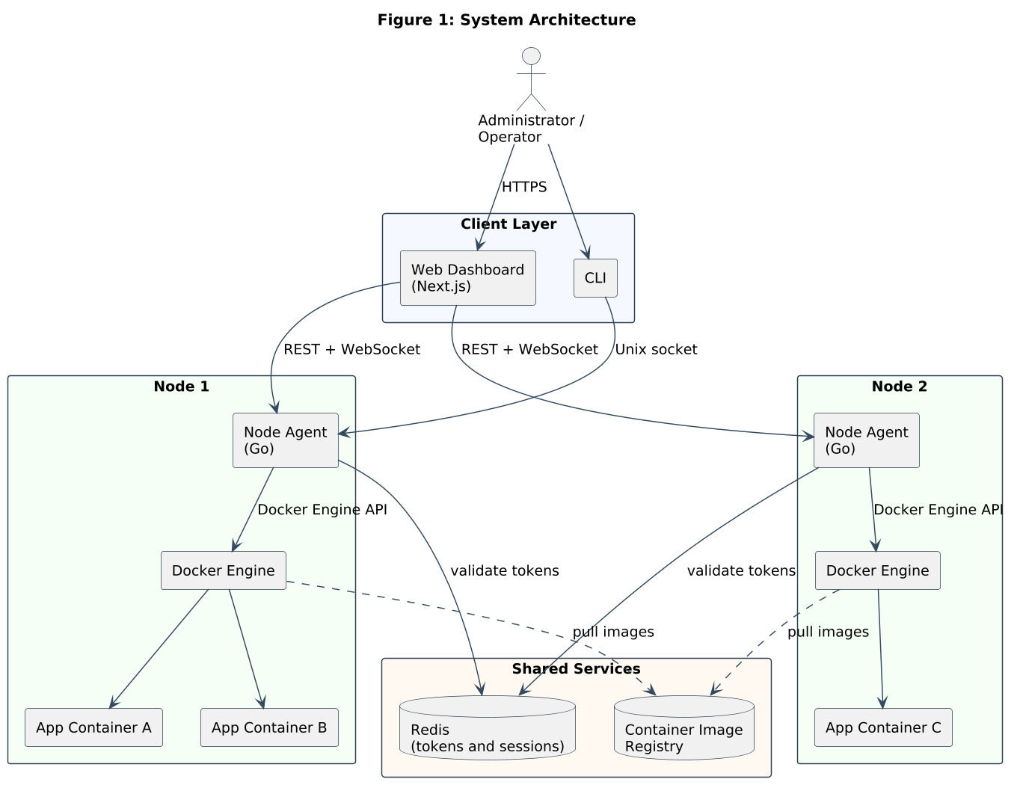
Working: Every node runs the same agent; user sessions are shared through a common Redis instance, so one login works on all nodes. The agent maps every app definition to a Docker container with resource limits, a persistent volume, and a restart policy, and drives it through the Docker Engine API. The dashboard and the CLI use one HTTP and WebSocket API for start/stop, live console, and files. A monitoring endpoint reports CPU, memory, and health for each node, and the scheduler places each new application on the least-loaded healthy node.

Name & Sign of the Guide : Dr. Pratvina Vinayak Talele

