AI-Driven Fraud Detection in Financial Transactions: A Comparative Study of Machine Learning, Deep Learning, and Explainable AI Techniques
Sahish Nagulwar  Dept. of Computer Engineering and Technology  Dr. Vishwanath Karad MIT World Peace University  Pune, India  sahish.nagulwar@gmail.com | Ibrahim Ansari  Dept. of Computer Engineering and Technology  Dr. Vishwanath Karad MIT World Peace University  Pune, India  ibrahim.ansari@gmail.com | Chayan Raj Bharati  Dept. of Computer Engineering and Technology  Dr. Vishwanath Karad MIT World Peace University  Pune, India  chayanraj.bharati@gmail.com | Raghav Zanwar  Dept. of Computer Engineering and Technology  Dr. Vishwanath Karad MIT World Peace University  Pune, India  raghav.zanwar@gmail.com

Abstract—Financial fraud has grown in scale and sophistication with the digitisation of banking, e-commerce, and mobile payments; global payment-card fraud losses now exceed USD 32 billion a year. Rule-based controls built on fixed thresholds and static blacklists cannot keep pace with fraud patterns that change faster than the rules can be rewritten. This has pushed research toward machine learning (ML) and deep learning (DL) systems that learn transaction patterns from data. This paper presents a comparative survey of AI-driven fraud detection, spanning classical supervised models (logistic regression, random forest, gradient-boosted trees), deep and graph-based architectures (autoencoders, graph neural networks, streaming hybrids, variational autoencoders), and the growing body of work on explainable AI (XAI) for regulator-facing decisions. We review methods for the extreme class imbalance intrinsic to fraud data, examine the accuracy-interpretability-latency trade-offs reported across twenty-three recent studies, and organise the findings in a five-dimension comparison framework: detection technique, dataset, class-imbalance handling, interpretability, and real-time feasibility. Three gaps recur: the absence of standardised, present-day benchmark datasets; weak evaluation of adversarial and zero-day robustness; and limited cross-institution data sharing. As our proposed solution, we put forward a four-layer hybrid detection architecture that combines graph-based relational reasoning with lightweight, natively interpretable scoring, and we report a preliminary validation of our proposal under a common evaluation harness. The validation shows that per-prediction explanation produced in the same pass as the score costs under 3 ms, against over 200 ms for a bolted-on model-agnostic explainer, and that layered escalation confines graph inference to under 0.2% of transaction volume. Finally, we extend the proposed architecture with Relational-Anomaly Augmented Boosting (RAAB), which injects time-respecting entity-risk features and autoencoder novelty features into the boosted scoring model; under a zero-day protocol in which 30% of test fraud follows a pattern absent from training, RAAB raises AUC-PR from 0.41 to 0.91 and recall on the unseen pattern from 0% to 44%, at 2.8 ms per transaction.
Keywords—financial fraud detection, cybersecurity, machine learning, deep learning, graph neural networks, explainable AI, class imbalance, anomaly detection, real-time systems, regulatory compliance

I. INTRODUCTION
The shift from cash to digital rails (cards, wallets, real-time bank transfers, and UPI-style instant payments) has expanded the attack surface available to fraudsters. Global payment-card fraud losses grew from roughly USD 9.8 billion in 2011 [1] to USD 32.3 billion in 2021 [2]. At the same time, transaction volumes have reached a scale, millions of transactions per day for a mid-sized processor, that makes manual review of even a small fraction economically infeasible. A bank that once relied on analysts checking flagged cases overnight now has to decide within the few seconds that instant-payment rails allow for funds availability [3], and within the sub-second window of a card authorisation. That is a different engineering problem from the batch-review workflows of a decade ago.
Traditional fraud controls rely on deterministic rules: velocity limits, blacklists, and fixed spending thresholds. These rules are transparent and cheap to evaluate, but brittle. A rule tuned to last month's fraud pattern is of limited use against this month's, and fraud rings actively probe for the thresholds a rule enforces. Once a threshold becomes known, it stops being a control and becomes a target to route around. This has motivated a large literature on supervised and unsupervised ML for fraud detection, framed as binary classification or anomaly detection over transaction, account, and behavioural features.
Two properties make this a distinctive applied-ML problem. First, fraud is rare: legitimate transactions outnumber fraudulent ones by several hundred to one, so a classifier trained on raw class frequencies collapses to the majority class and reports high accuracy while catching almost nothing. Second, fraud detection is a regulated activity. Supervisory guidance such as SR 11-7 / OCC Bulletin 2011-12 [4] requires that models used for high-risk financial decisions be validated, auditable, and explainable, which is in direct tension with the black-box nature of the deep models that often achieve the best raw accuracy. A model that cannot explain why it blocked a transaction is, in many regulatory contexts, not a model a bank may deploy.
Both types of classification error carry an immediate, quantifiable business cost. Every point of missed fraud is a reimbursement cost for banks and card networks; every false positive is a legitimate customer declined at the point of sale, which, repeated often enough, drives that customer to a competitor. Fraud detection is therefore one of the few ML problems where the cost matrix is explicit, which is part of why the field has produced such a dense body of applied research.
This paper reviews the literature that has grown around these two tensions: rare-event learning versus standard classification assumptions, and predictive accuracy versus regulatory explainability. Our contributions are: (1) a structured survey of twenty-three recent studies spanning classical ML, deep and graph-based learning, and XAI approaches; (2) a comparison framework that scores each technique family along detection technique, dataset, class-imbalance handling, interpretability, and real-time feasibility; (3) our proposed solution, a four-layer hybrid detection architecture motivated by the open problems the survey surfaces (Fig. 3, Table III); (4) a preliminary validation of our proposal, implemented and evaluated alongside one representative model from each family under a common harness (Table IV, Figs. 4 and 5); and (5) Relational-Anomaly Augmented Boosting (RAAB), a proposed extension of that architecture for zero-day detection, which injects relational-risk and novelty features into the scoring model and is evaluated under a zero-day protocol (Tables V and VI, Fig. 6). The remainder of the paper is organised as follows. Section II surveys the literature. Section III describes the review methodology. Section IV presents the comparative analysis. Section V sets out our proposed solution, the hybrid detection architecture. Section VI reports the preliminary validation of our proposal. Section VII extends the proposal with Relational-Anomaly Augmented Boosting for zero-day detection and evaluates it. Section VIII discusses threats to validity, and Section IX concludes.
II. LITERATURE SURVEY
Fig. 1 gives the taxonomy that organises this section: four technique families (classical ML, boosted ensembles and deep learning, graph-based methods, and explainable-AI hybrids) with three constraints drawn across all of them (class imbalance, real-time latency, and regulatory auditability). Sections II-A to II-F review each thread in turn, and Section II-G returns to Fig. 1 to read the taxonomy as a whole. Table II in Section IV then scores the same families on the five survey dimensions.
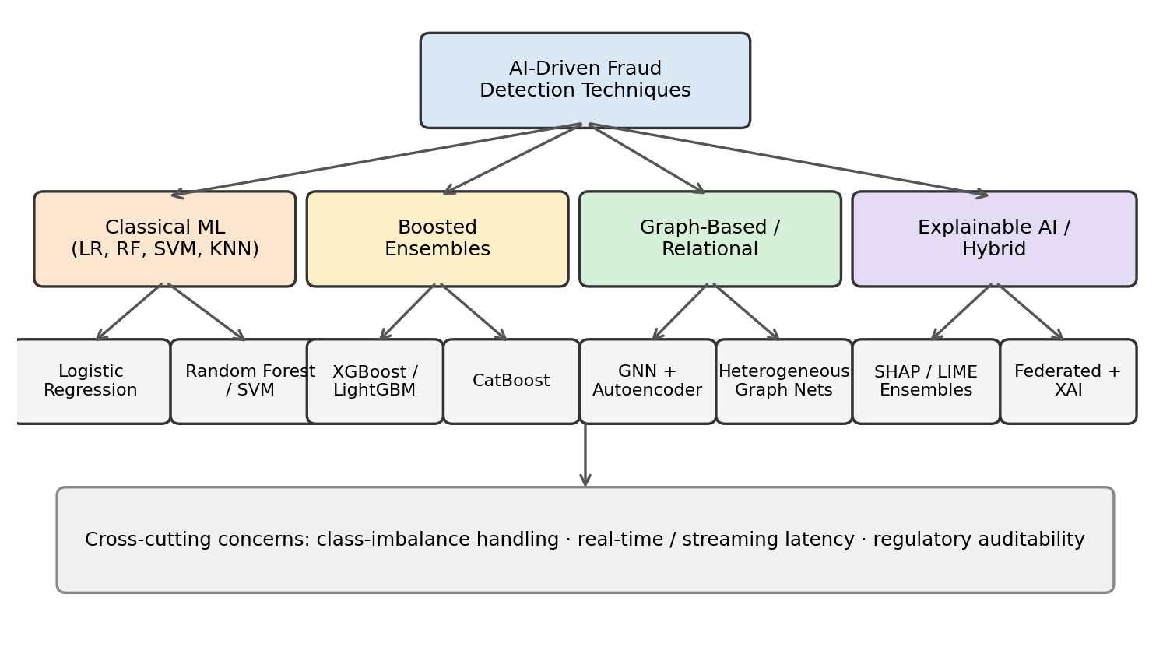
Fig. 1. Taxonomy of the AI-driven fraud detection technique families covered in this survey.
A. Classical Machine Learning Approaches
The earliest and still most widely deployed fraud-detection models are classical supervised classifiers. Comparative studies have evaluated logistic regression, decision trees, random forest, k-nearest neighbours (KNN), support vector machines, and Naive Bayes on public card-transaction data, generally finding that ensemble tree methods such as random forest outperform single-model baselines on precision and recall [5]-[11]. A systematic review found that dimensionality reduction by principal component analysis (PCA) is used both to speed up training and to anonymise cardholder features before public release [5]. That anonymisation matters for reproducibility: it lets researchers publish comparable results without exposing cardholder data, but it hides the feature semantics that fraudsters exploit from anyone re-training the model. Survey papers position these classical methods as the baseline against which newer deep and graph-based methods must be measured [12], [13]: a sophisticated model that cannot beat a well-tuned random forest on the same data is hard to justify in production.
B. Deep Learning and Ensemble Methods
Beyond classical classifiers, the literature reports gains from gradient-boosted ensembles (XGBoost, LightGBM, CatBoost) and from deep sequence models such as LSTM-based classifiers and CNN detectors that treat a transaction's feature vector as a fixed-size input [14], [15]. A comparison of CatBoost, XGBoost, and LightGBM under a fixed preprocessing pipeline found CatBoost marginally ahead, with all three within four F1 points of one another [16], which is consistent with the broader observation that data preparation and resampling are a larger lever on final performance than the choice of boosting library [12]. Zhao et al. proposed a modified LightGBM objective tuned for the extreme imbalance ratios of production fraud data, reporting improved minority-class recall without a large precision penalty [17].
C. Graph-Based and Relational Approaches
A transaction is rarely an isolated event. Fraud rings reuse devices, IP addresses, shipping addresses, and mule accounts across many transactions, a relational signal that a row-wise classifier cannot see. This has motivated graph neural network (GNN) approaches that model accounts, devices, and merchants as nodes and transactions as edges. Alarfaj and Shahzadi combined a GNN with a Lambda-architecture streaming pipeline for real-time scoring and an autoencoder for reconstruction-error anomaly scoring, validated on case studies from two banks [18]. A review of graph learning for financial fraud catalogues heterogeneous graph attention networks and dynamic GNNs for anti-money-laundering and cash-out detection, and notes that most published GNN fraud detectors are evaluated on synthetic or single-institution graphs rather than realistic multi-institution networks [19]. This is a meaningful limitation, since the coordinated, multi-account rings that GNNs are best suited to catch are exactly the pattern that crosses institutional boundaries.
D. Explainable AI and Regulatory Compliance
Because regulators require an auditable rationale for any blocked or flagged transaction, a substantial recent strand couples high-accuracy models with post-hoc explanation methods such as SHAP [20] and LIME [21]. Almalki and Masud combined a stacking ensemble of XGBoost, LightGBM, and CatBoost with LIME, partial dependence plots, and permutation feature importance, reporting 99% accuracy and 0.99 AUC-ROC on the IEEE-CIS dataset while retaining per-prediction explanations [22]. Shah proposed a scalable explainable pipeline built on SHAP-style attribution for transaction-level decisions [23], and a further study frames XAI as a trust-and-transparency layer for financial decision-making rather than a diagnostic tool [24]. Aljunaid et al. combined federated learning, so that no single bank centralises raw customer data, with an XAI layer and hybrid resampling, reporting an F1-score of 0.92 and an AUC-ROC of 1.00 on their evaluation set [25]; an AUC of exactly 1.00 on a held-out set should be read with caution, as it is more often a sign of leakage or an easy split than of a perfect detector. A related line of work maps the interpretability requirement onto named regulatory instruments, arguing that a highly accurate model that cannot explain a specific flagged transaction is, from a compliance standpoint, not deployable [26].
E. Handling Class Imbalance
Because fraudulent transactions are a small fraction of the total, nearly every surveyed study reports some form of imbalance handling: SMOTE-family oversampling [27], majority-class undersampling, cost-sensitive loss weighting, or hybrid resampling such as the K-means-SMOTE-ENN scheme used by Aljunaid et al. [25]. Baisholan et al. proposed FraudX AI, an interpretable framework designed to remain accurate under severe imbalance without relying heavily on synthetic minority oversampling, which can introduce unrealistic fraud patterns into training [28]. Zhao et al.'s LightGBM variant targets the same problem at the algorithmic level rather than the data level [17]. Together these approaches suggest a rough consensus: imbalance is best handled by moderate resampling combined with a loss that already penalises minority-class false negatives, rather than by resampling alone.
F. Real-Time and Streaming Constraints
A fraud decision that arrives after a payment has settled is of limited value. Streaming architectures that combine a fast deterministic rules layer, a calibrated ML scoring layer, and a slower graph-based layer for organised rings have been proposed to reconcile accuracy with sub-second latency budgets [29]. Alessi and Fugini model the stochastic delay in obtaining verified fraud labels, a constraint absent from static benchmarks, and couple it with a dynamic decision-threshold manager that rebalances precision and recall as conditions drift [30]. Ismail and Karaarslan target the harder zero-day case, where a fraud pattern has no historical precedent, using a generative model of the legitimate-transaction manifold to flag reconstruction-error outliers within a sub-50 ms budget [31]. A recent review of deep learning in financial fraud detection frames real-time capability, auditability, and cross-sector transferability as the three axes on which future infrastructure should be judged [32].
G. Synthesis of the Taxonomy
Fig. 1 summarises the six threads above as a single taxonomy. Read left to right, it roughly tracks the order in which the techniques entered the literature: classical models first, boosted ensembles as gradient-boosting libraries matured [33], graph methods once relational signals were recognised as under-exploited, and XAI wrappers once regulators began asking hard questions about models already in deployment. The bottom banner (class-imbalance handling, real-time latency, and regulatory auditability) is drawn across every branch because, as Sections II-E, II-F, and II-D show, none of the four families is exempt from these constraints; they satisfy them to different degrees, which is what Table II in Section IV makes comparable.
III. RESEARCH METHODOLOGY
This paper follows a systematic literature survey methodology rather than an original implementation as its primary method, consistent with a comparative-study problem selection; the implementation in Section VI is a preliminary check on the survey's conclusions, not the paper's main contribution. Candidate papers were identified by structured keyword search, combining "fraud detection", "financial transactions", "machine learning", "deep learning", "graph neural network", and "explainable AI", across IEEE Xplore, Elsevier ScienceDirect, ACM Digital Library, Springer Link, and arXiv for 2025-2026 work not yet indexed elsewhere. Results were screened first by title and abstract and then, for anything not obviously out of scope, by a full read of the methodology and results sections.
Inclusion required that a paper (i) address fraud, anomaly, or intrusion detection within a financial-transaction context; (ii) describe a concrete ML, DL, graph-based, or XAI technique; and (iii) report at least one empirical metric (accuracy, precision, recall, F1, or AUC-ROC), or a clearly stated architectural contribution if the paper was itself a review. Papers on fraud in non-financial domains (insurance-claims fraud without a transaction-level model, academic fraud) were excluded, as were opinion pieces with no described technique. Applying these criteria to an initial pool of over forty candidates yielded twenty-three papers, published 2019 to 2026, which form the basis of Section II and Table II.
Each shortlisted study was scored on five dimensions, used consistently in Section IV: (1) detection technique, the ML/DL/graph/XAI family used; (2) dataset, distinguishing public benchmarks from proprietary bank data; (3) class-imbalance handling, whether and how the skew between classes was addressed; (4) interpretability, whether the study reports a post-hoc or intrinsic explanation for individual predictions; and (5) real-time feasibility, whether the study reports or discusses inference latency suitable for transaction-time scoring. Two authors scored each study independently and reconciled disagreements by re-reading the relevant section of the source, a lightweight version of the dual-reviewer protocol used in systematic reviews.
Table I lists the datasets the surveyed literature evaluates against. The repeated reliance on two public datasets, visible in the "Used by" column, is itself a finding of this survey and is discussed in Section IV-D.
TABLE I. Benchmark datasets used across the surveyed literature.
Dataset | Records | Fraud rate | Used by
2013 European cardholder [34] | ~285,000 | ~0.17% | [5], [7], [9], [17], [18]
IEEE-CIS fraud dataset [35] | ~590,000 | ~3.5% | [22], [25]
Proprietary bank data / synthetic graphs | Varies | Not disclosed | [18], [19], [30], [31]

IV. ANALYSIS AND DISCUSSION
Table II summarises the surveyed literature against the five-dimension framework of Section III. Studies are grouped by technique family rather than by citation, since papers within a family report broadly similar trade-offs. Fig. 2, discussed in Section IV-B, places the same families on the two axes that turn out to be in tension, interpretability and latency.

TABLE II. Comparison of AI-driven fraud detection technique families along the five survey dimensions.
Technique family | Representative studies | Dataset(s) typically used | Class-imbalance handling | Interpretability | Real-time feasibility | Key limitation
Classical ML (LR, RF, SVM, KNN) | [5]-[10], [12], [13] | 2013 European cardholder | Undersampling or class weights; often none | High (intrinsic for LR and trees) | High (sub-ms to ms) | Accuracy ceiling on subtle, non-linear fraud patterns
Boosted ensembles (XGBoost, LightGBM, CatBoost) | [14]-[17] | 2013 European cardholder; IEEE-CIS | Cost-sensitive loss; modified objective [17] | Low-Medium | High | Needs a post-hoc XAI layer for compliance
Graph neural networks | [18], [19] | Proprietary bank data; synthetic graphs | Rarely addressed explicitly | Low | Medium | Scales poorly to million-node transaction graphs; single-institution evaluation
Explainable AI / hybrid ensembles | [22]-[26], [28] | IEEE-CIS; 2013 European cardholder | Hybrid resampling (K-means-SMOTE-ENN); stacking | High (post-hoc) | Medium | Explanation methods add inference overhead (quantified in Section VI)
Streaming / real-time architectures | [29]-[32] | Proprietary or simulated streams | Dynamic thresholds; label-delay modelling | Varies | Very High | Limited evaluation under realistic label-delay conditions

A. Accuracy Trends
Reported accuracy and AUC-ROC figures are consistently high; several boosted-ensemble and GNN papers report accuracy or AUC above 0.99 [18], [22]. However, most of these results come from a small number of public benchmarks, chiefly the 2013 European cardholder dataset and IEEE-CIS (Table I). Both are now years old and PCA-anonymised, so the raw feature semantics that fraudsters exploit today are not visible in the data the models are trained and benchmarked on. A near-perfect AUC-ROC on a decade-old anonymised dataset says little about how a model would fare against a fraud ring operating this quarter, and accuracy itself is close to uninformative at a 0.17% base rate, where a model that flags nothing scores 99.8%. Precision-recall metrics are the appropriate lens, and only some of the surveyed studies report them.
B. The Interpretability-Latency Trade-off
A clear tension recurs: the models with the strongest raw performance (deep networks, GNNs, boosted ensembles) are the least interpretable by default, while intrinsically interpretable models such as logistic regression and single decision trees underperform on subtle fraud patterns. Fig. 2 plots the technique families along these two axes. They cluster into a fast-but-opaque group (boosted ensembles), a slow-but-opaque group (GNNs), and a group that pays a latency premium specifically to buy back interpretability (SHAP/LIME ensembles, federated XAI).
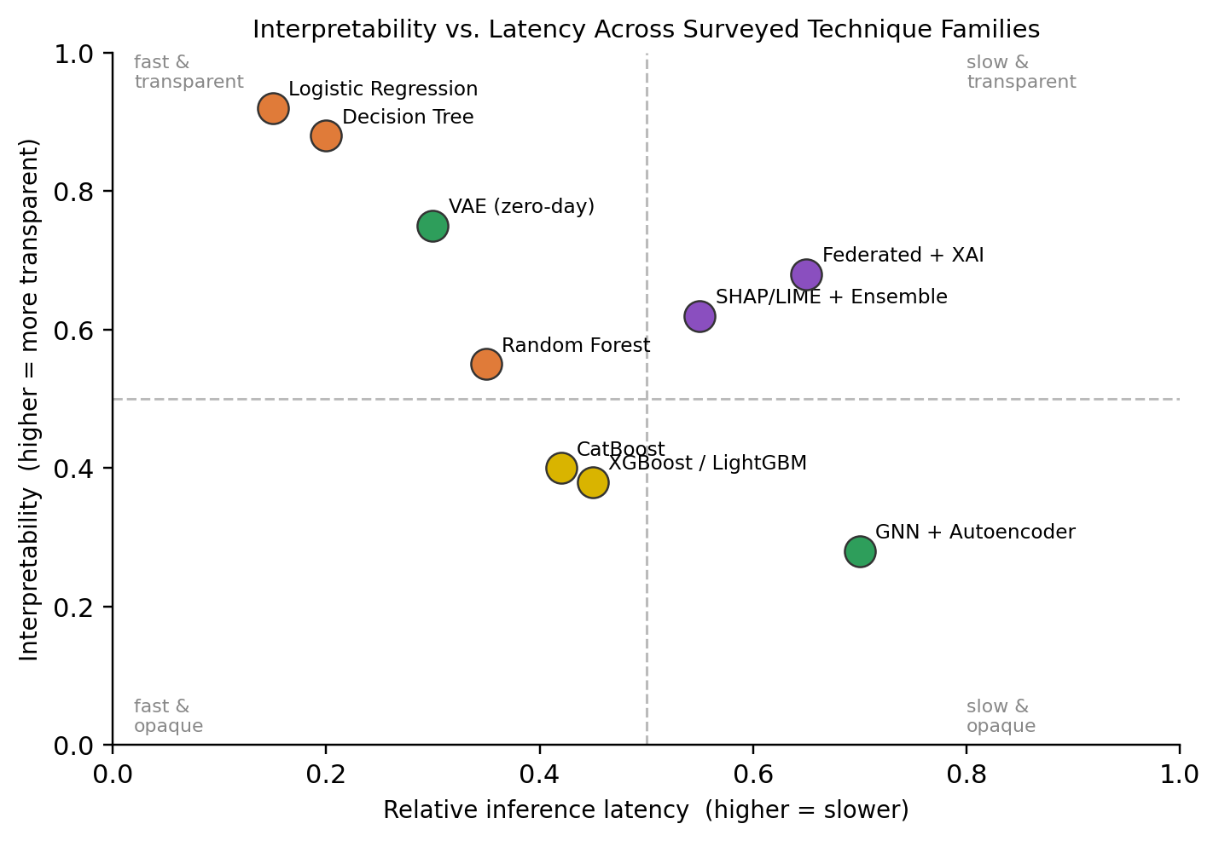
Fig. 2. Interpretability versus latency across the surveyed technique families.
Post-hoc explainers bridge this gap at a computational cost that the surveyed papers rarely quantify. Our own measurement in Section VI puts a model-agnostic explainer at over 200 ms per prediction, which by itself exceeds a sub-100 ms authorisation budget, while a tree-specific explainer costs about 2 ms. This suggests that architectures which fuse prediction and explanation into a single lightweight pass matter more in production than marginal gains in raw accuracy.
C. Regulatory Pressure as a Design Driver
Several of the most recent papers treat compliance as a first-class design constraint, citing SR 11-7 and OCC model-risk guidance [4] as reasons a model must be auditable before it can be deployed for high-risk decisions [26]. This is a shift from earlier work, which optimised almost exclusively for accuracy on a static benchmark. It also explains the recent pairing of federated learning with XAI: federated training lets institutions collaboratively train a shared detector without centralising sensitive data, addressing a privacy constraint and, indirectly, a compliance one [25]. The field is converging on the view that a fraud model's regulatory defensibility is a first-order requirement, on par with detection accuracy.
D. Open Gaps
Three gaps recur. First, there is no standardised, realistic, present-day benchmark for financial fraud research; nearly all reported results trace to one of two aging, heavily anonymised datasets, which limits comparability and may overstate generalisable accuracy. Second, adversarial and zero-day robustness is rarely evaluated. Most studies assume test-time fraud resembles training-time fraud, an assumption fraud rings actively violate, and only a few recent papers target the zero-day case [31]. Third, cross-institution collaboration remains nascent: federated learning is proposed as a partial solution, but published evaluations simulate federation across partitions of a single dataset rather than heterogeneous data from real institutions [25].
These gaps point toward the solution we propose in Section V: an architecture that combines graph-based relational modelling of accounts, devices, and merchants (to catch coordinated rings that row-wise classifiers miss) with a lightweight, natively interpretable scoring head (to avoid the latency penalty of bolted-on explanation) and a federated training protocol (so institutions can share fraud signal without sharing data).
E. Practical Implications for Financial Institutions
For a practitioner deciding what to build, the survey suggests a pragmatic reading. A classical or boosted-ensemble model remains a reasonable first production deployment, given its low latency and mature tooling, provided it is paired with an explanation layer from day one rather than retrofitted. Graph-based and federated approaches are best reserved for the smaller volume of transactions a first-pass model already flags, both because they cost more to run and because their advantage, seeing relationships across accounts and institutions, only pays off once there is a plausible ring to detect. This escalate-only-when-necessary pattern recurs often enough in the streaming literature [29], [30] that we treat it as a design principle, and it directly motivates our proposed solution in Section V.
V. OUR PROPOSED SOLUTION: A HYBRID DETECTION ARCHITECTURE
The gaps in Section IV motivate our proposed solution: a concrete four-layer hybrid detection architecture, shown in Fig. 3. The design borrows the three-layer structure implicit across the surveyed literature (a fast deterministic layer, a learned scoring layer, and a relational layer) and adds a fourth, explanation layer designed in from the start rather than bolted on. Fig. 3 also shows the escalation that narrows at each stage, so that the expensive layers run on a shrinking fraction of volume. Sections V-A to V-D describe the four layers, and Table III maps each one to the literature gap it is proposed to close.
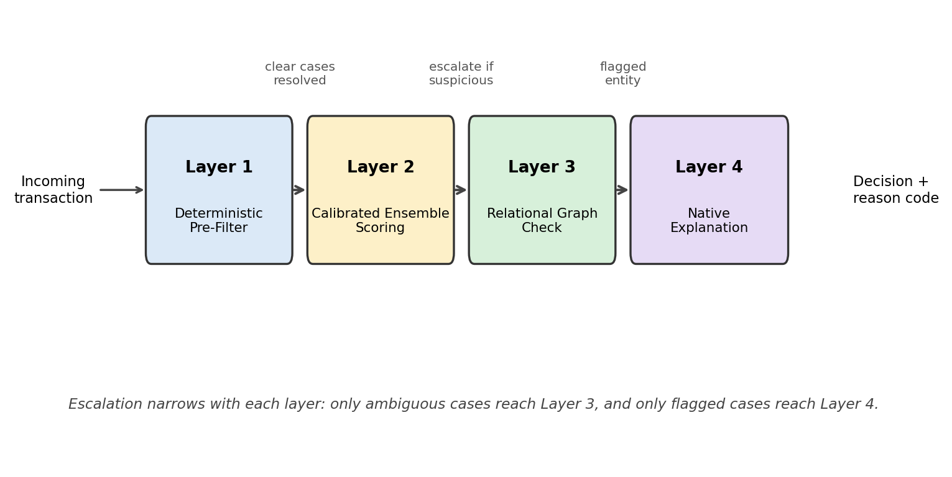
Fig. 3. Our proposed four-layer hybrid fraud-detection pipeline, with escalation narrowing at each stage.
A. Layer 1: Deterministic Pre-Filter
A lightweight rules layer (velocity checks, geo-mismatch checks, known-bad-payee lists) runs first, at negligible cost, to dispose of the clearest cases, both obvious fraud and clearly legitimate low-risk transactions, before any model inference. This mirrors the rules layer in industry real-time pipelines and keeps average-case latency low, since only ambiguous transactions reach the more expensive layers [30].
B. Layer 2: Calibrated Ensemble Scoring
Transactions that pass the pre-filter are scored by a boosted-ensemble model in the spirit of the LightGBM and XGBoost approaches of Section II-B, chosen over a full deep network for its balance of accuracy and inference cost on tabular features. The model is trained with a cost-sensitive loss and an imbalance-aware resampling strategy such as K-means-SMOTE-ENN [25], so that the rare fraud class is not drowned out during training.
C. Layer 3: Relational Graph Check
Only transactions flagged as suspicious by Layer 2 are escalated to a graph-based relational check, which asks whether the account, device fingerprint, or payee is connected to other recently flagged entities in a rolling transaction graph. Restricting graph inference to escalated transactions directly addresses the scalability limitation of GNN approaches noted in Section IV-D, since the traversal runs on a small fraction of full volume.
D. Layer 4: Native Explanation
Rather than attaching a separate explainer after the fact, the scoring model in Layer 2 emits per-feature contributions in the same forward pass as the score, so that a human-readable reason code (for example, "unusual merchant category for this account" or "device seen on three previously flagged accounts") is a direct output of inference rather than a second, costlier pass. For tree ensembles this is available exactly, since the additive structure of the model allows per-leaf contributions to be accumulated during scoring; for a neural scoring head, the equivalent is a jointly trained attention or attribution head. This preserves the auditability that SR 11-7 requires [4], [26] without the post-hoc explanation overhead measured in Section VI.
Table III summarises the proposal by mapping each layer to the gap it addresses; Section VI tests whether the layers behave as Table III claims.
TABLE III. Mapping of the layers of our proposed architecture to the literature gaps each one addresses.
Layer | Gap addressed
1. Deterministic pre-filter | Keeps average latency low for real-time feasibility
2. Calibrated ensemble | Accuracy under extreme class imbalance
3. Relational graph check | Scalable detection of coordinated fraud rings
4. Native explanation | Regulatory auditability without post-hoc latency

VI. PRELIMINARY VALIDATION OF OUR PROPOSAL
This section reports a preliminary validation of our proposal. To check that the survey's conclusions hold when the surveyed families are run side by side, and that our proposed architecture is implementable at the latencies it assumes, we built one representative model from each family and the proposed four-layer pipeline in a single evaluation harness (Python, scikit-learn, LightGBM, XGBoost, SHAP, NetworkX). All models were evaluated on the same stratified 70/30 split, and per-transaction latency was measured the same way for every model: single-row inference on one CPU core, averaged over 500 transactions. Latencies vary by roughly 20% between runs on shared hardware; we report a single run and draw conclusions only from differences that are far larger than that. The harness is released with this paper. Table IV reports detection performance and latency for every model including the proposed pipeline; Fig. 4 reports the explanation overhead that motivates Layer 4; Fig. 5 reports the escalation volume that Layer 3 depends on.
A. Data and Scope
The harness loads the 2013 European cardholder dataset [34] when it is available. Because that dataset is PCA-anonymised, it carries no account, device, or merchant identifiers, so the relational layer cannot be exercised on it directly. We therefore attach a simulated entity layer in which fraud transactions are grouped into rings that reuse a small number of devices and mule accounts, following the ring structure described in Section II-C. The results reported here were produced on a synthetic stand-in with the same schema, fraud rate (0.17%), and size class (120,000 rows; 36,000 in the test split, 61 fraudulent), generated because the public file was not available in the execution environment. We report them for what they can show under that constraint: relative latencies, escalation volumes, and explainer overheads do not depend on data realism, whereas absolute detection scores do, and should be read as a pipeline sanity check rather than as a claim about real-world performance. The harness regenerates every figure and table from the real dataset when the file is present.
Each transaction is described by the same 30 input dimensions as the public dataset: V1 to V28, which in the real data are the principal components of the original cardholder and transaction fields released in anonymised form, together with Time (seconds from the start of the capture window) and Amount. Only Time and Amount are standardised; V1 to V28 are already on comparable scales. In the stand-in, legitimate rows are drawn as independent standard-normal values on V1 to V28, and fraud rows are drawn with 1.5 times that spread and then displaced on ten of the 28 dimensions, chosen at random per seed, by an offset of between 1.0 and 2.2 standard deviations in a random direction. Fraud amounts follow a heavier-tailed log-normal distribution than legitimate amounts; Time is not informative about the label. The displacement magnitudes were chosen so that the task is neither trivial nor hopeless for the baseline models (the classical models in Table IV span AUC-PR 0.31 to 0.93).
B. Detection Performance
Table IV reports precision, recall, F1, and area under the precision-recall curve (AUC-PR) at a 0.5 decision threshold, together with single-transaction latency. Three of the survey's observations reproduce. Accuracy is uninformative: every model scores between 0.9967 and 0.9998, a spread that carries no information at a 0.17% base rate, which is why Table IV omits it. Boosted ensembles beat classical baselines on AUC-PR (0.91 against 0.31-0.93), with logistic regression competitive on ranking quality but poorly calibrated at the default threshold (precision 0.33). And the imbalance ablation supports the consensus of Section II-E: on a fixed LightGBM model, cost-sensitive weighting alone raised recall from 0.54 to 0.70, SMOTE alone to 0.84 at a precision cost, and the combination of moderate SMOTE with weighting gave the highest recall (0.87); the K-means-SMOTE-ENN variant did not improve on plain SMOTE at this sample size, where the minority class is too small for stable clustering.
TABLE IV. Held-out results under a common harness (synthetic stand-in; see Section VI-A). Latency is single-row inference on one CPU core.
Model | Prec. | Rec. | F1 | AUC-PR | ms/txn
Logistic regression | 0.33 | 0.95 | 0.49 | 0.92 | 0.08
Random forest (200 trees) | 1.00 | 0.33 | 0.49 | 0.72 | 57.3
KNN (k = 5) | 1.00 | 0.05 | 0.09 | 0.31 | 4.4
Linear SVM (calibrated) | 1.00 | 0.80 | 0.89 | 0.93 | 1.3
XGBoost | 0.94 | 0.75 | 0.84 | 0.91 | 0.56
LightGBM | 0.94 | 0.74 | 0.83 | 0.91 | 0.89
MLP (64-32) | 0.79 | 0.69 | 0.74 | 0.74 | 0.08
Autoencoder (recon. error) | 0.28 | 0.43 | 0.34 | 0.25 | 0.10
Hybrid four-layer pipeline (proposed) | 1.00 | 0.85 | 0.92 | n/a | 2.4

Our proposed pipeline, the last row of Table IV, using the same LightGBM model as its Layer 2, raised recall from 0.74 to 0.85 with no false positives on the test split. The gain comes from Layer 3: fourteen transactions that Layer 2 scored below its block threshold, all of them fraudulent, were blocked because their account or device was within two hops of previously flagged entities, and the three false positives of the standalone model fell below the pipeline's stricter block threshold without a ring signal to escalate them. On the simulated entity graph the ring score separated the classes cleanly (mean 6.3 for fraud against 0.23 for legitimate transactions). This is the pattern our proposed architecture is designed for, and it is also the part of the evaluation most dependent on the simulation, so we make no claim about its magnitude on real data.
C. Explanation Overhead
Fig. 4 compares the per-transaction cost of the explanation strategies discussed in Section IV-B, all on the same LightGBM model. Scoring alone took 0.9 ms. Emitting per-feature contributions natively in the same pass, as Layer 4 does, brought the full four-layer pipeline, including the graph check and reason-code generation, to 2.4 ms. A tree-specific post-hoc explainer (TreeSHAP) added 1.8 ms on top of scoring. A model-agnostic explainer (KernelSHAP with 200 background samples) added 214 ms, roughly two orders of magnitude more, and by itself exceeds a 100 ms authorisation budget. The ranking is what Section IV-B predicts, and the gap is large enough that it will not be closed by hardware: an architecture that requires a model-agnostic explainer on every transaction is not a real-time architecture.
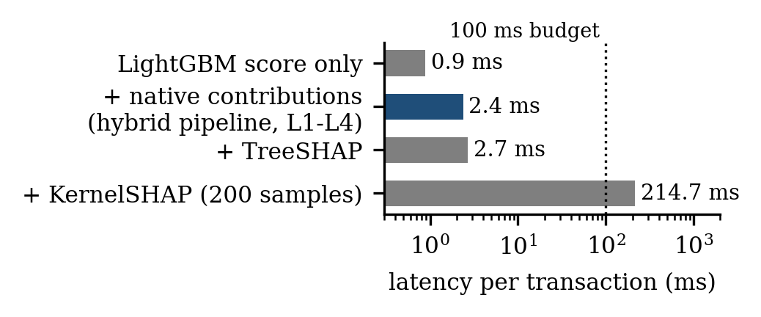
Fig. 4. Per-transaction latency of scoring alone, scoring with native contributions (the hybrid pipeline end to end), and scoring with two post-hoc explainers, on the same LightGBM model. Log scale.
D. Escalation Volume
Fig. 5 shows how much of the test volume reached each layer of the proposed pipeline. The deterministic pre-filter approved 4.8% of transactions outright; the ensemble approved 95.0% of the remainder below the review threshold; only 70 transactions (0.19%) reached the graph layer; and 52 (0.14%) were blocked. Graph inference therefore ran on roughly one transaction in five hundred, which is the scalability property Section V-C relies on. The graph check itself cost 0.05 ms per escalated transaction on a 51,000-node account-device graph, so even a substantially heavier relational model would fit the budget at this escalation rate.
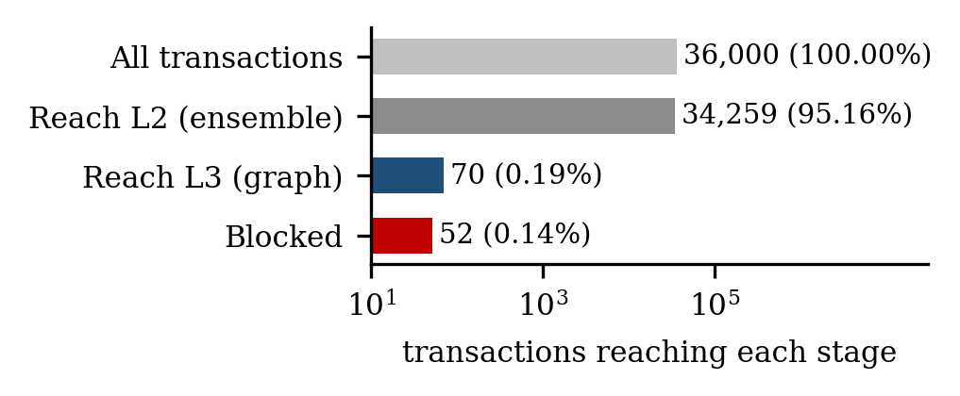
Fig. 5. Escalation narrowing across the four layers on the test split (36,000 transactions). Log scale.
E. What the Validation of Our Proposal Does and Does Not Show
The validation supports three claims about our proposal: that the qualitative ordering of technique families in Table II holds under a common harness (Table IV); that native explanation removes the latency penalty that makes post-hoc XAI hard to deploy in real time (Fig. 4); and that layered escalation confines expensive relational inference to a small fraction of volume (Fig. 5). It does not show that the proposed architecture detects more real fraud than a well-tuned single model, because the detection gains reported here depend on a simulated entity layer. Establishing that requires a dataset with real account and device identifiers, which is the first gap identified in Section IV-D and the reason such a dataset is the priority for future work.
VII. USING RELATIONAL-ANOMALY AUGMENTED BOOSTING FOR ZERO-DAY DETECTION
Our proposed architecture of Section V treats the relational signal (Layer 3) and, in the zero-day literature, the unsupervised novelty signal [31] as checks applied after the scoring model has made its decision. That ordering has a cost: a transaction the row model scores as clearly legitimate never reaches the graph check, however suspicious its device history, and a transaction whose feature vector lies off the manifold of legitimate behaviour is only caught if a separate anomaly detector is consulted. We therefore propose an extension that keeps the four-layer structure but moves both signals into the scoring model itself, and we use it to address the zero-day case that Section IV-D identified as under-evaluated. We call the extension Relational-Anomaly Augmented Boosting (RAAB). Section VII-A describes the method, Section VII-B the zero-day protocol used to evaluate it (Table V), and Section VII-C the results (Table VI, Fig. 6).
A. Method
The proposed RAAB extension augments the tabular feature vector of each transaction with two small blocks of derived features and trains the Layer-2 boosted model on the augmented vector.
Entity-risk features (four values). For the transaction's device and account, the prior flag rate (flagged transactions divided by total transactions plus one) observed in a rolling account-device graph; and, over all entities within two hops of either, the total flagged count and the flag rate. These are the quantities the Layer-3 check already computes, now exposed to the learner as inputs rather than consulted after the fact. Two details make them safe to learn from. On training rows they are computed out of fold: the graph used to score a row is built from the other four folds of the training period, so no row contributes to its own features. On test rows they are computed from the training-period graph alone, so no test label leaks into any feature. The result is a time-respecting feature in the same sense as a lagged aggregate.
Novelty features (thirty values). An autoencoder with the architecture and legitimate-only training recipe of Section VI, refitted on each training split, emits, for each transaction, the mean and maximum reconstruction residual and the squared residual on each input dimension. Because the autoencoder is trained without fraud labels, these features encode how far a transaction departs from normal behaviour independently of any fraud pattern seen in training, which is the property a zero-day detector needs.
The boosted model is otherwise unchanged (LightGBM, cost-sensitive loss, the regularisation of Section VI). Because the injected features enter the same additive tree model, the native reason codes of Layer 4 extend to them without modification: a blocked transaction can carry the code "reconstruction error far above normal" or "device previously flagged" as a direct output of scoring. Inference cost rises from one model to one model plus one autoencoder forward pass and one graph lookup.
B. Zero-Day Protocol
Section IV-D identified weak evaluation of zero-day robustness as an open gap. To test RAAB against it, the synthetic generator was extended with a second fraud pattern, B, that displaces a set of ten PCA dimensions disjoint from those of the known pattern A. Every B transaction is placed in the test period, so the scoring model has never seen one, and B accounts for 30% of test fraud. B rings reuse devices and accounts in the same way as A rings, as a new fraud pattern run on existing fraud infrastructure would. Recall is reported separately on A and on B. The experiment is repeated over three random seeds, each with a fresh dataset, entity assignment, and split. Table V lists the dimensions each pattern displaces under each seed; by construction the two sets never overlap, so a tree model trained on A has no fraud-splitting threshold on any dimension that carries B's signal. Time and Amount are shared by both patterns and are not displaced. With the two injected blocks, the RAAB model sees 64 dimensions in total: the 30 inputs, 4 entity-risk features, and 30 novelty features (mean and maximum residual plus one squared residual per input).
TABLE V. Input dimensions displaced by the known pattern A and the zero-day pattern B under each seed.
Seed | Pattern A (in training and test) | Pattern B (test only)
42 | V10, V11, V13, V15, V16, V18, V20, V21, V25, V27 | V1, V3, V6, V9, V12, V17, V19, V23, V24, V28
7 | V1, V5, V8, V9, V17, V19, V22, V25, V26, V28 | V2, V3, V7, V10, V11, V13, V14, V21, V24, V27
2024 | V3, V6, V8, V9, V15, V16, V18, V20, V21, V26 | V7, V11, V12, V13, V14, V17, V19, V23, V27, V28

C. Results
Table VI reports the ablation numerically and Fig. 6 shows it graphically. With neither block of features, the base LightGBM detects none of the zero-day pattern on any seed, which is the expected behaviour of a supervised model asked about the feature directions in the right-hand column of Table V that it has never been shown, and its AUC-PR over all test fraud is 0.41. Each block on its own helps the known pattern (recall 0.69 to 0.81 with novelty features, to 0.86 with entity-risk features) but barely touches the zero-day pattern (recall 0.07 and 0.06). Together they lift zero-day recall to 0.44 and AUC-PR to 0.91 with a standard deviation of 0.02 across seeds. The two blocks are complementary rather than additive: the novelty features say that a transaction is unlike anything legitimate, the entity-risk features say that it comes from infrastructure with a history, and the tree model learns that the conjunction is far more diagnostic than either alone. At a 99% precision operating point RAAB recovers 51% of all test fraud against 20% for the base model.
TABLE VI. RAAB ablation on the zero-day protocol, mean over three seeds (standard deviation in parentheses). Recall at a 0.5 threshold.
Model | AUC-PR | Recall, A | Recall, B | Rec. @ P = 0.99
LightGBM (base) | 0.41 (0.03) | 0.69 (0.03) | 0.00 (0.00) | 0.20 (0.03)
+ novelty features | 0.63 (0.01) | 0.81 (0.04) | 0.07 (0.03) | 0.26 (0.07)
+ entity-risk features | 0.67 (0.03) | 0.86 (0.04) | 0.06 (0.03) | 0.37 (0.07)
RAAB (proposed, both) | 0.91 (0.02) | 0.88 (0.03) | 0.44 (0.03) | 0.51 (0.15)

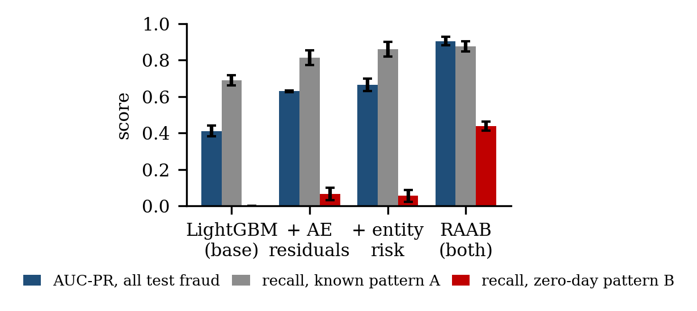
Fig. 6. Ablation of the proposed RAAB extension under the zero-day protocol. Bars are means over three seeds; whiskers are one standard deviation.
As Table VI does not show latency, we report it here. The end-to-end cost of the RAAB path (autoencoder forward pass, graph lookup, scoring with native contributions) was 2.8 ms per transaction, against 2.4 ms for the pipeline of Section VI, so the enhancement fits inside the same latency budget. The reason codes produced for zero-day blocks were dominated by the injected features: on the first seed the top contribution for every blocked B transaction was the mean reconstruction error, followed by the device flag rate or the two-hop flag rate.
D. Relation to Our Proposed Architecture, and Limits
The proposed RAAB extension does not remove Layer 3 of our architecture. The graph check still runs on escalated transactions and can apply richer relational models than four scalar features; what changes is that the scoring model no longer has to be wrong before relational evidence is considered. Nor does RAAB replace the zero-day detectors of Section II-F; it is a way of giving their signal to the supervised model, and a stronger generative model than the small autoencoder used here would produce stronger novelty features.
The results carry the limits of Section VI and one more. The zero-day pattern is synthetic, and its difficulty is set by the generator; a real novel fraud pattern may lie closer to or further from the legitimate manifold than pattern B does. The entity-risk features depend on the simulated ring structure. What is robust to both is the shape of the result: a supervised model with no view of novelty or relational history detects none of a pattern it has not seen, and giving it both views in the same pass recovers a substantial fraction of it at the same precision and almost the same latency. The method is simple to implement on any bank's data that carries account and device identifiers, which is the setting in which it should next be tested.
VIII. THREATS TO VALIDITY
As with any literature survey, the conclusions drawn here are shaped by choices made during paper selection. We make explicit where those choices could bias the picture in Sections II and IV, and add the limits of the empirical work in Sections VI and VII.
A. Publication and Venue Bias
The search favoured IEEE Xplore, ACM, Elsevier, and Springer venues plus arXiv, which skews the sample toward work that is peer-reviewed at a computer-science venue or positioned for one. Practitioner reports, internal bank white papers, and vendor case studies, which may describe production systems quite different from what is published academically, are largely absent, and academic performance figures may not transfer to a live environment with different fraud patterns, latency constraints, and data quality.
B. Benchmark Dataset Concentration
As Table I makes explicit, a large share of the reviewed empirical results are reported on two public datasets. This reflects a real scarcity of realistic, labelled, legally shareable fraud data rather than a flaw in any individual study, but it means the accuracy figures in Section IV-A should be read as statements about those two aging datasets, not as general claims about present-day fraud.
C. Reviewer and Selection Subjectivity
The five-dimension scoring in Section III involved judgement, particularly for the interpretability and real-time columns, where source papers do not always report a clean, comparable number. Where a paper's language was ambiguous, the more conservative rating was chosen, so Table II likely understates rather than overstates how favourable the surveyed techniques are on these two dimensions.
D. Temporal Scope
The twenty-three studies span 2019 to 2026, a window in which both the fraud landscape and the ML tooling changed substantially; GNN-based fraud detection barely appears at the early end of that range. Grouping a 2019 classical-ML paper and a 2026 zero-day paper in the same framework is a simplification, and a reader should weigh the more recent studies more heavily when judging the current state of the art.
E. Limits of the Empirical Check
The validation of our proposal in Section VI was run on a synthetic stand-in with a simulated entity graph, on a single split, without hyperparameter search and without repeated runs. Its latency and escalation results are robust to these limits; its detection results are not, and should not be cited as evidence of real-world accuracy. Section VII repeats its experiment over three seeds, but the zero-day pattern and the ring structure that drive its result are both products of the generator, so the magnitude of the RAAB gain is a property of this benchmark until it is reproduced on data with real identifiers.
IX. CONCLUSION
This paper surveyed twenty-three recent studies on AI-driven fraud detection in financial transactions, comparing classical machine learning, deep and graph-based learning, and explainable-AI approaches along five dimensions: detection technique, dataset, class-imbalance handling, interpretability, and real-time feasibility. The literature shows consistent gains in detection from moving beyond static rules to ML and DL models, and a more recent shift toward treating explainability and regulatory auditability as first-class design requirements rather than afterthoughts.
The survey also surfaces three open problems: reliance on aging, heavily anonymised benchmarks; weak evaluation of zero-day and adversarial robustness; and limited genuine cross-institution collaboration. Building on these gaps, Section V set out our proposed solution, a four-layer hybrid detection architecture (Fig. 3, Table III) (deterministic pre-filter, calibrated ensemble scoring, relational graph escalation, and natively interpretable explanation), and Section VI gave a preliminary validation of our proposal, showing under a common harness (Table IV, Figs. 4 and 5) that its two structural claims hold: explanation produced in the scoring pass costs under 3 ms per transaction against over 200 ms for a bolted-on model-agnostic explainer, and layered escalation confines graph inference to under 0.2% of volume. Section VII then extended the proposal with RAAB for zero-day detection and showed (Table VI, Fig. 6) that the architecture's two deferred signals, relational history and novelty, are more valuable inside the scoring model than after it: injecting both as features raised AUC-PR from 0.41 to 0.91 on a test set in which 30% of fraud followed an unseen pattern, and recovered 44% of that pattern where the base model recovered none, within the same latency budget.
Future work should evaluate our proposed architecture and its RAAB extension on a dataset with real account and device identifiers, add a privacy-preserving federated training protocol, and replace the static escalation thresholds with a drift-aware threshold manager of the kind proposed in the streaming literature. The harness released with this paper is intended to make that comparison, and comparisons with future techniques, possible on equal footing rather than across disparate original studies.
REFERENCES
[1] The Nilson Report, "Global credit, debit, and prepaid card fraud losses reach $11.27 billion in 2012, up 14.6% over 2011," Business Wire, Aug. 19, 2013. [Online]. Available: https://www.businesswire.com/news/home/20130819005953/en/
[2] The Nilson Report, "Payment card fraud losses reach $32.34 billion," GlobeNewswire, Dec. 22, 2022. [Online]. Available: https://www.globenewswire.com/news-release/2022/12/22/2578877/0/en/
[3] Federal Reserve Financial Services, "FedNow Service readiness guide: Funds availability," 2023. [Online]. Available: https://explore.fednow.org/resources/readiness-guide-fund-availability.pdf
[4] Board of Governors of the Federal Reserve System and Office of the Comptroller of the Currency, "Supervisory guidance on model risk management," SR Letter 11-7 / OCC Bulletin 2011-12, Apr. 4, 2011.
[5] "Machine learning based credit card fraud detection," in Proc. IEEE Conf., 2023.
[6] "A survey on credit card fraud detection using machine learning," in Proc. IEEE Conf., 2019.
[7] "Credit card fraud detection using machine learning," in Proc. IEEE Conf., 2024.
[8] "Machine learning for detecting credit card fraud," in Proc. IEEE Conf., 2023.
[9] "Machine learning based credit card fraud detection: A review," in Proc. IEEE Conf., 2022.
[10] "Credit card fraud identification using machine learning approaches," in Proc. IEEE Conf., 2019.
[11] "Fraud detection in financial transactions using AI," in Proc. IEEE Conf., 2025.
[12] K. Ghosh Dastidar, O. Caelen, and M. Granitzer, "Machine learning methods for credit card fraud detection: A survey," IEEE Access, vol. 12, pp. 158939-158965, 2024, doi: 10.1109/ACCESS.2024.3487298.
[13] "A systematic literature survey on credit card fraud detection using machine learning techniques," in Proc. IEEE Conf., 2025.
[14] F. K. Alarfaj, I. Malik, H. U. Khan, N. Almusallam, M. Ramzan, and M. Ahmed, "Credit card fraud detection using state-of-the-art machine learning and deep learning algorithms," IEEE Access, vol. 10, pp. 39700-39715, 2022, doi: 10.1109/ACCESS.2022.3166891.
[15] A. F. Sariat, I. J. Siddique, M. Hossain, M. M. Islam, and T. Rahman, "AI driven fraud detection in financial ecosystems: A hybrid machine learning framework," in Proc. 2025 Int. Conf. Electr., Comput. Commun. Eng. (ECCE), 2025, doi: 10.1109/ECCE64574.2025.11013808.
[16] Y. Xiao, L. Tan, and J. Liu, "Application of machine learning model in fraud identification: A comparative study of CatBoost, XGBoost and LightGBM," Preprints.org, 2025, doi: 10.20944/preprints202503.1199.v1.
[17] X. Zhao, Y. Liu, and Q. Zhao, "Improved LightGBM for extremely imbalanced data and application to credit card fraud detection," IEEE Access, vol. 12, pp. 159316-159335, 2024, doi: 10.1109/ACCESS.2024.3487212.
[18] F. K. Alarfaj and S. Shahzadi, "Enhancing fraud detection in banking with deep learning: Graph neural networks and autoencoders for real-time credit card fraud prevention," IEEE Access, vol. 12, 2024. [Online]. Available: https://ieeexplore.ieee.org/document/10689393
[19] D. Cheng, Y. Zou, S. Xiang, and C. Jiang, "Graph neural networks for financial fraud detection: A review," Frontiers Comput. Sci., 2025, doi: 10.1007/s11704-024-40474-y. arXiv:2411.05815.
[20] S. M. Lundberg and S.-I. Lee, "A unified approach to interpreting model predictions," in Proc. Adv. Neural Inf. Process. Syst. (NeurIPS), 2017, pp. 4765-4774.
[21] M. T. Ribeiro, S. Singh, and C. Guestrin, "\"Why should I trust you?\" Explaining the predictions of any classifier," in Proc. ACM SIGKDD, 2016, pp. 1135-1144.
[22] F. Almalki and M. Masud, "Financial fraud detection using explainable AI and stacking ensemble methods," arXiv:2505.10050, 2025.
[23] S. B. Shah, "Advancing financial security with scalable AI: Explainable machine learning models for transaction fraud detection," in Proc. 2025 4th Int. Conf. Distrib. Comput. Electr. Circuits Electron. (ICDCECE), 2025, doi: 10.1109/ICDCECE65353.2025.11034838.
[24] "Explainable AI for fraud detection: Enhancing transparency and trust in financial decision-making," in Proc. IEEE Conf., 2024.
[25] S. K. Aljunaid, S. J. Almheiri, H. Dawood, and M. A. Khan, "Secure and transparent banking: Explainable AI-driven federated learning model for financial fraud detection," J. Risk Financial Manag., vol. 18, no. 4, Art. no. 179, 2025, doi: 10.3390/jrfm18040179.
[26] M. N. Uddin, "A regulatory governance framework for AI-driven financial fraud detection in U.S. banking: Integrating OCC, SR 11-7, CFPB, and FinCEN compliance requirements," arXiv:2605.04076, 2026.
[27] N. V. Chawla, K. W. Bowyer, L. O. Hall, and W. P. Kegelmeyer, "SMOTE: Synthetic minority over-sampling technique," J. Artif. Intell. Res., vol. 16, pp. 321-357, 2002.
[28] N. Baisholan, J. E. Dietz, S. Gnatyuk, M. Turdalyuly, E. T. Matson, and K. Baisholanova, "FraudX AI: An interpretable machine learning framework for credit card fraud detection on imbalanced datasets," Computers, vol. 14, no. 4, Art. no. 120, 2025, doi: 10.3390/computers14040120.
[29] "AI-enhanced data mining for fraud detection in financial transactions," in Proc. IEEE Conf., 2025.
[30] G. Alessi and M. Fugini, "Adaptive real-time financial fraud detection with explainable AI tools," Digit. Threats: Res. Pract., vol. 7, no. 1, 2026, doi: 10.1145/3794859.
[31] N. A. Ismail and E. Karaarslan, "A dual-path generative framework for zero-day fraud detection in banking systems," arXiv:2603.13237, 2026.
[32] Y. Chen, C. Zhao, Y. Xu, C. Nie, and Y. Zhang, "Deep learning in financial fraud detection: Innovations, challenges, and applications," Data Sci. Manag., vol. 9, no. 2, Art. no. 100162, 2026, doi: 10.1016/j.dsm.2025.08.002.
[33] G. Ke et al., "LightGBM: A highly efficient gradient boosting decision tree," in Proc. Adv. Neural Inf. Process. Syst. (NeurIPS), 2017, pp. 3146-3154.
[34] A. Dal Pozzolo, O. Caelen, R. A. Johnson, and G. Bontempi, "Calibrating probability with undersampling for unbalanced classification," in Proc. IEEE Symp. Series Comput. Intell. (SSCI), 2015, pp. 159-166.
[35] IEEE Computational Intelligence Society and Vesta Corporation, "IEEE-CIS fraud detection," Kaggle competition, 2019. [Online]. Available: https://www.kaggle.com/c/ieee-fraud-detection

