School of Computer Science & Engineering, MIT-WPU
CCA3 — Cloud Computing & Natural Language Processing — Panel B, Team 16

Three Follow-up Experiments on the Indian Proverb Corpora: Reverse Retrieval, Idiom Detection in Text, and a Language-Model Interpretation Benchmark

Team information
Member | PRN | Research question / model
Sahish Nagulwar | 1032233310 | Reverse retrieval: situation to proverb (LaBSE and TF-IDF indexes)
Ibrahim Ansari | 1032233145 | Idiom identification in running text (detector trained on MAGPIE)
Chayan Raj Bharati | 1032233134 | Language-model interpretation benchmark (Qwen2.5-0.5B-Instruct, FLAN-T5-base)

Problem statement
Develop a multilingual NLP framework that identifies Indian idioms and distinguishes their literal meaning from culturally intended figurative meaning across Indian languages, while modeling cultural context and linguistic variation. CCA3 extends the CCA1 work on the Marathi, Hindi and Assamese proverb corpora with three follow-up experiments, one per member, each run on all three corpora.

1. Abstract
CCA1 built three annotated proverb corpora (545 Marathi, 344 Hindi, 103 Assamese) from public-domain books and showed that the intended meaning of a proverb cannot be read off its words: retrieval of that meaning collapses when the query crosses from English into the source language, and a multilingual embedding model gave nothing on romanized text. CCA3 takes three of the extensions planned afterwards and runs each on all three corpora. Reverse retrieval suggests a proverb for a plain description of a situation, using TF-IDF and LaBSE indexes over the explanations. An idiom detector is trained and validated on MAGPIE, 48,395 real English sentences labelled for figurative or literal usage, and the recipe is applied to the three proverb corpora. A benchmark asks two open language models, Qwen2.5-0.5B-Instruct and FLAN-T5-base, for the meaning of each proverb and scores the answer against the compiler's explanation with a random-explanation control and an echo baseline. Reverse retrieval reaches Hit@5 of 0.5, 0.75 and 0.7 (Marathi, Hindi, Assamese; LaBSE) against random baselines of 0.02 to 0.07. The detector scores 0.862 accuracy on real sentences against a 0.746 majority baseline and 0.91 to 0.94 on the proverb corpora. In every language the models' margin over the control is smaller than the margin from simply repeating the proverb, and near zero on romanized input. The three experiments are joined in a terminal chatbot that answers a situation with proverbs, judges whether a sentence uses an idiom figuratively, and shows a model's interpretation next to the recorded meaning.

2. Introduction
A proverb says one thing and means another. "Perpetual crops, perpetual poverty" is not about farming; it describes a farmer who stays poor because he keeps borrowing. Systems that read text compositionally get the words right and the meaning wrong, and the problem is sharper in Indian languages, where the stock of proverbs is large, regionally varied and thinly digitised. CCA1 addressed this by building corpora from colonial-era compilations that record the intended meaning next to the literal text (Manwaring, 1899; Fallon, 1886; Gurdon, 1896), and by measuring how far that meaning can be recovered. Three findings set up the present work: a proverb shares no more vocabulary with its own explanation than with a random one; retrieval of the intended meaning works within English but drops sharply with the romanized source text as the query (P@1 0.347 to 0.120 for Assamese, 0.129 to 0.029 for Marathi, 0.081 to 0.024 for Hindi); and LaBSE, run zero-shot on that romanized text, stayed at the random baseline.
CCA3 follows the plan written after CCA1 and implements three of its extensions, one per member, each run on all three corpora with one shared code path so the languages can be compared fairly. The three were chosen because together they cover the three things a user would ask a proverb system to do: find a proverb for a situation (reverse retrieval), tell whether a sentence is using a proverb figuratively (idiom detection), and say what a proverb means (interpretation, here tested on language models). Each notebook ends in a plain function (suggest, is_figurative, explain) so the three experiments can be joined into one chatbot interface. A fourth planned extension, cross-language equivalence linking, was implemented in the first round of CCA3 notebooks but is left out of this report because its yield was too small to evaluate properly.

2.1 Research questions
RQ1 (Sahish Nagulwar): Given a plain description of a situation, can the right proverb be retrieved from the explanation index of each corpus, and does a semantic index (LaBSE) do better than a lexical one (TF-IDF)?
RQ2 (Ibrahim Ansari): Can a detector that separates figurative from literal usage, trained on real English sentences, be built with the CCA1 recipe, and does it transfer to Marathi, Hindi and Assamese proverbs placed in running text?
RQ3 (Chayan Raj Bharati): When a small open language model is asked what a proverb means, does its answer come closer to the compiler's recorded meaning than the proverb's own literal text does, and does that hold when the input is the romanized source language rather than English?

2.2 Research contributions
Sahish Nagulwar: a situation-to-proverb retrieval index for each of the three corpora, a test set of 28 hand-written situation queries (written by members who did not build the index they test), an evaluation of lexical against semantic indexing on it, and the suggest() interface that returns proverbs with their literal translation and recorded meaning.
Ibrahim Ansari: an idiom-usage detector trained on 38,716 real English sentences and tested on 4,840, with per-class precision and recall and an analysis of the features it relies on; the transfer of the same recipe to the three proverb corpora in carrier sentences with real literal sentences as negatives; and the is_figurative() interface.
Chayan Raj Bharati: a proverb-interpretation benchmark of 60 proverbs per language on which two open language models are scored under two input conditions, with a random-explanation control and an echo baseline that separate interpretation from restatement; per-proverb margin distributions; and the explain() interface, which shows the model's answer next to the recorded meaning.
Shared: a terminal chatbot (PanelB_16_CCA3_chatbot.py) that routes each message to one of the three experiments and reports which one answered, with a language filter and a switch for the language model. It was built jointly and is credited to the team rather than to one member.

2.3 Methodology
Sahish Nagulwar: for each corpus, the explanations of all proverbs with a recorded meaning (338 Marathi, 305 Hindi, 75 Assamese) are indexed twice, with TF-IDF (word level, English stop words removed) and with LaBSE sentence embeddings (normalized, cosine similarity). A query is a one-sentence situation description; the proverbs are ranked by the similarity of their explanation to it. Each query targets one proverb, and Hit@1, Hit@5 and mean reciprocal rank are computed against a random-ranking baseline. The descriptions avoid copying words from the explanation.
Ibrahim Ansari: Step A trains TF-IDF over word unigrams and bigrams with logistic regression (balanced class weights) on the MAGPIE training split and tests on its test split, labels idiomatic versus literal usage. Step B applies the same recipe to each language: the proverbs (literal translations) are placed in six carrier sentences as positives, and real literal MAGPIE sentences are placed in the same carriers as negatives, under 5-fold cross-validation; the carriers cancel, so the classifier must decide from content. Step B carries a stated confound, since 1890s book English and modern BNC English differ in register, and Step A is treated as the honest number.
Chayan Raj Bharati: 60 proverbs with explanations per language (random sample, seed 42). Qwen2.5-0.5B-Instruct and FLAN-T5-base are prompted for a one-sentence meaning, once with the literal translation and once with the romanized source text. The answer is scored by LaBSE similarity to the gold explanation; the control is its similarity to a random other explanation; the margin is the difference. The echo baseline scores the literal translation itself the same way. Both models run on CPU with greedy or two-beam decoding.
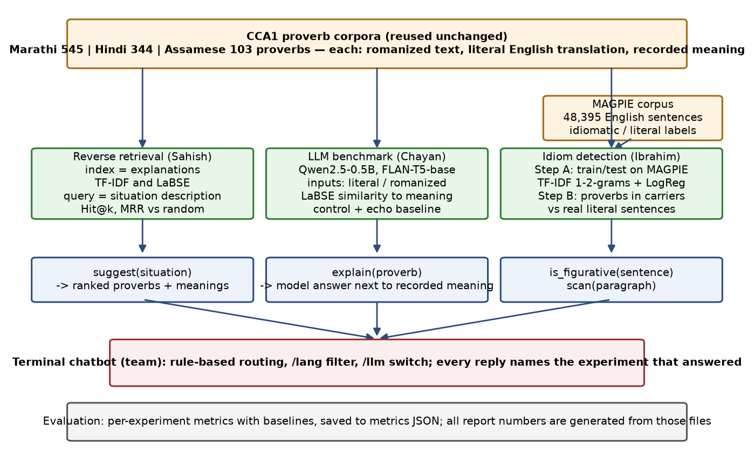
Figure 1: Methodology of CCA3: the three corpora and MAGPIE feed three experiments, one per member, whose functions are joined in the team chatbot; all numbers come from the saved metrics files.
Inference: The three experiments share their inputs and their evaluation style but not their models, so a difference between them is a difference in task, not in data preparation.

2.4 Description of corpora
Sahish Nagulwar: the three CCA1 corpora, reused unchanged. Each row has the romanized proverb, its literal English translation, the compiler's explanation of the intended meaning, and a theme label. Marathi (Manwaring, 1899; Clarendon Press) has 545 proverbs of which 338 carry an explanation of about 10 tokens; Hindi (Fallon, 1886; Medical Hall Press, Banaras) has 344 of which 305 carry a gloss of about 11 tokens; Assamese (Gurdon, 1896; Assam Secretariat Press) has 103 of which 75 carry a commentary of about 37 tokens. All three are public domain on the Internet Archive. The retrieval index is built on the explanation field, so the corpus for this experiment is effectively 718 short English texts, one per proverb, plus the 28 situation queries written for the test.
Ibrahim Ansari: MAGPIE (Haagsma, Bos and Nissim, 2020), the largest public corpus of potentially idiomatic expressions in context: 48,395 sentences from the British National Corpus, each containing one of about 1,700 idiom types, annotated as idiomatic (36,328) or literal (12,067) usage, with genre labels and a fixed training/development/test split. It is distributed under a research licence (stored with the submission) and used here for Step A. For Step B the three proverb corpora supply the positives (every proverb's literal translation, two carrier sentences each) and MAGPIE's literal sentences of 5 to 25 tokens supply the negatives, giving 2,180 Marathi, 1,376 Hindi and 412 Assamese test sentences.
Chayan Raj Bharati: the same three corpora, restricted to proverbs with an explanation and sampled to 60 per language so that generation on CPU stays within minutes per model. For each sampled proverb two inputs are used: the literal English translation and the romanized source text as printed in the book. The gold text is the compiler's explanation. The Assamese sample covers 60 of its 75 explained proverbs; the Marathi and Hindi samples are about a fifth of theirs.

2.4.1 Corpus screenshots and statistical analysis
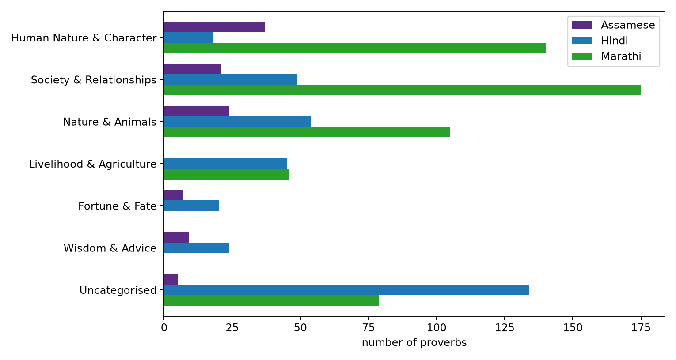
Figure 2: Sahish Nagulwar: number of proverbs per shared category and language in the three CCA1 corpora (from the CCA1 analysis).
Inference: Society and human character dominate in all three corpora and nature imagery is third; the indexes therefore cover similar ground across languages, which is what lets one set of situation queries be written in the same style for all three.
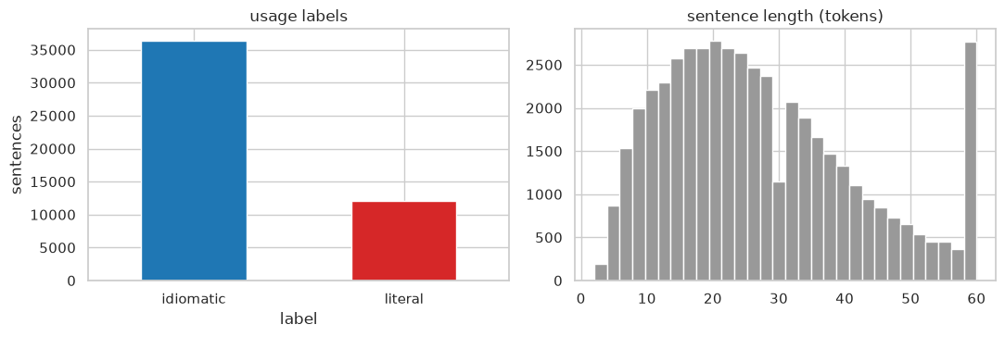
Figure 3: Ibrahim Ansari: MAGPIE corpus analysis, usage-label counts and sentence lengths.
Inference: Idiomatic uses outnumber literal ones three to one, so the majority baseline is 0.746 and the literal class is the hard one; sentences are mostly 15 to 30 tokens, far longer than the proverbs, which matters when the two are mixed in Step B.
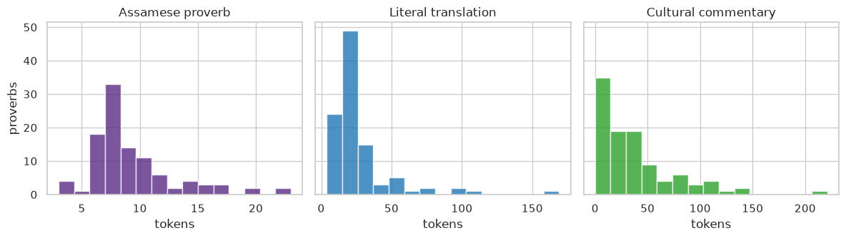
Figure 4: Chayan Raj Bharati: token-length distributions of the Assamese proverb, its literal translation and its commentary (from the CCA1 analysis).
Inference: The commentary is several times longer than the proverb itself, so an answer scored against it by similarity can only match part of it; this is why the benchmark uses a margin over a random explanation rather than the raw similarity.
Screenshots of the data as used. Figures below show sample rows of each corpus file, a sample of MAGPIE rows, and a record table that places proverbs and idiom occurrences side by side.
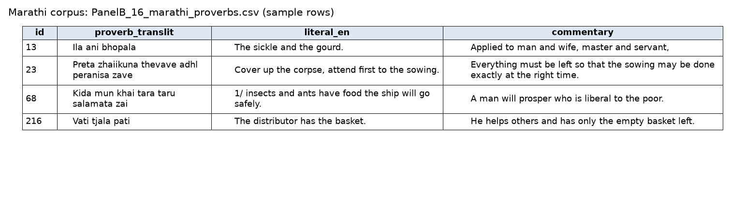
Figure 5: Marathi corpus file, sample rows (romanized proverb, literal translation, recorded meaning).
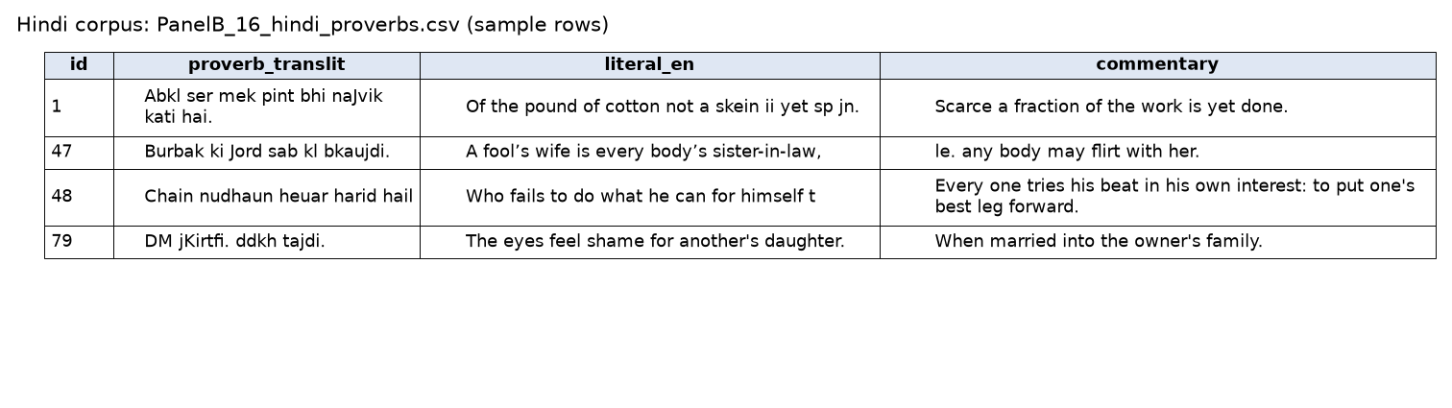
Figure 6: Hindi corpus file, sample rows.
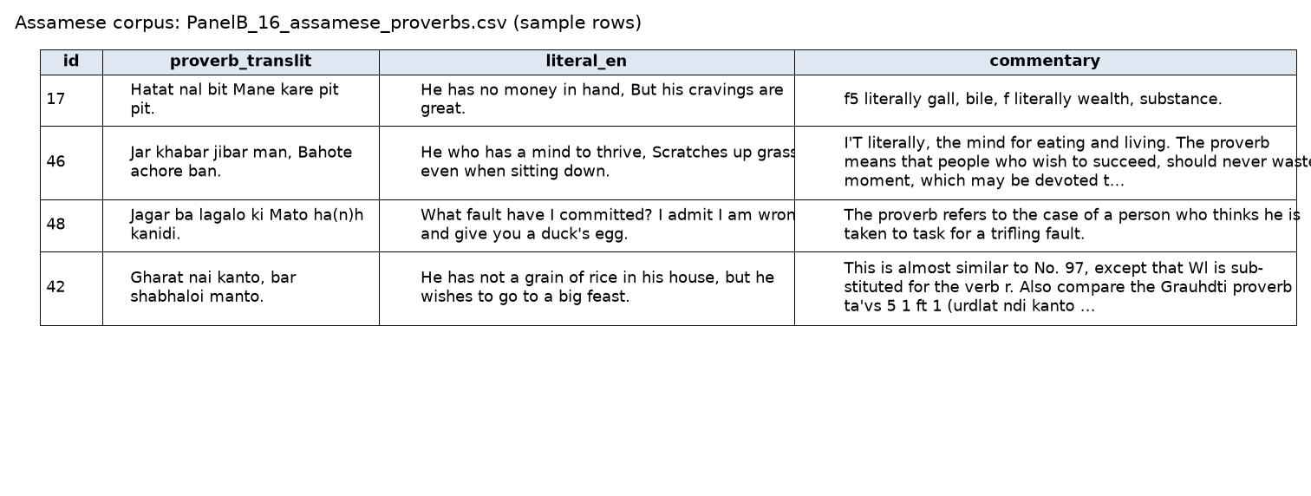
Figure 7: Assamese corpus file, sample rows.
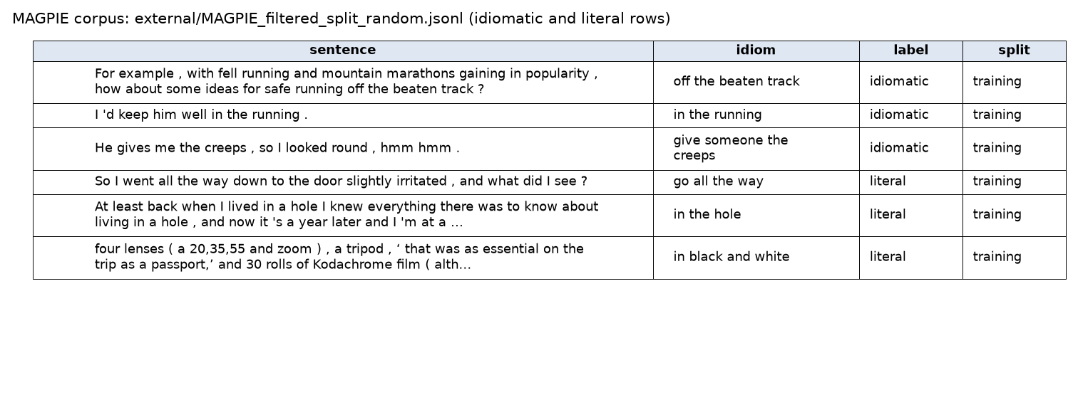
Figure 8: MAGPIE rows: sentence, the idiom it contains, the annotated usage label and the split.
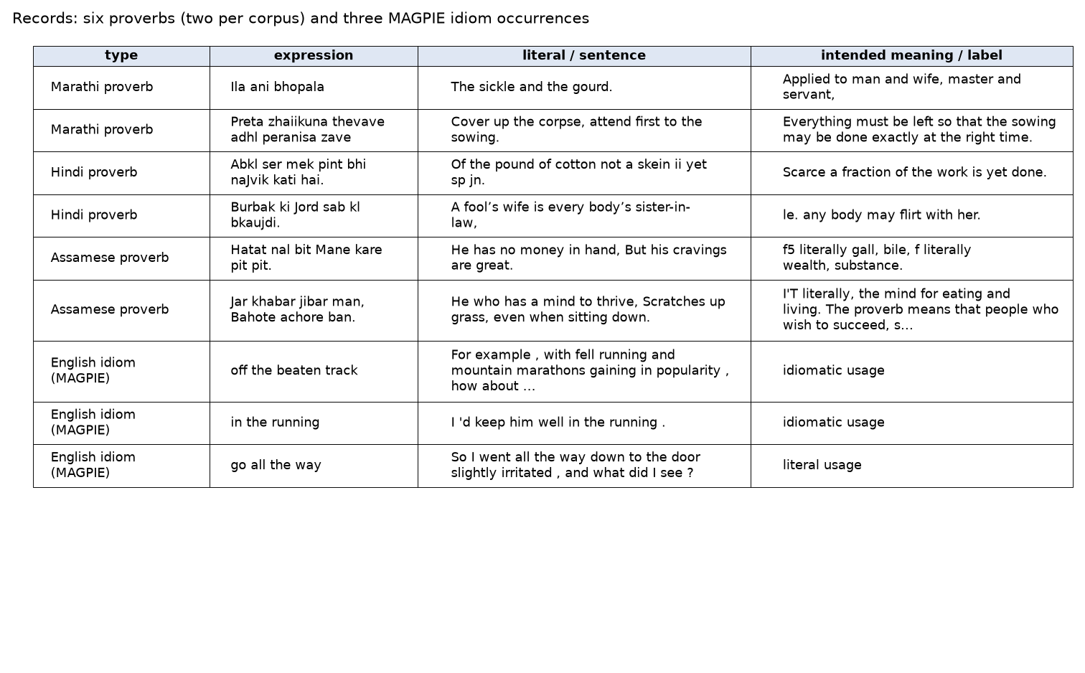
Figure 9: Record of proverbs and idioms: two proverbs per corpus with literal translation and intended meaning, and three MAGPIE idiom occurrences with their usage label.
Inference: A proverb record carries its meaning as free text written by the compiler, while an idiom record carries only a usage label; this is why proverb experiments are scored by similarity to a text and the idiom experiment by classification accuracy.

2.5 Implementation
Sahish Nagulwar (PanelB_16_CCA3_v2_reverse_retrieval.ipynb): the notebook loads the three corpora, builds a TF-IDF vectorizer and a LaBSE embedding matrix over each corpus's explanations, and defines rank_ids(language, query, model), which returns proverb ids ordered by cosine similarity to the query. The 28 situation queries are scored for both indexes, and Hit@1, Hit@5 and MRR are tabulated with a random baseline computed from the index size. The suggest() function wraps rank_ids and returns the top proverbs with translation and meaning. Everything runs in about a minute on CPU.
Ibrahim Ansari (PanelB_16_CCA3_v2_idiom_detection.ipynb): the notebook reads MAGPIE from JSON lines, keeps the idiomatic and literal rows, trains a scikit-learn pipeline (TfidfVectorizer with 1-2-grams, LogisticRegression with balanced class weights) on the training split and reports accuracy, macro-F1, per-class precision and recall, the confusion matrix and the strongest features on the test split. It then builds the Step B sets for each language with the carrier templates and runs 5-fold cross-validation with the same pipeline. The is_figurative() function returns the class probabilities for any sentence.
Chayan Raj Bharati (PanelB_16_CCA3_v2_llm_benchmark.ipynb): the notebook loads the two models with the transformers library (Qwen through its chat template with left padding; FLAN-T5 as a sequence-to-sequence model), prompts each model in batches of eight for every sampled proverb under both inputs, embeds the answers with LaBSE, and computes the similarity to the gold explanation, the control similarity to a random explanation, and the margin per proverb. Results are aggregated per language and system, plotted as bars and per-proverb box plots, and five Hindi examples are printed with both models' answers. The explain() function returns a model answer for any proverb.
Data trained upon. Reverse retrieval and the language-model benchmark have no training step: the index is built directly from the explanations shown above, and the models are used as released. The idiom detector is the one trained component; the two figures below show rows of the data it was trained on.
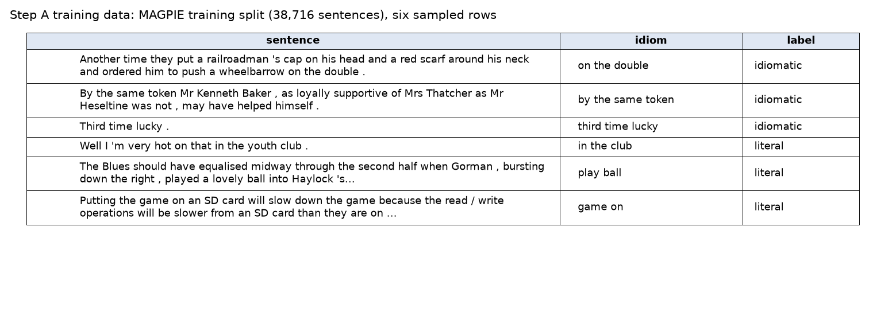
Figure 10: Training data for Step A: six rows sampled from the MAGPIE training split of 38,716 sentences, with the idiom and the usage label the detector learns to predict.
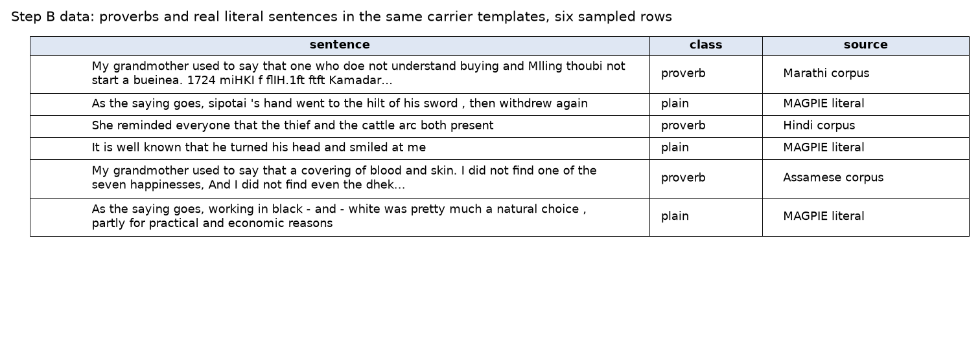
Figure 11: Data for Step B: proverbs from the three corpora and real literal MAGPIE sentences placed in the same carrier templates, labelled proverb or plain.
Inference: Both classes share the same six carrier phrases, so the detector cannot use the phrase as a shortcut and has to decide from the embedded content.
Chatbot interface (team): a single Python script with no dependencies beyond those of the notebooks. At start-up it loads the three corpora, embeds every explanation and literal translation with LaBSE, and trains the idiom detector on the MAGPIE training split (about a minute in total). A message is routed by simple rules: the prefix figurative: sends the sentence to the detector, the prefix explain: or a question of the form what does ... mean sends the text to the interpreter, and anything else is treated as a situation and sent to reverse retrieval. The interpreter first looks the text up in the corpora (LaBSE similarity to the literal translations, plus a substring match on the romanized form) and, if a close entry exists, prints the recorded meaning; it then asks Qwen2.5-0.5B-Instruct for a one-sentence meaning, loaded on first use, and prints the similarity between the two. Commands /lang and /llm restrict the corpus and switch the model off or on. Every reply names the experiment that produced it. The figure below shows a real session.
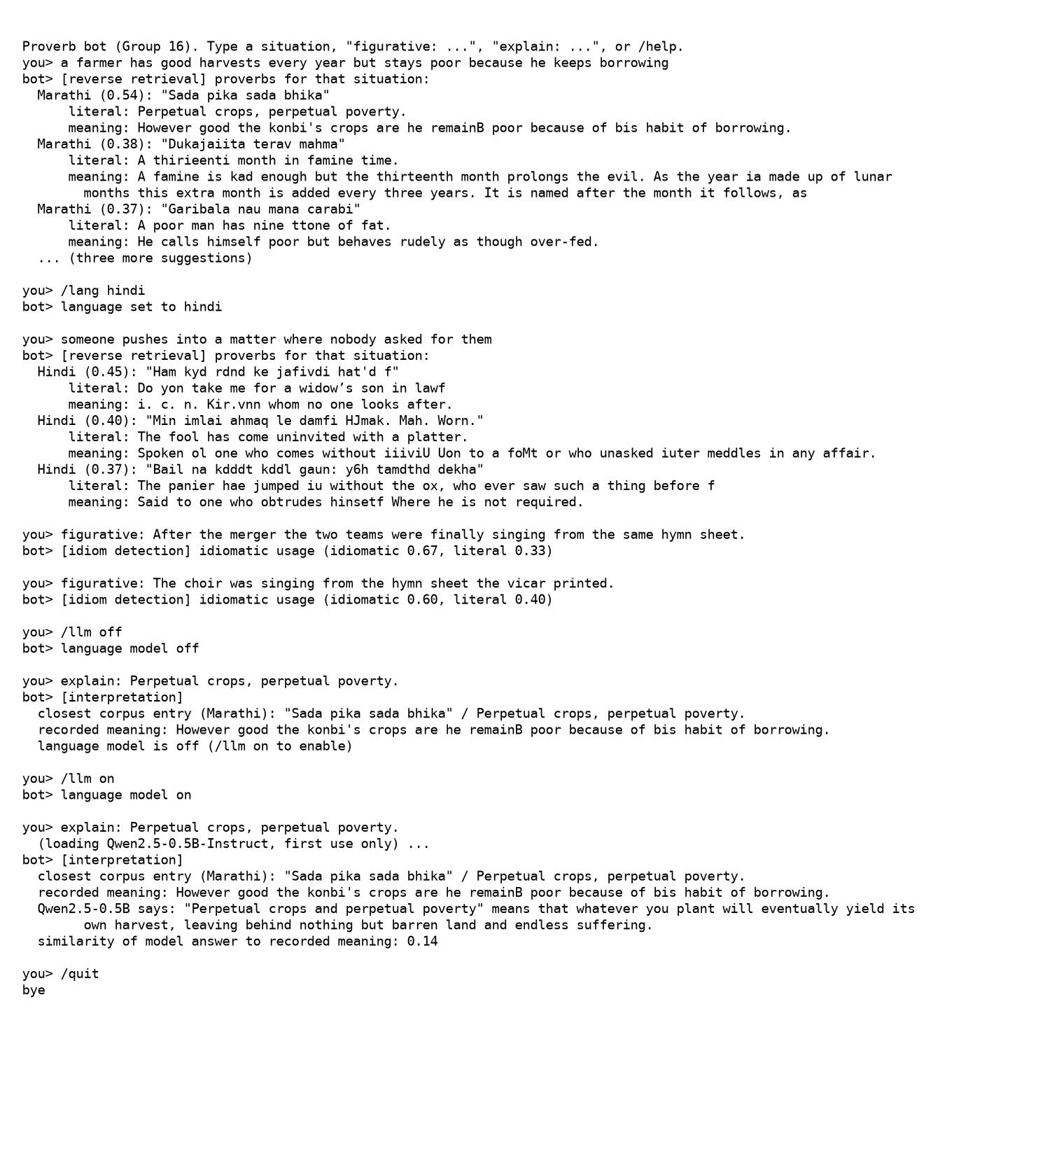
Figure 12: A session with the team chatbot covering the three experiments: reverse retrieval in all languages and in Hindi only, idiom detection on a figurative and a literal sentence, and interpretation with the language model off and on.
Inference: The situation query returns the intended Marathi proverb first at 0.54 similarity; the two detector calls show the literal minority-class weakness seen in Section 2.6.2 (the literal choir sentence is still scored idiomatic at 0.60); and the interpretation call reproduces the benchmark finding live, with the model's confident but wrong meaning scoring 0.14 against the recorded one, which is why the bot shows both.

2.6 Results

2.6.1 Sahish Nagulwar: reverse retrieval
Language | Index | Hit@1 | Hit@5 | MRR
Marathi | TFIDF | 0.3 | 0.5 | 0.401
Marathi | Labse | 0.5 | 0.5 | 0.518
Marathi | Random | 0.003 | 0.015 | 0.019
Hindi | TFIDF | 0.125 | 0.375 | 0.246
Hindi | Labse | 0.625 | 0.75 | 0.68
Hindi | Random | 0.003 | 0.016 | 0.021
Assamese | TFIDF | 0.4 | 0.6 | 0.517
Assamese | Labse | 0.3 | 0.7 | 0.429
Assamese | Random | 0.013 | 0.067 | 0.065
Table: reverse retrieval on the hand-written situation queries (10 Marathi, 8 Hindi, 10 Assamese).
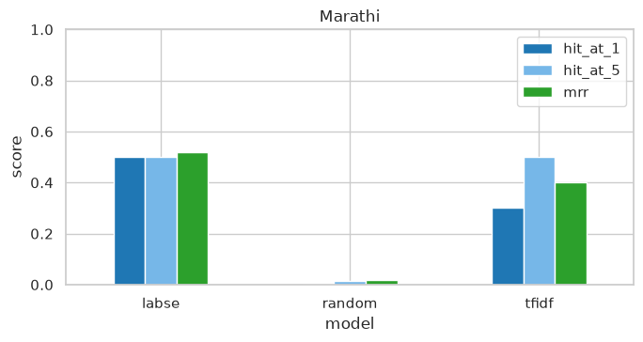
Figure 13: Marathi reverse retrieval: Hit@1, Hit@5 and MRR for the TF-IDF and LaBSE indexes against the random baseline.
Inference: The target proverb is in the top five for 50 percent of the queries at best, against 1.5 percent by chance; LaBSE has the better MRR (0.518).
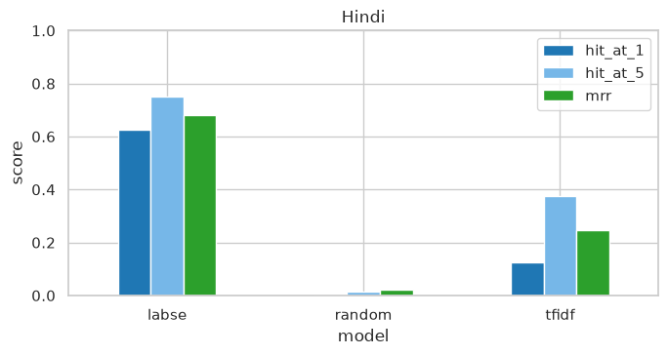
Figure 14: Hindi reverse retrieval: Hit@1, Hit@5 and MRR for the TF-IDF and LaBSE indexes against the random baseline.
Inference: The target proverb is in the top five for 75 percent of the queries at best, against 1.6 percent by chance; LaBSE has the better MRR (0.680).
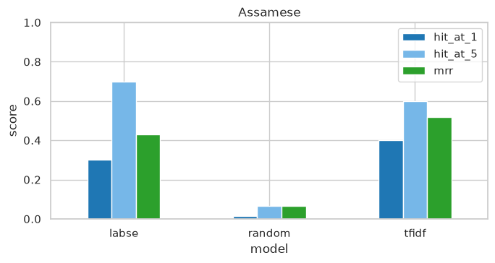
Figure 15: Assamese reverse retrieval: Hit@1, Hit@5 and MRR for the TF-IDF and LaBSE indexes against the random baseline.
Inference: The target proverb is in the top five for 70 percent of the queries at best, against 6.7 percent by chance; TF-IDF has the better MRR (0.517).
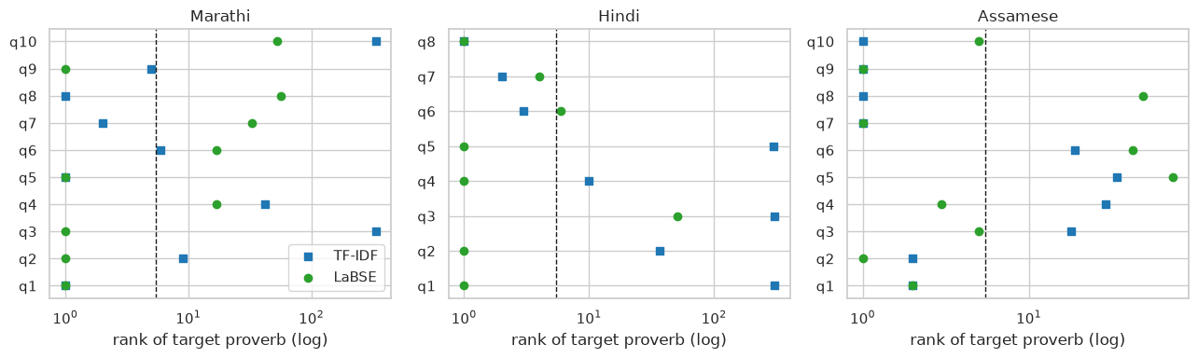
Figure 16: Rank of the target proverb for every situation query, by language and index; points left of the dashed line are top-5 hits.
Inference: Misses are not near misses: when an index fails it tends to rank the target far down the list, which means the failed queries describe the situation in a way the explanation does not, rather than the index being slightly off.
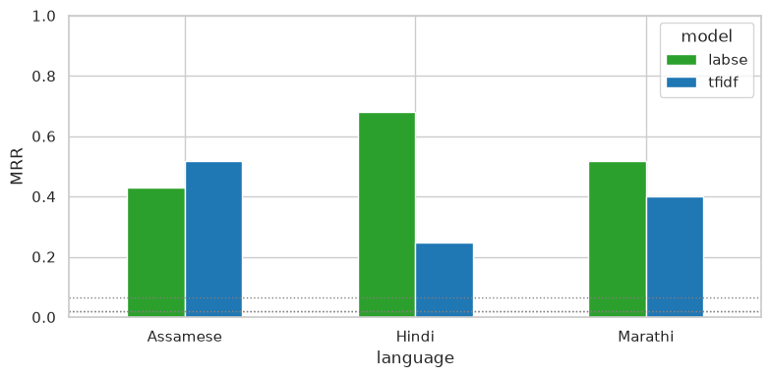
Figure 17: Mean reciprocal rank by language and index; dotted lines are the random baselines.
Inference: LaBSE leads for Marathi and Hindi and TF-IDF leads for Assamese, where the long Gurdon commentaries share concrete words with the situations; both are an order of magnitude above random in every language.
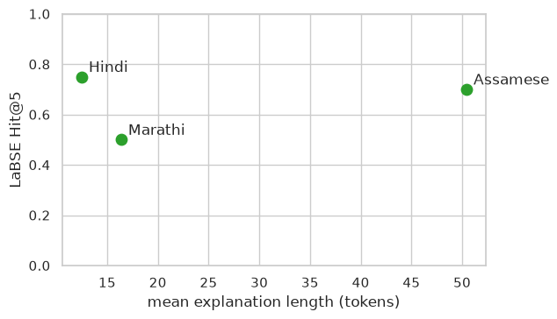
Figure 18: LaBSE Hit@5 against the mean length of the indexed explanations.
Inference: The two corpora with longer explanations retrieve better; the one-sentence Marathi explanations give the index the least to match on.
Success and failure cases. Table below lists, from the 28 queries, the queries where the LaBSE index ranked the target first and the queries where it missed the top five, with what was returned instead.
Outcome | Language | Situation query | Target proverb (literal) | Returned first | Rank of target
success | Marathi | Acting carefully so that neither of two friends is hurt by a decision. | Injury nt&er to tie plant nor to the cucumher. | Injury nt&er to tie plant nor to the cucumher. | 1
success | Marathi | A man arranges everything so that the benefit comes only to himself. | A hoe dratet toil tovardt tit. | A hoe dratet toil tovardt tit. | 1
success | Marathi | A farmer has good harvests every year yet stays poor because he keeps borrowing. | Perpetual crops, perpetual poverty. | Perpetual crops, perpetual poverty. | 1
failure | Assamese | A poor man wants to attend a grand feast he cannot afford. | He has not a grain of rice in his house, but he wishes to go to a big… | What fault have I committed? I admit I am wrong, and give you a duck'… | 74
failure | Marathi | Something has finally reached its full ripeness or maturity. | It haa come to per/ectioK, it U ripe on the stem. | Hmeever much you rub charcoal it mill still be llack. | 57
failure | Marathi | While one person is in deep trouble, another only worries about his own small concern. | T'ife camel if droumiriff and the goat Oikt him ike depth tihe water. | Hmeever much you rub charcoal it mill still be llack. | 53
Table: reverse-retrieval success and failure cases (LaBSE index).
The failures share a pattern: the situation names a consequence (a trivial shortfall, a reckless spender) while the recorded meaning names a cause or a scene, so neither words nor embedding bring them together; the successes are the queries that paraphrase the recorded meaning closely.

2.6.2 Ibrahim Ansari: idiom identification in running text
Set | Sentences | Accuracy | Macro-F1 | Baseline
MAGPIE test (Step A) | 4,840 | 0.862 | 0.827 | majority 0.746
Marathi proverbs in carriers (Step B) | 2,180 | 0.943 | 0.943 | chance 0.5
Hindi proverbs in carriers (Step B) | 1,376 | 0.933 | 0.933 | chance 0.5
Assamese proverbs in carriers (Step B) | 412 | 0.913 | 0.913 | chance 0.5
Table: detector results on real text and on the three proverb corpora.
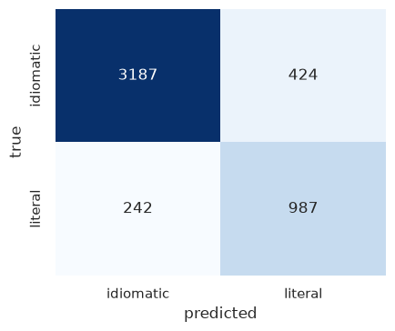
Figure 19: Confusion matrix on the MAGPIE test split (4,840 real sentences).
Inference: Idiomatic uses are recognised at 0.883 recall and literal uses at 0.803; the main error is literal uses predicted as idiomatic, the direction expected when idiomatic examples outnumber literal ones three to one in training.
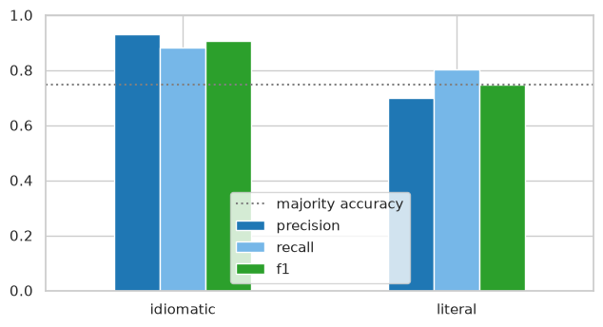
Figure 20: Precision, recall and F1 per class on MAGPIE; the dotted line is the majority-class accuracy.
Inference: The literal class has the lower precision (0.700): about a third of the sentences flagged as literal are actually idiomatic, so a chatbot using this detector should report the probability rather than a hard label.
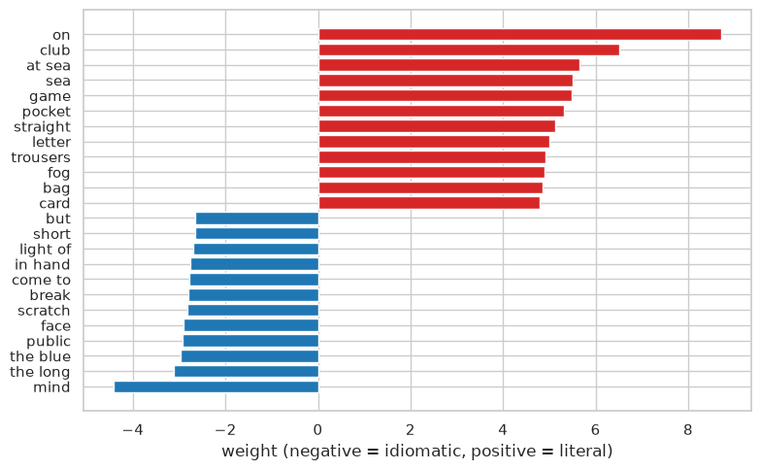
Figure 21: The strongest features for each class in the MAGPIE detector.
Inference: Features on the literal side are concrete and physical, features on the idiomatic side are discourse and evaluation words; the detector is learning the register of figurative use, not the idioms themselves, which is why it can transfer to unseen proverbs.
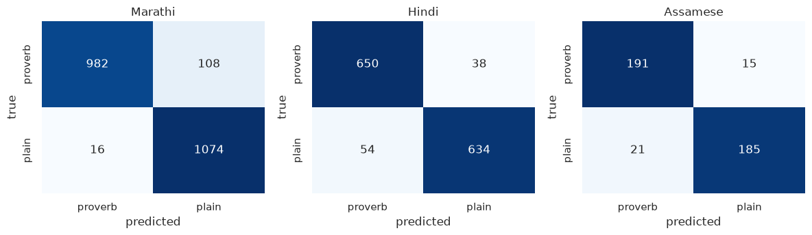
Figure 22: Step B confusion matrices for Marathi, Hindi and Assamese proverbs in carrier sentences (5-fold cross-validation).
Inference: Errors are few and balanced in all three languages; the smallest set (Assamese, 412 sentences) has the most, as expected from its size.
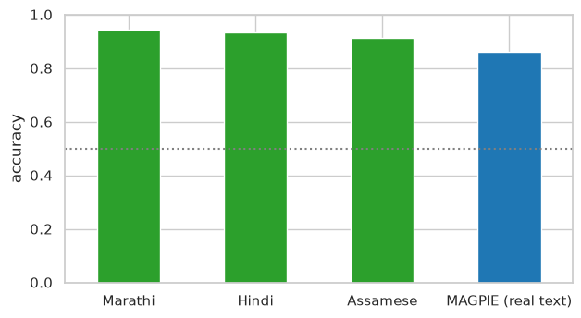
Figure 23: Detection accuracy on the three proverb corpora (Step B) next to the real-text result (Step A).
Inference: Step B accuracies of 0.91 to 0.94 are higher than Step A because of the register difference between 1890s book English and modern BNC sentences; the honest estimate of real-text detection is the Step A bar.
Success and failure cases from the MAGPIE test split, with the detector's probability of idiomatic usage.
Outcome | Sentence | Idiom | True | Predicted | P(idiomatic)
success | She has never stepped out of line . | out of line | idiomatic | idiomatic | 0.79
success | Nellie and I tiptoed quietly back down the aisle and out of the door . | down and out | literal | literal | 0.2
failure | " It was me that shot the bull , son . | shoot the bull | literal | idiomatic | 0.88
failure | Everett , similarly enthusiastic , described it as ‘ being on the stump’ . | on the stump | idiomatic | literal | 0.49
Table: idiom-detection success and failure cases.
The failures are the two directions the matrix predicts: a literal sentence with vivid wording read as idiomatic, and an idiom in quotation marks inside a plain report read as literal. Both are cases where the register cue the detector relies on points the wrong way.

2.6.3 Chayan Raj Bharati: language-model interpretation benchmark
System | Marathi: margin | Hindi: margin | Assamese: margin
Qwen2.5-0.5B / literal_en | +0.042 | +0.051 | +0.046
Qwen2.5-0.5B / romanized | +0.016 | +0.005 | +0.007
flan-t5-base / literal_en | +0.064 | +0.049 | +0.058
flan-t5-base / romanized | +0.015 | +0.002 | -0.008
echo baseline | +0.077 | +0.073 | +0.086
Table: mean margin (similarity to the gold explanation minus similarity to a random explanation) per system and language, 60 proverbs each.
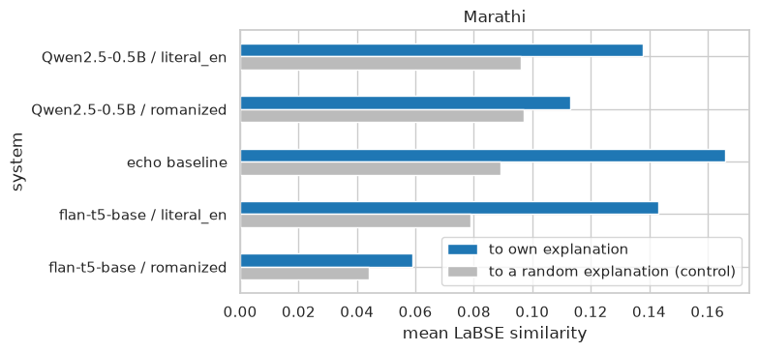
Figure 24: Marathi: mean similarity of each system's answer to the compiler's explanation (blue) against the control (grey), for both inputs and the echo baseline.
Inference: With the literal translation as input Qwen's margin is +0.042, below the echo baseline's +0.077; with romanized Marathi it is +0.016. The model writes a fluent meaning that is no closer to the recorded one than the proverb text itself, and gets nothing from the source-language form.
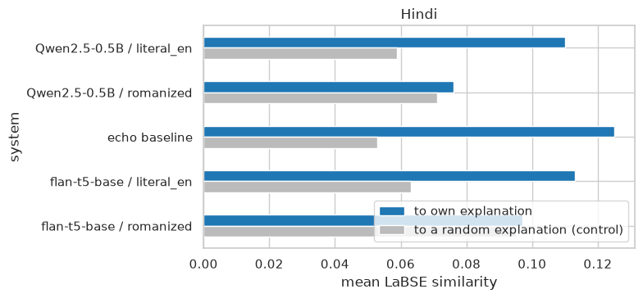
Figure 25: Hindi: mean similarity of each system's answer to the compiler's explanation (blue) against the control (grey), for both inputs and the echo baseline.
Inference: With the literal translation as input Qwen's margin is +0.051, below the echo baseline's +0.073; with romanized Hindi it is +0.005. The model writes a fluent meaning that is no closer to the recorded one than the proverb text itself, and gets nothing from the source-language form.
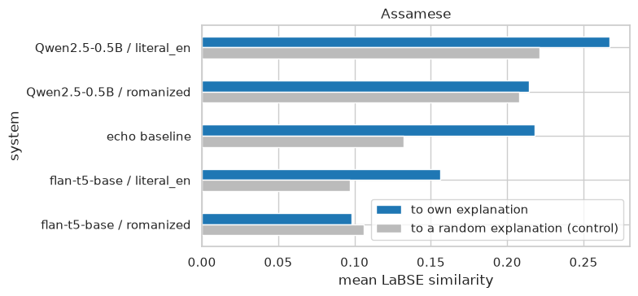
Figure 26: Assamese: mean similarity of each system's answer to the compiler's explanation (blue) against the control (grey), for both inputs and the echo baseline.
Inference: With the literal translation as input Qwen's margin is +0.046, below the echo baseline's +0.086; with romanized Assamese it is +0.007. The model writes a fluent meaning that is no closer to the recorded one than the proverb text itself, and gets nothing from the source-language form.
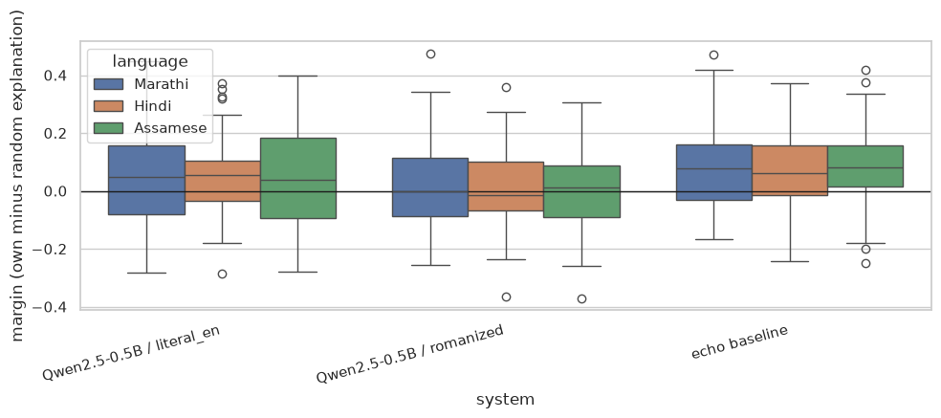
Figure 27: Per-proverb margin distributions for the Qwen conditions and the echo baseline, by language.
Inference: The echo baseline sits above zero for most proverbs in every language, the literal-input Qwen condition straddles zero with a wide spread, and the romanized condition is centred on zero; the model helps for some proverbs and hurts for as many.
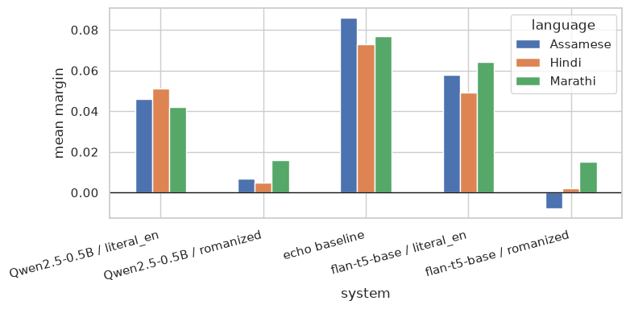
Figure 28: Mean margin per system across the three languages; the echo baseline is the bar each model has to beat.
Inference: The ordering is the same in all three languages: echo first, then the literal-input models, then the romanized-input models near zero. The CCA1 cross-lingual wall holds for generative models.
Success and failure cases: Qwen2.5-0.5B-Instruct answers with the highest and lowest margins on a fresh sample of 24 proverbs (literal-translation input).
Outcome | Language | Proverb (literal) | Recorded meaning | Model answer | Margin
success | Hindi | Let the iron cUre and the smith care; why | Smiths in Idttia keep a man on fixed wages to blow their bellows, and the point of the pr… | The proverb "Let the iron cUre and the smith care; why" suggests that it's unnecessary to worry about or take… | +0.40
success | Assamese | A horse is known by his ears, A woman in times of adversity, And a ra… | not break on the whetstone. As to the faithfulness of women, horses, etc., cf. the Persia… | The proverb suggests that qualities like good horses (virtue) and a razor (wisdom) can help individuals navig… | +0.39
failure | Hindi | Tott made it fly away, I fried and ate it | Teeeh your graadmothfr to eiiok eggs. | The proverb "Tott made it fly away, I fried and ate it" means that something was so delicious or satisfying t… | -0.13
failure | Assamese | The egg plant that is out of season, cries out pluck me, pluck me. | This saying is expressive of contempt towards men who are too pushing. 246. The bagari pl… | This proverb means that when something is no longer suitable or desirable, it should be taken care of and rep… | -0.13
Table: language-model success and failure cases.
The successes are proverbs whose literal text already states a general rule, so a paraphrase lands near the recorded meaning; the failures are proverbs built on a specific image (a fried bird, an out-of-season vegetable) where the model explains the image rather than the point, confidently and wrongly.

2.7 Discussion
Sahish Nagulwar: the results in Figures 13 to 18 answer RQ1 positively for all three corpora. A situation written in ordinary words retrieves the target proverb in the top five for 75 percent of the Hindi queries and 70 percent of the Assamese ones, with random baselines under 7 percent, so the index is usable as a suggestion tool. The semantic index is better for Marathi and Hindi (Figure 17), which is the result the queries were designed to produce, since they avoid the explanation's words; the lexical index wins for Assamese because Gurdon's long commentaries carry enough concrete nouns to match on. Figure 18 ties retrieval quality to explanation length, which is the clearest guidance for the chatbot: the shorter the recorded meaning, the more the suggestion depends on the semantic index. The test sets are small, so the hit rates have wide uncertainty and the figures should be read as a demonstration rather than a benchmark.
Ibrahim Ansari: Figure 19 and Figure 20 show that the CCA1 recipe, TF-IDF features with logistic regression, separates figurative from literal usage in real sentences at 0.862 accuracy against a 0.746 majority baseline, with the literal minority class as the weak point (0.700 precision). Figure 21 explains why the detector transfers: it relies on the register of figurative use, evaluation and discourse words against concrete physical ones, not on memorised idioms, so unseen Marathi, Hindi and Assamese proverbs are caught by the same cues (Figures 22 and 23). The Step B numbers are inflated by the register gap between the 1890s translations and modern BNC sentences and are reported with that caveat; the real-text figure is the one to quote. RQ2 is answered: the recipe works on real text and transfers, and the remaining gap is a corpus of our languages' proverbs in genuine running text.
Chayan Raj Bharati: Figures 24 to 28 answer RQ3 in the negative, consistently. In all three languages the echo baseline has the largest margin (Marathi +0.077, Hindi +0.073, Assamese +0.086); a small instruction-tuned model given the literal translation produces a fluent meaning that is no closer to the compiler's than the proverb itself, and given the romanized source text its margin is near zero (Figure 28). The per-proverb distributions in Figure 27 show this is not an average hiding a bimodal result: the literal-input condition helps about as often as it hurts. This is the CCA1 finding, that romanized historical text is opaque to pretrained models, now observed for generation as well as retrieval. Larger models may interpret better, but the controls would apply unchanged, and the chatbot therefore shows the model's answer next to the recorded meaning rather than in place of it.

2.8 Conclusion
Three extensions of the CCA1 work were implemented on all three proverb corpora with one shared code path, one per member. Sahish Nagulwar built situation-to-proverb retrieval and showed it finds the right proverb in the top five for most hand-written situations in every language, with the semantic index ahead where explanations are short. Ibrahim Ansari built an idiom-usage detector on 48,395 real English sentences, reached 0.862 accuracy against a 0.746 baseline, showed that it works from the register of figurative use, and transferred it to the three proverb corpora. Chayan Raj Bharati built a benchmark with controls that separate interpretation from restatement and found that two small open language models do not beat the proverb's own text in any language, and gain nothing from romanized input. Each experiment ends in a function, and the team chatbot joins the three into one interface that reports the recorded meaning alongside any model answer. The practical conclusion is the same as CCA1's and now rests on more evidence: native-script recovery is the precondition for embedding and generative models to contribute on the source-language text.

2.9 References
Chung, H. W., Hou, L., Longpre, S., et al. (2022). Scaling instruction-finetuned language models. arXiv:2210.11416.
Fallon, S. W. (1886). A dictionary of Hindustani proverbs. Banaras: Medical Hall Press. Corpus source: https://archive.org/details/in.ernet.dli.2015.42145
Feng, F., Yang, Y., Cer, D., Arivazhagan, N., & Wang, W. (2022). Language-agnostic BERT sentence embedding. Proceedings of the 60th Annual Meeting of the Association for Computational Linguistics, 878-891.
Gurdon, P. R. (1896). Some Assamese proverbs. Shillong: Assam Secretariat Printing Office. Corpus source: https://archive.org/details/someassameseprov00gurdrich
Haagsma, H., Bos, J., & Nissim, M. (2020). MAGPIE: A large corpus of potentially idiomatic expressions. Proceedings of the 12th Language Resources and Evaluation Conference, 279-287. Corpus: https://github.com/hslh/magpie-corpus
Liu, C. C., Koto, F., Baldwin, T., & Gurevych, I. (2024). Are multilingual LLMs culturally-diverse reasoners? An investigation into multicultural proverbs and sayings. Proceedings of NAACL 2024.
Manwaring, A. (1899). Marathi proverbs. Oxford: Clarendon Press. Corpus source: https://archive.org/details/marathiproverbs00manwgoog
Qwen Team (2024). Qwen2.5 technical report. arXiv:2412.15115.
Reimers, N., & Gurevych, I. (2019). Sentence-BERT: Sentence embeddings using Siamese BERT-networks. Proceedings of EMNLP-IJCNLP 2019, 3982-3992.
Tan, M., & Jiang, J. (2021). Does BERT understand idioms? A probing-based empirical study of BERT encodings of idioms. Proceedings of RANLP 2021, 1397-1407.

