CCA3 — Cloud Computing & Natural Language Processing — Panel B, Team 16

Individual contribution to the team report: Chayan Raj Bharati (1032233134)
This document collects the sections of the team report (PanelB_16_LCA3_MiniProject_Report.docx) that belong to Part III, the part contributed by Chayan Raj Bharati. The text, tables and figures are the same as in the team report, and figure and table numbers are kept as in the team report so the two documents can be read side by side. The code for this contribution is PanelB_16_CCA3_v2_llm_benchmark.ipynb.

Research question
RQ3 (Part III): When a small open language model is asked what a proverb means, does its answer come closer to the compiler's recorded meaning than the proverb's own literal text does, and does that hold when the input is the romanized source language rather than English?

Research contribution
Part III: a proverb-interpretation benchmark of 60 proverbs per language on which two open language models are scored under two input conditions, with a random-explanation control and an echo baseline that separate interpretation from restatement; per-proverb margin distributions; and the explain() interface, which shows the model's answer next to the recorded meaning.

Methodology
Part III: 60 proverbs with explanations per language (random sample, seed 42). Qwen2.5-0.5B-Instruct and FLAN-T5-base are prompted for a one-sentence meaning, once with the literal translation and once with the romanized source text. The answer is scored by LaBSE similarity to the gold explanation; the control is its similarity to a random other explanation; the margin is the difference. The echo baseline scores the literal translation itself the same way. Both models run on CPU with greedy or two-beam decoding.

Description of corpora
Part III: the same three corpora, restricted to proverbs with an explanation and sampled to 60 per language so that generation on CPU stays within minutes per model. For each sampled proverb two inputs are used: the literal English translation and the romanized source text as printed in the book. The gold text is the compiler's explanation. The Assamese sample covers 60 of its 75 explained proverbs; the Marathi and Hindi samples are about a fifth of theirs.

Corpus analysis
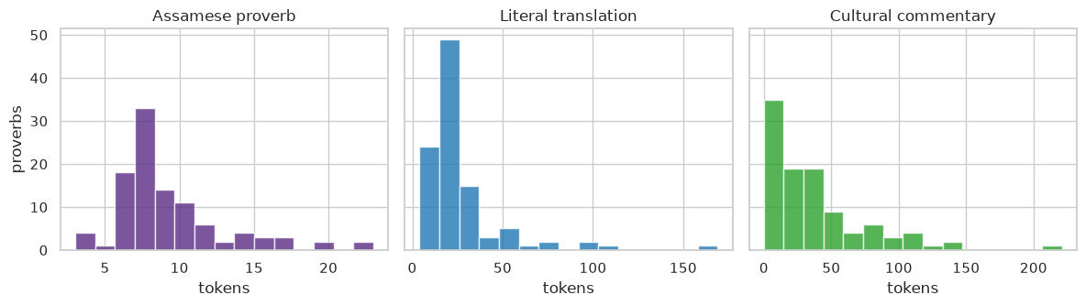
Figure 4: Part III: token-length distributions of the Assamese proverb, its literal translation and its commentary (from the CCA1 analysis).
Inference: Gurdon's commentary is usually several times longer than the proverb. An answer scored by similarity against it can only ever cover part of that text, so raw similarity would be low for everyone. That is the reason the benchmark reports a margin over a random explanation instead.

Implementation
Part III (PanelB_16_CCA3_v2_llm_benchmark.ipynb): the notebook loads the two models with the transformers library (Qwen through its chat template with left padding; FLAN-T5 as a sequence-to-sequence model), prompts each model in batches of eight for every sampled proverb under both inputs, embeds the answers with LaBSE, and computes the similarity to the gold explanation, the control similarity to a random explanation, and the margin per proverb. Results are aggregated per language and system, plotted as bars and per-proverb box plots, and five Hindi examples are printed with both models' answers. The explain() function returns a model answer for any proverb.

Results
Table 12: Mean margin (similarity to the gold explanation minus similarity to a random explanation) per system and language, 60 proverbs each.
System | Marathi: margin | Hindi: margin | Assamese: margin
Qwen2.5-0.5B / literal_en | +0.042 | +0.051 | +0.046
Qwen2.5-0.5B / romanized | +0.016 | +0.005 | +0.007
flan-t5-base / literal_en | +0.064 | +0.049 | +0.058
flan-t5-base / romanized | +0.015 | +0.002 | -0.008
echo baseline | +0.077 | +0.073 | +0.086
Inference: The echo baseline has the largest margin in every language, so neither model adds meaning beyond what the proverb text already carries; romanized input gives margins near zero.
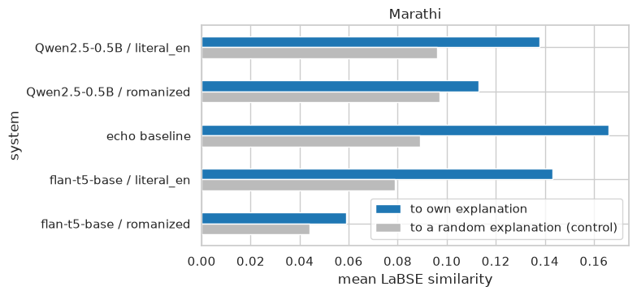
Figure 17: Marathi: mean similarity of each system's answer to the compiler's explanation (blue) against the control (grey), for both inputs and the echo baseline.
Inference: With the literal translation as input Qwen's margin is +0.042, below the echo baseline's +0.077; with romanized Marathi it is +0.016. The model writes a fluent meaning that is no closer to the recorded one than the proverb text itself, and gets nothing from the source-language form.
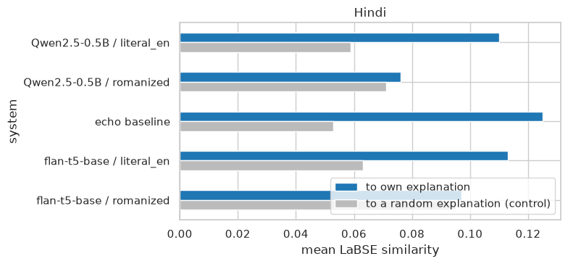
Figure 18: Hindi: mean similarity of each system's answer to the compiler's explanation (blue) against the control (grey), for both inputs and the echo baseline.
Inference: With the literal translation as input Qwen's margin is +0.051, below the echo baseline's +0.073; with romanized Hindi it is +0.005. The model writes a fluent meaning that is no closer to the recorded one than the proverb text itself, and gets nothing from the source-language form.
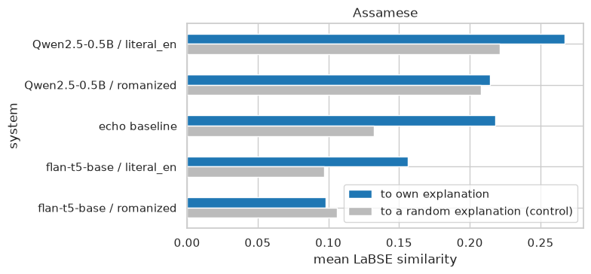
Figure 19: Assamese: mean similarity of each system's answer to the compiler's explanation (blue) against the control (grey), for both inputs and the echo baseline.
Inference: With the literal translation as input Qwen's margin is +0.046, below the echo baseline's +0.086; with romanized Assamese it is +0.007. The model writes a fluent meaning that is no closer to the recorded one than the proverb text itself, and gets nothing from the source-language form.
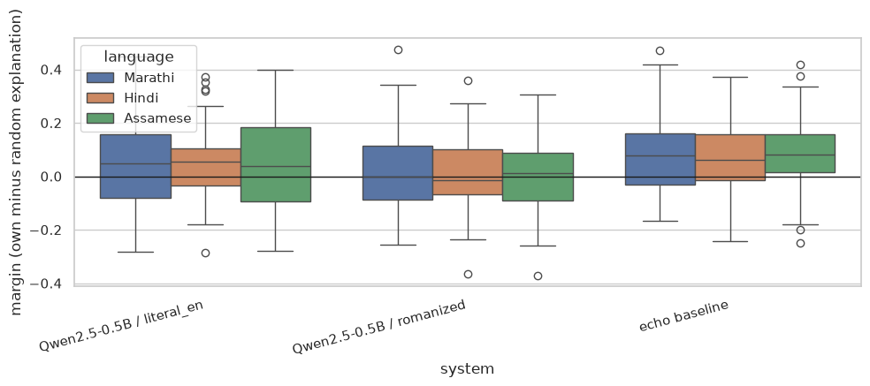
Figure 20: Per-proverb margin distributions for the Qwen conditions and the echo baseline, by language.
Inference: For most proverbs, in every language, the echo baseline is above zero. Qwen with the literal translation as input is spread widely on both sides of zero, and with romanized input it sits on zero. So the model helps on some proverbs and hurts on about as many.
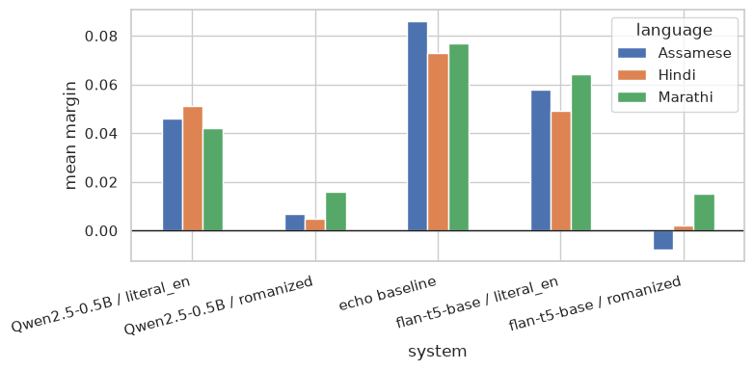
Figure 21: Mean margin for each system over the three languages. The echo baseline is the bar a model has to clear.
Inference: The order never changes across the three languages. Echo comes first, the models with literal input next, and the models with romanized input last, close to zero. The wall CCA1 ran into on romanized text is still there when the model generates instead of retrieves.
Success and failure cases. We drew a fresh sample of 24 proverbs, gave Qwen2.5-0.5B-Instruct the literal translations, and kept the answers with the highest and the lowest margins.
Table 13: Best and worst answers from the language model.
System | Marathi: margin | Hindi: margin | Assamese: margin
Qwen2.5-0.5B / literal_en | +0.042 | +0.051 | +0.046
Qwen2.5-0.5B / romanized | +0.016 | +0.005 | +0.007
flan-t5-base / literal_en | +0.064 | +0.049 | +0.058
flan-t5-base / romanized | +0.015 | +0.002 | -0.008
echo baseline | +0.077 | +0.073 | +0.086
Inference: The good answers come from proverbs whose literal text already reads like a general rule; a paraphrase of it lands close to what the compiler wrote. The bad ones come from proverbs built around one concrete image, a fried bird, a vegetable out of season. There the model explains the image and misses the point, and it does so with full confidence.

Discussion
Part III: Figures 17 to 21 answer RQ3 in the negative, consistently. In all three languages the echo baseline has the largest margin (Marathi +0.077, Hindi +0.073, Assamese +0.086); a small instruction-tuned model given the literal translation produces a fluent meaning that is no closer to the compiler's than the proverb itself, and given the romanized source text its margin is near zero (Figure 21). The per-proverb distributions in Figure 20 show this is not an average hiding a bimodal result: the literal-input condition helps about as often as it hurts. This is the CCA1 finding, that romanized historical text is opaque to pretrained models, now observed for generation as well as retrieval. Larger models may interpret better, but the controls would apply unchanged, and the chatbot therefore shows the model's answer next to the recorded meaning rather than in place of it.

