CCA3 — Cloud Computing & Natural Language Processing — Panel B, Team 16

Individual contribution to the team report: Ibrahim Ansari (1032233145)
This document collects the sections of the team report (PanelB_16_LCA3_MiniProject_Report.docx) that belong to Part II, the part contributed by Ibrahim Ansari. The text, tables and figures are the same as in the team report, and figure and table numbers are kept as in the team report so the two documents can be read side by side. The code for this contribution is PanelB_16_CCA3_v2_idiom_detection.ipynb.

Research question
RQ2 (Part II): Can a detector that separates figurative from literal usage, trained on real English sentences, be built with the CCA1 recipe, and does it transfer to Marathi, Hindi and Assamese proverbs placed in running text?

Research contribution
Part II: an idiom-usage detector trained on 38,716 real English sentences and tested on 4,840, with per-class precision and recall and an analysis of the features it relies on; the transfer of the same recipe to the three proverb corpora in carrier sentences with real literal sentences as negatives; and the is_figurative() interface.

Methodology
Part II: Step A trains TF-IDF over word unigrams and bigrams with logistic regression (balanced class weights) on the MAGPIE training split and tests on its test split, labels idiomatic versus literal usage. Step B applies the same recipe to each language: the proverbs (literal translations) are placed in six carrier sentences as positives, and real literal MAGPIE sentences are placed in the same carriers as negatives, under 5-fold cross-validation; the carriers cancel, so the classifier must decide from content. Step B carries a stated confound, since 1890s book English and modern BNC English differ in register, and Step A is treated as the honest number.

Description of corpora
Part II: MAGPIE (Haagsma, Bos and Nissim, 2020), the largest public corpus of potentially idiomatic expressions in context: 48,395 sentences from the British National Corpus, each containing one of about 1,700 idiom types, annotated as idiomatic (36,328) or literal (12,067) usage, with genre labels and a fixed training/development/test split. It is distributed under a research licence (stored with the submission) and used here for Step A. For Step B the three proverb corpora supply the positives (every proverb's literal translation, two carrier sentences each) and MAGPIE's literal sentences of 5 to 25 tokens supply the negatives, giving 2,180 Marathi, 1,376 Hindi and 412 Assamese test sentences.

Corpus analysis
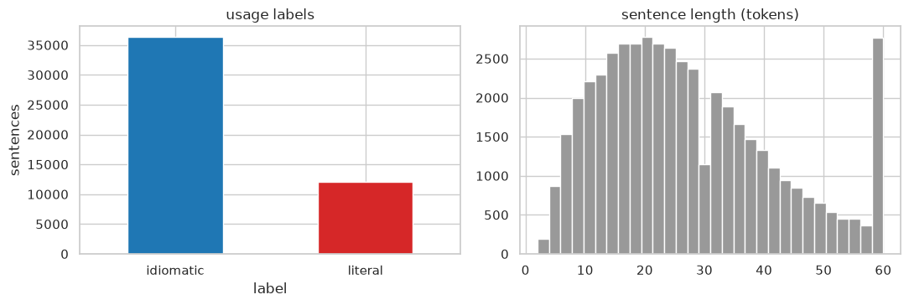
Figure 3: Part II: MAGPIE corpus analysis, usage-label counts and sentence lengths.
Inference: Idiomatic uses outnumber literal ones three to one, so the majority baseline is 0.746 and the literal class is the hard one; sentences are mostly 15 to 30 tokens, far longer than the proverbs, which matters when the two are mixed in Step B.

Implementation
Part II (PanelB_16_CCA3_v2_idiom_detection.ipynb): the notebook reads the MAGPIE file line by line and drops everything except the rows labelled idiomatic or literal. On the training split it fits a scikit-learn pipeline, a TfidfVectorizer over unigrams and bigrams followed by LogisticRegression with balanced class weights. On the test split it prints accuracy and macro-F1, precision and recall for each class, the confusion matrix, and the features with the largest weights. After that it builds the Step B sets, one per language, from the carrier templates and runs the same pipeline under 5-fold cross-validation. is_figurative() takes any sentence and returns the two class probabilities.
Table 6: Training data for Step A: six rows sampled from the MAGPIE training split of 38,716 sentences, with the idiom and the usage label the detector learns to predict.
Sentence | Idiom | Label
Another time they put a railroadman 's cap on his head and a red scarf around his neck and ordered him to push a wheelbarrow on the double . | on the double | idiomatic
By the same token Mr Kenneth Baker , as loyally supportive of Mrs Thatcher as Mr Heseltine was not , may have helped himself . | by the same token | idiomatic
Third time lucky . | third time lucky | idiomatic
Well I 'm very hot on that in the youth club . | in the club | literal
The Blues should have equalised midway through the second half when Gorman , bursting down the right , played a lovely ball into Haylock 's… | play ball | literal
Putting the game on an SD card will slow down the game because the read / write operations will be slower from an SD card than they are on … | game on | literal
Inference: The detector sees whole sentences, not the idiom alone, so the words around the idiom are what it learns from.
Table 7: Data for Step B: proverbs from the three corpora and real literal MAGPIE sentences placed in the same carrier templates, labelled proverb or plain.
Carrier sentence | Label | Source
My grandmother used to say that one who doe not understand buying and Mlling thoubi not start a bueinea. 1724 miHKI f flIH.1ft ftft Kamadar… | proverb | Marathi corpus
As the saying goes, sipotai 's hand went to the hilt of his sword , then withdrew again | plain | MAGPIE literal
She reminded everyone that the thief and the cattle arc both present | proverb | Hindi corpus
It is well known that he turned his head and smiled at me | plain | MAGPIE literal
My grandmother used to say that a covering of blood and skin. I did not find one of the seven happinesses, And I did not find even the dhek… | proverb | Assamese corpus
As the saying goes, working in black - and - white was pretty much a natural choice , partly for practical and economic reasons | plain | MAGPIE literal
Inference: Both classes share the same six carrier phrases, so the detector cannot use the phrase as a shortcut and has to decide from the embedded content.

Results
Table 10: What the detector scores on real sentences and on the three proverb corpora.
Set | Sentences | Accuracy | Macro-F1 | Baseline
MAGPIE test (Step A) | 4,840 | 0.862 | 0.827 | majority 0.746
Marathi proverbs in carriers (Step B) | 2,180 | 0.943 | 0.943 | chance 0.5
Hindi proverbs in carriers (Step B) | 1,376 | 0.933 | 0.933 | chance 0.5
Assamese proverbs in carriers (Step B) | 412 | 0.913 | 0.913 | chance 0.5
Inference: Step A on real sentences is the honest number; the higher Step B scores partly reflect the register gap between 1890s book English and modern sentences.
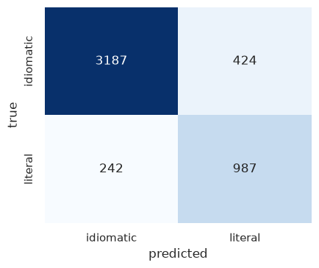
Figure 12: Confusion matrix on the MAGPIE test split (4,840 real sentences).
Inference: Recall is 0.883 for idiomatic uses and 0.803 for literal ones. Most of the mistakes go one way: literal sentences called idiomatic. That is what you would expect when the training data has three idiomatic examples for every literal one.
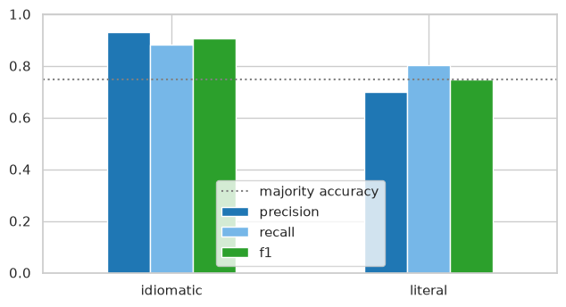
Figure 13: Precision, recall and F1 per class on MAGPIE; the dotted line is the majority-class accuracy.
Inference: Precision is lower on the literal side (0.700). Roughly one in three sentences the detector calls literal is in fact idiomatic. A chatbot built on it should therefore show the probability and not just a label.
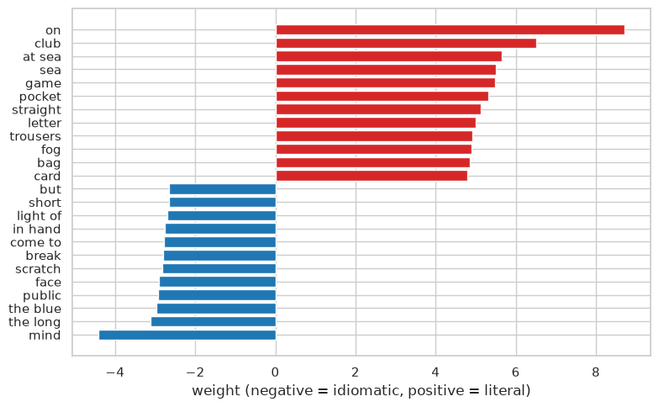
Figure 14: Features with the largest weights on each side of the MAGPIE detector.
Inference: The literal side is full of concrete, physical words. The idiomatic side is mostly discourse and evaluation words. In other words the detector has picked up the register in which people use figurative language, not a list of idioms, and that is what lets it work on proverbs it has never seen.
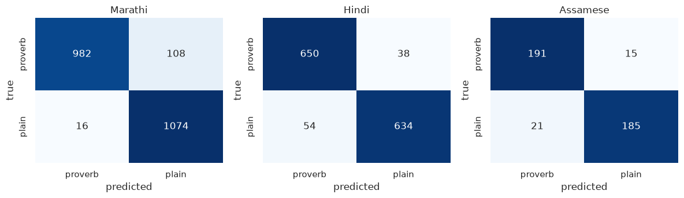
Figure 15: Step B confusion matrices for Marathi, Hindi and Assamese proverbs in carrier sentences (5-fold cross-validation).
Inference: Errors are few and balanced in all three languages; the smallest set (Assamese, 412 sentences) has the most, as expected from its size.
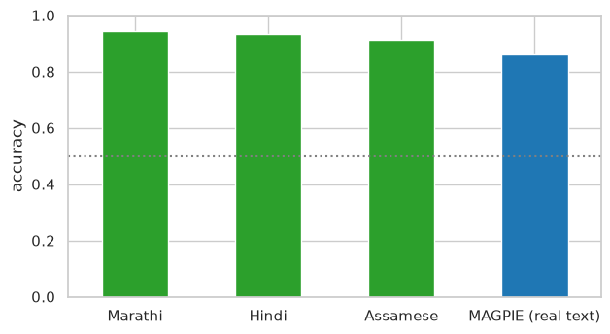
Figure 16: Detection accuracy on the three proverb corpora (Step B) next to the real-text result (Step A).
Inference: Step B accuracies of 0.91 to 0.94 are higher than Step A because of the register difference between 1890s book English and modern BNC sentences; the honest estimate of real-text detection is the Step A bar.
Success and failure cases from the MAGPIE test split, with the detector's probability of idiomatic usage.
Table 11: Idiom-detection success and failure cases.
Outcome | Sentence | Idiom | True | Predicted | P(idiomatic)
success | She has never stepped out of line . | out of line | idiomatic | idiomatic | 0.79
success | Nellie and I tiptoed quietly back down the aisle and out of the door . | down and out | literal | literal | 0.2
failure | " It was me that shot the bull , son . | shoot the bull | literal | idiomatic | 0.88
failure | Everett , similarly enthusiastic , described it as ‘ being on the stump’ . | on the stump | idiomatic | literal | 0.49
Inference: The failures are the two directions the matrix predicts: a literal sentence with vivid wording read as idiomatic, and an idiom in quotation marks inside a plain report read as literal. Both are cases where the register cue the detector relies on points the wrong way.

Discussion
Part II: Figures 12 and 13 show that the CCA1 recipe, TF-IDF features with logistic regression, does separate figurative from literal usage in real sentences: 0.862 accuracy against a majority baseline of 0.746. Its weak spot is the literal class, the minority, at 0.700 precision. Figure 14 is the reason the detector transfers at all. What it has learned is the register of figurative use, evaluation and discourse words on one side and concrete physical words on the other, rather than a stock of idioms. Proverbs from Marathi, Hindi and Assamese that it has never seen trigger the same cues (Figures 15 and 16). The Step B numbers come with a caveat we have stated already: 1890s translations and modern BNC sentences differ in register, and that gap inflates the scores, so the real-text number is the one to quote. RQ2 is answered. The recipe works on real text and it carries over. What is still missing is a corpus of our languages' proverbs inside genuine running text.

