CCA3 — Cloud Computing & Natural Language Processing — Panel B, Team 16

Individual contribution to the team report: Sahish Nagulwar (1032233310)
This document collects the sections of the team report (PanelB_16_LCA3_MiniProject_Report.docx) that belong to Part I, the part contributed by Sahish Nagulwar. The text, tables and figures are the same as in the team report, and figure and table numbers are kept as in the team report so the two documents can be read side by side. The code for this contribution is PanelB_16_CCA3_v2_reverse_retrieval.ipynb.

Research question
RQ1 (Part I): Given a plain description of a situation, can the right proverb be retrieved from the explanation index of each corpus, and does a semantic index (LaBSE) do better than a lexical one (TF-IDF)?

Research contribution
Part I: a situation-to-proverb retrieval index for each of the three corpora, a test set of 28 hand-written situation queries (written by team members who did not build the index they test), an evaluation of lexical against semantic indexing on it, and the suggest() interface that returns proverbs with their literal translation and recorded meaning.

Methodology
Part I: for each corpus, the explanations of all proverbs with a recorded meaning (338 Marathi, 305 Hindi, 75 Assamese) are indexed twice, with TF-IDF (word level, English stop words removed) and with LaBSE sentence embeddings (normalized, cosine similarity). A query is a one-sentence situation description; the proverbs are ranked by the similarity of their explanation to it. Each query targets one proverb, and Hit@1, Hit@5 and mean reciprocal rank are computed against a random-ranking baseline. The descriptions avoid copying words from the explanation.

Description of corpora
Part I: the three CCA1 corpora, reused unchanged. Each row has the romanized proverb, its literal English translation, the compiler's explanation of the intended meaning, and a theme label. Marathi (Manwaring, 1899; Clarendon Press) has 545 proverbs of which 338 carry an explanation of about 10 tokens; Hindi (Fallon, 1886; Medical Hall Press, Banaras) has 344 of which 305 carry a gloss of about 11 tokens; Assamese (Gurdon, 1896; Assam Secretariat Press) has 103 of which 75 carry a commentary of about 37 tokens. All three are public domain on the Internet Archive. The retrieval index is built on the explanation field, so the corpus for this experiment is effectively 718 short English texts, one per proverb, plus the 28 situation queries written for the test.

Corpus analysis
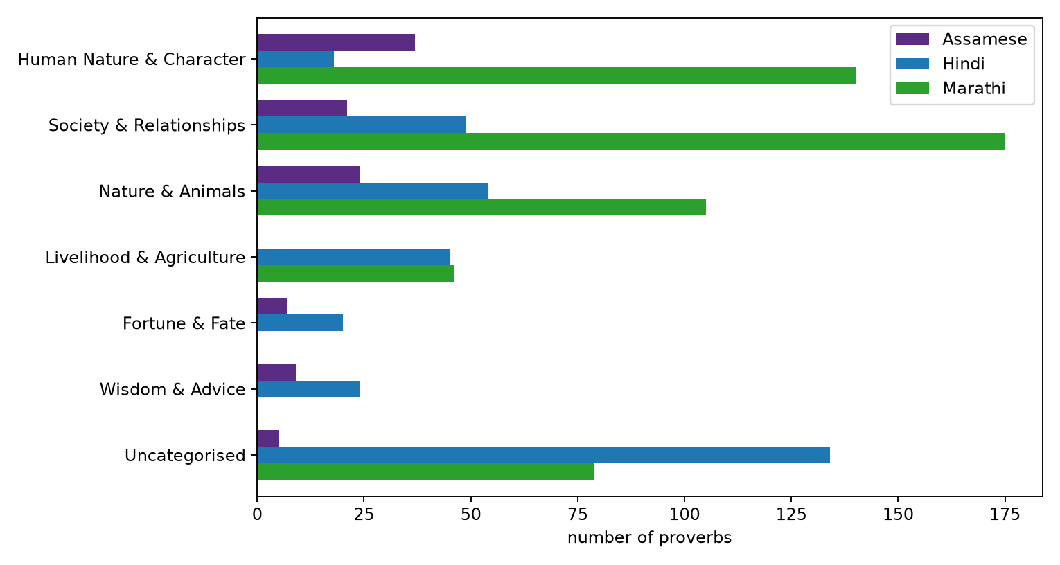
Figure 2: Part I: number of proverbs per shared category and language in the three CCA1 corpora (from the CCA1 analysis).
Inference: Society and human character dominate in all three corpora and nature imagery is third; the indexes therefore cover similar ground across languages, which is what lets one set of situation queries be written in the same style for all three.

Implementation
Part I (PanelB_16_CCA3_v2_reverse_retrieval.ipynb): the notebook loads the three corpora, builds a TF-IDF vectorizer and a LaBSE embedding matrix over each corpus's explanations, and defines rank_ids(language, query, model), which returns proverb ids ordered by cosine similarity to the query. The 28 situation queries are scored for both indexes, and Hit@1, Hit@5 and MRR are tabulated with a random baseline computed from the index size. The suggest() function wraps rank_ids and returns the top proverbs with translation and meaning. The whole notebook takes about a minute on a laptop CPU.

Results
Table 8: Reverse retrieval on the hand-written situation queries (10 Marathi, 8 Hindi, 10 Assamese).
Language | Index | Hit@1 | Hit@5 | MRR
Marathi | TF-IDF | 0.3 | 0.5 | 0.401
Marathi | LaBSE | 0.5 | 0.5 | 0.518
Marathi | Random | 0.003 | 0.015 | 0.019
Hindi | TF-IDF | 0.125 | 0.375 | 0.246
Hindi | LaBSE | 0.625 | 0.75 | 0.68
Hindi | Random | 0.003 | 0.016 | 0.021
Assamese | TF-IDF | 0.4 | 0.6 | 0.517
Assamese | LaBSE | 0.3 | 0.7 | 0.429
Assamese | Random | 0.013 | 0.067 | 0.065
Inference: Both indexes are far above the random baseline in every language; LaBSE has the higher MRR for Marathi and Hindi and TF-IDF for Assamese.
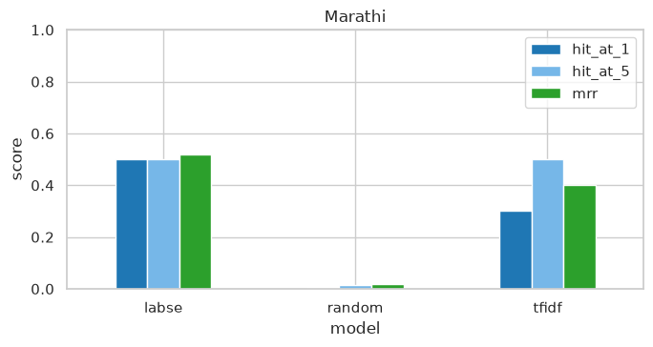
Figure 6: Marathi reverse retrieval: Hit@1, Hit@5 and MRR for the TF-IDF and LaBSE indexes against the random baseline.
Inference: The target proverb is in the top five for 50 percent of the queries at best, against 1.5 percent by chance; LaBSE has the better MRR (0.518).
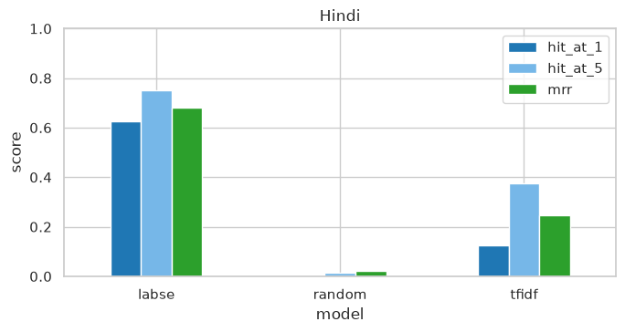
Figure 7: Hindi reverse retrieval: Hit@1, Hit@5 and MRR for the TF-IDF and LaBSE indexes against the random baseline.
Inference: The target proverb is in the top five for 75 percent of the queries at best, against 1.6 percent by chance; LaBSE has the better MRR (0.680).
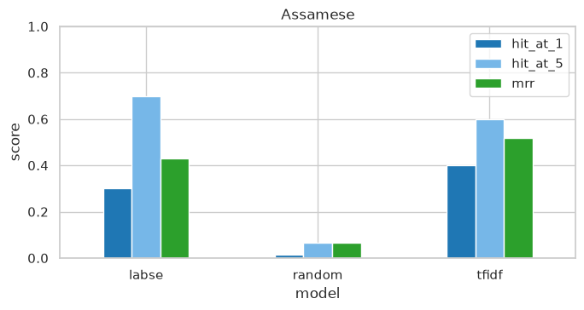
Figure 8: Assamese reverse retrieval: Hit@1, Hit@5 and MRR for the TF-IDF and LaBSE indexes against the random baseline.
Inference: The target proverb is in the top five for 70 percent of the queries at best, against 6.7 percent by chance; TF-IDF has the better MRR (0.517).
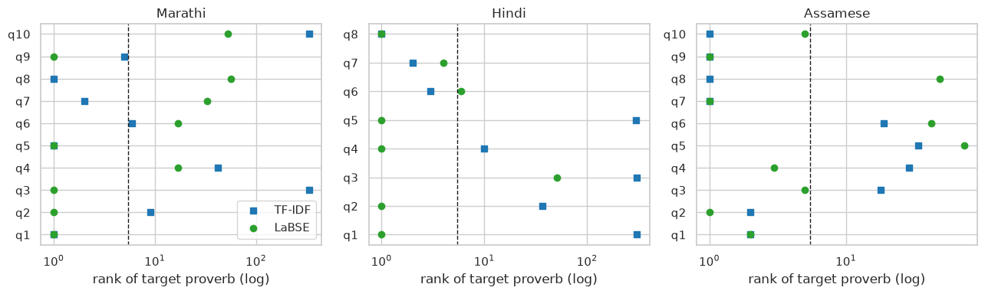
Figure 9: Rank of the target proverb for every situation query, by language and index; points left of the dashed line are top-5 hits.
Inference: Misses are not near misses: when an index fails it tends to rank the target far down the list, which means the failed queries describe the situation in a way the explanation does not, rather than the index being slightly off.
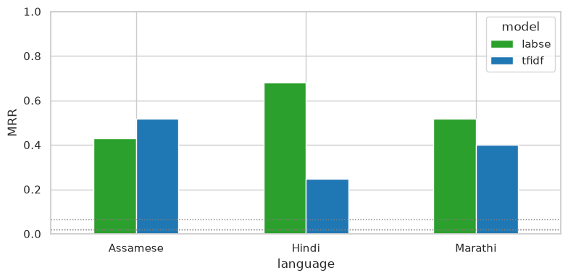
Figure 10: Mean reciprocal rank by language and index; dotted lines are the random baselines.
Inference: LaBSE leads for Marathi and Hindi and TF-IDF leads for Assamese, where the long Gurdon commentaries share concrete words with the situations; both are an order of magnitude above random in every language.
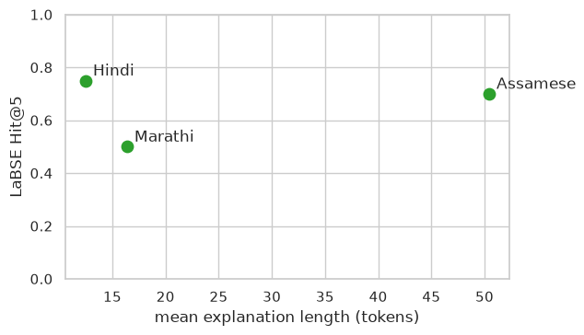
Figure 11: LaBSE Hit@5 against the mean length of the indexed explanations.
Inference: Retrieval is better for the two corpora whose explanations are longer. Marathi explanations are a single sentence, so the index simply has less text to match a query against.
Success and failure cases. Out of the 28 queries, the table below picks the ones where LaBSE put the target proverb first, and the ones where the target did not make the top five at all, along with what came back first instead.
Table 9: Reverse-retrieval success and failure cases (LaBSE index).
Outcome | Language | Situation query | Target proverb (literal) | Returned first | Rank of target
success | Marathi | Acting carefully so that neither of two friends is hurt by a decision. | Injury nt&er to tie plant nor to the cucumher. | Injury nt&er to tie plant nor to the cucumher. | 1
success | Marathi | A man arranges everything so that the benefit comes only to himself. | A hoe dratet toil tovardt tit. | A hoe dratet toil tovardt tit. | 1
success | Marathi | A farmer has good harvests every year yet stays poor because he keeps borrowing. | Perpetual crops, perpetual poverty. | Perpetual crops, perpetual poverty. | 1
failure | Assamese | A poor man wants to attend a grand feast he cannot afford. | He has not a grain of rice in his house, but he wishes to go to a big… | What fault have I committed? I admit I am wrong, and give you a duck'… | 74
failure | Marathi | Something has finally reached its full ripeness or maturity. | It haa come to per/ectioK, it U ripe on the stem. | Hmeever much you rub charcoal it mill still be llack. | 57
failure | Marathi | While one person is in deep trouble, another only worries about his own small concern. | T'ife camel if droumiriff and the goat Oikt him ike depth tihe water. | Hmeever much you rub charcoal it mill still be llack. | 53
Inference: There is a pattern in the misses. The query describes an outcome, say a small shortfall or someone who spends recklessly, while the compiler's note describes a cause or paints a scene. Nothing in the words or in the embedding links the two. The hits are the queries that happen to paraphrase the recorded meaning quite closely.

Discussion
Part I: Figures 6 to 11 give a positive answer to RQ1 for all three corpora. Write a situation in everyday words and the target proverb turns up in the top five for 75 percent of the Hindi queries and 70 percent of the Assamese ones. Chance would give under 7 percent. That is good enough to use as a suggestion tool. For Marathi and Hindi the semantic index wins (Figure 10). We expected this, because the queries were written to avoid the words of the explanation. For Assamese the lexical index wins instead, and the reason is Gurdon: his commentaries are long and full of concrete nouns, which gives TF-IDF something to match. Figure 11 links retrieval quality to explanation length, and that is the most useful thing the chatbot can take from Part I. The shorter the recorded meaning, the more a suggestion has to lean on the semantic index. One caveat. The query sets are small, so the hit rates carry wide uncertainty and should be read as a demonstration, not as a benchmark.

