LCA3 mini project — Cloud Computing & Natural Language Processing, Panel B, Team 16 (data article format, version 3)

ARTICLE INFORMATION
Article title
Dataset of Marathi, Hindi and Assamese proverbs with literal translations and recorded meanings, with the situation queries and idiom-usage data of a mini project on figurative meaning
Authors
Sahish Nagulwar, Ibrahim Ansari*, Chayan Raj Bharati
Affiliations
School of Computer Science and Engineering, Dr. Vishwanath Karad MIT World Peace University, Survey No. 124, Paud Road, Kothrud, Pune 411038, Maharashtra, India
Corresponding author’s email address and Twitter handle
ibrahim.ansari@mitwpu.edu.in (corresponding author); sahish.nagulwar@mitwpu.edu.in; chayan.bharati@mitwpu.edu.in
Keywords
proverbs; figurative meaning; idiom detection; cross-lingual retrieval; sentence embeddings; low-resource languages; OCR corpora
Abstract
The data describe three machine-readable proverb corpora built from public-domain compilations: 545 Marathi proverbs from Manwaring (1899), 344 Hindi proverbs from Fallon (1886) and 103 Assamese proverbs from Gurdon (1896). Each record holds the proverb as romanized in the book, its literal English translation, the compiler's explanation of the intended meaning, the book's own theme label and one of six shared categories. The corpora were extracted from Internet Archive OCR text with a rule-based pipeline that labels blocks by their share of English function words, cleans OCR noise and keeps only entries with a recoverable proverb and translation; the raw OCR text and the extraction scripts are included so every row can be traced back to a line of the source. Alongside the corpora, the dataset holds the data used by the mini project built on them: 28 hand-written situation queries with their target proverbs, for situation-to-proverb retrieval with TF-IDF and LaBSE indexes, and the MAGPIE corpus of 48,395 English sentences with idiomatic or literal usage labels, on which an idiom-usage detector was trained before being applied to the proverbs. The corpora can be reused for figurative-language research in three under-resourced Indian languages, for cross-lingual meaning alignment, and as a test of whether language models interpret obscure proverbs or merely restate them.

SPECIFICATIONS TABLE
Subject | Computer Science: Artificial Intelligence; Arts and Humanities: Linguistics
Specific subject area | Natural language processing of figurative language: proverb and idiom corpora for Marathi, Hindi and Assamese, with retrieval, detection and language-model interpretation outputs.
Type of data | Table (CSV, XLSX). Raw and processed data.
Data collection | Three public-domain proverb compilations (1886-1899) were downloaded as OCR text from the Internet Archive and segmented into entries. Blocks inside each entry were labelled as romanized proverb, literal English translation or recorded meaning by the share of common English function words, cleaned of OCR noise, and kept only if the proverb and translation were recoverable. Theme labels were taken from the books' section headings and mapped to six shared categories. The MAGPIE corpus of English idiom usage was obtained from its public repository. Situation queries were written by hand by team members. Model outputs were produced on CPU with scikit-learn, LaBSE sentence embeddings, Qwen2.5-0.5B-Instruct and FLAN-T5-base.
Data source location | Institution: Dr. Vishwanath Karad MIT World Peace University, Pune, Maharashtra, India. Primary sources: Internet Archive digitizations of Manwaring (1899), Fallon (1886) and Gurdon (1896) [1-3]; MAGPIE corpus, University of Groningen [4].
Data accessibility | The data are supplied with the course submission (Google Classroom, Panel B, Team 16) in the folders listed under Data Description; they are not deposited in a public repository, in line with the course confidentiality requirement. Direct URLs to the primary sources: https://archive.org/details/marathiproverbs00manwgoog ; https://archive.org/details/in.ernet.dli.2015.42145 ; https://archive.org/details/someassameseprov00gurdrich ; MAGPIE: https://github.com/hslh/magpie-corpus (redistributed under its research licence, which is included).
Related research article | None. The data support the team's course reports CCA1 and CCA3 (Cloud Computing and Natural Language Processing, 2026), which are not published articles.

VALUE OF THE DATA
- They are the only machine-readable proverb collections for Marathi, Hindi and Assamese together that pair each proverb with its literal translation and its intended meaning, written by the original compilers; nothing comparable exists for these three languages in one schema.
- Researchers in figurative-language processing, cross-lingual semantics and low-resource Indian-language NLP can reuse the corpora directly as supervision: the recorded meaning is a gold explanation, which is rare for proverbs.
- The proverbs come from obscure nineteenth-century books, so they are unlikely to be in language-model training data; the benchmark material lets others test interpretation rather than memorisation.
- The raw OCR text and the extraction scripts make every row traceable, so the corpora can be corrected and extended (native-script recovery, modern dictionaries) by anyone.

BACKGROUND
A proverb says one thing and means another: "perpetual crops, perpetual poverty" is not about farming but about a farmer who stays poor because he keeps borrowing. Systems that read text compositionally get the words right and the meaning wrong, and the problem is sharper in Indian languages, where the stock of proverbs is large, regionally varied and thinly digitised. The team problem statement for the course asked for a multilingual framework that identifies Indian idioms and separates their literal meaning from the culturally intended one. The first project (CCA1) built the three corpora from colonial-era compilations that record the intended meaning next to the literal text [1-3], and measured that a proverb shares no more vocabulary with its own explanation than with a random one, that retrieval of the meaning collapses when the query is the romanized source text, and that a multilingual embedding model [5] gave nothing on that romanized text.
The mini project (LCA3) extended that work with three experiments run on all three corpora with one shared code path: situation-to-proverb retrieval, idiom-usage detection validated on a real English corpus [4] and transferred to the proverbs, and a language-model interpretation benchmark with controls that separate interpretation from restatement [7,8,11]. This article describes the corpora and the query and training data those experiments used.

DATA DESCRIPTION
The dataset is organised in two folders of the course repository, cca1 (corpora and extraction code) and cca3 (the situation queries and the MAGPIE corpus used in the experiments). Table 1 summarises the three corpora and Table 2 lists every data file.
Table 1. The three proverb corpora.
Language (source) | Proverbs | With recorded meaning | Mean tokens: proverb / translation / meaning | Theme labels
Marathi (Manwaring 1899) | 545 | 338 | 4.9 / 21.9 / 10.2 | 13 book sections
Hindi (Fallon 1886) | 344 | 305 | 6.7 / 10.0 / 11.4 | none (alphabetical dictionary)
Assamese (Gurdon 1896) | 103 | 75 | 9.2 / 26.7 / 36.7 | 10 theme buckets from subject headings
Inference: The three corpora differ by an order of magnitude in size and in how long the recorded meaning is: Marathi meanings are one sentence, Assamese commentaries run to several, which affects how much text a retrieval index has to match against.
Table 2. Data files in the dataset (<lang> stands for marathi, hindi or assamese).
File or folder | Content
cca1/corpus/PanelB_16_<lang>_proverbs.csv | One row per proverb: id, theme, theme_bucket, proverb_translit, literal_en, commentary (three files).
cca1/corpus/PanelB_16_<lang>_categorised.csv | The same rows with the shared six-way category and the basis for it.
cca1/corpus/PanelB_16_<lang>_corpus.xlsx | Excel workbook per language: cleaned corpus, counts by category, and the full raw OCR text as a sheet.
cca1/corpus/PanelB_16_<lang>_*_raw.txt | Unedited OCR text of each book as downloaded (395 KB, 1.5 MB, 179 KB).
cca1/corpus/source_pdfs/ | The three scanned books (PDF, 44 MB in total).
cca1/PanelB_16_extract_marathi.py, _extract_hindi.py, _build_corpus.py, _categorize.py | Extraction and categorisation scripts; raw text in, CSV out.
cca3/external/MAGPIE_filtered_split_random.jsonl (+ licence) | 48,395 English sentences with idiomatic/literal usage labels and a fixed split [4]; obtained from its public repository.
cca3/report/PanelB_16_CCA3_v2_situation_queries.csv | The 28 hand-written situation queries (10 Marathi, 8 Hindi, 10 Assamese) with the id, romanized text and literal translation of the target proverb.
Inference: Every processed file can be traced back to a raw OCR file and a scanned page through the extraction scripts, so a doubtful row can be checked against the book.
Each corpus row carries six fields. Tables 3 to 5 show sample rows from each corpus file as they appear in the CSV, Figure 1 shows the shared category distribution, Table 6 shows rows of the MAGPIE file, and Table 7 places proverb records next to MAGPIE idiom records to make the two record types concrete.
Table 3. Marathi corpus file, sample rows.
id | Romanized proverb | Literal translation | Recorded meaning
13 | Ila ani bhopala | The sickle and the gourd. | Applied to man and wife, master and servant,
23 | Preta zhaiikuna thevave adhl peranisa zave | Cover up the corpse, attend first to the sowing. | Everything must be left so that the sowing may be done exactly at the right time.
68 | Kida mun khai tara taru salamata zai | 1/ insects and ants have food the ship will go safely. | A man will prosper who is liberal to the poor.
216 | Vati tjala pati | The distributor has the basket. | He helps others and has only the empty basket left.
Inference: The recorded meaning is a single sentence and the translation is often longer than it, so the Marathi index has the least text to match a situation against.
Table 4. Hindi corpus file, sample rows.
id | Romanized proverb | Literal translation | Recorded meaning
1 | Abkl ser mek pint bhi naJvik kati hai. | Of the pound of cotton not a skein ii yet sp jn. | Scarce a fraction of the work is yet done.
47 | Burbak ki Jord sab kl bkaujdi. | A fool’s wife is every body’s sister-in-law, | le. any body may flirt with her.
48 | Chain nudhaun heuar harid hail | Who fails to do what he can for himself t | Every one tries his beat in his own interest: to put one's best leg forward.
79 | DM jKirtfi. ddkh tajdi. | The eyes feel shame for another's daughter. | When married into the owner's family.
Inference: Fallon writes short literal glosses and a meaning of similar length; the romanized line is the longest field, and it is the one multilingual models cannot read.
Table 5. Assamese corpus file, sample rows.
id | Romanized proverb | Literal translation | Recorded meaning
17 | Hatat nal bit Mane kare pit pit. | He has no money in hand, But his cravings are great. | f5 literally gall, bile, f literally wealth, substance.
46 | Jar khabar jibar man, Bahote achore ban. | He who has a mind to thrive, Scratches up grass, even when sitting down. | I'T literally, the mind for eating and living. The proverb means that people who wish to succeed, should never waste a moment, which may be devoted t…
48 | Jagar ba lagalo ki Mato ha(n)h kanidi. | What fault have I committed? I admit I am wrong, and give you a duck's egg. | The proverb refers to the case of a person who thinks he is taken to task for a trifling fault.
42 | Gharat nai kanto, bar shabhaloi manto. | He has not a grain of rice in his house, but he wishes to go to a big feast. | This is almost similar to No. 97, except that Wl is sub- stituted for the verb r. Also compare the Grauhdti proverb ta'vs 5 1 ft 1 (urdlat ndi kanto …
Inference: Gurdon's commentaries run to several sentences and carry concrete nouns, which is why a lexical index does comparatively well on this corpus.
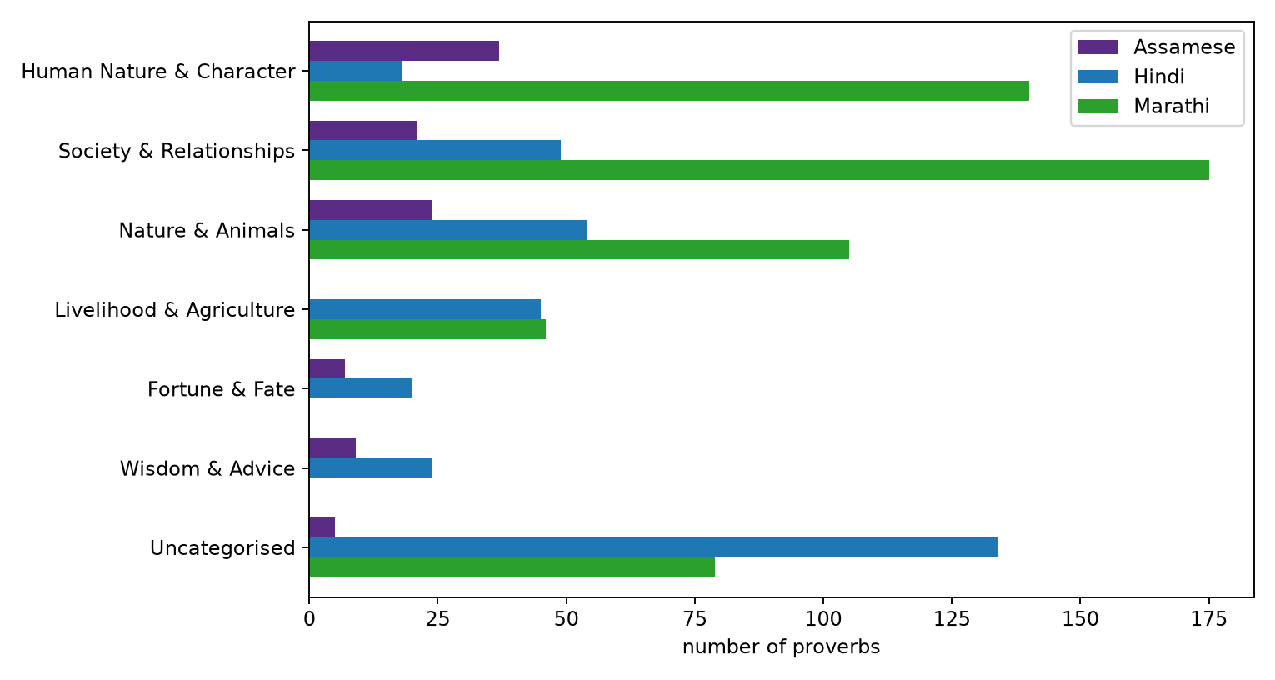
Figure 1. Number of proverbs per shared category and language.
Inference: Society and human character dominate in all three corpora and nature imagery is third, so the three collections cover similar ground and can be queried in the same style.
Table 6. MAGPIE rows: sentence, the idiom it contains, the annotated usage label and the split.
Sentence | Idiom | Usage label | Split
For example , with fell running and mountain marathons gaining in popularity , how about some ideas for safe running off the beaten track ? | off the beaten track | idiomatic | training
I 'd keep him well in the running . | in the running | idiomatic | training
He gives me the creeps , so I looked round , hmm hmm . | give someone the creeps | idiomatic | training
So I went all the way down to the door slightly irritated , and what did I see ? | go all the way | literal | training
At least back when I lived in a hole I knew everything there was to know about living in a hole , and now it 's a year later and I 'm at a … | in the hole | literal | training
four lenses ( a 20,35,55 and zoom ) , a tripod , ‘ that was as essential on the trip as a passport,’ and 30 rolls of Kodachrome film ( alth… | in black and white | literal | training
Inference: The same idiom string appears with both labels, so the label depends on the surrounding sentence and not on the idiom; this is the property a usage detector has to learn.
Table 7. Records: two proverbs per corpus with literal translation and intended meaning, and three MAGPIE idiom occurrences with their usage label.
Record type | Expression | Literal translation or context | Meaning or usage label
Marathi proverb | Ila ani bhopala | The sickle and the gourd. | Applied to man and wife, master and servant,
Marathi proverb | Preta zhaiikuna thevave adhl peranisa zave | Cover up the corpse, attend first to the sowing. | Everything must be left so that the sowing may be done exactly at the right time.
Hindi proverb | Abkl ser mek pint bhi naJvik kati hai. | Of the pound of cotton not a skein ii yet sp jn. | Scarce a fraction of the work is yet done.
Hindi proverb | Burbak ki Jord sab kl bkaujdi. | A fool’s wife is every body’s sister-in-law, | le. any body may flirt with her.
Assamese proverb | Hatat nal bit Mane kare pit pit. | He has no money in hand, But his cravings are great. | f5 literally gall, bile, f literally wealth, substance.
Assamese proverb | Jar khabar jibar man, Bahote achore ban. | He who has a mind to thrive, Scratches up grass, even when sitting down. | I'T literally, the mind for eating and living. The proverb means that people who wish to succeed, s…
English idiom (MAGPIE) | off the beaten track | For example , with fell running and mountain marathons gaining in popularity , how about … | idiomatic usage
English idiom (MAGPIE) | in the running | I 'd keep him well in the running . | idiomatic usage
English idiom (MAGPIE) | go all the way | So I went all the way down to the door slightly irritated , and what did I see ? | literal usage
Inference: A proverb record carries its meaning as free text written by the compiler, while an idiom record carries only a usage label; this is why proverb experiments are scored by similarity to a text and the idiom experiment by classification accuracy.

EXPERIMENTAL DESIGN, MATERIALS AND METHODS
Corpus construction. The OCR text of each book was downloaded from the Internet Archive [1-3]. The text was split into entries (numbered entries for Gurdon, section page-headers and entry breaks for Manwaring, romanized-line detection for Fallon). Inside each entry, every block was scored by the fraction of its words that are common English function words: a low share marks the romanized proverb, a high share in the first block marks the literal translation, and later high-share blocks, parenthesised notes or blocks with cue phrases such as "said of" mark the recorded meaning. Stray symbols were removed, junk tails trimmed and garbage lines dropped. An entry was kept only if the proverb and the translation each had at least three recoverable words; Fallon entries also had to pass an English-ratio check on translation and gloss. This is why the corpora are smaller than the books (Marathi about 1,900 printed, 545 kept; Hindi 449 candidates, 344 kept; Assamese 218 parsed, 103 kept): damaged entries were dropped rather than patched. Theme labels come from the books' own section headings, and a keyword map assigns one of six shared categories (human nature, society, nature and animals, livelihood, fortune and fate, wisdom) with the basis recorded per row. Figure 2 shows the pipeline.
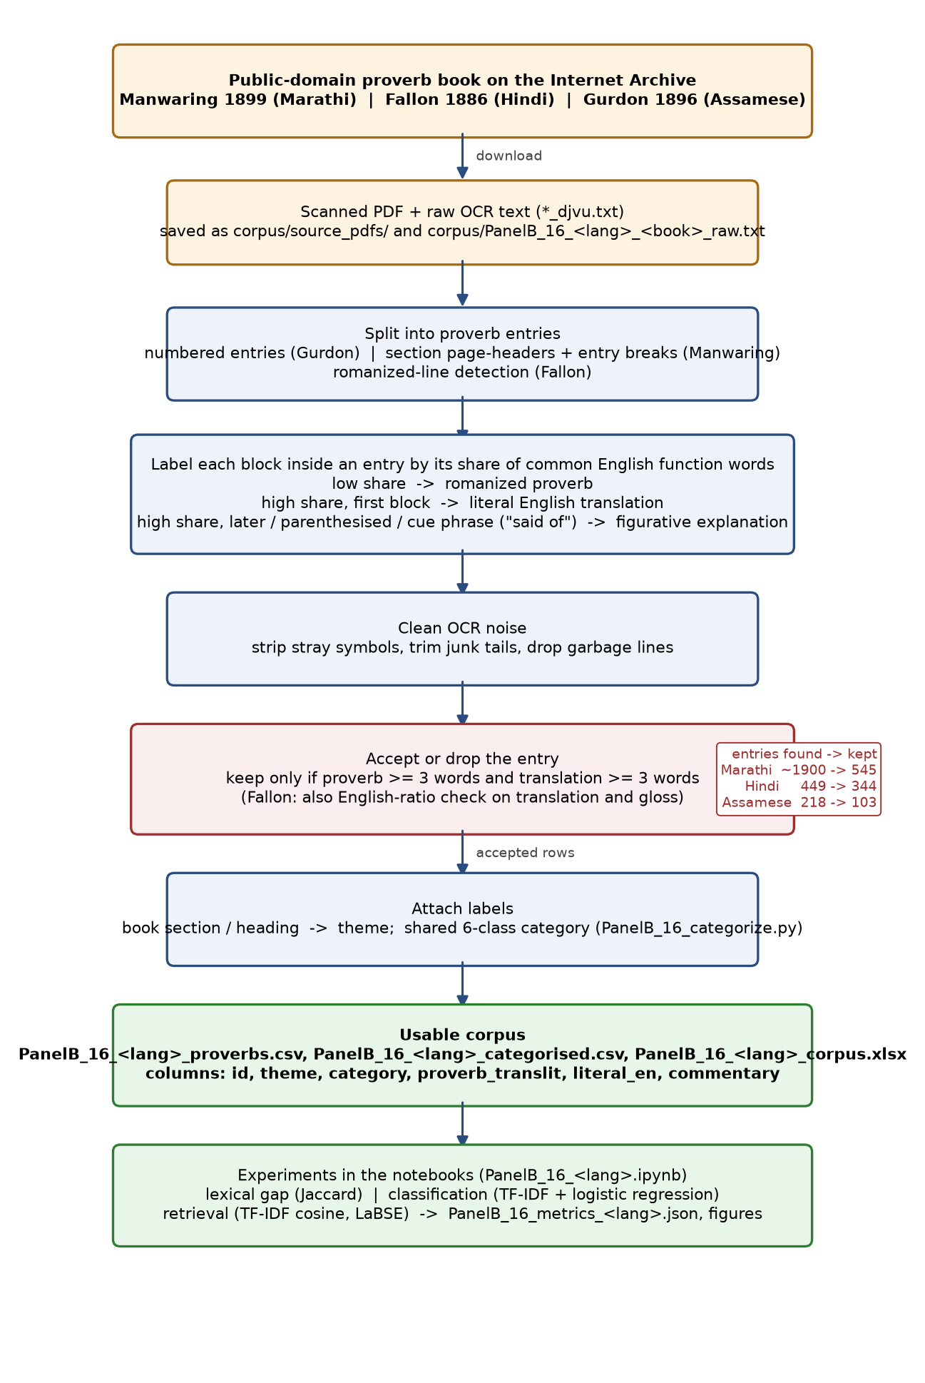
Figure 2. From scanned book to usable corpus; the counts beside the red box are entries found against entries kept.
Inference: Most of the loss happens at the acceptance rule, not at OCR: entries were dropped whenever the proverb or the translation could not be recovered, so the kept rows are clean at the cost of coverage.
Representations. Two representations are used throughout: TF-IDF vectors (scikit-learn [14], English stop words removed, sublinear term frequency) and LaBSE sentence embeddings [5,6], normalised so that the dot product is the cosine similarity. Both run on CPU.
Situation-to-proverb retrieval. For each corpus the recorded meanings of all proverbs that have one (338, 305 and 75) are indexed with both representations. A query is a one-sentence situation description written by a team member who did not build that index, targeting one proverb and avoiding the words of its recorded meaning; 10 Marathi, 8 Hindi and 10 Assamese queries were written. Proverbs are ranked by the similarity of their recorded meaning to the query, and Hit@1, Hit@5 and mean reciprocal rank are computed against a random-ranking baseline.
Idiom-usage detection. Step A trains TF-IDF over word unigrams and bigrams with logistic regression (balanced class weights) on the MAGPIE training split (38,716 sentences) and tests on its test split (4,840), labels idiomatic versus literal usage [4]. Step B applies the same recipe to each language: the proverbs (literal translations) are placed in six carrier sentences as positives and real literal MAGPIE sentences of 5 to 25 tokens are placed in the same carriers as negatives, under 5-fold cross-validation, so the carriers cancel and the classifier decides from content.
Interpretation benchmark. 60 proverbs with recorded meanings per language (random sample, seed 42) are given to Qwen2.5-0.5B-Instruct [8] and FLAN-T5-base [7] with the prompt "Explain the meaning of this proverb in one sentence", once with the literal translation and once with the romanized source text. The answer is scored by LaBSE similarity to the recorded meaning; the control is its similarity to a random other recorded meaning; the margin is the difference. The echo baseline scores the literal translation itself the same way. Greedy decoding for Qwen (chat template, left padding), two-beam decoding for FLAN-T5, 48 new tokens, batches of eight.
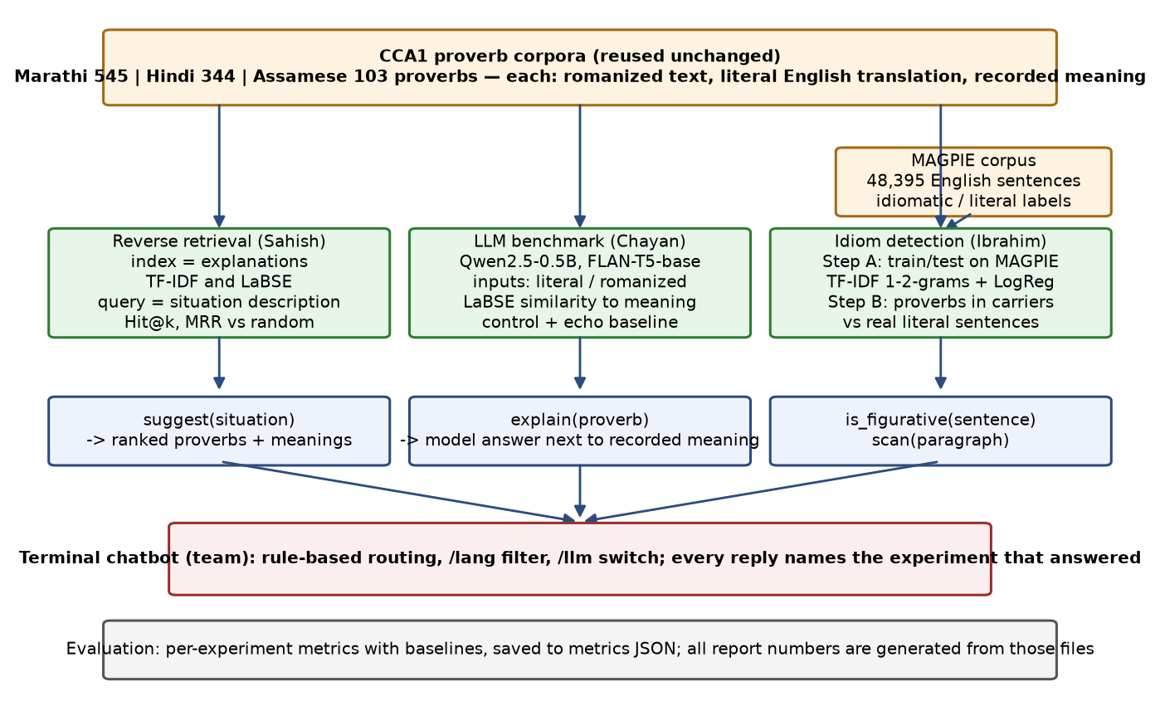
Figure 3. Design of the three experiments on the three corpora.
Inference: The three experiments share their inputs and their evaluation style but not their models, so a difference between them is a difference in task, not in data preparation.

LIMITATIONS
- OCR noise. The books were printed between 1886 and 1899 and the OCR text carries character errors in many translations and meanings; rows were kept whenever the fields were recoverable, so noisy rows are present. The raw text is included so that they can be corrected.
- Romanization. The proverbs are in the books' nineteenth-century romanization, not native script, which is the main reason multilingual models perform poorly on them; native-script recovery is the next step.
- Size. The Assamese corpus has 103 proverbs (75 with meanings), the smallest of the three; the situation query sets have 8 to 10 items per language, so retrieval scores carry wide uncertainty.
- Idiom detection is English-only. MAGPIE is an English corpus; the proverbs reach the detector through their English translations, and the carrier-sentence data differ in register from modern English, which inflates the Step B scores.
- The language models are small (0.5 and 0.25 billion parameters) and were run on CPU; the famous-versus-obscure split of the benchmark needs a frequency source and was not run.

ETHICS STATEMENT
The work did not involve human subjects, animal experiments or data collected from social media platforms. The primary sources are books published between 1886 and 1899 that are in the public domain; the MAGPIE corpus is redistributed under its research licence, which is included with the data. The authors have read and follow the ethical requirements for publication in Data in Brief.

CRediT AUTHOR STATEMENT
Sahish Nagulwar: Data curation (Marathi corpus), Investigation (situation-to-proverb retrieval), Software, Visualization, Writing - original draft. Ibrahim Ansari: Data curation (Hindi corpus), Investigation (idiom-usage detection), Software (extraction pipeline), Visualization, Writing - original draft. Chayan Raj Bharati: Data curation (Assamese corpus), Investigation (interpretation benchmark), Validation, Visualization, Writing - review and editing. All authors wrote the situation queries for a language other than their own.

ACKNOWLEDGEMENTS
The authors thank Dr. Suja Panickar, course instructor for Cloud Computing and Natural Language Processing, for the problem statement and the review of the course reports. This research did not receive any specific grant from funding agencies in the public, commercial, or not-for-profit sectors.

DECLARATION OF COMPETING INTERESTS
The authors declare that they have no known competing financial interests or personal relationships that could have appeared to influence the work reported in this paper.

REFERENCES
[1] A. Manwaring, Marathi Proverbs, Clarendon Press, Oxford, 1899. https://archive.org/details/marathiproverbs00manwgoog
[2] S.W. Fallon, A Dictionary of Hindustani Proverbs, Medical Hall Press, Banaras, 1886. https://archive.org/details/in.ernet.dli.2015.42145
[3] P.R. Gurdon, Some Assamese Proverbs, Assam Secretariat Printing Office, Shillong, 1896. https://archive.org/details/someassameseprov00gurdrich
[4] H. Haagsma, J. Bos, M. Nissim, MAGPIE: A large corpus of potentially idiomatic expressions, in: Proceedings of the 12th Language Resources and Evaluation Conference, 2020, pp. 279-287. https://github.com/hslh/magpie-corpus
[5] F. Feng, Y. Yang, D. Cer, N. Arivazhagan, W. Wang, Language-agnostic BERT sentence embedding, in: Proceedings of the 60th Annual Meeting of the Association for Computational Linguistics, 2022, pp. 878-891.
[6] N. Reimers, I. Gurevych, Sentence-BERT: Sentence embeddings using Siamese BERT-networks, in: Proceedings of EMNLP-IJCNLP, 2019, pp. 3982-3992.
[7] H.W. Chung, L. Hou, S. Longpre, et al., Scaling instruction-finetuned language models, arXiv:2210.11416, 2022.
[8] Qwen Team, Qwen2.5 technical report, arXiv:2412.15115, 2024.
[9] M. Tan, J. Jiang, Does BERT understand idioms? A probing-based empirical study of BERT encodings of idioms, in: Proceedings of RANLP, 2021, pp. 1397-1407.
[10] V. Dankers, C. Lucas, I. Titov, Can transformer be too compositional? Analysing idiom processing in neural machine translation, in: Proceedings of the 60th Annual Meeting of the Association for Computational Linguistics, 2022, pp. 3608-3626.
[11] C.C. Liu, F. Koto, T. Baldwin, I. Gurevych, Are multilingual LLMs culturally-diverse reasoners? An investigation into multicultural proverbs and sayings, in: Proceedings of NAACL, 2024.
[12] S. Khanuja, D. Bansal, S. Mehtani, et al., MuRIL: Multilingual representations for Indian languages, arXiv:2103.10730, 2021.
[13] D. Kakwani, A. Kunchukuttan, S. Golla, et al., IndicNLPSuite: Monolingual corpora, evaluation benchmarks and pre-trained multilingual language models for Indian languages, in: Findings of EMNLP, 2020, pp. 4948-4961.
[14] F. Pedregosa, G. Varoquaux, A. Gramfort, et al., Scikit-learn: Machine learning in Python, Journal of Machine Learning Research 12 (2011) 2825-2830.

